
Assignment 2:
Operating Systems
CertHE Computing Skills for Workplace

Computer Architecture and Operating Systems. ACCA4022_LON
DR. Redhwan Al-Amri (Lecturer)
University of Wales Trinity Saint David
(London Campus)
Student Name: Ersal Nezhdet Rashid
Student Number: 2025 3042 51
Group: 02

Table of Contents
Introduction 1
1. Key functions of general Operating Systems 1
1.1 Process and Processor Management 1
1.2 Memory Management 2
1.3 File System Management 2
1.4 Security and Protection 3
2. Use of Windows OS CLI commands. 5
3. Use of Linux OS CLI commands. 9
4. Use of Windows OS scripts. 11
5. Use of Linux OS scripts. 14
Conclusion 15
References 16
Appendices 16

Introduction
This report provides an overview of the underlying types and mechanisms provided by general-purpose operating systems. An operating system is the interface between user and the computer hardware. In the first part of this report, I will discuss main functions covered by any operating system and I will show their locations such with screenshots. After that, I will explain how to use command-line tools for file and process management in Windows & Linux environment. At last, you will see how to automate routine tasks on the computer.

1. Key functions of general Operating Systems

1.1 Process and Processor Management

The operating system manages every program that is currently running. You can also think of these running programs as "processes." When multiple programs are executed simultaneously on a computer, the operating system must balance the allocation of processor (CPU) time among all these processes [1]. It determines which program runs and for how long, ensuring the computer operates smoothly without freezing. The Windows Task Manager displays active programs and their CPU usage rates.
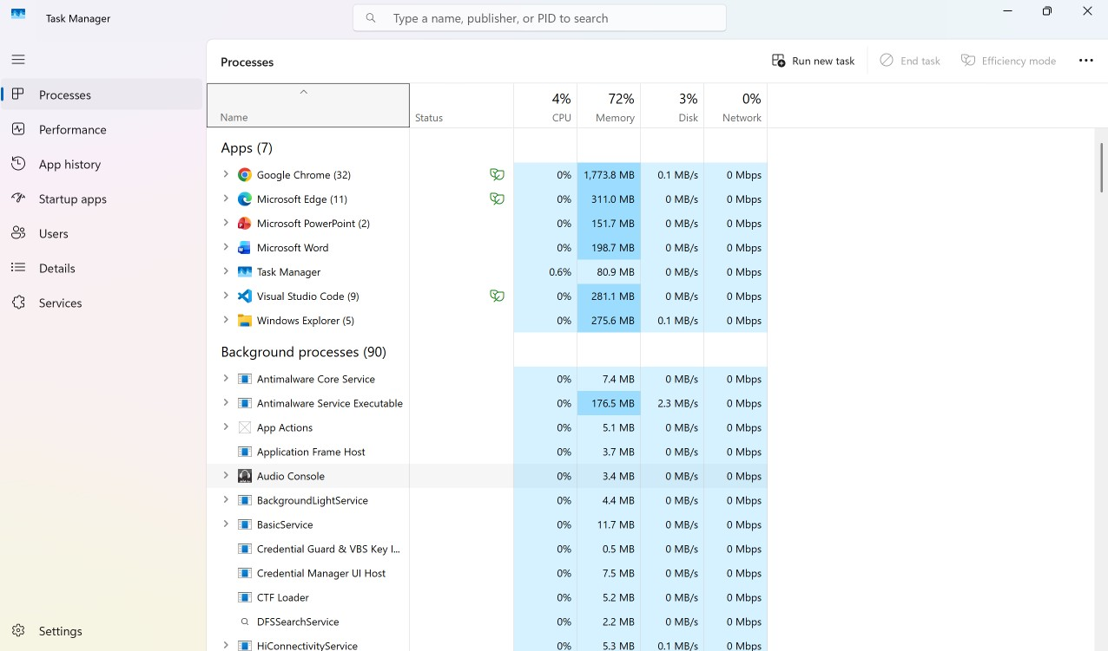
Figure 1: Windows Task Manager displaying active processes and their CPU utilization.

1.2 Memory Management
Operating systems play a crucial role in memory management. They manage the main memory, known as RAM. The operating system tracks which programs are using memory at any given time [2]. When you launch an application, the operating system allocates a specific amount of memory to it. Conversely, when you close the application, the operating system reclaims that memory. This prevents data conflicts between applications [3]. The Performance tab in the Task Manager displays the amount of memory being used.
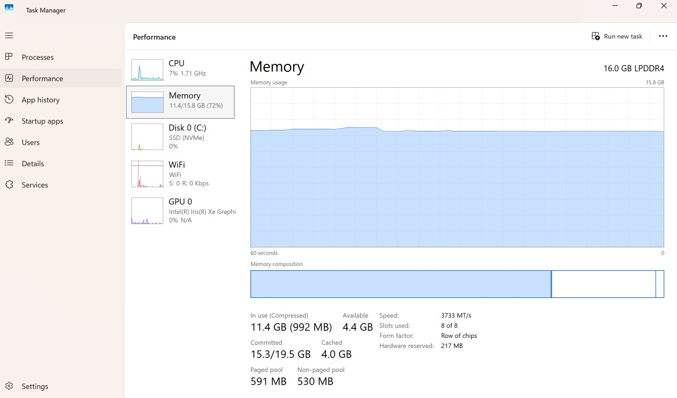
Figure 2: Performance tab in Task Manager showing real-time memory (RAM) allocation.

1.3 File System Management

Computer data is stored on hard drives or SSDs, and the operating system manages this data through files and folders. You can create, delete, and move these files [3]. The operating system also controls who can read or write specific files. Windows File Explorer helps users easily manage and locate these files.
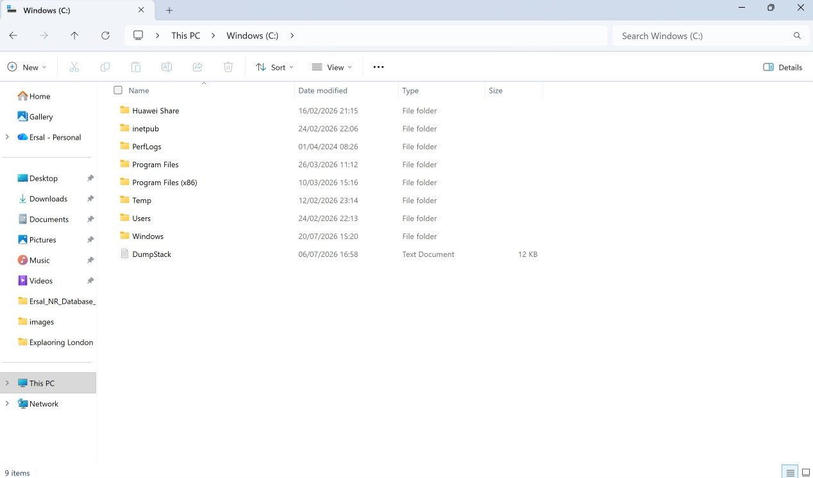
Figure 3: Windows File Explorer illustrating the hierarchical directory structure on the local drive.

1.4 Security and Protection

An operating system must communicate with hardware components such as the mouse, keyboard, and printer. It accomplishes this through small pieces of software called device drivers [1]. The operating system acts like a boss; it takes control of the hardware and relays user inputs. It ensures harmony between software and hardware. In Windows, Device Manager provides the function of displaying all connected hardware. Device drivers play the role of a bridge between an OS and hardware devices operating as per commands are interpreted correctly whereas hardware resources are consumed efficiently. Moreover, the OS limits hardware access with user-mode applications through device driver management a key defensive design to avoid changes from having system-wide impact or unauthorized people taking control over hardware devices [1].

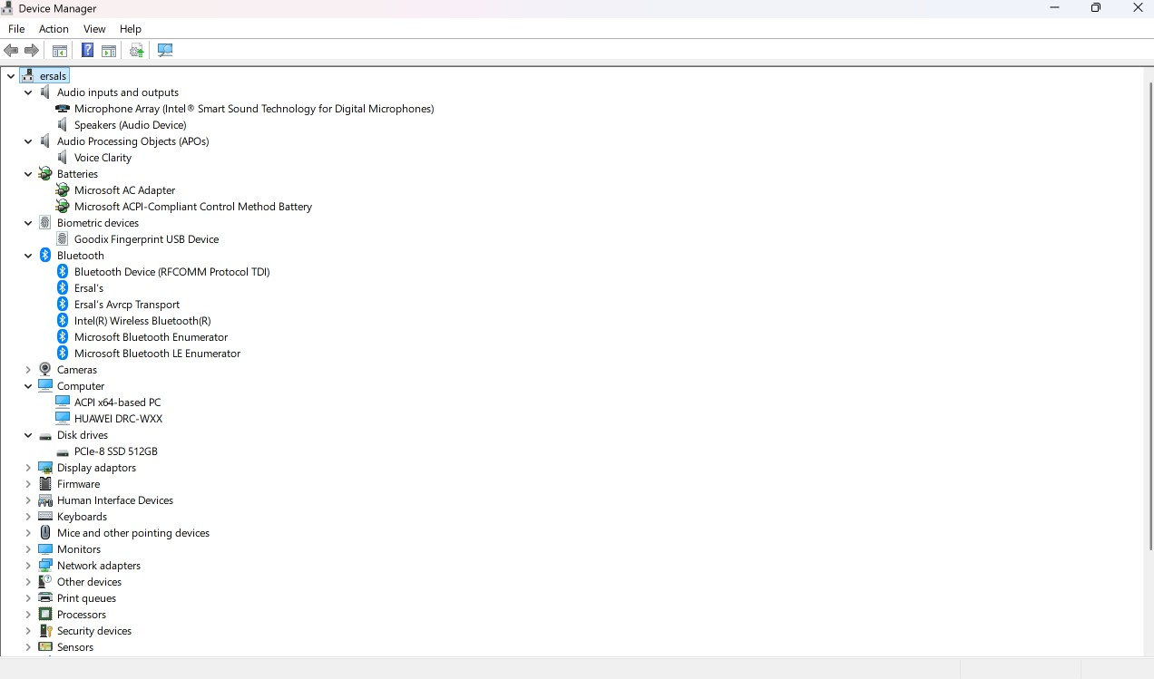
Figure 4: Windows Device Manager listing the connected hardware components and their drivers.

2. Use of Windows OS CLI commands.
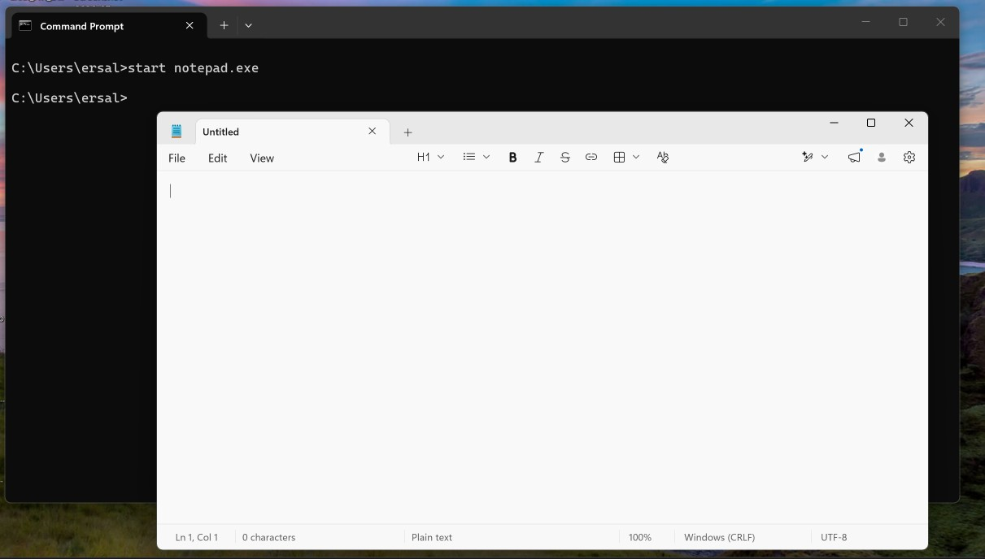

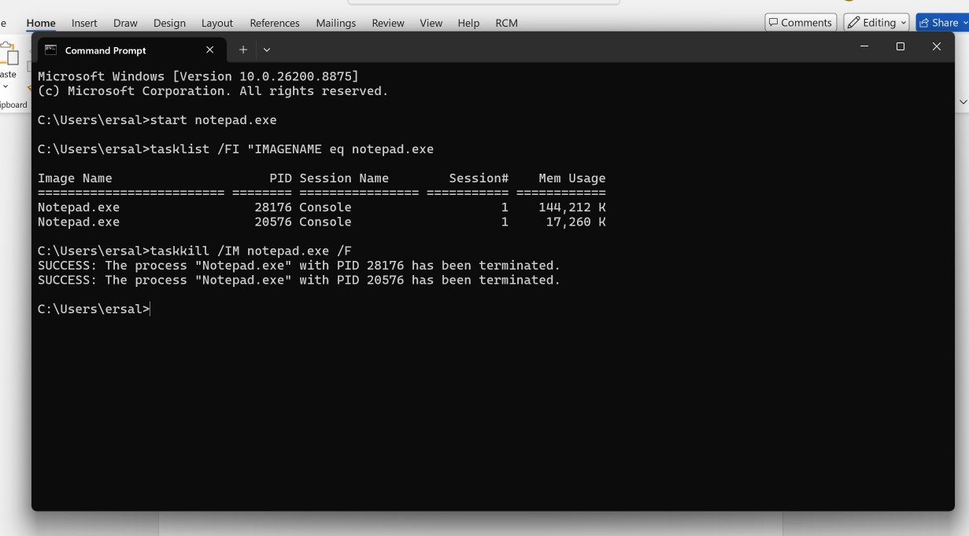
Figure 5: CMD terminal showing process management commands (start, task list, and task kill).

Process management in Windows Command Prompt is efficiently handled using batch commands [4]. The `start` command is used to launch an application (such as opening Notepad). To view specific programs rather than listing all running ones, the `task List` command is used in conjunction with the `/FI` (filter) switch [5]. To terminate a selected process, the `task kill /IM` command is used with the `/F` (force) switch.

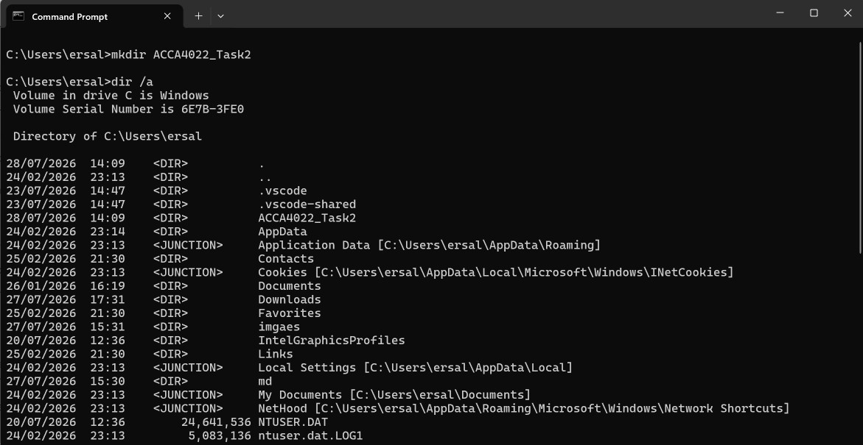
Figure 6: CMD terminal displaying the creation of a new directory and listing all files using the /a switch.

Command Prompt is extremely valuable for managing files and directories. It is where we can quickly create new folders for our projects using the “mkdir” command. We use the `dir` command to view data stored in a directory. When the `/a` switch is used, this command displays all files and folders, including hidden ones [5].

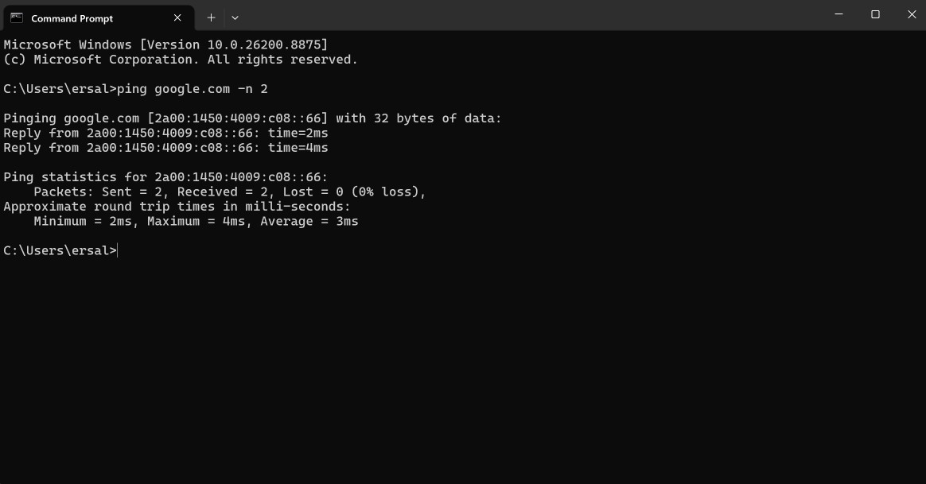
Figure 7: CMD terminal displaying network connectivity testing using the ping command.

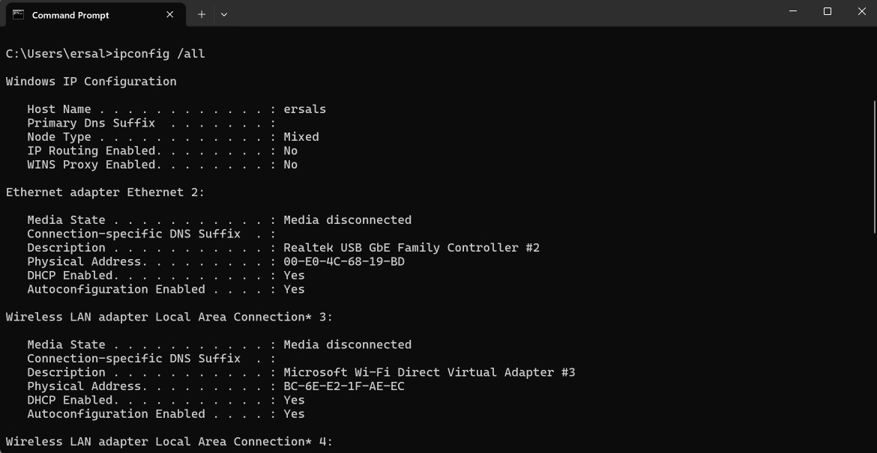
Figure 8: CMD terminal showing detailed IP configuration and network adapters using the /all switches.

Network monitoring is crucial for verifying internet access. As shown in Figure 7, the ping command sends data packets to a website to check the connection. In this scenario, we can use the -n option to save time by limiting the test to two packets [5]. Additionally, we can use the ipconfig command with the /all parameter, which provides detailed information about your computer's network adapters and IP addresses.
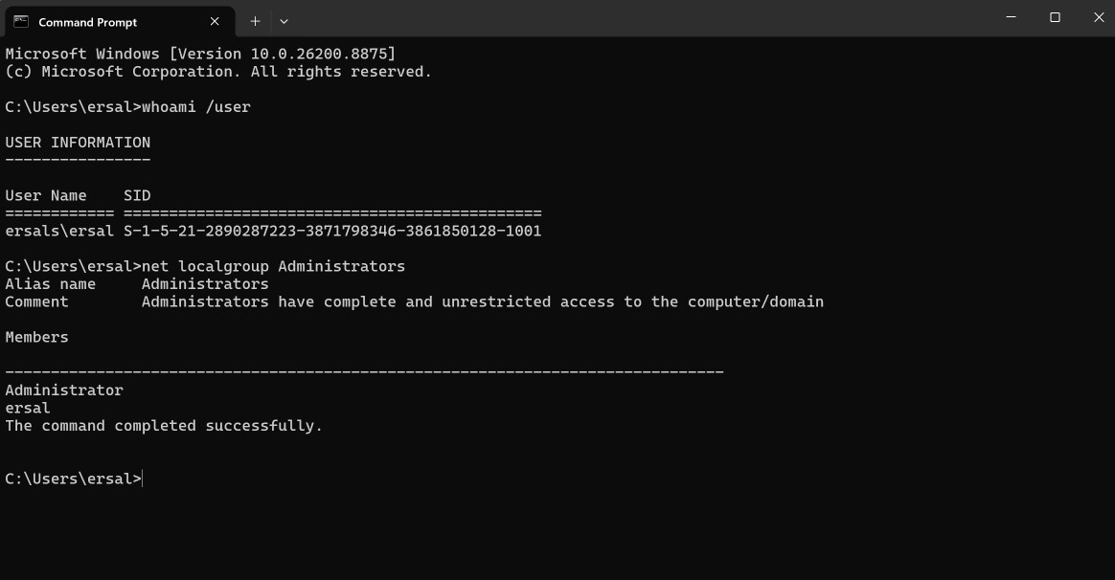
Figure 9: CMD terminal displaying current user details and listing members of the Administrators group.

Managing user accounts is another important task of operating system. In the Windows Command Prompt, we can use the `whoami` command with the `/user` parameter to view details about the active user. The `net localgroup` command is also quite useful; by adding "Administrators" as a parameter, we can easily list all users with administrative privileges on the computer [5].

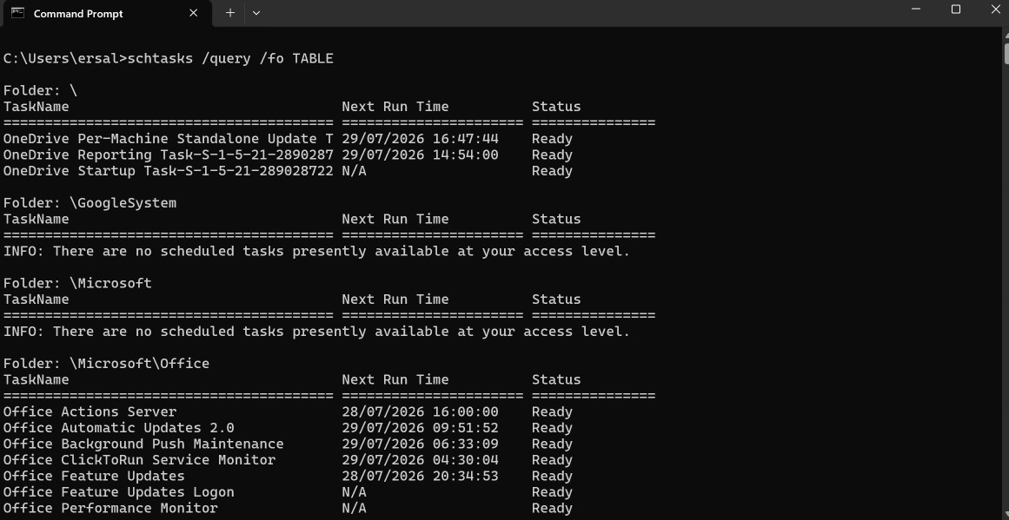
Figure 10: CMD terminal listing scheduled system tasks in a table format using the /query and /fo switches.
In the Windows operating system, most automated tasks run in the background. The `schtasks` command is used to view these scheduled jobs; adding the `/query` parameter requests a list of all scheduled tasks from the system. Additionally, using the `/fo TABLE` switch ensures that the output is presented in an organized, human-readable table format [5].

3. Use of Linux OS CLI commands.
The Linux command-line interface (CLI) offers powerful and flexible tools that enable system administrators to efficiently perform tasks such as system capacity management, monitoring of system performance parameters, and the maintenance of operational security functions. Unlike graphical user interfaces, the CLI provides finer control over the operating system through text-based instructions and command flags used as needed. Execution of essential Linux CLI commands related to process management, file operations, network commands, and task scheduling.

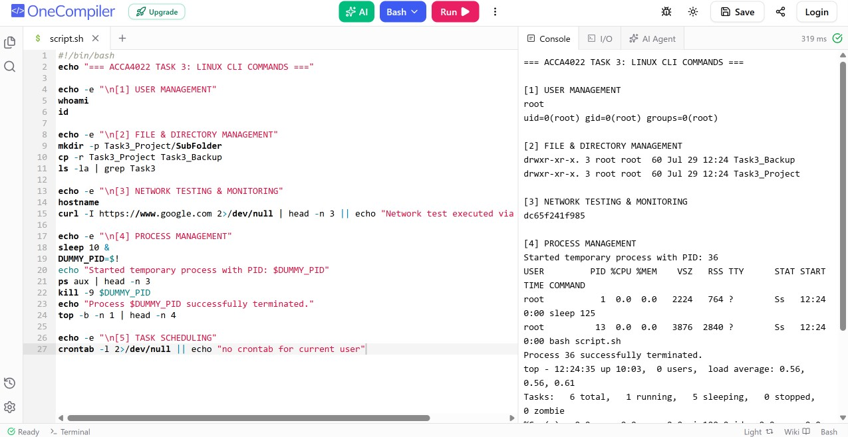
Figure 11: Linux terminal displaying multi-utility command executions across process, file, network, user, and task scheduling operations.

The two fundamental sets of commands/parameters tested and used for monitoring system status and performing diagnostics are as follows:

-User Management: The `whoami` command instantly returns the username used in the current session, while the `id` command provides more detailed identity information such as the UID, primary group, supplementary group memberships, and more [3].

-File and Directory Management: The `mkdir -p` command can operate recursively when creating nested directory paths, avoiding errors if parent directories already exist [3]. Additionally, the `ls -la` command presents a detailed, long-format list of all files, including hidden system files [2], and the `cp -r` command copies directory trees recursively.

-Network Testing and Monitoring: The `hostname` command is used to determine the machine's network name, whereas the `curl -I` command checks remote web servers by sending HTTP header requests to verify connection status and server response headers [4].

-Process Management: The `sleep` command is used to delay execution; we utilized this command in conjunction with `ps aux` to examine currently running system processes and their detailed resource usage characteristics [3]. The `kill -9` command abruptly terminates and stops unresponsive processes using their PIDs, while the `top -b -n 1` command provides a non-interactive, instantaneous snapshot of CPU and memory usage [2].

-Task Scheduling: The `crontab -l` command lists all existing cron jobs configured for the logged-in user, thereby enabling the automated execution of system background tasks and the scheduling of monitoring operations [2].

4. Use of Windows OS scripts.
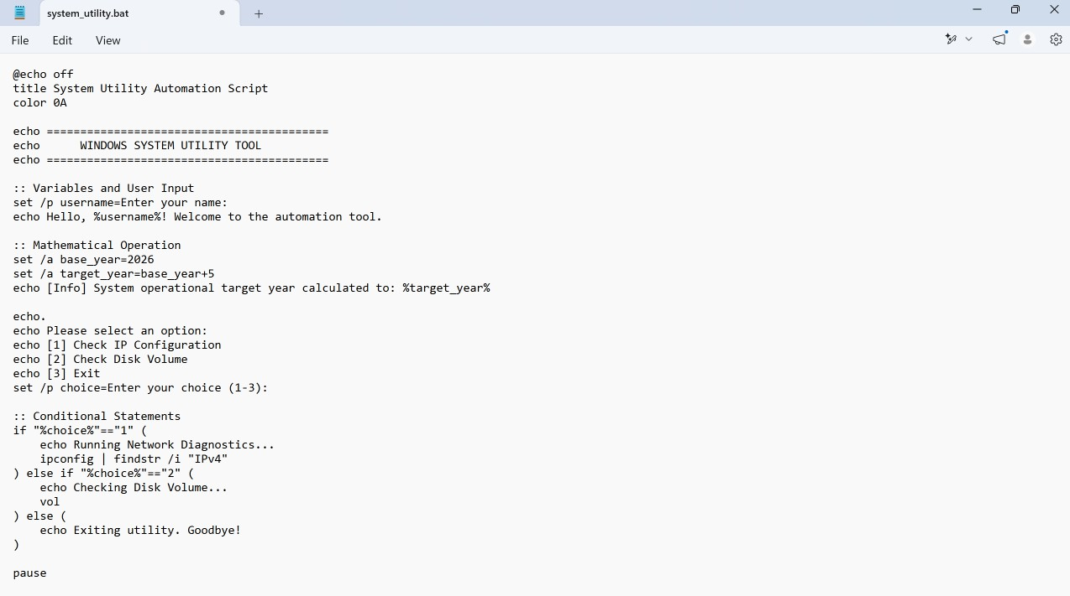
Figure 12: Notepad text editor displaying the source code of system_utility.bat, featuring variables, user input, arithmetic calculations, and conditional statements.

We use standard Windows Batch syntax to create our first automation script. This script configures environment variables, accepts interactive user input via the `set /p` command, executes a mathematical expression (addition: `set /a`) to determine a target processing year, and employs nested `if-else` conditional statements to reflect the user's various menu selections, as shown in Figure 12.
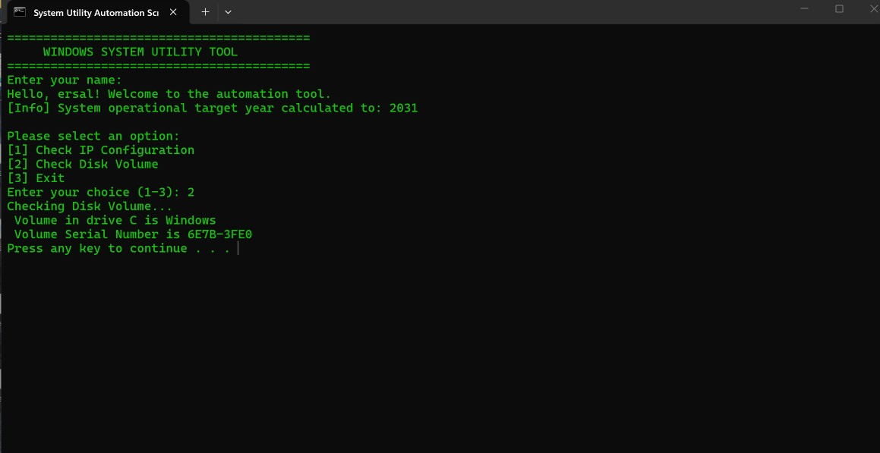
Figure 13: Command Prompt terminal showing the interactive runtime execution of system_utility.bat, displaying user greeting, calculated variables, and conditional disk volume diagnostics.
As shown in Figure 13, the `sysmonitoring` helper script is executed at runtime. The command-line interface interactively prompts the user for a name, displays the mathematically determined target year (2031), presents a menu of system options, and correctly parses the conditional input selection (2) to automatically execute the diagnostic logic associated with the disk volume.

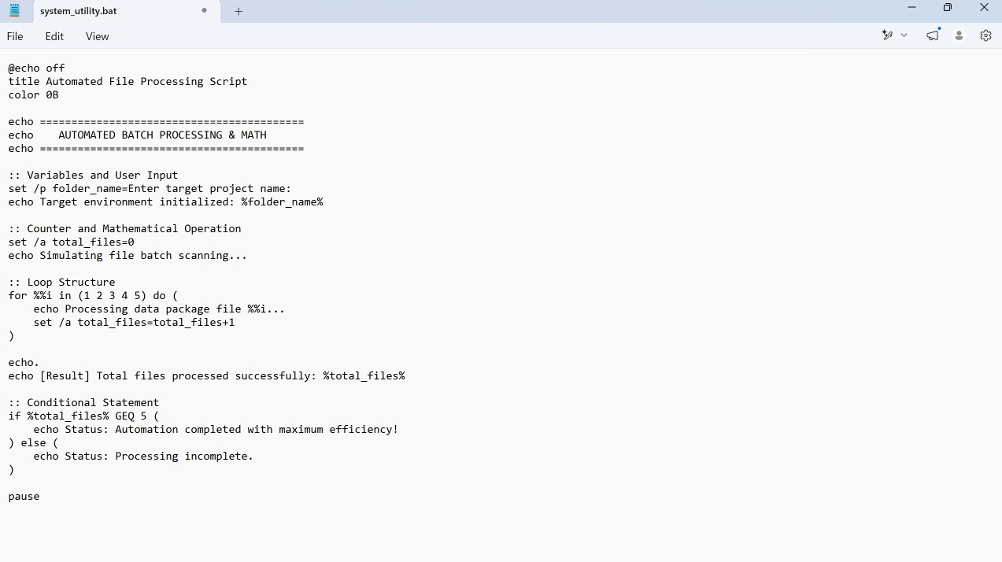Figure 14: Notepad interface showing the source code of file_automation.bat, utilizing for loop structures, incremental arithmetic counters, and conditional evaluation blocks.
The second automation script illustrates a more advanced batch processing workflow implemented using this tool. As shown in Figure 14, the script incorporates user input to define the project environment, a "for" loop to process data packets, the use of incremental mathematical operations (`set /a`), and conditional "if" statements to check task completion status.

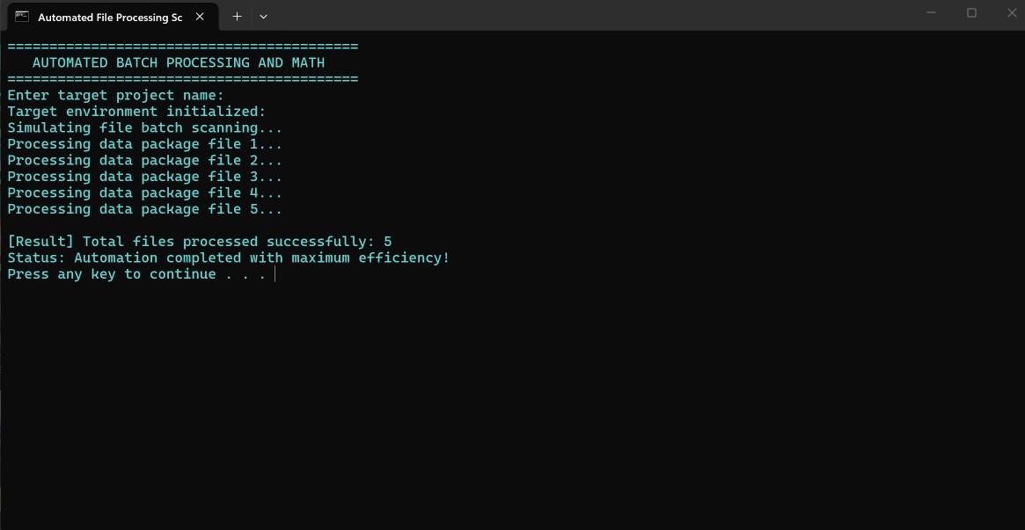Figure 15: Command Prompt terminal displaying the successful runtime execution of file_automation.bat, showing real-time loop iteration tracking, automated mathematical counter processing, and final conditional status validation.
The file automation script produces clean execution output (Figure 15). The registered project input is successfully accessed in the terminal; the process executes by sequentially processing blocks, either recursively or dependently, until completion, the total number of files is calculated with mathematical accuracy and without restriction, and a final efficiency status message appears upon completion.

5. Use of Linux OS scripts.
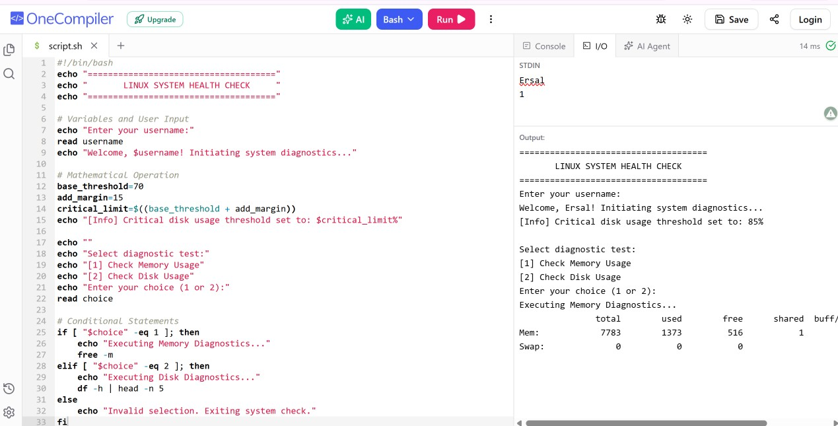
Figure 16: Online Bash environment displaying both the source code of health_check.sh and its successful runtime execution. The script incorporates user input reading, arithmetic operations, and conditional diagnostics.

A custom Bash shell script has been created to demonstrate command-line automation on Linux platforms. The implementation is illustrated in Figure 16, where the `read` command interactively captures user input. The script performs calculations regarding system limits—such as `critical_limit=$((base_threshold + add_margin))`—and incorporates a standard `if-elif-else` control flow like that found in the C language. This structure is combined with a split-pane view displaying the commands to be executed based on the provided input; furthermore, the inclusion of `free -m` command output in the analysis serves as an indicator of the effectiveness of Bash scripts in automating routine system administration tasks.
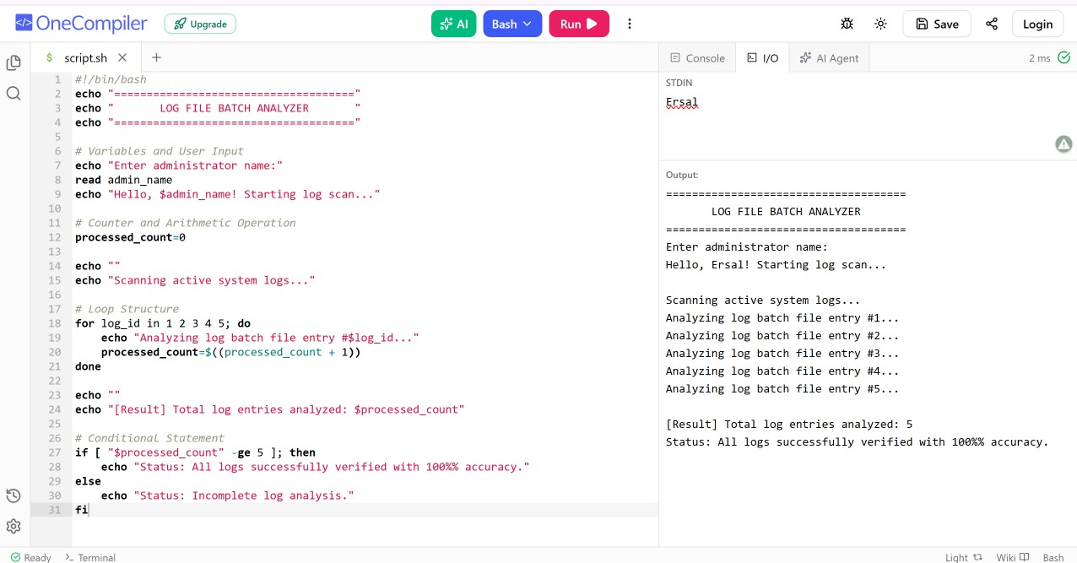
Figure 17: Online Bash environment displaying the source code and runtime execution output of the log file analyzer script, demonstrating interactive input handling, incremental loop iterations, arithmetic counting, and final conditional status validation.

To address Linux requirements, a second Bash script was created for automated file and log analysis. As shown in Figure 17, the `log_analyzer` script accepts administrator input, initializes an arithmetic counter, and processes sequential log entries using a `for` loop structure. The script tracks progress through incremental mathematical operations (`processed_count=$((processed_count + 1))`), checks for completion via conditional statements, and notifies the user upon successful execution.

Conclusion
This report illustrated how critical Operating Systems are to making computer operating. The study will include the primary functions of an OS like handling memory, executing processes and file archive. We were also taught to control both Windows and Linux using CLI as opposed to just clicking around with a mouse. In the end, we saw how quick and easy it can be to automate daily tasks, do simple calculations, and save some time by writing a few lines of code. In short, learning these OS utilities really allows us to better manage our computers.

References
[1] A. Silberschatz, P. B. Galvin, and G. Gagne, Operating System Concepts, 10th ed. Hoboken, NJ: Wiley, 2018.
[2] R. H. Arpaci-Dusseau and A. C. Arpaci-Dusseau, Operating Systems: Three Easy Pieces. Madison, WI: Arpaci-Dusseau Books, 2018. [Online]. Available: https://pages.cs.wisc.edu/~remzi/OSTEP/
[3] Tutorials Point, "Operating System Tutorial". [Online]. Available: https://www.tutorialspoint.com/operating_system/index.htm
[4] Microsoft Learn, "Windows commands", 2023. [Online]. Available: https://learn.microsoft.com/en-us/windows-server/administration/windows-commands/windows-commands
[5] W. R. Stanek, Windows Command-Line Administrator's Pocket Consultant, 2nd ed. Redmond, WA: Microsoft Press, 2008.

Appendices
Evidence of Engagement with Online Certified Course
These screenshots illustrate my active engagement with the Cisco Networking Academy based "Operating Systems Basics" course. These images show my practice over different modules starting from Linux principles to Client Server communications and application management on the Linux hosts which I played around implementing really doing hands-on helped me deepen an extent knowledge of these OSs explained in this report.

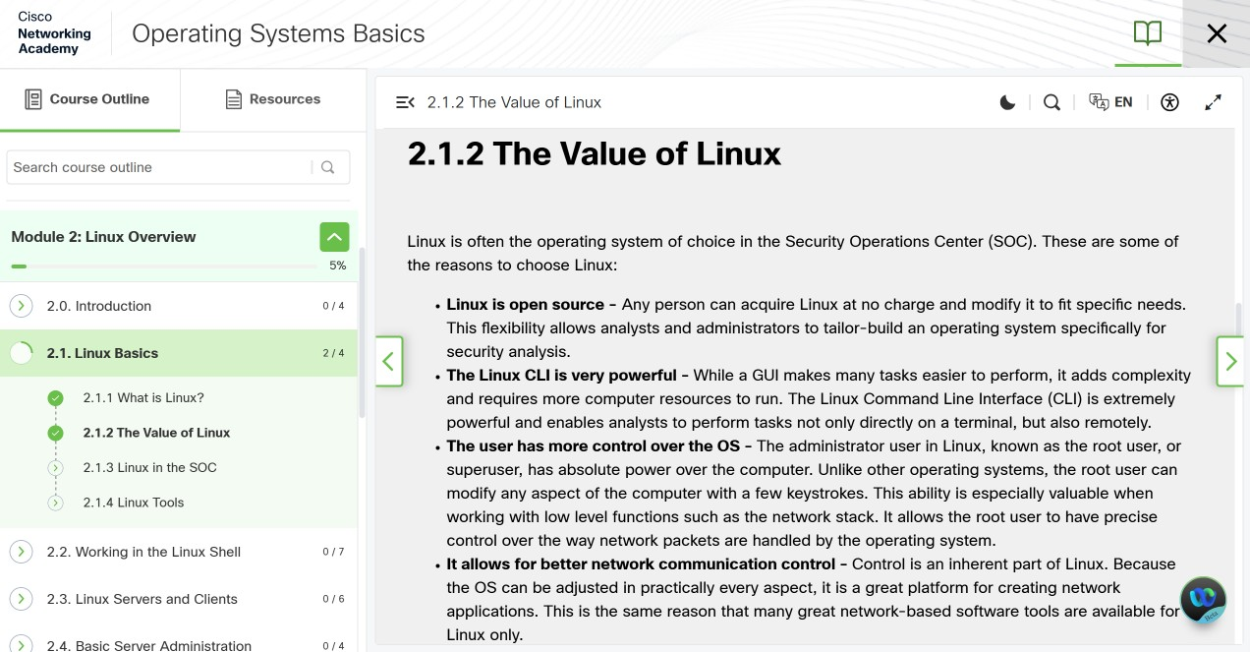
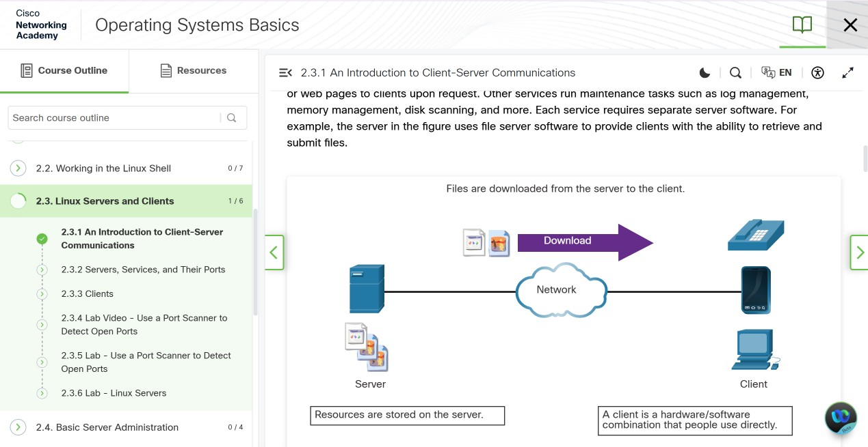
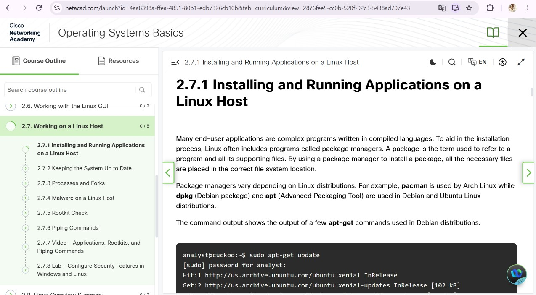

Appendix 2:
Lecture Activity Documentation Screenshot of the lecture presentation materials covering core operating system functions (UWTSD module resources).
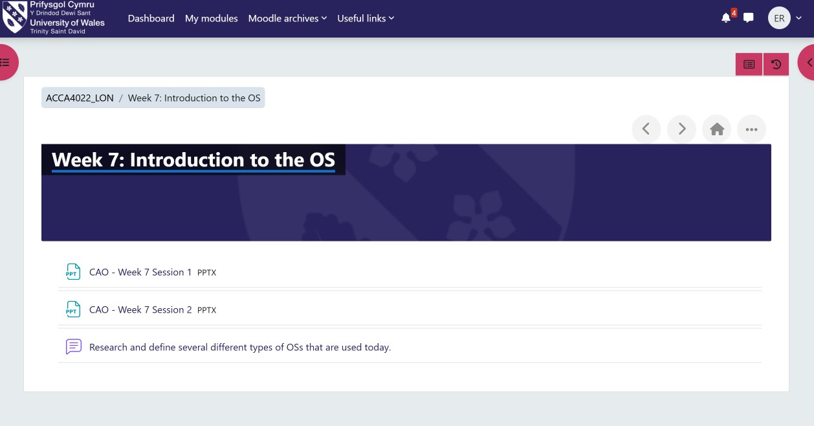
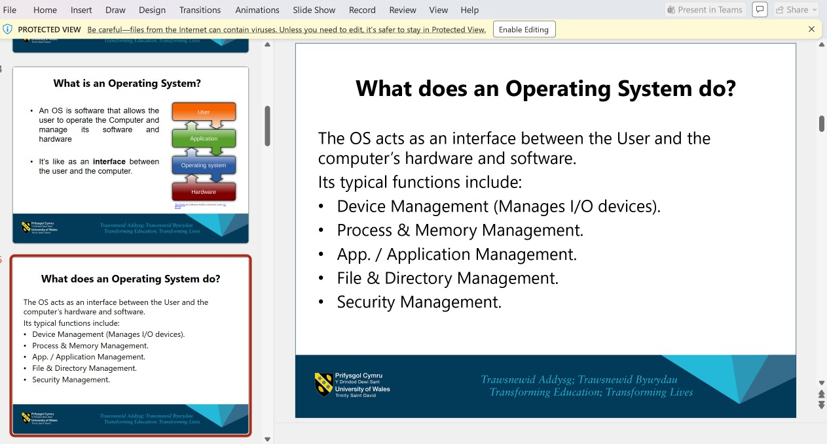
Screenshot of the Tutorial activity regarding OS types from Week 7 learning materials on UWTSD Moodle.

