

LOCATION: Swansea | LLEOLIAD: abertawe
LEVEL 3 | LEFEL 3
EXAMINATION PERIOD | CYFNOD ARHOLIADAU
JULY/AUGUST 2020 | IAU/AWST 2020

MODULE CODE: m3x01513
SCIENCE RESIT

TIME: 2 HOURS
answer all questions

Equipment or materials required – calculator
Adnoddau neu ddefnyddiau sydd eu hangen - cyfrifiannell

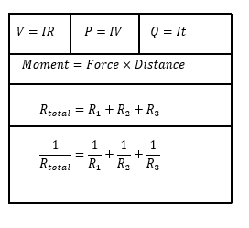
ANSWER ALL QUESTIONS

- Write down the units for the following: [5]

a) Velocity
b) Acceleration
c) Force
d) Mass
e) Weight

- Given that the equation for solar radiation can be written as;

$$Momentum=Force×Velocity$$

Write down the units of momentum [2]

- A body of weight 1250kN rests on a rough inclined plane which is at an angle of 22.1⁰ to the horizontal.

a) Draw a free body diagram in your answer booklet showing the weight, normal reaction, friction and the component of weight that acts down the slope [2]

b) Calculate:
i. the magnitude of the component of weight acting down the slope [3]
ii. Hence state the magnitude of friction acting up the slope [2]
c) Calculate the magnitude of the normal reaction to the surface. [4]

- Figure 1 shows a 4.6m uniform plank balanced at its centre. A 22.5N weight rests on the left hand edge.

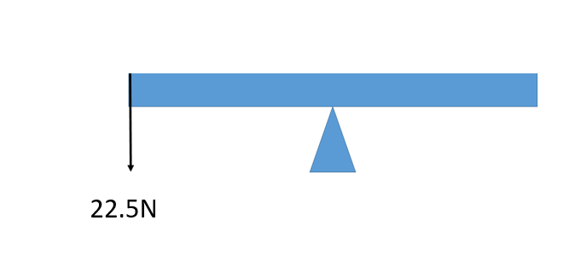

Figure 1

- Determine the moment caused by the 22.5N weight and state its direction.
[2]

- In figure 2 a 45N weight is added to the right hand side of the pivot. Determine the distance that the 45N weight needs to be from the centre in order to balance the plank. [3]

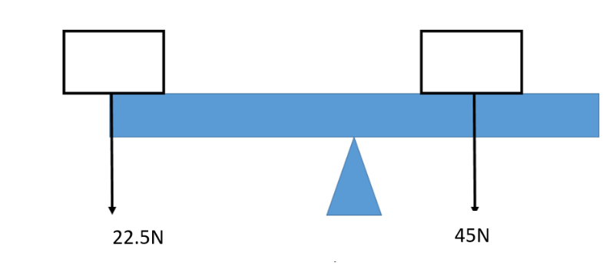

Figure 1

Figure 2

- Figure 3 shows a 35m uniform beam of weight 5.5KN which is at rest. The beam is supported by two pillars. Pillar X is positioned 2.5m from the left hand side of the beam, pillar Y is positioned 3m from the right hand side of the beam.

X
Y
Figure 3

a) Copy this diagram on your answer booklet, showing all forces. [2]

b) Determine both support forces. [8]

6. Define the following electrical characteristics. [2]

a) Potential difference
b) Resistance

7.

a) Calculate the voltage required to cause a current of 0.12A to flow through a wire of resistance 1kΩ [2]

b) What is the current through a particular wire if the voltage across it is 12V and the resistance is 22 Ω [2]

8. From the circuit below:

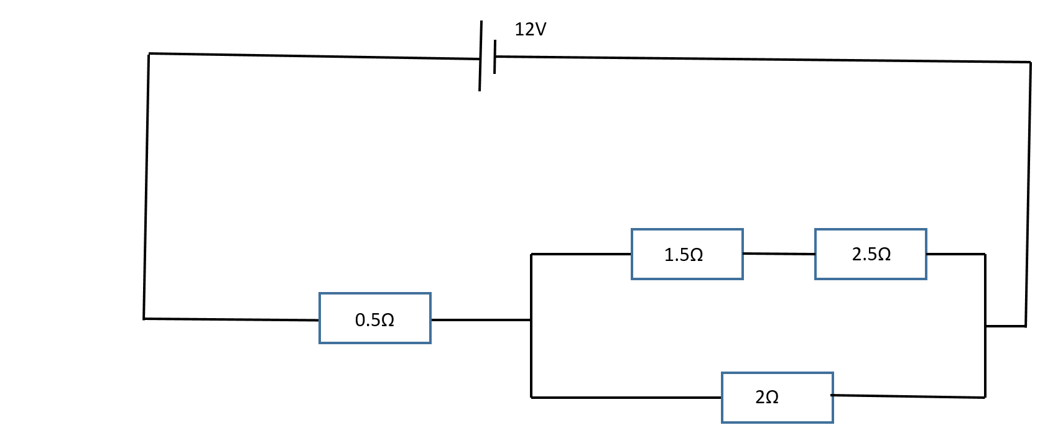

a) Show that the total resistance is 1.83Ω [4]
b) Calculate the current leaving the battery [2]
c) What is the voltage drop across the 0.5Ω resistor [2]
d) What current flows through the 2Ω resistor [3]
e) What current flows through the 1.5Ω and 2.5Ω resistor [3]

9. Figure 5a and 5b show resistors in series
a) Calculate the total resistance shown below [2]
b) What current would flow if a 12V battery was placed across them [2]
c) What would be the combined resistance of the three resistors if they were placed in parallel [3]

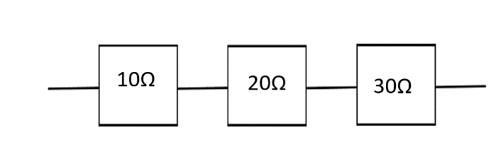

Figure 5a

[Total 60 Marks]

Diwedd/End

