
University Of Wales Trinity Saint David

Research Report



Module: Digital Skills and Research Methods
Module Code: BMSW4003_BIRM
Student: Keila Costa (2127935)

Contents

1. Introduction................................................................................................................... 3
2. Research design .......................................................................................................... 4
2.1. Research Question.................................................................................................4
2.2. Method ..................................................................................................................5/6
2.3. Ethical Considerations ...........................................................................................7
3. Results................................................................................................................... 8/9/10/11
4. Discussion................................................................................................................... 12/13
5. Conclusion ................................................................................................................... 14
6. Reference List.............................................................................................................. 15
7. Appendix A …………………………….......................................................................... 16/17

Introduction



Continuing the work done previously in this same class "Does students need to provide training on how to use technology to collaborate at UWTSD?" We carried out a questionnaire in order to better understand what other students at this university think about the same subject. In this way we base our work not only on the literary research done previously, but also on the true report of several students. We know that it is important for students to know how to use the internet, as this will put them in a privileged place where they are always following the changes in the current world and become more capable in terms of learning, but also because they learn about the dangers of the internet and how they should act so that they are always in a safe position. However, the benefits are not only for students but also for the university that will have free marketing on social networks among other benefits, but for this to happen we must know what the real needs of students in general are and that is what this report is for, to identify the real difficulties of students in relation to the technologies most used in this establishment. And an important message is that “The important point to understand is that using technology is not a choice anymore. it is a necessity.”

2. Research design
Through the base question of our report “Does students need to provide training on how to use technology to collaborate at UWTSD?”, we formulated new questions for the questionnaire.
2.1. Research Question
- I consent to take part in this questionnaire voluntarily.
This question was asked to make sure that we can use the answers of the person being asked and to be safe from the fact that the person is participating voluntarily.

- Do you feel able to use MS Teams to collaborate with others at UWTSD?
This question was asked in order to understand if students have difficulties using MS Teams

- Would you like to have training on how to use the OneDrive to collaborate with others?
This question was asked in order to understand how comfortable students feel to use OneDrive and if they think that some type of training is necessary.

- Rank these applications in order according to which you would like to have training on how to use.
In this question we put as answer option Whatsapp, Moodle, MS Word, OneDrive and MS Teams in order to understand which one students have the most difficulties in using

- Your age is
This question was asked with the aim of understanding whether the difficulties are more related to a certain age group.

- How strongly you agree or disagree with those statements
For this question, we put the following sentences as an answer option: - "There is enough training provided about how to use MS Teams at UWTSD" and -"More training on how to use the OneDrive to collaborate is needed at UWTSD". And this question was asked to understand if the students would really be interested in having training in relation to how to use these technologies.

- Your occupation is
This question was asked in order to understand whether students' difficulties are related to their occupation.

Method


The method used for this work was the Quiz through Microsoft Forms. It is a simple method of creating surveys or tests, inviting others to respond using any type of web browser or mobile device, and at the same time allowing us to have access to real-time results as volunteers respond to the questionnaire/ search. This method allows us to create questions in several different formats, place a link on the web and collect the answers with automatically created graphics. So, with so many advantages and facilities, we decided to use this simple and effective method for our report.
After choosing the method to be used, we had to choose our target audience, the body of our research, and in this way, so that the answers were in accordance with our problem, which was how students can help this university using technology, we decided that we would choose the students to answer our questions and we start with our classmates.
Below are the questions we asked that we thought would be relevant and would help us answer whether students at this university need training to use a certain type of technology.
- I consent to take part in this questionnaire voluntarily

Yes or no?

- Do you feel able to use MS Teams to collaborate with others at UWTSD?

Yes, No or Maybe?

- Would you like to have training on how to use the OneDrive to collaborate with others?

Yes, No or Maybe?

- Rank these applications in order according to which you would like to have training on how to use.

WhatsApp, Moodle, MS Word, OneDrive or MS Teams

- Your age is:

Under 22 years, 22-26 years, 27-30 years, 31-33 years or more than 33 years?

- How strongly you agree or disagree with those statements:

There is enough training provided about how to use MS Teams at UWTSD

More training on how to use the OneDrive to collaborate is needed at UWTSD

- Your occupation is:
Student, employed, self-employer or parent?

Ethical Considerations


This report was carried out with ethical considerations so all participants were treated with respect and without any type of discrimination. The participants participated voluntarily without any kind of pressure or oppression on our part, so our first question was to confirm if they are participating voluntarily, as we believe in the freedom of each one as an individual.
The work was carried out rigorously, with great care in relation to the collection of information, focusing on the truth and only the truth, so there was no type of falsification or manipulation of data/results.
All participants were treated equally with the same time to answer the questions and without any type of differentiation regarding gender, ethnicity, age or occupation.

Results


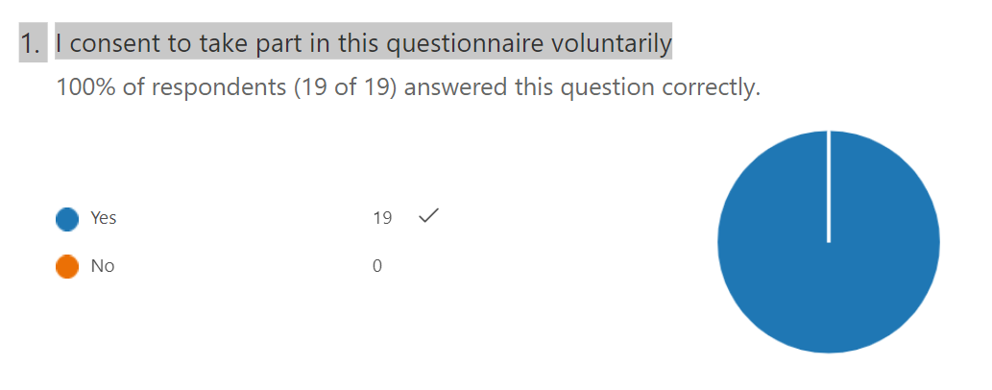
In accordance with ethical principles, 100% of the participants voluntarily participated in this
questionnaire.

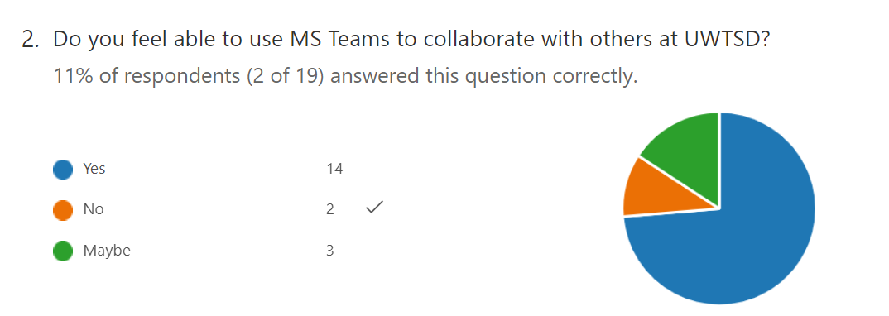

According to the sample, most students are comfortable using MS Teams.
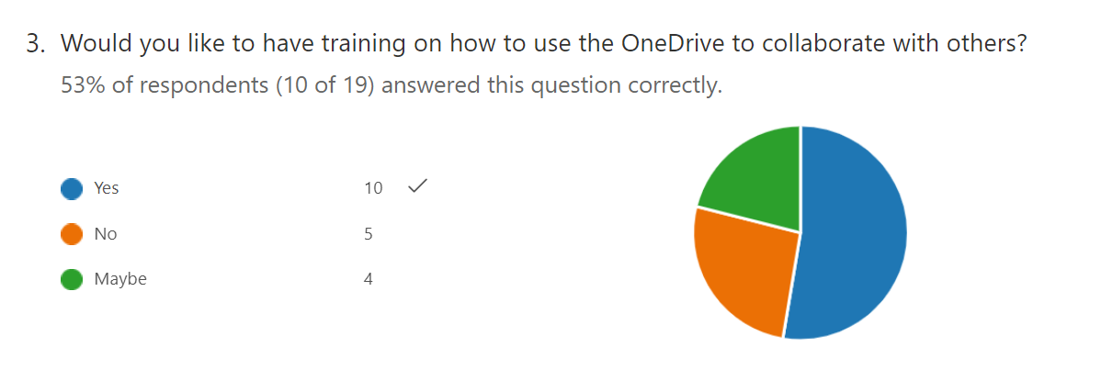
Regarding OneDrive, 53% of participants think that they should be trained to know how to use this App, which means that most students do not feel completely comfortable using OneDrive.
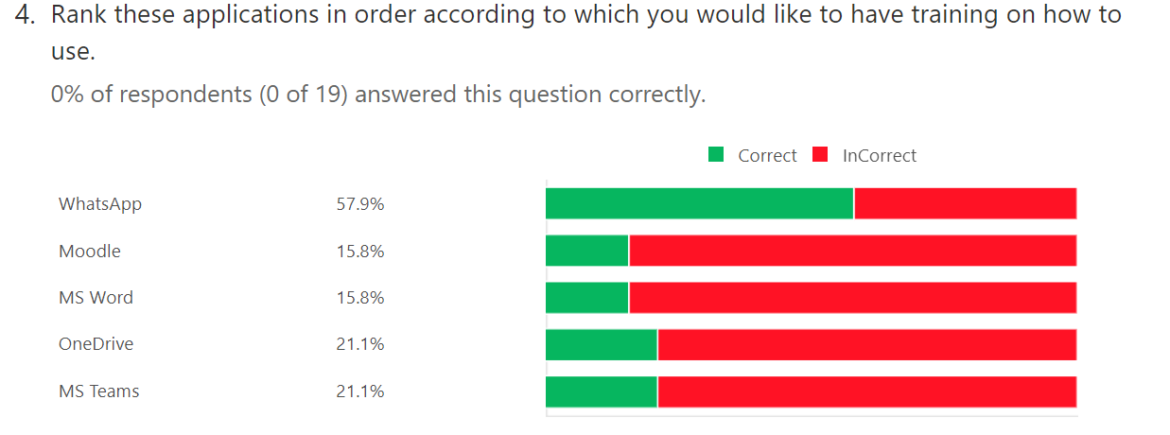

According to the data in this question, most students feel more comfortable when using Watsap, perhaps because this is an App that is widely used daily and even outside the university environment. However, regarding Moddle and MS Word, most of them agree that students should be trained to know how to use these two programs efficiently. Regarding OneDrive and MS Teams, students also reveal that they should have some training.

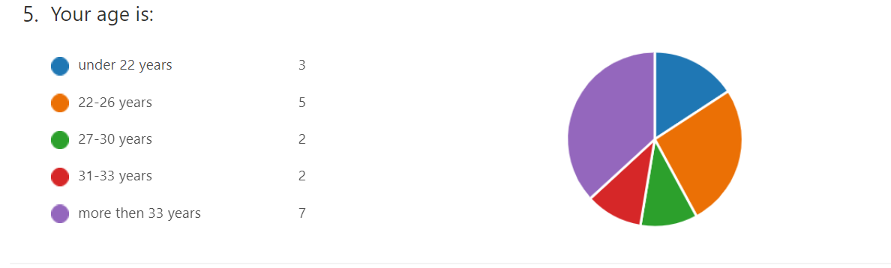

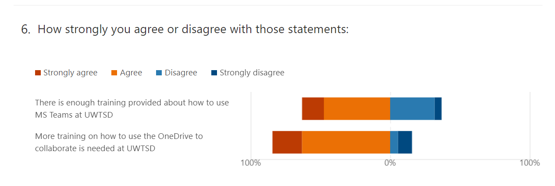
More than 50% of the respondents are aged between 22-26 and over 33 years old, with the majority of them being over 33 years old. Therefore, we can perhaps conclude that the age of the respondents is related to their difficulties in using technology, since in their school days the internet was little used and therefore these people need greater support when it comes to new technologies, so they need more training and monitoring.

More than 50% of respondents agree or strongly agree that there is sufficient training in how to use MS Teams at UWTSD, while in relation to OneDrive more than most respondents agree that there should be more training in how to use it.

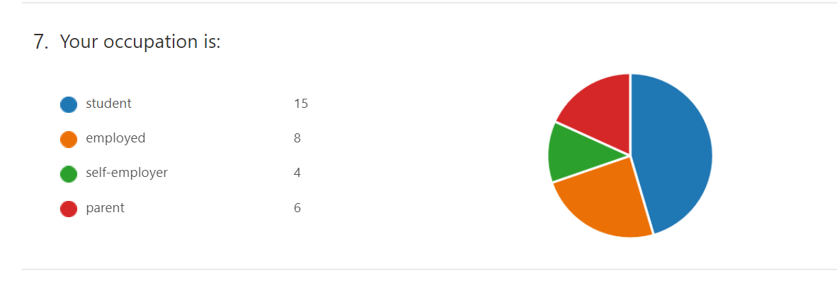
With regard to occupation, 12% of respondents are self-employed, 18% have as occupation caring of their children, 24% are employed and corresponding to 45% are students, and in this group they fall into those who only study and those who, in addition to other occupations, also study.

In short, most respondents are over 33 years old, which may explain their difficulties in using technology as a way of collaborating with the university and therefore these people agree that there should be more training in relation to how to use the technologies. Most respondents feel comfortable using Ms Teams, however there is still a percentage of respondents who do not feel comfortable and believe that more training is needed, however the App that seems to have the greatest difficulty in using it is OneDrive being that 53% of students agree that there should be training to use it, which means that they do not feel comfortable with this App, however the study also reveals that most students also experience difficulties in using Moodle and MsWord. Watsap, which is also an important technological tool that helps in communication between the students of this college, proved to be the App where students feel less difficulties in using it, and I believe that this is due to the fact that nowadays most people use watsap, even outside the university environment in order to communicate with your relatives and friends. Without forgetting that even though it was not revealed in this study, when sending the questionnaires, we realized that most of the respondents are foreigners, or have family members abroad, which in a way forces them to know how to use whatsap in order to communicate with their relatives who are in other countries, and this is a fast, cheap and common method of communication in several countries of the world.
Discussion



This questionnaire had 19 participants, all of whom are part of the UWTSD and we decided to do it this way so that the information collected is relevant in relation to our objective. Of these 19 participants, we found that most of them are over 33 years old, which could be one of the reasons for the difficulty of our participants, with only 11% of the participants aged between 27 and 30 years old.
I was surprised by the percentage of people who indicated that they would like to be trained to use Moodle, since this is a tool that we use constantly, that is, from my point of view, this would be the tool in which the majority of respondents would indicate that they don't have any difficulties in using it, however it is also a tool that I don't really know how to use properly, but I thought that I was the only one who had this difficulty, so it's interesting to know that I'm not the only one who needs help at this point and it's This is why communication and this type of research are so important because it helps us to discover that the difficulties of one person can be the same difficulty of a group of people and this helps us not to feel useless or less capable of learning .
This research is in line with the research carried out previously by me and my group, as it is still evident the importance of developing our technological skills and how the internet is increasingly used in education, more precisely in the university environment. As was found in the previous research, it is necessary and important to have adequate training for students regarding how they should use new technologies in order to help themselves and the UWTSD. Because a good part of the students revealed how much they feel difficulties and the desire they have to learn because most of them answered that they think there should have more training for students, which means that they want to improve their performance and are interested in extras classes or workshops.
Regarding my thoughts, I can say that the results of this research surprised me in the sense that I did not expect that the majority of the participants would reveal that they did not feel comfortable using most of the technological tools mentioned and also because most of the respondents agreed that training is necessary to help them better understand and to make good use of each one of the Apps, because in my opinion it was certain that there are people with difficulties and who would like to have help in this regard, but I do not expect a number so big. For me, even if a small number of students need help, I think it is important that the university have initiatives to support these students so that they do not feel excluded, however with this research I could see that the number of students who need help is not small and I include myself in that group.
I found out that, like me, most of my colleagues have difficulty using Apps, such as Moodle, and even though we use them constantly I still feel like I only know the basics, but I didn't feel comfortable to express my difficulties because I thought I was the only one with these problems, so I believe that this research had a very positive result for me because it made me more comfortable with my difficulties in using these Apps and today I feel more comfortable to talk about this subject. In the same way that this research had a very positive effect on me, I believe it will also have on my colleagues and all those who took part in this research.
It was interesting to know that although I had already done a previous research on this topic, I was still surprised by the results of this new research, because it is not based only on literary research but also on true answers that were given by students who are part of the same academic reality as I am.

Conclusion


To conclude, it is important that students have training in how to use new technologies so that they develop at a personal and intellectual level, so that they are aware of the dangers of the internet and thus keep themselves safe, but it is also important from the point of view of the university, as more developed students at an intellectual level is something that will be reflected in the grades of each one and in the general grades of the university, which will place the university itself in a good position in terms of ranking. And answering the question in this report, we found that training is necessary for students to learn how to use new technologies because a good part of them do not feel completely confident when using the Apps used in the university environment and most respondents confirm that they feel the need for training.
Finally, I would like to encourage all those who are not comfortable with new technologies, to ask for help, to talk to their teachers and perhaps also to the student service team in order to try to find a solution to overcome this technological barrier. I also advise UWTSD to look for ways to encourage students to always keep up to date, and to show the importance of technology nowadays, and this can be done through complementary classes or workshops for all those who feel they need this extra help, and in this way we will be contributing both to the evolution of the student and to the evolution of the UWTSD.

Reference List

Lewis, G., 2013. Bringing technology into the classroom-Into the Classroom. Oxford University Press.
Raja, R. and Nagasubramani, P.C., 2018. Impact of modern technology in education. Journal of Applied and Advanced Research, 3(1), pp.33-35.
Thomas, A., Prajapati, R.T.B. and Kaur, A., 2022. Technology-powered education post pandemic: Importance of knowledge management in education. In Handbook of Research on Lifestyle Sustainability and Management Solutions Using AI, Big Data Analytics, and Visualization (pp. 185-196). IGI Global.
Tran, T.T.T., 2020. Students’ attitude towards doing while-reading comprehension exercises using Microsoft Forms. Vietnam Journal of Education, 4(2), pp.55-60.
Venezky, R.L., 2004. Technology in the classroom: Steps toward a new vision. Education, Communication & Information, 4(1), pp.3-21.

Appendix A



