

Student Name: Arkeshbhai Rajubhai Pansuriya
Student ID number: 2529488

Programme: Master of Business Administration

Module: Strategic Management

Module code: LCMB7003

Lecturer: Amare Desta, Zulf Khan
Internal Verifier: Vasilios Tavlaridis, Hoang Nguyen

Assessment component: Individual report

Title: Management consultancy report of Netflix for strategic position and recommendations

Table of Contents
1. Organisational Context and Overview 4
1.1 Historical Perspective, Mission, Vision and Business Model 4
1.2 Industry, Competitors and Market Position 4
2. External and Internal Analysis 5
2.1 PESTEL Analysis: Opportunities and Threats 5
2.2 Internal Environment Analysis (VRIO Analysis) 8
2.2.1 Brand Equity and Global Reputation 9
2.2.2 Original Content and Intellectual Property 9
2.2.3 Artificial Intelligence and Data Analytics Capability 10
2.2.4 Financial Strength and Investment Capability 10
2.2.5 Organisational Culture and Innovation 10
2.2.6 Internal Weaknesses 11
2.3 SWOT Analysis 12
3. Comprehensive and holistic view of the organisation 14
3.1 Corporate Social Responsibility (CSR) Strategy 14
3.1.1 Current CSR Strategy 14
3.1.2 Alignment with Business Objectives 14
3.1.3 Critical Evaluation 14
3.2 Balanced Scorecard 15
Professional Balanced Scorecard table 15
3.2.1 Financial Perspective 15
3.2.2 Customer Perspective 16
3.2.3 Internal Business Process Perspective 16
3.2.4 Learning and Growth Perspective 17
4. Strategic Choices and Implementation 18
4.1 Business-Level Strategic Choices 18
4.1.1 Evaluation of Generic Strategies 18
4.1.2 Positioning via Hybrid and Differentiation Models 18
4.2 Identification and Validation of the Preferred Strategy 18
4.2.1 Selection of the Strategic Direction 18
4.2.2 Strategic Validation Using Analytical Frameworks 19
4.3 Performance Optimisation and Competitive Advantage 20
4.3.1 Mechanisms for Optimum Performance 20
4.3.2 Sustaining Competitive Advantage 20
4.4 Implementation Challenges and Mitigation Solutions 20
4.4.1 Identification of Operational Bottlenecks 20
4.4.2 Mitigation Strategies and Change Management 21
Section 2: Reflective Account 23
2.1 Description 23
2.3 Feelings 23
2.4 Evaluation 23
2.4 Analysis 23
2.5 Conclusion 24
2.6 Action Plan 24
References 25

1. Organisational Context and Overview

1.1 Historical Perspective, Mission, Vision and Business Model
This report selects Netflix, Inc., focusing specifically on its United Kingdom streaming market. The UK is suitable since Netflix has been operating there for more than five years, the market data in the market is significant and publicly available, and the UK is a highly competitive streaming environment. Originally established in 1997 as a DVD-rental company, Netflix has become a worldwide streaming service and entertains people in over 190 countries and 37+ languages (Bitran, 2022). The company has a mission that includes entertainment globally at the same time, with a strategic vision that focuses on consistently engaging audiences with powerful, personalised entertainment and discovery.
The Netflix business model is mainly a combination of subscription-video-on-demand (SVoD) with an advertising-supported option, which has become more significant (Zhao, 2025). Consumers make recurring monthly subscriptions to view movies, TV shows, games and original content. Proprietary content, worldwide distribution, algorithmic recommendations and wide-ranging customer data help the company create value. In the UK, Netflix thus acts as a digital platform bringing together content producers and consumers and generating revenue by selling attention in the form of subscriptions and advertisements.

1.2 Industry, Competitors and Market Position
Netflix operates in a highly competitive video-streaming and digital entertainment business in the UK. 68% of Households in the UK had subscribed to at least one SVoD service, indicating a high level of market penetration (Ofcom, 2023). The most popular service was Netflix, with the percentage reaching 55% of households compared to 14% of Amazon Prime and Disney+ (Durrani, 2024). Moreover, Netflix also represented the maximum of all SVoD/AVoD viewing time, which manifests good competitive positioning.
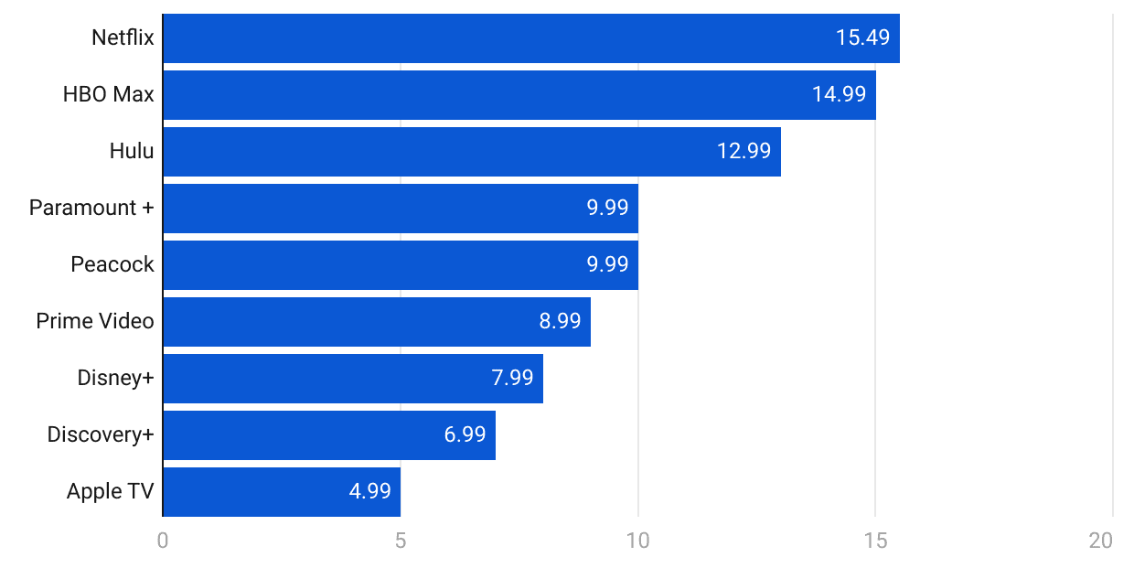
Figure 1: Netflix preference
Source: (Bhalla, 2025)
Nonetheless, the competitive pressure becomes higher with market maturity. All Amazon Prime Video, Disney+, Apple TV+, Paramount+ and broadcaster websites are challenged by consumers with limited time and discretionary money regarding entertainment. Netflix's differentiation has been through a strong brand, recommendation technology and content (Hsiao, 2024). It is where original content is also a system that brings differentiation, though the saturation of subscriptions and growing pace of price sensitivity are strategic threats. This makes the position of Netflix in the UK strong yet not invincible and needs ongoing content, pricing and advertising innovations.

2. External and Internal Analysis

2.1 PESTEL Analysis: Opportunities and Threats
PESTEL analysis illustrates that Netflix is in a UK environment that has important opportunities and threats. The regulatory developments, the economic conditions, consumer behaviour, changes in technology, environmental expectations, and legal requirements affect the strategic position of the organisation.
Political Factors
Political regulation in the UK poses both threats of compliance and reputational opportunities. Online Safety Act heightens platform accountability in terms of online safety and content administration (GOV.UK, 2025). This can add to the cost of compliance and complexity to Netflix's streaming operations. Nevertheless, greater control might boost consumer confidence. According to the UK government, the Online Safety Act came into effect in October 2023, and it shows the growing political significance of regulation of digital platforms (GOV.UK, 2025).
Economic Factors
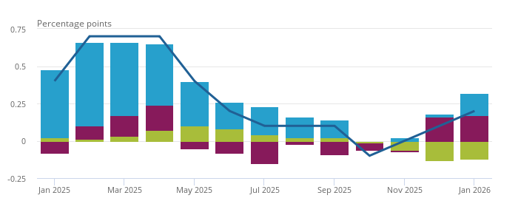
Figure 2: UK GDP
Source: (ONS, 2026b)
The economic situation affects consumer preference for discretionary subscriptions. UK real GDP grew by 0.2%, which suggests economic growth (ONS, 2026b). This hereby justifies the possibility of a rise in demand for digital entertainment. Nevertheless, consumer price inflation was 3.0%, which can cause a higher household financial burden (ONS, 2026a). That way, Netflix can grow the cheap performance of ad-supported subscriptions, but price increases will probably cause cancellations and switching to lower tiers.
Social Factors
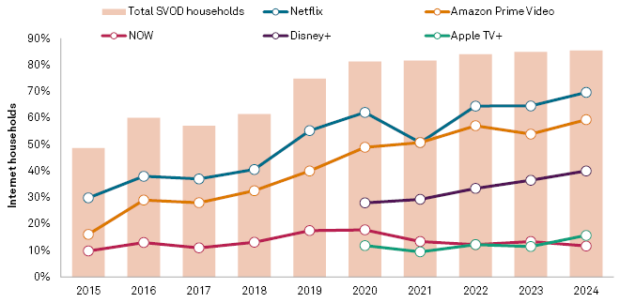
Figure 3: Netflix in UK households
Source: (S&P Global, 2025)
Streaming has gone mainstream in the UK in family homes, which presents a good prospect for Netflix. By 2025, 85% of UK households subscribe to a minimum of one SVoD service, and Netflix had a penetration of 70% of households (S&P Global, 2025). Some households cancelled their streaming subscriptions during the year. However, a smaller share chose to increase their subscriptions, highlighting mixed consumer spending patterns across streaming services. Thus, sensitivity to prices and market maturity jeopardise growth of revenue in the future.
Technological Factors
The presence of technology can give Netflix a chance to enhance differentiation and efficiency in its operation. Personalisation and content discovery can be enhanced using artificial intelligence, recommendation algorithms and data analytics. In 2025, Netflix announced more than 325 million paid memberships globally, showing the incredible size of data to be optimised technologically (Spangler, 2026). However, it becomes difficult to see competitors employing even more similar technology, and the risk of compromising customer trust and competitive advantage arises because of cybersecurity and AI governance.
Environmental Factors
The aspects of environmental sustainability are becoming more pertinent to the actions of digital platforms. Netflix also announced that its activities and value chain produced about 1.1 million metric tonnes of carbon dioxide equivalent in 2024 (Netflix, 2024). This shows the environmental impact of data centres, content production and digital infrastructure. Consequently, carbon cuts open an avenue to enhance corporate image, even though investments in sustainability can drive up the cost of operations.
Legal Factors
Netflix is continually threatened by legal obligations. The UK General Data Protection Regulation apply to organisations handling personal data (Ke and Sudhir, 2022). Companies providing customised services such as Netflix have to be able to uphold data responsibility and remain compliant while keeping customer data safe and enabling trusted digital experiences. The company's strategic options include pricing based on advertising, personalisation, and AI-driven customised content. Subscription saturation, regulation and tough competition, and product sensitivity among consumers are all important threats in turn.

2.2 Internal Environment Analysis (VRIO Analysis)
The VRIO model helps to determine whether an organisation's resources and capabilities will provide a sustainable competitive advantage based on their value, rarity, imitability, and organisation. Netflix has several strategic assets that have helped it stay a leader in the UK streaming space. But some internal constraints pose strategic challenges for future growth.
Resource/Capability | V | R | I | O | Strategic Outcome
Global Brand Reputation | ✓ | ✓ | ✓ | ✓ | Sustained Competitive Advantage
Original Content Portfolio | ✓ | ✓ | ✓ | ✓ | Sustained Competitive Advantage
AI Recommendation System | ✓ | ✓ | ✓ | ✓ | Sustained Competitive Advantage
Customer Data and Analytics | ✓ | ✓ | ✓ | ✓ | Sustained Competitive Advantage
Financial Resources | ✓ | Moderate | Moderate | ✓ | Temporary Competitive Advantage
High Content Investment Dependence | ✗ | ✗ | ✗ | ✗ | Internal Weakness

Table 1: VRIO Analysis

2.2.1 Brand Equity and Global Reputation
Netflix's global brand is one of its strongest strategic resources because it directly supports customer acquisition, retention and pricing power. Netflix’s revenue growth in 2025 was 16% year-on-year to reach US$45.183 billion, with operating income rising to US$13.3 billion (Netflix, 2025).
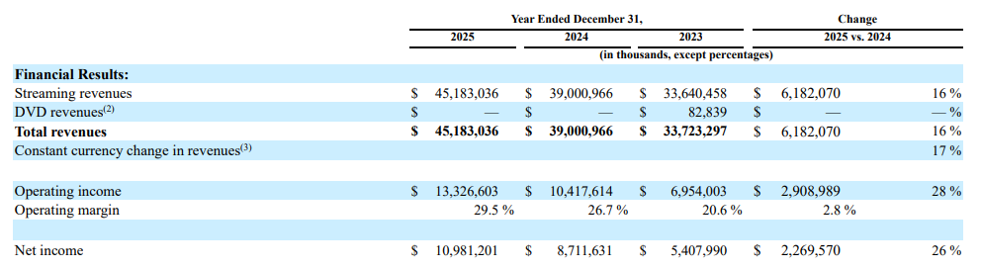
Figure 4: Netflix’s annual revenue growth
(Source: Netflix, 2025)
This shows that Netflix has been able to translate its positive brand image into monetary returns and not just a subscriber base. Additionally, the company reported that it had achieved 96 billion viewing hours in the second half of 2025 (Netflix, 2025). It reflects high customer engagement and loyalty. For Netflix, the ability to consistently innovate, produce original high-quality content and gain global fame over the years is something that is hard for competitors to replicate.

2.2.2 Original Content and Intellectual Property
Netflix has many strategic assets, such as its original content and intellectual property (IP). These assets are important because they enable Netflix to differentiate itself from its competitors. Netflix has a tight grip on its movies, TV series, trademarks, copyrights, patents and technologies, making it challenging for competitors to duplicate its efforts. Netflix has also been spending heavily on developing original programming, as more than 90% of the cost of each content asset has been recognised within four years or less, which is a sign of continuing investment in new content programmes (Lentati, 2026). During the second half of 2025, viewers watched 94 billion hours of content, including millions of viewers across the globe for KPop Demon Hunters and Stranger Things 5 (Netflix, 2025b). Such special initiatives are an effective way to foster loyalty and provide Netflix with leverage.
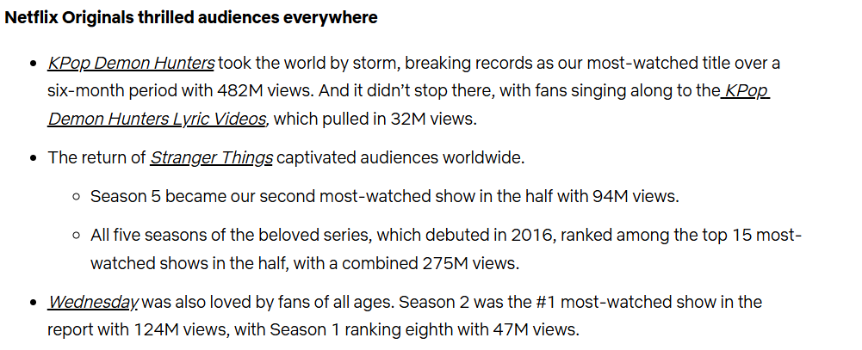
Figure 5: Stranger Things became Netflix’s most-watched show with 94M views
(Source: Netflix, 2025b)

2.2.3 Artificial Intelligence and Data Analytics Capability
Netflix's AI and data analytics are a key strategic asset, enhancing customer experience and business function. The company leverages AI and machine learning to understand viewing history, search activity and content preferences (Bano et al. 2025). This makes it easier for the customer to locate the relevant content and helps increase viewing time and customer retention. The Netflix Recommendation system also helps the viewers in content planning, marketing and operational decisions based on analysing the digital footprint of the customers.

2.2.4 Financial Strength and Investment Capability
Netflix has sufficient financial resources to sustain its growth and innovation. In 2025, Netflix generated US$45.2 billion in revenue, which was 16% higher than the previous year. Operating income rose to US$13.3 billion, and the operating margin improved to 29.5% (Netflix, 2025b). In addition, Netflix posted US$9.5 billion in free cash flow to invest in content and technology (Rui, 2024). These financial resources enable the company to invest in new programmes, AI capabilities and global expansion. But other competitors like Amazon and Apple also have sufficient financial resources. So, this ability gives a short-term competitive edge.

2.2.5 Organisational Culture and Innovation
A strength of Netflix is their organisational culture, which helps the organisation in innovation and swift decision-making. The company updated its Culture Memo in 2024, after receiving over 1,500 comments from employees. It indicates that staff are encouraged to provide ideas and ways to improve the business at Netflix. On the other hand, Netflix has values like “People over Process”, “The Dream Team” and “Farming for Dissent”, which allow employees to question decisions openly and propose new ideas (Netflix, 2025c).
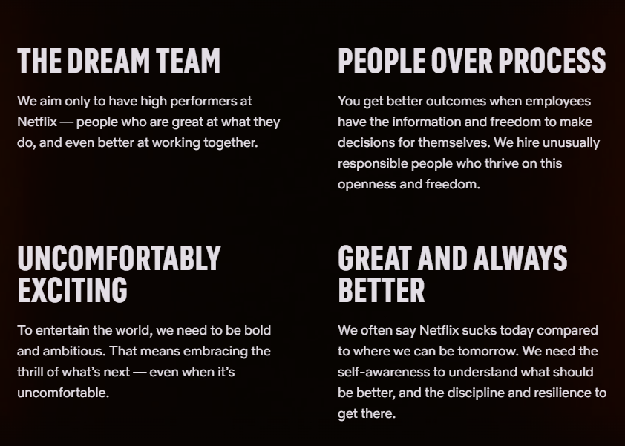
Figure 6: Netflix’s culture memo
(Source: Netflix, 2025c)
This culture proved useful for Netflix's launch of new features like the revamped TV home page and increased live content in 2025. This culture is difficult to replicate, which gives Netflix a competitive edge.

2.2.6 Internal Weaknesses
Although Netflix is very capable, there are important weaknesses within its own organisation. The company is very dependent on expensive original material to retain subscribers. At 31 December 2025, Netflix's senior debt was US$14.5 billion, and its recognised content liabilities were US$5.7 billion (Netflix, 2025). On the other hand, the company has not recognised streaming content commitments as liabilities yet. The company also states that content amortisation depends on estimated future viewing patterns. If actual viewing rate gets declined less than anticipated, profitability may be impacted. These high costs can limit strategic agility and raise operational risk.

2.3 SWOT Analysis
Strengths | Weaknesses
- Strong global brand with high customer trust and loyalty.  - Extensive original content library protected by intellectual property rights.  - Advanced AI recommendation system and strong data analytics capability.  - Strong financial performance, generating US$45.2 billion in revenue and US$9.5 billion in free cash flow in 2025 (Netflix, 2025).  - Innovative organisational culture that supports continuous product and technology development. | - Heavy dependence on costly original content production.  - High financial commitments, including US$14.5 billion senior debt and significant long-term content obligations (Netflix, 2025).  - Mature UK streaming market limits subscriber growth.  - Profitability depends on the continued success of new content releases.  - Increasing operating costs may reduce financial flexibility.
Opportunities | Threats
- Expansion of the advertising-supported subscription model.  - Greater use of AI to improve content discovery and operational efficiency.  - Increasing demand for local and regional content production.  - Growth of live programming, games and interactive entertainment.  - Rising digital entertainment consumption across global markets. | - Strong competition from Disney+, Amazon Prime Video, Apple TV+ and other streaming platforms.  - Increasing price sensitivity among UK consumers.  - Tightening data privacy and digital platform regulations.  - Rising content production costs and talent competition.  - Cybersecurity and AI governance risks can reduce the reputation of the organisation (Awurum, 2025).

Table 2: SWOT Analysis
From the SWOT analysis, it can be seen that Netflix is in a good strategic position as its strengths are greater than its weaknesses. It has a strong global brand, original content and AI features, which add to its competitive advantage in the UK streaming market, as well as a strong financial performance. These resources also aid in maintaining continuous innovation and customer satisfaction. But Netflix's business model is based on high production costs and long-term investments, which puts it at risk of facing internal issues. The UK has a more mature streaming market, and it is becoming increasingly difficult to attract new customers. Netflix has a few opportunities for improving its market position externally. An ads-based subscription model can generate extra income and increase the customer base that's price-sensitive. By leveraging AI, companies can enhance personalisation, advertising effectiveness, and operational efficiency.

3. Comprehensive and holistic view of the organisation

3.1 Corporate Social Responsibility (CSR) Strategy

3.1.1 Current CSR Strategy
Netflix's current Corporate Social Responsibility (CSR) strategy has three key pillars: environmental sustainability, inclusion and belonging, and responsible corporate governance. To minimise its environmental footprint, Netflix plans to lower its GHG emissions by approximately 50% by 2030 (Netflix, 2025d). In addition, Netflix is taking steps to minimise emissions from film and television production by implementing energy-efficient processes and leveraging more environmentally friendly technologies. In the social realm, the company is committed to diverse storytelling, equality and inclusion for employees and creators in the workplace. Netflix's Code of Ethics, Supplier Code of Conduct and Human Rights Statement and executive governance policies have been strengthened to promote responsible business practices in the area of governance. These efforts demonstrate Netflix's long-term value creation efforts, while it conducts business responsibly in the UK market.

3.1.2 Alignment with Business Objectives
The strategy of Netflix's CSR is directly related to its business objective of expanding the UK's Subscription Video-on-Demand (SVoD) service (São Bento, 2025). The company invests in different films and TV shows, including within the UK, to draw in viewers from various backgrounds and boost engagement. The environmental programme makes a contribution towards emission reduction in content production, which is a prerequisite for efficient and responsible business operations. Netflix also follows the UK Modern Slavery Act, Supplier Code of Conduct and Human Rights Statement to ensure responsible business practices across its supply chain (Q4cdn, 2025). These things help develop customer trust, enhance the brand of Netflix and minimise the risks of business. This is because the company has a CSR strategy that enables sustainable growth and keeps Netflix competitive in the UK streaming market.

3.1.3 Critical Evaluation
Netflix's CSR activities are consistent with its business goals, but its impacts are overall mixed. According to Tambini, (2025), Netflix has made good progress in developing a variety of content, improving its governance and setting environmental targets. These efforts have helped to reinforce its brand reputation and foster trust within the UK market. However, according to Milosavljević and Bajić, (2025), Netflix still relies on big productions of films and TV shows for its business, and despite its efforts to be green, it generates significant carbon emissions. Furthermore, the direct business impacts of diversity and environmental programmes are not easy to measure.

3.2 Balanced Scorecard

Professional Balanced Scorecard table
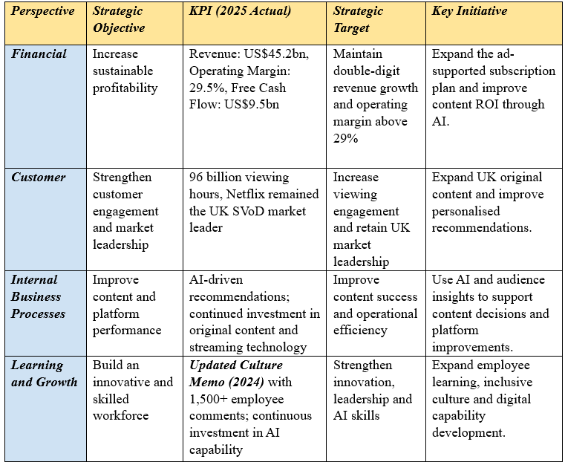
Table 3: Balanced Scorecard

3.2.1 Financial Perspective
The financial aspect aligns with Netflix's vision of entertaining the world and aims to ensure sustainable and profitable growth in the UK Subscription Video-on-Demand (SVoD) market. The primary objective is to increase revenue with a high profit margin. Some of the key performance indicators (KPIs) are annual revenue (US$45.2 billion), operating margin (29.5%), and free cash flow (US$9.5 billion) in 2025 (Netflix, 2025). It highlights the company's capacity to invest in the UK market, as Netflix does not report separate financial results for the UK. The objective is to maintain good profitability and growth in revenues over time. To pursue this, Netflix is taking initiatives to introduce a new ad-supported subscription service, boosting investment in high-quality content in the UK and leveraging AI to improve content investment decisions and efficiency.

3.2.2 Customer Perspective
The customer side of the equation is helping to achieve Netflix's mission of entertaining the world by enhancing the viewing experience for UK customers. The main objective is to increase customer engagement and retain its leading position in the UK's Subscription Video-on-Demand (SVoD) market. KPI Measures are household penetration in the UK, viewing time and adoption of the ad-supported plan (ASP). Netflix achieved a 59% penetration rate in UK households in Q1 2025, while it had a penetration rate of 13% in 2024. Netflix's penetration rate in UK households in Q1 2025 was 59%, compared with 13% in 2024 (News, 2025).
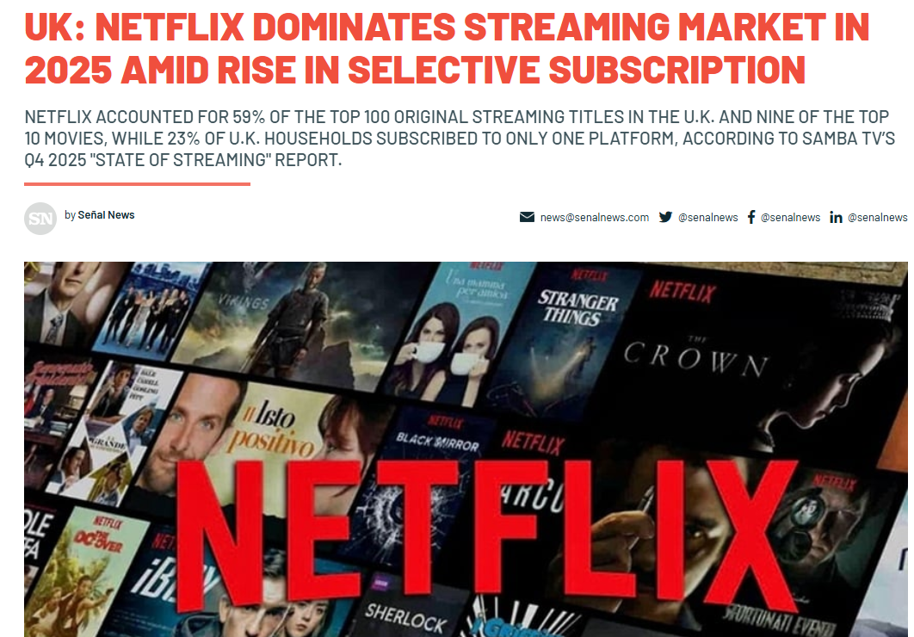
Figure 7: Netflix accounted for 59% of the top 100 original streaming titles in the U.K
(Source: News, 2025)
The objective is to increase customer loyalty and engagement. This involves a range of initiatives like increasing the amount of UK content, improving the recommendations powered by AI, and enhancing personalised viewing experiences.

3.2.3 Internal Business Process Perspective
The internal business process perspective helps Netflix to achieve their mission by enhancing the quality of its service and the quality of its content in the UK's SVoD market. The primary objective is to deliver top-quality UK content and a seamless streaming experience. KPIs cover the number of productions that are made in the UK, content engagement and platform performance. Netflix's investments in UK content are strong, with over 100 new and returning films, series and documentaries with a budget of 135 billion euros (ET Bureau, 2026). The goal is to enhance the quality of content and the effectiveness of operations. Key initiatives include working with UK production companies, using AI to support content decisions and improving streaming technology to give UK viewers a better and more reliable viewing experience.

3.2.4 Learning and Growth Perspective
The internal business process perspective helps Netflix to achieve their mission by enhancing the quality of its service and the quality of its content in the UK's SVoD market. The primary objective is to deliver top-quality UK content and a seamless streaming experience. KPIs cover the number of productions that are made in the UK, content engagement and platform performance. Netflix's investments in UK content are strong, with over 100 new and returning films, series and documentaries announced in 2025. The goal is to enhance the quality of content and the effectiveness of operations. Key initiatives include working with UK production companies, using AI to support content decisions and improving streaming technology to give UK viewers a better and more reliable viewing experience.

4. Strategic Choices and Implementation

4.1 Business-Level Strategic Choices

4.1.1 Evaluation of Generic Strategies
Netflix UK needs to consider basic business-level strategic options like cost leadership, differentiation, and focusing on its leading position in the fully developed UK Subscription Video-on-Demand (SVoD) market (Joonas, Mahfouz and Hayes, 2023). Traditionally, Netflix has pursued a differentiation strategy and has been a very generous spender on original, high-budget, UK-centric shows, from The Crown to local dramas, as well as focusing on a proprietary recommendation system that improves the user experience (Morris, 2022). But with a highly competitive market and macroeconomic cost-of-living issues in the UK, a pure differentiation model could potentially lose customers to those who are price sensitive.

4.1.2 Positioning via Hybrid and Differentiation Models
Strategic Dimension | Pure Differentiation Model | Hybrid & Ad-Supported Model (Netflix UK Focus)
Primary Value Driver | Exclusive high-end content, Better UI and no commercial interruptions. | Access points that are accessible for all, original content and varied tiers.
Target UK Consumer Segment | High-spending households or entertainment-oriented households who are less responsive to increases in subscription fees (Jiang and Zhang, 2026) | Mainstream households facing economic inflation and household budgeting who are price sensitive or are very tolerant of advertising.
Competitive Advantage | Brand Loyalty based on a perception of uniqueness, high production quality and proprietary technology (Mahdi et al. 2022) | Expanding market share, reducing the rate of churn, diversified monetisation (subscription + ad revenue).
Table 4: Positioning via Hybrid and Differentiation Models

4.2 Identification and Validation of the Preferred Strategy

4.2.1 Selection of the Strategic Direction
Netflix UK needs to make a strategic choice on pursuing a dual-tier market penetration strategy and diversifying its portfolio to become a growth player and a competitive player in the UK Subscription Video-on-Demand (SVoD) market (Jati and Serenade, 2024). The decision to go one way has focused on building up the ad-supported tier to attract price-sensitive audiences, and building up local UK original programmes and integrated digital entertainment offerings, including mobile gaming (Majka, 2024).

4.2.2 Strategic Validation Using Analytical Frameworks
Force | Intensity Level | Key Driver in the UK SVoD Market
Threat of New Entrants | Low to Moderate | Difficult cost of producing content, difficult cost of setting up streaming infrastructure worldwide; established brand loyalty deters.
Bargaining Power of Buyers | High | Switching costs are low, and there are plenty of other options (Disney+, Amazon Prime Video, BBC iPlayer) available for consumers.
Bargaining Power of Suppliers | High | Talent unions, A-list creators, and big sports/content rights holders get high prices for their work.
Threat of Substitutes | High | A wide range of other forms of entertainment, such as social media, video games, and traditional broadcast television (Sheikh et al., 2022).
Competitive Rivalry | High | Because of the saturation in the mature UK market, continued price competition, ad tier rollouts, and content wars are the nature of the competition.
Table 5: Porter's Five Forces analysis
Porter's Five Forces framework reveals that buyer power and the threat of substitutes in the UK streaming industry are high, but this is counterbalanced by the differentiation of offering localised content and cost (Sheikh et al., 2022).
SAFe Pillar | Evaluation Criteria for Netflix UK's Strategy | Strategic Verdict & Market Impact
Suitability | Is the ad tier/content local right for UK market saturation and price sensitivity? | High: Counteracts economic inflation and decline in economic growth rates directly.
Acceptability | Is the risk acceptable to stakeholders, shareholders, and UK consumers? | High: Expands consumer options, but keeps financial yield expectations unchanged.
Feasibility | Is Netflix technologically, financially and organizationally able to carry it out? | High: Backed by robust AI infrastructure, ample cash flow, and scalable streaming tech.
Table 6: SAFe framework
The SAFe framework can be used to test the Netflix UK strategic direction by reviewing the strategic initiatives for Suitability, Acceptability and Feasibility, ensuring that they respond to external threats in the market and are feasible to do in terms of operations and finances.

4.3 Performance Optimisation and Competitive Advantage

4.3.1 Mechanisms for Optimum Performance
Netflix UK has implemented various mechanisms for algorithmic optimisation, tier diversification for cost optimisation and content scaling localisation to optimise the financial and operational performance of its business in the UK SVoD market. The recurables and ad-supported tiers generate more ARPU (Average Revenue per User) and reduce churn in down economic cycles (Aldoseri et al. 2023). On the other hand, information-based analytics can be used to optimise bandwidth and content acquisition by e-commerce companies. This will ensure that the investment will be focused on high-return British productions and entertainment integrations into the digital sphere.

4.3.2 Sustaining Competitive Advantage
Continuous innovation, brand equity and positioning, and creating barriers to entry that cannot be matched by competitors such as Amazon Prime Video or Disney+ are essential to Netflix UK's competitive edge. Netflix's approach is to leverage its proprietary recommendation engines and sophisticated behavioural data analysis to provide an experience that's so personalised that consumers have a higher hurdle to switching to a different service (Reddy, 2025).

4.4 Implementation Challenges and Mitigation Solutions

4.4.1 Identification of Operational Bottlenecks
Operational Challenge | Description and Impact on Netflix UK
Ad-Tier Technological Integration | Integrating real-time programmatic advertising infrastructure with current streaming systems without compromising the video experience or latency times for UK audiences (SS, 2025)
Content Licensing and Production Friction | Complex regulatory compliance, talent unions and localised co-productions in the UK can lead to content delivery pipelines that take longer and production costs that are higher due to content licensing and production friction.
Subscriber Churn and Ad Fatigue | Finding ways to overcome consumer rejection of ad placements or changes in subscription tiers, with the risk of some subscribers subscribing to an ad-free service, such as Amazon Prime Video or Disney+ (Neglur and Rajeswari, 2026)
Table 7: Identification of Operational Bottlenecks

4.4.2 Mitigation Strategies and Change Management
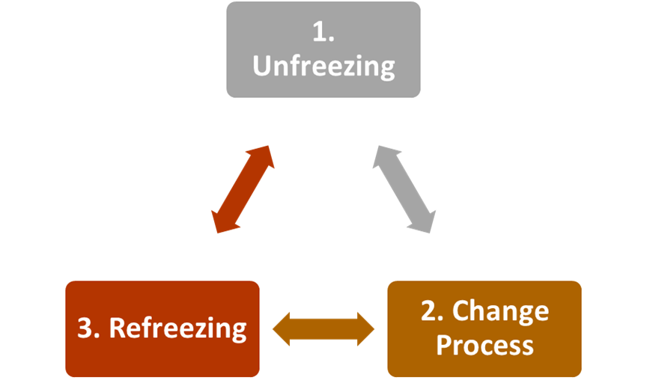
Figure 8: Lewin's Change Model
(Source: Self-created)
Netflix UK needs to implement structured change management processes as well as powerful technological protective measures. Based upon Lewin's Change Model, leadership must commit to unfreezing entrenched operational practices, which they must do by communicating the financial imperative to expand to ad tier to internal stakeholders (Ellis, 2023). Netflix, in terms of technology, should join with top programmatic ad tech partners to deliver ads seamlessly, in real-time and without negatively impacting user experience.

Section 2: Reflective Account

2.1 Description
I chose Netflix's UK subscription video-on-demand (SVoD) service as my assessment choice, as it is one of the largest and most competitive streaming markets. I took the time to read the brief of the assignment to understand the scope and decided to concentrate on one market rather than Netflix's global business. Throughout the research process, I gathered data from the following sources: Netflix's Annual Report, SEC filings, ESG Report, Ofcom, UK Government publications and academic journals. Then I used various strategic frameworks to analyse Netflix's current situation and suggested the most appropriate business strategy for the UK market (PESTEL, VRIO, SWOT, CSR analysis, Balanced Scorecard and SAFe).

2.3 Feelings
Initially, I struggled with the research process because Netflix is available in many nations (Netflix, 2025). However, for the assignment, I was required to concentrate on the UK market only. Also, I discovered Netflix does not provide separate financial data for the UK, making the analysis more challenging. The more I did my research, the more my confidence grew as I learned how to utilise company reports in conjunction with the UK industry data. This gave me insight into the importance of basing strategic decisions on good data rather than opinion.

2.4 Evaluation
One positive part of my work was using reliable and recent sources instead of depending only on academic articles. Current and measurable information has been provided by Netflix's Annual Report, SEC filings, ESG Report and Ofcom reports. These sources were used to create a more accurate analysis of the UK streaming market. Another merit was the use of multiple rather than single models. PESTEL described the external factors, and VRIO described Netflix's internal strengths (Breskovic et al. 2025). Based on this, SWOT created one strategic overview. But there were some problems for me too. The majority of company information was provided on a global basis, not for the UK. This was addressed by overlaying company information, derived from global information, with UK-specific market reports, to ensure the analysis remained relevant to the selected market.

2.4 Analysis
This evaluation enabled me to gain insight into the importance of the combination of the right evidence with the right business frameworks in good strategic analysis. I found that I had to use only one framework to assess Netflix's UK SVoD business, but it wasn't enough. So, I have used PESTEL to analyse the external environment, VRIO to analyse the internal strengths and SWOT analysis to link both. I was then introduced to the link between the business strategy and operational performance via CSR and Balanced Scorecard. It was also crucial to verify all numbers before employment (Silva et al. 2025). I checked information on Netflix's Annual Report, SEC filings, Ofcom reports and academic journals to make sure that the data was up-to-date, accurate and pertinent to the UK market. This helped me to put together an analysis that was of good quality and credible.

2.5 Conclusion
This assessment was useful for me to understand strategic management and evidence-based business analysis. I learned that it is essential to select reliable and current information as well as to apply the appropriate frameworks. Concentrating on Netflix's UK SVoD market was interesting to see how one organisation has different opportunities and challenges in a given market. I applied PESTEL, VRIO, SWOT, CSR, Balanced Scorecard and SAFe to gain a more comprehensive picture of the strategic situation of the organisation. This exposure helped me to improve my research skills, my critical thinking and decision-making skills, and gave me the confidence needed to create a strategic business report using evidence and viable recommendations.

2.6 Action Plan
Area for Improvement | Action Plan | Expected Outcome
Research skills | Using more recent company reports, Ofcom publications and academic journals before starting the analysis. | Improve the quality and reliability of evidence.
Data validation | Comparing data from multiple trusted sources before using statistics. | Increasing accuracy and credibility of findings.
Strategic analysis | Connecting business frameworks more effectively and explaining their relationships clearly. | Producing stronger critical analysis.
Time management | Creating a detailed research schedule and reviewing each section before submission. | Completing the report on time with better overall quality.
Table 8: Action Plan

References
Aldoseri, A., Al-Khalifa, K.N. and Hamouda, A.M., (2023). Re-thinking data strategy and integration for artificial intelligence: concepts, opportunities, and challenges. Applied Sciences, 13(12), p.7082.
Awurum, N.P., (2025). The Double-Edged Sword of AI in Cybersecurity: Organizational Risks, Defensive Strategies, and Governance Implications. Open Access Library Journal, 12(11), pp.1-16.
Bano, R., Azim, F., Mahmood, Z., Sanaullah, A. and Ali, O., (2025). The role of artificial intelligence in personalized marketing: Enhancing customer experience, predictive targeting, and brand engagement. The Critical Review of Social Sciences Studies, 3(2), pp.50-65.
Bhalla, P. (2025). Streaming services statistics by Features, market size, share, platforms, users, and country (2025). [online] Electro IQ. Available at: https://electroiq.com/stats/streaming-services-statistics/ [Accessed 21 July 2026].
Bitran, T. (2022). Netflix turns 25 today. [online] Netflix. Available at: https://www.netflix.com/tudum/articles/netflix-trivia-25th-anniversary [Accessed 21 July 2026].
Breskovic, D., Oblakovic, G. and Dadic, M., (2025). External Market Forces and Strategic Implications for Telecommunications Infrastructure in Croatia. Fiber and integrated optics, 44(6), pp.519-549.
Durrani, A. (2024). Top streaming statistics in 2024. [online] Forbes. Available at: https://www.forbes.com/home-improvement/internet/streaming-stats/ [Accessed 21 July 2026].
Ellis, P., (2023). Managing change--the Lewin model 3: refreeze. Wounds UK, 19(4).
ET Bureau (2026). Netflix says it invested $135 billion in content over decade, created 425,000 jobs globally. [online] The Economic Times. Available at: https://m.economictimes.com/industry/media/entertainment/netflix-says-it-invested-135-billion-in-content-over-decade-created-425000-jobs-globally/articleshow/131043493.cms [Accessed 10 Aug. 2026].
GOV.UK (2025). Online safety act: Explainer. [online] GOV.UK. Available at: https://www.gov.uk/government/publications/online-safety-act-explainer/online-safety-act-explainer [Accessed 21 July 2026].
Hsiao, Y.-H. (2024). The business strategy analysis of Netflix. Transactions on social science education and humanities research, [online] 11(2960–1770), pp.760–767. Available at: https://pdfs.semanticscholar.org/0418/cdfee079cdbf834abd369556b64f1fc6fb43.pdf
Jati, I.M. and Serenade, V., (2024). Netflix's Global Market Entry and Adaptation Strategies Critical Review. Jurnal Informatika Ekonomi Bisnis, pp.932-936.
Jiang, X. and Zhang, S., (2026). Research on Market Positioning and Brand Differentiation Analysis System Based on Convolutional Neural Network and Temporal-difference value prediction. Systems and Soft Computing, p.200548.
Joonas, K., Mahfouz, A.Y. and Hayes, R.A., (2023). Strategy for Growth and Market Leadership: The Netflix Case. AIMS International Journal of Management, 17(2), p.87.
Ke, T.T. and Sudhir, K. (2022). Privacy rights and data security: GDPR and personal data markets. Management science, 69(8), pp.4389–4412.
Lentati, A. (2026). Content Economics: Spend, Amortization, and Library Valuation. [online] IB Interview Questions. IB IQ. Available at: https://ibinterviewquestions.com/guides/tmt-investment-banking/content-economics-amortization, [Accessed 10 Aug. 2026].
Mahdi, A.A., Chalechale, A. and AbdelRaouf, A., (2022). A hybrid indoor positioning model for critical situations based on localization technologies. Mobile Information Systems, 2022(1), p.8033380.
Majka, M., (2024). Penetration pricing: A strategy for rapid market entry and growth. [Online], Available at: https://www.researchgate.net/profile/Marcin-Majka-2/publication/386086960_Penetration_Pricing_A_Strategy_for_Rapid_Market_Entry_and_Growth/links/674304a8868c966b932ab6e5/Penetration-Pricing-A-Strategy-for-Rapid-Market-Entry-and-Growth.pdf, [Accessed on: 10th August, 2026].
Milosavljević, I. and Bajić, N.S., (2025). The Impact of Netflix and Video Streaming Services on Changes in Distribution, Production, and Audience of Television Series. Društvene i humanističke studije, 10(1 (27)), pp.763-784.
Morris, K.L., (2022). Netflix Strategic Business Analysis., [Online], Available at: https://scholarworks.umt.edu/cgi/viewcontent.cgi?article=1425&context=utpp, [Accessed on: 10th August, 2026].
Neglur, I.S. and Rajeswari, P.S., (2026). Keeping viewers hooked: Netflix’s innovative strategies for reducing churn. Journal of Information Technology Teaching Cases, 16(1), pp.29-39.
Netflix (2024). 2024 Netflix Environmental Social Governance Report . [online] Available at: https://s22.q4cdn.com/959853165/files/doc_downloads/2025/6/2024-Netflix-Environmental-Social-Governance-Report.pdf. [Accessed 21 July 2026].
Netflix (2025c). Netflix culture — the best work of our lives. [online] Netflix. Available at: https://jobs.netflix.com/culture [Accessed 10 Aug. 2026].
Netflix, (2025), 2025 Annual Report, [Online], Available at: https://s22.q4cdn.com/959853165/files/doc_financials/2025/ar/99482238-46b2-4d0d-b292-40e6781bdf03.pdf, [Accessed on: 10th August, 2026].
Netflix, (2025d), Net Zero + Nature: Our Commitment to the Environment, [online] Available at: https://about.netflix.com/news/net-zero-nature-our-climate-commitment [Accessed 10 Aug. 2026].
Netflix. (2025b), What We Watched the Second Half of 2025, [online] About Netflix. Available at: https://about.netflix.com/en/news/what-we-watched-the-second-half-of-2025 [Accessed 10 Aug. 2026].
News, S. (2025). UK: Netflix dominates streaming market in 2025 amid rise in selective subscription - Señal News. [online] Senalnews.com. SEÑAL NEWS. Available at: https://senalnews.com/en/data/uk-netflix-dominates-streaming-market-in-2025-amid-rise-in-selective-subscription [Accessed 10 Aug. 2026].
Ofcom (2023). Media Nations: UK 2023 . [online] Available at: https://www.ofcom.org.uk/__data/assets/pdf_file/0029/265376/media-nations-report-2023.pdf [Accessed 21 July 2026].
ONS (2026a). Consumer price inflation, UK. [online] Ons.gov.uk. Office for National Statistics. Available at: https://www.ons.gov.uk/economy/inflationandpriceindices/bulletins/consumerpriceinflation/april2026 [Accessed 21 July 2026].
ONS (2026b). GDP monthly estimate, UK. [online] Ons.gov.uk. Office for National Statistics. Available at: https://www.ons.gov.uk/economy/grossdomesticproductgdp/bulletins/gdpmonthlyestimateuk/january2026 [Accessed 21 July 2026].
Q4cdn, (2025), UK Modern Slavery Act 2015: Transparency Statement, [Online], Available at: https://s22.q4cdn.com/959853165/files/doc_downloads/governance_docs/2021/11/UK-Modern-Slavery-Act-Statement.pdf, [Accessed 10 Aug. 2026].
Reddy, N., (2025). Sustainable Competitive Advantage in the Era of Digital Platforms: A Systematic Review. Stout in Business and Management, 1(1), pp.13-22.
Rui, A.K. (2024). 2 Big Winners in the Streaming Industry. [online] Yahoo Finance. Available at: https://sg.finance.yahoo.com/news/2-big-winners-streaming-industry-041500516.html [Accessed 10 Aug. 2026].
S&P Global (2025). UK digital entertainment market update, 2025. [online] S&P Global Market Intelligence. Available at: https://www.spglobal.com/market-intelligence/en/news-insights/research/uk-digital-entertainment-market-update-2025 [Accessed 21 July 2026].
São Bento, R.S.P., (2025). Video Streaming Platforms: How Subscription Video on Demand Platforms Can Attract New Subscribers in the Portuguese Market Exploring Relevant Literature on Subscriber Attraction and Content Strategies for Subscription Video on Demand Platforms (Master's thesis, Universidade NOVA de Lisboa (Portugal)).
Sheikh, R.A., Bhatia, S., Metre, S.G. and Faqihi, A.Y.A., (2022). Strategic value realization framework from learning analytics: a practical approach. Journal of Applied Research in Higher Education, 14(2), pp.693-713.
Silva, A., Maldonado, I., da Silva, M. and Cepeda, C., (2025). Sustainability balanced scorecard: systematic literature review. Journal of Risk and Financial Management, 18(6), p.324.
Spangler, T. (2026). Netflix tops 325 million subscribers, plans to boost content spending 10% to $20 billion in 2026. [online] Variety. Available at: https://variety.com/2026/tv/news/netflix-q4-2025-financial-earnings-subscribers-1236635615/ [Accessed 21 July 2026].
SS, H., (2025). Deconstructing the Netflix Machine: A Case Study of Netflix's Production-to-Delivery Ecosystem. Available at SSRN 5537379.
Tambini, D., (2025). The “Netflix effect” revisited: OTT video, media globalization and digital sovereignty in 4 countries. Telecommunications Policy, 49(5), p.102935.
Zhao, E.J. (2025). The politics of streaming time: When elastic time meets troubled tiers in the turn to the subscription video-on-demand (SVOD) model. Convergence the international journal of Research into new media technologies.

