Photobook Proforma

Student Name: Rebecca Davies

Section 1: Knowledge and Understanding Skills: 20%

Guidance specific to task (from the brief):

Your evaluation should show clear understanding of the history, function, practical development and production of the photobook through a range of critically understood examples. The analysis of these will highlight the functions and strategies employed by the photographer and your interpretation of their communication of meaning through the publication.

Using examples (3 max), explore your understanding of the history, function and practical development of the photobook. Your analysis should highlight the strategies used by the artist/photographer to communicate their message. Include visuals (500 – 1000 words)

During the mid nineteenth century, photobooks were used as a scientific documentation tool, whereby there was a focus on the classification of botanical specimens. One of the first photobooks created was in 1852 by Anna Atkins. Photographs of British Algae: Cyanotype Impressions consists of a photobook that documents scientific records of plant specimens. This was done using the cyanotype process rather than a camera, whereby Atkins produced consistent blue backgrounds with white silhouettes of the specimens. The images were sequenced systematically to allow for comparison and classification. This format is important in showcasing how these works function as a system of knowledge rather than individual pieces of art. This emphasises structure, clarity, and objectivity, reinforcing photography’s function as scientific record rather than artistic interpretation. As my work uses fake images to seem real, I had to present my work in a scientific way by having one image per page and a very minimal, structured layout. The images are all centred on the page, with only slight variation in height. This documentation style was essential in communicating the authenticity that I needed. I used this artist mainly to understand how to present my work in terms of layout, as their work was very scientific and trusted as truth. I used this as a way to influence how I could present my own work.

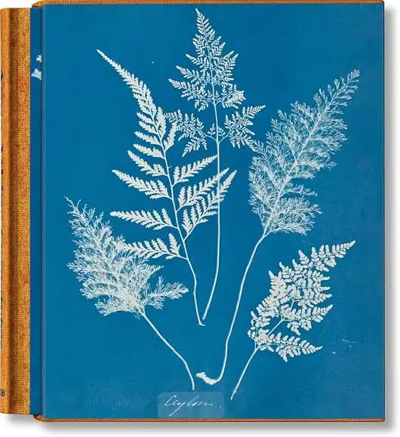
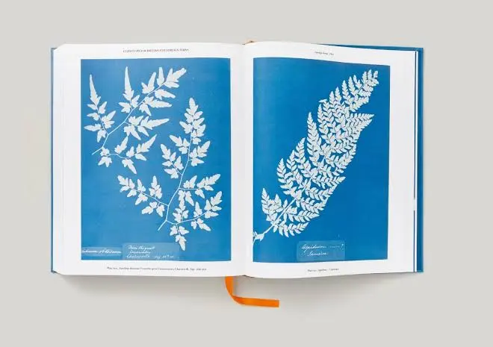

In contrast, Iris Garden (2013) by John Cage and William Gedney showcases a conceptual approach, whereby the photobook reuses archival material to explore how meaning can be reshaped through curation and sequencing instead of documenting reality. The images are organised in an unpredictable sequence, encouraging viewers to look deeper into the work, highlighting how images can take on different interpretations based on their position within a sequence. This leads to a more reflective viewing experience. This showcases how the photobook acts as a curated space rather than a fixed narrative, whereby the focus shifts from image arrangement as a method of organising to an active tool for shaping perception. Furthermore, the physical structure of this photobook moves beyond a traditional bound format. The boxed presentation, where images and text must be discovered through viewer interaction, highlights the importance of the book as a container where meaning is constructed rather than simply displayed as evidence. This work led me to develop the idea of connecting words with imagery, while also understanding that sequencing and curation can reshape meaning. While they used this to create their own narrative and highlight different interpretations, I used this in a way where the viewer does not realise this beforehand. I also considered the physical construction. The idea of having the images in a box felt very important to me, as it made the images feel more personal and valuable. This structure made it feel like I was looking at something archival and meaningful, which I wanted to replicate in my own work, especially as my project is based on my mother’s memories. Even though the images are reconstructed, I still wanted viewers to feel that personal connection. Iris Garden was a main inspiration in terms of presentation and design. The idea of the box, having a clean image on the box and tray, and a plain fabric cover were all influenced by this.
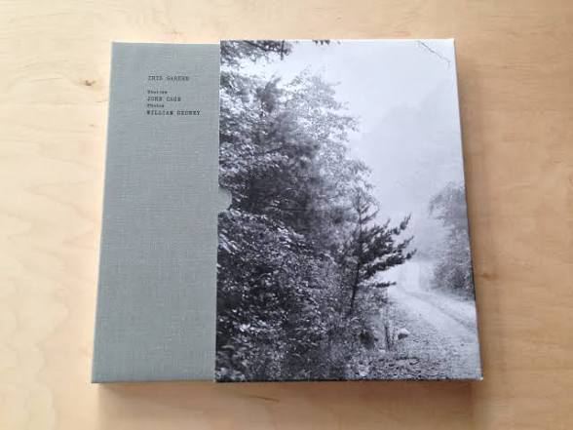
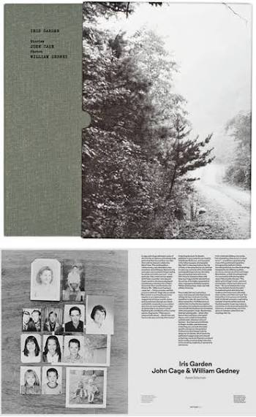
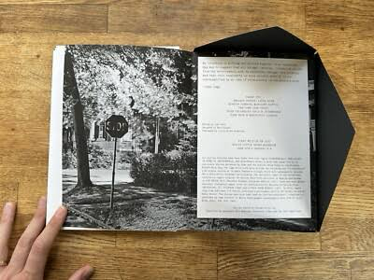

Moreover, Mrs. Merryman’s Collection (2012) by Anne Merryman explores how photobooks can suggest meaning rather than present clear factual narratives. This work consists of collected postcards that engage with themes of memory and interpretation. Merryman’s work focuses on presenting a structure that encourages viewers to create their own meaning through sequencing and arrangement, suggesting a narrative rather than directly stating one. The sequence is fragmented, combining a mixture of surreal, found-style postcards curated by the artist. The work is presented as if these are inherited or archival items. It tells the story of a collection of postcards supposedly passed down from a grandmother; however, this narrative is entirely constructed. I was particularly interested in this work because it closely relates to my own approach. While they used found-style imagery, I used AI-generated images, but both construct a false narrative. I used this as a strong reference point in understanding how to communicate this idea, looking at how they structured the work, revealed information, and guided the viewer without directly stating that the images were not real. The layout is also minimal, with strong use of white space, which is similar to my own work. This reinforced that my approach was effective. One of the most useful aspects of this was experiencing the work as a viewer, which helped me understand what worked well and what could be improved within my own project.

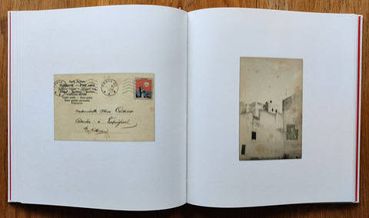
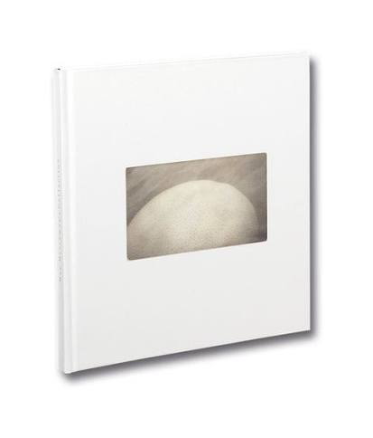
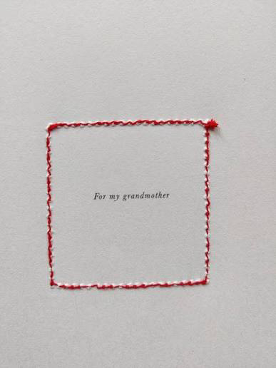
Across all my research, it became clear that sequencing and structure are very important in how photobooks create meaning. In the work I explored, they all shared the same purpose of presenting images with intention. Layout, design, and sequencing are used to shape interpretation and guide how the work is understood. While Anna Atkins focuses on scientific recording. Both John Cage, William Gedney and Anne Merryman explore conceptual approaches. Although their work is different, they all demonstrate how structure and sequencing shape meaning. In conclusion, the development of my photobook shows how I was influenced by these approaches. I used elements of documentary presentation as a foundation but applied them in a more conceptual and interpretive way. Through sequencing, repetition, and physical design, I constructed meaning rather than simply present images.

Section 2: Cognitive and Intellectual Skills: 30%

Guidance specific to task (from the brief):
Your research report should critically analyse the theories and concepts explored in your photobook, as well as the techniques it employs. Focus on developing a reasoned and informed debate rather than simply describing the work. Your analysis should lead to clear, valid conclusions, considering the form of the book, the reading experience it creates.
Avoiding description, critically analyse the theme/ context you explore within your photobook. Your critical analysis should demonstrate your cognitive and intellectual skills in how you have understood the subject and made work as a response to it. Consider how the form of your book communicates meaning in relation to the subject of exploration. (500 -1000 words)

This photobook explores the fragility and unreliability of memory. Through this project, I developed a deeper understanding of how memory is not fixed or accurate. I explore this through a combination of archival photography and AI generated imagery. It is based on my mother’s childhood trip to Switzerland, where I used both her original photographs and an interview, I conducted with her to investigate how memories are formed, recalled, and reconstructed. The final book consists of 28 images, including 27 AI generated images and 1 real photograph, which is only revealed at the end through the list of illustrations. Throughout the sequence, the viewer assumes that all images are authentic. This is done deliberately to build trust and then disrupt it, creating a narrative based on deception and realisation.
The central theme of my work is that memory is fragile, unstable, and shaped through interpretation and subjectivity. It is continuously reshaped over time through a range of different aspects such as personal perception, and external influences. I communicate this concept through my ai generated images, whereby I show how memory can be reinforced, distorted, or replaced. By replacing the real with AI generated imagery, I force viewers to experience this uncertainty themselves. AI introduces a new way of generating false visual memories, this therefore challenges the idea of photography as evidence. Overall, this links to wider issues of misinformation and visual trust within a modern-day sense. It also reflects a cultural shift from documentation to digital construction. I realised that people often trust photographs without questioning them, even though images can feel real regardless of whether they are. I also noticed that memory tends to retain emotion more strongly than detail. My mum could recall how she felt about moments from the trip, but not always specific information. This shows how memory becomes increasingly subjective over time. This led me to question the relationship between photography and truth, recognising that the authenticity of images is often based on someone’s perceptions rather than the true meaning. My work challenges the idea that photographs must come from real events, whereby I blur the boundary between real and constructed memory.
My creative response uses photography because it is historically associated with truth and documentation. The AI images strengthen the illusion of authenticity, while the personal text act as anchors of reality. All AI images were created from my mum’s interview responses. Whereby, the book begins as nostalgic and believable but becomes more unsettling after the reveal. The similarity between the original real images and AI images is intentional, I wanted to ensure the images were as believable as possible. To do this I matched colour, grain, scale, and material qualities to maintain consistency. Throughout this process, I realised how important the photobook format is in controlling how the work is experienced. The sequencing builds trust gradually before disrupting it, shaping how viewers interpret the images. This creates a more active engagement, as meaning is revealed over time rather than immediately understood. The physical format of the book also contributes to meaning. Presented within a box, it suggests memory as something stored and layered. The contrast between the handmade elements and the more controlled outer structure reflects the tension between fragility and construction within memory.
A key strength of this work is the use of deception to encourage viewer participation. Instead of simply illustrating that memory is unreliable my work makes the viewer experience that uncertainty firsthand. By doing this, I shift the photo back from something passive into something that actively requires questioning. I believe the aspect that made this highly effective was the sequencing that I used not revealing the truth until the end encourages viewers to reconsider their assumptions. Although that is the argument that this approach can raise ethical questions around trust and manipulation someday may feel misled. Which overall just highlights the meaning of my work further. Furthermore, there are other aspects that are very important and can easily change my work from being effective to non-effective. For example, they were limitations in the use of AI. Some of my images that I created did have inconsistencies and if I had to use them in my final selection, it could break the illusion and reveal the concept far too early. While it can be argued that having these inconsistencies can reinforce the idea of memory and AI being unstable, it does not work for the type of concept that I was focusing on within my work.
In conclusion, this photo book demonstrates that memory and photography are both unreliable. I show how the way things are presented can lead people to form assumptions and believe things very easily. As a result, my work encourages viewers to question what they see and what they believe. However, I also wanted to highlight their importance. They both still hold significant value within society, especially in a time where AI is increasingly reshaping how we experience images and the past.

Section 3: Practical Skills: 40%

Guidance specific to task (from the brief):
Present your book professionally, carefully considering how you deploy methods, technical processes. Your methods should synthesize the form of your book and the context/meaning of your subject. Your book should demonstrate proficiency, selection in editing and flair. The decisions you make should be as product of significant research into book production and design. Within your evaluation, ensure to provide examples of book dummies to show the developments in your practical processes. These decisions should be as product of significant book design planning including alternative idea generation.
Evaluate the methods and technical processes you have employed in the making of this body of practice. Explain your process for making your book, consider how editing/ design/ typography and format speak to the subject matter you have explored. Provide examples of the book dummies you have created over the past semester to show developments in your practical processes. (800 – 1500 words)

Throughout the process of making my book, I made sure to carry out a range of experiments and test. In total, I created around twelve different book dummies, whereby I continued to constantly shape and reshape the sequencing, structure, and overall meaning throughout my work. During this process, my decisions became much more refined and intentional, whereby I learned how to think about every step I was taking rather than just doing something because I liked it. As well as the physical making of the book, there were also other key aspects such as editing the Ai generated photographs, designing the presentation, typography, and the overall aesthetic of my work. All these elements work together to communicate the themes of memory, truth, and constructed reality. In terms of my images, I blended my mother’s childhood memories of her trip to Switzerland with information gathered from an interview to create the AI images. I used the original archival photographs as a reference point so that I could edit the AI images to closely match them in tone, colour, cropping, blur, and overall quality. This helped refine the realism and consistency across the sequence.

The reason I chose this specific trip is because I have heard these stories many times growing up, and each time my mum tells them a little bit differently, certain aspects or details would change slightly each time she would tell the story. This shows how fragile memory is and how it can be reconstructed over time. I decided to use AI rather than just showing the original images because I wanted to highlight the fragile nature of memory, exploring how memory can change and be interpreted differently over time. Although I also wanted to show how photography is no longer always reliable. Images are often seen as truth or evidence, but in a time where AI exists, this assumption can be challenged. There is a strong link between memory and image reconstruction, whereby AI became my way of actively questioning this.

I created the AI images using Exactly.AI, where I first uploaded the real images to train the system so that the generated images would visually match. I then used detailed prompts based on my mum’s interview responses. This process involved many iterations and in total I produced over one hundred images before I could finish selecting the final ones. This process was time consuming, especially because there was a daily limit of 10 generated images. This shows that while AI is dramatically improving it still has its limitations. I then used Photoshop and Lightroom to edit the images. Colour grading was especially important. This was because I noticed that the original photographs had a slight pink undertone while the AI images were either too cold or too warm. I also adjusted contrast, tone, exposure, and grain to create consistency through the collection. Furthermore, I also intentionally added blur and imperfect cropping to reflect how the original images were taken by an eleven year old, making them feel more believable. Printing was also a key stage. I tested a range of papers including glossy, smooth, cotton, and textured papers. Glossy paper made the images feel too new and artificial, so I chose a textured cream paper. This slightly reduced the image quality which made them feel older and more archival. The texture also removed the digital feel and made the images more physical and real.
In terms of the book making process, I initially planned to present the images as separate pieces so viewers could rearrange them and create their own narrative. However, after developing multiple book dummies, I changed this into a fixed photobook format. This decision was made because I was using real words from my mother's interview alongside artificial images. I chose to use text as the writing grounded the images and made them feel more believable. The book format influenced viewers to turn the pages around as well as allowing for a more controlled sequence, which encourages viewers to move through it slowly and build their own assumptions.
In total I created around twelve book dummies, which were all essential to the development of my concept and book making. The earlier versions focused more on structure and construction, whereby I would test a range of different formats such as boxes, slipcases, and alternative book forms. I eventually chose a slipcase as it felt more protective and conceptually appropriate. I wanted the images to be concealed within a boxlike structure to give the impression of being protected precious items. The use of a box also acts as a physical metaphor for memory, suggesting that it is stored, hidden, and revealed over time. However, as I progressed the book dummies became more focused on materials, appearance, and overall meaning. I experimented with different coverings such as paper, fabric, and vinyl. In terms of the slipcase and tray, I chose vinyl because it felt artificial and constructed, creating a clean aesthetic overall. Although, for the handbook cover I chose a fabric material which created a more personal and tactile feel, allowing viewers to feel more connected to the work within. This contrast reinforced the idea of artificial versus real without it being too obvious to viewers. Later on, my book dummies focused more on the binding, stitching, and formatting techniques. I decided on a hardcover book with visible stitching. I wanted to support the protected use of the box with having a hard cover as I felt a paperback would contradict the use of the box. For the stitching I used a black thread to highlight the handmade aspect. The imperfections within the stitching were not necessarily intentional, although I did decide to keep this aspect to reflect the imperfect nature of memory.

One key issue I faced was incorrectly sizing the slipcase and tray. This taught me the importance of accuracy and planning in construction. Overall, making a wide range of book dummies helped me to become more critical and intentional within my work. Which helped me to justify every decision rather than just saying I liked it or preferred it.
In terms of the layout throughout my book, I made sure to carefully consider the way in which my structure is communicating the concept of my work to the viewer. For instance, each page contains one image, followed by the back of the image and text scattered around both sides. Furthermore, I used a lot of white space to isolate the images, and I spaced out the writing to slow down the viewing process, whereby viewers are able to build trust in the images and create their own assumptions. I also made sure the Images were smaller and centrally placed but vary slightly in position to maintain interest and create a narrative. This repeated structure creates a sense of consistency and reinforces the idea of photographic evidence, linking back to scientific and archival presentation.
For the typography aspect, I used a typewriter style font because it is normally associated documentary and archival aspects. This helped to reinforce themes of memory, recording, and authenticity while also adding a slight nostalgic quality as this is quite an old-fashioned style. The text is minimal and placed carefully so it supports the images rather than overwhelming them. I wanted viewers to actively read it rather than it being immediately obvious, adding to the mystery within the narrative itself. Moreover, the title itself was intentionally hidden on the tray rather than the cover or the slip tray. I did this to encourage viewers to form their own assumptions before being given any contexts or clues. This was also mimicked with the use of an index page at the back. Which supports the mystery aspect, whereby it is only revealed to viewers which images are real after the full experience of reading the book and making their own assumptions.
One of the strongest aspects within my project is the use of materials. I had chosen every texture and surface with intention. For instance, the contrast between vinyl and fabric, as well as the use of textured paper within the book, all contribute to how the work is experienced by the viewer. However, there are areas for improvement. The finish of the materials such as the vinyl edges on the slipcase could be more refined, and my stitching technique could be developed further.
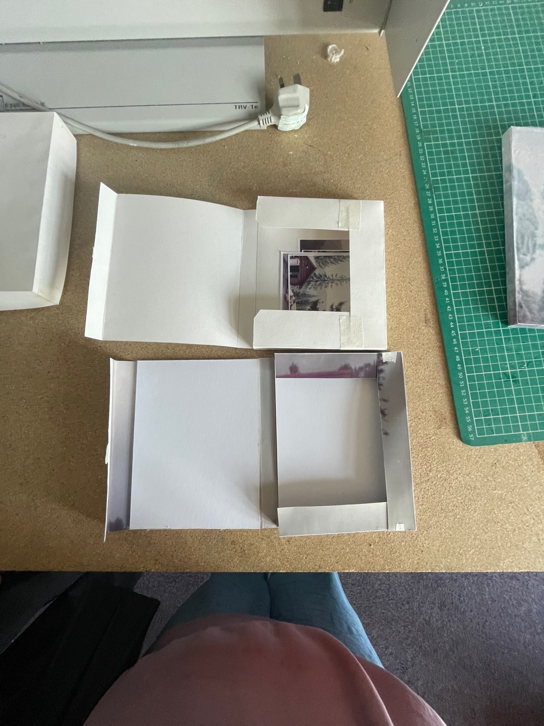
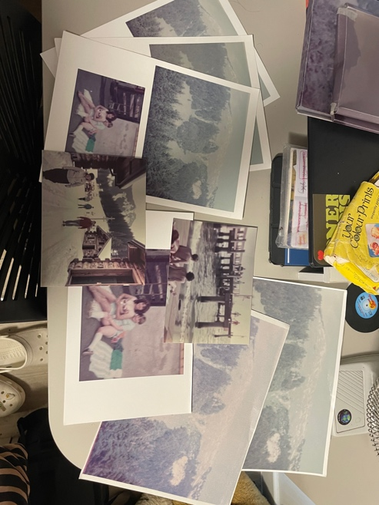
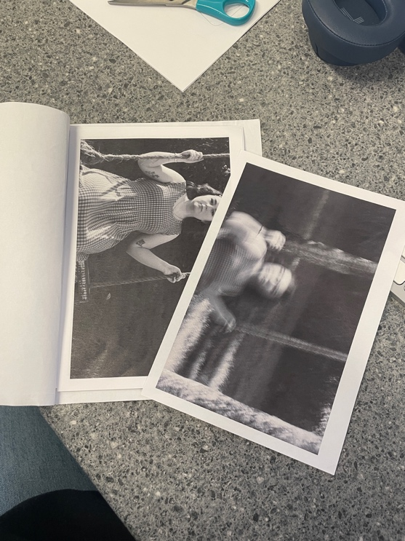
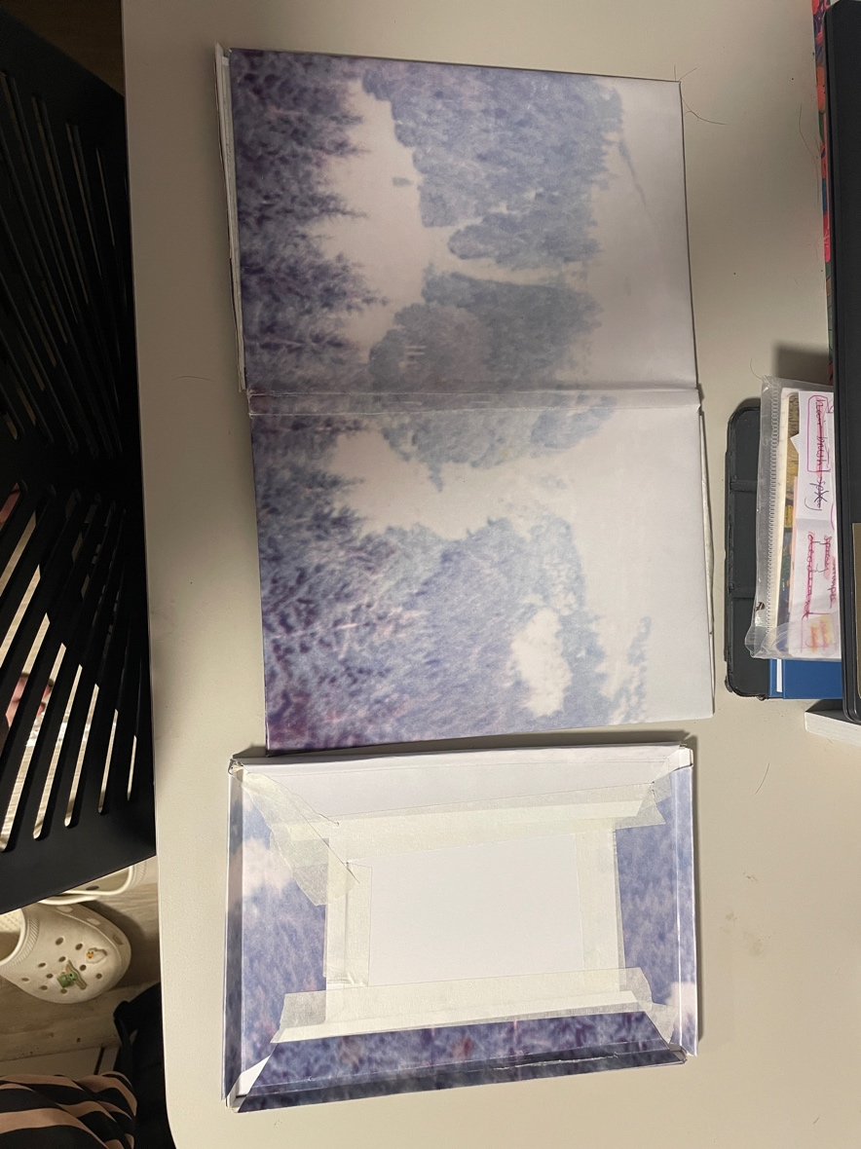
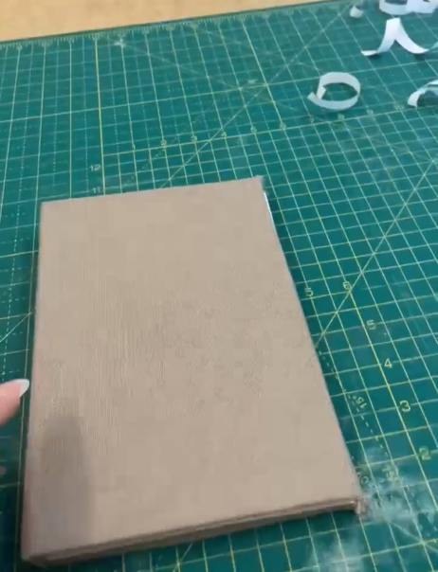
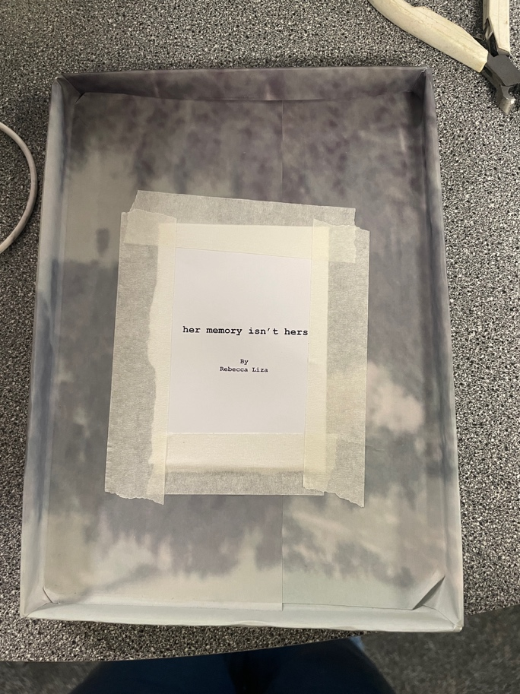

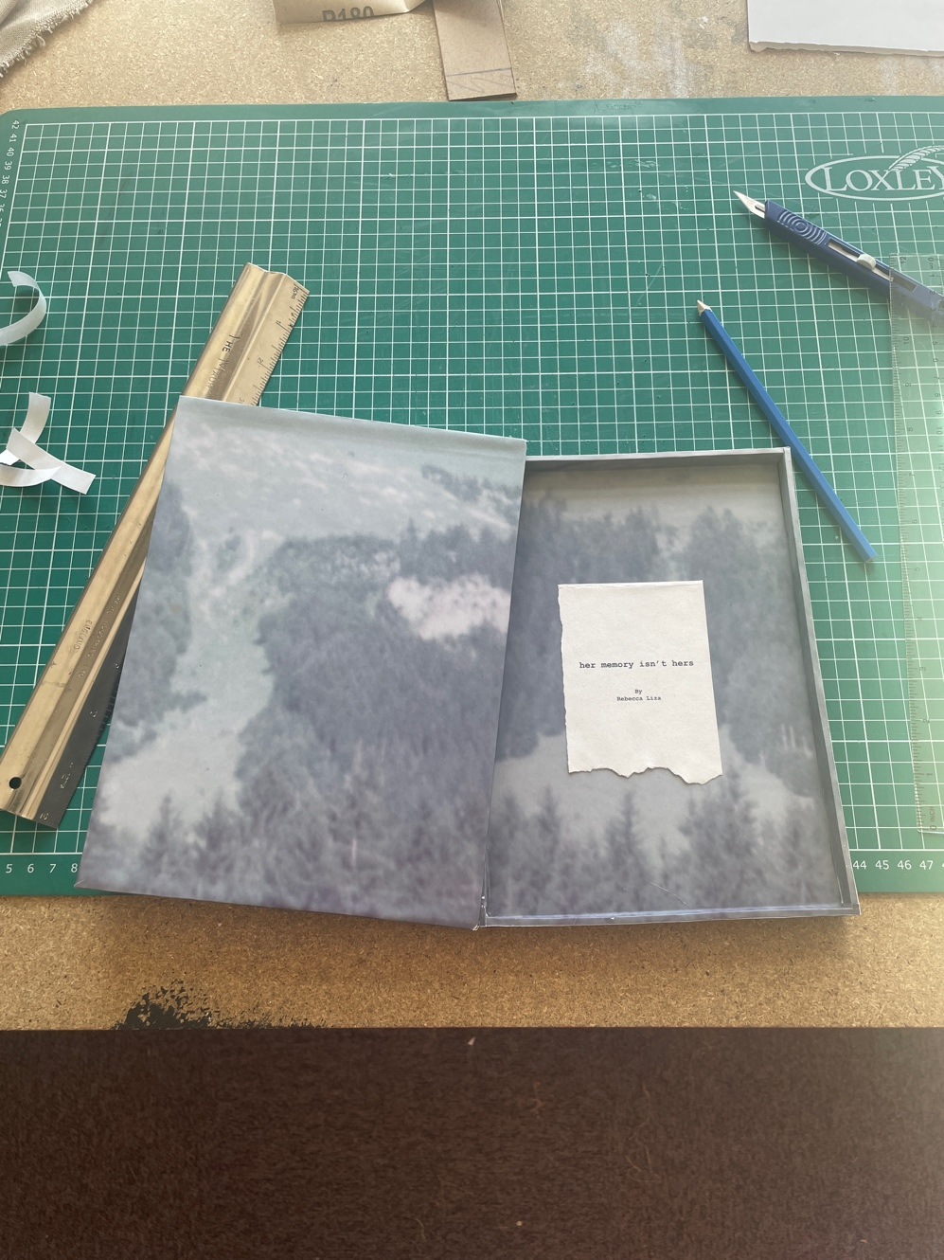

Section 4: Transferable Skills for Life and Professional Practice 10%

Guidance specific to task (from the brief):

Your photobook should meet industry standards in design, development, and production. Plan your workflow according to your chosen publication method to ensure timely completion. Active participation in sessions is essential for sharing your work, engaging in discussions, and demonstrating both employability skills and a strong grasp of the module content. Your evaluation should reflect on your learning throughout the process and highlight the transferable skills you have developed.
Evaluate what you have learnt throughout the process of making your photo-book. Pay particular attention to the transferable skills you have developed. (500-1000 words)

Throughout this project, I have developed my transferable skills in both a creative and practical sense. One of the main things I have learnt is the importance of challenging myself. I have done this by continuously experimenting and refining the concept of my work, rather than simply following an idea without questioning it. I also realised how important it is to allow ideas to develop rather than becoming too fixed on my first idea. Although I began with a clear focus on the fragility of memory, my project still evolved over time. For example, the collaboration with AI was not part of my original plan. I was able to incorporate it into my work because I had an open mind and I allowed myself to keep exploring different directions my work could go. This helped me understand connections between AI and memory that I had not previously considered. It showed me that if you keep exploring further, rather than restrict yourself, you can deepen your understanding and knowledge of your concept.

In terms of creative and conceptual learning, I learned that ideas need to be tested and developed. At the beginning of the project my idea was extremely broad, and I was unsure how to communicate it visually. However, through experimentation and gaining regular feedback, from the lectures and my peers, the concept became more refined. This made me realise the more you know about ur subject the more understanding you have in terms of how to visually communicate your work. On the other hand, I also learned that I do not have to communicate ideas in a direct or obvious way. My early approaches were quite literal, whereby I was brainstorming some editorial work I could use on the original imagery that I have seen from my artist research. However, over time I became more confident in creating more conceptual and subtle work, which allowed the work to become more layered in theory work, and engaging with viewers.

Another key area of development was communication. I tend to keep ideas to myself until they feel finished, but this project showed me the value of sharing ideas while they are still developing. By discussing my work with my lecturers and peers, I gained different perspectives that helped improve both the concept and the outcome. This also strengthened my ability to think critically about my work, as I became more aware that what I intend to communicate is not always what the viewer understands. This led me to develop a stronger awareness of the viewer. I had to consider how someone unfamiliar with the project would interpret the work, particularly with the element of deception and the final reveal that my book consists of. By Sharing my book dummies and prototypes during my tutorials I was able to find areas that were unclear or misleading in any way. This process allowed me to refine my work and better control how the narrative is communicated.

During this project I did face some challenges. I had a habit of overcomplicating certain decisions by trying to make everything overly conceptual. For example, I initially tried to figure out the number of pages based on symbolic reasoning, which I noticed was unnecessary after my tutorial with my lecture. Therefore, through a mixture of feedback and experimentation, I learned how to simplify decisions while keeping meaning. This helped me become more confident in judging when something was effective and when it was excessive.

As well as creative development I also gained a range of technical skills, such as editing, design, and bookmaking. Firstly, I improved my use of Photoshop and Lightroom, particularly in colour grading. In which, I ensured consistency and realism in the AI generated imagery using the archival images as reference. I also learned how to use InDesign which was new to me. This helped me to develop an understanding of how different software supports various stages of the process, such as editing, layout, and print preparation. Moreover, I developed a much stronger understanding of sequencing. I learned that the order of images can significantly influence how viewers interpret the work, and that sequencing can shape meaning rather than simply present it. This became a key part of my project and changed how I approach visual storytelling.

In addition to these skills, I have also developed several transferable skills that can be valuable beyond this project. For instance, my time management skills would be essential in terms of business or creative projects. This was developed through my ability to organise editing, printing, and construction within deadlines. Although I had initially met the final deadline, I had to remake the box close to submission, which showed me the importance of allowing extra time for unexpected issues. This highlighted the need for more realistic planning and time buffers in future work. In terms of organisation, I was able to manage multiple image files, edits, and book dummies throughout the project. However, prioritising tasks is an area for improvement. There were times when I focused too much on certain aspects, such as the box making, and not enough on others, such as practice my stitching techniques. Overall, this ended up affecting my workflow and is something I will aim to improve on in future projects.

Furthermore, problem solving was another important skill I developed. Throughout the making process, I came across challenges with materials, sizing, and construction. For example, when the book did not fit inside the box, I had to figure out the best plan of action. My main choice was to decide whether to remake the book or the box. I chose to remake the box as it was more practical and efficient. Situations like this needed quick decision making and adaptability. In terms of critical thinking, this project forced me to constantly evaluate my work through my regularly updated book dummies. Whereby I had to select images, design work, and question whether my decisions were effective. I became more selective and more aware of the reasoning behind my choices. This led to the development of my communication, whereby through tutorials and discussions I became more confident in explaining my ideas and justifying my decisions, as well as responding to feedback.

I believe one of the strongest skills I developed was my adaptability. I stayed open to feedback and willing to change direction of my work when I need to, rather than staying fixed on one idea. This allowed me to refine both the concept and the outcome more effectively. However, If I were to repeat this project, I would plan the construction stages more carefully. I would do this by allowing myself more time for testing and refinement. As well as making sure I focus on improving my technical precision such as stitching. I would also ensure better prioritisation of tasks throughout the process. Overall, this project shows significant development in my creative, technical, and transferable skills. It has strengthened my ability to think critically, solve problems, manage time, and communicate ideas effectively.



