LCBB4013 Stakeholder Engagement
Component 1: Coursework-Portfolio
Portfolio on Cannon Hill Park to Moseley Cycle Route (Birmingham)

Student Name: Ilie Marin
Student ID: 2512903

Table of Contents
Element 1: Introduction 3
1.1 Describe the selected project and its relevance 3
1.2 Six key stakeholders who benefit from the project 5
Element 2: Stakeholder Engagement Strategies 6
2.1 A power, influence, and interest table and assign the stakeholders 6
2.2 Stakeholder map and justification 8
2.3 Basic communication plan, consultation strategy with justifications 9
Element 3: Ethical Consideration in Stakeholder Consultation, Participation, and Feedback 12
3.1 Methods of consultation, the ethical consideration concerning collected data, bias and DEI 12
3.3 Stakeholder feedback will be collected and reviewed 14
Element 4: Conclusion and Reflection 14
4.1 Conclusion 14
4.2 Reflection account on effective stakeholder engagement for project success and sustainability 15
Reference List 17

Element 1: Introduction

1.1 Describe the selected project and its relevance
The Cannon Hill Park to Moseley Cycle Route is an active travel construction project in Birmingham, UK. It creates a 0.8-segregated path from Edgbaston Road to Park Hill and Chantry Road, linking Moseley to the A38 cycle track and the city centre (Birmingham Be Heard, 2022). It is funded by the government's “Active Travel Plan” and promotes safe, everyday cycling and walking.
Project Details
Route path: It runs past Cannon Hill Park on Edgbaston Road, continuing via Russels Road, Salisbury Road and Park Hills to Aclester Road in Moseley (Birmingham City Council, 2023).
Infrastructure: It includes a two-way segregated cycleway on Edgbaston Road, new pedestrian and cycle crossings, widened footways and lowered 20 mph speed limits in residential sectors such as Russell Road and Salisbury Road (Push Bikes, 2021).
Funding: The UK government's active travel grants nearly 3.34 million GBP via Birmingham City Council (Mullaney, 2026).
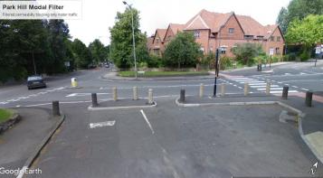
Figure 1: Cannon Hill Park to Moseley Cycle Route project
(Source: Push Bikes, 2021)
Relevant and community impact
It connects Suburban Moseley directly into Birmingham’s wider growing cycling networks, including the Rea Valley and A38 corridors. The project aims to reduce car dependency for local schools and commuter trips by physically separating vulnerable road users from heavy motor traffic. It aligns with broader localised redesign efforts, training into low-traffic neighbourhood concepts and local centre upgrades.

CSR
The project aligns with public-sector social responsibility and sustainability goals by promoting active travel, reducing carbon emissions, improving local air quality and enhancing community health and road safety. This project reduces reliance on fossil-fuel vehicles along Edgbaston Road, Park Hills, and Chantry Road.
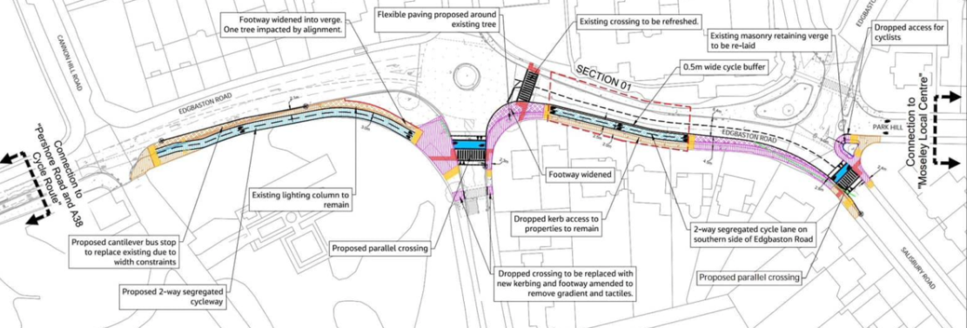
Figure 2: Cannon Hill Park to Moseley Cycle Lane Extension
(Source: Councillors et al., 2024)

1.2 Six key stakeholders who benefit from the project
Stakeholder Group | Core benefits provided (How) | Impact on stakeholder
Local Bicycle Commuters | Safer, segregated route  Directly linking Moseley Local Centre to the city Center via A38 spur (Councillors et al., 2024) | Reduces collision risk with motor vehicles and provides a faster, less stressful daily commute.
School children and parents | Protected infrastructure  They are safe in vulnerable locations at SS John & Monica Primary School. | Encourage safe, active school runs while restricting vehicle-parking risk near school gates via new yellow line.
Project contractors and employees | Infrastructure experience  Local infrastructure implementation experiences | The project increases job creation among local communities
Local Residents (Moseley & Edgbaston) | Traffic Calming  A 20 mph speed reduction on Salisbury Road and modal filters | Lowers neighbourhood noise, decreases localised exhaust pollution and fosters safer street spaces for families
Local business and shops | Increased foot and bike traffic  More people are walking or riding bicycles instead of driving cars | Drives sustainable consumer footfall to local cafes, independent makers, and retail venues without worsening parking shortages
Birmingham City Council | Progress on strategic targets  They set out in the Birmingham walking and cycling strategy (Birmingham City Council, 2023) | Successfully utilise ring-fenced Active Travel Fund Grants to build a cohesive, low-carbon public transit network
Table 1: Six key stakeholders and impact on them

Element 2: Stakeholder Engagement Strategies

2.1 A power, influence, and interest table and assign the stakeholders
Stakeholder Matrix
Stakeholder Group | Power Level | Influence Level | Interest Level | Matrix category and strategic management strategy
Birmingham City Council | High | High | High | Key player (manage closely): They control project funding (via Active Travel Funds), hold the legal rights to approve Traffic Regulation Orders (TRO) and own final executive decision-making
Project contractors and employees | High | Medium | Low | Keep Satisfied: They directly control the daily construction schedules, quality, and technical execution but must strictly adhere to the council baseline budgets and layout plans (‌Peng, and Zhou, 2025)
Local Residents (Moseley & Edgbaston) | Low | Medium | High | Keep informed and consulted: They are deeply impacted by structural street modification such as one-way conversions and localised parking reductions. They shape implementation via public consultation and active feedback
Local business and shops | Low | Medium | Low | Monitor: local businesses and shops have increased product sales and raised profit outcomes

Local bicycle commuters | Low | Medium | High | Keep Informed: They directly benefit from new segregated bicycle lane infrastructure. They hold strong indirect influence by acting as vocal advocates via regional cycle campaigns to secure journeys
School children and parents | Low | Medium | High | Keep informed: They primarily focus on road safety, specifically regarding school runs near key landmarks, including SS John & Monica Catholic Primary schools (Bham, 2025). They stand to gain heavily from enhanced zebra crossings and traffic calming measures
Table 2: Stakeholder Matrix
Analysis
A Stakeholder Matrix is a tool used in project management to analyse, identify, and prioritise stakeholders based on their influence and interest in the project. As depicted by Maqbool et al. (2022), the stakeholder matrix helps project managers and the team understand stakeholders' expectations, needs, and potential impact on the project. The Birmingham City Council has funded the project and approved TRO guidelines (Delib, 2026). Project Contractors and employees control project schedules and technical execution for the project. Local residents have prioritised one-way conservation and collected feedback. Local businesses are expected to increase product sales, while local bicycles benefit from modern infrastructure. School Children and parents have benefited from improved road safety.

2.2 Stakeholder map and justification
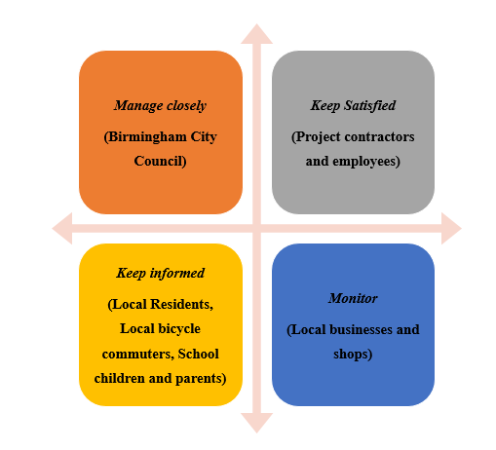
Figure 3: Stakeholder Map
Justification
Manage Closely (Birmingham City Council)
Birmingham City Council is placed in the “manage closely” (high power and high interest) category of the stakeholder matrix for the Canon Hill Park to Moseley Cycle Route, as it is leading the project. They are responsible for fund administration and authority for traffic regulation and infrastructure changes. They approve Traffic Regulation Orders (TROs), Revised Approved Plan Design (RAPD) layouts and planning outcomes (Govt UK, 2026). They control implementations, contracts, and alignment with the wider Birmingham Cycle Revolution.
Keep Satisfied (Project contractors and employees)
In a stakeholder matrix such as a Power or Interest grid, project contractors and employees are placed in the “Keep Satisfied” quadrants (High power, low-to-medium first influences in broad strategic goals) as they possess high operational power to impact project execution, cost and timeline. Project contractors and employees ensure construction quality, site safety compliance and daily labour productivity on the site (Bamfo-Agyei et al., 2022). In addition, fair pay, clear site instructions, and proper resources have reduced disputes in the workplace.

Keep informed (Local Residents, Local bicycle commuters, School children, and parents)
For the Cannon Hill Park to Moseley Cycle Route project, local residents, local bicycle commuters, school children, and parents are categorised into “Keep Informed” as they have high interest but low power. They cannot legally approve, block, or halt the construction, but rather the route drastically alters their daily environments, safety, and routines.
Monitor (Local businesses and shops)
Individual small shops cannot stop or fundamentally alter public infrastructure decisions made by the city council. Road layout, one-way systems, and parking changes affect consumers' access and deliveries. Local shops are businesses for the project and are placed in the “Monitor” category as they have limited influence over project designs, yet their daily trade and deliveries can be affected by local traffic changes.

2.3 Basic communication plan, consultation strategy with justifications
A communication plan is a calculated chart that outlines an organisation's objectives, key messages, channels, and communication activities that help achieve organisational goals in the market (Golding, 2022). A public consultation and communication plan has played a vital role in the project by gathering public feedback through the “Birmingham Be Heard portal”, engaging residents on Traffic Regulation Orders (TROs) and helping shape design adjustments for safer active travel.
Who will communicate with | What information needs to be shared | When to communicate with them | Medium of communication | Frequency
Birmingham City Council  (Projet team) | They are sharing information such as progress updates, milestone achievements, budget tracking, and risk reports. | Pre-construction to project closeout | They use “letters” as a medium of communication for progress meetings and status reports. | Weekly

Project contractors and employees | They share information such as health and safety guidelines, site plans, daily work schedules and design spaces to complete the project | Prior to site mobilisation and ongoing process | They use “telephone” as a medium of communication for site briefing and manage works on the project | Daily
Local Residents (Moseley & Edgbaston) | Construction start dates, road closures, traffic diversions, and noise alerts are key information to share | After developing the construction plan to the end of the project | They have used “letters, Birmingham Be Heard portal and community forms” as a medium of communication | Monthly (Milestone based)
Local business and shops | Access restrictions, delivery window adjustments, and parking changes are key information that has been shared | 4 weeks prior and during disruptive phases | They have used “direct visits, letters, and phone calls” for communication methods | Monthly basis
Local bicycle commuters | They have informed on alternative cycling detours, route closure and phase completion | Ahead of route alterations | They have used council websites, cycling advocacy groups and social media as a medium of communication | Weekly updates

School children and parents | They have informed of safe walking or cycling paths and temporary school-run crossing changes | Prior to the time and construction changes for them | School newsletters, SMS alerts, flyers via school | Start of term
Table 3: Communication Plan
Analysis
The Birmingham City Council has shared progress updates, milestones, achievements, and budget tracking with a “letter,” a communication medium, in a weekly process. Project contractors and employees have shared information such as safety guidelines, site plans, daily work schedules, and design spaces to complete the project within the deadline. They have used “Telephone” as a communication medium to communicate on a regular basis. Local Residents have shared construction start dates, road closures, traffic diversions, and noise alerts by using “letter” as a communication medium on a monthly basis. While local businesses and shops have shared information like access restrictions, delivery window adjustments and parking changes by utilising council websites and social media through weekly updates.

Element 3: Ethical Consideration in Stakeholder Consultation, Participation, and Feedback

3.1 Methods of consultation, the ethical consideration concerning collected data, bias and DEI
Methods of consultation
In a construction project, consultation is a two-way communication process in which project workers, developers or managers seek professional advice, technical guidance, and public feedback from experts and stakeholders to make informed decisions to resolve issues. As depicted by Hosseini Tabaghdehi and Ayaz (2025), ethical stakeholder consultation requires transparency, fairness, respect, and accountability. Ethical stakeholder consultation for the Cannon Hill Park to Moseley Cycle Route construction project in Birmingham has required balancing active travel benefits with local disruptions. Planners ensure transparent communication, equitable inclusion of marginalised voices, and fair burden-sharing regarding parking and congestion. They are also genuinely responsive to community feedback rather than training public engagements.
Transparency and informed equity: Birmingham City Council has provided accessible, jargon-free details on Traffic Regulation Orders (TROs), layout adjustments and parking loss. These initiatives are important for legal compliance, maintaining public trust, securing community feedback, and highlighting practical impacts on local access, needs and managing daily traffic flow before work begins (Zhang and Paik, 2026). They ensure vulnerable or non-digital residents receive physical or direct notification alongside online portals.
Inclusive and power balance: Consultation among Local Residents, local businesses and shops, local bicycle commuters, school children and parents are key areas balancing stakeholders' power. Host engagement sessions at varied times and accessible venues, accommodating diverse physical and scheduling needs.
Accountability and responsiveness: Stakeholders' feedback has developed strong support and intense local concerns regarding congestion and construction safety. Employees and the project coordinator provide layouts and blueprints of the work to gain trust between local authorities and the public.

The ethical considerations concerning collected data
Ethical considerations for collected data involve moral rules in the way people's information is gathered, saved, and used. The key areas of collected data are getting user permissions, keeping details private, and being open about how information is used (Pina et al., 2024). In the context of the “Cannon Hill Park to Moseley Cycle Route” project, they have followed transparency and public consultation, privacy and surveillance and Equality and community impact. In the transparency and public consultation phase, they have followed open disclosure and informed consent from the survey participants to avoid biased information. In the context of Privacy and surveillance, Birmingham City Council have followed data minimisation and securely handled information for safety concerns. In terms of equality and community impact, they have followed fair representations and resource accountability in data collection methods.
DEI
Diversity, Equity and Inclusion (DEI) is an organisational framework and philosophy designed to promote fair treatment, representation, and full participation of people. As depicted by Khadka, (2024), stakeholder identity theory helps explain how people categorise themselves into in-group and out-group, shaping workplace bias and intergroup dynamics. The key principles of social identity theory are social categorisation, social identification, social comparison, and positive distinctiveness.
Social Identity Theory
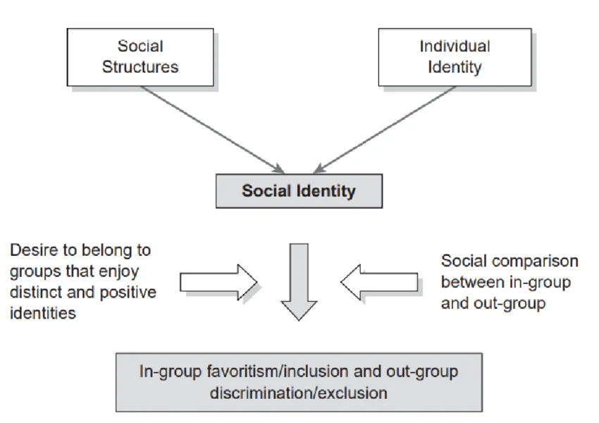
Figure 4: Social Identity Theory
(Source: Irene et al., 2026)

The Cannon Hill Park to Moseley Cycle Route project incorporates DEI by ensuring accessible active travel infrastructure for diverse demographics, conducting open public consultation, and prioritising safety. Physical segregation protects vulnerable road users of all ages and abilities. In order to follow the “social categorisation” principle, the Birmingham City Council uses levels of difference and lane separators to protect users who feel less safe mixing with fast traffic, such as children and older adults. The council have followed “positive distinctiveness” by relocating and upgrading zebra crossings to improve safety for pedestrians and disabled or mobility-impaired individuals.

3.3 Stakeholder feedback will be collected and reviewed
The council will collect feedback from the “Birmingham Be Heard” platform that reflects community sentiments without misrepresenting monitors or majority opinion. They will notify participants in traffic counts, speed surveys and public consultation events of their inputs and spatial data will be shaped into TROs. They will not select the same feedback twice; they will focus on collecting diverse feedback from stakeholders. The local authorities will review and modify the TROs and adjust crossing placements before construction starts. However, the key concerns will be parking loss on Chantry Road, junction congestion and the precise layout near the park entrance.

Element 4: Conclusion and Reflection

4.1 Conclusion
The assignment has demonstrated a stakeholder plan of the transport system, especially “Cannon Hill Park to Moseley Cycle Route.” The project has been developed for growing cycling networks, reducing carbon emissions and community safety. The key stakeholders of the project are local bicycle commuters, school children and parents, project contractors and employees, local residents, local businesses and shops and Birmingham City Council. The stakeholder matrix has demonstrated that Birmingham City Council is managed closely; project contractors and employees are kept satisfied, local businesses and shops are monitored, whereas local residents, bicycle commuters, children, and parents are kept informed. The findings of the assignment highlighted that stakeholders have used different media of communication such as letters, newspapers, telephone, and council websites. The report has highlighted that stakeholders have followed “transparency and informed equality”, “inclusive and power balance” and “accountability and responsiveness.”
The Social Identity Theory has been followed for diversity, equality, and inclusion for stakeholders. Birmingham Council has followed principles such as “social categorisation” and “positive distinctiveness” to support communities, which align with the CSR approach. The conclusive statement of the assignment demonstrated that stakeholder engagement and their contributions have played a significant role in the local infrastructure project.

4.2 Reflection account on effective stakeholder engagement for project success and sustainability
Gibbs’ reflective model
Gibbs’ reflective cycle is a framework for reflection, used in learning and professional development. The six stages of this model are description, feelings, evaluation, analysis, and conclusion and action plan. I have selected this model to demonstrate my knowledge of stakeholder engagement for project success and sustainability.
Description
I have selected the Cannon Hill Park to Moseley Cycle Route project in Birmingham. I have described six key stakeholders, such as “local bicycle commuters, school children and parents, project contractors and employees, local residents, local businesses and shops and Birmingham City Council.” I have read the Stakeholders matrix and defined stakeholders based on matrix principles (Power and Interest). I have developed a communication plan and medium to raise stakeholder engagement. In the context of DEI, I have identified that transparency and equality are key methods of consultation. I have included stakeholder Identity Theory principles as the theoretical underpinning in DEI strategy.
Feelings
I have felt that stakeholders’ engagement in a construction project increases the success rate. I have felt motivated to collect information on the construction and define their role to complete the project. I have assumed that transparency in communications and reducing biased feedback plays significant roles in completing the project in a timely manner.

Evaluations
I have evaluated after completing the project, my strong skills are problem-solving and written communication. However, I have weaknesses in critical thinking and decision-making skills. I have incorporated problem-solving skills to develop a communication plan for project success. I have showcased written communication skills to reduce grammatical mistakes and improve sentence construction. However, my lack of critical thinking skills has created challenges in aligning DEI with stakeholder Identity Theory principles. On the other hand, my lack of decision-making skills has created challenges in narrating the role of government policies in the construction project.
Analysis
I have analysed effective stakeholder engagement in construction projects aligned with community needs and environmental goals. I have analysed groups based on their power, influence, and interest in the project. As depicted by Ishola et al. (2024), project success relies on transparent communication, addressing power dynamics and treating engagements as ongoing, long-term relationships in society. I believe that mapping key groups and integrating feedback help in the project-related decision-making process.
Conclusion
The overall findings have illustrated that stakeholder contributions play an immense role in project success rates. The sustainability approach among teammates has a positive impact on project completion. However, I need to improve my critical thinking and decision-making skills to narrate stakeholder engagement for project success and sustainability.
Action Plan
I will attend extra class activities in class (specific), collect feedback from class teachers (measure), and attend the class on a regular basis (actionable) to improve my knowledge of stakeholder engagement (relevance) within 8 months (time-bound). I will purchase a YouTube course (Specific), collect feedback from online teachers (measures), and read journals and articles (actionable) to improve my knowledge of sustainability (relevance) within a 1-year time frame (Time-bound).

Reference List
Bamfo-Agyei, E., Thwala, D.W. and Aigbavboa, C., (2022) ‘Performance improvement of construction workers to achieve better productivity for labour-intensive works’. Buildings, 12(10), p.1593. https://www.mdpi.com/2075-5309/12/10/1593
‌Bham (2025) SS. John and Monica Catholic Primary School. [online] Available at: https://stjonmon.bham.sch.uk/ [Accessed 5 Aug. 2026].
Birmingham Be Heard (2022) Cannon Hill park to Moseley cycle route - Birmingham City Council - Citizen Space. [online] Available at: https://www.birminghambeheard.org.uk/economy/moseley-cycle-route/ [Accessed 5 Aug. 2026].
Birmingham City Council (2023) Cannon Hill Park to Moseley cycle route | Cycle routes: proposed and underway | Birmingham City Council. [online] Birmingham.gov.uk. Available at: https://www.birmingham.gov.uk/info/50122/cycling_in_birmingham/2920/cycle_routes_proposed_and_underway/2 [Accessed 6 Aug. 2026].
Councillors Izzy Knowles, Philip Mills and Moseley Liberal Democrats (2024) Cannon Hill Park to Moseley Cycle Lane Extension. [online] Available at: https://moseleylibdems.com/2024/10/24/cannon-hill-park-to-moseley-cycle-lane-extension/ [Accessed 8 Aug. 2026].
Delib (2026) TRO Management ┃Traffic Regulation Orders┃Citizen Space. [online] Available at: https://www.delib.net/use-case/citizen-space/digital-tro-management [Accessed 6 Aug. 2026].
‌Golding, B., (2022) Towards the “perfect” weather warning: Bridging disciplinary gaps through partnership and communication (p. 270). Springer Nature.
Govt UK (2026) New design guidance to raise the bar for new build developments. [online] GOV.UK. Available at: https://www.gov.uk/government/news/new-design-guidance-to-raise-the-bar-for-new-build-developments [Accessed 7 Aug. 2026].
Hosseini Tabaghdehi, S.A. and Ayaz, Ö., (2025) ‘AI ethics in action: a circular model for transparency, accountability and inclusivity’. Journal of Managerial Psychology. https://bura.brunel.ac.uk/bitstream/2438/31699/3/FullText.pdf
Irene, J.O., Daniels, C., Irene, B.N.O., Kelly, M. and Frank, R., (2026) ‘A social identity approach to understanding sustainability and environmental behaviours in South Africa’. Local Environment, 31(1), pp.50-68. https://www.tandfonline.com/doi/pdf/10.1080/13549839.2024.2376546
Ishola, A.O., Odunaiya, O.G. and Soyombo, O.T., (2024) ‘Stakeholder communication framework for successful implementation of community-based renewable energy projects’. International Journal of Frontiers in Engineering and Technology Research, 7(2), pp.25-43. https://www.researchgate.net/profile/Akinwale-Ishola/publication/385812540_Stakeholder_communication_framework_for_successful_implementation_of_community-based_renewable_energy_projects/links/67360bfd37496239b2bf05ed/Stakeholder-communication-framework-for-successful-implementation-of-community-based-renewable-energy-projects.pdf
Khadka, C., (2024) ‘Social identity theory and group behavior’. TUTA Journal, pp.105-120. https://nepjol.info/index.php/tutaj/article/download/74063/56708
Maqbool, R., Rashid, Y. and Ashfaq, S., (2022) ‘Renewable energy project success: Internal versus external stakeholders' satisfaction and influences of power‐interest matrix’. Sustainable Development, 30(6), pp.1542-1561. https://onlinelibrary.wiley.com/doi/pdf/10.1002/sd.2327
Mullaney,. M (2026) B13 Moseley, B14 Kings Heath & B12 Balsall Heath | ## **The £3.4million Moseley cycle lane that nobody uses.** | Facebook. [online] Available at: https://www.facebook.com/groups/1699168073667527/posts/3560918344159148/ [Accessed 8 Aug. 2026].
‌Peng, J. and Zhou, F., (2025) ‘Multi-project staff scheduling optimization considering employee welfare in construction projects’. Buildings, 15(10), p.1706 https://www.mdpi.com/2075-5309/15/10/1706.
Pina, E., Ramos, J., Jorge, H., Váz, P., Silva, J., Wanzeller, C., Abbasi, M. and Martins, P., (2024) ‘Data privacy and ethical considerations in database management’. Journal of Cybersecurity and Privacy, 4(3), pp.494-517. https://www.mdpi.com/2624-800x/4/3/24
Push Bikes (2021) Consultation: Cannon Hill Park to Moseley Cycle Route | Push Bikes. [online] Available at: https://www.pushbikes.org.uk/blog/consultation-cannon-hill-park-moseley-cycle-route [Accessed 8 Aug. 2026].
Zhang, G. and Paik, S.M., (2026) ‘Research into a BIM-based transparency and trust mechanism for the Irish construction supply chain: a pathway to systemic delivery’. Frontiers in Built Environment, 12, p.1814765. https://www.frontiersin.org/journals/built-environment/articles/10.3389/fbuil.2026.1814765/full
Bibliography
Bogacz-Wojtanowska, E., Jedynak, P., Wrona, S. and Pluszyńska, A., (2022) Universities, stakeholders and social mission: Building cooperation through action research. Routledge.

