

Full Name: Febechukwu Miriam Iwuala
Student ID Number: 2409092
Programme: BSc Health & Social Care
Module: Creativity and Value Creation
Component 2 – Written Assignment (Report)
Module Code: BMHP5014
Lecturer: Zarah Ahmed

CARE CONNECT UK
One Patient. One Coordinated Discharge Plan. One Connected Care Journey.
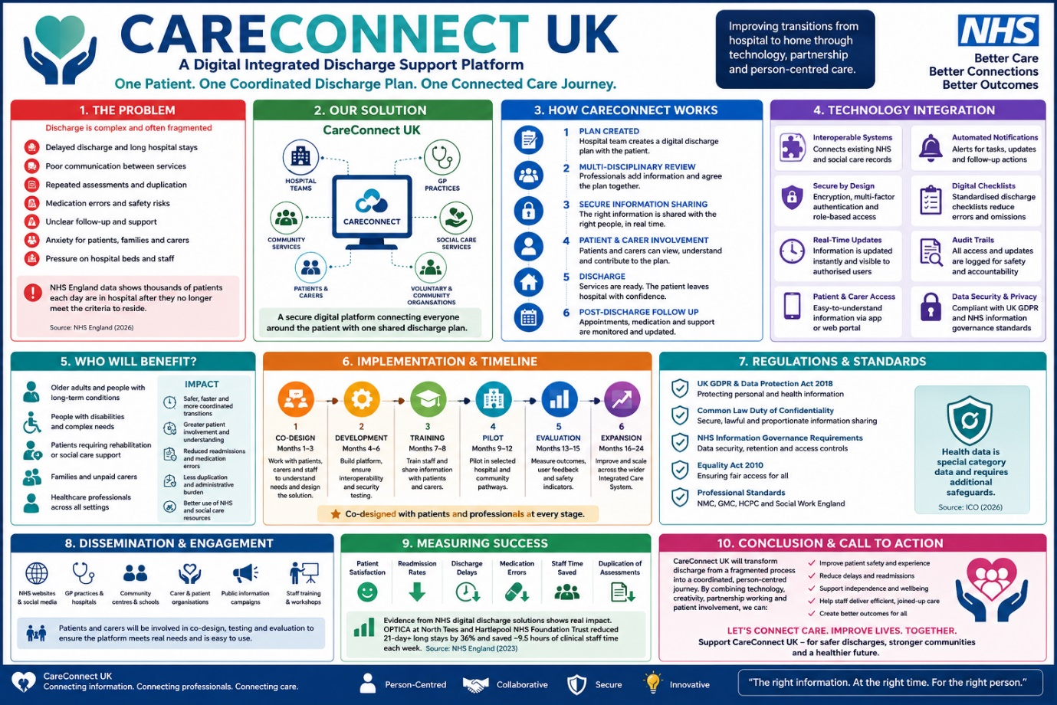

CareConnect UK: Transforming Hospital Discharge Through Integrated Digital Innovation
Good morning and thank you for the opportunity to present my proposal.
Imagine a healthcare system where every patient leaves hospital with one coordinated discharge plan shared in real time by hospitals, GPs, community teams, social workers, patients and carers. Fewer delays, fewer medication errors, and better coordinated care this is the vision behind CareConnect UK.
CareConnect UK is a secure digital discharge coordination platform that strengthens communication and continuity of care across health and social care. Rather than replacing existing NHS systems, it builds on Shared Care Records by securely connecting information across organisations through interoperable technology (NHS England, 2023a; NHS England, 2023b).
Although the NHS Discharge to Assess (D2A) model has improved patient flow by supporting earlier discharge, many patients still experience delays, repeated assessments and poor communication after leaving hospital (NHS England, 2022). The model depends on effective information sharing between hospitals, primary care, community services and social care. However, fragmented digital systems often result in incomplete information, duplicated work and inconsistent follow-up care, increasing the risk of readmissions and placing further pressure on NHS services (Gonçalves-Bradley et al., 2022; NHS England, 2024a).
CareConnect UK addresses these challenges by creating one secure, shared discharge plan that supports integrated, person-centred care and ensures all professionals involved have access to accurate, up-to-date information.
This is where CareConnect UK can make a difference.
Rather than replacing the current D2A pathway, CareConnect UK has been designed to strengthen it. The platform would provide one secure, shared discharge plan containing essential clinical and social care information, including diagnoses, medications, allergies, rehabilitation goals, community support, social care arrangements, follow-up appointments and individual patient preferences. Every authorised professional involved in discharge planning would be able to update information in real time, ensuring that all organisations are working from the same accurate and current care plan (NHS England, 2023b).
Importantly, CareConnect UK places patients and carers at the centre of the discharge process. Too often, patients become passive recipients of decisions made by professionals. My proposal encourages partnership by enabling patients and carers to securely access discharge information, confirm their preferences, ask questions and better understand their ongoing care before leaving hospital. This supports the principles of shared decision-making and person-centred care by recognising individuals as active partners in planning their recovery (National Institute for Health and Care Excellence, 2021).
The need for innovation has never been greater. NHS England continues to report thousands of patients remaining in hospital despite no longer meeting the criteria to reside, reducing hospital capacity and increasing pressure across emergency and elective care pathways (NHS England, 2024a). At the same time, an ageing population, increasing numbers of people living with multiple long-term conditions and growing demand for integrated health and social care services require new approaches that improve coordination rather than simply increasing activity (The King's Fund, 2022).
CareConnect UK has been designed with these challenges in mind. It would benefit older adults, people living with multiple long-term conditions, individuals requiring rehabilitation, patients with disabilities and those requiring ongoing social care following hospital discharge. Family members and unpaid carers would also benefit from clearer communication and greater involvement in discharge planning. Healthcare professionals including doctors, nurses, pharmacists, occupational therapists, physiotherapists, social workers, GPs and community nursing teams would gain faster access to accurate information, reducing duplication of work and strengthening multidisciplinary collaboration. Ultimately, NHS organisations and local authorities would benefit through reduced discharge delays, improved patient flow, better use of hospital beds and more efficient use of limited healthcare resources (NHS England, 2023b; The King's Fund, 2022).
CareConnect UK is not simply another digital platform. It is a practical service innovation that strengthens an existing national discharge model by improving communication, supporting integrated working and ensuring that every patient experiences a safer, more coordinated transition from hospital to home.

How CareConnect UK Works

Let me show you how CareConnect UK would transform hospital discharge.

Discharge planning would begin as soon as a patient is medically optimised under the NHS Discharge to Assess (D2A) pathway. Clinicians, including doctors, nurses, pharmacists, therapists and social workers, would contribute to one secure, real-time discharge plan, creating a shared record of the patient's clinical and social care needs (NHS England, 2022).

Before discharge, the plan would be securely shared with GP practices, community healthcare providers, social care teams and voluntary organisations, ensuring all services have access to accurate information and reducing delays caused by poor communication (NHS England, 2023a; NHS England, 2023b).

Patients and carers would also have secure access to their discharge information, enabling them to review care plans, understand follow-up arrangements and participate in decisions about their recovery, supporting person-centred care (National Institute for Health and Care Excellence, 2021).

After discharge, the platform would continue to support coordinated care by allowing authorised professionals to monitor ongoing treatment, rehabilitation and support, improving continuity of care within the community.

Technology Integration

CareConnect UK builds on existing NHS digital systems rather than replacing them, making the proposal both practical and cost-effective. It connects Shared Care Records, electronic patient records and GP systems through secure APIs, improving interoperability across health and social care (NHS England, 2023b).

Real-time updates, automated discharge notifications and secure access controls ensure accurate information sharing while protecting patient confidentiality and meeting NHS information governance standards (NHS England, 2023c).

More than a digital platform, CareConnect UK redesigns discharge around the patient, reducing duplication, improving collaboration and allowing healthcare professionals to spend more time delivering care.

Implementation Strategy
Successful innovation depends on careful planning. For this reason, I propose introducing CareConnect UK through a phased pilot within a single Integrated Care System (ICS). Beginning on a smaller scale would allow the platform to be evaluated, refined and adapted before wider implementation across England.
The first phase would focus on co-design. Patients, carers, clinicians, social workers, digital specialists, voluntary organisations and NHS leaders would work together to identify service needs and ensure the platform reflects real clinical practice. This collaborative approach would promote shared ownership while increasing staff engagement and public confidence in the innovation (The King's Fund, 2022).
The second phase would involve platform development, interoperability testing and cybersecurity assurance to ensure safe integration with existing NHS systems. Staff training would follow, providing healthcare professionals with the knowledge and confidence required to use the platform effectively. Patients and carers would also receive information and support to maximise engagement while recognising that not everyone can access digital services independently.
The pilot would then be implemented within selected hospital discharge pathways before undergoing comprehensive evaluation. Outcomes such as discharge delays, hospital length of stay, readmission rates, patient satisfaction, staff experience and digital performance would be monitored to assess effectiveness before expansion across additional Integrated Care Systems.

Leadership and Partnership Working
Technology alone cannot transform healthcare. Success depends on effective leadership, strong partnerships and a shared commitment to improving patient care.
CareConnect UK would bring together NHS trusts, GP practices, community healthcare providers, local authorities, social care organisations, voluntary sector partners, digital developers and patient representatives. Each stakeholder has an important role in ensuring discharge planning is coordinated, person-centred and responsive to local needs.
Strong clinical leadership would be essential throughout implementation. Leaders would encourage collaboration across organisational boundaries, promote a culture of continuous improvement and support staff through organisational change. This reflects the NHS Healthcare Leadership Model, which emphasises shared leadership, collaboration and improving services through collective action (NHS Leadership Academy, 2013). By involving frontline professionals and patients throughout design, implementation and evaluation, CareConnect UK would encourage innovation that is practical, sustainable and focused on improving outcomes.

Governance and Professional Responsibilities
CareConnect UK would maintain the highest standards of confidentiality, security and professional accountability. It would comply with the UK General Data Protection Regulation, the Data Protection Act 2018, the Common Law Duty of Confidentiality and NHS information governance standards (UK Government, 2018a; UK Government, 2018b; NHS England, 2023c). Access would be restricted to authorised professionals using role-based permissions, secure authentication and audit trails to protect patient information.
Healthcare professionals would continue to practise in line with the Nursing and Midwifery Council Code and Good Medical Practice, ensuring ethical, confidential and collaborative care (Nursing and Midwifery Council, 2018; General Medical Council, 2024).
To promote digital inclusion, CareConnect UK would complement existing communication methods. Printed information, telephone support and face-to-face discussions would remain available to ensure equitable access for all patients.

Creating Value Through Innovation
The value of CareConnect UK extends far beyond introducing another digital platform. Its greatest strength lies in improving communication, coordination and patient experience across the entire discharge pathway.
For patients, the platform would provide safer transitions between hospital and home by ensuring they receive clear, accurate and accessible discharge information. Greater involvement in discharge planning would increase confidence, support self-management and reduce anxiety during recovery. Families and unpaid carers would benefit from a better understanding of medications, follow-up appointments and available community support, enabling them to provide care more effectively.
Healthcare professionals would also benefit significantly. By providing immediate access to accurate information, CareConnect UK would reduce repeated assessments, minimise unnecessary paperwork and improve multidisciplinary communication. This would allow clinicians to spend more time delivering direct patient care and less time searching for or duplicating information. At an organisational level, improved coordination could reduce delayed discharges, improve hospital bed availability and support more efficient use of NHS resources, creating value for patients, staff and the wider health and social care system (Porter, 2010).
Evidence Supporting the Proposal
This proposal is supported by existing evidence demonstrating the benefits of effective discharge planning and digital innovation.
A Cochrane systematic review found that well-planned hospital discharge can reduce hospital length of stay and improve coordination between health and social care services, particularly for people with complex needs (Gonçalves-Bradley et al., 2022). This suggests that strengthening communication during discharge can improve both patient outcomes and service efficiency.
There is also growing evidence that digital solutions can improve patient flow. NHS England reported positive outcomes following the introduction of the OPTICA digital discharge management system at North Tees and Hartlepool NHS Foundation Trust. The project achieved a 36% reduction in hospital stays longer than 21 days while saving approximately 9.5 hours of clinical staff time each week, demonstrating how digital innovation can improve operational efficiency without compromising patient care (NHS England, 2024b).
CareConnect UK builds on this evidence. Rather than introducing an entirely new way of working, it enhances existing NHS initiatives, including the Discharge to Assess model and Shared Care Records, by strengthening interoperability, improving multidisciplinary communication and placing patients at the centre of discharge planning.
Measuring Success
To ensure CareConnect UK delivers measurable improvements, a comprehensive evaluation framework would be introduced from the start of the pilot.
Clinical outcomes would include reductions in hospital readmissions, medication-related incidents and delayed discharges. Operational measures would assess hospital length of stay, duplication of assessments, staff administrative workload and patient flow across the Integrated Care System. Patient experience would be evaluated through satisfaction surveys, involvement in discharge planning and confidence in managing care after leaving hospital. Digital performance indicators, including platform adoption, information-sharing completion rates, system reliability and cybersecurity incidents, would ensure the platform remains safe, effective and responsive to user needs.
Continuous evaluation would allow the system to evolve based on feedback from patients, carers and healthcare professionals, ensuring that CareConnect UK continues to meet changing service needs.
Challenges and Future Sustainability
Although CareConnect UK offers significant benefits, I recognise that successful implementation will require careful management of several challenges.
Initial investment will be needed to develop interoperable technology, integrate existing NHS systems and deliver staff training. Organisations may also experience resistance to change as professionals adapt to new ways of working. Strong leadership, comprehensive education and ongoing stakeholder engagement will therefore be essential to encourage adoption and maintain confidence throughout implementation (NHS Leadership Academy, 2013).
Digital exclusion also remains an important consideration. Not every patient has access to digital devices, reliable internet connectivity or the confidence to use online services. To ensure equitable access, CareConnect UK would complement existing communication methods rather than replace them. Printed discharge information, telephone support and face-to-face discussions would continue to be available so that no patient is disadvantaged by digital innovation.

CONCLUSION
Ladies and gentlemen, hospital discharge should mark the start of recovery, not uncertainty.
While the NHS Discharge to Assess model has improved patient flow, its success depends on effective communication across health and social care. CareConnect UK strengthens this pathway by providing one secure, shared discharge plan that improves communication, reduces duplication, supports multidisciplinary working, and places patients and carers at the centre of care.
Rather than replacing existing systems, CareConnect UK enhances them through better integration, supporting NHS priorities for digital transformation, integrated care, and person-centred practice. By investing in this innovation, we can reduce discharge delays, improve patient safety, and create a more efficient and coordinated healthcare system.
I invite you to support the pilot implementation of CareConnect UK within an Integrated Care System. Together, we can transform hospital discharge into a safer, more connected, and person-centred experience.
Thank you for your time, and I welcome your questions.

REFERENCE LIST
Department of Health and Social Care (2022) Health and Care Act 2022. Available at: https://www.legislation.gov.uk/ukpga/2022/31/contents (Accessed: 28 July 2026).
General Medical Council (2024) Good Medical Practice. Available at: https://www.gmc-uk.org/ethical-guidance/good-medical-practice (Accessed: 28 July 2026).
Gonçalves-Bradley, D.C., Lannin, N.A., Clemson, L.M., Cameron, I.D. and Shepperd, S. (2022) 'Discharge planning from hospital', Cochrane Database of Systematic Reviews, 2(2), CD000313. Available at: https://www.cochranelibrary.com/cdsr/doi/10.1002/14651858.CD000313.pub6/full (Accessed: 28 July 2026). https://doi.org/10.1002/14651858.CD000313.pub6.
National Institute for Health and Care Excellence (2021) Shared Decision Making (NG197). Available at: https://www.nice.org.uk/guidance/ng197 (Accessed: 28 July 2026).
NHS England (2022) Hospital Discharge and Community Support Guidance. Available at: https://www.england.nhs.uk/publication/hospital-discharge-and-community-support-guidance/ (Accessed: 28 July 2026).
NHS England (2023a) Shared Care Records. Available at: https://transform.england.nhs.uk/information-governance/guidance/shared-care-records/ (Accessed: 28 July 2026).
NHS England (2023b) Interoperability: What it Means for Health and Care. Available at: https://transform.england.nhs.uk/key-tools-and-info/what-is-interoperability/ (Accessed: 28 July 2026).
NHS England (2023c) Information Governance. Available at: https://transform.england.nhs.uk/information-governance/ (Accessed: 28 July 2026).
NHS England (2024a) Discharge and Criteria to Reside Data Collection. Available at: https://www.england.nhs.uk/statistics/statistical-work-areas/discharge-delays/ (Accessed: 28 July 2026).
NHS England (2024b) OPTICA: Improving Hospital Discharge and Patient Flow at North Tees and Hartlepool NHS Foundation Trust. Available at: https://transform.england.nhs.uk/ai-lab/ai-award/optica/ (Accessed: 28 July 2026).
NHS Leadership Academy (2013) Healthcare Leadership Model. Available at: https://www.leadershipacademy.nhs.uk/resources/healthcare-leadership-model/ (Accessed: 28 July 2026).
Nursing and Midwifery Council (2018) The Code: Professional Standards of Practice and Behaviour for Nurses, Midwives and Nursing Associates. Available at: https://www.nmc.org.uk/standards/code/ (Accessed: 28 July 2026).
Porter, M.E. (2010) 'What is value in health care?', New England Journal of Medicine, 363(26), pp. 2477–2481. Available at: https://www.nejm.org/doi/full/10.1056/NEJMp1011024 (Accessed: 28 July 2026). https://doi.org/10.1056/NEJMp1011024.
The King's Fund (2022) Integrated Care Systems Explained. Available at: https://www.kingsfund.org.uk/publications/integrated-care-systems-explained (Accessed: 28 July 2026).
Topol, E. (2019) The Topol Review: Preparing the Healthcare Workforce to Deliver the Digital Future. Available at: https://topol.hee.nhs.uk/ (Accessed: 28 July 2026).
UK Government (2010) Equality Act 2010. Available at: https://www.legislation.gov.uk/ukpga/2010/15/contents (Accessed: 28 July 2026).
UK Government (2018a) Data Protection Act 2018. Available at: https://www.legislation.gov.uk/ukpga/2018/12/contents (Accessed: 28 July 2026).
UK Government (2018b) UK General Data Protection Regulation (UK GDPR). Available at: https://www.legislation.gov.uk/eur/2016/679/contents (Accessed: 28 July 2026).

