Name: Rhys Carter
Module: Computational Thinking (ACCA4016)
Date: 23/01/2020

Drawing a Rectangle

Drawing a right-angle triangle

Draw circle inside of square

Draw Join Symbol

Use case diagram

Code
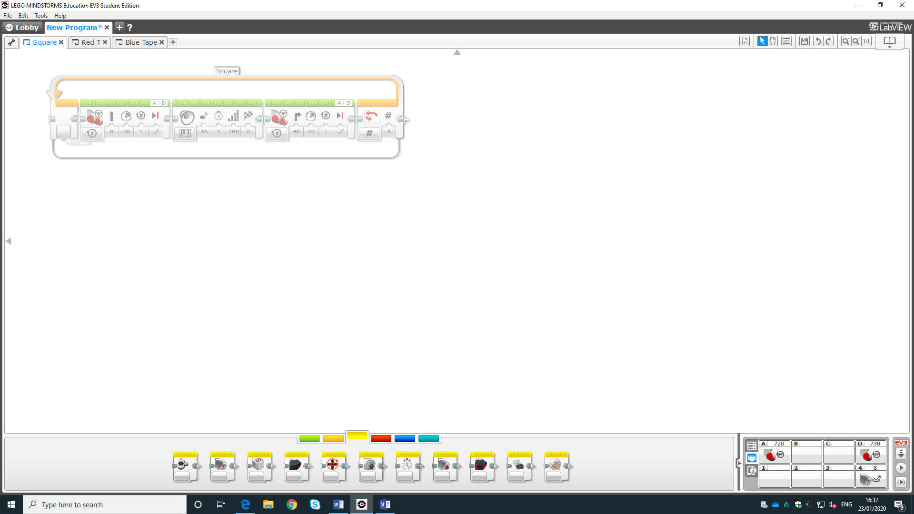
This code is for moving the robot and activating sounds.

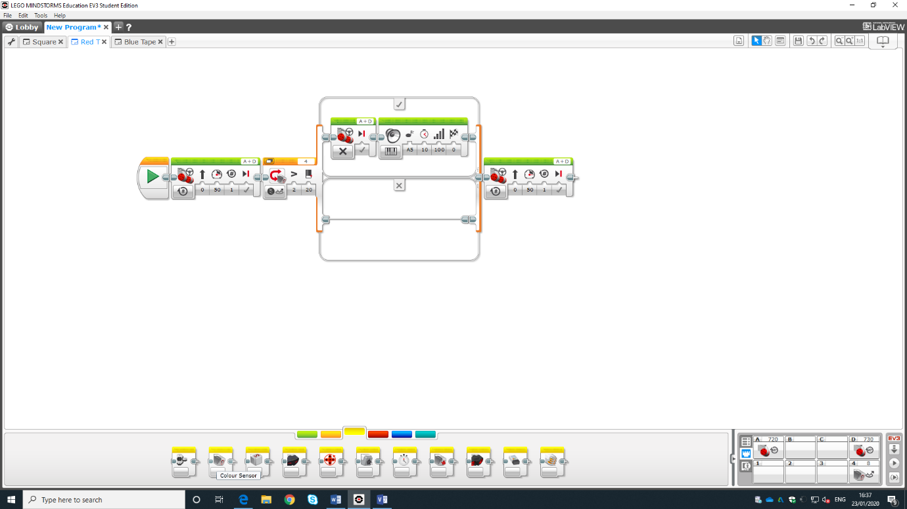

This code is for moving and turning the robot and playing sounds if an issue occurs.

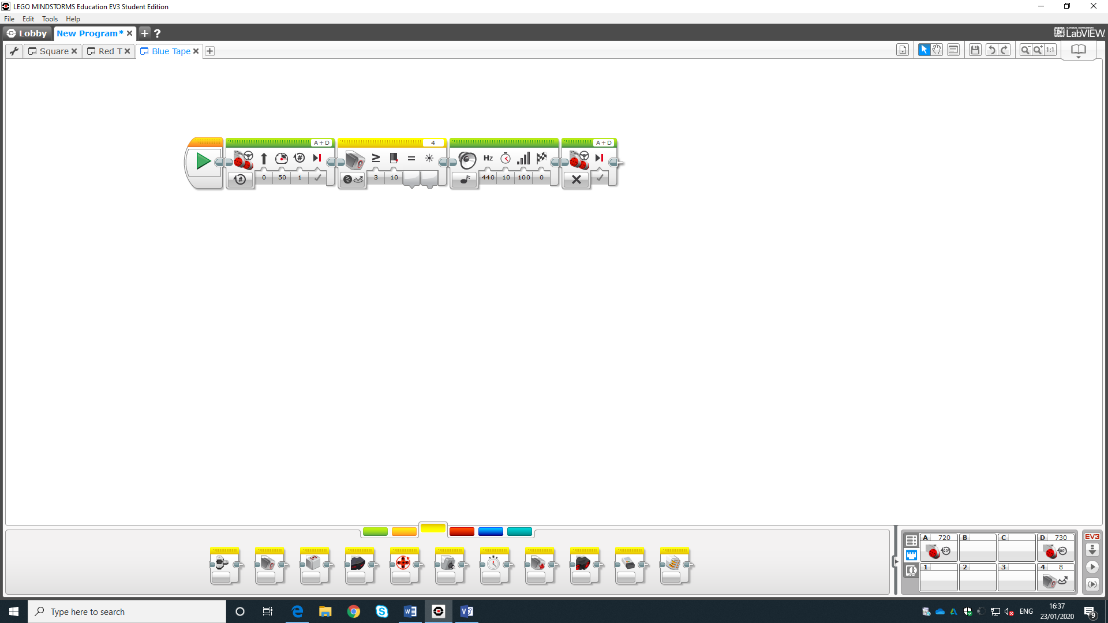
This code is for ending the program is blue tape is present.

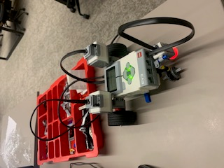
Picture of Robot

