Student Name: | Samsul Alom
Student Number: | 1605851
Module No: | BMSK500_LON
Module Title:  Lecturer: | Knowledge and Information Management Skills for the Workplace  Tanja Nathan

Content
Page

- Introduction………………………………………………………………………….1
- Relationship between data, information & knowled…………………………2 to 3
- The relationship between individual knowledge & organizational knowledge…4 to 5
- Applying analysis and modelling techniques to identify knowledge……………5
- Strategic management of knowledge…………………………………………5 to 6
- Knowledge manament (KM) process framework……………………………6 to 7
- Evaluating actual and potential knowledge assetts..………………………..7 to 8
- Evaluating what is required to create, store, apply and intergrate knowledge...8 to 9
- Considering the importance of interlectual property rights………………………9
- Explaining the contribution knowledge assttes have on organizations…9 to 10
- Evaluating the knowledge requirement for organisations……………….11 to 13
- Evaluating organizations framework for enabling knowledge sharing…13 to 14
- Recommending improvement to current framework…………………….14 to 15
- Conclusion and References………………………………………………..16 to 17

Introduction

The Department for Work and Pensions (DWP) is an industry which is the current workplace of mine. The DWP is a non profit based organization of several different departments. It maintains itself by way of specific procedures policies and legislations with in parliament so that it ensures that the public receive equality and fairness in the delivery of services it provides. It collects significant amount of revenue from tax payers. Customers are likely to switch to digital processes for this advancement of technology as DWP has moved with the times to create much easier ways for customers to provide data and for the DWP to store it in various different systems and at the same time, has rolled it into one system. Based on my workplace, the following information is covered in my report.
- The relationship between data information & knowledge
- The relationship between individual’s & organizational knowledge
- Evaluating potential knowledge assets
- Knowledge management and the importance of knowledge
Later the importance of intellectual properties such as managing the knowledge and making it more efficient in the manner it is used, which are also discussed (Peloso, J. 2003).
Based on my current workplace, an organizational framework for enabling knowledge share is depicted. In the last part several recommendations are attached so that knowledge sharing can become more effective. The contribution of knowledge asset is also described. Every organization requires unique knowledge that’s why knowledge requirement varies from one organization to another organization.

Relationship between data, information & knowledge

Data demonstrates some perceptions that are considered to have almost no incentive until the point that has been prepared & changed into information. The main characteristic of data is it is systematic & it is organized methodically. Data is derived from facts which are considered to be raw. In generic form, it can be concluded that all the information is regarded as data. A concept that is represented automatically which can be sign or that can be other symbol will be regarded as data (Pivert, O. 2016). Example of data is when information is gathered about an inventory such as whether the stock is defective, a progression of non-arbitrary symbols, a gathering of non-arbitrary facts etc.
Processed data which is considered to be important is known as information. If the data is meaningful & demonstrates a purpose it will be regarded as information. Information is interpreted so that the recipient can widely understand the purpose. For example law, income statements from customers, etc. Informational value can be divided into intangible & tangible value. Information can be transferred into various encoded versions, which will help in securing the important information. Encrypted information is decrypted by authorized persons to maintain the confidentiality. Uncertainty is reduced by validating information. Information can be gathered thorough observation & also from customer answers to enquiries.
Knowledge is referred to as communality, mindfulness or comprehension of something for example data, actualities, depictions which is procured through understanding or instruction by seeing, finding & learning. It can allude to a hypothetical or reasonable comprehension of a subject. It tends to be verifiable and express in terms of something (Pivert, O. 2016). It is kind of systematic or pretty much formal. When data is collected and as it is meaningful to the user, it is regarded as information and when the information is understood well it will be regarded as knowledge.
So it can be concluded that:
Data | It can be referred as symbol, numbers or objects/items
Information | Processed data that is regarded as useful
Knowledge | When data & information are applied
Table no: 01
Based on that table, a graphical representation can be made which shows a hierarchical series of data, information & knowledge:

Source: Self-made
This is a hierarchical view of relationship among data, information & knowledge. Data is prevailing in the lower level, in the mid-level there is information. It can be seen that knowledge in the top layer that means if the data & information is subjected to be well define, one can gather a good knowledge from these.
As I work in the public sector as a manager and a decision maker on the Employment and Support Allowance (ESA) benefit section, an example of data in my organization is customer personal details. That can be the customer’s medical details and most recent medical examination test called a Work Capability Assessment (WCA). When this information and data is applied, for example by reviewing the report of the Health care Professionals (HCP) who examines the customer as part of the ESA benefit procedure to identify whether the customer is fit or un-fit for normal day to day work despite the customer having numerous medical conditions. Based on that information, the Decision Maker (DM) can undertake an assessment of the customer from the HCP medical examination report and gain additional information from a telephone call. There may be a change in the customer’s medical condition since the WCA, which could overturn the HCP recommendation.
Below is the vision that the DWP has laid out for individual citizens of UK:-
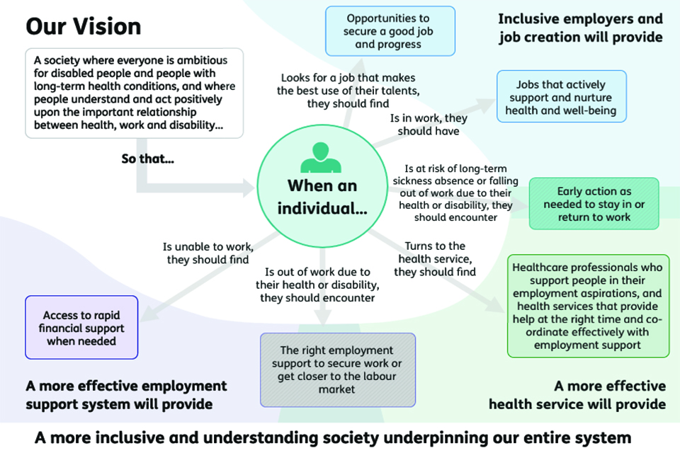
Source: (Green, D. Hunt, J. 2017)

The relationship between individual knowledge & organizational knowledge

The common connection between individual & authoritative learning remains one of the challenged issues in hierarchical learning discussion. Individual knowledge & organizational knowledge are the two distinct branches of knowledge management (Spigner, C. 2012). The dialog uncovers the psychological measurement of learning as a procedure that rises over numerous levels & units of investigation.

The investigation of individual as well as organizational knowledge features the various & interlocking setting that characterize the substance & procedure of learning in association. Individual knowledge can be explicit in nature. Organizational knowledge is one more idea that includes almost no accord of writing. Varieties incorporate the degree to which the information is spread inside the organization & in addition the real make up of this learning. When gathering information from a new subunits or gathering is joined & used to make new information, the subsequent inferred & unequivocal learning can be called organizational knowledge (Gherardi, S. 2009). An exceptionally regular argument is to utilize something like Microsoft SharePoint which is a software of knowledge based. Others present more extensive view. Singular information, shared learning & generalized learning are distinctive angles or perspective of organizational knowledge.
In case of individual knowledge, in my company when employees gather data & information to utilize their knowledge, that can be thought as individual knowledge. But when data & information is gathered to apply in organizational context, that is referred as organizational knowledge (Gherardi, S. 2009). Employees can use the knowledge for their own career development. Individual knowledge is useful for helping employees to develop their career & increase their productivity & capacity. On the other hand, organizational knowledge is used to apply for developing organizational structure. To enhance the productivity of organization, employees work together & they apply their knowledge for the benefit of the organization. That’s why they differ in analyzing different situation.

Applying analysis & modelling techniques to identify knowledge

Knowledge assets are regarded as information drivers of an association’s property (Mentzas, G. 2003). This can be unorganized & implicit information. So for instance, there would be profound levels of key staff. On the other hand, these can be structured, unequivocal & classified information. What is fascinating about knowledge is the more one restructures it, the more one can classify information. The simpler is for sharing knowledge both inside & remotely.

A graphical representation is given below:
- Strategic management of knowledge

It is referred as strategic process which enables organizational learning. There are many knowledge related activities under the umbrella of strategic management. There can be learning organizational context, human capital & intellectual property rights etc. To support organizational learning which will occur by working in a team, will require different strategy & tools to implement. This is much broader which also concludes the context of social aspects. Traditional management follows different approach (Spigner, C. 2012). Knowledge management is intangible in nature that’s why it needs to be managed in a different way. Traditional tangible asset management techniques will not work for intangible asset management. That’s why this knowledge management technique is used to evaluate intangible assets.

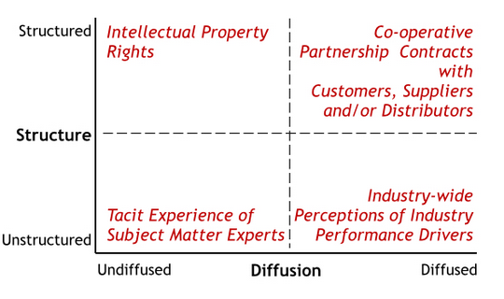
Source: (World Economic Forum, 2018)

SSM Process:

It focuses on the learning at pre-procedure of planned development venture is recognized, shared & utilized. The information is identified with building up & keeping up contacts with customers with activities & potential individual customers. The examination connected the SSM approach for social event information, this yielded startling bits of knowledge & well springs of rich inferred learning that had been previously ineffectively explained, shared & comprehended by numerous numbers all the while. There can be different stages such as SSM stage 1, stage 2 & stage 3 (What-when-how.com, 2018).

Within my work place this technique can be used to learn how to come into a solution regarding a particular problem. On a regular basis customers are in dispute with decisions made by employees from the ESA section of the benefit centre. The knowledge and skills acquired are based on experience of handling difficult customers on the phone. This knowledge is then past on to the decision makers that have been newly released from the training to complete decisions on customers after the HCP medical examinations have found them to be fit for work. Keeping to the script of policy and legislation is not simple when dealing with extremely argumentative customer phone calls. The quality however, is based on personal behaviour and attitude. Sounding sympathetic on the phone is an intangible skills asset compared to writing a report and posting the result to the customer.
- Knowledge management (KM) process frame work
This process was built by Bukowitz & Williams. It defines strategic management in a basis that will depict the enhancement of knowledge assets (Peel, J. 2012). The qualities of this model lay on its key centre, which basically puts learning administration activity into setting. It is likewise significant that the thought of divestment is incorporated something, which is frequently absent from KM model. KM activities are after effect for the reaction of strategic & vital changes & needs.

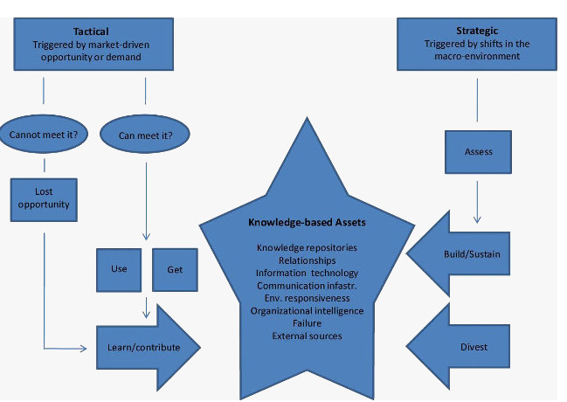
Source: (Hajric, E. 2018)
By using this model in my department, knowledge assets can be identified. This will enhance the expertise of my decision making key personals strategies.

Evaluating actual & potential knowledge assets

In spite of the generally high estimation of information, deciding an exact figure for the estimation, knowledge assets demonstrates exceptionally troublesome. One reason is that exact measure of the estimation of knowledge assets have been difficult is that knowledge being immaterial, is regularly lumped with intangibles in valuation approaches (Mentzas, G. 2003). Another issue comes from not having the capacity to recognize the impact of various resources. A particular study has been conducted in Research & Development consumptions, on a firm which has incentive in the remote interchanges. As the potential knowledge assets demonstrates the potentiality of a company to acquire knowledge assets (Schwartz, D. & Teeni, D. 2011). Though it is quite simple, companies are not able to keep pace with its potentiality consistently as sometimes it may differ from its potential. Actual knowledge assets mean in reality how many assets have been acquired by the company. Sometimes it may go over its potential, sometimes it may underperform. It is relied upon some factors which lead our department to over performing stage or under performing stage. Regression analysis can help to evaluate knowledge assets. The determined factor can be the annual performance, and assets which are tangible, expected earnings which are intangible which can be found by subtracting the earnings which has been found from tangible assets. After that present value of intangible assets will be found (Schwartz, D. & Teeni, D. 2011).

As the community and economy becomes close nit with the digitalisation of all company business communication systems, it’s important to capture knowledge. This will also provide advantages for DWP and the public’s network communication behaviour. Knowledge should be proactively protected by an organization as it is an asset for the organization. Retaining knowledge demonstrates adapting company’s information effectively.
- Evaluating what is required to create, store, apply and integrate knowledge
Create knowledge: To create a knowledge base several steps are needed to be followed which are given below:
- Conducting thorough research, which should be cross-functional: To develop a good knowledge base it needs planning otherwise they won’t get access to their desired information
- Defining viable procedures, which is minimum: This is used when a new version of a procedure is launched. Concept should deliver high return, not inefficiency
- Determining content and plan: In this stage, the team will go for executing new ideas based on their knowledge
- Plan should be outlined: As the employees now know what is right for our business, they can develop new projects.
- Building analytical capabilities, which is right: Without right analytics, knowledge can go out of control quickly. That’s why focusing on impact is necessary.
- Focusing on continuously improvement of knowledge: It can be demonstrated as a two way communication. To grow the knowledge base of employees, good infrastructure system is necessary.
Store knowledge: Knowledge should be stored for various reasons these are depicted below:

- This will give an organisation good opportunity to increase the performance stream and improve economic growth
- New ideas should be developed, to develop knowledge to be used by employees. But if employees don’t store the knowledge they won’t understand the public’s conditions
- When data is limited this will help to get insights about the current conditions
- This will help to keep alignment with the changing technology so that they can overcome new challenges
- It will help in aligning with customer behaviour and trends
- This will also help in innovating new ideas, which will be relevant to our desired customer segments.

To store knowledge, several methods can be used. Knowledge can be stored by using reports, documents, databases etc. when these are documented there is a less
fear of losing information. But these must be secured so that unauthorised person’s do not get access to that information. If knowledge is available to everyone, retaining that will not provide security.

Apply knowledge: Applying knowledge means how an employee utilises his knowledge. In our organisation, certain training is given on how to communicate with customers, how to utilise company resources. By implementing new projects employees can apply their knowledge. If knowledge is created & stored but it is not implemented, this will go in vain. That is why this should be applied to identify whether knowledge that is stored by the organisation adds value. If that doesn’t add any value, then that should be discarded into bin to create new place for new knowledge base.
Knowledge can be applied when employees can take new projects, innovate new products which will help to increase our customer service for the public and retain reputation. But if knowledge is not applied properly, the organisation will be at stake (Dau, F., et al. 2005). That’s why applying relevant knowledge is important rather than trying to incorporate vague knowledge. Every industry requires different knowledge segment. One type of strategic knowledge won’t work for another different sector. Within the DWP and in my department, we need to apply strategic knowledge related to improving the welfare of our public.
Integrate knowledge: Knowledge integration is the process by knowledge model’s that have been integrated into a common model. When different employees get different knowledge over different sectors, they need to work in a team to increase the sustainability for the organisation. They can also incorporate new information to the existing knowledge so that they can improve the knowledge management process (Dau, F., et al. 2005). But the new information should be modified based on the existing information. To work in a team, knowledge gets diversified as different employees are experts in different sectors for example one develops strategic plans, others identify required modification.

Considering the importance of intellectual property rights

Intellectual properties of my company are trademark, patents, copyrights, trade secrets etc. The importance of considering the importance of intellectual property rights are given below (Peloso, J. 2003):
- As my organisation is a non-profit based organisation, being competitive is not our drive rather it is to ensure the welfare of the public at large;
- This will form the essential part of our advertisement which will create superior brand image to our customers;
- If the organisation faces financial problems it can take bank loan. But bank loans are given if we keep valuable asset as a mortgage to them. That’s why the intellectual properties can be used as security to the bank loans;
- As these intellectual properties are intangible assets they are valued based on cost, market or income based valuation.
- The DWP however, is not in a position where it requires loans from banks rather it is the other way around in this case as it is a government public sector organisation.

Explaining the contribution knowledge assets have on organisations

Knowledge assets are also considered to be asset’s of the organisation. But like the physical assets they are intangible in nature. Knowledge of asset’s is important because it helps the company to grow and or compete. That’s why retention of knowledge asset is very much important (Mentzas, G. 2003). If the knowledge assets are organised then this can be shared quickly to employees, which will help them to understand the value of knowledge management.

The contributions of knowledge assets to organization are given below:-
- Knowledge assets help our organisation to become innovative in digitalisation. If our organisation has valuable strategic knowledge assets then it will reduce the risk of foot fall and customer compliments rather than customer complaints. In this government department, we need to cope with the diverse background and behaviour of vulnerable customers on welfare. If we fail to provide differentiated services to our customers we will lose our reputation and place doubt in community welfare. Managing knowledge asset is very much important. This can be demonstrated by a flow chart on the next page:

Source: Self-made
- To enhance the organisations’ performance, knowledge assets help a lot. If the knowledge assets are properly utilised then this can avoid disappointment tour customers. As the objective of our organisation is to maximise customer service it is important to increase the performance.
- Knowledge assets help to innovate new ideas by formulating new strategies. It improves employees’ innovation process & by enhancing their innovation process, the organisation receives praise and benefits all involved. If knowledge assets are not managed properly, then our organisation won’t be able to sustain its reputation and risk economic disruption.
- If the knowledge assets are more valuable and unique ones, it will help the organisation solve its critical problems immediately. As the situation is very much complex today, new challenges arise. If the knowledge assets of our organisation is poor quality in nature, how will it address critical issues.
- High quality assets will save resource cost, save time as well as improve performance.
- Knowledge assets also facilitate the process of managers’ decision making. If the decision making process of managers’ are well informed, they can take the projects which will increase performance for our customers and make life even more easier for them.

Evaluating the knowledge requirement for the organisations
Organisation needs to decide the knowledge requirements, which align with organisational goals & objectives. This will be given much importance to the success of it. While considering the present learning, it will decide what extra knowledge is required (Dau, F., et al. 2005). Knowledge should be specific to our organisation. As this is a government department providing welfare for the wide communities at large where I work and knowledge requirements will be based on continuously improving public services. Knowledge can be based on two sources:
- External source such as conference;
- Internal source such as intellectual intangible sources;.
The knowledge requirements are driven by several factors such as (Pivert, O. 2016):
- The size & complexity of the organization: If the organisation has huge operations and many employees, which create complexity. For big organizations, knowledge requirement should be different from small organizations;
- It also depends on the risks level & opportunity. If the risk level is high, it will require more diverse knowledge.
- Another important factor is the need to access the knowledge.
These are graphically presented below:-

Source: Self-made
Required knowledge in the decision making process for customers who seek to claim welfare benefits on Employment and Support Allowance (ESA), is given below:
- The ESA benefit looks at and focuses on the ability of a customer to cope in work rather than not in work.
- DWP research and statistics show that after about two years on the Incapacity benefit customers were more likely to die than to find a job.
- ESA is different as its main aim is to ensure that no person is written off and people who are able to work are given the best assistance.
- This was set up to ensure that the people with illness and disabilities can be moved into employment.
- The core aspect of the ESA claim journey is the WCA which is the medical examination test. This is on a points based system that requires information from the customer in regards their typical day activity.
- Once this information has been provided to the Healthcare Professional (HCP), it will then be released and up loaded onto a system that is part of a network system also viewed by the DWP decision making officers.
- Customers with severe medical conditions are eligible for the most financial support.
- People with mental or physical impairments that limit them from the majority of work but not all types of work, are placed in the Work Related Activity Group (WRAG).
- The WRAG requires customers to attend the Job Centre in order for the work coach to review progress for tailor made employment.
- There is another group for customers who’s medical conditions completely limit them on a long-term or short-term period called the Support Group (SG). The maximum period is three years year’s and hen reviewed.
- DWP is fully aware that medical conditions can improve after time or they can decline.
- Depending on the outcome of the review they can be placed in the WRAG or either go back to the SG or removed completely if conditions significantly improve.

Source: Department for Communities website

- Relevant knowledge regarding the public sector industry such as the major benefit systems within the DWP are those who are regarded as highly skilled based and knowledge based. This comes from many years of experience of working in different departments of the DWP and not only in the medical department such as ESA. There are many different grades and level of particular knowledge and information and the stages of public sector industry life cycle. These are initial stage when it is at the operational stage. This is the low stage and it costs are reduced. The 2nd stage is acceleration of knowledge, information and learning behaviour and guidance as an executive officer (EO). This means the industry’s knowledge increases rapidly. The mature stage means the higher executive officer (HEO) grade. The learning return gets much more efficient. Therefore relevant knowledge of these phases is important.
- The legal requirements such as major rules & regulations, compliance, and relevant papers;
- Knowledge about strategy is their products inspection as the compliance officers can drive away our customers if the customers fail to deliver evidence requested for compliance. That’s why it’s important to keep an eye on customer activity;
- To create an equal and fair image, we need employees who can give us good customer service and communication strategy of the services that are available. If the communication strategy is poor, customers won’t be able to get proper information.
- To have good knowledge on web based software to connect with customers through online and to meet the customer needs;
- Knowledge of processing, document filing, writing reports, planning of events such as telekits to iron out issues are also important;
- Good communication skill with innovative mind & ability to work in a group for project works too;
- Good eye for understanding the detail information.
These can be summarized below:

Source: Self-made

Evaluating organizations framework for enabling knowledge sharing

As it has been previously discussed that knowledge should be stored & applied when it is important. In the organization, there is a hierarchical system that’s why knowledge needs to be shared from higher level employee to lower level employee or vice versa (Dupuy, F. 2016). If knowledge is not properly shared there will be difference of information, which will create obstacles to achieve goals. If employees are not properly given direction what to do, they will make mistakes. That’s why organizational framework should be based on a system that supports good knowledge sharing process. Organizational framework of our company which enables knowledge sharing is given below:
- My organization gives emphasis over open door policy. That means, every employee from lower level employees to mid-level employees get access to the higher level authorities when they feel difficulties to solve a critical problem
- Before beginning any project, employees get proper reasons as to why the project is being produced so that they can utilise it with organizational goals. This helps them to work properly and if there is proper guideline, they won’t face complexities.
- Another important way of knowledge sharing is arranging staff meeting every week. This session is held for approximately 30 minutes. This helps to keep the employees updated about the current ongoing matters. They are also allowed to present their opinion based on their knowledge and research. Employee participation is highly encouraged.
- The organizational culture is such that employees are open to changes, which can also help to restructure the company as per requirement.
- There are standard procedures, which operates effectively to share knowledge. Employees get direction from their supervisor also.

Recommending improvements to the current framework
As it is important to share knowledge within organization, every organization has developed different organization system for enabling knowledge (Dupuy, F. 2016). In my organization, sharing knowledge is equally important. Knowledge is created through various processes and this is also stored in documents, databases and different software IT systems. It is protected by robust virus protectors and the stored knowledge is applied when it is requires. But sometimes, we need to work on a project for example to create a solutions to issues and concerns that effect business processes. For this purpose we have to work in a team. Team members need to communicate with one another so that we can make the project successful. If team members don’t integrate the knowledge, it will be difficult to cope up with tasks (Schwartz, D. & Teeni, D. 2011). That’s why now integration is important. To integrate knowledge, knowledge sharing is important. Recommendations to improve the current organizational framework are given below:
- Session meeting that is held for 30 minutes every monthly or weekly if necessary, is not enough because employees need to present their opinion on a certain issues. But for time constraints, sometimes it has been seen that, many of them can’t present their views and get de-motivated. This also has a negative impact for example this increases job dissatisfaction. That’s why we have high employee turnover. To reduce that, employers need to share their ideas so that they can understand that their participation is also important.
- There is no systematic way for us to approach to higher management. This also creates ambiguity. If it has been clarified which problem we can go and to whom then it can reduce that ambiguity. As it is quite natural that all senior employees don’t have similar expertise on every issue. One is an expert in handing a particular issue, others may be expert at dealing with different significant issue. That’s why it should be clearly defined who will handle which type of issues so that employees don’t need to waste time in searching for their required solution.
- Employees should give feedback and instructions from every project outcome so that they can get acknowledged for the project. This will reduce cost and save time as it is difficult to tell every employee about a certain change personally. If a project changing procedure is documented and given to every employees this will reduce the pressure on the overall organisations departments and operational systems. Every employee will have relevant knowledge about what to do and what he or she must do.
If these things are implemented, knowledge sharing systems will be improved and it will increase our organizations’ effectiveness. To maintain a good organizational culture, it is important to restructure organization’s knowledge sharing systems otherwise this will create inconsistency within the organization. If the recommended information is taken into consideration, our knowledge sharing framework will be effective and employees won’t suffer or feel confused with issues and problems.

Conclusion

Knowledge has become an important issue for every organization. That’s why it has to be managed properly. There is a systematic approach on how knowledge is created, stored, applied & integrated especially in this fast moving close networking technological time. Another important issue is to retain intellectual properties which are copyrights, trademarks etc. To gain advantage, it’s important to secure this property. If these get disclosed, customers will be well aware of our strategy and they will try to abuse or take advantage of the government provision. We may lose our current reputation as a result of this. There are also several recommendations to improve my workplaces knowledge sharing system because if the system isn’t modified with advancements of technology, this will create disunity of information.

References

Dau, F., Mugnier, M. and Stumme, G. (2005). Conceptual structures: common semantics for sharing knowledge. 7th ed., Berlin: Springer.
Department for Communities website.
https://www.communities-ni.gov.uk/articles/questions-and-answers-employment-and-support-allowance-advisers [Accessed 15 Nov. 2018]..
Dupuy, F. (2016). Sharing Knowledge. 12th ed., Palgrave Macmillan.
Gherardi, S. (2009). Organizational Knowledge. 7th ed. Hoboken: John Wiley & Sons, Ltd.
Green, D (2017) Secretary of State for Work and Pensions and Hunt, J (2017), Secretary of State for Health. Updated 30/November/2017. Work, health and disability green paper: Improving lives.
https://www.gov.uk/government/consultations/work-health-and-disability-improving-lives/work-health-and-disability-green-paper-improving-lives [Accessed 11 Dec. 2018]..
Hajric, E. (2018). KM models | Knowledge management model. [Online] Knowledge-management-tools.net. Available at: https://www.knowledge-management-tools.net/three-km-models.html [Accessed 19 Dec. 2018].
Peel, J. (2012). Knowledge Management. 9 ed., Delhi: Orange Apple.
Peloso, J. (2003). Intellectual property. Bronx, N.Y.: H.W. Wilson Co.
Pivert, O. (2016). Flexible approaches in data, information and knowledge management. 5th ed. Springer International PU.
Mentzas, G. (2003). Knowledge asset management. 10 ed., London: Springer.
Schwartz, D. & Teeni, D. (2011). Encyclopedia of knowledge management. 9 ed., Hershey, Pa.: Information Science Reference.
Spigner, C. (2012). Knowledge Is Power. 7th ed., Pearson.
What-when-how.com. (2018). Identifying Knowledge Assets in an Organization. [Online] Available at: http://what-when-how.com/portal-technologies-and-applications/identifying-knowledge-assets-in-an-organisation/ [Accessed 22 Dec. 2018].
World Economic Forum. (2018). Do you understand your company’s knowledge assets? [Online] Available at: https://www.weforum.org/agenda/2015/04/do-you-understand-your-companys-knowledge-assets/ [Accessed 29 Dec. 2018].

