

Strategic Evaluation of Patagonia's International Expansion into Vietnam: A Critical Analysis of Market Attractiveness and Entry Mode Strategy
Programme: Master of Business Administration
Module: International Business Concepts

Lecturer: Jean Wang

Student Name: Tahmina Akter Mili
Student ID: 2525073

Submission Date: 14-08-2026

AI Use Acknowledgement
I recognize the use of artificial intelligence (AI) tools in the preparation of this report, but I note that the use of such tools was limited. ChatGPT was only used to help with grammar checking, and get clarity of some cconcepts as modes of entry. All research, literature selection, application of international business theories and academic judgements are original and my own work. All AI-generated content was reviewed, verified and edited against authoritative academic texts to ensure accuracy, originality and adherence to University policies on academic integrity and responsible use of AI.

Contents
AI Use Acknowledgement 2
Section 1 8
1. Organizational Classification and Global Strategy 8
1.1 Organisational Context and Strategic Company Profile 8
1.2 Strategic Categorisation using Bartlett and Ghoshal's Framework 9
1.2.1 Critical Evaluation of Patagonia's Transnational Strategy 9
1.2.2 Why Vietnam? Strategic Rationale 10
1.3 Global Configuration and Competitive Advantage 10
2. Macro-Environmental Appraisal and Market Attractiveness 12
2.1 Vietnam's Political and Institutional Environment: An Institutional Theory Perspective 12
2.1.1 Institutional Opportunities and Constraints for Patagonia 13
2.2 Economic Attractiveness of Vietnam for Patagonia 14
2.2.1 Purchasing Power and Premium Pricing 15
2.3 Vietnam's Legal Environment and Investment Risks for Patagonia 17
2.3.1 Legal Advantages for Patagonia 17
2.3.2 Legal Risks and Constraints 17
2.4 Vietnamese Consumer Culture and Market Fit for Patagonia 18
2.4.1 Hofstede and Patagonia's Brand Positioning 18
2.4.2 Sustainability, Outdoor Consumption, and Digital Behaviour 19
2.5 Vietnam's Market Attractiveness and Industry Competition 20
2.5.1 Market Attractiveness 20
2.5.2 Competitive Intensity and Patagonia's Position 20
2.5.3 GE/McKinsey Assessment 21
2.6 Market Entry Synthesis using Dunning's Eclectic Paradigm (OLI) 22
2.6.1 Ownership Advantages 22
2.6.2 Location Advantages 23
2.6.3 Internalisation Advantages 24
2.6.4 Critical Assessment of OLI for Patagonia's Vietnam Entry 26
3. Entry Mode Strategy and Strategic Synthesis 26
3.1 Patagonia's Historical International Expansion Pattern 26
3.2 Strategic Fit and Justification: Critical Evaluation of Patagonia's Entry Strategy for Vietnam 27
3.2.1 Comparative Evaluation of Entry Modes 28
3.2.2 Strategic Fit for Patagonia 29
3.3 Conclusion and Final Recommendations 30
3.3.1 Final Recommendations 30
3.3.2 Conclusion 30
Section 2 32
4. Reflective Account: Gibbs Reflective Cycle 32
4.1 Description 32
4.2 Feelings 33
4.3 Evaluation 33
4.4 Analysis 34
4.5 Conclusion 34
4.6 Action Plan 34
References 35

List of Tables
Table 1: Patagonia Strategic Company Profile (Author) 8
Table 2: Bartlett and Ghoshal's International Strategy Matrix (Author) 9
Table 3: Political Opportunities and Institutional Constraints for Patagonia in Vietnam (Author) 13
Table 4: Vietnam Economic Indicators and Strategic Implications for Patagonia (Author) 15
Table 5: Legal Environment and Investment Risk for Patagonia in Vietnam (Author) 17
Table 6: GE/McKinsey Market Attractiveness Assessment for Patagonia in Vietnam (Author) 20
Table 7: Application of Dunning's OLI Advantages to Patagonia's Entry into Vietnam (Author) 24
Table 8: Patagonia's Historical International Entry Modes (Author) 26
Table 9: Comparative Evaluation of Entry Modes for Patagonia in Vietnam (Author) 28

List of Figures
Figure 1: Patagonia Logo (Patagonia, 2025) 7
Figure 2: Patagonia's International Value Chain (Author) 11
Figure 3: Vietnam GDP Growth Rate (World Bank, 2025) 14
Figure 4: Retail Sales in Vietnam (Statista, 2026) 15
Figure 5: Hofstede's Cultural Dimensions for Vietnam (The Culture Factor, 2025) 18
Figure 6: Patagonia Competitors in Vietnam (Hasan et al., 2024) 20
Figure 7: OLI Framework (Bulmer et al., 2024) 21
Figure 8: Vietnam's Inflation Rate (World Bank, 2025) 23
Figure 9: Entry Modes Strategies (Nagle et al., 2025) 27
Figure 10: Gibbs Reflective Cycle (Anh, 2025) 31

Section 1

Organizational Classification and Global Strategy

Organisational Context and Strategic Company Profile
Patagonia was established in California in 1973 and had $1.47 billion in revenue in FY2025, of which 39% came from abroad, highlighting the fact that it is quite reliant on demand outside of the US (Patagonia, 2025).
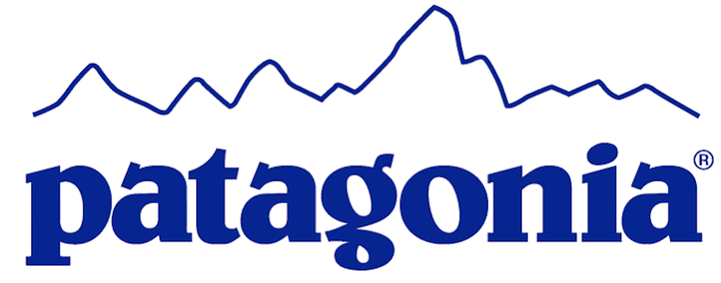
Figure 1: Patagonia Logo (Patagonia, 2025)
Its footprint spans Europe, Japan, Australia, and other markets, but the balance remains US-led at 61%. This setup involves owned retail, e-commerce, and wholesale outlets, and its sustainability credentials are further strengthened by more than 90% of its product range being Fair Trade Certified (Patagonia, 2025).
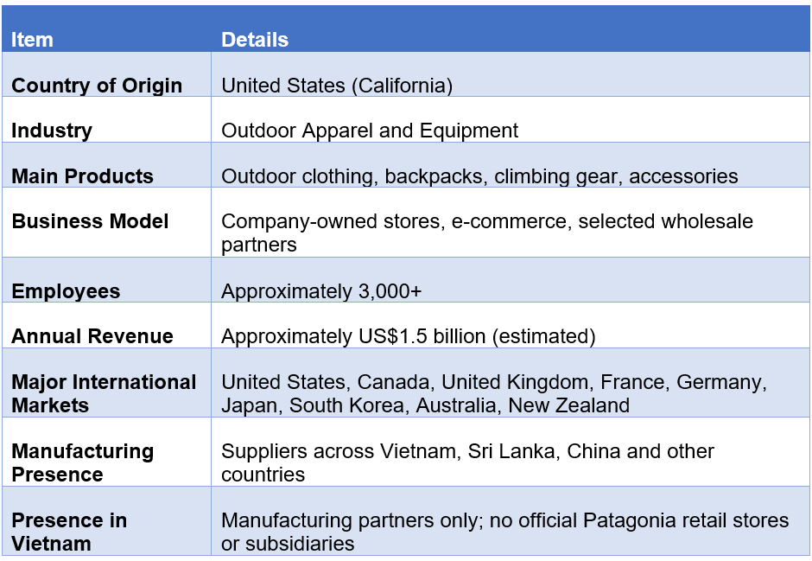
Table 1: Patagonia Strategic Company Profile (Author)

Strategic Categorisation using Bartlett and Ghoshal's Framework
Bartlett and Ghoshal's model assess multinational strategies based on the integration of global and local responses (Macro & Ott, 2024). Patagonia is described as transnational, as its international scale is combined with strong central control over sustainability, product quality and brand values. Its European, Japanese, and Australian activities illustrate this balance: the quality of products, environmental values, and brand communication are the same, while the formats, the relevance of the products, and the relationship with the customer are different. This helps to protect the unique position of Patagonia, but also means increased coordination and compliance requirements.

Critical Evaluation of Patagonia's Transnational Strategy
Patagonia's global integration is reflected on the centralized product and brand governance and on the requirements to suppliers regarding environmental and social performance. These controls help to spread knowledge and sustainability practices throughout its global network, fostering differentiation and credibility. Maintaining uniformity of standards amongst the widely distributed suppliers on the other hand, however, makes monitoring costs higher, which could limit flexibility. Responsiveness is thus local. Patagonia has the flexibility to adapt products and their interactions with customers to various climates and markets without changing its fundamental offering. While standardization can lead to less market relevance, adaptation can lead to a loss of consistency in the premium positioning of the product (Shourkaei et al., 2024).
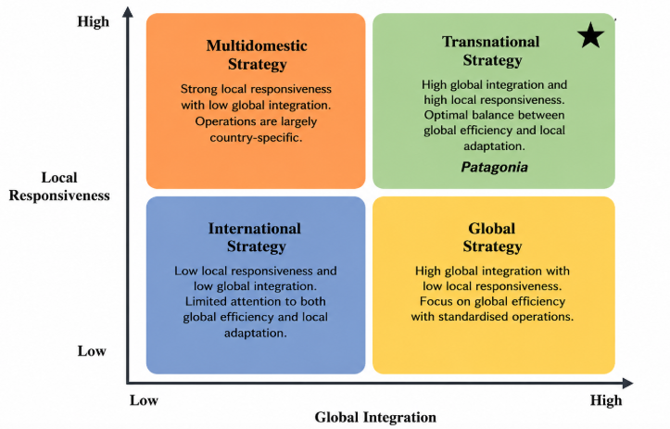
Table 2: Bartlett and Ghoshal's International Strategy Matrix (Author)

Why Vietnam? Strategic Rationale
Vietnam warrants further examination because it is already part of Patagonia’s manufacturing network but lacks the direct retail presence established in markets such as Japan and Europe (Furst & Akdag, 2025). This provides a unique opportunity to evaluate if Patagonia can expand its global model to Vietnam without sacrificing control, sustainability, and brand value.

Global Configuration and Competitive Advantage
An analysis of Patagonia's Value Chain across countries indicates that the company's competitive advantage is found in its ability to manage sustainability in its widely distributed operations, not in the cost leadership. Product design is centralized in California and brand governance is also centralized; sourcing and manufacturing is decentralized to other countries such as Vietnam. It gives Patagonia both the central control and international production possibilities. With $1.47 billion in FY2025 revenue, 39% of which came from overseas, its overseas presence is pivotal to its strategic business (Dezi et al., 2025). Market access is achieved through international retail, e-commerce, and selected wholesale channels, and Worn Wear adds value by repairing, reusing and retaining customers. In comparison to more affordable brands, like Decathlon, Patagonia places greater emphasis on sustainability, durability, and brand distinction, which it uses to justify its higher prices. Geographically distributed suppliers, however, add to monitoring and coordination costs due to tight environmental regulations. This global configuration is essential for determining if Patagonia's sustainable approach and model of operation can be successfully implemented in Vietnam.
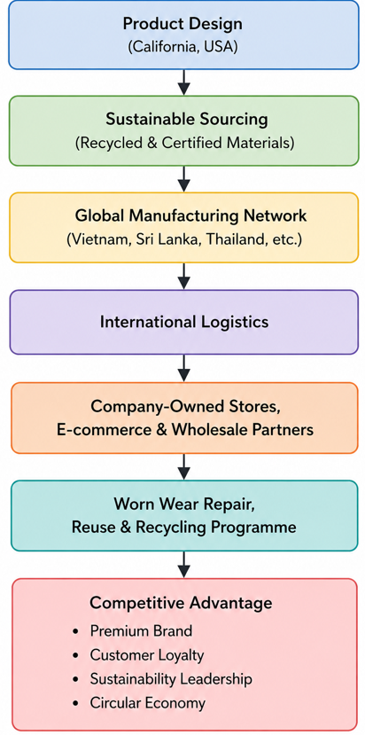
Figure 2: Patagonia's International Value Chain (Author)

Macro-Environmental Appraisal and Market Attractiveness

Vietnam's Political and Institutional Environment: An Institutional Theory Perspective
The Institutional Theory indicates that Patagonia will be successful in entering the Vietnamese market based on its sustainability-based strategy conforming to the formal institutions in Vietnam. The policy stability in Vietnam is conducive to Patagonia's long-term investment, and its National Green Growth Strategy 2021–2030 clearly encourages the shift to green production and consumption (Le et al., 2025). This results in greater institutional alignment for Patagonia over a less mature market, especially in terms of the circular economy and responsible sourcing model.

Institutional Opportunities and Constraints for Patagonia
Vietnam's pledge for a Net Zero 2050 further strengthens this alignment, further enhancing Patagonia's environmental positioning in Vietnam. It also enhances Vietnam's integration into global trade and investment networks thanks to its membership in CPTPP since 2019, EVFTA since 2020 (Tran & Thanh, 2026). The importance of this is greater than the broader political stability for Patagonia, as it is already a country that depends on the import and export of goods.
But the compatibility of institutions does not rule out operational risk. Generally, foreign investors enjoy the same conditions of access to the Vietnamese market as domestic investors, with exceptions for certain activities specified in Vietnam's Law on Investment 2020 (Can & Dang, 2024). So, Patagonia can proceed with direct investment provided they evaluate retail-specific approvals and administrative procedures prior to investing. The other trade-off in environmental regulation is that compliance costs could rise, but Vietnam's green policy direction is largely aligned with Patagonia's existing sustainability governance.
Patagonia is therefore institutionally appealing to Vietnam, not just because of its political stability, but also because of the policy direction it is increasingly taking, which shares many similarities with Patagonia's environmental capabilities. The main implication is to enter gradually, using the first retail operation to test regulatory execution and institutional relationships before committing to wider expansion.
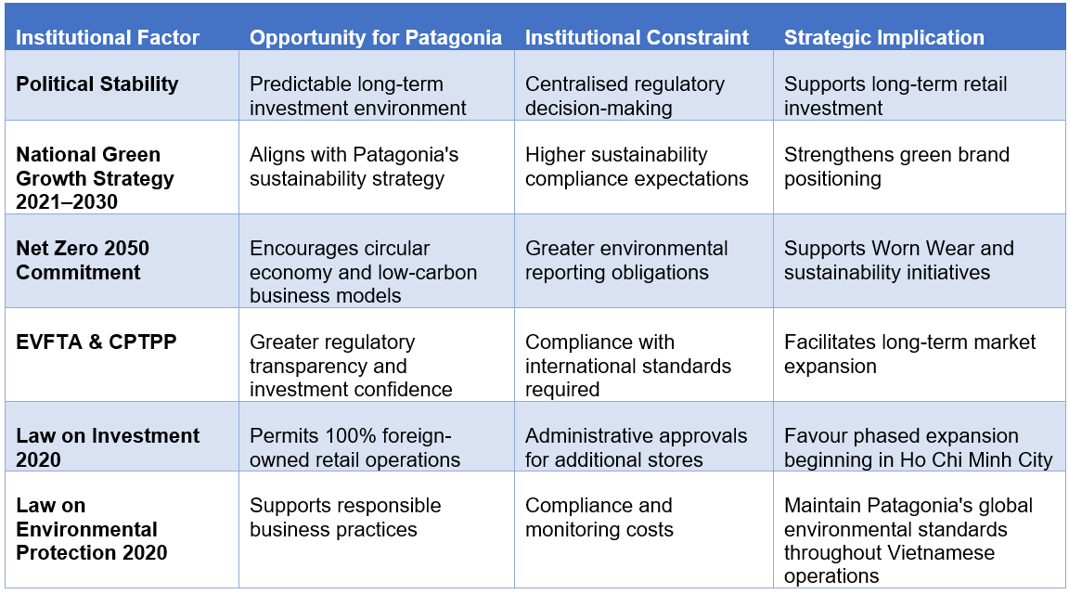
Table 3: Political Opportunities and Institutional Constraints for Patagonia in Vietnam (Author)

Economic Attractiveness of Vietnam for Patagonia
Vietnam's economic situation does not offer a mass-market opportunity, but rather a selective one for Patagonia. In 2025 GDP increased by 8.02% to about $514 billion and GDP per capita increased to about $5,026. The relatively stable conditions for pricing are created by inflation of 3.31% (World Bank, 2025). But Vietnam's income level is still significantly lower than Patagonia's established markets like the U.S., Japan, and Western Europe. So, Patagonia's high price can't be justified by its GDP growth, but by the growing affluent group in Ho Chi Minh City and Hanoi with higher purchasing power who will be able to afford Patagonia's much higher prices.
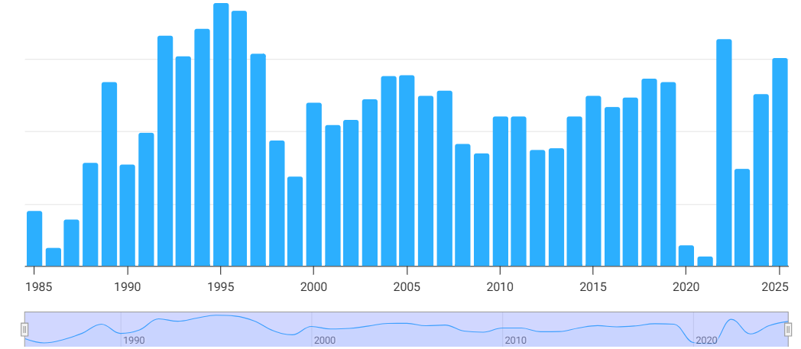
Figure 3: Vietnam GDP Growth Rate (World Bank, 2025)

Purchasing Power and Premium Pricing
While nominal income does not necessarily reflect the purchasing power of consumers, PPP is a more accurate measure of this than it is an indication of the absence of the affordability constraint in Patagonia. A typical Vietnamese consumer would be hit with a much higher relative cost for Patagonia than would a typical consumer in the United States or Japan. This limits Patagonia's potential customer base and makes direct competition with Decathlon, whose lower prices support broader market penetration, commercially unrealistic (Ngo et al., 2024). Therefore, Patagonia should rely on price differentiation through premiumization, not price competition, by emphasizing durability, sustainability, and repairability.
Vietnam's retail sales growth of more than 9% in 2025 and expanding digital economy strengthen the opportunity for a direct-to-consumer model (Statista, 2026). E-commerce can enable Patagonia to appeal to a high-value customer base without having to invest in an extensive national store footprint. However, the fluctuations of Vietnamese dong against the USD might have an impact on profit margins of imported goods. Part of the exposure can be reduced by the existing Vietnamese manufacturing network in Patagonia, which relies on less inventory.
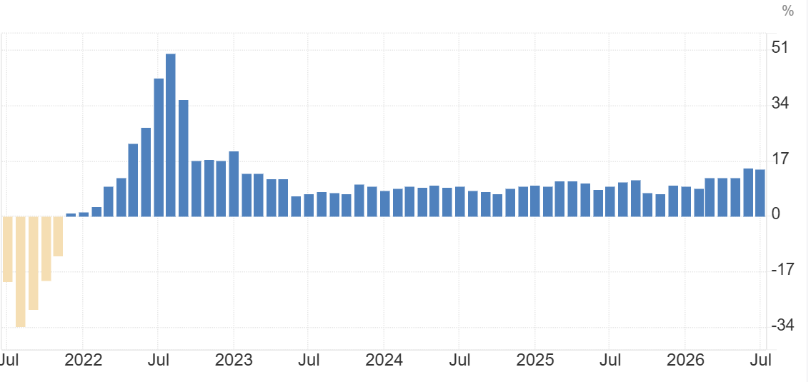
Figure 4: Retail Sales in Vietnam (Statista, 2026)
Consequently, Vietnam can accommodate Patagonia's premium niche in a narrow range of urban customers but not as a ‘market of scale’. The right approach is a controlled premium expansion coupled with digital retailing, the local supply chain benefit, and a step-by-step investment approach.
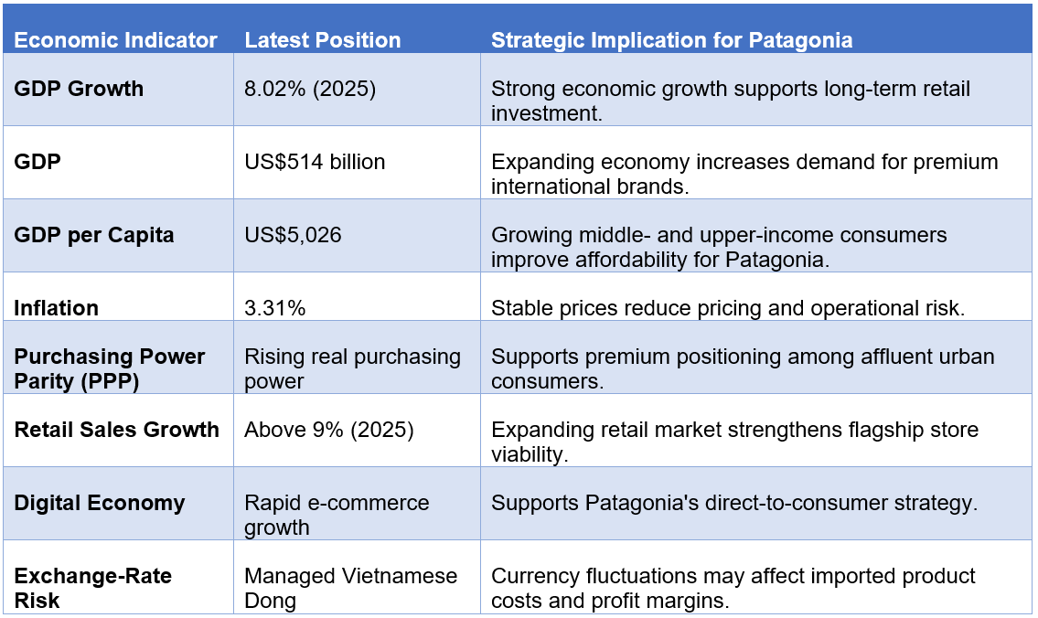
Table 4: Vietnam Economic Indicators and Strategic Implications for Patagonia (Author)

Vietnam's Legal Environment and Investment Risks for Patagonia

Legal Advantages for Patagonia
The Law on Investment 2020 and the Law on Vietnam's Law on Investment 2020 and Law on Enterprises 2020 provide a basis for Patagonia to establish a wholly foreign-owned retail operation, giving it greater control than licensing or franchising over pricing, product quality and sustainability standards. This is especially crucial as Patagonia's competitive edge is closely tied to the delivery of its environmental commitments to customers. Direct ownership would be better than a franchise because it would minimize the risk of the local partners diluting Patagonia's global sustainability criteria. Additionally, the Labour Code 2019 sets standards for working conditions, occupational health, and safety that could complement Patagonia's current supplier and labour standards. Similarly, the Law on Environmental Protection 2020, including the extended producer responsibility obligations, is strategically aligned with the repair, re-use, and circular economy initiatives in Patagonia (Bozsik & Ngo, 2023).

Legal Risks and Constraints
However, legal compatibility does not mean low regulatory risk. Patagonia needs to take care of Vietnamese licensing and enterprise registration and monitor compliance when establishing or expanding retail operations, which would be reduced in the exporting or third-party distribution methods. There may also be additional obligations that raise monitoring and reporting expenses, but these obligations can also enhance Patagonia's differentiation. Another concern is intellectual property rights, as counterfeit clothing from unauthorized retailers and platforms could jeopardize Patagonia's brand authenticity and high-quality pricing model. The 2023 Law on Protection of Consumers' Rights also expands the requirements related to product information, quality, and complaints (Manaysay, 2026). They are important for Patagonia because if their customers are not protected, it could affect the brand as a lot of customers rely on trust.
Therefore, Vietnam's legal framework is not only strategically suitable but also practically challenging. The best thing about Patagonia is that they have a direct ownership control of compliance and brand protection, and the hardest is that they have to incur extra regulatory costs to keep the compliance and keep the standards in place during the expansion (Chien et al., 2026).
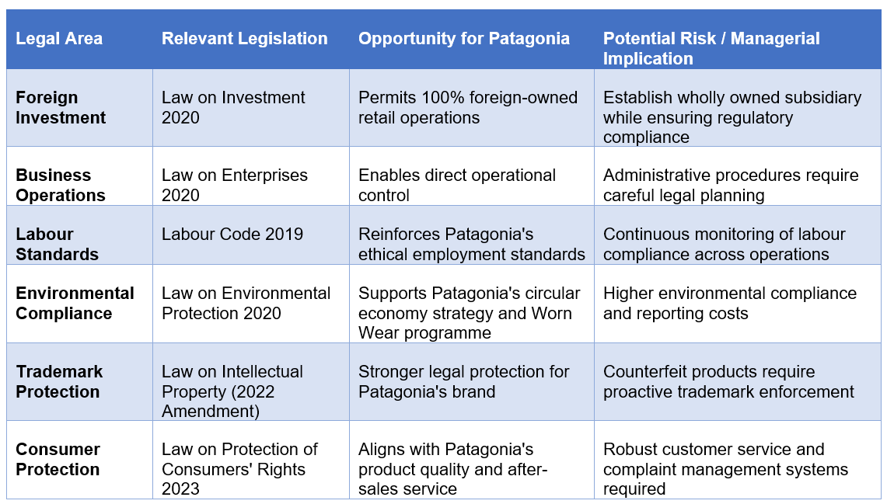
Table 5: Legal Environment and Investment Risk for Patagonia in Vietnam (Author)

Vietnamese Consumer Culture and Market Fit for Patagonia

Hofstede and Patagonia's Brand Positioning
Hofstede's scores show the possibilities and constraints for Patagonia in Vietnam. Vietnam's score of 70 in Power Distance and 30 in Individualism indicates that here the focus should be on establishing a trusted institution, rather than just on an individual's identity with the environment. That's in contrast to a more activist approach to markets like the United States. The Long-Term Orientation score of 47 is a more comparable foundation for supporting durability, repair, and the Worn Wear concept of this product, but that does not necessarily make the premium price tag one that Patagonia deserves (The Culture Factor, 2025).
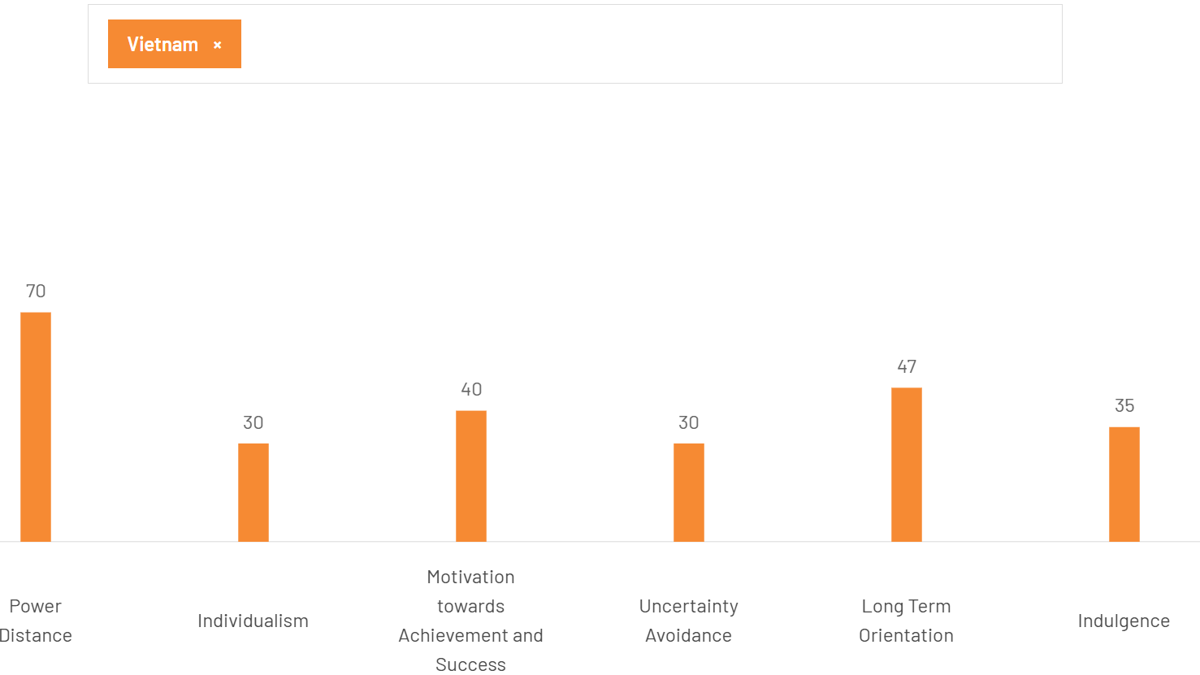
Figure 5: Hofstede's Cultural Dimensions for Vietnam (The Culture Factor, 2025)

Sustainability, Outdoor Consumption, and Digital Behaviour
There is evidence of genuine potential among Vietnamese consumers. The study on the Vietnamese Gen Z reveals that the perceived value of green clothes, the quality of the clothes, environmental concern, and social influence have a positive relationship with the intention of purchasing green clothes, which further strengthens Patagonia's focus on sustainable and environmentally friendly products (Nguyen & Hà, 2026). But it is not enough to assume that the level of environmental awareness will result in a willingness to pay the premium that Patagonia expects to charge for its products at the U.S. market rate.
Digital behaviour enhances the opportunity. In 2025, Vietnam's e-commerce market is estimated to reach approximately $32 billion, and internet penetration has surpassed 80% (Nguyen & Hà, 2026). For Patagonia, this supports a direct digital entry alongside a physical flagship rather than relying entirely on expensive retail expansion. The strong reliance on platforms like Shopee and TikTok Shop, however, also poses counterfeit and brand-control risks.

Vietnam's Market Attractiveness and Industry Competition

Market Attractiveness
Vietnam offers Patagonia a selectively attractive rather than mass-market opportunity. The total value of the broader sportswear market was estimated at around $819.4 million in 2025, and Southern Vietnam had 38.7% of this, with Ho Chi Minh City of special interest to Patagonia for their first retail outlet. Tourism is also supported by outdoor participation, with Vietnam welcoming nearly 21.2 million international visitors in 2025, increasing 20.4% on 2024, further driving the demand for functional outdoor clothing (Phan & Le, 2025). However, Patagonia's addressable market is considerably smaller than the overall sportswear market because its premium pricing excludes much of Vietnam's price-sensitive consumer base.

Competitive Intensity and Patagonia's Position
Selective entry is more appropriate when there is competition. International brands dominated Vietnam's sportswear market, with adidas capturing 19% value share, Nike 4%, and Anta found its share to be 3% (Hasan et al., 2024). The other risk is Decathlon with its expansive physical footprint and lower costs, providing significantly more access than Patagonia. The North Face and Columbia compete more directly in technical outdoor apparel, while local brands such as VietTrek and Armyhaus can compete through lower prices and local relevance. Therefore, Patagonia is not a viable option for volume or price. The advantages it has are its differentiation through repair, its durability, environmental activism, and supply-chain standards.
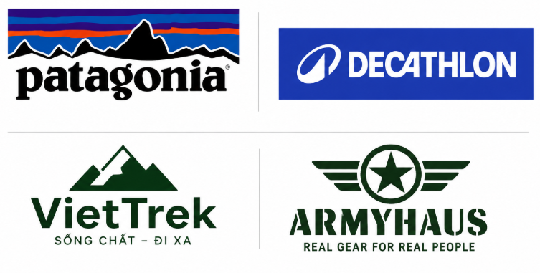
Figure 6: Patagonia Competitors in Vietnam (Hasan et al., 2024)

GE/McKinsey Assessment
Patagonia's market attractiveness is medium-high, yet it is not as competitive as it could be since it has a global brand but not much local presence and prices are high. Vietnam manufacturing relationships are also available but the local presence is limited (Agrawal, 2026). Therefore, selective investment in the right strategic position is to start in a niche premium urban market rather than nationwide expansion.
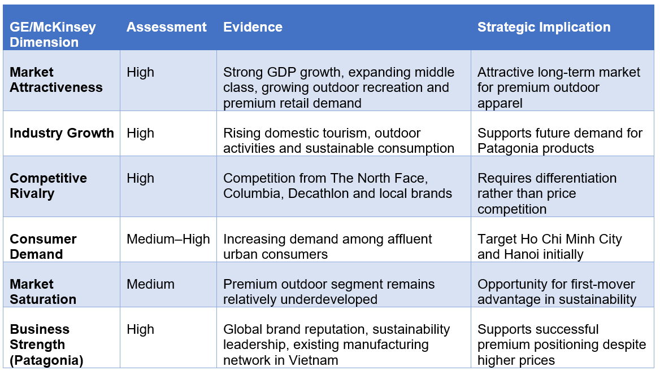
Table 6: GE/McKinsey Market Attractiveness Assessment for Patagonia in Vietnam (Author)

Market Entry Synthesis using Dunning's Eclectic Paradigm (OLI)
Dunning's Eclectic Paradigm is based on three conditions: Ownership (O), Location (L), Internalisation (I). The framework provides an explanation of why a firm may be able to export its firm-specific advantages to other countries, the reasons why a specific host country may be appealing to a firm, and the reasons why the advantage may need to be maintained in-house (Bulmer et al., 2024). Vietnam can be evaluated on the basis of OLI on Patagonia, but Vietnam's sustainability-focused goals need more expansive interpretation.
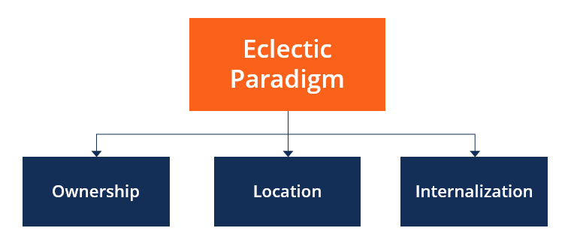
Figure 7: OLI Framework (Bulmer et al., 2024)

Ownership Advantages
Patagonia has good ownership advantages which can be shared with Vietnam if they are recognised and accepted by the consumer in that market. The most significant benefit it offers is its brand reputation, durability, environmental credibility, and circularity. Patagonia's B Corp certification and environmental efforts set it apart from the price-conscious brands like Decathlon, and are a foundation for premium positioning. This is also strengthened by the Worn Wear system of its, which also helps to prolong product life and promote repairs and not replacement (Bulmer et al., 2024).
Moreover, Patagonia is a company with a distinct operational advantage as the company already has manufacturing partners in Vietnam. This prior knowledge of the Vietnamese suppliers decreases the uncertainty a new company would experience in setting up its operation in Vietnam (Robertson et al., 2026). But the advantages of ownership entail restrictions as well. Patagonia's high environmental and social standards make it more expensive and its high prices limit the scope of its market. In 2025, Vietnam's GDP per capita was about $5,026, although GDP had increased by 8.02% (World Bank, 2025). This example illustrates that there is no direct correlation between GDP growth and a mass market for Patagonia's high-priced products. Therefore, its ownership benefits are more applicable to the high-income market in the city compared to the broader Vietnamese market.

Location Advantages
Vietnam offers both mixed and strategic location advantages for Patagonia. It is a very growing economy, as evidenced by its GDP growth of 8.02% estimated for 2025, GDP of $514 billion and inflation of 3.31% (World Bank, 2025). For Patagonia, however, these indicators should not be interpreted simply as evidence of market attractiveness. Rising purchasing power is a more important question as to whether that premium positioning is viable. Expansion of premiums is challenging nationwide, as Vietnamese purchasing power is lower than that of existing market Patagonia like the United States, Europe, and Japan, creating a potential market segment in the major urban centres (Hong & Thuy, 2026).
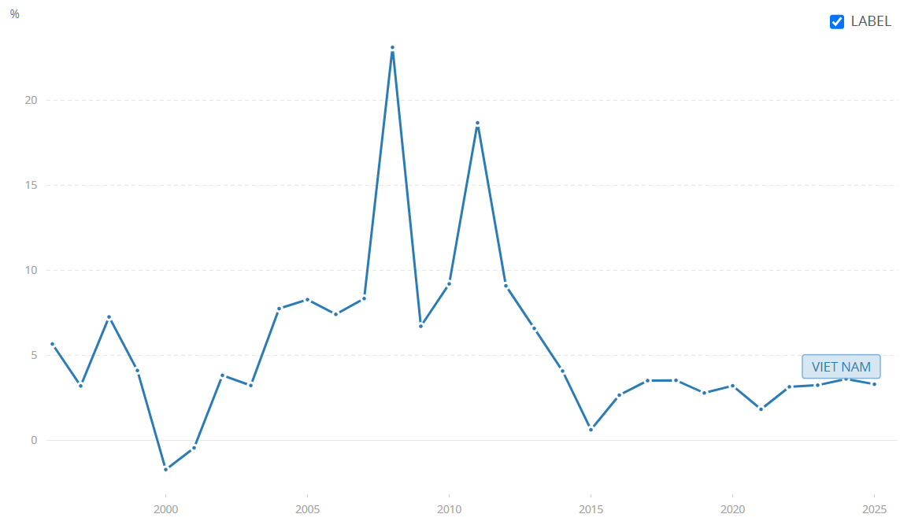
Figure 8: Vietnam's Inflation Rate (World Bank, 2025)
Vietnam's location advantage is greater if the current manufacturing role is considered. Patagonia already has manufacturing partners in Vietnam and has knowledge and relationships with them before venturing into the retail sector. This minimizes the risk of unfamiliarity when operating in a country where Patagonia does not currently have a footprint in the supply-chain.
Vietnam's direction of green growth is also in harmony with the sustainability model of Patagonia with the current environmental policies (Thanh et al., 2024). On the other hand, location advantage is mitigated by administrative requirements, regulatory considerations, exchange-rate risk, and by the competition of existing brands of outdoor and sportswear. Thus, Vietnam is not a mass market for the automatic disposition of any product, but rather a potential or select market, especially in major cities.

Internalisation Advantages
The internalisation aspect offers a compelling reason for Patagonia to stay in control of its retail business in Vietnam. The main elements of Patagonia's competitive advantage lie in intangible factors like brand authenticity, environmental standards, product quality, repair services, and customer experience. Licensing or franchising would make it harder to ensure that the local partners focus on sales instead of Patagonia's sustainability needs (Ha & Frommel, 2023).
Being a 100% operation would enable Patagonia to have pricing control, product presentation, staff training, environmental claims, and customer engagement (Le et al., 2023). This is especially relevant in Vietnam as Patagonia's high-end sustainability offering would have to be explained to consumers and not taken for granted as it is in other markets. If direct ownership is achieved it may also be able to link a flagship store with ecommerce and potential future Worn Wear activities, which may lead to increased consistency across customer touch points.
But internalisation is more costly in terms of capital, managerial inputs, and the risks associated with operating in Vietnam than exporting, or having independent distributors (Hong & Linh, 2023). Thus, only if the benefits of maintaining the intangible assets of Patagonia outweigh these extra costs is the decision justifiable. Given that authenticity and sustainability are central to Patagonia's differentiation, internalisation offers stronger strategic control, but it should be implemented gradually rather than through immediate nationwide expansion.
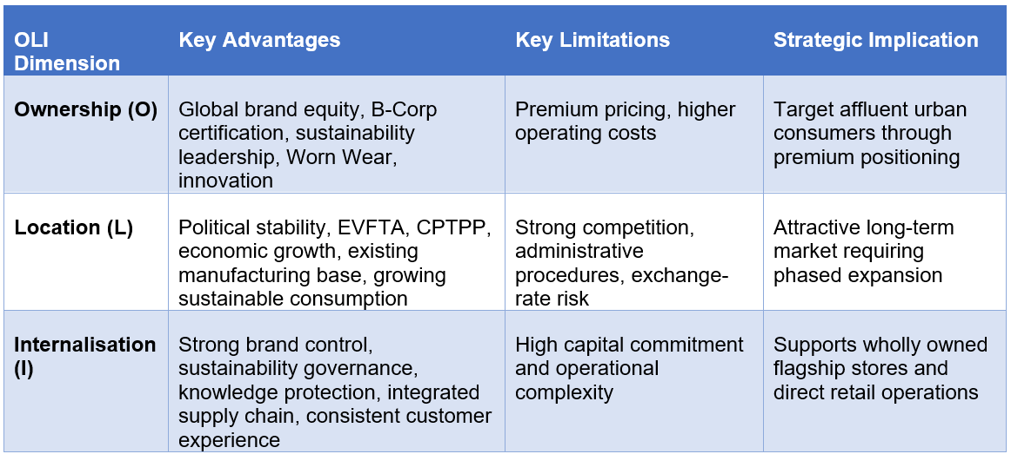
Table 7: Application of Dunning's OLI Advantages to Patagonia's Entry into Vietnam (Author)

Critical Assessment of OLI for Patagonia's Vietnam Entry
OLI offers a robust theory to explain the potential for Vietnam to become part of Patagonia's portfolio due to three conditions: Patagonia's distinctive ownership advantages, Vietnam's relevant location advantages, and the protection of these ownership advantages through internalisation. OLI does not completely account for Patagonia's internationalisation, however. The benefits to the economy are also strongly considered in the framework, and decisions made in Patagonia are also driven by environmental purpose, social responsibility, and long term sustainability (Nguyen et al., 2023).
This restriction underscores the need for a complement such as Institutional Theory. The implementation of the Green Growth Strategy and the Net Zero 2050 commitment (Pham, 2025), as well as Vietnam's environmental regulations, will have an impact on the legitimacy of Patagonia's sustainability-led approach. Likewise, for Patagonia there is a path-dependency advantage in its current Vietnamese manufacturing relationships which OLI cannot fully explain.
In general, OLI has a positive outlook on Vietnam as an entry opportunity, but it is a selective one. The best strategic fit is a wholly owned in a high-end urban location where Patagonia can maintain the integrity of its brand and sustainability credentials and see if Vietnamese consumers are prepared to pay premium for Patagonia's high-end products as their purchasing power and environmental awareness increase.

Entry Mode Strategy and Strategic Synthesis

Patagonia's Historical International Expansion Pattern
Patagonia's expansion into overseas markets has been successful, largely through carefully managed, incremental growth, instead of fast international market penetration. The Japanese case is the most obvious; Patagonia set up its Japanese subsidiary in 1988, and opened its first directly operated Tokyo store in 1989, with a further 17 Japanese stores opening by 2011 (Bato, 2024). This is in contrast to markets where Patagonia has less reliance on e-commerce and authorised dealers to achieve greater reach without investing as much in the physical channel. Patagonia has a present presence in over 70 markets and retail locations internationally, such as Japan, South Korea, Australia, Chile, and Argentina. The mix of direct and select external channels shows that Patagonia strives to control what is most important for the customer experience and brand values, and to invest less capital into what is not that important.
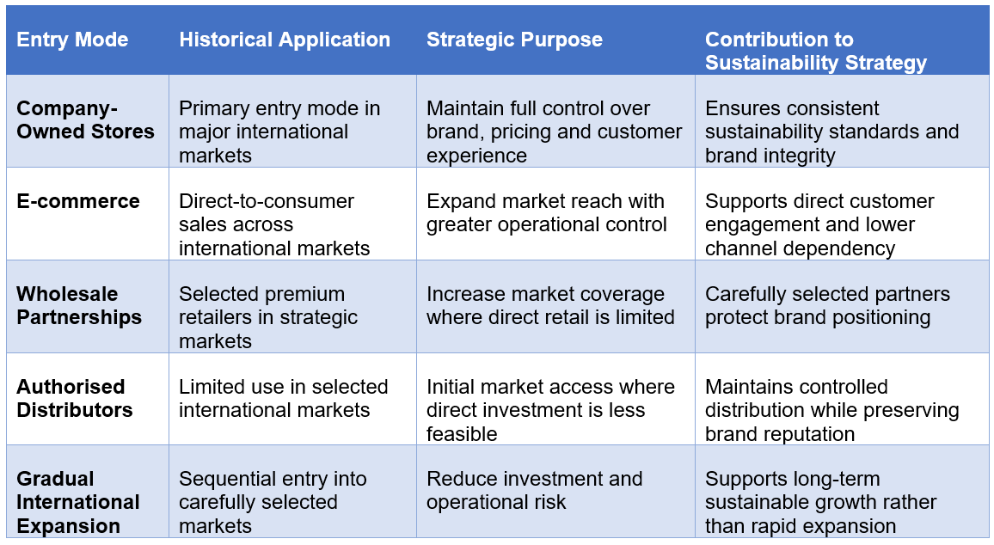
Table 8: Patagonia's Historical International Entry Modes (Author)

Strategic Fit and Justification: Critical Evaluation of Patagonia's Entry Strategy for Vietnam
Vietnam's historical preference for controlled internationalisation is an excellent foundation to build on when it comes to company owned retail, however it would be too rigid to copy without considering the market. According to Transaction Cost Theory, it is better to have transactions internalised when it is more expensive to monitor and secure transactions with external parties than to monitor and secure them internally (Nagle et al., 2025). This is especially important for Patagonia, given that environmental requirements and the quality and authenticity of their products are hard to define and track via traditional contracts.
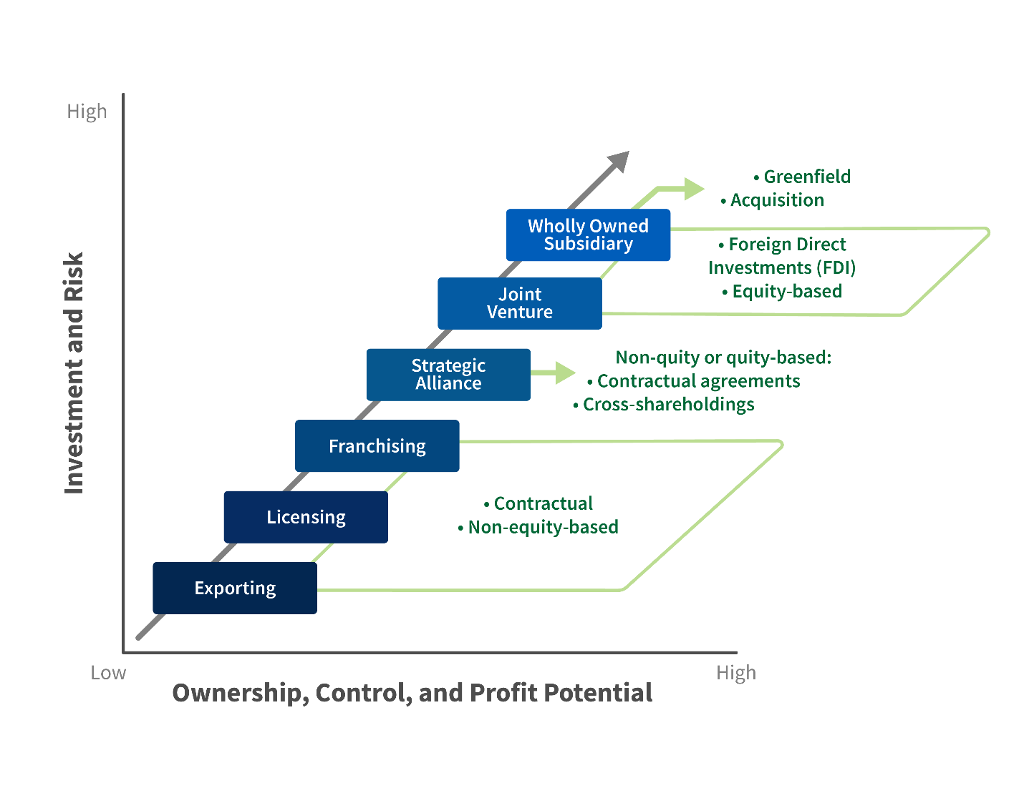
Figure 9: Entry Modes Strategies (Nagle et al., 2025)

Comparative Evaluation of Entry Modes
Wholly owned subsidiary is Patagonia's first choice as it gives the maximum control over pricing, customer experience, sustainability claims, and Worn Wear activities. The control is key in Vietnam as Patagonia would be offering a quality product in an economy where cost is still a concern. The downside is the highest capital cost and the regulatory, financial, and operation risk (Nguyen, 2026). Therefore, the appropriate application is a single flagship operation, not immediate nationwide investment.
A joint venture ranks second. It would give Patagonia local knowledge, relationships, and less financial risk than franchising or licensing, and more influence than each of those options. But there might be disagreements regarding pricing, environmental considerations, and growth rate, undermining the uniformity of Patagonia's business model (Anh, 2025).
Acquisition ranks third because it might offer instant access to the Vietnamese retail infrastructure and the customers. But the integration costs for Patagonia would be significant and there is little evidence that an existing outdoor retailer in Vietnam has a similar sustainability positioning (Allal-Cherif et al., 2023). This is making acquisition less strategic than creating Patagonia's own customer experience.
Exporting is fourth since it demands relatively low capital and offers flexibility, but weak control over customer experience and few opportunities to show repair, recycling, and circularity. Fifth and sixth are franchising and licensing, as these have relatively low investment needs, but increase the risk of brand protection and sustainability governance.
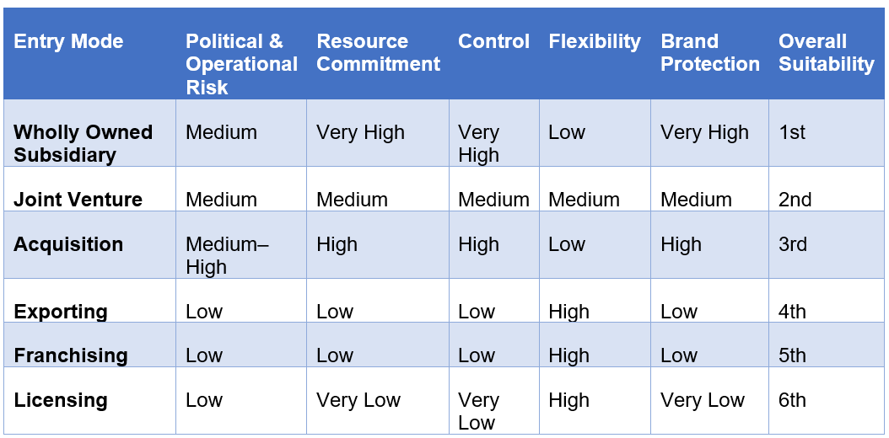
Table 9: Comparative Evaluation of Entry Modes for Patagonia in Vietnam (Author)

Strategic Fit for Patagonia
In addition, Internalisation Theory strengthens the argument for direct ownership, by highlighting that Patagonia's most important resources (such as brand credibility, sustainability knowledge, and ethical sourcing) are intangible and hard to be secured under contract. The 8.02% growth rate of GDP means Vietnam's economy is expanding, and GDP per capita at around $5,026 also shows the need for rational deployment of capital in the country, not nationwide (World Bank, 2025).
So, Patagonia should continue to manage the scale of their high-control strategy, putting in place one 100% owned store in Ho Chi Minh City as a flagship, while utilising their ecommerce channels, and then monitoring to see how it goes before additional investment.

Conclusion and Final Recommendations

Final Recommendations
- Enter Vietnam via a single 100% owned patent store in Ho Chi Minh City, where direct ownership offers better control than franchising, licensing, or joint ventures over Patagonia's high-end positioning and sustainability criteria.
- Combine the store with Vietnamese-language e-commerce and expand the market without having to copy the high fixed costs of opening additional stores.
- Leverage on the existing manufacturing network in Vietnam to enhance coordination of supply-chains, while keeping Patagonia's international environmental and labour standards.
- Test consumers' reaction, profit, and regulatory efficiencies before investment and require evidence, not assumption on the countrywide need, before going into Hanoi.

Conclusion
The analysis indicates that Vietnam is a viable but selective opportunity for Patagonia, rather than a market for rapid nationwide expansion. The economic capacity has been improving with the GDP of Vietnam growing at 8.02% in 2025, and GDP per capita about $5,026 (World Bank, 2025), which is still lower than the GDP per capita of established markets in Patagonia; thus, the potential premium customer base is still small. Vietnam's appeal lies not only in the size of its markets, but also in its growing “premium” urban market and established manufacturing ties.
The advantages of sustainable management, brand credibility, and durability are strong for Patagonia, and its economic growth, institutional alignment, and existing supply-chain relationships are relevant for Vietnam, making entry supported by the OLI analysis. But to meet regulatory standards, to be price competitive and be responsive to the competitive pressures, Patagonia must not over-commit resources.

Section 2

Reflective Account: Gibbs Reflective Cycle
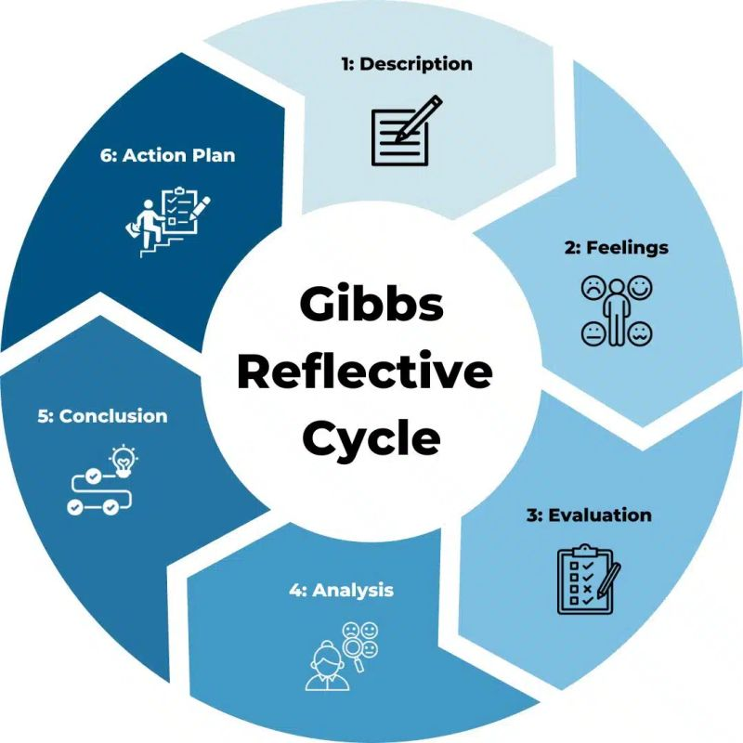
Figure 10: Gibbs Reflective Cycle (Anh, 2025)

Description
In this report, I critically analysed the expansion plan for Patagonia into Vietnam and applied academic theory and real business evidence to create an evidence-based international market entry strategy. I did not only concentrate on the economic growth of Vietnam, but developed a research structure that started with the analysis of the international strategy, sustainability-driven business model, and historical expansion patterns of Patagonia. I subsequently reviewed the political, economic, legal, cultural, and competitive context of Vietnam through peer-reviewed journal articles, government documents, and industry reports. The findings were systematically synthesized using Bartlett and Ghoshal's Transnational Strategy, Porter's Value Chain, Institutional Theory, Dunning's Eclectic Paradigm (OLI), and Transaction Cost Theory in order to support the suggested entry mode. In this report I made sure to apply each theoretical perspective, without justifying it alone, but only as it relates to Patagonia and Vietnam.

Feelings
At the beginning of this report, I found it challenging to identify a country that was strategically suitable for Patagonia while also providing sufficient academic and industry evidence for critical analysis. First of all, I concentrated on the potential of Vietnam as an economy, but then the lectures and academic articles gave me a better understanding that institutional, legal, and cultural elements are all crucial for the success of international expansion. Rather than focusing on descriptive statements, I now focused on the theories that are used to explain Patagonia's expansion strategy and how they complement each other. At the same time I gained a growing sense of ability to make critical comparisons of evidence and to make realistic recommendations based on academic research as well as country-specific data. This experience helped to enhance my confidence in doing research by myself and using international business theory as a basis for my strategic decisions.

Evaluation
The strongest aspect of my research process was the integration of academic literature with current country-specific evidence to support every strategic argument. I started collecting lots of data about Vietnam initially, but then realised that some of it wasn't applicable to Patagonia's entry into the market. This encouraged me to look at the evidence that showed the sustainability strategy, premium market positioning and long-term goals for international markets that Patagonia is taking. It was especially difficult to find recent data on Vietnam's premium outdoor apparel market as much of the available information was available for the broader fashion industry. To counteract this, I have contrasted ideas from academic journals, government information, and industry reports and only included information that I could make clear to be associated with Patagonia's business model.

Analysis
The creation of this report gave me a fresh outlook on international business theories. I started from treating each framework separately but realized in the lectures and case discussions that they are best used together. In such cases, I relied on Institutional Theory, as it explained how Vietnam's policy and regulatory framework might affect Patagonia's growth, and Dunning's OLI framework was used to consider whether direct investment was the best option. Also, I learned that it was impossible to tell the whole story of Patagonia's decision in terms of one single theory, because it was an environmental mission that also shaped the company's international expansion, in addition to the commercial aim. This helped me to build arguments, based on evidence not just describe theories or present information, and made me more confident of myself doing that.

Conclusion
The production of this report has led me to realize that the key to success when expanding internationally is not just to use one or two theories or market indicators. As I worked through the research I tended to be more selective in how I employed the academic literature with each source playing a direct role in the assessment of Patagonia's expansion into Vietnam. Before I made any recommendation, I learned to look at political, legal, cultural, and competitive factors, rather than the market simply because of economic growth. This way I was able to come to more balanced and realistic conclusions, as they took note of opportunities as well as potential risks. It also reiterated the need to challenge information but not just take it at face value and whether it is relevant to the firm's strategy or not.

Action Plan
From this report, I will make a few notes about things I would improve on for future research projects. I am thinking about starting to look for academic literature earlier, to allow me more time to look at different perspectives and find gaps in evidence. I also would like to build my skills to use company reports and academic sources but not be overwhelmingly dependent on one or the other. During this report, I learned that using theoretical approaches are more helpful when combined together instead of talking about them separately. Additionally, I plan to enhance my skills with the industry databases to gather more detailed market data, especially for niche industries that do not have easily accessible data.

References
Agrawal, A. (2026). Patagonia: Sustainability, sourcing, and supply chain strategy.
Allal-Cherif, O., Costa Climent, J. and Ulrich Berenguer, K.J. (2023). Born to be sustainable: How to combine strategic disruption, open innovation, and process digitization to create a sustainable business. Journal of Business Research, 154, p.113379. doi: https://doi.org/10.1016/j.jbusres.2022.113379
Anh, P.V. (2025). Recognition over performance: A critical review of ESG practices in Vietnam. SSRN Electronic Journal. doi: https://10.2139/ssrn.5478947
Bato, V. (2024). The future of international business: Integrating the circular economy for sustainable success. E3S Web of Conferences, 585, pp.11004–11004. doi: https://10.1051/e3sconf/202458511004
Bozsik, N. and Ngo, D.M. (2023). The effects of foreign direct investment on the performance of small-medium enterprises: The case of Vietnam. Journal of International Studies, 16(1), pp.57–70.
Bulmer, S., Palakshappa, N., Dodds, S. and Harper, S. (2024). Sustainability, brand authenticity and Instagram messaging. Journal of Business Research, 175, p.114547. doi: https://10.1016/j.jbusres.2024.114547
Can, L. Van and Dang, T.N. (2024). Challenges in searching for Vietnam’s growth drivers through 2030. Asian economic policy review (Online). doi: https://10.1111/aepr.12458
Chien, T.M., Phuc, P.H. and Diem, H.T.N. (2026). Protecting children’s rights in international trade disputes: A legal perspective from Vietnam on products infringing intellectual property rights. The Future of Child-Friendly Justice and Children’s Rights in Vietnam, pp.227–247. doi: https://10.1007/978-981-95-3521-7_15
Dezi, L., Hysa, X., Calabrese, M. and Mercuri, F. (2025). Open total quality management in the circular economy age: A social enterprise perspective through the case of Patagonia. Total Quality Management & Business Excellence, 36(3–4), pp.1–15. doi: https://10.1080/14783363.2022.2051698
Furst, T. and Akdag, H.C. (2025). Integrating circular economy principles in the fashion industry: A case study of Patagonia. Lecture notes in mechanical engineering, pp.325–338. doi: https://10.1007/978-3-031-83611-4_24
Ha, P.V. and Frommel, M. (2023). Corruption, business environment, and firm growth in Vietnam. International Journal of Finance & Economics, 28(3). doi: https://10.1002/ijfe.2547
Hasan, M.R., Swazan, I.S. and Das, D. (2024). Beyond the seams: Evaluating competitiveness and comparative advantage in Vietnam’s apparel industry. Journal of Chinese Economic and Foreign Trade Studies, 17(1), pp.4–28. doi: https://10.1108/jcefts-10-2023-0050
Hong, H.P. and Thuy, H.T. (2026). Vietnam’s challenges in fulfilling EVFTA and CPTPP commitments on sustainable marine resource management: Legal regulations, practice and problems. Asia-Pacific Journal of Ocean Law and Policy, pp.1–51. doi: https://10.1163/24519391-bja10100
Hong, N.T.H. and Linh, T.K. (2023). Institutional investors, corporate governance and firm performance in an emerging market: Evidence from Vietnam. Cogent Economics & Finance, 11(1). doi: https://10.1080/23322039.2022.2159735
Le, T.-H., Park, D. and Castillejos-Petalcorin, C. (2023). Performance comparison of state-owned enterprises versus private firms in selected emerging Asian countries. Journal of Asian Business and Economic Studies, 30(1). doi: https://10.1108/jabes-08-2021-0116
Le, T.T., Bui Thị Tuyet, N. and Le Anh, T. (2025). Drive sustainable business performance with humane entrepreneurship, knowledge management: The mediation of sustainable business advantage and sustainable business model innovation. European Journal of Innovation Management. doi: https://10.1108/ejim-12-2023-1079
Macro, S. and Ott, U.F. (2024). The evolution of the ability to effectively innovate in a transnational organization – a configurational analysis. Journal of International Management, 30(6), pp.101200–101200. doi: https://10.1016/j.intman.2024.101200
Manaysay, F.V. (2026). Envisioning a transition towards a circular economy for plastics: Policy narratives in the extended producer responsibility regulations of the Philippines and Vietnam. Asian Politics & Policy, 18(2). doi: https://10.1111/aspp.70077
Nagle, F., Seamans, R. and Tadelis, S. (2025). Transaction cost economics in the digital economy: A research agenda. SSRN Electronic Journal. doi: https://10.2139/ssrn.3661856
Ngo, T.T.A., Vo, C.H., Tran, N.L., Nguyen, K.V., Tran, T.D. and Trinh, Y.N. (2024). Factors influencing generation Z’s intention to purchase sustainable clothing products in Vietnam. PLOS ONE, 19(12), p.e0315502. doi: https://10.1371/journal.pone.0315502
Nguyen, M.Q. and Hà, T.A. (2026). Exploring the impacts of cultural factors at individual level on environmental value orientations: Insights from young Vietnamese consumers. Acta Psychologica, 264, p.106514. doi: https://10.1016/j.actpsy.2026.106514
Nguyen, P.T. (2026). The impact of technical barriers to trade on Vietnam’s fruit and vegetable exports to key markets. Journal of International Logistics and Trade, pp.1–16. doi: https://10.1108/jilt-09-2025-0082
Nguyen, T.T.H., Darsono, S.N.A.C., Phan, G.Q., Pham, T.H. Van, Bach Thi, H. and Johari, S.M. (2023). The nexus between corporate performance and state ownership in Vietnam: Evidence of state ownership’s inverted u-shape and provincial business environment influences. Journal of Risk and Financial Management, 16(12), p.499. doi: https://10.3390/jrfm16120499
Patagonia (2025). Company history. [online] Patagonia. Available at: https://www.patagonia.com/company-history/
Pham, H. (2025). The influence of corporate social responsibility (CSR) on brand equity: From sustainable marketing perspectives. doi: https://http://www.theseus.fi/handle/10024/892153
Phan, T.N. and Le, S.T.Q. (2025). Current status and analysis of the solution of greening in the textile industry in Vietnam. Engineering Science Letter, 4(01), pp.8–12. doi: https://10.56741/esl.v4i01.657
Robertson, V., Truong, L., Botzenhardt, T. and Pätzmann, J.U. (2026). Consumer attitudes towards clothing rentals in Vietnam and Germany: Insights for sustainable fashion start-ups. Contributions to Management Science, pp.99–125. doi: https://10.1007/978-3-032-17560-1_6
Shourkaei, M.M., Taylor, K.M. and Dyck, B. (2024). Examining sustainable supply chain management via a social‐symbolic work lens: Lessons from Patagonia. Business Strategy and the Environment, 33(2), pp.1477–1496. doi: https://10.1002/bse.3552
Statista (2026). Topic: Retail sector in Vietnam. [online] Statista. Available at: https://www.statista.com/topics/5334/fmcg-retail-in-vietnam/?srsltid=AfmBOopATRI5BGRgdAPvLnRrSARru86ZKhsUCLyffqJr3HYP8f6l9uiG
Thanh, T.T.M., Duy, V.B., Ngoc, L.M., Thao, N.T. and Thu, D.T. (2024). Comparative analysis of the impacts of CPTPP and EVFTA on Vietnam’s textile export activities. VNU University of Economics and Business, 4(2). doi: https://10.57110/vnu-jeb.v4i2.255
The Culture Factor (2025). Country comparison tool - Vietnam. [online] Theculturefactor.com. Available at: https://www.theculturefactor.com/country-comparison-tool?countries=vietnam
Tran, H.M. and Thanh, N.V. (2026). The journey to sustainable green in Vietnam By 2050. Advances in Economics, Business and Management Research, pp.510–532. doi: https://10.2991/978-94-6239-624-1_38
World Bank (2025). Viet Nam | World Bank Group. [online] Worldbank.org. Available at: https://www.worldbank.org/ext/en/country/vietnam

