TESCO CORE VALUES ˂=> ALDI CORE VALUES
Developing Workplace Critical Thinking
BMSW5101
Grasu Cristina-Andreea
(1814440)

Applying the Toulmin Model of Argument I will discuss Tesco and Aldi values on the employees and what impact has on their life. I will compare the main values of the companies and what is the contrast between them. Tesco’s main objective regarding their values are : “No one tries harder for customers” , “We treat people how they want to be treated”, “Every little help makes a big difference” (Tesco PLC, 2020) while the Aldi values are : “Consistency”, “Simplicity”, “Responsibility” (Careers.aldi.us, 2020).
Each of these companies have different goals in their organization. Tesco want to offer to their employees customers and communities every think that can ensure the organizational success such as home-delivery , low prices , Clubcard , click and collect and benefits for his employees such as holiday and sick pay , maternity leave and many others (Tesco-careers.com, 2020). Also, Aldi says that “…a great employer means offering a culture that values the differences of everyone it employs” this means that they treat everyone with equality. (Aldi.co.uk, 2020)
CLAIM : Tesco value his employees more that Aldi.
DATA/EVIDENCE: Tesco puts more value on employees than Aldi because in one store you will find more employees on a single shift and each dealing with a specific sector such as: Customer Assistant, Customer Delivery Drivers, Management Colleagues and Warehouse assistant, this thing brings benefits to his employees because they can be less stressful and motivated them to work with much pleasure to satisfy Tesco’s customers. (Tesco-careers.com, 2020).
Based on what and employee says Aldi, “on a single shift has no more than 4 or 6 employees and…. senior management don’t care how badly we as employees are injured or exhausted or totally and thoroughly burned out from not having enough support and recognition for our grueling hard work!” (Indeed.com, 2018)
WARRANT: Tesco value” We treat people as they want to be treated “evidence the fact that Tesco treats their employees with trust and respect.(Tesco PLC, 2020) while Aldi seems to give more importance in what they offer to their customer and not in how they treat their employees , “Creates efficiency, clarity and clear direction within our organization as well as for our customers” (Careers.aldi.us, 2020).

BACKING: Based on the employees reviews regarding Tesco and Aldi environmental workplace people says that Tesco is : (Indeed.co.uk, 2020)
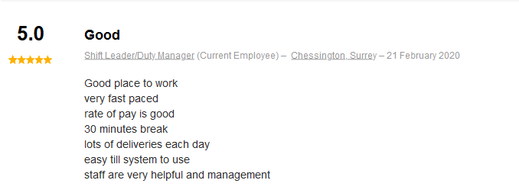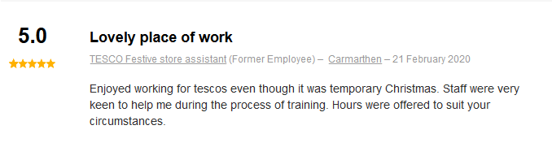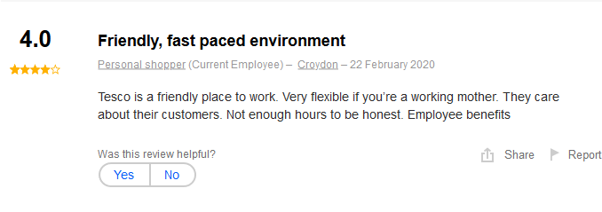
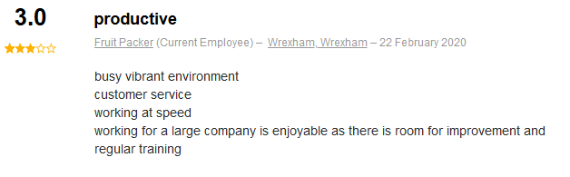

While from employees’ point of view working for Aldi sometimes can be exhausted, really tired and stressful. In fact and employees says that: “If you don't hit these targets, you are shown your actual speed and have a performance review meeting with managing staff. If this happens three times you can be let go” (Stice, 2019)
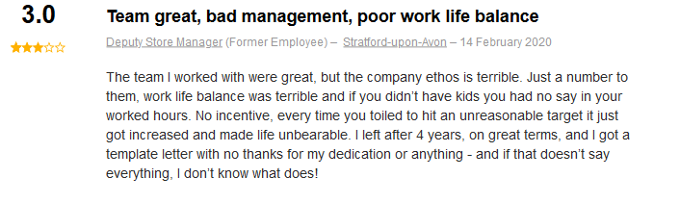
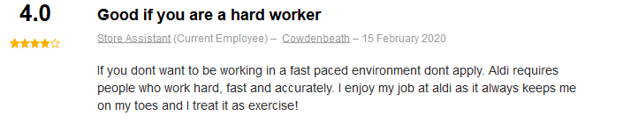
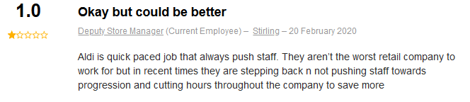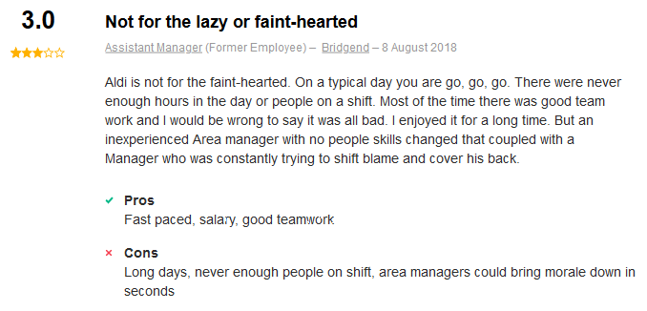
REBUTAL:. There can always be discussions about how employees see the way their company treats them, even if employees say the company doesn't treat them the way they claim, there can always be pros and cons. Based on my research for an employee is more important , to be paid fairly and treated with respect than the company’s social impact.” According to the polling and research company Gallup, companies with disengaged workers suffer from 16% lower profitability, 18% lower productivity, and 37% lower job growth Organizations with engaged employees, however, receive 100% more job applications.” (Heinig, 2018)
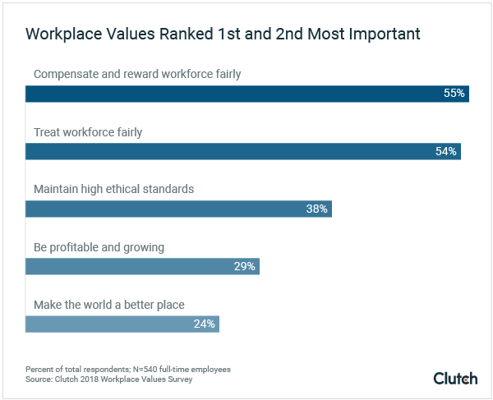
QUALIFER: A retail company needs to put more emphasis on the personal values of the employees only so that the company will be successful because, if the employees are treated with respect in their turn, they will satisfy customers.

REFERENCES
1. Tesco PLC. (2020). Core Purpose and Values. [online] Available at: https://www.tescoplc.com/about/how-we-do-business/core-purpose-and-values/ [Accessed 22 Feb. 2020].
2. Careers.aldi.us. (2020). Working Here. [online] Available at: https://careers.aldi.us/working-here [Accessed 22 Feb. 2020].
3. Tesco-careers.com. (2020). Benefits | Tesco Careers. [online] Available at: https://www.tesco-careers.com/explore-our-world/benefits/ [Accessed 23 Feb. 2020].
4. Aldi.co.uk. (2020). Corporate Responsibility- Our People- Equal Opportunities - ALDI UK. [online] Available at: https://www.aldi.co.uk/about-aldi/corporate-responsibility/people/equal-opportunities [Accessed 23 Feb. 2020].
5. Tesco-careers.com. (2020). Stores and Distribution | Tesco Careers. [online] Available at: https://www.tesco-careers.com/stores-and-distribution/ [Accessed 23 Feb. 2020].
Indeed.com. (2018). How many full time employees does an Aldi store have | ALDI | Indeed.com. [online] Available at: https://www.indeed.com/cmp/Aldi/faq/how-many-full-time-employees-does-an-aldi-store-have?quid=1anl631nk1agi4dt [Accessed 23 Feb. 2020].
6. Stice, J. (2019). Workers reveal what it's really like to work at Aldi. [online] Mashed.com. Available at: https://www.mashed.com/150935/workers-reveal-what-its-really-like-to-work-at-aldi/ [Accessed 24 Feb. 2020].
7. Heinig, I. (2018). What Do Employees Value Most in Their Job? | Clutch.co. [online] Clutch.co. Available at: https://clutch.co/hr/resources/what-employees-value-most [Accessed 24 Feb. 2020].

