Student Id - 1715708
Name: Frederic Legris
Work-Based Project
Module BMPF4008

Word count: 3753
Date of Submission: 30th April 2019

Contents
1 Project Proposal 2
1.1 The Topic 2
1.2 Rational 2
1.3 The Intended Impact 2
1.4 The proposed Methodology 3
1.5 Ethics and Insider Researcher 4
2 Project Report 4
2.1 Introduction 4
2.2 Literature review 4
2.2.1 Heat Pumps 5
2.2.2 PHOTOVOLTAIC 5
2.3 Methodology 6
2.4 Findings 8
2.4.1 Calculation and estimation 10
2.4.2 Mauritius Meteorological Services 10
2.4.3 Photovoltaic 11
2.4.4 Heat Pump 12
2.5 Conclusion & Recommendations 12
References 14
Websites: 14
3 Appendices 15
Appendix 1: Questionnaire 15
Appendix 2: Analysis 17
Appendix 3: Solar Panels 19
Appendix 4: Heat Pump 21
4 Ethics Form 22

1 Project Proposal

1.1 The Topic
A feasibility study to find a viable and sustainable method to heat the main swimming pool (1800m3) of LUX* Belle Mare at a minimum of 28 degrees Celsius in winter.

1.2 Rational

For the past five years, hotels in Mauritius have started promoting their heated swimming pools as a Unique Selling Point especially during the winter season.
As part of the renovation in 2014, LUX* Belle Mare embraced the same strategy and implemented a system in order to heat its swimming pool. The system consisted of capturing the heat emission from the chillers in order to heat the pool. This method only reaches its optimum in summer when the chillers are working at full capacity. In winter, when the chillers are used at half capacity, the heat emission is low and hence not adequate to heat the swimming pool.
Whilst the hotel is marketed with a heated pool, the temperature of the latter reaches an average of only 20 degrees Celsius in winter. This has led to many guest complaints and pressure from tour operators resulting in potential loss of business.

1.3 The Intended Impact

The intended impacts of the research is as follows:
- Identify and implement a cost effective and environmentally friendly method for heating the pool of LUX* Belle Mare up to a minimum of 28 degrees Celsius in winter.
- In so doing, minimise or eliminate the guest complaints related to pool temperature.
- This research would also have a positive impact on my knowledge and understanding of sustainable pool heating methods which is aligned to the “green philosophy” of The Lux Collective.
- Moreover I will be able to grasp maximum information and enrich myself in those new technologies which are more and more on demand

1.4 The proposed Methodology

The method which will be used for this research will be primarily qualitative and explorative (both primary and secondary data). It will consist of:
Existing research and survey:
- Overview of what competitors proposed and are using (e.g.: Temperature of water, size of pool, strategic locations….)
- Sunlight yield on the east coast region
- Type and capacity of heat pumps to be used on the existing system

Interviews:
The purpose of interviews is to obtain more detailed qualitative information from Maintenance Managers of other resorts regarding their systems which could help to design and implement a durable and green solution to the problem.

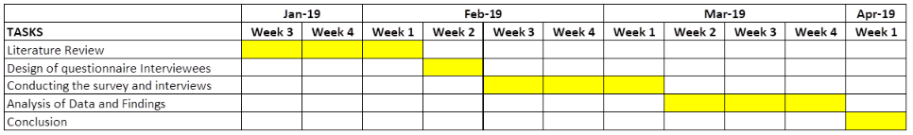

Figure 1: Gantt chart

1.5 Ethics and Insider Researcher

The research will be specific to the outlined technical field and will thus have no impact on a third party. The first part of the research will be based on published articles and journals. The second part of the research will involve hotel maintenance managers on the east coast of Mauritius who will share only what they are willing to share. Data collected will be used for the purpose of this research only.

Project Report

2.1 Introduction

The purpose of the project is to find a practical and sustainable method of heating the main swimming pool (capacity 1800m³) of LUX* Belle Mare at a desired temperature of 28 degrees Celsius in winter.
The implementation of a system in order to heat the swimming pool was done in 2014 during the renovation. The system consisted of using the heat emission from the chillers in order to heat the pool. This method only reaches its optimum temperature in summer when the chillers are working at full capacity. In winter, since the chillers only operate at 30% of its capacity, the heat recovered is very low, resulting in a temperature around 20 degrees which is 9 degrees less than the desired temperature. This has led to many guest complaints and explicit demand to fix same from tour operators.
The aim of the study will help in developing new skills, explore what is realisable here in Mauritius and benchmark against competitors who also have heated/temperature controlled pools.

Literature review

The research focused on the value of using:
a) Heat pumps
b) Photovoltaic panels

2.2.1 Heat Pumps

The operating principles of a heat pump is that it uses the ambient temperature and the energy found in same to heat the water from the pool. The heat pump will work at its highest peak when the air becomes warmer. (See Figure1)
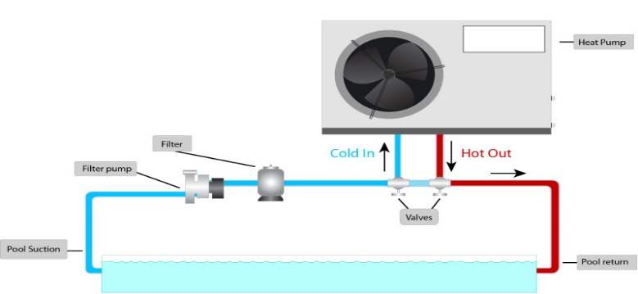
Figure 1: Heat pump operation
Chan et al (2003) have done a study on the evaluation of the thermal performances, energy saving and financial feasibility of using heat pumps for heating of an outdoor swimming pool compared to conventional electric boiler and gas fired condensing boilers. Even if the survey was not conducted in Mauritius, the principle of using the heat pump remains the same and the more the ambient air is hot and damp, the better will be the performance of the heat pump.
In doing so, the saving in energy when using heat pumps compared to fossil fuel is less expensive as Mauritius is well known for its hot climate.
Moreover, green house and noxious emission can also be reduced indirectly, thus contributing to a greener planet.

2.2.2 PHOTOVOLTAIC

Since the hotel sector is energy intensive and electricity is a major expense for hotel operations; making use of greener sources of energy will help to reduce operation their electrical consumption.
Being blessed with a good light exposure on the east coast of the island even during the winter period, the photovoltaic panels will be an advantage for producing electricity which will in return run the heat pumps and at the same time reducing the energy consumption.
Consequently, the introduction of photovoltaic panels which are built in such a way that it convert day light into electricity, could be advantageous.
Hossam-Eldin et al (2015) has been studying three generations of photovoltaic and has demonstrated to what extent the use of Green technology has evolved during the past years.
The performance of the Photovoltaic technologies and different basic materials used for its manufacturing stage have been dissected and elaborated in such a way that the complete overview of its conception is obtained.
Hossam-Eldin et al (2015) have mentioned that nowadays, with the new technologies in photovoltaic, it is proven that 28% of the sun’s energy can be converted into electricity. In the current situation, the fact that in winter we do have only 6hrs of sunlight (minimal compared to summer), the yield will still be sufficient to produce electricity with the new technologies in photovoltaic.
Nema et al (2010) shows different characteristics of photovoltaic and how solar cells convert photons into electric potentials and when connected in series can generate a substantial voltage.
The combination of the two technologies (Heat Pumps & Photovoltaic) with more in-depth research on site and calculation will be of great asset in the realisation of the project.

2.3 Methodology

The research work was based on our direct competitors in a competitive set of same category as LUX* Belle Mare along the east coast. Likewise, all these hotels have the same characteristics as being exposed to the south east trade winds dropping at the same time the ambient temperature during winter season. Other important features are that most of these hotels have sea facing pools.

COMPETITIVE SET
HOTELS | POOL HEATED
- St Geran Hotel | YES
- Prince Maurice Hotel | YES
- Constance Hotel | NO
- Long Beach Hotel | YES
- Residence Hotel | YES
- Shangri-La Hotel | YES
- Four Seasons Hotel | YES

Table 1.3: Competitive set on the East Coast

The methodology is both qualitative and quantitative in order to be aligned with what competitors are proposing to their guest and among those 7 Hotels listed in the competitive set featured above in Table 1.3, one has been removed since it doesn’t offer this facility to their guest.
Other aspects of the survey are:
- Temperature setting of their pool
- Size of pools that are being featured in those different hotels
- Strategic location
- Method used to heat the pool
- Problem encountered with those equipment
- What are the hidden costs attached to same
The survey of not more than 30 minutes, was made on site together with my peers - Maintenance Managers as these hotels which are some 5kms to 10 kms along the same coastal road. The questionnaire used was more as a guide to have a consistency on the research questions, making the recording part consistent and on track with what was expected at the end.
The enquiry was made in such a way that explicitly outlined the technical information needed and thus had no impact on a third party. It was conducted as a more casual meeting - face to face dialogue. Before any site visit, the maintenance managers were contacted by phone just for a small brief on what was the purpose of the survey and were re-assured that it was only for data collection purposes.
Despite the fact that risk of any adverse effect or outcome was very low, in regards to any negative response from my peers, most of the technical data was already available online for the in depth calculation part such as:
- Meteorological solar data from dawn to dust (from meteorological station)
- Capacities of heat pumps/water flow required
- Photovoltaic production range (calculation of numbers of panels required for green energy sources to reduce energy consumption)
Moreover, pertaining to The Lux Collective code of Ethics and Data protection Act 2017, all data generated by the research is stored on company computers which are protected, anonymous and used only for research purposes outlines.

2.4 Findings

The first component of the survey was based on the 07 hotels listed in the competitive set same as LUX* Belle Mare where:
- Constance Hotel was removed since their main pool is not heated
Based on the information gathered from the questionnaires an Analysis has been done in a spreadsheet (Appendix 2)
The survey was done with 06 hotels’ Maintenance Managers namely:
- St Geran Hotel
- Prince Maurice Hotel
- Long Beach Hotel
- Residence Hotel
- Shangri-La Hotel
- Four Seasons Hotel

The survey itself was done in three distinct parts:
- A questionnaire was made to ease the survey. Before going through, an explanation was given to interviewee
- A quick site visit of their installation to have an overview of their system in place.
- Collection of secondary data from meteorological station and some affiliated companies with whom we use to work.(same regroup in appendix 3,4)
Question 1 was asked in such a way to investigate on the volume of water used in the other resorts pertaining to their respective swimming pools ,as same is very important to determine which is the best methods that was used to heat such volume of water. Therefore, the analytic part reveal that 5 hotels out of 6 have a volume of water to be heated which is above 800m3, same as LUX* Belle Mare, which contains 1800m3 of water.
During the discussion with the other maintenance managers on the swimming pool capacity, one important point was raised on the fact that the more the volume of water increases, the more the re-circulation takes time. As after filtration of pool water, it passes through a heat exchange that transfers the heat recovered from the chillers to the water via inox plates (see Figure A). This cycle continues until the required temperature is reached (In simple terms, the total volume of water of a said pool has to pass through the heat exchanger to be able to achieve the required temperature.)
The temperature range for the pools in all the listed hotels are around 26-28 degrees, while 5 of the 6 hotels have a heating time of maximum 12Hrs to reach the required temperature.
Moreover, 100% of the 06 properties listed above use the heat recovery system from their chillers (Centralised Air-Conditioning System) which are of higher performance in terms of heat recovery compared to LUX* Belle Mare Hotel.
During the site visit while doing the survey, it has been noted that the chillers from the other resorts were more efficient in terms of capacity and make. The in-built system of their chillers had a better heat recovery system compared to what is readily available at LUX* Belle Mare where, the temperature recovered from the heat recovery system is around 40 to 45 degrees compared to 50 to 60 degrees for the other hotels. The way the design of heat recovery was done, they were able to exploit the maximum possible from the heat recovery system which was then stocked in big tanks before diverging same to different usage.
From big storage tanks, the water was pumped directly to the boiler and reheated if need be for domestic purposes. Another pump circulated the volume required to a heat exchanger (see Figure A) next to the pool plant room for the pool heating.
For question 4 on whether the hotels have guest complaints about pool temperature, all hotels said they had none. However from the research perspective, the chillers work less during the winter season, due to the ambient temperature being cooler and therefore the heat recovered from the chillers will be less and somehow the water might be less heated or can take longer time for the pool to reach the required temperature. Refer to average temperature in winter as opposed to summer in Figure 2 below.

Note:
On the left hand side there is an inlet for hot water from the chiller heat recovery and output back to chillers.
On the right hand side there is the input from pool filtration system that takes the heat through the thin inox plate via a heat transfer technique and sends it back to the pool.
The same process is done continually until the entire pool reaches the required temperature.
Figure 2- heat exchanger

In terms of energy recording system, the maintenance managers from the other resorts don’t perform any separate recording for energy consumption but similarly to LUX* Belle Mare Hotel, all the other hotels tabulate their electrical consumption per guest and per night. On average, 4 hotels on 6 have a total consumption which varies between 55Kwh and 60Kwh per guest and per night, whereas 2 hotels are less than 50Kwh per guest and per night.

2.4.1 Calculation and estimation

The exercise below is derived from the comparison of average electrical consumption of any of the hotels found in the competitive group. Another important note that was discussed with the other maintenance manager was on the energy required to operate such big hotels with large amount of rooms, pools, equipment, pumps, air-conditioning system, lightings and that in a near future, alternative green sources will be required.
Assuming an average of 150 rooms’ hotel with a 100% occupancy and 300 guests, the total cost for electrical consumption per day will be approximately Rs110, 310. (1Kwh =Rs 6.14)
Therefore, any hotel in the competitive group spends approximately more than Rs 3,039,300 only on electricity consumption per month.
Another cost effective method in the long run, is the usage of chemical product for stability of the pool water. Even though, 5 hotels mentioned that they don’t have a variation in product-use for cleaning, the answers obtained seemed to be biased as with high temperature the chemical products have the tendency to evaporate quicker. This question is more quantitative, as those hidden costs can alter maintenance expenses in the long run.
Similarly, the servicing contract for the chillers varies as follow:
- 2 hotels have servicing three times per year twice per year for
- 4 hotels conduct same twice per year

In doing so, the probability of having breakdowns is very low.
The scenario is the same with the actual heat recovery system of LUX* Belle Mare Hotel: this is where the findings will help in designing a cheaper and more ecological method to top-up the swimming pool during the winter season to the desired temperature.

2.4.2 Mauritius Meteorological Services

An in-depth survey was made on the meteorological services for the East Coast in order to have an overview of the weather conditions in the region (see Table 1.4.2 below)

Mauritius Meteorological Services
Region: East
Station: Fuel
MONTH | TEMPERATURE |  |  |  | HUMIDITY | WIND |  | SUNSHINE |  | RAINFALL | NO OF DAYS WITH | NO OF DAYS WITH
MONTH | Mean Max | Highest Max | Mean Min | Lowest Min | % | Mean Wind Speed | Highest Gust | Daily | Mean
MONTH | (71 - 00) | Recorded | (71 - 00) | Recorded | % | Km/h | Km/h | Hrs per day | Monthly | LTM (71-00) | RAINFALL >1MM | RAINFALL <5MM
January | 28.8 | 34.5 | 22.0 | 16.0 | 84 | 8.00 | 156 | 7.00 | 216.3 | 261.3 | 17 | 9
February | 28.7 | 33.0 | 22.3 | 17.5 | 86 | 9.1 | 238 | 6.6 | 186.1 | 334.1 | 17 | 10
March | 26.6 | 34.0 | 22.0 | 17.4 | 84 | 9.6 | 201 | 6.7 | 209.4 | 231.2 | 17 | 9
April | 27.6 | 32.5 | 21.2 | 16.3 | 85 | 9.1 | 121 | 6.00 | 179.1 | 240.00 | 17 | 9
May | 26.2 | 29.5 | 19.3 | 14.0 | 83 | 9.3 | 60 | 6.3 | 193.9 | 167.7 | 15 | 8
June | 24.6 | 28.5 | 17.8 | 12.8 | 82 | 10.8 | 78 | 6.1 | 182.8 | 104.00 | 14 | 7
July | 23.7 | 27.5 | 17.3 | 11.0 | 82 | 12.3 | 61 | 6.1 | 187.6 | 102.5 | 16 | 6
August | 23.8 | 28.5 | 17.00 | 12.0 | 81 | 11.7 | 63 | 6.1 | 187.7 | 104.9 | 15 | 6
September | 24.3 | 28.0 | 171 | 11.0 | 81 | 11.2 | 69 | 6.3 | 189.5 | 70.1 | 11 | 4
October | 25.4 | 30.0 | 17.9 | 11.0 | 81 | 11.00 | 59 | 6.8 | 210.1 | 62.2 | 11 | 3
November | 27.1 | 31.5 | 19.4 | 12.5 | 81 | 10.1 | 114 | 7.3 | 219.8 | 82.00 | 10 | 4
December | 28.2 | 32.5 | 21.00 | 16.0 | 84 | 9.1 | 200 | 7.00 | 216.8 | 201.8 | 13 | 7

Table 1.4.2: Mauritius Meteorological services yearly temperature record sheet

Note:
The highlighted figures are the five months during which the temperature and sunlight are lowest

Mauritius being a tropical island and despite the meteorological conditions that prevail during the winter season, the temperature proves to be quite high compared to winter in the northern hemisphere.
As highlighted in figure 3 the minimum temperatures registered are 17 - 22 degrees during the day and with 6.1 hours of sunshine per day at a humidity level of 81% as per chart above. In those conditions, the implementation of photovoltaic panels can be operating at an optimum efficiency with those parameters.
Another piece of information obtained from “greenyellow” which is a company working closely with us (see appendix 3).The quality, thickness and dimensions of a photovoltaic panels, may give outstanding performances at low irradiance (very low exposure to sunlight) with an average efficiency of 96.5 % for irradiances between 200W/m2 to 1000W/m2 .Therefore, with minimum sunlight/sun exposure the performance of those photovoltaic panels remain high.

2.4.3 Photovoltaic

From all the data collected, an evaluation of a section of the resort’s roof-top was done in collaboration with a local supplier, Sotratech Ltd, in order to calculate the quantity of panels that can be implemented in the resort and the outcome in terms of energy.
The result of this exercise gave a total of 112 photovoltaic panels for a coverage of only 30% of roofs in the resort. Assuming that a 100% coverage would end-up with a total of 373 panels that can be implemented in such a way that all the solar energy produced always gets shared through the existing power grid, taking the electrical load way for the heat pumps.
An average dimension of a panel is around 1.44m2 for a yielding of 288W, the estimation of the total production at a very low sun radiation during winter period can reach 107.4KW/day and a total of 3,222 KW/ month
Those estimations show that the implementation of the heat pumps will be powered by green energy, resulting in a saving on the electrical consumption after the installation of the heat pumps to top up the pool temperature from the existing circuit.

2.4.4 Heat Pump

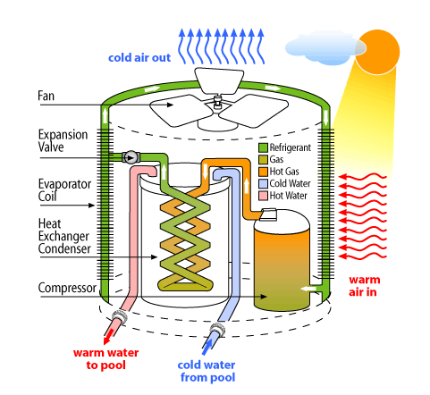
The heat pump also works at its optimum power when the ambient temperature is hot. Pertaining to the Mauritius Meteorological services chart in figure 3, the use of heat pumps can top-up in a short period of 8 to 12 hrs to reach up to 27-28 degrees.

Figure 4: Heat pump

In the case of LUX* Belle Mare: the cold water inlet from the pool would have to be replaced by the water coming from the chiller’s heat recovery system and the water out will be sent to the heat exchanger plate (similar to Figure 2) at the swimming pool plant room to heat the pool.
Moreover, doing the survey proved very fruitful in terms of personal learning as this enabled me acquiring better understanding of how other hotels were performing similar task in different ways.

2.5 Conclusion & Recommendations

The researcher is of the opinion that we do have feasible information for the final proposition in view of increasing the swimming pool temperature during the winter period. As a pointer, the research work showed that the heat pumps is a good means for increasing the water coming out from the heat recovery system of the chillers and then send to the heat exchanger of the swimming pool where heat transfer will occur to increase the water to the desired temperature.
Taking into consideration the temperature records obtained from the meteorological station, the use of photovoltaic panels as source of energy that could eventually be:
Used to produce electricity and send to the main grid
- Used to absorb the power required to run the heat pumps during winter period
- Used to reduce total electrical consumption of the hotel in summer when heat pumps will not be required (electricity production will still be ongoing via photovoltaic panels)
Presently, we are working with “greenyellow” which is a company that conduct surveys in order to assess your current situation and find smart energy solution.

Therefore:

- Site inspection of all usable roof for installation of photovoltaic panels was done & measurement taken
- Calculation is in process to quantify energy that can be obtained
- They will see feasibility of implementing the heat pumps without the hotel investing any capital
- Based on actual savings recorded, the hotel will be required to pay the company a fixed percentage from the savings generated for a defined period of years.

In doing so, the hotel will still gain on green energy production during summer period from October to April during which the heat pumps will not be in operation. The energy yield by the photovoltaic panel will help in the reduction of the overall cost on energy consumption and at the same time pay back the implementation of those equipment.
By implementing the full scope of the proposed solution, the project in itself proved to be cost effective and environmentally friendly method for heating the pool of LUX* Belle Mare up to a minimum of 28 degrees Celsius in winter.

References

- W. Chan, C. Lam (2003). Journal of sustainable tourism. School of Hotel & Tourism Management, Hong Kong Polytechnic University, Vol. 11, No. 1, Pg. 74-83
- International Journal of Energy and Environment (Vol1, issue3, 2010 pp.487-500)
- Green, M. A, “Clean Energy from Photovoltaics", World Scientific Publishing Co., Hackensack, NJ, 2001
- Hossam-Eldin, A & Refaey, M. & Farghly, A. (2015). A Review on Photovoltaic Solar Energy Technology and its Efficiency.
- Nema, S., Nema, R. and Agnihotri, G. (2010). ‘Matlab / Simulink based study of photovoltaic cells / modules / array and their experimental verification’. International Journal of Energy and Environment, 1(3), pp.487-500.

Websites:
- Canadian Solar Inc. Aug. 2017; www.canadian solar.com
- (https://www.researchgate.net/publication/287792329_A_Review_on_Photovoltaic_Solar_Energy_Technology_and_its_Efficiency)

3 Appendices

Appendix 1: Questionnaire

Hotel: ………………………….. Date: ………………………..

The objective of this survey is to do understand the feasibility of incorporating heat pumps to the existing circuit in order to increase the temperature of the main swimming pool of LUX* Belle Mare.
- What is the pool capacity that you are currently heating
Below 600m³ 600 – 800 m³ Above 900 m³

- By which means is your pool heated?
Heat Recovery
Heat Pump
Gas Heater
Solar Panel
Any Other Method If so, please elaborate
………………………………………………………………………….

- To what temperature is your pool set?
19 – 25 degree 26 – 28 degree 29 – 30 degree

- In winter, do you get complaints from guest on pool temperature?
Yes No

- During rainy & windy season, how long does the pool take to reach your required temperature?

1 – 6hrs
7 – 12hrs
Above 13hrs
Is your plant room equipped with an electrical metering?

Yes No

- What is your daily consumption in KWH/GNS?

Below 50Kwh
Between 55kwh – 60kwh
Above 65kwh

- Have you noticed any variation in the amount of product use for cleaning of your pool with a higher pool temperature compared to ambient temperature?

Yes

No

- What the frequency for the servicing of your equipment?

Every month
Every 3 months
Every 6 months
One per year

- Have you had any inconvenience/ break down/ service challenges since the installation of your system?

Yes
No

If yes, please elaborate:

Appendix 2: Analysis
 | Survey Sample Size: 06 Hotels
 | Questions | 1 | 2 | 3 |  |  | Analysis
 | Questions | Below 600m3 | 600 - 800 m3 | Above 900m3 |  |  | Total 1 | Total 2 | Total 3 | Total/Question
 | Q1: What is the pool capacity that you are |  | 1 | 5 |  |  | 0 | 1 | 5 | 6
 | Currently heating?
 |  |  | 16.66% | 83.30% |  |  | 0 | 16.66% | 83.30%
 |  | Heat Recovery | Heat Pump | Gas Heater | Solar Panel |  | Total 1 | Total 2 | Total 3,4
 |  | 6 |  |  |  |  | 6 | 0 | 0 | 6
 | Q2: By which means is your pool heated?
 |  | 100% |  |  |  |  | 100% | 0% | 0%
 |  | 19 - 25 degrees | 26 - 28 degrees | 29 - 30 degrees |  |  | Total 1 | Total 2 | Total 3
 |  |  | 6 |  |  |  | 0 | 6 | 0
 | Q3: To what temperature is your pool set?
 |  |  | 100% |  |  |  | 0% | 100% | 0% | 6
 |  | YES | NO |  |  |  | Total 1 | Total 2
 | Q4: In Winter, do you get complaints from |  | 6 |  |  |  | 0 | 6 |  | 6
 | Guests on pool temperature?
 |  |  | 100% |  |  |  | 0% | 100%
 |  | 1 - 6 Hrs | 7 - 12 Hrs | Above 13Hrs |  |  | Total 1 | Total 2 | Total 3
 | Q5: During rainy & windy season, how long does the pool take to reach your required temperature? |  | 5 | 1 |  |  | 0 | 5 | 1 | 6
 |  |  | 83.30% | 16.66% |  |  | 0% | 83.30% | 16.66%
 |  | YES | NO |  |  |  | Total 1 | Total 2
 | Q6: Is your plant room equipped with an electrical metering? |  | 6 |  |  |  | 0 | 6 |  | 6
 |  |  | 100% |  |  |  | 0% | 100%
 |  | Below 50Kwh | Between 55Kwh | Above 65Kwh |  |  | Total 1 | Total 2 | Total 3
 |  |  | and 60Kwh
 |  | 2 | 4 |  |  |  | 2 | 3 | 0 | 6
 | Q7: What is your daily consumption in KWH/GNS?
 |  | 33.33% | 66.66% |  |  |  | 33.33% | 66.66% | 0%
 |  | YES | NO |  |  |  | Total 1 | Total 2
 | Q8: Have you noticed any variation in the
 | Amount of product use for cleaning of your pool with a higher pool temperature compared to the ambient temperature? | 1 | 5 |  |  |  | 1 | 5 |  | 6
 |  | 16.66% | 83.30% |  |  |  | 16.66% | 83.30%
 |  | Every Month | Every 03months | Every 06months | One Per Year |  | Total 1,4 | Total 2 | Total 3
 | Q9: What is the frequency for the servicing of |  | 2 | 4 |  |  | 0 | 2 | 4 | 6
 | your equipment?
 |  |  | 33.33% | 66.66% |  |  | 0% | 33.33% | 66.66%
 |  | YES | NO |  |  |  | Total 1 | Total 2
 | Q10: Have you had any inconvenience/break down/service challenges since the installation of your system? |  | 6 |  |  |  | 0 | 6 |  | 6
 |  |  | 100% |  |  |  | 0% | 100%

Appendix 3: Solar Panels

Appendix 4: Heat Pump
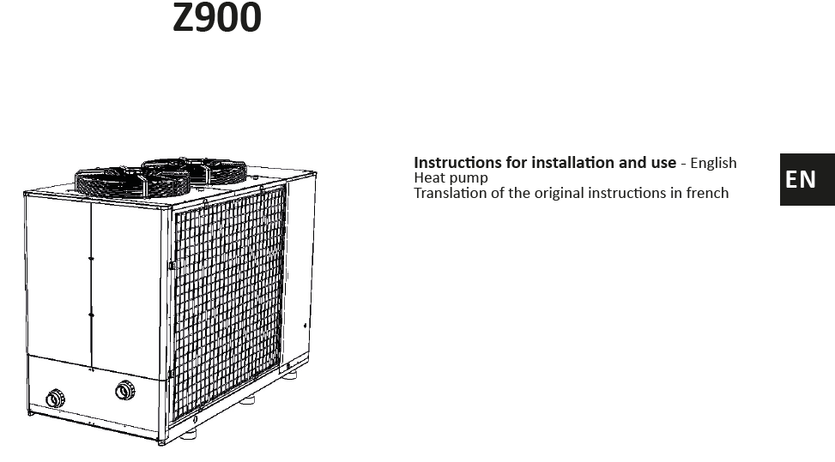
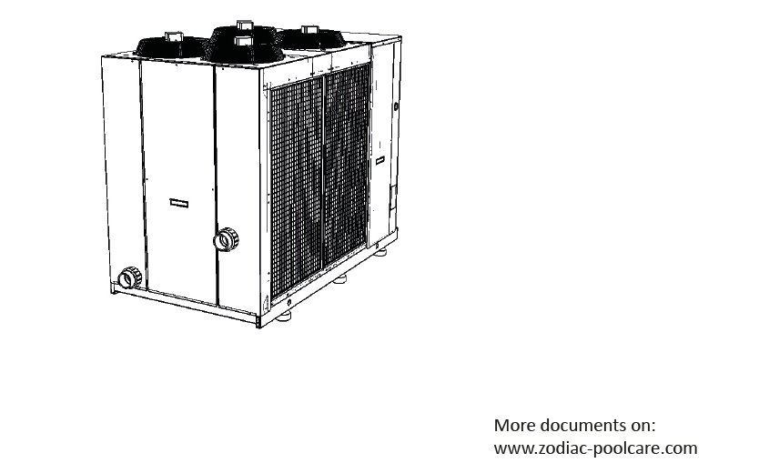

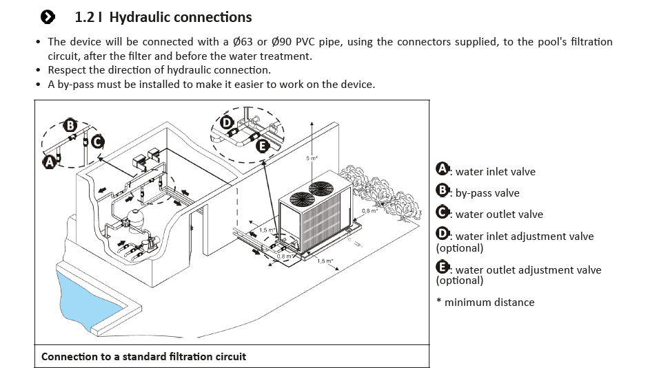

4 Ethics Form


APPLICATION FOR ETHICAL APPROVAL

In order for research to result in benefit and minimise risk of harm, it must be conducted ethically. A researcher may not be covered by the University’s insurance if ethical approval has not been obtained prior to commencement.

The University follows the OECD Frascati manual definition of research activity: “creative work undertaken on a systematic basis in order to increase the stock of knowledge, including knowledge of man, culture and society, and the use of this stock of knowledge to devise new applications”. As such this covers activities undertaken by members of staff, postgraduate research students, and both taught postgraduate and undergraduate students working on dissertations/projects.

The individual undertaking the research activity is known as the “principal researcher”.
Ethical approval is not required for routine audits, performance reviews, quality assurance studies, testing within normal educational requirements, and literary or artistic criticism.
Please read the notes for guidance before completing ALL sections of the form.
This form must be completed and approved prior to undertaking any research activity. Please see Checklist for details of process for different categories of application.

SECTION A: About You (Principal Researcher)

Full Name: |  |  | LEGRIS FEDERIC LOUIS FRANCO
Tick all boxes which apply:
Member of staff: | ☐ | Student: |  | ☒ | Honorary research fellow: | ☐

Faculty/School/Centre: | WIWBL
Campus: | Carmarthen
E-mail address: | Frederic.legris@luxbellemare.com
Contact Telephone Number: | 0023059191740
For students:
Student Number: | 1715708 | Undergraduate | ☒
Programme of Study: | Cert HE in Professional Practice | Taught Postgraduate | ☐
Director of Studies/Supervisor: | Tessa Oosthuizen | Research | ☐

SECTION B: Approval for Research Activity

Has the research activity received approval in principle?  (please check the Guidance Notes as to the appropriate approval process for different levels of research by different categories of individual) |  | YES | ☒ | NO | ☐
 |  |  |  | Date
If Yes, please indicate source of approval (and date where known): | Research Degrees Committee |  | ☐
 | Faculty Research Committee |  | ☐
 | Other (write in)  WIWBL Ethics Board Representative. |  | ☒
Approval in principle must be obtained from the relevant source prior to seeking ethical approval.
SECTION C: External Ethical Guidance Materials

Please list the core ethical guidance documents that have been referred to during the completion of this form (including any discipline-specific codes of research ethics, and also any specific ethical guidance relating to the proposed methodology). Please tick to confirm that your research proposal adheres to these codes and guidelines.
The LUX Collective Code of Ethics | ☒
 | ☐
 | ☐

SECTION D: External Collaborative Research Activity

Does the research activity involve collaborators outside of the University? |  | YES | ☐ | NO | ☒
If Yes, please provide the name of the external organisation and name and contact details for the main contact person:
Institution | .
Contact person name
Contact person e-mail address

Where research activity is carried out in collaboration with an external organisation
Does this organisation have its own ethics approval system? | YES | ☐ | NO | ☐
f Yes, please attach a copy of any final approval (or interim approval) from the organisation

SECTION E: Details of Research Activity

Indicative title: | Feasibility of heating the main swimming pool at LUX Belle Mare during winter
Proposed start date: |  | Proposed end date:
Purpose of research activity (including aims and objectives)
Outline the purpose, aims and objectives of the research activity, including key research questions. Show briefly how existing research has informed the proposed activity and explain what the research activity will add and how it addresses an area of importance. (Maximum 300 words)
Background
In 2014 LUX Belle Mare was renovated and new chillers for the air-conditioning system were installed. The aim was to use the heat recovery system of the chillers to heat the main swimming pool of the resort with a capacity of 1800 m3 of water. The pool is situated in front of the beach which expose to the south east trade wind.
The project revealed to be unfruitful as during the winter period the percentage of guest using air-conditioning in the rooms is very low. By doing so, the heat recovery system cannot run at its optimum capacity and is unable to heat a pool of that capacity with the climatic condition that prevails. As a result we have been facing a lot of guest complaints during winter.

Aims
The aims of the research will therefore be:
- How to incorporate to the existing circuit, heat pumps in order to increase the temperature of the pool with a minimum investment
- A full study on usage of photovoltaic solar panel as primary source of energy for the heat pumps.

Previous Research

The below articles elaborate on the usage of photovoltaic and heating pumps in the production of electricity.
- Energy-saving Supporting Tourism Sustainability: A Case Study of Hotel Swimming Pool Heat Pump, Chan & J.C. Lam JOURNAL OF SUSTAINABLE TOURISM Vol. 11, No. 1, 2003
- Types of Solar Cells and Application, American Journal of Optics and Photonics 2015; 3(5): 94-113 Published online August 21, 2015
- "Clean Energy from Photovoltaics “, Green, M. A, World Scientific Publishing Co., Hackensack, NJ, 2001
- The photo capacitor: An efficient self-charging capacitor for direct storage of solar energy, Chapin, D. M.; Fuller, C. S.; Pearson, G. L. Affiliation. Applied. Phys, vol. 25, 1954, pp. 676

Other references
- Guest comments questionnaires
- Trip Advisor guest comments

Personal learning outcomes
- During the research process, I will have the opportunity to read about different technics use in solar panels and how to make optimum use of that renewable energy source
- To what range can we make use of heat pumps in order to increase water temperature and what factors/elements that must be taken into consideration when choosing a heat pump
- What are the long benefits when making use of both heat pumps and photovoltaic panels
- Maintenance implications for various heating systems

Proposed methods
Provide a brief summary of all the methods that may be used in the research activity, making it clear what specific techniques may be used. If methods other than those listed in this section are deemed appropriate later, additional ethical approval for those methods will be needed. (Maximum 600 words)
Methodological Position
Evaluate where we stand vis a vis our competitors of the east coast of having the main pool heated taking into consideration their strategic location and exposure to the wind.
.
Methods
- Survey:
- Overview of what competitors proposed (e.g.: Temperature of water, size of pool, strategic locations….)
- Sunlight yield on the east coast region
- Type and capacity of heat pumps to be used on the existing system
- Interviews:
- The purpose of interviews is to obtain more detailed qualitative information from Maintenance Managers of other resorts having these facilities which could help to design and implement a durable and green solution to our problem.
Analysis

Survey:
To gather data in order to do a feasibility study and identify the most appropriate method of heating the pool – solar energy and heat pumps.

Location of research activity
Identify all locations where research activity will take place.
All research, surveys will be done at the resort( e.g.: where to installed the heat pumps, roof surfaces to be use for photovoltaic panels, water flows etc….)
For the other resort, survey will be done both by phone and site visit to designated hotel to have a better overall insight of their product.
Research activity outside of the UK
If research activity will take place overseas, you are responsible for ensuring that local ethical considerations are complied with and that the relevant permissions are sought. Specify any local guidelines (e.g. from local professional associations/learned societies/universities) that exist and whether these involve any ethical stipulations beyond those usual in the UK (provide details of any licenses or permissions required). Also specify whether there are any specific ethical issues raised by the local context in which the research activity is taking place, for example, particular cultural sensitivities or vulnerabilities of participants.
Mauritius

SECTION F: Scope of Research Activity

Will the research activity include: | YES | NO
Use of a questionnaire or similar research instrument? | ☒ | ☐
Use of interviews? | ☒ | ☐
Use of diaries? | ☐ | ☒
Participant observation with their knowledge? | ☐ | ☒
Participant observation without their knowledge? | ☐ | ☒
Use of video or audio recording? | ☐ | ☒
Access to personal or confidential information without the participants’ specific consent? | ☐ | ☒
Administration of any questions, test stimuli, presentation that may be experienced as physically, mentally or emotionally harmful / offensive? | ☐ | ☒
Performance of any acts which may cause embarrassment or affect self-esteem? | ☐ | ☒
Investigation of participants involved in illegal activities? | ☐ | ☒
Use of procedures that involve deception? | ☐ | ☒
Administration of any substance, agent or placebo? | ☐ | ☒
Working with live vertebrate animals? | ☐ | ☒
Other primary data collection methods, please explain in this box | ☐ | ☐

If NO to every question, then the research activity is (ethically) low risk and may be exempt from some of the following sections (please refer to Guidance Notes).

If YES to any question, then no research activity should be undertaken until full ethical approval has been obtained.

SECTION G: Intended Participants

Who are the intended participants: | YES | NO
Students or staff at the University? | ☐ | ☒
Adults (over the age of 18 and competent to give consent)? | ☒ | ☐
Vulnerable adults? | ☐ | ☒
Children under 18? | ☐ | ☒
Prisoners? | ☐ | ☒
Young offenders? | ☐ | ☒
Those who could be considered to have a particularly dependent relationship with the investigator or a gatekeeper? | ☐ | ☒
People engaged in illegal activities? | ☐ | ☒
Others (please identify): | ☐ | ☒

Participant numbers and source
Provide an estimate of the expected number of participants. How will you identify participants and how will they be recruited?
Peers of resort nearby on the east coast with whom we share common goals

Information for participants: | YES | NO | N/A
Will you describe the main research procedures to participants in advance, so that they are informed about what to expect? | ☒ | ☐ | ☐
Will you tell participants that their participation is voluntary? | ☒ | ☐ | ☐
Will you obtain written consent for participation? | ☐ | ☐ | ☒
Will you explain to participants that refusal to participate in the research will not affect their treatment or education (if relevant)? | ☐ | ☐ | ☒
If the research is observational, will you ask participants for their consent to being observed? | ☐ | ☐ | ☒
Will you tell participants that they may withdraw from the research at any time and for any reason? | ☒ | ☐ | ☐
With questionnaires, will you give participants the option of omitting questions they do not want to answer? | ☒ | ☐ | ☐
Will you tell participants that their data will be treated with full confidentiality and that, if published, it will not be identifiable as theirs? | ☒ | ☐ | ☐
Will you debrief participants at the end of their participation, in a way appropriate to the type of research undertaken? | ☒ | ☐ | ☐
If NO to any of above questions, please give an explanation

Information for participants: | YES | NO | N/A
Will participants be paid? | ☐ | ☒ | ☐
Is specialist electrical or other equipment to be used with participants? | ☐ | ☒ | ☐
Are there any financial or other interests to the investigator or University arising from this study? | ☐ | ☒ | ☐
Will the research activity involve deliberately misleading participants in any way, or the partial or full concealment of the specific study aims? | ☐ | ☒ | ☐
If YES to any question, please provide full details
(this box should expand as you type)

SECTION H: Anticipated Risks

Outline any anticipated risks that may adversely affect any of the participants, the researchers and/or the University, and the steps that will be taken to address them.
Risks to participants
For example: emotional distress, financial disclosure, physical harm, transfer of personal data, sensitive organisational information
The research that will be done will be specific to the outlined technical field and will thus have no impact on a third party.

If research activity may include sensitive, embarrassing or upsetting topics (e.g. sexual activity, drug use) or issues likely to disclose information requiring further action (e.g. criminal activity), give details of the procedures to deal with these issues, including any support/advice (e.g. helpline numbers) to be offered to participants. Note that where applicable, consent procedures should make it clear that if something potentially or actually illegal is discovered in the course of a project, it may need to be disclosed to the proper authorities
The research that will be done will be specific to the outlined technical field and will thus have no impact on a third party. Fellow maintenance managers will share only what they are willing to.

Risks to investigator
For example: personal safety, physical harm, emotional distress, risk of accusation of harm/impropriety, conflict of interest
None anticipated

University/institutional risks
For example: adverse publicity, financial loss, data protection
No risks are anticipated

Adverse outcomes
List measures put in place to limit any adverse effects or outcomes of research activity where appropriate. Include any emergency protocols.
The fact that we have a very good relationship among the maintenance managers on the east coast, the risk of any adverse effect or outcome is very low. In the event that I do not get the information from the maintenance managers, the research will be based on technical data.

Disclosure and Barring Service
If the research activity involves children or vulnerable adults, a Disclosure and Barring Service (DBS) certificate must be obtained before any contact with such participants. | YES | NO | N/A
Has a DBS certificate been obtained? | ☐ | ☐ | ☒

SECTION I: Feedback, Consent and Confidentiality

Feedback
What feedback will be provided to participants, how will this be done and when?
The aim of the research will be explained to participants by phone before meeting them.

Informed consent
Describe the arrangements to inform potential participants, before providing consent, of what is involved in participating. Describe the arrangements for participants to provide full consent before data collection begins. If gaining consent in this way is inappropriate, explain how consent will be obtained and recorded.
Participants will be informed and explained the aim of the research and the outline of the project.
Confidentiality / Anonymity
Set out how anonymity of participants and confidentiality will be ensured in any outputs. If anonymity is not being offered, explain why this is the case.
For both survey and interviews, only technical data will be used

SECTION J: Data Protection and Storage

In completing this section refer to the University’s Research Data Management Policy and the extensive resources on the University’s Research Data Management web pages (http://uwtsd.ac.uk/library/research-data-management/).
 | YES | NO
Does the research activity involve personal data (as defined by the Data Protection Act)? | ☐ | ☒
If YES, provide a description of the data and explain why this data needs to be collected:
Does it involve sensitive personal data (as defined by the Data Protection Act)? | ☐ | ☒
If YES, provide a description of the data and explain why this data needs to be collected:

Will the research activity involve any of the following activities: | YES | NO
Electronic transfer of data in any form? | ☐ | ☒
Sharing of data with others at the University? | ☐ | ☒
Sharing of data with other organisations? | ☐ | ☒
Export of data outside the European Union or importing of data from outside the UK? | ☐ | ☒
Use of personal addresses, postcodes, faxes, emails or telephone numbers? | ☐ | ☒
Publication of data that might allow identification of individuals? | ☐ | ☒
Use of data management system? | ☐ | ☒
Data archiving? | ☐ | ☒
If YES to any question, please provide full details, explaining how this will be conducted in accordance with the Data Protection Act (and/or any international equivalent):

Will the research activity involve storing personal data on one of the following: | YES | NO
Manual files (i.e. in paper form)? | ☒ | ☐
University computers? | ☐ | ☒
Private company computers? | ☒ | ☐
Home or other personal computers? | ☐ | ☒
Laptop computers/ CDs/ Portable disk-drives/ memory sticks? | ☐ | ☒
“Cloud” storage or websites? | ☐ | ☒
Other – specify: | ☐ | ☒
For all stored data, explain the measures in place to ensure data confidentiality, including details of password protection, encryption and anonymisation:
Data Protection Act 2017

List all who will have access to the data generated by the research activity:
The researcher, the mentor and the financial controller

List who will have control of, and act as custodian(s) for, data generated by the research activity:
The researcher only

Give details of data storage arrangements, including where data will be stored, how long for, and in what form. Will data be archived – if so how and if not why not.
Data generated by this research will be stored on company computers which are protected by password. Data will be anonymous, and used only for the research purposes outlined.

SECTION K: Declaration

The information which I have provided is correct and complete to the best of my knowledge. I have attempted to identify any risks and issues related to the research activity and acknowledge my obligations and the rights of the participants.

In submitting this application I hereby confirm that I undertake to ensure that the above named research activity will meet the University’s Research Ethics and Integrity Code of Practice
Signature of applicant: | Frederic Legris | Date: | 05.12.18

For students:
Director of Studies/Supervisor: | Tessa Oosthuizen
Signature:
Date: | 05-12-2018

For staff:
Head of School/Assistant Dean: | Annette Fillery-Travis
Signature: | Annette Fillery-Travis
Date: | April 2019

Checklist: Please complete the checklist below to ensure that you have completed the form according to the guidelines and attached any required documentation:
☒ | I have read the guidance notes supplied before completing the form.
☒ | I have completed ALL RELEVANT sections of the form in full.
☒ | I confirm that the research activity has received approval in principle
☒ | I have attached a copy of final/interim approval from external organisation (where appropriate)
☒ | I understand that it is my responsibility to ensure that the above named research activity will meet the University’s Research Ethics and Integrity Code of Practice.
☒ | I understand that before commencing data collection all documents aimed at respondents (including information sheets, consent forms, questionnaires, interview schedules etc.) must be confirmed by the DoS/Supervisor, module tutor or Head of School.

RESEARCH STUDENTS AND STAFF ONLY
All communications relating to this application during its processing must be in writing and emailed to pgresearch@uwtsd.ac.uk , with the title ‘Ethical Approval’ followed by your name.
You will be informed of the outcome of your claim by email; therefore it is important that you check your University and personal email accounts regularly.

STUDENTS ON UNDERGRADUATE OR TAUGHT MASTERS PROGRAMMES should submit this form (and receive the outcome) via systems explained to you by the supervisor/module leader.

This form is available electronically from the Academic Office web pages: http://www.uwtsd.ac.uk/academic-office/

Application Process

All staff research projects and all research students must submit the Ethical Approval Form to the University Ethics Committee via the Postgraduate Research office (pgresearch@uwtsd.ac.uk). Staff research directly in relation to personal study for taught undergraduate or Masters programmes should be submitted via the Faculty procedures explained below.

Taught masters and taught undergraduate research Ethical Approval Forms are considered within Faculties. Faculties will provide details of the specific processes for this. Where the Ethical issues within any single ethical application are of particular concern the Faculty will refer these to the University Ethics Committee. Any student activity that involves the collection of primary data needs to undergo Ethical approval, this includes assignment work as well as dissertations.

Notes for guidance in completion of this form

Section A: About You
Please complete all relevant sections

Section B: Approval for research activity
Research proposals must be approved in principle before applying for Ethical Approval. The proposal approval only becomes final when the ethical approval is received.

The process for proposal approval varies according the individual and programme of study:
- Research students, by application on form PG1 to the Research Degrees Committee
- Taught students by review of research proposal within Faculties (Faculties provide specific details of these processes)
- Staff, by agreement by the Head of School/Assistant Dean

Section C: External Ethical Guidance materials
Many discipline areas are required to operate with the discipline specific codes of research ethics (for example health, psychology, education etc.), any such codes must be listed and you must tick to confirm that you have consulted with these.

Section D: External Collaborative Research Activity
Provide details of the external collaborative partners, where appropriate you might want to submit a copy of the external collaboration agreement with the Ethical Approval Form. If the partner requires the research to be subject to its own internal Ethical approval process then please provide details of that process and a copy of any final (or interim) approvals received from the organisation.

Section E: Details of Research Activity
Remember that the individuals reviewing this Ethical Approval Form may not have seen your research proposal, and also may not be experts in the specific area of your research. The information provided should therefore be jargon free and clearly stated.
Indicative Title: please use the same title as used on the research proposal.
Purpose: the Ethical approval process will want to ensure that the methods you propose are adequate and appropriate to address the research aims and objectives. Excessive additional data collection can be seen as unethical.
Proposed Methods: the Ethical approval process seeks to ensure that you understand the methods that are intended, and that the implementation of those methods will be appropriate and without unnecessary impact on respondents. Please be specific.
Location: this needs to mention geographical location and also local situation (for example, within Local Authority Offices in Cardiff, using a private room but close to other individuals). If you are collecting data within an organisational setting then you need to explain the permissions that you have obtained to do this.
Research Activity outside of the UK: please complete this section in detail, and note any guidance you have received. Also describe your own familiarity (or not) with the location that you will be utilising.

Section F: Scope of Research Activity
Please tick ALL of the research activities that might be undertaken. If any additional types of activity are intended then please add an extra box and describe these.
If you have answered no to all questions in F then sections G and J do not need to be completed. Section H should be considered, and may be completed. Signatures are still required in section K.

Section G: Intended Participants
Please tick all categories that might apply.
Numbers & Source: if you are using a series of different methods or research activities please list numbers for each stage/phase. Be clear about how you will find respondents. Will you use intermediaries, and if so how? How will you ensure compliance with your sampling strategy?
Information for participants: all participants should be appropriately informed about the research, what is expected of them and what will happen to the information that they provide. The Ethical review process does not ask to see this documentation, but requires this to be reviewed and approved by the Director of Studies in the case of research students, the supervisor/module tutor in relation to students on taught programmes and the Head of School/Assistant Dean in relation to staff research.

Section H: Anticipate Risks
All research carries some level of risk. The answers you provide to questions in this section will be reviewed to ensure that you have an appropriate understanding of the type of risks involved and how you can mitigate against these risks.
Risk to participants Think very carefully about how your actions/questions/discussions might affect the people you are involving as participants. You might identify the risk as small but it would still be a risk. Many types of question have the potential to make respondents less content with their life / job; you need to recognise and try to ameliorate any such effects
If these are business owners, time with you may reduce profit.
In some locations physical risk is very real to both participants and yourself, please consider this.
Risk to you, the researcher Think about where you will meet people, if there are any dangers involved in the location. If you are meeting people as individuals think about using a public place. In general do not visit people in their own homes or remote locations. If you are talking to individuals about certain issues think about how their responses might affect you emotionally. What about the risk of collecting insufficient data?
Risk to the University When undertaking your research, you are acting as a member of the University (student or staff). Professionalism is important, so it is important to be well organised and well prepared. Punctuality, clarity etc. are all part of this. What will you do to ensure this? You must ensure you do not harm the good name of the University in any way and do nothing to undermine the reputation of the research it conducts and sponsors. Upholding high standards of conduct and integrity are vital in this regard. You must also conduct the research in such a way to minimise the potential for claims of negligence made against the University, its researchers and any collaborating individual or organisation. In this respect you should always comply with ethical, legal and professional frameworks, obligations and standards as required by statutory and regulatory authorities, as well as the university’s Research Integrity and Ethics Code of Practice. Research misconduct in this respect can take many forms, including:
- fabrication: making up results or other outputs (eg, artefacts) and presenting them as if they were real
- falsification: manipulating research processes or changing or omitting data without good cause
- plagiarism: using other people’s material without giving proper credit
- failure to meet ethical, legal and professional obligations: for example failure to declare competing interests; misrepresentation of involvement or authorship; misrepresentation of interests; breach of confidentiality; lack of informed consent; misuse of personal data; and abuse of research subjects or material
- improper dealing with allegations of misconduct: failing to address possible infringements such as attempts to cover up misconduct and reprisals against whistle-blowers

Adverse Outcomes. Think carefully about the possibilities, and cover here

Section I: Feedback, Consent and Confidentiality
Feedback to participants: outline your approach. Will interview transcripts be shared with respondents to check accuracy? Will summaries of questionnaire analysis be made available to respondents in some way? Will an overview report be provided? How and when?
Informed consent: Draft letter / e-mail / or heading (or footer) section of questionnaire must be approved by DoS/supervisor (if research student), supervisor/module tutor if taught student, or Head of School / Assistant Dean if a member of staff.
Confidentiality/Anonymity. Explain clearly how you will ensure confidentiality and anonymity.

Section J: Data Protection and Storage
Before completing this section it is necessary to read the University’s Research Data Management information. The questions that follow are designed to ensure compliance with the Data Protection Act as well as established research protocols.

Many research activities will involve electronic transfer of data and use of data management systems in the summarisation and analysis of data. You will need to explain these in relation to compliance with the Data Protection Act.
Think carefully about who will have access to your data, this will include supervisors and examiners. Also that a thesis will be made available via the University library and the British Library system. If you are seeking an access bar for a period of time after completion then mention it here. If you will provide a copy of your findings, or intend to give a presentation, to a facilitating/ supporting/accessing organisation then explain that in this section. But also think about the general principle of data sharing, as explained in the Research Data Management information.
In terms of storage of data please ensure security, and also mitigate against loss of data.

Section K: Declaration
Ensure the appropriate countersignatures have been provided
Look carefully at the checklist and ensure that you comply with and tick all that are relevant to your research.

