BSc (Hons) Health and Social Care

Module: Introduction to Independent Research Skills

BMHP5019

Component 1: Written Assignment (Research proposal)
Student ID: 2335277
Student Name: Farima Stefania- Lorena
Date of submission: 12 March
Word count: 400 words

Topic: Evaluating the Impact of Social Prescribing on Reducing Loneliness in the Aging Population of the UK

Table of Contents

Title, Review question and Objectives 3
Rationale 3
Methods 4
Data analysis 5
Ethical considerations 5
References 6

Title, Review question and Objectives
Title:
Evaluating the Impact of Social Prescribing on Reducing Loneliness in the Aging Population of the UK.
Review question:
What are the potential impacts of social prescribing interventions for reducing social isolation and loneliness among the aging populations within the UK?
Objectives:
- To evaluate the role of social prescribing within the UK’s National Health Services (NHS) framework for elderly care.
- To examine the effectiveness of social prescribing (Link Worker) intervention in improving subjective wellbeing for older adults within the UK.
- To analyse the primary barriers and facilitators that influence the engagement of the aging population of the UK with social prescribing schemes.
- To provide actionable recommendations for UK healthcare organisations for reducing the loneliness among the aging population through social prescribing.

Rationale
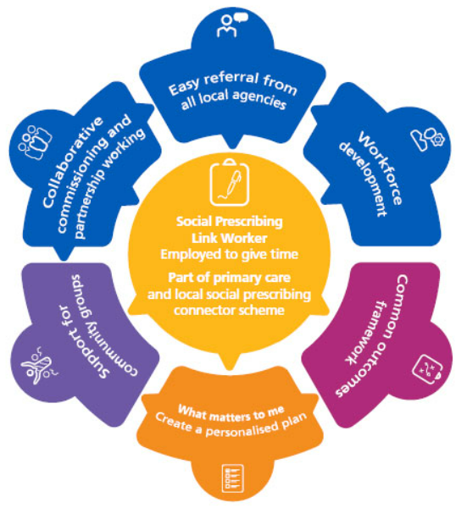
Figure 1: Components of social prescribing
(Source: NHS, 2024)
Loneliness is considered as one of the significant challenges associated with public health in the UK among the aging population (Jentoftet al., 2025). According to Age UK, more than 2 million people within England over the age of 75 years leave alone and more than 1 million older people go over a month without speaking to a friend, neighbour or a family member (NHS, 2024). The study has shared that hundreds of thousands of elderly people lonely and cut off from society who are aged over 75. Simultaneously, the study by the World Health Organisation (WHO) Commission on Social Connection has revealed that 1 in 6 people worldwide is affected by loneliness and provides a significant impact on their well-being (WHO, 2025). Loneliness is linked to an estimated 100 deaths every hour more than 8, 71,000 dates annually (WHO, 2025). The study by NHS (2024), has explained that through social prescribing link workers into primary care networks through their GP practice starting with 1000 new social prescribing link workers placed by 2020/21 and to see at least 2.5 million people benefiting from the personalised care. The evaluation of the whole research will provide significant benefits to the potential stakeholders of the health and social care sector of the UK by improving the healthy life condition of elderly population (Wang et al., 2023).

Methods
The project will use scoping review methodology by synthesizing existing secondary data. This approach provides the benefits of a broader road mapping of the evidence regarding social prescribing and loneliness (Munn et al., 2022).
Database:
Systematic searches will be conducted by using secondary data collection methods using databases like Google Scholar, Pubmed and so on.
Keywords:
“Social Prescribing”, “Loneliness among elderly population of the UK”, “social isolation among elders”.
Inclusion and exclusion criteria:
Inclusion Criteria | Exclusion Criteria
- Peer reviewed journals and articles  - UK Government reports  - Considering resources between 2019-2026  - Resources written in English | - Studies outside UK  - Studies apart from elderly population  - Resources older before 2019  - Non English Publications
Table 1: Inclusion and exclusion criteria
(Source: Self-generated)

Data analysis
The collected secondary data will be analysed through thematic analysis method. This effectively involves reading the selected articles and identifying the appropriate patterns or themes (Lochmiller, 2021). This method contributes to categorising how different interventions can provide impact on the quality life of an aging population.

Ethical considerations
As this is a secondary research, the study does not involve any direct contact with participants. However, the ethical integrity will be maintained by reporting data accuracy and avoiding the fabrication of data findings (JassimRahiman, 2025). The study will ensure all the original authors are acknowledged through appropriate referencing methods for avoiding issues like plagiarism (Gupta et al., 2024).

References
Gupta, D.P., Bhamboo, D.U. and Khandal, A., (2024), October. 'Upholding Ethics in Academic Research: Challenges and Solutions to Plagiarism'. In Proceedings of the 1st International Conference on Educational, Cultural and Societal Approaches in Literature, Communication, & Translation (ECSA_LCT 2024).
JassimRahiman, K., (2025). Ensuring Research Integrity: Plagiarism, Fabrication, and Falsification.
Jentoft, E.E., Sandset, T. and Haldar, M., (2025). Problematizing loneliness as a public health issue: an analysis of policy in the United Kingdom. Critical Policy Studies, 19(1), pp.1-18.
Lochmiller, C.R., (2021). Conducting thematic analysis with qualitative data. The qualitative report, 26(6), pp.2029-2044.
Munn, Z., Pollock, D., Khalil, H., Alexander, L., Mclnerney, P., Godfrey, C.M., Peters, M. and Tricco, A.C., (2022). What are scoping reviews? Providing a formal definition of scoping reviews as a type of evidence synthesis. JBI evidence synthesis, 20(4), pp.950-952.
NHS (2024) NHS choices. Available at: https://www.england.nhs.uk/personalisedcare/social-prescribing/ (Accessed: 09 March 2026).
NHS (2024) NHS choices. Available at: https://www.nhs.uk/mental-health/feelings-symptoms-behaviours/feelings-and-symptoms/loneliness-in-older-people/ (Accessed: 09 March 2026).
Wang, H., Coyte, P.C., Shi, W., Zong, X. and Zhong, R., (2023). Social governance and sustainable development in elderly services: innovative models, strategies, and stakeholder perspectives. Sustainability, 15(21), p.15414.
WHO (2025) Social Connection linked to improved health and reduced risk of early deathWorld Health Organization. Available at: https://www.who.int/news/item/30-06-2025-social-connection-linked-to-improved-heath-and-reduced-risk-of-early-death (Accessed: 09 March 2026).

