TRINITY SAINT DAVID UNIVERSITY OF WALES (LONDON CAMPUS)
MODULE NAME: SOFTWARE SOLUTIONS FOR BUSINESS
MODULE CODE: ACCA 4026
LECTURER: RAJEEV NATH
STUDENT NAME: MARIA CAROLINA MURANI DE DIEGO
STUDENT ID: 2508280

11/12/2025
Assessment
Portfolio Report on Contemporary Software Applications for Business

Table of Contents
Introduction
Main Body
Task 1: e-Commerce Website Builders and Software Solutions
Task 2: Mind Map of Contemporary Software Applications
Task 3: Office Applications for Creating, Storing, Presenting, and Analysing Data
a. Office Applications Overview
b. Practical Testing of Office Applications
Task 4: Communication and Collaboration Applications
a. Overview of Communication and Collaboration Tools
b. Practical Testing of Communication and Collaboration Tools
Conclusion
References
Appendices

Introduction

Introduction

The global retail environment has been transformed by the continuous rise of e-commerce. Businesses increasingly rely on website-building software to create professional online stores without requiring extensive technical expertise. This discussion critically examines two dominant contemporary platforms – Shopify and Wix eCommerce – focusing on their functionality, usability, scalability, and overall strategic suitability for modern digital enterprises. Both systems support the democratisation of online trade, yet they differ in design philosophy, cost structure, and technical depth.

Main Body

Task 1 e-Commerce Website builders/software solutions

Shopify Overview
Established in 2006 in Canada, Shopify has evolved into one of the world’s largest cloud-based e-commerce ecosystems, supporting millions of merchants internationally (Shopify Annual Report, 2024). The platform provides a full range of tools, including website hosting, payment processing, analytics, marketing automation, and application integrations. Its primary strength lies in scalability – the ability to accommodate micro-retailers as well as global corporations.
Shopify’s strategic advantage is its extensive app marketplace and developer-friendly API architecture, which allow seamless integration with logistics, social-media marketing, and accounting systems (Forbes, 2024). The native Shopify Payments gateway simplifies global transactions, accepting multiple currencies and enhancing international competitiveness.
Nevertheless, Shopify’s advanced customisation can demand coding knowledge or professional web-development support. The subscription model and transaction charges may also deter micro-enterprises seeking low-cost entry into e-commerce.
Wix eCommerce Overview
Wix eCommerce, created by Wix Ltd in Israel, originated as a general website builder and has gradually incorporated comprehensive retail functionality since 2012. Its main appeal is usability: a drag-and-drop interface supported by AI-driven design recommendations enables users with minimal technical skills to build visually engaging stores (Wix Business Report, 2024). The platform integrates product listings, inventory tracking, digital payments, and marketing features within a single environment.
The system’s design flexibility and mobile-responsive templates make it particularly attractive to creative industries and small firms aiming to establish brand identity quickly. Furthermore, the Wix Owner App allows merchants to manage sales and communication from smartphones, aligning with current trends in mobile entrepreneurship.
However, Wix eCommerce is less suited to complex, high-volume operations. Limited third-party integrations restricted multi-currency capabilities, and smaller storage capacity can constrain expansion. Thus, its competitive strength lies primarily in accessibility and design freedom rather than enterprise-scale performance.
Comparative Discussion
While both platforms deliver end-to-end solutions for online retail, they serve distinct strategic purposes. Shopify prioritises professional reliability and growth potential, whereas Wix emphasises ease of use and creative control.
Shopify operates on a robust infrastructure capable of supporting omnichannel strategies – including integration with Amazon, TikTok, and physical point-of-sale systems – which enhances its relevance for scaling businesses. In contrast, Wix targets entrepreneurs who value autonomy and aesthetic control more than advanced logistics.
From a cost perspective, Wix generally offers lower starting prices and no transaction commissions on external gateways, making it more economical for start-ups. Shopify’s higher pricing, however, reflects its enterprise-grade functionality and support network. Customer service is more comprehensive on Shopify, offering 24/7 support and extensive documentation, while Wix provides efficient but less specialised assistance.
Strategic and Sustainability Insights
Strategically, Shopify represents a Platform-as-a-Service (PaaS) model that enables firms to outsource complex digital infrastructure while concentrating on marketing and consumer engagement. Its scalability aligns with growth-oriented strategies and internationalisation objectives. Wix, by contrast, contributes to the democratisation of digital commerce, empowering small enterprises to compete creatively with minimal barriers to entry.
Both organisations also incorporate sustainability into corporate strategy. Shopify’s Planet Programme invests in carbon-removal projects, while Wix publicly commits to renewable energy for its data centres (Shopify Sustainability Report, 2023; Wix Corporate Responsibility, 2024). These initiatives reflect broader environmental, social, and governance (ESG) trends that influence consumer trust and brand reputation.
Critical Conclusion
In conclusion, Shopify and Wix eCommerce embody two complementary approaches to digital commerce. Shopify delivers a technically robust and highly scalable environment ideal for established or rapidly expanding businesses. Wix eCommerce offers an intuitive and visually oriented solution optimised for start-ups, freelancers, and creative sectors. The selection between them depends primarily on organisational scale, resource availability, and long-term strategic vision. Both platforms demonstrate how contemporary e-commerce software contributes to sustainable innovation, inclusive participation, and the continued evolution of the global digital economy.

Task 2

Mind-map of Contemporary Software Applications
Description and Benefits of Mind Mapping
Mind mapping is a visual thinking and organisational technique that represents information around a central concept using branches, keywords, and associations (Buzan & Griffiths, 2018). It helps individuals and organisations to structure complex ideas, promote creativity, and enhance memory retention. In a business context, mind mapping transforms linear data into a clear visual framework, improving the ability to plan, analyse, and communicate strategies.
According to Davies (2011), mind mapping supports whole-brain thinking by engaging both the logical and creative aspects of cognition, which results in better problem-solving and innovation. Within organisations, it facilitates brainstorming, project planning, and knowledge management. When applied to software selection or business operations, a mind map allows managers to visualise relationships between technologies and their functions, ensuring more informed decisions.
The benefits of mind mapping in business operations include:
1. Enhanced Productivity: By visually connecting tasks, tools, and objectives, mind maps streamline workflow design and prevent duplication of effort.
2. Improved Collaboration: Teams can collectively develop maps that clarify goals and responsibilities, promoting shared understanding (Eppler, 2006).
3. Better Strategic Decision-Making: Mind maps help to identify gaps, opportunities, and dependencies between business functions, enabling data-driven strategies.
4. Effective Learning and Retention: Employees retain more information when it is visually represented rather than presented in textual form (Buzan & Griffiths, 2018).
Thus, mind mapping is not merely a creative activity but a powerful managerial tool that enhances clarity, integration, and efficiency across organisational operations.

b. Mind Map of Contemporary Software Applications
The mind map for this task focuses on contemporary software applications that support daily business operations. At its centre lies the core node labelled “Business Operations Software”, branching into six major categories: Communication, Productivity, Project Management, E-commerce, Data Analytics, and Cloud Storage.
1. Communication Tools:
Zoom, Slack, and Microsoft Teams enhance collaboration across remote or hybrid work environments. These platforms allow instant messaging, video conferencing, and file sharing, supporting seamless organisational communication.
2. Productivity Suites:
Microsoft 365 and Google Workspace provide document creation, spreadsheets, and presentation tools accessible via cloud systems. They promote real-time co-authoring and version control, essential for agile business operations.
3. Project Management Applications:
Trello, Asana, and Monday.com enable efficient task tracking, resource allocation, and progress monitoring. Their visual boards and automation functions help teams manage projects systematically.
4. E-commerce Platforms:
Shopify, Wix eCommerce, and WooCommerce facilitate digital retail operations. These platforms allow businesses to create online stores, manage inventories, process payments, and analyse customer data.
5. Data Analytics Tools:
Tableau and Microsoft Power BI transform complex datasets into visual dashboards, supporting evidence-based decision-making and strategic forecasting.
6. Cloud Storage Solutions:
Google Drive, Dropbox, and OneDrive offer secure cloud-based file management, ensuring data accessibility and collaboration from any location.
Figure 1 presents a mind map of contemporary software applications that support day-to-day business operations.
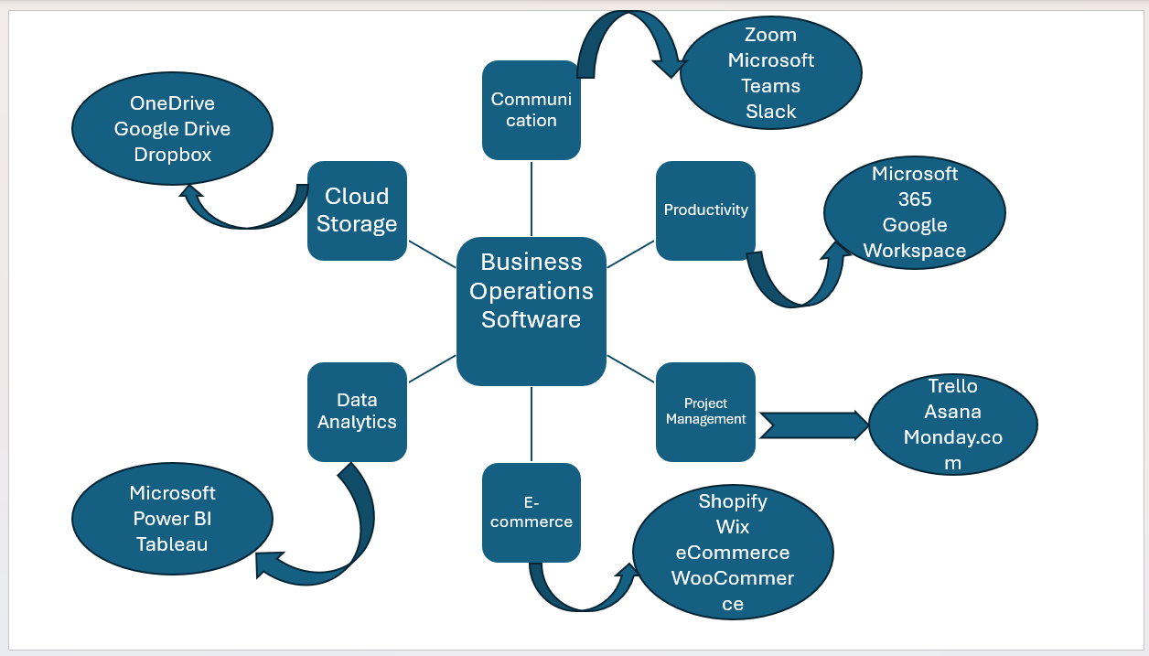
Figure 1: Mind map of contemporary software applications used in day-to-day business operations

Task 3 Office Applications for Creating, Storing, Presenting, and Analysing Data

a. Explanation of four office software solutions (MS Word, MS PowerPoint, MS Excel, MS Access)

Modern organisations rely on office software to create documents, analyse data, communicate information, and manage records. Among the most used applications are Microsoft Word, Microsoft PowerPoint, Microsoft Excel, and Microsoft Access. Although these programs belong to the same Microsoft 365 ecosystem, each one has a distinct purpose and set of capabilities. Understanding their functions, advantages, and limitations is essential for selecting the right tool for specific business tasks.

Microsoft Word is the principal tool for producing written documents such as reports, letters, contracts, policies, and proposals. It offers a wide range of formatting features, including paragraph controls, templates, themes, headers and footers, and automatic tables of contents. These features allow organisations to maintain consistency and professionalism in their documentation. Another significant advantage of Word is its integration with cloud storage platforms such as OneDrive and SharePoint, enabling teams to collaborate on documents in real time. Co-authoring, tracked changes, and commenting tools have become essential in modern workplaces where employees often work remotely or across different time zones. Despite its strengths, Word does have limitations. It becomes less efficient when dealing with large volumes of numerical data, and complex formatting can sometimes break when documents are transferred between different devices or template versions. Therefore, although Word is ideal for written communication, it is not suitable for analytical tasks.

While Word focuses on text-based documents, Microsoft PowerPoint is designed for visual communication. It enables users to create slideshows that combine text, images, diagrams, animations, charts, and multimedia. This makes PowerPoint a central tool for delivering presentations during meetings, training sessions, conferences, and marketing pitches. The program provides preset slide layouts and design templates that allow users to create professional slides even without design experience. PowerPoint also includes features such as Presenter View, which displays notes and upcoming slides for the speaker while the audience sees only the current slide. Additionally, the program integrates with Excel to import charts and with Teams for virtual presentations. However, PowerPoint can be misused—for example, by placing too much text on slides or overusing visual effects, resulting in presentations that confuse rather than clarify. Its effectiveness therefore depends not only on the software but also on the presenter’s communication skills and design choices.

Microsoft Excel, by contrast, is a powerful analytical tool used to store, compute, and interpret numerical information. It consists of a grid of cells in which users can enter data, formulas, and functions. Businesses use Excel for financial modelling, budgeting, forecasting, sales reporting, and inventory monitoring. Excel includes hundreds of built-in functions for mathematics, statistics, finance, and logic, which allow users to analyse large datasets with precision. Advanced tools such as PivotTables, Goal Seek, conditional formatting, and charts turn raw data into meaningful insights that support managerial decision

b. 1. Mail Merge in Microsoft Word

Mail Merge is a feature that allows users to create personalised documents by combining a standard template with external data. Businesses frequently use this tool when sending marketing letters, payment reminders, or customer notifications, as it reduces manual work and ensures consistent formatting.

For this activity, I created a simple Excel spreadsheet containing fictional customer names, addresses, and company information. I then opened Microsoft Word and designed a basic letter template that included placeholders for personalised data. After selecting Mailings > Start Mail Merge, I connected the Excel file as the data source and inserted the relevant merge fields (such as First Name, Last Name, and Company) into the letter body.

By using the Preview Results function, I was able to review how the letter would appear for each individual customer. Finally, I used the Finish & Merge option to generate multiple personalised letters automatically. This practical exercise demonstrates how Word can streamline communication processes and reduce repetitive administrative work in a business environment.

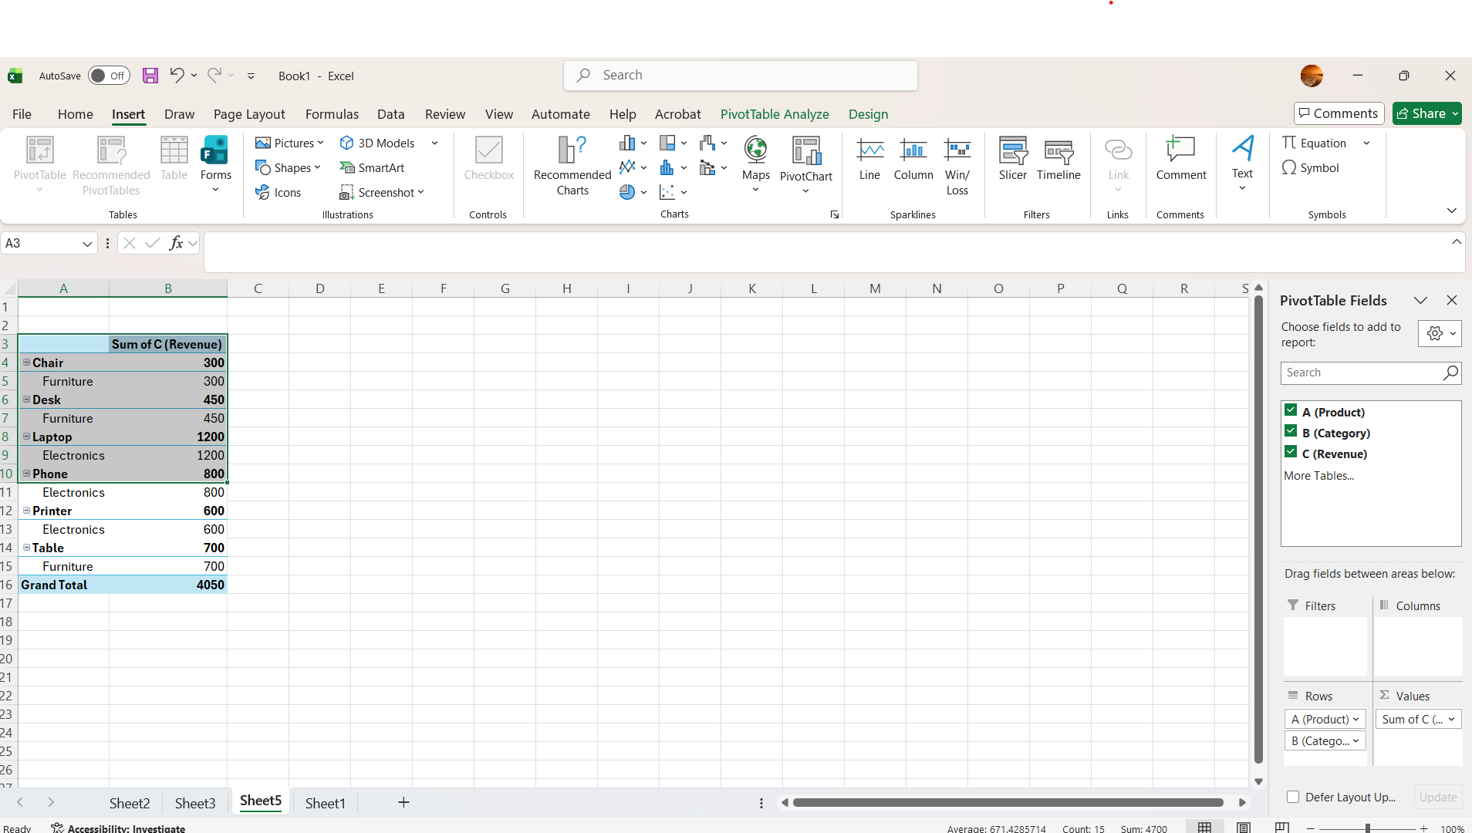
Figure 1: Excel file containing customer data

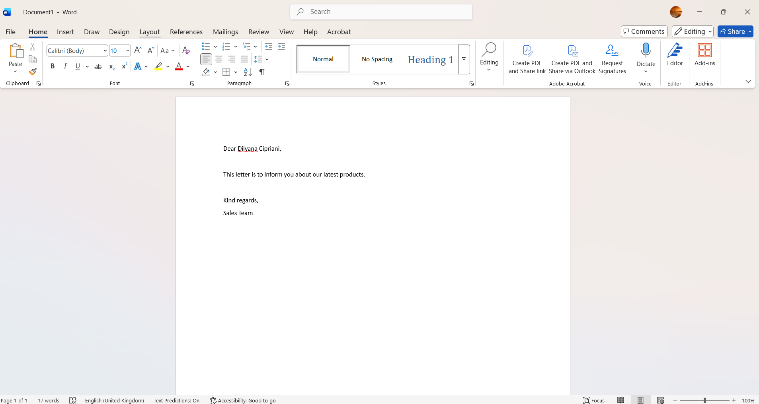

Figure 2: Word letter template before inserting merge fields

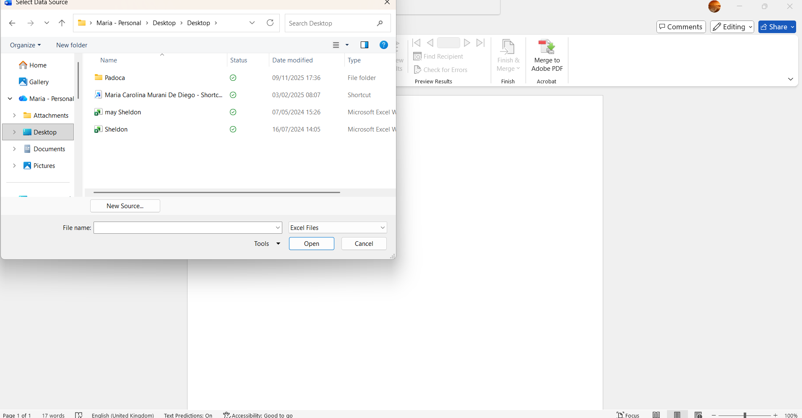

Figure 3: Mail Merge data source selection

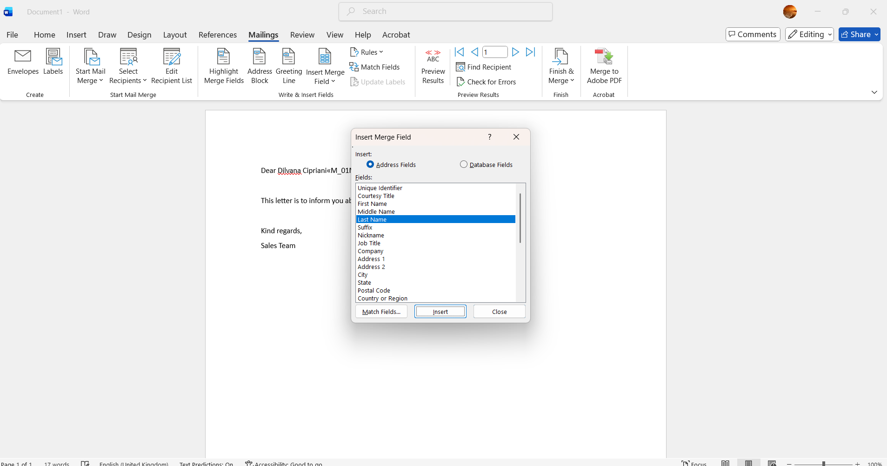

Figure 4: Merge fields inserted in the document

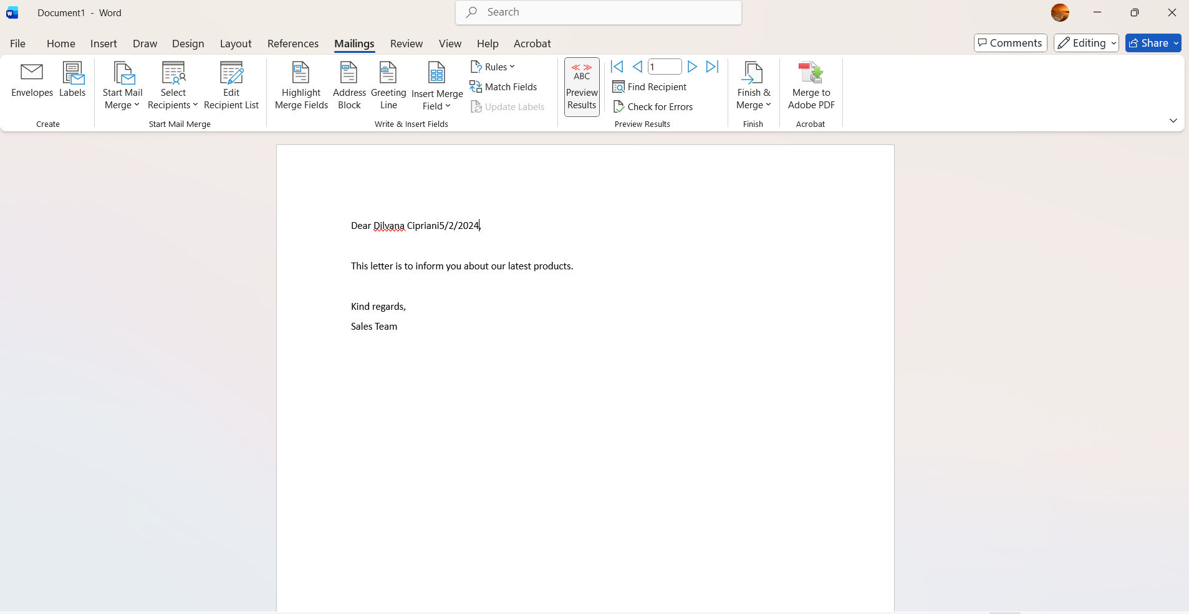

Figure 5: Preview of the final personalised letter

2. PivotTable in Microsoft Excel

Excel’s PivotTable feature is widely used in companies to summarise and interpret large datasets. It allows managers to analyse sales performance, identify trends, and support strategic decision-making.

In this practical task, I created a small dataset of fictional sales transactions, including fields such as product category, quantity sold, and revenue. After selecting the dataset, I inserted a PivotTable using Insert > PivotTable and placed it in a new worksheet. I then arranged the fields by placing Category in the Rows area and Revenue in the Values area.

This automatically generated a summary showing the total revenue for each product category. To explore the data further, I applied sorting and added a filter to narrow results by specific time periods. The PivotTable instantly recalculated all values, demonstrating how Excel can transform raw data into meaningful insights.

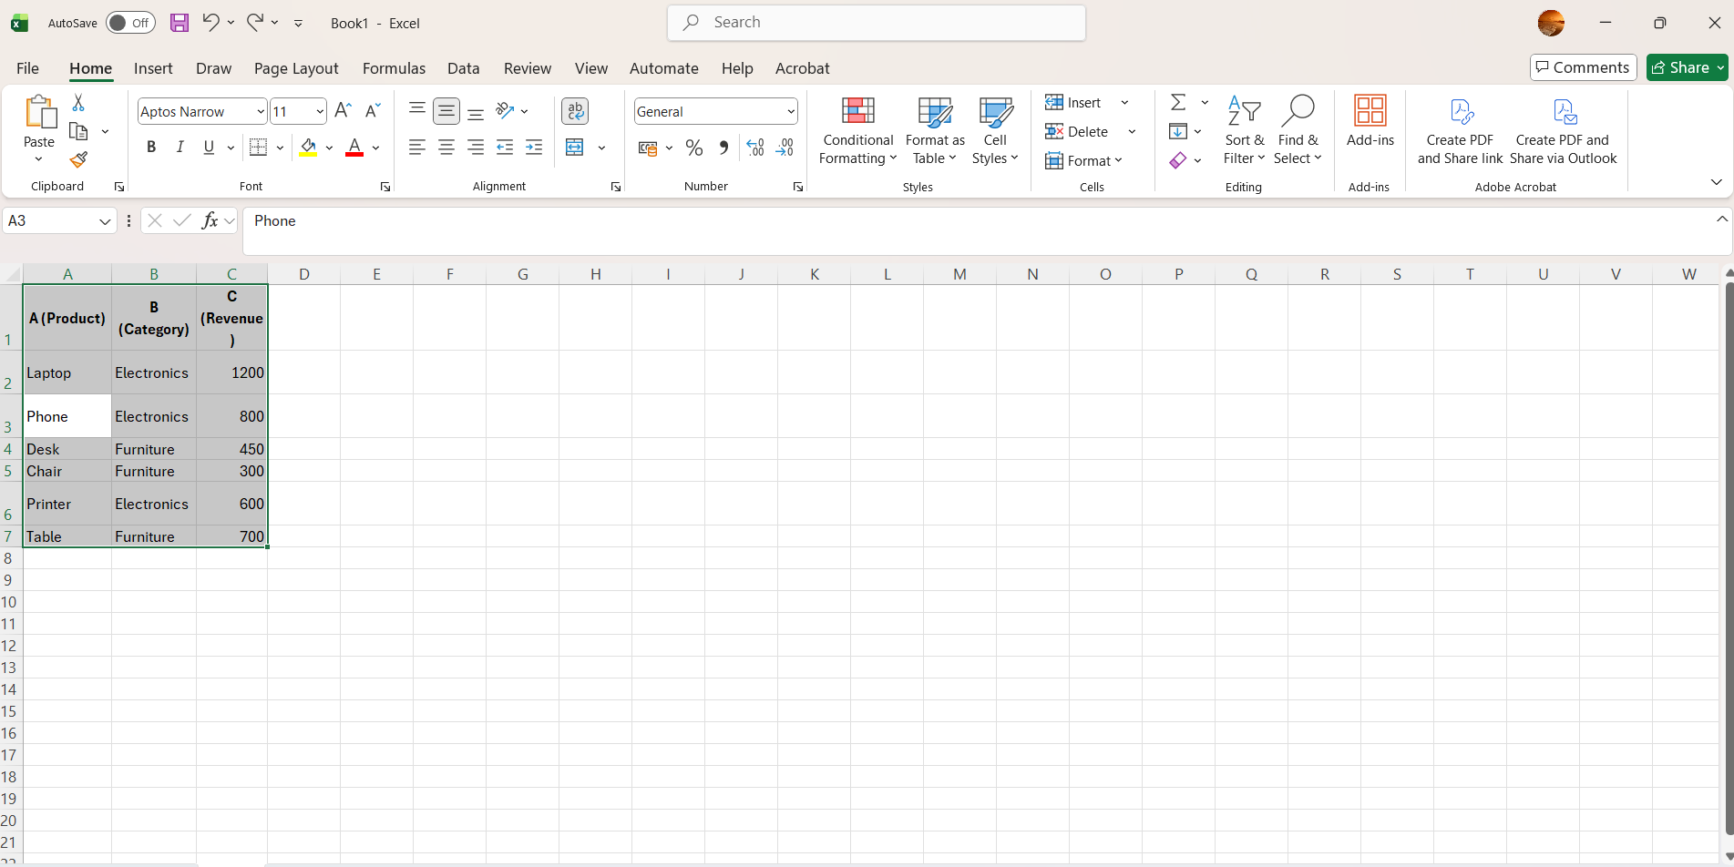
Figure 6: Insert Raw Sales Data

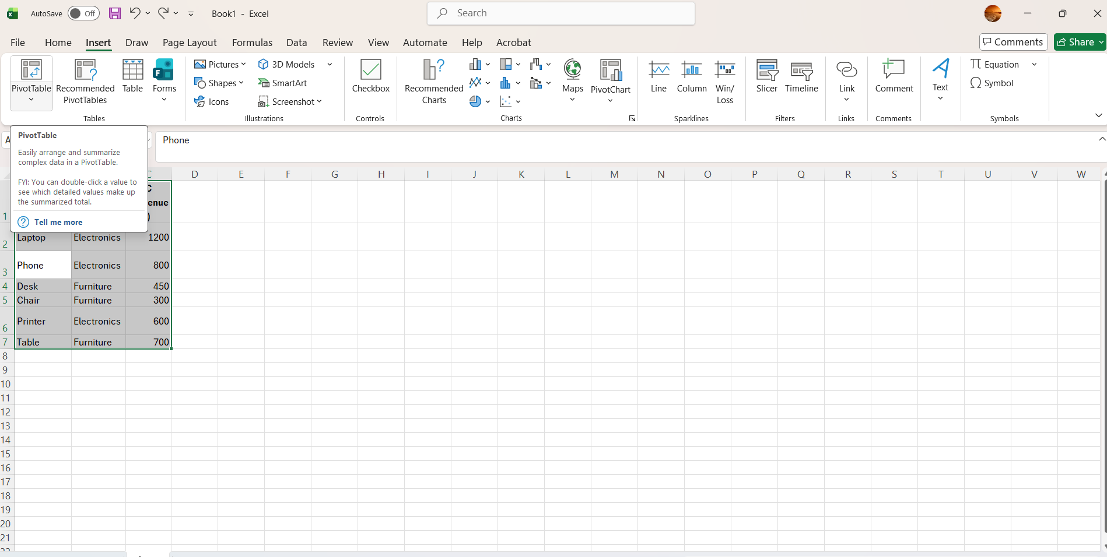
Figure 7: Insert PivotTable dialog box

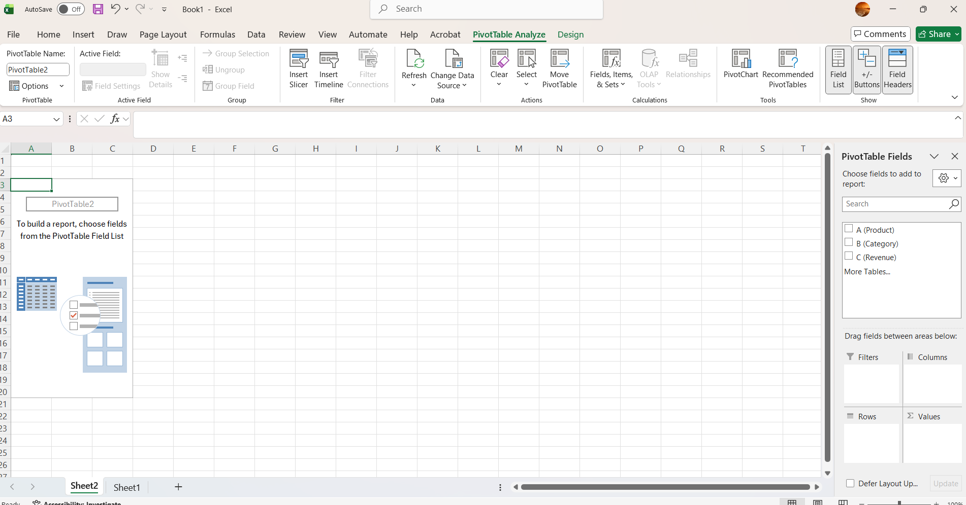
Figure 8: PivotTable field configuration

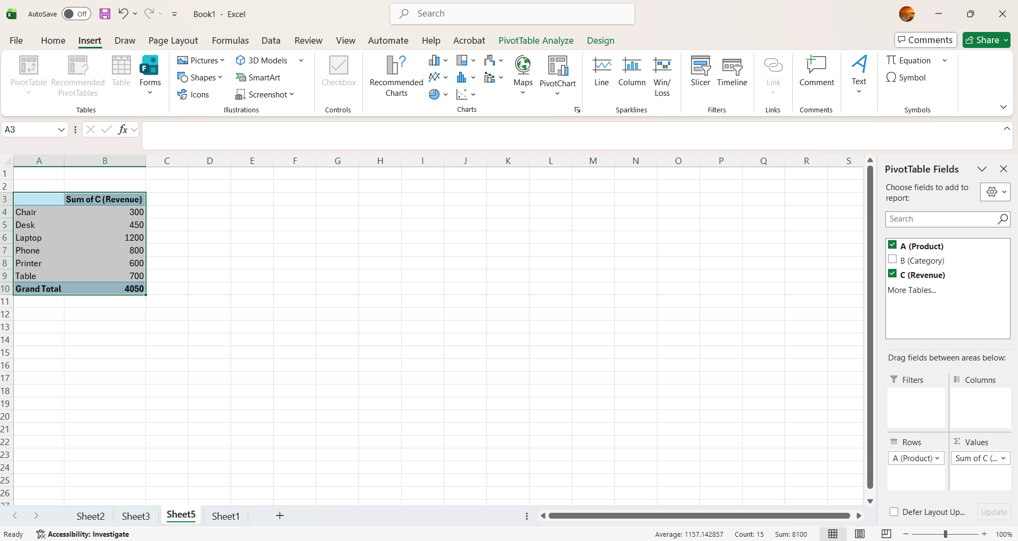
Figure 9: Completed PivotTable summarising revenue.

Task 4

Communication and Collaboration applications

a.
Digital communication and collaboration tools have become essential in contemporary business environments, particularly due to the growth of hybrid and remote work. This section examines one communication tool—Microsoft Outlook—and one collaboration tool—Microsoft OneDrive. Both platforms are widely used in organisations of all sizes and enable employees to share information, coordinate tasks, and maintain productivity.

Microsoft Outlook – Communication Tool

Microsoft Outlook is one of the most widely used communication platforms in the corporate world. It integrates email, a calendar system, contact management, and scheduling features within a single application. Because of this integration, employees can send messages, organise meetings, and manage tasks without switching between different software tools.

One of the main strengths of Outlook is its ability to structure communication. Emails can be organised into folders, tagged with categories, or flagged for follow-up. Rules can be created to automatically sort incoming emails, helping staff manage high volumes of communication. This is particularly valuable in busy business environments where employees receive dozens of messages daily.

Outlook is also a powerful scheduling tool. The calendar allows users to create appointments, send meeting invitations, and view the availability of other participants. This significantly reduces the back-and-forth communication normally required to organise a meeting. The integration with Microsoft Teams enables users to add online meeting links directly from the calendar, supporting remote collaboration.

Despite these advantages, Outlook has certain limitations. The volume of communication can sometimes become overwhelming, leading to information overload if not managed effectively. Users must rely on good organisational habits—such as inbox rules or scheduled email checks—to avoid distractions. Outlook also depends on stable internet connectivity for synchronisation, which may be a drawback in environments with poor network access.

Microsoft OneDrive – Collaboration Tool

Microsoft OneDrive is a cloud-based storage and sharing platform that plays a central role in collaborative work. It allows users to store files online, synchronise them across devices, and access them from any location. Organisations rely on OneDrive because it eliminates the need for USB drives, reduces data loss, and enables secure file sharing.

A key feature of OneDrive is real-time co-authoring. When a file is stored in OneDrive, multiple users can open and edit it at the same time using Word, Excel, or PowerPoint. Changes appear instantly, and users can see each other’s cursor or comments. This functionality is particularly useful for teamwork, project planning, and document reviews. It prevents version-control issues that occur when file copies are exchanged through email.

OneDrive also includes security features such as permission settings, password-protected links, and version history. These tools help organisations manage sensitive information and restore previous versions of files if necessary. The integration with Microsoft 365 makes OneDrive a central hub for modern collaboration.

However, OneDrive also has limitations. If permissions are not configured correctly, files may be shared accidentally with the wrong people. Cloud storage also depends on internet connectivity, although offline synchronisation helps minimise disruptions. Additionally, large organisations must ensure that they implement clear folder structures and data-governance policies to prevent duplication and confusion.

Conclusion:

Together, Outlook and OneDrive illustrate how communication and collaboration technologies support modern business operations. Outlook provides structured email communication and efficient scheduling, while OneDrive promotes teamwork through shared documents and cloud-based workflows. When integrated within the Microsoft 365 environment, these tools help organisations maintain productivity, support remote work, and ensure secure information management.

b.
To demonstrate how communication and collaboration tools operate in a real business environment, I carried out two practical activities using Microsoft Outlook and Microsoft OneDrive. These tasks highlight how digital tools support efficient communication, organised file sharing, and cooperative work in modern organisations.

1. Practical Use of Microsoft Outlook (Communication Tool)

Email communication remains essential in business, and Microsoft Outlook is one of the most widely adopted tools for this purpose. In this activity, I created and sent a professional email, attached a cloud-based document, and scheduled a meeting with the recipient. These actions reflect common daily tasks performed by employees in corporate environments.

To begin, I opened Outlook and selected New Email to compose a message. I wrote a formal email addressed to a colleague (or a fictional recipient) and included a clear subject line related to a typical workplace task, such as sending a report or requesting information. The layout of the message demonstrated a professional structure, including greeting, body paragraph, and closing phrase.

Next, I attached a document stored in OneDrive by selecting Attach File > Browse Web Locations > OneDrive. This method allows the recipient to access the file through a secure cloud link, which is more efficient than sending multiple file versions as attachments. It also supports real-time collaboration because any updates to the shared file are automatically available to both users.

Finally, I used the Reply with Meeting feature to convert the email conversation into a scheduled appointment. By selecting a date, time, and online meeting link (via Microsoft Teams), I created an organised meeting invitation that would appear on both calendars.

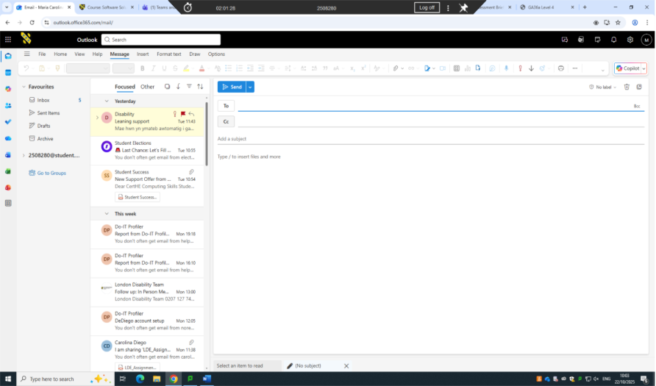

Figure 10: New Outlook email being composed

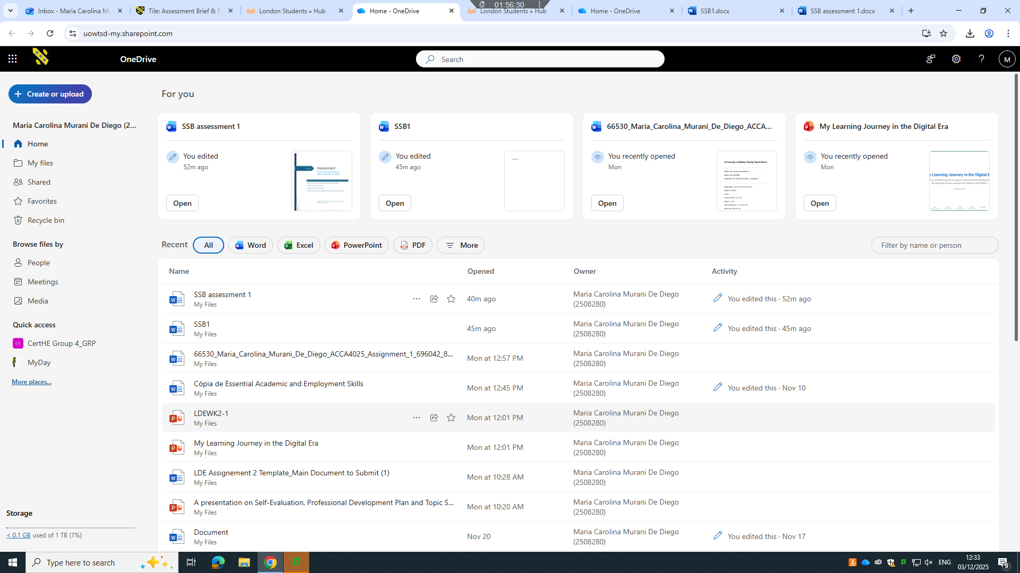

Figure 11: OneDrive file sharing and collaboration interface.

2. Practical Use of Microsoft OneDrive (Collaboration Tool)

To demonstrate the collaborative capabilities of OneDrive, I created a shared folder, uploaded a document, and collaborated on it using live editing features. Cloud-based collaboration is vital in workplaces where teams work remotely or across different departments.

The activity began by accessing OneDrive and creating a new folder labelled “Project Files.” I uploaded a Word document into this folder and then selected Share to choose a collaborator. I granted edit permissions, replicating how a real organisation might allow staff members to contribute to shared documents.

Once the file was shared, I opened it using Word Online, which immediately displayed the collaborator’s presence when they accessed the document. Real-time co-authoring allows multiple users to type, edit, or comment simultaneously. This eliminates issues such as duplicate copies of files or lost progress.

Finally, I reviewed the document’s Version History to examine previous changes. This feature provides an additional layer of security by allowing users to restore older versions or track specific contributions. It is especially useful during long-term projects where many edits occur.

This practical task demonstrates how OneDrive simplifies teamwork by centralising documents, enabling shared editing, and maintaining version control — all essential functions in collaborative business environments.

Conclusion

This portfolio has explored a wide range of digital tools and software solutions that support modern business operations. Through the analysis of e-commerce platforms, mind-mapping techniques, office applications, and communication technologies, the report demonstrates how software has become a central driver of organisational efficiency, decision-making, and innovation.

The comparison between Shopify and Wix highlighted how different e-commerce systems meet the needs of distinct business models. While Shopify provides scalability and professional integration suited to growing enterprises, Wix emphasises accessibility for start-ups and creative industries. This contrast illustrates how technology selection must always align with organisational goals, resources, and strategic direction.

The examination of mind-mapping reinforced the importance of visual thinking in planning, problem-solving, and managing complex information. The mind map created for this assessment positioned contemporary software tools within functional categories, showing how organisations rely on diverse applications for communication, productivity, analytics, and online commerce.

The review of office applications—Word, PowerPoint, Excel, and Access—demonstrated how workplace software enables employees to produce professional documents, deliver presentations, analyse numerical data, and manage databases. The practical tasks involving Mail Merge and PivotTables provided concrete evidence of how digital literacy enhances everyday business tasks and supports informed decision-making.

Finally, the analysis of Microsoft Outlook and OneDrive highlighted the essential role of communication and collaboration technologies in hybrid and remote working environments. The practical demonstrations showed how these tools streamline email communication, meeting scheduling, document sharing, and collaborative editing.

Overall, this portfolio emphasises that effective use of software is not merely a technical ability; it is a critical organisational competence. Businesses that integrate these tools strategically are better positioned to improve efficiency, support teamwork, and adapt to the evolving digital landscape.

References

[1] T. Buzan and C. Griffiths, Mind Maps for Business. London, UK: Pearson, 2018.

[2] W. M. Davies, “Concept mapping, mind mapping and argument mapping: What are the differences and do they matter?,” Higher Education, vol. 62, no. 3, pp. 279–301, 2011.

[3] R. Eppler, “A comparison between concept mapping, mind mapping and visual metaphors as complementary tools for knowledge construction and sharing,” Information Visualization, vol. 5, no. 3, pp. 202–210, 2006.

[4] Forbes, “E-commerce platform innovation and growth: Shopify and Wix,” 2024. [Online]. Available: https://www.forbes.com. [Accessed: 09-Jan-2026].

[5] Shopify, “Annual Report 2024,” 2024. [Online]. Available: https://www.shopify.com. [Accessed: 09-Jan-2026].

[6] Shopify, “Shopify Sustainability Report 2023,” 2023. [Online]. Available: https://www.shopify.com/sustainability. [Accessed: 09-Jan-2026].

[7] Wix, “Business Performance Report 2024,” 2024. [Online]. Available: https://www.wix.com. [Accessed: 09-Jan-2026].

[8] Wix, “Corporate Responsibility and Sustainability Report 2024,” 2024. [Online]. Available: https://www.wix.com. [Accessed: 09-Jan-2026].

[9] Microsoft, “Microsoft Word – Create and edit professional documents,” Microsoft 365, 2025. [Online]. Available: https://www.microsoft.com. [Accessed: 09-Jan-2026].

[10] Microsoft, “PowerPoint – Design presentations,” Microsoft 365, 2025. [Online]. Available: https://www.microsoft.com. [Accessed: 09-Jan-2026].

[11] Microsoft, “Excel – Analyze and visualize data,” Microsoft 365, 2025. [Online]. Available: https://www.microsoft.com. [Accessed: 09-Jan-2026].

[12] Microsoft, “Access – Database management system,” Microsoft 365, 2025. [Online]. Available: https://www.microsoft.com. [Accessed: 09-Jan-2026].

[13] Microsoft, “Outlook for business – Email and calendar,” Microsoft 365, 2025. [Online]. Available: https://www.microsoft.com. [Accessed: 09-Jan-2026].

[14] Microsoft, “OneDrive for Business – Cloud storage and file sharing,” Microsoft 365, 2025. [Online]. Available: https://www.microsoft.com. [Accessed: 09-Jan-2026].

[15] G. Johnson, K. Scholes, and R. Whittington, Exploring Corporate Strategy, 12th ed. Harlow, UK: Pearson, 2022.

