Advanced Processes and Materials

Assignment 1

Aluminium Helicopter Floor Panel

By Brett Nethell

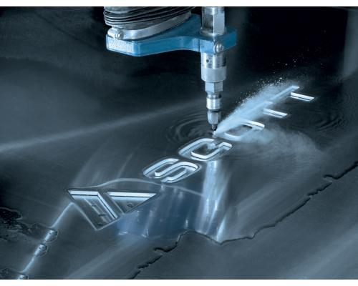
Figure 1

Introduction

In this report there will be a comparison of two alternative methods of manufacturing a helicopter aluminium floor panel. The main process to be compared against the two alternatives is the process currently being used by the company who already manufacture these floor panels, this process is CNC milling. CNC milling has been around for a long time, it uses a programme written for the machine to move a spinning carbon steel tool bit that cuts a part at a decent speed with a decent surface finish and these days a very tight tolerance such as the company achieving +/-0.0127. A very traditional method of manufacture that currently does the job. However, with the new technology arising, the company want to look at other methods of manufacture that will be more energy efficient and produce less waste. The only issue with changing manufacturing processes is the initial cost, but this may be overlooked due to the future savings involved with the change of manufacturing. Using data for different manufacturing process will also be clear in this assignment to show the true values of different processes and help to compare them. The aim of this report/assignment will be to show the company in question how different manufacturing processes may improve their company’s efficiency, speed and money saving capabilities.
The two non-traditional manufacturing methods that will be looked at are Water Jet cutting and Laser Beam Machining. These have been chosen because of the very different benefits they would bring to the company, however in both cases money saving will be a common trait in the long term. I will discuss these advantages and disadvantages in this report.

Alternative process 1 – Water Jet Cutting
The first process that will be a great investment is water jet cutting manufacture. This process uses very high-pressure water (around 60,000 PSI) to cut through all different types of material. Widely used in the food industry for hygiene reasons, this manufacturing process has very little tool costs along with a cleaner and cheaper work space. The helicopter floor panel that is to be manufactured isn’t very thick only being 25 mm in depth, this is great as one of the problems with water jet cutting is that the thicker the material the bigger the tolerances must be to allow for the sweeping of the water jet, as it loses pressure through the material.
There is a very important component called the intensifier which is how the water reaches pressures all the way up to 90,000 PSI. “Using hydraulic pressure over water system, the intensifier pump is driven by a motor which helps the intensifier pump use its piston and cylinder arrangement to create the high pressure needed to cut the material” (ESAB, n.d.)
As well as the use of very high-pressured water, metal grains are added to the water just before the water is sprayed out the nozzle to help it cut through the given material. However, the use of these metal grains may make recycling of the water very difficult as they will have to filtered out in order not to damage the systems components.
The main concern with this process of manufacture is the tolerance it can achieve, specified by the company the CNC milling machine can achieve a tolerance of +/-0.0127. However, the water jet has a maximum tolerance of +/-0.025 so above the limit the company have specified. If the company are willing to look past this as they are manufacturing a floor panel then the water jet cutting process is really one to be considered. Adding a next step of CNC milling once the main cut is done may help to improve the tolerance values, however this is not suggested as extra costs will ensue just to improve the tolerance value very so slightly.
When looking at the water jet process against the CNC milling, in the water jet process there is no swarf produced and no burs that will need a second manufacturing process/step in order to be put right. The water jet cutting process will also give a better finish to the floor panel than the milling process, this is down to the milling requiring numerous movements in order to complete the cut whereas the water jet process does its cutting in one motion moving around the component.
If the water is reused, then it will mean major savings for the company. The better efficiency of the water jet cutting process will also help them save as the water jet may take half the time the milling machine would take to complete the floor panel.
The initial cost of the waterjet cutting process is expensive especially down to needing a jewel in the nozzle however the cost and time savings that will follow may well mean the money is made back very quickly. Also considering the sale or use of the CNC milling machines, this means that they could use it for more work or sell it, either way making more money for the company.
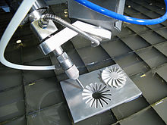
Investment cost start at £90k but can range anywhere from that to over £400k.

Figure 2 – A 5 axis Water-Jet cutting machine.

Alternative process 2 –Laser Beam Machining

The second process chosen is Laser Beam machining. Chosen again for its low tool cost compared to milling, this process acts just like a laser to cut through material. Choosing this process may will bring the same benefits as the water jet cutting process but with a greater start up cost. However, this is traded off for an excellent tolerance value which is beyond what the company specified or probably need. A maximum tolerance of +/-0.013 will ensure the floor panel is always very accurately manufactured and achieve a slightly better surface finish than Water Jet machining. Achieving a surface roughness of 0.2 µm compared to Water Jet at 3.2 µm. This will interest the company as they specified improving their surface finish, it may also be a trade-off for the expense of the laser beam system.
The main cost of this process comes from tool cost/initial start up cost. This may take longer than the Water Jet process to cover cost and start to see real savings. However once invested this machinery will be a great asset to the company and like the Water Jet process potentially bring in more work.
“A high energy laser beam hits the surface of the component, the heat energy absorbed on the surface of the component melts and vaporizes the material away from the component” (Mishra, 2017)
This process is shown in the simple diagram below.
Investment cost start at £250k but can range from that to over £1.4M.
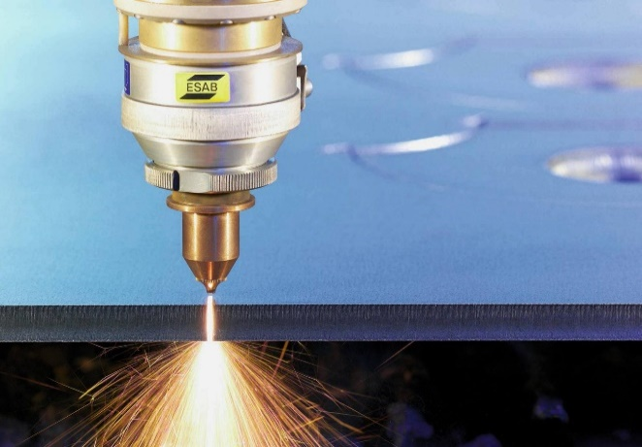

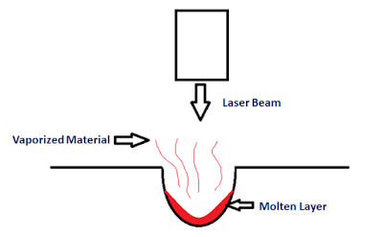
Figure 3- Laser Machining at work.
Figure 4 Working Example of LBM

Discussion / conclusions

Looking at the advantages and disadvantages of the two chosen products in comparison to the currently used CNC milling machine process it is clear to see that a movement toward non-traditional process for this company and purpose would be beneficial. When It comes to choosing one it is ultimately up to the company in question. However, from this report and the research carried out, it seems that the Water Jet process may be the right choice even if it does have a downfall on achieving the specified tolerance. Reasons for this are that the Water Jet process is a very fast-growing method with many companies and industries using the technology, due to this it is clear to see that it is an effective method of manufacture and with the ever-increasing use, the technology is likely to improve even more than it already has. This would mean components for the system will last longer and cost less. Making the move over to a non-traditional process such as Water Jet maybe risky but will also help the company stand out from the others, making them more appealing to customers.
The Laser Beam Machining is also a good investment and is a very accurate processes of manufacture, however in this case it may be too accurate and much of a risk for the company to take. The benefits that this increased accuracy could be that the company are asked to manufacture more complex and important aerospace components that require a very accurate tolerance value, which will therefore bring in more highly paid work.
As said before if the company are wiling to overlook the slightly higher tolerance value that the Water Jet system brings, then this non-traditional manufacturing process will be able to expand and modernise their company like there are looking at doing.
This report has looked at how both Water Jet machining and Laser Beam machining could help the company in question expand, looking at how these two alternative processes provide different advantages and disadvantages it is important that the company consider each alternative process carefully as they can affect the company massively in either a positive or negative way.
Both processes are seen to be an improvement on the current CNC milling process which compared to these two alternatives is a space consuming, dated and inefficient manufacturing process in the modern day. By making a switch to either alternative process will help to modernise and expend the company in different ways, however that was the aim of this report to showcase two alternative methods the company could investigate and/or use.

References
ESAB. (n.d.). Retrieved from http://www.esabna.com/us/en/education/blog/waterjet-cutting-process-basics.cfm
Mishra, P. (2017, May 2). Retrieved from Mechanical Booster: http://www.mechanicalbooster.com/2017/05/laser-beam-machining.html

Research for this report/assignment is mainly from lecture content, however internet research has been carried out and referenced where appropriate.
Costs and waterjet info: - http://www.hydromar.co.uk/waterjet-cutting-how-does-it-work.aspx
Machine/process tolerances: - https://www.engineeringclicks.com/tolerance-surface-roughness/
Figure 1 - https://www.scottautomation.com/products/waterjet-cutting/
Figure 2 - https://en.wikipedia.org/wiki/Water_jet_cutter
Figure 3 - https://mindvis.in/articles/page/8
Figure 4 - http://www.mechanicalbooster.com/2017/05/laser-beam-machining.html

