

LEVEL 6

SEMESTER 1

MODULE CODE: SHSS6079
Curriculum Adventure
aSSESSMENT TYPE: Problem BAsed learning assignment

COMPONENT WEIGHTING: 50 %

WORD COUNT: 2500 WORDS

MODULE TUTOR: Nalda Wainwright

Working in groups respond to the following problem to individually produce a paper.

Temporary post, six months: Work with the physical education department of TSD secondary school.
Changes in the curriculum in Wales will be focussing on Areas of Learning and Experience (AoLE) in place of subjects.
The PE department of TSD secondary school are seeking support to develop the Health and Well-being AoLE in the school. Applicants need to demonstrate an understanding of Adventurous Activities and outdoor learning. Prepare a paper for the SMT outlining how the school grounds could be developed to support adventurous activities and outdoor learning. Your paper needs to demonstrate how the changes will contribute to the development of physical literacy, and health and well-being.

SUBMISSION DETAILS: December 13th 2019

School of Sport, Health & Outdoor Education

Assessment Feedback Sheet

Student No. /Name: 1700888/Samuel Sharp
Module: Curriculum Adventure
Module Code: SHSS6079

Personal Evaluation – to support your academic progress please complete the section below BEFORE submitting your work.
What do you consider to be the best aspects of this work? |  |  | I liked how it made me think about what schools can do.
Which aspects do you consider could have been improved in this piece of work? |  |  | More academic reading to link to.
What have you found most satisfying whilst undertaking this submission? |  |  | The school visits and the designing of the school grounds.
ASSESSMENT CRITERIA | Learning  Outcomes |  | GRADE
ASSESSMENT CRITERIA |  |  | Poor  < 20% | Weak  20-29% | Unsatisfactory  30-39% |  | Satisfactory  40 – 49% | Good  50 – 59% | Very Good  60 – 69% | Excellent  70 – 84% |  | Exceptional  85– 100% | %
critically evaluate the importance of adventure to individual learning, personal development and health and well being | 1 |  |  |  |  |  |  |  |  |  |  |  | 30%
critically analyse a range of developments for the school grounds that are appropriate to outdoor and adventurous learning and support health and well being | 1, 3 |  |  |  |  |  |  |  |  |  |  |  | 20%
Able to evaluate a range of learning opportunities to underpin outdoor and adventure in the whole curriculum | 3 |  |  |  |  |  |  |  |  |  |  |  | 30%
Critically analyse the role of adventure and the outdoors in the development of children’s physical literacy. | 4 |  |  |  |  |  |  |  |  |  |  |  | 20%
It is expected that students will present work that is proof read and follows the School Reference Guide and Assessment Checklist. Therefore a range of 0 – 10 marks will be deducted for non-completion of any of the points on the checklist below.
TUTOR COMMENTS:

Submission date:  via Turnitin |  | Return date:  (at least within 4 weeks) |  |  |  | Tutor: |  |  |  |  | Mark:

Assignment Checklist

- Please complete the Personal Evaluation section of the Assessment Feedback sheet and paste it into the front of your assignment

- Submission is a single word file, clearly labelled with your name and module code
- Font style - Times New Roman, size -12 for text and 14 for headings
- Ink colour – black only
- Line spacing – 1.5 line spacing and 2cm- 2.5cm page margins
- Quotations more than three lines to be indented 1 line spacing
- One line space between paragraphs, paragraphs must be left aligned
- Pagination (your essay should have page numbers)
- All tables and figures are internally referenced and have a title
- Word count checked and written at end of text (before references and any appendix)
- Essay is within 10% of the word limit (excluding references and any appendices)
- All references in the text are included in the reference list
- Correct referencing following the Harvard style, as described in the Palgrave study skills book ‘Cite them Right’.
- Correct spelling using UK English
- Correct use of punctuation
- Grammar and syntax correct- double check anything that has a green line under it
- I have read my assignment out loud to myself and it makes sense and is easy to read
- Somebody else has read my work and it makes sense to him or her!
- I have checked and I have not plagiarised
Failure to follow these guidelines will cost you marks!

School development
There is a rising issue within young people and children that their health and wellbeing is not as it should be. It is not just the children that suffer. According to Pearson: The Worlds Learning Company A study from the NHS in 2018 shows that 1 in 8 young people under the age of 19 have at least one mental health disorder. Similarly figures pulled from the Teacher Wellbeing Index show that 67% of education professionals are stressed and a further 57% are considering leaving teaching due to health concerns.
As there is a draft for a new curriculum in Wales that is planned to be released in 2022 that has the title of Health and Wellbeing, I think it is a great opportunity to address these issues and bring forwards plans to develop a school grounds that will adhere to the curriculum and benefit not only the students but the staff and subjects that are taught in school.
Throughout schools in the UK and wales there is a specific curriculum that the school needs to follow. Unfortunately many schools do not facilitate the outdoor perspectives of the curriculum. I have been brought in to develop this school in a way that they can facilitate and encourage the use of the outdoors and directly link it to the curriculum.
As part of this development I am going to focus on some short, medium and long term goals. The goals will be developments that will range from things that can be implemented immediately to things that can take up to 5 years or longer. For these plans, some of the long term goals will be developed and ready to use for the new curriculum however some plans will not.

Overview
As part of the development for this school I have developed a small amount of plans that I would like to implement. These plans will include lots of different ideas and thoughts on what the school can do to make use of the grounds that they have. After a long period of time I would expect this school to have developed to its full potential, provided they follow the planned changes to the new curriculum. Should some of these developments begin now, they can be ready for when the curriculum is released in 2022. This would give the school and other schools chance to develop what they can in time and begin to implement these changes in their teaching.
The development of this school is to really emphasise what we can do with the school grounds to support adventurous activities and outdoor learning. It will also focus on the development of children’s physical literacy and health and wellbeing.
For this school I am going to try and implement different forms of challenge courses that can be developed and changed over time. A challenge course can be really good as they can be built and developed through time.
The short and medium length plans will be the focus of my essay, as they are what I really think can make a great positive first impression on the school and will have an impact sooner. In addition, the relatively short length of my placement means sustainable plans will need to be implemented quickly, so that they can be carried on beyond the 6 months.
Every piece of development made for this school will help to facilitate the new draft curriculum, physical literacy and health and wellbeing.

Short, Medium and Long Term Plans
For my short term goals I need to implement something that will work quickly and something that may not cost that much to do. In doing this I am able to give the school something they can use almost straight away, this can then be used for any subject and can hopefully give the school students and staff what we call an instant win. This is when it is something they like gets done straight away to gain their favour.
My medium term goals will be things that can be something completely unrelated to my other goals but will take a little longer to process. These goals could be developing a small section of the school grounds into an area for planting flowers, trees and even have some vegetable patches. This section of the grounds can really help for certain subjects and can benefit the whole school; they may just take a little longer to put into place.
Then for my long term goals I would be creating something that may be finished after 3-5 years. These plans are long term as they either take a while to develop or are expensive, meaning you need time to gather funds. Most of the time it will be done in small sections and the school will gather money and develop the grounds as they go and then the long term goal is that by the end of the 5 years it will be finished.

What is a Challenge Course?
A challenge course is a name given to lots of different styles of courses such as high ropes courses, low ropes courses and other group initiative activities (Attarian, 2001). Some primary schools may know them as timber trails and other schools and people might have their own names for it.
According to Rohnke, Tait, and Wall (1994) the definition of a challenge course is that it is “an experiential adventure programme, which offers groups and individuals the opportunity to participate in a series of activities involving mental, physical and emotional risk taking” (p. 1).
Lots of people hear the words “challenge course” and associate them with these extreme high ropes course towering up in the trees. However it covers a lot more than just that. It covers all sorts of different courses that have the same sort of design and structure but can be used at different levels and in different ways. Some can be more technical that others.

Philosophy of Challenge Courses
The Building Blocks
There are three concepts that can really help you understand the philosophical underpinnings of challenge courses. These building blocks are 1. Experiential learning. 2. Small – group dynamics and 3. Adventure. These are the primary ingredients to support a challenge course programme as an educational experience. Using these challenge courses with the basis of these building blocks you can support student growth and development. These can be in things such as attitude, positive interpersonal relationships, communication skills and group development. All these things are common outcomes that can come along with appropriate courses.

Experiential Education
What Mark Wagstaff has written in ‘Developing Challenge Course Programmes for Schools’ seems to be very similar to Kolb’s learning cycle of a concrete experience, reflective observation, abstract conceptualisation and active experimentation. He also explains how the Association for Experiential Education defines experiential education as: “experiential education is a process which a learner constructs knowledge, skills, and values from direct experience”.

Small – Group Dynamics
“The more pressure placed on students to achieve and the more difficult the material to be learned, the more important it is to provide social support within the learning situation” (Johnson et al., p. 1:9). Challenge courses focus on small groups or individuals to complete them, as you can use them for many different things that can include group or individual work. The work you will be doing on these challenge courses help the students to focus and develop their skills of working in groups and efficiency within their learning.

Adventure
The concept of adventure is what makes challenge courses a unique brand of experiential learning. The term adventure means to engage in a daring or risky activity. Challenge courses are a prime example of something that can help with the development of a child’s ability with dealing with possibly risky activities or environments. When you add the elements of risk and challenge to a child’s learning you can help them to think for themselves and decide what risks they are able to take, this in turn adds to their overall physical literacy and ability to learn through experience.
Adventure is a continuous and evolving thing, for each person adventure is different. This is because we each have our own thoughts, feeling and fears. Adventure can be so many different things and it can be supported by the idea of challenge by choice. This really gives the child a better perspective on different activities and situations as it gives them the opportunity to decide whether it is something they want to do. You are no longer being forced to do something you do not want to do. Having this freedom to have your own adventures can take pressure off you as you are not expected to do one thing but to do something you consider adventurous.

Benefits
When it comes to benefits of challenge courses, it can be quite easy to see them when someone is using one, however can be a little harder to imagine for some people.
Newberry and Lindsey (2000) conducted an experiment for at-risk adolescents, they watched and assessed these young people after participating in a low element challenge course, or simply on a ground timber trail. They found that the locus of control increased and their confidence increased, which lead to them taking their own risks and also being able assess the risk and have the confidence to take it.
As soon as young people begin believing in themselves for things like challenge courses, they then begin to believe themselves in other things. Activities that offer experiential learning give you the chance to engage mentally and physically. You will then have a different approach and attitude to your learning and can then pass this on to other subjects and activities that you take part in.
One of the biggest things with outdoor learning and experiential learning is being able to learn from mistakes and taking that on so you can do better next time. This mindset is very easy to use for everything you do.

Short term goals
My short-term goal will be to do something that will not take much time at all so that I can make an instant positive impact on the school and its grounds. This would be the beginning for my medium and long-term goals.
For my short-term goals, I am going to include lots of simple improvements to help develop the grounds. These will be things like adding lots of seating areas, the first set of a challenge course and possibly things like a fire pit and planting willow. Not all my short-term goals are things that will be completed straight away, for example getting the children to plan willow in certain ways so eventually and over time they can learn to look after it and form it into a living willow sculpture. The short-term aspect of it is planting it in a certain way so that when it begins to grow you can form and shape it into what you want.
Seating Areas – see appendix 1
For the seating area I will be placing long benched along the south facing walls just above the rugby pitches. I will also find out where people like to congregate around the school and see about putting picknick benches and other seating in those areas.
Willow Planting – see appendix 2
The willow planting will be something to give to the students and allow them to have owner ship for. They will be tasked with coming up with a design so that when they plant it, it will be in a certain shape and then when it begins to grow, they can then weave and shape it into what ever design they wanted. I will situate this between the redgra and the science block as there is a medium to large unused area of grass that would be great to have a willow garden for use for anyone in the school to plant different types of willow to use for other willow workshops and different willow sculptures. These willow workshops could fit perfectly into the school’s enrichment programme.
Fire Pit &Wild Garden – see appendix 3
This area will be a slightly developed wild area that will have some wild growth and a log circle with a fire pit in the middle. This area can be used for almost anything as it can be used as an outdoor classroom or more obviously some fire building skills workshops. This is the perfect spot for some if not all classes to use to make their classes interesting and having some fun making a fire and cooking marshmallows and s’mores.

Medium term goals
My medium-term goals will be things that cannot be done straight away and will take a few weeks – months to do. These will be things that have been developed from my short-term goals and can be developed to my long-term goals.
Low Element Challenge Course – see appendix 4
This will be something that will be developed and build over time. This will again be given to the students to decide what type of course they want. They will be given a list and chose the one they want and give reasons why.
As these challenge courses develop and grow, they can be used for more things. To begin with they can have a very simple play-based use.
As shown in appendix 4 there is a large space between the rugby pitches and the redgra that can be developed and used for a large challenge course area. This area would be added to over time and become a complete trail that can be used in both lesson times and in break times. For the first piece of the challenge course I would start with something that the students really like and would be able to use without supervision. This will be something that can link perfectly into the new (draft) curriculum. This low element challenge course will pave the pathway for even more variations of different challenge courses. This will hopefully become a large area that has a large variety of different courses.
Footpath – see appendix 5
For this I want to have a path that goes almost around the entire school. This path will take you past every point in the school grounds that will have had some development. This path will be a way you can go around the school without having to walk on muddy grass if you didn’t want to. The path shown in the appendix is only a small section of what the path will cover within the school grounds.

Long term goals – see appendix 6
My long-term goals will be things that have developed from my short and medium-term goals. Ideally the school will have had a full development of challenge course, flower beds, wild gardens, vegetable and fruit patches with a possible greenhouse, a forest school area and more areas that can be utilised for outdoor classrooms.
The picture in appendix 6 is not a complete design for what the school will look like, but it is a brief outline of what is could be and where things would go.
Throughout the development of all these things there will be some key areas that will be focused on. This will be a focus on outdoor learning, physical literacy and how the health and wellbeing in young people can be improved in schools. Ingunn Fjortoft (2001) talks about how the use of the outdoors and its affordances to young people really affect the motor development skills and increase their learning ability. He talks about how children should spend more time in the outdoors and be introduced to an environment for play as it stimulates the motor development in children.
Reference List

Attarian, A. (2001). Trends in outdoor adventure education. Journal of Experiential Education, 24(3), 141.

Rohnke, K. Tait, C. & Wall, J. (1997). The complete ropes course manual (2nd ed.)

We need to talk about mental health and wellbeing in schools, Pearson UK, Pearson.com https://www.pearson.com/uk/educators/schools/issues/working-together-to-build-healthy-and-happy-schools/we-need-to-talk-about-mental-health-and-wellbeing-in-schools.html (Accessed 05/12/19)

Johnson, D. W., Johnson, R. T., & Holubec, E. J. (1992). Advanced cooperative learning. Edina, MN: Interaction.

Kolb, D. (1984). Experiential Learning: Experience as the source of learning and development. Englewood Cliffs, NJ: Prentice Hall.

Wagstaff, M. (2003) ‘History and Philosophy of Challenge Courses’ in Wurdinger, S. & Steffen, J. Developing Challenge Course Programmes for Schools. USA: Kendall/Hunt Publishing Company, pp 3-16.

Allison, P. (2003) ‘Key Principles: Trust, Risk and Learning’ in Wurdinger, S. & Steffen, J. Developing Challenge Course Programmes for Schools. USA: Kendall/Hunt Publishing Company, pp 17-29.

Fjortoft, I. (2001). Early Childhood Education Journal, 29(2), pp, 111 – 117.

Appendix

Appendix 1

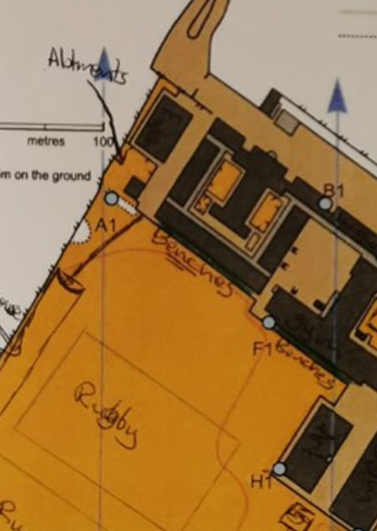

Appendix 2

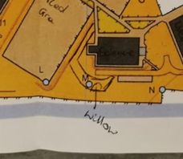

Appendix 3

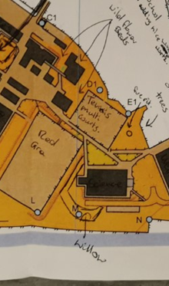

Appendix 4

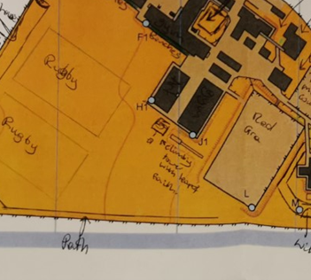

Appendix 5

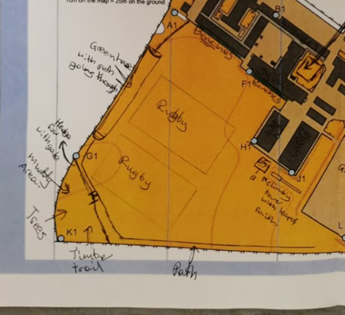

Appendix 6



