
Certificate of Higher Education Skills for the Workplace (Health and Social Care)
Professional Development within Health and Social Care
LCHS4009
Tittle: Professional career Development within H&SC
- Module Number: LCHS 4009 (LON)
- Assignment No: ASSIGNMENT 2
- Your Name: KEDIJA ALI HUSSEN
- ID Number: 2434785
- Your Tutor’s Name: Amitava Banik

Executive Summery

This portfolio will show my professional preparedness to work in the health and social care sector as a Social Worker. It includes a specific job analysis, a specific CV, and a personal statement that is done according to the requirements of the industry. The most important strengths outlined in a SWOT analysis are communication and empathy, whereas areas such as ICT capabilities and flexibility should be developed. A personal development plan based on SMART gives a set of systematic plans on how to improve continuously. Reflection practice through the Reflective Cycle, which is presented by Gibbs, is also integrated into the portfolio, where performance in the presentation and feedback comments of lecturers are critically assessed. On the whole, the report outlines my lifelong learning and professional development in social care practice.

Table of Contents
1. Introduction 4
2. Chosen Job Vacancy 4
3. Task 1: Professional CV 6
4. Task 2: Personal Statement 7
5. Task 3a- SWOT Analysis 8
6. Task 3b- Personal development plan 9
7. Reflective Writing 10
8. Conclusion 12
References 13

1. Introduction
The report will demonstrate the role and application of professional development within social and health. Professional development suggests that individuals are required to identify their strengths and weaknesses by conducting a self-assessment and improving their weak areas with a proper roadmap (Donath et al., 2023). Candidates who aim to serve in the social and health care industry must have proper skills and competencies that match the industry standards and service user’s preference. The portfolio will be based on an individual's personal curriculum vitae, and it will nominate the most suitable job role for the individual.

2. Chosen Job Vacancy
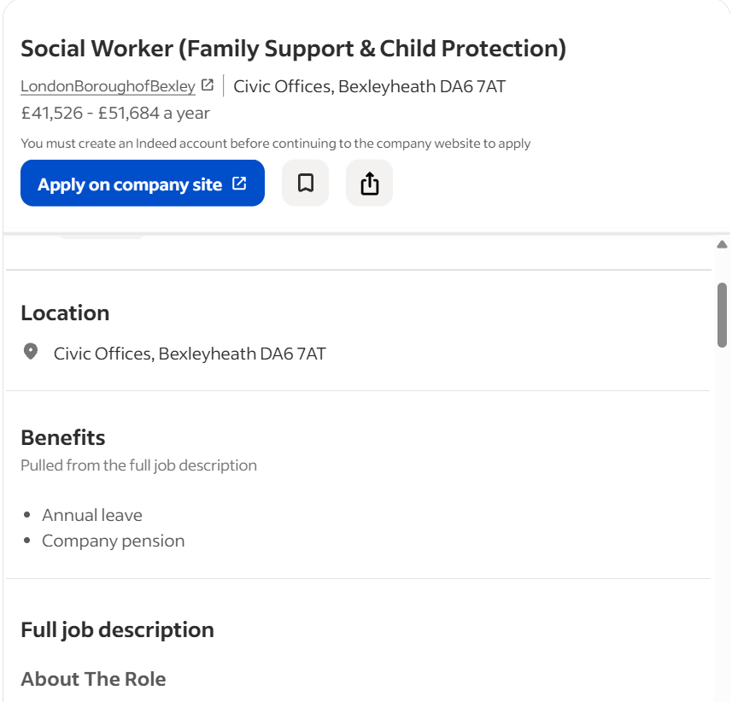
Figure 1: Social Worker Job Advertisement
(Source: Indeed, 2023)

The nominated job role is in the field of social work. The name of the job advertiser is the London Borough of Bexley, which is situated in Bexleyheath. The organisation has established itself in Bexley, offering a strong learning and development programme with the aim of improving the lives of children and families. The organisation is family-oriented and guides families and individuals in their career development, talent management, and other aspects of life, so people can flourish in their lives. The firm offers personalised training to users and makes them feel confident. The Borough of Bexley is hiring talent that matches the core principles of the organisation. It focuses heavily on skill development and ensures that all staff are equipped with proper skills and competencies. The primary target group is adolescents seeking to improve their social standing and professional prospects. The organisation is looking for practitioners who can navigate e-learning platforms. The candidate profile of the job advertisement includes interlinked social work skills, expertise, and qualifications. As the individual has a degree certification in social and health care, this job role aligns with the credentials.

3. Task 1: Professional CV
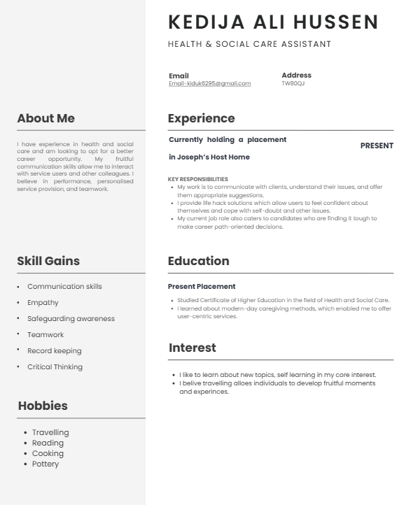
Figure 2: Personal CV
(Source: Self-created)

4. Task 2: Personal Statement
I have experience in health and social care and am looking to opt for a better career opportunity. My fruitful communication skill allows me to interact with service users and other colleagues. I believe in performances, personalised service provision, and teamwork. The social and health care sector in the United Kingdom is rising, and people are looking for professional experts who provide personalised and user-centric services. This industry is very broad with numerous job roles such as caregiver, child care supporter, adolescent mentor, and family mentor. As the industry is growing and people are ready to pay a premium for good quality services, I want to capitalise on this huge opportunity. I have a proper degree certification in social and health care-related work, which enables me to stay in this niche market. According to reports, the health and social care industry employed around 4.16 million people in 2022 (Statista, 2024). Having said that, my core work responsibilities are to communicate with clients and understand their issues, and offer them appropriate suggestions. Skill development allows employees to leverage career opportunities as organisations are preferring competent workers (Kumar and Hooda, 2024). Alongside, I provide life hack solutions that allow users to feel confident about themselves and cope with self-doubt and other issues. Having said that, my current job role is also catering to candidates who are finding it tough to make career path-oriented decisions. I have an academic qualification in the field of social and health care. I am currently working in Joseph’s Rest Home and have gained real work experience. I offer personalised caregiving services to users and help them build strong and confident personalities. I gained multiple transferable skills, including communication skills, empathy, teamwork, and critical thinking. Employability prospects depend on candidates’ caliber and self learning ability (Bennett et al., 2023). Through this, I gained how to interact with clients and understand their specific issues.
In addition to that, I have gained several skills and competencies that will help me in my future career advancement. I am good at people-to-people interaction, which is driven by my fruitful communication skills. I maintained professionalism and took feedback from my users. Apart from this, I put major efforts into ethical consideration and ensure that users’ personal information is protected. I am looking for a career advancement because I believe my service and work can help a lot of people. It will be also beneficial for me because I will be able to develop new knowledge and . A caregiving job is a holistic approach that falls under social development goals and institutions required to maintain a positive workplace environment (Heijkants et al., 2023). In brief, I am looking to opt for new work experience and want to serve people with a human-centric approach.

5. Task 3a- SWOT Analysis
Strengths | Weaknesses
- I have a strong standing in human interaction, which is driven by my effective communication skills. I can easily build good relationships with people and make them feel comfortable and valued. This allies my to understand people’s issues from an empathic and human-centric angle.  - I am highly productive and work with preciseness which allows me to maintain punctuality. This underlines my strong foot in time management aspects, which is required in a job role like social work. I can easily complete tasks such as counseling and providing training on deadlines. This enables me to reduce work-related stress, which is a vital aspect to have in this field. | - I am not optimal when it comes to digital platform use, which is a major barrier to my career advancement.  - I am dependent on my individual competencies and often find it tough in a new environment, which showcases my weakness in flexibility.
Opportunities | Threats
- I can offer personalised training and also take feedback from service users with the help of my communication attributes. | - The absence of ICT knowledge could create major pitfalls in my future career.  - I am not flexible, which is a key trait to have in the modern-day professional field.
Table 1: Personal SWOT Analysis
(Source: Self-created)

6. Task 3b- Personal development plan
Specific Objective | Measurable | Achievable | Resource Required | Time-bound
I want to develop ICT skills and aim to enhance my technical knowledge. ICT skills allow individuals to have proper expertise in digital-led work (Weber and Greiff, 2023). These skills include multiple platform-based knowledge, such as Zoom, Google meet Microsoft Office, Microsoft excel and presentation. This skill is highly important to have because modern-day care-giving service providers have a major presence in e-learning-based platforms. | I will measure my progress when I achieve proper skill and knowledge about modern-day digital platforms such as Zoom and Google Meet. | This skill can be developed easily by enrolling in professional skill development courses. These courses provide personalised training to candidates and reskill with proper coaching and guidance. Along with this, I will enroll in e-learning platforms that are cost-effective, and learning content can be easily accessed. | In this case, monetary support is essential. I will also collect feedback from my peers and colleagues to monitor and assess my work progress. | This skill can be developed in 6 months.
My adaptability skill has major room for improvement, and I want to improve it through proper skill training and development. Adaptability skills enable employees to adjust their interpersonal needs that match with the workplace environment (Sony and Mekoth, 2022). | I will measure my progress through continuous learning and adapting to organisational settings. | This attribute can be achieved by enrolling in workshops. I will join workshops and work as a volunteer to become more adaptable and flexible. It will enable me to become more open, and I will be able to work in coordination. | 365-degree feedback in a performance evaluation tool, which allows taking anonymous feedback from peers and supervisors (Custom Insight, 2024). | It can be achieved after 3 months of training.
Table 1: SMART framework for Personal Development Plan
(Source- Self-created)

7. Reflective Writing
This reflection is based on Reflective Cycle (1988) by Gibbs, which gives a systematic approach to the evaluation of the learning experiences in six steps: description, feelings, evaluation, analysis, conclusion and action plan.
1. Description
My professional portfolio was the basis of the presentation concerning the Social Worker position in the London Borough of Bexley. It contained my CV, personal statement, SWOT analysis, and a personal development plan in the form of SMART. I described how my communication competency, empathy and collaboration fit in social care practice. I also identified the areas of weakness, namely, my low ICT competence and adaptability and suggested using the structured training and the 360-degree feedback as the means to improve. The aim of the presentation was to show professional self awareness and willingness to advance in career in the field of health and social care.
2. Feelings
I was nervous before I presented since speaking before an audience is one of the areas where I feel I am not confident. Nonetheless, I was also ready since the content was grounded on my personal experiences. In the course of the presentation, my confidence began to grow, particularly when I was describing my strengths and development objectives. Upon having done the presentation, I was relieved and satisfied though I also realised that there were areas which should be improved, especially the critical analysis and theoretical integration.
3. Evaluation
Several aspects went well. My presentation was well organized and comprehensible. My lecturer was appreciative about the applicability of the SWOT analysis and clarity of the SMART goals as my goals were realistic and attainable. I was also clear in my communication and was also professional. Nevertheless, the lecturer made constructive feedback saying that my reflection was descriptive rather than analytical. I failed to incorporate academic theories adequately in order to argue in support of my points critically. Moreover, I could have been sure of what I delivered, and at times, I repeated myself.
4. Analysis
My strengths of the presentation can be associated with preparation and self-awareness, which can be attributed to Gibbs (1988) argument that structured reflection increases the effectiveness of learning. My strengths are in communication. According to employability research, interpersonal competence enhances professional credibility (Zhang et al., 2024). Nevertheless, the lack of theoretical convergence implies the lack of full movement via the experiential learning cycle. Although I explained and contemplated on experience, I was not entirely involved in abstract conceptualisation through in-depth application of theory. Moreover, I require becoming more adaptable. flexibility to be an important element in a contemporary workplace (Paschina, 2023). The feedback of the lecturer indicated the need to go beyond the surface thought to a critical evaluation that is evidence-based.
5. Conclusion
This experience has taught me that successful reflection needs to be critically thought and have a theoretical basis. I have come to realize that the personal experience should be offered without any academic frameworks. The feedback provided by the lecturers has also enhanced my understanding of the distinction between description and analysis, which is critical towards gaining higher academic performance.
6. Action Plan
In my action plan, during the following month, I will modify the reflection writing competency by training to connect at least two theories in academic literature in each section of the reflection. In three months, I will be involved in a minimum of two mock presentation sessions to learn how to be more confident and minimize the repetition. I will also want to get structured feedback from peers and lecturers. During the six months, I will maintain ICT competence development with certified training and use 360-degree feedback to track the progress. This scheduled period will also guarantee the ongoing growth in academic reflection and professional presentation abilities.

8. Conclusion
Concluding this personal portfolio, it can be said that personal development is highly important for achieving professional success. This is a lifelong activity that enables individuals to reskill themselves and become competent in the job market. The portfolio underlines that the health and social care industry is growing at a significant rate in the UK. People are hiring experts to guide them in their personal and professional lives. Therefore, this industry has further room for growth, which motivates the individual to capitalise on the opportunity. The portfolio includes a real job advertisement that matches the individual’s skills and competencies. Furthermore, a self-reflection is embedded in the profile based on self-assessment.

References
Bennett, D., Knight, E. and Li, I. (2023) The impact of pre-entry work experience on university students’ perceived employability. Journal of Further and Higher Education, 47(8), pp.1140-1154. https://www.tandfonline.com/doi/pdf/10.1080/0309877X.2023.2220286
Custom Insight. (2024) What is 360 Degree Feedback ? [online] custominsight.com. Available from: https://www.custominsight.com/360-degree-feedback/what-is-360-degree-feedback.asp (Accessed 27 February 2026).
Donath, J.L., Lüke, T., Graf, E., Tran, U.S. and Götz, T., 2023. Does professional development effectively support the implementation of inclusive education? A meta-analysis. Educational Psychology Review, 35(1), p.30. https://link.springer.com/content/pdf/10.1007/s10648-023-09752-2.pdf
Heijkants, C.H., de Wind, A., van Hooff, M.L., Geurts, S.A. and Boot, C.R. (2023) Effectiveness of team and organisational level workplace interventions aimed at improving sustainable employability of aged care staff: a systematic review. Journal of Occupational Rehabilitation, 33(1), pp.37-60. https://link.springer.com/content/pdf/10.1007/s10926-022-10064-5.pdf
Indeed. (2023) LONDON BOROUGH OF BEXLEY. [online] Available from: https://uk.indeed.com/cmp/London-Borough-of-Bexley?campaignid=mobvjcmp&from=mobviewjob&tk=1jid0hvpchblv801&fromjk=d5962a470377f093 (Accessed 26 February 2026).
Kumar, J. and Hooda, G. (2024) Skill Development Programmes: Challenges and Employment Opportunities. SEDME (Small Enterprises Development, Management & Extension Journal), 51(2), pp.161-175. https://journals.sagepub.com/doi/pdf/10.1177/09708464241252316
Paschina, S., (2023). Trust in management and work flexibility: a quantitative investigation of modern work dynamics and their impact on organizational performance.https://www.um.edu.mt/library/oar/handle/123456789/114032
Sony, M. and Mekoth, N. (2022) Employee adaptability skills for Industry 4.0 success: a road map. Production & Manufacturing Research, 10(1), pp.24-41. https://www.tandfonline.com/doi/pdf/10.1080/21693277.2022.2035281
Statista. (2024) Health and social care employment United Kingdom 2000-2018. [online] Available from: https://www.statista.com/statistics/461993/health-and-social-care-employment-in-the-united-kingdom-uk/ (Accessed 27 February 2026).
Weber, A.M. and Greiff, S. (2023) ICT skills in the deployment of 21st century skills: A (cognitive) developmental perspective through early childhood. Applied Sciences, 13(7), p.4615. https://doi.org/10.3390/app13074615
Zhang, H., Khaskheli, A., Raza, S.A. and Masood, A., (2024). Linkage between students’ skills and employability: moderating influence of university reputation. Corporate Reputation Review, 27(4), pp.229-248.https://link.springer.com/article/10.1057/s41299-023-00169-9

