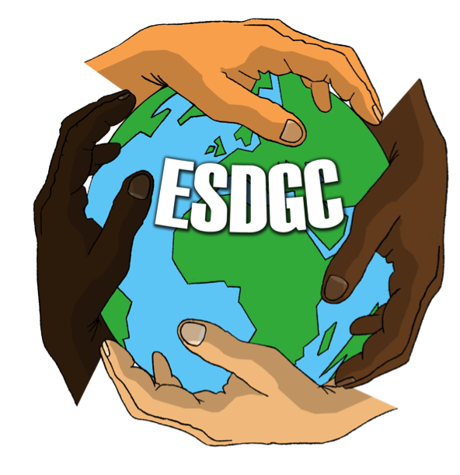
This Photo by Unknown Author is
licensed under CC BY-NC-SA
(Source: Stanwell.org, 2018) (Source: Simple.scot, 2018)

Student number-1402105 (Image from:
EAEC6010
Sustainability in the early years
What is ESDGC?
According to the Welsh Assembly Government (2008) Education for Sustainable life time choices that they make and the consequences of those choices states Learning Wales, (2017).
ESDGC is imbedded in the curriculum and provides opportunities for children to develop skills and learn about the importance of doing it. There are many schemes such as, Eco schools, Fair trade, and healthy schools that support and promote ESDGC in schools today suggests Estyn, (2014).
Nelson Mandela said, ‘Education is the most powerful weapon you can use to change the world’. (cited by Welsh Government, 2008)
What is sustainability?
Sustainability is explained as ‘maintaining the world we live in’ according to Macomikids, (2013). Sustainable development meets the needs of the present without compromising the ability of future generations to meet their own needs states the Bruntland report, (1992). To be sustainable allows us to care for our world and recognise areas that need improvement for a better future.
ESDGC in Wales
Education for Sustainable Development and Global Citizenship, known as ESDGC is being mainstreamed across all education settings with the aim of it being embedded into many subjects. ESDGC has seven themes. These consist of-
• The natural environment
• Consumption and waste
• Climate change
• Wealth and poverty
• Identity and culture
• Choices and decisions
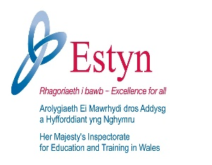
• Health
This Photo by Unknown Author is licensed under CC BY-SA
What is early education?
Early education is recognised as the Early Years Foundation Stage (EYFS) where standards are set for child learning, development and care for children. All associated with childcare must follow the EYFS. There are different standards in Wales, England and Scotland. (GOV Wales, 2017)
Within the Foundation phase there are seven areas of learning to concentrate on. These are delivered through different ways, such as practical and learning activities. Also, by giving a range of different experiences in and outdoors. The seven areas are-
*Personal and social development, well-being and cultural diversity
*Language, literacy and communication skills
*Mathematical development
*Welsh language development
*Knowledge and understanding of the world
*Physical development
*Creative development (GOV Wales, 2017)
In Wales practitioners aim to deliver ESDGC in the classroom with the support of resources, materials and organisations. In 2010 ESTYN introduced ESDGC as part of the inspection framework, and because of this ESTYN assess the quality and provision in all education sectors when inspected. (Welsh Government, 2017) The aim of ESDGC is to give understanding of the impact on others of the choices and decisions we make and how they are linked to the lives of others all over the world, the economy and the environment we live in according to Wales Government, (2017).

The Global Learning programme in Wales
The Global Learning Programme in Wales, (no date) aims to work together with a national network of schools, who are committed to giving and delivering high quality teaching. By doing this they aim to educate about global issues that are happening in the world today that effects each one of us. When settings are registered with GLP-W, access to a range of resources is made available along with opportunities to develop knowledge regarding promoting sustainability. (GLP-W, (no date).
Children and teachers benefit from the GLP-W. Teachers are provided with opportunities to work with others to share and support best practice ideas, also
they are provided with resources to support learning in the class room.
GLP-W provide information on global issues that can result in children recognising the impact and the role that they take in making the world a better place.

Opportunities
Many opportunities are given to children to learn and develop skills regarding sustainability in the early years setting according to Samuelsson, I. and Kaga, Y. (2008). Introducing sustainability at an early age is important sates the Early Childhood Australia, (2018). It is from the early childhood period that children develop their basic values, attitudes, skills, behaviours and habits, which may be long lasting according to Samuelsson, I et al (2008). Didnet, V (no date) agrees stating that for all to join as one human family to bring forth sustainable global society founded on respect for nature, universal human rights, economic justice, and a culture of peace.
Froebel (no date) believes with his theory that children learn from an early age, with the brain development being more active from birth to three. His theory consists of children doing real life activities and that knowledge will grow from this.
In nurseries and school’s children are exposed to the subject of sustainability, therefore knowledge and understanding of what problems there are in the world are gained. Today, settings integrate sustainable development into day to day education as part of the curriculum. No matter where in the world, it is the same idea regarding sustainability. Practitioners support learning in regard to sustainability by providing activities and giving information to increase knowledge with the aim to prevent further degradation of our planet.
Early years settings need to support and present the message in a fun, exciting, challenging and above all stimulating way for the children to engage and communicate according to David, A. (2010). This is done by the interdisciplinary approach, using the outdoors for learning and learning through real life projects. Montessori, Vygotsky along with Steiner had the same belief, of practitioners being like a scaffold, to support learning and to encourage child led learning. Hibberd, K. (2016)
Samuelsson, et al (2008) and Kinver, M. (2016) believe that learning in the outdoors is beneficial for children as it allows a holistic approach for children to be more knowledgeable and boosts their development.
Bronfenbrenner’s ecological theory (learning theories, 2013) believed that children learn from others, with the relationships with people, such as family, friends and community, surrounding the children providing knowledge and fuelling development
Challenges
Settings today believe by doing activities to promote sustainability that they can be time consuming. Williams, D. (2017) points out that many see taking time out to concentrate on specific projects as a chore. However, it is hard to deny that children do benefit from such activities. The foundation framework offers support for practitioners and parents to encourage learning. The Early Years Foundation Stage promotes learning through encouraging positive relationships, enabling environment and with the belief that learning should be based on play experiences. Thinking that a time needs to be set aside is incorrect states Harris, D.C. (2018) as promoting sustainable development is part of the curriculum and does not need to be time consuming. Some critics believe that the need to put aside specific time in the setting is a strain for practitioners leaving them under pressure, resulting in giving negative feelings along with lack of interest and reacting negatively towards the child believes Davis, J. and Elliott, S. (2014). It is essential that children have opportunities to take risks as children need to be challenged to learn suggests Knight, S. (2009).
The practitioner should be the facilitator rather than the instructor giving support to the child allowing the child to feel encouraged and enthusiastic with the child leading and showing the way suggests Steiner’s theory cited by Knight, S. (2009).
Pestalozzi, Froebel and Steiner believe that their approach to education benefits children, allowing children to play without the interference of adults Knight, S. (2014). This linking to Forest school, as the teacher is the provider and a guide with the responsibility for providing an environment to stimulate children’s learning.
Aim
According to David, A. (2010) the aim of the sustainable school’s strategy is by 2020 that all schools are to be classed as sustainable schools. The sustainable school’s strategy has eight doorways to help and embed sustainability into the curriculum. By entering the eight doorways path it is supporting and educating children about the world they live in and how to make it a better place.
The eight doorways are recognised as-
*Food and drink
*Energy and water
*Travel and traffic
*Purchasing and water
*Buildings and grounds
*Inclusion and participation
*Local wellbeing
*Global dimension

Activity example on how to promote sustainability
Gardening
Gardening is an important activity for children according to Better Health, (2017) as children can benefit and be hands on, developing many a life time skill such as, science and nature. It is classed as a healthy, fun activity for children as children can learn from gardening while having fun. Allowing time to be spent outdoors digging in soil, getting dirty, creating things and watching plants grow states Fernando, N. AND Potock, M. (2018). Simple things such as, how things grow? where they come from? and how to care for plants or vegetables? All these give children a chance to be responsible, and to understand the cause and effects of not caring for something and what may happen. An example of this could be as simple as if you don’t water the vegetables they will not grow, resulting in the plant dying. This in its self is a valuable lesson for children. Children can gain self-confidence when achieving a goal of growing their own food believes Better Health, (2017).
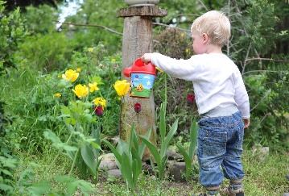 (Source: pixabay, 2018)
Self-confidence is achieved by seeing something small such as a seed being planted, watching it grow, to become a beautiful flower. Love of nature is developed by being outdoors whilst learning about the environment in a safe pleasant place believes Pugh, G. (2007). Discovering-learning about the science of plants and weather. How the weather impacts on the growing period. From here talks could take place in regard to where different vegetables grow in difference parts of the world.
To be physical, shared play activity and teamwork.
To be creative-different ways of growing vegetables and flowers. Big gardens to planting in pots or tyres.
Nutrition- as to where in the world food and flowers have originated from.
How to introduce gardening into ESGDC
Through this simple activity the seven themes can be covered.
Choices and decisions can be made on what to plant and where to plant it. Discussions can be held if working in a group and from this, decisions can be made with agreeing on something resulting in different consequences states the University of Colorado, (2009). By making decisions children are encouraged to express their feelings and look at other views. With the aim that their personal action has a consequence.
Consumption and waste can relate to the growing of food. Here water and its importance can be explained, and the impact of not caring after what they grow resulting in food being wasted. The ability to grow own fresh food.
Health is vital and by being outdoors children benefit according to Hepp, A. (2018). The importance of being healthy and having a healthy diet is vital to a happy healthy life. The need to care for others health and look after the world we live in. Seeing that children are responsible for caring and making sure that what they eat impacts on their health states Main, E. (2009).
Identity and culture is recognised when looking at other countries food and what they eat. How everybody is different, what they eat and how people look different and also have different beliefs. Depending where in the world they come from, children can understand and respect differences according to Yeros, J. (2017).
The natural environment where all of us can make a difference by caring for the environment we live in.
Wealth and poverty have many a different level. Being rich or poor, locally and globally, with the aim that everyone should be treated equally. Growing and making things that you are able eat and use yourself is a simple way to show children that these can save money and at times growing your own food being healthier believes Godman, H. (2012).
Climate change and its impact on the world. Identifying effects of global warming and climate change. Different in different countries. Lack of water in hot countries resulting in vegetables and food not growing, therefor no food for people to eat. (T2group, (no date)
Many organisations support ESDGC in settings by providing practitioners with knowledge and resources. These organisations consist of-

Eco schools- empowers children and young adults to improve the
Environment by a rewarding programme to guide schools on their sustainable development states David, A. (2010).

(Source: Fairtrade, 2017)

Fair trade- recognised as a social movement, who help producers in
developing countries to achieve better trading conditions and promotes sustainable farming. (Fairtrade, 2017).
Fairtrade schools are developing all over the country. By joining, schools are recognised as a worldwide movement, of all different ages to help make a difference in the world. They provide resources for children and teachers to learn about their work and how we are all connected to people in the world.

Amnesty- This is an international human right’s organisation that campaign against injustice and inequality worldwide (Amnesty, 2018).

This Photo by Unknown Author is licensed under CC BY-NC-ND
(Source: logok.org)

Eden Project- This organisation is an educational charity, which believes in promoting sustainable development by underlining the importance of how being green benefits our future (Eden, 2018). From composting waste to saving water, all at Eden work together to change things for the better.

Student number-1402105
Reference List
Amnsety, (2018) www.logok.org [Accessed: 27th of April 2018]
Better Health, (2017) ‘Gardening for children’ www.betterhealth.vic.gov.au [Accessed: 27th of April, 2018]
Bruntland report for the world commission on environment and development, (1992)
Child care Canada (2017) The contribution of early childhood education to a sustainable society [online] Available: www.chilcarecanada.org [Accessed 2nd of December, 2017]
David, A. (2010) Sustainability Published: London Practical Pre Schools books.
Davis, J.M. 2015. Young Children and the Environment-Early education for sustainability. (2nd ed). Cambridge University Press
Davis, J. and Elliott, S. (2014) Research in Early Childhood Education for Sustainability. London: Routledge.
Didonet, V. (no date) Early childhood education for a sustainable society
Estyn, (2014) ‘Progress in education for sustainable development and global citizenship’ www.estyn.gov.wales [Accessed: 17th of April 2018]
Fair trade, (2017) ‘Fair trade schools’ [online] Available: www.schools/fairtrade.org.uk [Accessed:1st of December, 2017]
Fernando, N. and Potock, M. (2018) ‘Gardening with kids: How it affects your child’s brain, body and soul. www.pbs.org [Accessed: 27th of April 2018]
Froebel (no date) Froebel gifts [online] Available: www.froebelgifts.com [Accessed 2nd of December 2017]
Global Learning Programme-Wales, (no date) [online] Available: www.glpw.globaldimensions.org.uk [Accessed 1st of December,2017]
Godman, H. (2012) ‘Backyard gardening: grow your own food, improve your health’ www.health.harvard.edu [Accessed: 27th of April 2018]
Harris, D.C. (2018) The Guardian ‘It captures their imagination’: sustainability through the arts’ www.theguardian.com [Accessed: 27th of April 2018}
Hepp, A. (2018) ‘5 health benefits of kids playing outside’ www.care.com [Accessed: 27th of April 2018]
Hibberd, K. (2016) Too much paper work for childcare practitioners [online] Available: www.earlyyearscareers.com [Accessed 2nd December, 2017]
Kay, J. (2012) Good practice in the early years. (3rd ed). London: Continuum International Publishing.
Kinver, M. (2016) ‘Outdoor learning boosts children’s development’ BBC News
Knight, S. (2009) Forest schools and outdoor learning in the early years. London: Sage Publications.
Learning theories, (2013) ‘Bronfenbrenner’s bioecological model of development’ www.learmingtheories.com
Learning Wales, 2017. Welsh Government. Education for Sustainable Development and Global Citizenship. www.learning.gov.wales
Macomikids (2103) What is sustainability? Youtube.com
Main, E. (2009) ‘A kids garden grows healthier eating habits’ www.rodalesorganiclife.com [Accessed: 27th of April 2018]
Pixabay, (2018) www.pixabay.com
Pugh, G. (2007) The Royal Horticultural Society- ‘Gardening in Schools’ www.growingschools.org.uk [Accessed: 27th of April 2018] Samuelsson, I and Kaga, Y. (2008) ‘The contribution of early childhood education to a sustainable society’ Paris: UNESCO
Simple www.simple.scot [ Accessed: 27th of April 2018[
Stanwell school www.stanwell.org [Accessed:27th of April 2018]
Swansea University, (no date) ‘Education for Sustainable Development and Global Citizenship’ www.swansea.ac.uk [Accessed: 27th of March 2018]
T2 knowledge bank www.t2group.co.uk
University of Colorado, (2009) ‘Benefits of Gardening for children’ www.peecworks.org [Accessed: 27th of April 2018
Welsh Government, 2017 Education for Sustainable development and global citizenship
Welsh Assembly Government, 2008.Education for Sustainable Development an Global Citizenship.
Williams, D. (2017) why bother? Early years Assessment in practice.
Yeros, J. (2017) Globe Trottin’ kids www.globetrottinkids.com [Accessed: 27th of April 2018]

