Hotel standards, reputation management, building and retaining customer loyalty

Name: Alina Bud
Student ID number: 2213954
Module title: Hospitality and Guest Service Management BMIH4003
Lecturer’s name: Charlotte Joyner

EXECUTIVE SUMMARY

For a hotel to build and retain customer loyalty it is necessary and can make a difference in a competitive, diverse, and ever-changing market. In this report this topic it is analysed through few different subjects. One of the subjects analysed is hotel standards, star rating of the hotels, and how this can impact the customer decision of purchasing. How reputation management it is handled cand have a positive or negative impact over reputation or brand imagine of the hotel. Examples from hotel industry are provided to support these ideas, to see that companies have different ways to manage customer loyalty. In the end of this analyse a conclusion and realistic recommendations are offered.

Contents
EXECUTIVE SUMMARY 1
INTRODUCTION 3
MAIN TOPICS 3
Hotel Standards 3
Reputation Management 4
Customer Loyalty 7
CONCLUSION 8
RECOMMENDATIONS 8
REFERENCE LIST 9

INTRODUCTION

This report analyses hospitality depending on the hotel standard, reputation management and customer loyalty and their impact on customer and different choices he can make. According to the number of stars that a hotel has, the client can get an idea of the facilities it offers, the evaluations based on specific criteria being offered by the establishment that offers stars. The customer can also express his opinion about the products or services of a hotel using online platforms, such as TripAdvisor, and the way companies handle reputation management can affect the perception of the brand. most hotels offer loyalty programs to make customers to return and why not, to attract new ones by offering them benefits, exclusive rates, free wi-fi and much more.

MAIN TOPICS

Hotel Standards

The number of stars a hotel has can be an important indicator for the customer, giving them an idea of what to expect when booking a hotel. The more stars the hotel has, the higher the expectations are, for example a 5-star hotel should offer higher quality products and services. Internationally, there are several systems established to determine the number of stars a hotel can have. They are as follows:
- AA – The Automobile Association, in the UK.
- AAA- American Automobile Association is the most known star rating Association in North America.
- Forbes Travel Guide – is popular across the globe.
- Australian Auto Clubs- rate all lodging properties in Australia.
- HOTREC – it is a star rating system in Europe (Jobs, 2022).

Despite the importance of hotel ratings, doesn't exist a worldwide recognised system and because of different cultures and environments, 5-star hotels in America can offer different facilities than 5-star hotel in England, or the same hotel can have different ratings (Khan, Hussain, and Khan, 2022). For example, Four Season Hotel Los Angeles at Beverly Hills it is a 5-star hotel according to Forbes Travel Guide and it is award winning in 2023 (Forbes Travel Guide, 2023), but according to AAA has four diamonds (AAA, 2023). When a hotel has multiple ratings can complicate the decision of selecting of the wanted hotel by the customer (Tefera and Migiro, 2018)

The higher the number of stars the hotel has, the facilities and the services are at different level, at a 5 -star hotels: exclusive locations, swimming pools, jacuzzi, 24/7 rooms service and reception, are just some of the service and facilities mandatory, in comparison to a 1-star hotel that offers only the essentials: reception, cleaning, possibly breakfast. These are highlighted in the price, the price of a 5 -star hotel being much more expensive than 1-star hotel (Arzaghi, Genc, and Naik 2023).

In the study of Yang, Wong and Wang (2012), the characteristics of the hotels in Beijing are presented according to the number of stars. As can be seen from Table 1 for 5 -star hotels the number of rooms, beds and employees is higher compared to hotels with less stars.

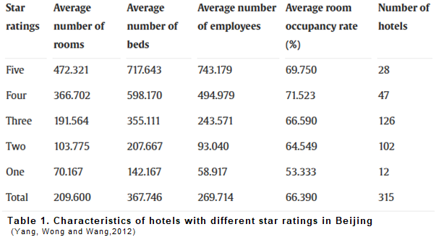

Reputation Management

By its definition, reputation management deals with influencing the interested participants and public discussions about the organization and its brand with the scope to observe their opinions and conversations and defending the brand by confronting the threatening, the wanted effect being to increase brand reputation. More business functions are involved: communications, marketing, legal, customer experience, sales, and loyalty (Gartner, 2023).
Hotel performance can be affected by the influence of online reviews and how are managed by marketing strategies. An improvement of online reviews (electronic word-of-mouth),
- 10% improvement in reviewers’ rating can increase sales by: 4.4%,
- the increase of an hotel reputation with a small percent (1%) can increase the price with 0,89%, room occupancy increased with 0, 54% and 1,42% in revenue per available room (RevPAR)
- an increase with 1 point in hotel review's score, leads increase the occupancy rate with 7.5 percentage (De Pelsmacker, Van Tilburg and Holthof, 2018).
The most used website it is TripAdvisor, where customer can easy post reviews, see ratings, others user’s opinions and information travel related. In the table can be seen the characteristic for 383 hotels sampled in a study, by TripAdvisor ranking (maximum score of 1 and minimum score of 1,042) which are correlated with hotel's star rating. The further tests were conducted for the 5-stars hotel and 3-star hotel ranking by TripAdvisor, but no satisfactory answer was given, being subject to more investigations (O'Connor, 2010).
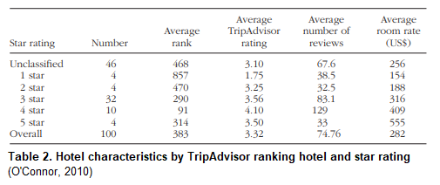
A complaint is not always a bad thing, awareness that it is a problem, the process of solving it can be a learning process which leads to a process that can improve the services offered (Heppell, 2015). However, the study of Min, Lim and Magnini (2015) shows that not all hotel operators respond to online reviews, even if those are positive, and don't have a system in place to do this. The authors are proposing a model (Figure 1) how to answer to a review to please the customer with the answer.
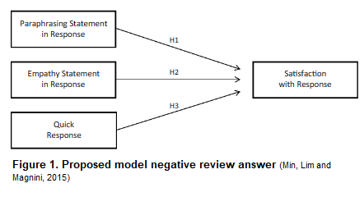
Four Seasons Hotels & Resorts acknowledges the importance to resolve the negative reviews, the research of Russell (2010) shows that clients can receive a bottle of wine of suggestions how to enhance their stay, in exchange of a negative review. One of negative review can be seen in picture 1 and the answer from the hotel company in picture 2.
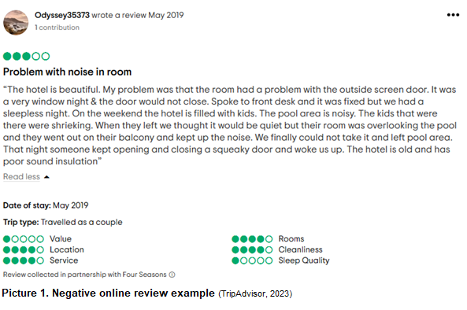
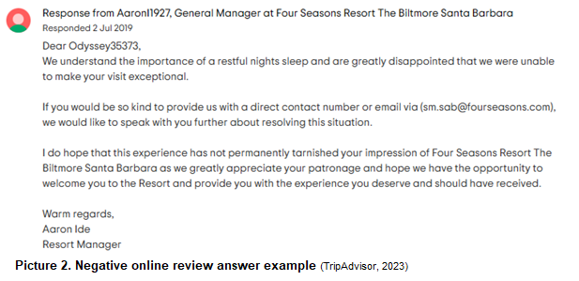
Contrariwise, in the study conducted by Chen and Tabari (2017), specifies that the managers of the Marriott Hotel Group do not offer refunds or discounts, for customers who have complaints. The reason behind this strategy is to protect the hotel and the image of the brand, to maintain customer equity and to avoid financial loss.

Customer Loyalty

Customer loyalty can be defined as the behaviour of the customer of re-purchasing of a product and tangible and intangible service, based on trust in the company, satisfaction offered by services provided and confidence. The return of existing customers can be achieved through the marketing and customers relationship departments efforts (Utami, 2015). Investing in customer loyalty it is much more profitable, to keep a customer it is cheaper comparing with the cost bring a new one (Tepeci, 1999).
Hilton Honors program has been selected the best loyalty program by the customers in years 2009, 2010, 2011, in 2011 having an important decision factor of 39,2 % for the members when booking with Hilton. The statistic about the other loyalty programs can be seen in Table 3 (Laškarin, 2013).
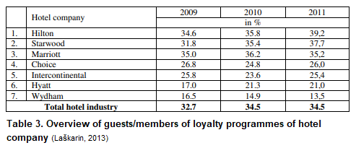
Becoming a Hilton Honors member is easy and free just by visiting the hotel's website. Once you become a member, you can take advantage of various offers: Hilton Honors discount rates, earn points for free nights, experiences, shopping, car rentals, digital check-in and key, no resort fees on reward stays and free wi-fi. The more Hilton Honors is used, the member level goes up to Silver, Gold and Diamond and the benefits are multiplying (Hilton, 2023). Comparing Hilton Honors with Marriott Bonvoy can be noticed that the benefits are very similar, first notable difference is the name of members tier for Marriot Bonvoy: Silver Elite, Gold Elite, Platinum Elite, Titanium Elite and Ambassador Elite (Marriott, 2023).
In the study conducted by Forrester Consulting on behalf of Collinson shows that customer engagement it is not achieved by 80% of loyalty programs. Two potentially reasons could be amongst survey organizations:
- the loyalty programs personalise only 26% of their offers.
- less than 41% of organizations follow the interaction of loyal customers with the brand through personalised and relevant services offered, to increase loyalty (eHotelier, 2019).

CONCLUSION

In conclusion, the classification of hotels according to the facilities offered in diverse numbers of stars or diamonds made by various organizations in different country, can confuse the customer about the quality of the hotel and booking a hotel that does not comply with his expectations (Callan R.J, 1995). On the other hand, the study of Vermeulen and Seegers (2009) of states that if the hotels pay attention to online travel platform related can make an improvement of online buying power, because the reviews increase the awareness of the brand and attitude toward the hotel, which can be defined as an effective reputation management. in terms of loyalty programs, hotels have many appealing offers with the scope to make customer loyal, but on a closer look they offer about the same thing (Craggs and Nozari, 2021).

RECOMMENDATIONS

Bellow recommendations are suggested, based on the statistics presented in this report:
- to avoid the confusion of the customer perceptions regarding the quality of the hotel (Minazzi, 2010), it is recommended to try to implement at the global level a system based on the same characteristics of the hotel when stars are given.
- it can be observed that the improved reviews are beneficial for the hotel company and can lead to market recovery opportunities, therefore it is suggested to increase attention to online environment, channels available and easy to access by the customer where they can express their satisfaction or dissatisfaction regarding the product or services provided (Levy, Duan and Boo, 2013).
- for the hotel companies to increase the level of personalization of loyalty programs, it is recommended to build a guest database of personal needs, wants and habits of segmented customers, as per Table 4 model (Laškarin, 2013).

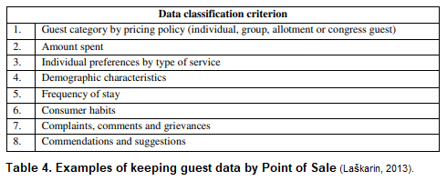
REFERENCE LIST
AAA (2023) Four Season Hotel Los Angeles at Beverly Hills. Available at: Four Seasons Hotel Los Angeles at Beverly Hills - Los Angeles CA | AAA.com (Accessed: 3rd of March 2023).
Arzaghi, M., Genc, I. H., & Naik, S. (2023) ‘Clustering and hotel room prices in Dubai’, Tourism Economics, 29(1), pp.116–136. Available at: Clustering and hotel room prices in Dubai - Mohammad Arzaghi, Ismail H Genc, Shaabana Naik, 2023 (sagepub.com) (Accessed: 1st March 2023).
Callan R.J. (1995) ‘Hotel classification and grading schemes, a paradigm of utilisation and user characteristics’, International Journal of Hospitality Management, 14(3), pp. 271-283.Available at: Hotel classification and grading schemes, a paradigm of utilisation and user characteristics - ScienceDirect (Accessed: 6th March).
Chen, W. and Tabari, S., (2017) ‘A study of negative customer online reviews and managerial responses on social media—case study of the Marriott Hotel group in Beijing’, Journal of Marketing and Consumer Research, 41, pp. 53-64. Available at: A study of negative customer online reviews and managerial responses on social media— case study of the Marriott Hotel Group in Beijing - Sheffield Hallam University Research Archive (shu.ac.uk) (Accessed: 27th February 2023).
Craggs, R. and Nozari, E. (2021) The best hotel rewards programs in the world- and shortcuts for building loyalty. Available at: The Best Hotel Rewards Programs in 2021—And Shortcuts for Building Loyalty With Each | Condé Nast Traveler (cntraveler.com) (Accessed: 6th March).
De Pelsmacker, P., Van Tilburg, S. and Holthof, C. (2018) ‘Digital marketing strategies, online reviews and hotel performance’, International Journal of Hospitality Management, 72, pp. 47-55. Available at: Digital marketing strategies, online reviews and hotel performance - ScienceDirect (Accessed: 4th March 2023).
eHotelier (2013) 80% of loyalty programs fail to drive further customer engagement. Available at: 80% of loyalty programs fail to drive further customer engagement - Insights (ehotelier.com) (Accessed: 5th March 2023).
Forbes Travel Guide (2023) 2023 Forbes Travel Guide Star Awards Winners. Available at: 2023 Star Awards Winners - Forbes Travel Guide (Accessed: 3rd of March 2023).
Gartner (2023) Reputation Management. Available at: Definition of Reputation Management - Gartner Marketing Glossary (Accessed: 4th March 2023).
Heppel, M. (2015) 5 Star Service – How to deliver exceptional customer service, 3rd edition, Harlow, England: Pearson. Available at: 5 star service : how to deliver exceptional customer service (exlibrisgroup.com) (Accessed at: 25th February 2023).
Hilton (2023) Hilton Honors. Available at: Hilton Honors - Earn Points, Hotel Rewards, and More (Accessed: 5th March 2023).
Jobs, S. (2022) Hotel star rating guide – categories and requirements. Available at: Hotel Star Rating Guide- Categories And Requirements | SOEG Hospitality (soegjobs.com) (Accessed: 23rd February 2023).
Khan, M.H., Hussain, A. and Khan, M.A. (2022) ‘A Review on Comparison of Hotels Star Rating Systems’, Journal of Managerial Sciences, 16(2), pp. 144-155. Available at: A Review on Comparison of Hotels Star Rating Systems | Journal of Managerial Sciences (qurtuba.edu.pk) (Accessed: 5th March 2023).
Laškarin, (2013) ‘Development of Loyalty programmes in the hotel industry’, Tourism and Hospitality Management, 19 (1), pp. 109-123. Available at: Microsoft Word - 8 Laskarin 15str (srce.hr) (Accessed: 5th March 2023).
Levy, S. E., Duan, W., & Boo, S. (2013) ‘An Analysis of One-Star Online Reviews and Responses in the Washington, D.C., Lodging Market’, Cornell Hospitality Quarterly, 54(1), pp. 49–63. Available at: An Analysis of One-Star Online Reviews and Responses in the Washington, D.C., Lodging Market - Stuart E. Levy, Wenjing Duan, Soyoung Boo, 2013 (sagepub.com) (Accessed: Accessed: 1st March 2023).
Marriott (2023) Marriot Bonvoy. Available at: Hotel & Resorts | Book your Hotel directly with Marriott Bonvoy (Accessed: 5th March 2023).
Min, H., Lim, Y. and Magnini, V. P. (2015) ‘Factors Affecting Customer Satisfaction in Responses to Negative Online Hotel Reviews: The Impact of Empathy, Paraphrasing, and Speed’, Cornell Hospitality Quarterly, 56(2), pp. 223-231. Available at: Factors-Affecting-Customer-Satisfaction-in-Responses-to-Negative-Online-Hotel-Reviews-The-Impact-of-Empathy-Paraphrasing-and-Speed.pdf (researchgate.net) (Accessed: 4th March 2023).
Minazzi, R. (2010) ‘Hotel classification systems: a comparison of international case studies’, Acta Universitatis Danubius.Œconomica, 6(4), pp. 64-86. Available at: 761-2850-3-PB-libre.pdf (d1wqtxts1xzle7.cloudfront.net) (Accessed: 5th March 2023).
O'Connor, P. (2010) ‘Managing a hotel's image on TripAdvisor’, Journal of hospitality marketing & management, 19(7), pp. 754-772. Available at: Managing_a_Hotels_Image_on_TripAdvisor-libre.pdf (d1wqtxts1xzle7.cloudfront.net) (Accessed: 4th March 2023).
Russell, J. (2010) ‘Evaluate the effectiveness of social media marketing on hotels’, Hospitality Management Review Student Journal at Sheffield Hallam University, 1. Available at: Evaluate the Effectiveness of Social Media Marketing on Hotels | Hospitality Management Review Student Journal at Sheffield Hallam University (shu.ac.uk) (Accessed: 25th February 2023).
Tefera, O. and Migiro, S. (2018) ‘Service quality and hotel ratings: Comparing the ratings by the hotel owners, government authority, online travel agents and customers’, African Journal of Hospitality, Tourism and Leisure, 7(2), pp. 1-17. Available at: article_18_vol_7__2__2018-libre.pdf (d1wqtxts1xzle7.cloudfront.net) (Accessed: 3rd of March 2023).
Tepeci, M. (1999), ‘Increasing brand loyalty in the hospitality industry’, International Journal of Contemporary Hospitality Management, 11(5), pp. 223-230. Available at: Increasing brand loyalty in the hospitality industry | Emerald Insight (Accessed: 23rd February 2023).
TripAdvisor (2023) Four Seasons Resorts the Biltmore Santa Reviews. Available at: FOUR SEASONS RESORT THE BILTMORE SANTA BARBARA - Updated 2023 (CA) (tripadvisor.co.uk) (Accessed: 4th March 2023).
Utami, S. (2015) ‘The influence of customers’ trust on customer loyalty’, International journal of economics, commerce and management, 3(7), pp. 638-653. Available at: 3743-libre.pdf (d1wqtxts1xzle7.cloudfront.net) (Accessed: 5th March 2023).
Vermeulen, I.E. and Seegers, D. (2009) ‘Tried and tested: The impact of online hotel reviews on consumer consideration’, Tourism Management, 30(1), pp. 123-127.Available at: Tried and tested: The impact of online hotel reviews on consumer consideration - ScienceDirect (Accessed: 6th March).
Yang, Y., Wong, K.K.F. and Wang, T. (2012) ‘How do hotels choose their location? Evidence from hotels in Beijing’, International Journal of Hospitality Management, 31(3), pp. 675-685. Available at: How do hotels choose their location? Evidence from hotels in Beijing - ScienceDirect (Accessed: 23rd February 2023).

