
Burberry’s Strategic Choices


Student: Cathie Davies
Student Number: 1705973
Course: Strategic Management
Course code: SBMA7103D
Lecturer: Gareth Hughes
Date: 29/07/2019

Burberry’s Strategic Choices

Executive Statement
After years of 0% or little growth at Burberry, and a new True Luxury strategy by new management that is looking like it is failing, Burberry requires urgently to consider all its strategic options going forwards.
This report finds that in the Burberry’s dynamic macro environment, where the US and China possibly heading for recession; Brexit threatening Burberry’s British manufacturing and design centres in Leeds and London, as well as sales to Europe and globally through a reduced popularity of Britain; increased protectionist agendas; and expanding environmental concerns. The macro environment does provide positives with the opportunities produced by a growing middle class and globally available technology. New technologies do not just provide opportunities for expansion for Burberry but also lower the barriers for competitors and so new disruptive strategies maybe the answer to Burberrys problems.
Burberry is well placed to follow new strategies having ample resources available to the firm, such as human, and capital with its low debt, high asset finances and also the available knowledge resources to put in place. There is evidence that it is the corporate culture of Burberry, still hurting from its ‘Chav’ status, internally if not externally and a low tolerance for risk. To turn this around, Burberry needs to be brave and take risks, looking to Blue Ocean strategies and bringing in new Change Leaders to exact the change needed.

Table of Contents

 |  | Executive Summary | ……… | Pg.1
 |  | Table of Contents | ……… | Pg.2
 |  | Introduction | ……… | Pg.3
1. |  | Burberry’s Strategic Position: The Main Strategic Issues Faced by Burberry in Maintaining Competitive Position | ……… | Pg.3
 | 1.1 | Burberry’s Macro Environment: Burberry PESTLE Analysis | ……… | Pg.3
 | 1.2 | Industrial Analysis: Porter’s 5 Forces | ……… | Pg.5
 | 1.3 | Internal Analysis of Burberry and Sources of Burberry’s Competitive Advantage | ……… | Pg.7
 | 1.3.1 | Porter’s Value Chain | ……… | Pg.7
 | 1.3.2 | Burberry’s Corporate Governance | ……… | Pg.8
 | 1.3.3 | Stakeholder Analysis: Mendelow’s Matrix | ……… | Pg.9
 | 1.3.4 | The Cultural Web | ……… | Pg.10
 | 1.4 | A Recap of Issues Raised in Analysis Combined with TOWS and Soars Analysis | ……… | Pg.11
2 |  | Burberry’s Strategic Choices | ……… | Pg.12
 | 2.1 | Corporate Strategic Choices | ……… | Pg.12
 | 2.2 | Options for a New Strategy | ……… | Pg.14
 | 2.2.1 | Strategy Clock | ……… | Pg.14
 | 2.2.2 | Ansoff’s Matrix | ……… | Pg.15
3 |  | Burberry’s Strategy in Action | ……… | Pg.17
 |  | Conclusion | ……… | Pg.19
 |  | Recommendations | ……… | Pg.20
 |  | References | ……… | Pg.21

Introduction
By Mintzberg’s (1987) definition of strategy, Burberry needs to decide ‘how’ with the PLAN of strategy, defend with PLOY of strategy, ‘actions’ of the strategy or PATTERN, where there POSITION is and defend, and PERSPECTIVE or context of the organisation to facilitate the strategies going forward (Mintzberg, 1987). Indications of performance of Burberry to date has seen steady stream of profits but has failed to provide growth in a ever more competitive industry. The company has seen only 4.2% compound annual growth rate for the years 2015-2017, compared to rival organisations Kering SA with a 17.2% growth rate and LVMH with a 10.9% growth rate, (Deloitte, 2019) and a decrease in revenue from £2,733m reported in 2018 and £2,720m in 2019. In the current uncertain, volatile and dynamic environment, an organisation requires good effective strategy throughout: at corporate level, business level and functional level as a means of defending position and as a ploy to deter potential new competitor. In order to achieve value for stakeholders and meet long term objectives, Burberry needs to adapt its strategy and “integrate it” at all levels of the organisation (Johnson et al, 2017). This report seeks to address how it is to do this.

- Burberry’s Strategic Position: The Main Strategic Issues Faced by Burberry in Maintaining Competitive Position

Corporate strategy of the an organisation must anticipate both the “industry it exists and environmental factors which influence; understand the resources available to the organisations internally through synergy but also externally and adjacent, all unique to the organisation itself which helps add value to the businesses individually” (Davies, 2019a: Zenger, 2013).

  - Burberry’s Macro environment: Burberry PESTLE Analysis

    - Political

Brexit and the uncertainty to where it will lead, plus Europe’s political unrest affecting exports as Burberry’s headquarters and high percentage of production is in the UK.

US protectionism agenda- tariffs on European and Chinese goods. Imports to the US more costly for consumers so greater competition from national brands in the country. Importing costs increasing for US brands is positive for Burberry competitively pricing globally.

    - Economical

Economic slowdown of China, Eurozone and US but China’s luxury market is still growing, and are second leaders in tourism globally, adding to sales outside the country. Economic predictions are not positive due to high GDP debt and ongoing trade wars with America. Emerging economies such as India, United Arab Emirates, Russia are predicted to be the source of all major growth in the Luxury retail industry, where GDP is set to grow, and with it the growth of middle classes with larger disposable incomes. American consumer have less disposable income and recession for the US is predicted Bain & co, 2019). Expansion into the US for Burberry is unadvisable at this time.

    - Sociological

Increasing power of High-earning-Not-Rich Yet (HENRYs). With 50% of the world population became Middle class in the last decade, a new “affluent” are going to be increasingly influential (PWC, 2019). Though presently the wealthiest in the world, they have high discretionary incomes at present which is predicted to grow (Deloitte, 2019). These HENRYs can be found globally in developed (e.g. US and UK) and emerging economies such as China and India. Of the HENRYs, it is Millennials and Gen Z ‘s who have the “highest spending per HENRY household” (Deloitte, 2019). In order to achieve growth, it is important that Burberry look to securing new markets and demographics.

    - Technological

Big Data offers new insights and opportunities to augment products and services to the individual customer, focusing more affectively on the most receptive audience and help develop effective customer engagement tools (Deloitte, 2019). AI: Tools such as Machine Learning, and chat bots sell to specific consumers, removing human interaction at the point of sale.

    - Legal
There has been a decrease in the ease of collection and use of personal data which has resulted from the employment of laws, limiting the ease that companies can transfer data internationally and an organisations ability to thoroughly assess potential opportunities in chosen markets.

    - Environmental
Customer expectations require businesses to consider sustainability issues such as ethically sourcing materials as standard or will suffer fall in demand. Brands in most corners of the fashion industries are trying to go above and beyond to try to appeal to customers values, this is specifically true of the Luxury Fashion industry where companies such as Prada have developed its Code of Ethics as far back as 2008 and has now become industry norm (Deloitte, 2019). Research suggests that consumers are willing to pay “premium prices” for brands which reflect their ethical and moral values so beneficial (Deloitte, 2019). Burberry have identified Sustainability in being high in their risk audit (Burberry, 2018).
  - Industry Analysis: Porter’s 5 Forces
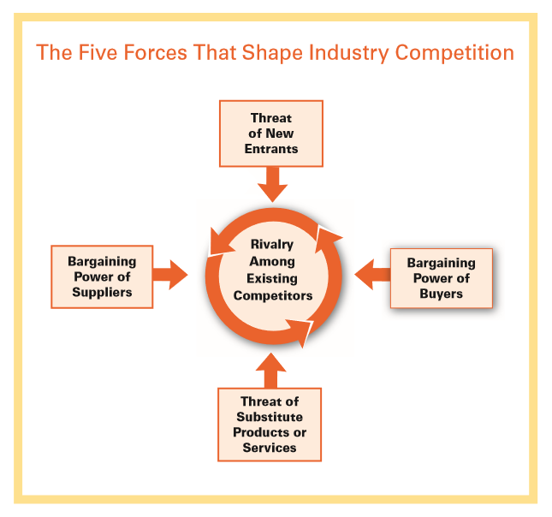
Figure1 (Porter, 2008)

    - Threat of New Competitors
Change in social expectations with the increase with Millennials has led to the reduced importance of ‘Exclusivity and Heritage’. Experience is not necessary cause for a premium price when value can be measured elsewhere for the consumer (Deloitte, 2019). This lower barrier of entry levels the playing field for Burberry’s competitors who also suffer from a decrease of brand loyalty in the retail industry in general (BOF, 2019).
Online distribution channels favoured by HENRYs (Bain, 2019) create lower barriers of entry to new competitors into the industry, helping to focus and sell via a personalised service to consumers while reducing cost and increasing efficiency. Barriers of entry are reduced as businesses are able to expand internationally without the need to develop marketing and sales skills in the chosen countries (Deresky, 2017).

    - Bargaining Power of Suppliers

Businesses are not only having to source more ethically and sustainably source goods and resources, there is also a need to be more transparent in the supply chain (Deloitte, 2019), the most skilled and ethical suppliers acquiring greater power (McKinsey & BOF, 2019).

    - Rivalry Among Existing Competitors

The fashion industry’s list of the most profitable companies have been dominated by the same 20 companies for over a decade who mostly consist of players in the Luxury market, and include LVMH but also Nike who occupy an accessible, lower cost luxury segment (see images 2 & 7) (McKinsey & BOF, 2019).

Global fashion industry is predicted to grow modestly in 2019 from 3.5% to 4.5%, with the Luxury segment most optimistic for growth with a predicted 4% to 6% (Bain & Co, 2019). The growth Luxury Goods Industry is dependent on the economic growth of a country. Due to economic and political uncertainty in developed countries such as France, US and UK, it is advisable to take advantage of the emerging economies and their HENRYs, such as India, the UAE and Russia. While these markets are fairly immature, competition is low and there is opportunity for brands such as Burberry to gain share. As they develop though, the incumbents will prove a barrier of entry (Deresky, 2017). These new markets are developing their own players who intern will increase competition on a global market.

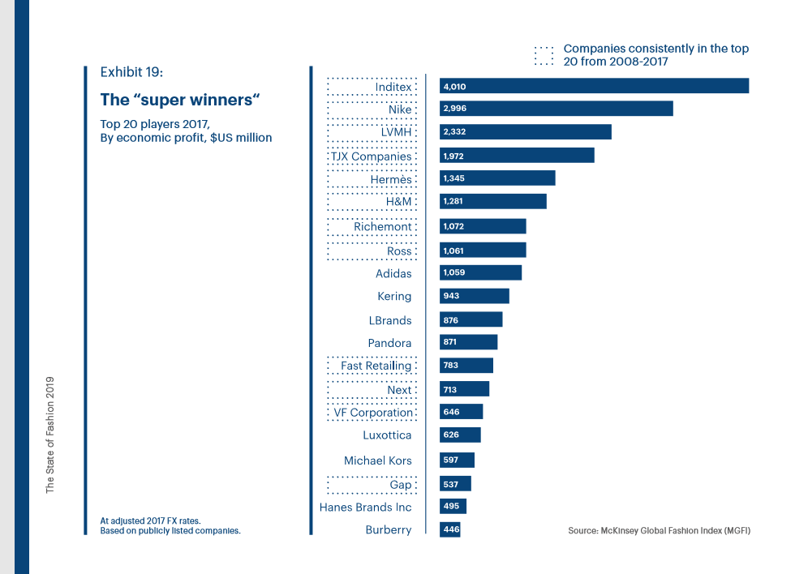
Figure 2 (Mckinsey & BOF, 2019).

    - Bargaining Power of Buyers

With the increasing power of the consumer demand is often driven by other factors other than price alone. For the luxury brands such as Burberry “core values” shared with buyers are key to competitive advantage (Deloitte, 2019).
Increased consumer power has also lead to increased expectation for “Consumer experience” where organisations are judged by ease of transactions as well as the interaction with brands (PWC, 2019)

    - Threat of Substitute Products and Services
Business of Fashion (2019) highlight the increasing trend of the “end of ownership” where different business models are taking form, and items are no longer bought by consumers but rented for a defined period. These new models are in the same vain as the disruption caused by AirBNB to the travel industry and Uber to the transport industry.

  - Internal Analysis of Burberry and Sources of Burberry’s Competitive Advantage

    - Porter’s Value Chain

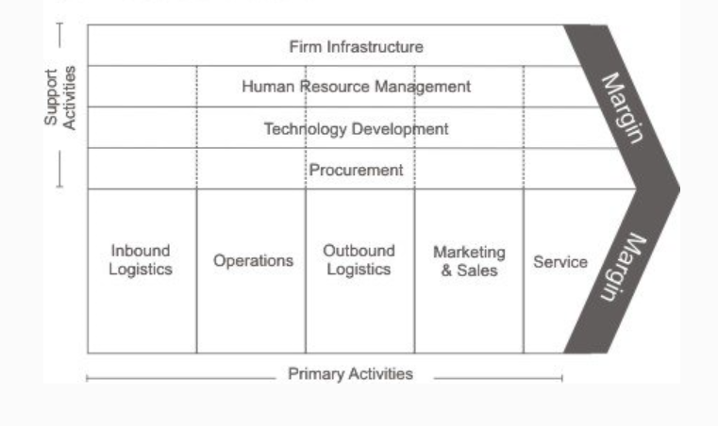
Figure 3 Porter’s Generic Value Chain (Mind Team, 2019)

      - Primary Activities

- Production & Operations: Fully owned manufacturing facilities in Leeds, UK and Italy.

- Research and Design a key value area however is not included in Porter’s generic value chain. Research and design is based in London, which enables Burberry to benefit from the interconnected industries and supporting in London, one of the global fashion capitals.

- Marketing & Sales: Currently Burberry’s online sales presence in 33 countries and traditional retail stores either wholly owned or franchised.
Burberry also sells wholesale to selected partners which in the market segment, braking contract with those who have not fitted brand vision, reducing presence globally particularly the Americas resulting in 0% growth (Burberry 2018).

      - Supporting Activities

- Firm Infrastructure: Most operations are broken up into separate Business units. Burberry Group Plc, Burberrys Corporate parent own or are majority shareholders of 70 separate business units which provide vertical integrated throughout the business, (Burberry, 2019). This provides significant control of quality and supply, but it can prove costly with the lack of economies of scale which can be achieved from outsourcing to specialists.

- Human Resource Management: HR is managed by Burberry’s Business Services Business unit, set up to provide services for not only Burberry’s business units but partnering businesses such as suppliers of raw materials. This increases Burberrys control and reduces power of suppliers.

- Technological Development: At its London based Burberry invests in innovation research into materials and techniques. At present Burberry are looking to reduced waste innovations and is “working towards a circular business model” (Burberry, 2019) that reuses and reduces resource use and waste.

    - Burberry’s Corporate Governance
Johnson et al (2017) states that the shareholder model is the “most important ownership model in economies” such as the UK. The shareholders do not have direct control of the company but instead delegate it to a board who act on the shareholders behalf. Burberry’s board is 8 the CEO, Chairman, CFO, and 5 other non-executives from various backgrounds. The boards is responsible for setting out Burberry’s strategic aims and providing leadership (Burberry, 2019).
Shareholders, though traditionally being primarily concerned with profit maximisation, the increase of institutional investors such as Blackrock Inc and Lindsell Train LTD who own the largest independent share amounts of 5% (Burberry, 2019) have led to an increase of other aims and influences on the companies, so leading to a larger stakeholder consideration. As remuneration packages for executives include shares, employees of the organisation have a larger stake in the business, so have an increased invested interest in the long term profitability of the business where stakeholders are required to be actively managed. Burberry, (2019) states the boards key aim is to keep the “interests of the stakeholder at the fore when making decisions”. Johnson et al, (2019) argues that this advantageous to Burberry as again it focuses the business on “long term horizons” with improved scrutinizing of the business and environment and less flawed risk taking. The increased eversion to risk can be also detrimental to the business.

    - Stakeholder Analysis: Mendelow’s Matrix
Mendelow’s Matrix alerts management to possible risks to Burberry by various stakeholders recognising individuals or group that are likely to have consequence for the business and to determine an “appropriate engagement strategy” to mitigate risk (Ginige et al, 2018).
Figure 4: Mendlow’s stakeholder matrix
Power |  | Level of Interest
Power |  | Low | High
Power | Low | Minimum Effort  - Financial  - Community | Keep Informed  - Employees  - Competitors
Power | High | Keep Satisfied  - Shareholders  - Suppliers  - Union  - Trade associations  - Government | Key Players  - Board  - Executive Comity-  - Customers

Key Players’ power comes from other ‘bases’: the board and executive comity have legitimate power, with the mandate to make decision which affect the company (French Raven, 1958). The additional key player to Burberry is its existing customer, who could be described as having cohesive power where they are able to punish the brand by abandoning it if it does not fulfil its wishes (French & Raven, 1958). To remedy this Burberry should strive to move their existing customer to a position of less power by increasing their customer base or lower interest through satisfying their additional need (Johnson et al, 2017). Financial institutions have minority power as Burberry has little to no long term liabilities and has sufficient reserves. If Burberry chooses to expand and requires capital investment then the power of the banks would increase.
To achieve stakeholder buy in Burberry has evolved what Hutchinson (2017) calls a “forum stakeholder interaction” where key concerns of stakeholders are adopted throughout the organisation and not limited to traditional Corporate Social Responsibility initiatives.

    - The Cultural Web

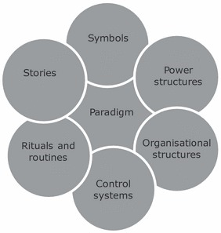Figure 5 (Mossop, et al, 2013)

Symbols: The Burberry Check is synonymous with Burberry but is commonly associated with its 2000s reputation of being the symbol of ‘chav’ culture (Bothwell, 2015). The brands market positions slipped almost overnight from high end luxury to mass market. (Moore And Birtwistle, 2004).
Power Structure: CEO Marco Gobbetti and Chief Designer Riccardo Tisci are given head status at Burberry, with the former heading corporate strategy and the latter heading the business strategy. The brand is being transformed by Riccado’s vision (Burberry, 2019), as Burberry’s single source of revenue based on one vision and not diversified is a high risk strategy in itself.
As share income remains high with Diluted Earnings per Share increasing 19% through the last year, there has been no appetite to push the bored for radical change in strategy which maybe the key for Burberrys future.
Organisational Structure: Burberry’s 2018/2019 Annual Report (2019) highlights the “building of mechanisms for to ensure two way dialogue between our workforce and the board” (Burberry, 2019) so lack of bottom up influence on the organisation and the bureaucratic culture to this point.
Control Systems: Control is executed through the employee network through training systems which enforces capabilities but also allows Burberry to illiterate its preferred values and culture throughout the organisation (Burberry, 2017).
Stories: “Globally recognised luxury brand with a distinctive British attitude” (Burberry 2017). ‘British attitude’ may not be a key attribute with the present political climate. With manufacturing in the EU, Brexit may lead to lack of staff morale, and other international protectionist agendas may also affect an organisational culture in culturally distant countries.

  - A Recap of Issues Raised in Analysis Combined with TOWS and SOARS Analysis
Weaknesses  - Low growth compared to competitors  - Lack of internal analytics capabilities  - Lack of corporate acknowledgment of emerging markets  - Previous bad PR from of burning ex-stock to high remunerations  - Historical ‘Chav’ persona  - British in a time where Britain’s popularity globally is at a low  - USP Heritage is becoming less important to consumers  - Enlarged value chain which may not deliver direct value at each point  - Risk perverse  - Hierarchical business model | Strength  - Relationship and social media marketing  - Personalisation product capabilities  - Existing social media strategy can provide analytic data  - Existing influencer and editorial relationships  - Existing Omni channel sales  - Vertical integrated value chain  - Increased capabilities and knowledge resources  - Subsidiaries globally, including presence in India which opens access to market  - Partnership with suppliers  - Manufacturing capabilities  - Logistical capabilities  - Supporting industries and centres of excellence: London, Leads and Milan.  - Award winning Mobile sales technology  - Board experience  - Stakeholder model looks for long term growth  - Long history  - Some evidence of bottom up communication | Aspirations  - Reduce costs  - Increase efficiency  - Become more agile  - Increase innovation  -All so to future proof the business  - Establish selves as a global leader
Threats  - No deal Brexit  - Uncertainty due to political unrest  - GDPR and other data laws limiting use and collection of data  - Larger established players with larger economies of scale and global presence  - Lower barriers of entry via the internet  - Reduced brand loyalty  - Transparency expected in supply chain  - End of ownership models and other disruptive innovations. | Opportunities  - Technology such as AI powered chatbots and Blockchain  - New affluent demographic  - New global markets  - Industry growth reported  - Sustainability initiatives  - Disruptive new models | Results  - Increase of employee moral with over 70% being proud to work for the company.  - Increase % growth in all markets.  - Improve ranking in Deloitte’s ‘Top 20’ Luxury Brands and other brand indexes.

- Burberry’s Strategic Choices

  - Corporate Strategic Decisions Taken by Burberry to Date:

Burberry has transitioned through many stages of hand to head to heart as defined by Prof. Birkinshaw (2012) as the sources of competitive advantage. What started in the industrial era, with their efficiency in production of their trench coats to then the power of information which lead to a mass markets, global brand, one which argument could be described as undifferentiated from competitors but also one that was not a cost leader (Porter, 2004). Porter reasons that to create or defend competitor advantage, then an organisation must compete by “scope” by being broad or narrow and “source” by being low cost leasers or differentiators (Johnson et al, 2017).
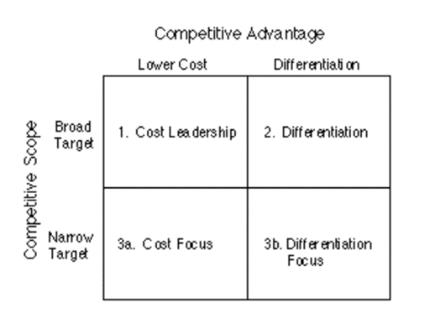

Figure 6 Burberry’s brand positioning (Burberry, 2019a),

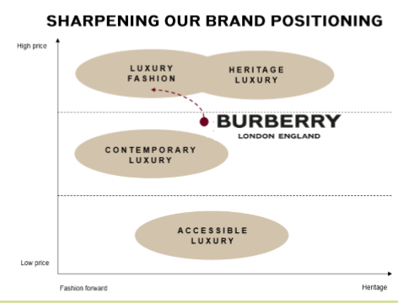
Figure 7 Porter’s generic strategies (IFM, 2019).

Present strategy sees Burberry attempt to differentiate in a narrow market repositioning itself in Luxury Fashion, an area that has seen higher than average growth, and high margins as demonstrated in figure 5 (Burberry, 2019a). This strategy of repositioning Burberry is fairly new, where Burberry as soon as early 2017 was seeking a strategy
of scope where they aimed at abroad premium mass market and demographic range, something which lead Burberry to feel they were in suffering from strategic drift (Burberry, 2016: Burberry, 2017). Problems that arise from such repositioning strategy in an already dominated market is that success is often based on “consistence of message and associations of brand with ideas that are already held strongly within consumer’s mind” (Hooley, et al, 2017).

In carrying out Porters Forces analysis does high light the issues that Burberry face in defining the industry it is in and the precarious positioning it is currently facing, straddling both the premium fashion market and the luxury goods markets. Though include fashion industry, luxury goods player such as LVMH include consumables and cosmetics industries in their business operations. Even in the Luxury and premium fashion markets both have clear divisions regarding consumer and positioning so have different factors effecting different points in the value chain. Research suggests that the Luxury good markets it broken up further regarding price and status with perceived benefits and exclusivity demanding higher returns (De Barnier, et al, 2012). This leads to strategic decisions that the company needs to make, where it chooses a position where it is a market leader and innovator or continuing with the strategy to step up the chain wear it potentially is follower and a small actor against other Luxury “super players” of Kering and LVHM (Mckinsey & BOF, 2019). In being in the ‘middle’ and not searching for competitive advantage through generic strategies of cost leadership or diversification, can lead Burberry to vulnerability to struggle (Kryscynski, 2012: Porter, 2004).

Other ways which Burberry has attempted to differentiate themselves are through promotional differentiation with their innovative use of social media (Deloitte, 2019) but also through a process of what Prof. Birkinshaw describes as a new era of competitive advantage through the heart (Birkinshaw, 2012). CRS has been adopted throughout the organisation, and its core to what Burberry are currently doing by developing initiatives which leverage its power with stakeholders and ones that it can actively control such as reduced waste through its manufacturing capabilities while offering additional differentiating strategies such as recommended by Deloitte (2019) that Luxury Brands offer “individualized and self-expressive products”. Offering high differentiation to consumers provide competitor advantage but doing in a sustainable way will appeal to its desired HENRY consumer group, unlike cumbersome Corporations such as Inditex, which is home to brands such as fast fashion brand Zara.
In middle position, inefficiency and lack of strategic vision in the face of a dynamic landscape with leave Burberry vulnerable to incumbents and new innovative brands, as was the case for Nokia who failed to innovated and adapt quick enough to combat the competitive threat which was Apple, one that could have possibly be seen if organisational bureaucracy which limited learning and information sharing was addressed and organisational design lead to a culture which encouraged these traits was adopted (Laamanen, et al, 2016). Though this is an example from a different industry, lessons learned are still relevant and should be considered as in the cases of American Apparel (High Nobility, 2016), whose fall from fashion was due to a lack of customers awareness and a toxic organisational culture. The ways it can do this are discussed in the next section.

  - Options for a New Strategic Approach

    - Strategy Clock

Whereas Porter argues that hybrid strategies lead to businesses being “stuck in the middle” (Johnson et al, 2017), other theorists maintain that there are indeed ways which organisations can peruse ‘hybrid’ strategies where combining strategies can result in competitive advantage. Tools such as Bowman’s strategy Clock can used to design distinct strategies for Burberry’s business units and while assessing competitiveness (Johnson et al, 2017).
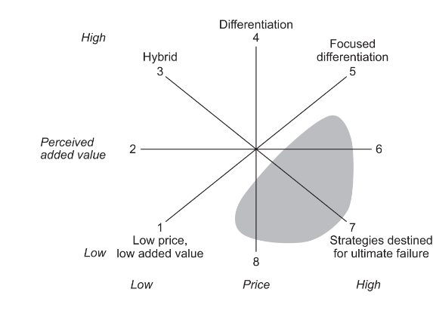
Figure 8: Bowman's strategic clock (AQA, 2019)

Unfortunately, where Burberry is hoping to be in segment 5, there is a great risk though that the differentiation is not focused enough at this time and distinct enough to place it in this category and ultimately it exists in segment 7, which is evidenced by the lack of growth it has experienced. The positives of this type of analysis is that it is “dynamic” and so with incremental steps it is easy to identify that in order to achieve growth Burberry requires move anti clock wise incrementally around the clock.

    - Ansoff’s Matrix
Ansoff (1988) explains analysis of organisations “diversification portfolios” isolates the “common synergy threads” so identifying strategy options. The tool is commonly used for “brainstorming” strategic options available to the organisations corporate governance (Johnson et al, 2019).

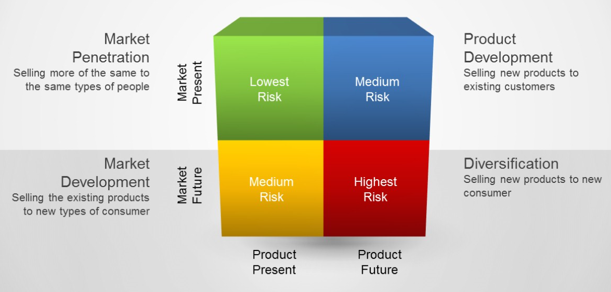
Figure 9 (Hughes, 2019)

      - Market Penetration: “It focuses on increasing sales of existing products to an existing market” (CFI, 2019).

This represents Burberry’s historic strategy. This could be achieved through increasing marketing strategies towards existing markets at a larger scale. Though a low risk strategy, there is the additional risk of “retaliation from Competitors” (Johnson, et al, 2017) who themselves will double down on their efforts leading to a costly battle against competitors who may have superior capabilities and resources such as Corporation LVHM.

In a dynamic environment, disruptive innovation is key and the existing skills that Burberry has amassed, social media activity is a key strength of the organisation. Burberry cannot rest though as the dynamic, disruptive nature of technology could soon leave Burberry behind.

      - Product Development: “It focuses on introducing new products to an existing market.” (CFI, 2019)
Burberry has the capabilities through its vertical integrated business units and certain parts of corporate culture such as shared values throughout its human resources, to leverage towards multiple staircase growth strategies where business units make money in their own right with every step and towards a long term protectory of where it hopes to be in future. As long as Burberry is careful of not cannibalising itself (Hooley et al, 2017), by producing new lines of products and services to the desired ‘True Luxury’ market Burberry can take a step towards its goals while not sacrificing its existing customers while “exploiting new skills and capabilities” (Baghai et al, 1996). What will limit Burberry’s ability for this is that it requires managers to act “entrepreneurial”, something that a culture of risk avoidance will prohibit (Baghai et al, 1996). This has the benefit of being low risk, though requires high investment which fortunately Burberry is in the position to provide.
Burberry has a see now buy now collection which release new products in limited numbers once a month. These small runs not only increases exclusivity, reduces waste, but also increases knowledge resources and capabilities which can be used for future business models such as ‘See now, buy now’ for their main range, which has been experimented with by other brands such as direct competitor Mulberry.

      - Market Development: “It strategy focuses on entering a new market using existing products.” (CFI, 2019).
Though Burberry recognises economic uncertainty as low in its risk audit in the annual reports (Burberry 2017; Burberry 2018; Burberry 2019) due to its perceived inability to alter event, there is a lack of acknowledgment of the growth in emerging countries markets other than China (Burberry, 2019). The phenomenon of social media influencers have opened the gates to access to global audiences which were once only reserved to those with large marketing budgets. Brands are also using Social Media as a tool directly engage with consumers. Digital platforms allow an ever more technological engaged consumer of all cultures to articulate their preferences and dislikes, while accelerating the pace which consumers expect access to new products opening up vast new opportunities (Deloitte, 2019).
Burberry Group Plc has the capability and resources horizontally integrate into new markets, internationally and should consider high growth markets such as India, where existing subseries mean that there is already synergies and capability for the region that can be leveraged. New markets mean that there is less competitive though competitions often mean existing infrastructure and interconnected industries exist that provide synergies for Burberry (Deresky, 2014). This can also be achieved through mergers and acquisitions of existing companies that have resources and capabilities beneficial to Burberry, this too is the case for all strategic options identified via Ansoff’s matrix (Johnson et al, 2019).

      - Conglomerate Diversification: “It focuses on entering a new market with the introduction of new products.” (CFI, 2019).
In contrast to seeking competitor advantage in an existing industry, there is a different way for Burberry to grow: through a Blue Ocean Strategy.
“Product/service differential is becoming very low as competitor numbers increase in different industries offering similar products, competitive analysis will help achieve competitiveness now for the organisation, whereas Blue Ocean will help develop new income revenues/competitiveness for the future ensuring the businesses sustainability.” (Davies, 2019).
Blue Ocean Strategy seeks to identify new industries in uncontested space. This corresponds with Mckinsey judgement that in order for fashion industries businesses such as Burberry to survive long term, there is a need for “self-disruption”. Burberry must be brave and look into vastly different and new business models. Looking to new substitute products and services, such as the reselling of second hand goods, as well as horizontal integration can expand the organisations prospects for growth.
To ensure that Burberry has the resources and capabilities required to meet new strategies in changing environments such as those identified as Blue Ocean Strategy, the firm needs to develop ‘dynamic capabilities’, of sensing, seizing and reconfiguring (Johnson et al, 2107). This is something that Burberry is fit for due to its existing capabilities which can be reconfigured and leveraged to fit dynamic need.
Horizontal integration in this way would lead higher risk, but ultimately the possibility of higher returns for shareholders. Burberry should consider looking to outside of the organisation to Strategic consultants such as McKinsey & Co, who would provide new insights, which is increasingly important as previously noted, Burberry have routinely ignored noticeable strategic option.
Just as mergers and accusations have been discussed, the option of new corporate parents is an option which needs to be given. The current business model has failed to deliver growth for a considerable period of time where other industry players have continued to grow (Deloitte, 2019). In the hands of the right new parents due to the acquisition of Burberry, synergies of knowledge and resources could be leveraged in a way that alone Burberry is not capable of doing. Again I reference LVHM, who have multiple brands such as McQueen and Louis Vuitton and are routinely the most valuable in the industry.

- Burberry’s Strategy in Action
Change does not develop at a constant rate but in the current global environment is accelerating at a heightened speed (Hayes,2019). Management of Burberry has the responsibility of managing change effectively for all stakeholders of the business. “Failure to introduce effective change can have a high impact: loss of market position, removal of senior management, loss of stakeholder credibility, loss of key employees, and reduction in employee engagement and motivation.” (CIPD, 2018).
In order to assist with change management, Hope Balogun have developed the Kaleidoscope model to assist with planning and implementation, where the organisational and change context feeding into the contextual features of the middle ring and which ultimately feeds into the change choice/implementation options open to the organisation (Open Tutorial, 2017).

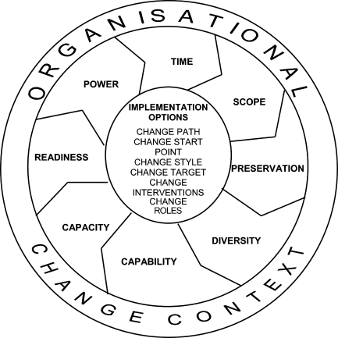
Figure 10, Kaleidoscope of Change (Hope & Balogun, 2002)

The variables is Burberry’s case would be
- Time: although not urgent, there is a pressing need by stakeholders for a quick turnaround of Burberry’s fortunes. Radical product development needed.
- Scope: An organisation wide culture change of bottom up communication is required to harness capabilities and create synergies. This will lead to a more complex change program that affects wider stakeholders.
- Preservation: Staff moral needs to be retained though Burberry’s report that only 70% of staff are proud of the company (Burberry, 2017).
- Diversity: divers business units and communities in Burberry, from finance to sales require different communication styles.
- Capability: Subsidiaries and business units provide knowledge that can be leveraged for change, but resistance to chance so far maybe evidence of a lack of capabilities for change. Members of the board include CEO’s and managers from successful FTSE 500 companies and other ultra-successful companies that have experience of large scale change (Burberry, 2019).
- Capacity: Finance available as well as options of refinancing for investment opportunities. Large global human resource numbers.
- Readiness: due to the ongoing changes at Burberry since 2017, staff are ready for change but maybe fatigued by it.
- Power: corporate governance structure of board, executives and managers allow for change agents through the organisation. Managers with Change leadership knowledge should be strategically placed through the organisation ensuring that resources are mobilised as required, enthuse key players and communicate enthusiasm and optimism of the plan (Kotter, 2011), so minimising resistance which can damage the effects of change (Kotter, 2011).

Leadership expert John Kotter also developed an Eight step Change Management process which reiterates the steps identified through the Kaleidoscope model for Burberry

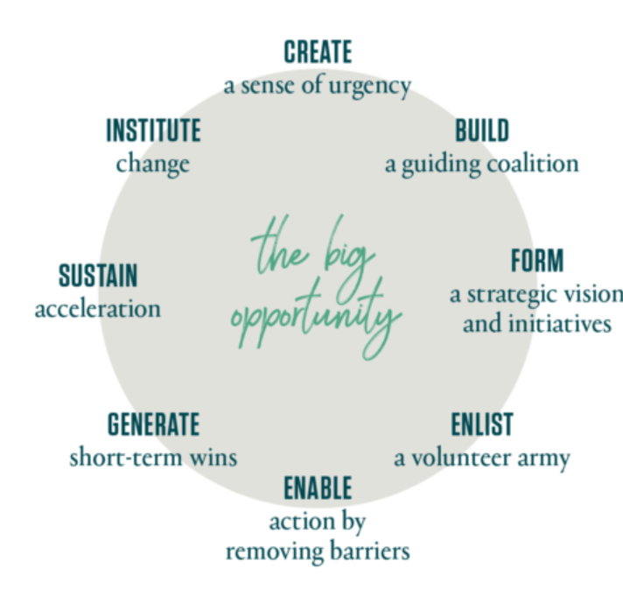 Figure 11 8-Step Process (Kotter Inc, 2019)

One negativity about the ‘8 steps’ is that it is a top down format of management, with the interests of top management influencing the organisation so not working for stakeholders (Johnson et al, 2017). By incorporating soft actions such as feedback loops throughout the process, stakeholder buy in will be increased and problems that Burberry have faced will be addressed.

Conclusion
In order to really diversify, Burberry’s corporate governance need to be willing to increase its risk appetite and take an entrepreneurial approach, leveraging skills and capabilities to focus on new markets and new products. In increasing the business ranges, Burberry will be able to mitigate risk in future uncertainty for example a Black Swan event.
If all else fails Burberry need to consider the unthinkable and relinquish control to a much larger corporate parent, who have the resources and capabilities to provide the synergies needed for Burberry to expand and flourish.

Recommendations
- Invention is only useful when put into to operation. Burberry should strive to put innovations it has developed into the heart of its products, becoming innovators and leaders instead of followers.

- Diversify product range, keeping cash cow of traditional customers market customers that the brand has tried to distance itself from while developing additional product ranges to meet the demand of the True Luxury market and the millennial HENRYs who have a different demands. By hitting multiple segments, it mitigates risk and stops the all or nothing current Luxury model which is failing to gain interest.

- Develop a bottom up communication to boost employee engagement, encouraging employees voice not only boosts moral but also encourages knowledge sharing. Greater considerations should be given to HR through out the organisation and CHRO placed on the board.

- A thorough assessment of the international landscape enacted, with openness to ALL possibilities. An international business plan should be carried out to for all possibilities and the most promising chosen and not ignored.

- Leverage existing capabilities, such as excellence in digital touchpoints to reach new global markets and individual consumers

- Consideration to mergers & Acquisitions with other brands in the market or even corporate diversification to consumables so to gain new skills and capabilities to progress in new strategic directions long term.

- Burberry needs self-disruption in a more aggressive form, looking to further existing programs such as ‘see now, buy now’ as inspiration.

- The board needs to give serious consideration to merger &acquisition of Burberry by a competitor so to inject new resources and life into the brand, while capturing a larger market share

- Burberry needs to hire or outsource experienced Change Leaders consultants to enact the change required in the organisation, The board although experienced in change, is too controlled by shareholders to fully push through the needed change.

References

ANSOFF, H. (1988), Corporate strategy. (Rev. ed.). Harmondsworth: Penguin.
AQA, (2019), Teaching guide: Bowman's strategic clock, available [online] at https://www.aqa.org.uk/resources/business/as-and-a-level/business-7131-7132/teach/teaching-guide-bowmans-strategic-clock (accessed on 22/07/2019)
BAGHAI, M., COLEY, S.C., WHITE, D., CONN, C., AND MCLEAN, R.J. (1996). Staircases to Growth. McKinsey Quarterly. Available [online] at https://www.mckinsey.com/featured-insights/employment-and-growth/staircases-to-growth. (accessed on 15/07/2019)
BAIN & COMPANY, (2019), Global personal luxury goods market expands to €260bn in 2018, with similar growth forecasted for 2019, available [online] at https://www.bain.com/about/media-center/press-releases/2019/spring-global-luxury-report/ accessed on 16/07/2019.
BBC (2017), Burberry's Christopher Bailey to leave at end of 2018, available [online] at https://www.bbc.co.uk/news/business-41816758 (accessed on 22/07/2019)
BCG, (2019), 2019 True-Luxury Global Consumer Insight, 6th Edition, BCG:Milan, available [online] at http://media-publications.bcg.com/france/True-Luxury%20Global%20Consumer%20Insight%202019%20-%20Plenary%20-%20vMedia.pdfn (accessed on 16/07/2019)
BHATTACHARYA, C. B., (2009), Corporate Social Responsibility: It's All About Marketing, Forbes, available [online] at https://www.forbes.com/2009/11/20/corporate-social-responsibility-leadership-citizenship-marketing.html#52e9fb022795 (accessed on 22/07/2019)
BIRKINSHAW, J. (2014) The changing sources of competitive advantage | London Business School. [video]. Available from: https://www.youtube.com/watch?v=GVP0tb6FzCs&feature=youtu.be (Accessedon 13/7/2019).
BOAZ, N., & FOX, E. A., (2013), Change leader, change thyself, McKinsey Quarterly, available [online] at https://www.mckinsey.com/featured-insights/leadership/change-leader-change-thyself (accessed on 23/07/2019)
BOF, (2019), 10 Trends That Will Define the Fashion Agenda in 2019, available [online] at https://www.businessoffashion.com/articles/professional/top-fashion-industry-trends-2019 (accessed on 22/07/2019)
BOTHWELL, C., (2005), Burberry versus The Chavs, BBC, available [online] at http://news.bbc.co.uk/1/hi/business/4381140.stm (accessed on 20/07/2019)
BOWMAN, E., & HELFAT, C. (2001). Does Corporate Strategy Matter? Strategic Management Journal, 22(1), 1-23. Retrieved from http://www.jstor.org.ezproxy.uwtsd.ac.uk/stable/3094251 (accessed on 20/07/2019)
BURBERRY, (2016), Annual Report 2015/16, available [online] at https://www.burberryplc.com/content/dam/burberry/corporate/Investors/Results_Reports/2016/5-annual_report_2015_16/Report_burberry_annual_report_2015-16.pdf, accessed on 01/07/2019.
BURBERRY, (2017), Annual Report 2016/17, available [online] at https://www.burberryplc.com/content/dam/burberry/corporate/Investors/Results_Reports/2017/AnnualReport/Burberry_AR_2016-17.pdf, accessed on 01/07/2019.
BURBERRY, (2018), Annual Report 2017/18, available [online] at https://www.burberryplc.com/content/dam/burberry/corporate/Investors/Results_Reports/2018/Burberry_AnnualReport_FY17-18.pdf, accessed on 01/07/2019.
BURBERRY, (2019a), Fact Sheet July 2019, available [online] at file:///C:/Users/Cathi/AppData/Local/Packages/Microsoft.MicrosoftEdge_8wekyb3d8bbwe/TempState/Downloads/EIGHTPAGER-%20post%20Q1.pdf (accessed on 23/07/2018)
BURKE A., ANDRÉ VAN STEL, THURIK R., (2010), Blue Ocean vs Five Forces, HBR, available [online] at https://hbr.org/2010/05/blue-ocean-vs-five-forces (accessed on 22/07/2019)
BUTLER, S., (2014), Aldi and Lidl increase share of British shoppers as inflation hits spending, available [online] at https://www.theguardian.com/business/2017/sep/19/aldi-and-lidl-increase-share-of-british-shoppers-as-inflation-hits-spending (accessed on 25/07/2019)
BUTLER, S., (2017), Burberry's sales growth slows despite 'exceptional' UK performance, The Guardian, Fri 21 Apr 2017, available [online] at https://www.theguardian.com/business/2017/apr/19/slump-in-burberry-shares-as-global-sales-growth-slows#img-1, accessed on 05/01/2019.
CFI, (2019), Ansoff Matrix: The Product/Market Expansion Grid, available [online] at https://corporatefinanceinstitute.com/resources/knowledge/strategy/ansoff-matrix/ (accessed on 06/07/2019).
CHANDLER, A. D., (1985), Strategy and structure. Cambridge, MA: MIT Press, 1962. found in Chaffee, E. (1985). Three Models of Strategy. The Academy of Management Review, 10(1), 89-98. Retrieved from http://www.jstor.org.ezproxy.uwtsd.ac.uk/stable/258215 (accessed on 20/07/2019)
CIPD, (2018), Change management, Learn how to manage, enable and support change management initiatives effectively, available [online] at https://www.cipd.co.uk/knowledge/strategy/change/management-factsheet#8084 (accessed on 22/07/2019)
CROSSAN M., VERA D., NANJAD L., (2008), Transcendent leadership: Strategic leadership in dynamic environments, The Leadership Quarterly, 19 (5), Pages 569-581
DAVIES, C., (2019), Step 2.3: Blue Ocean thinking, Carmarthen: UWTSD, available [online] at https://uniwales.curatr3.com/courses/SBMA7103D_PT-Strategic_Management_May_2019/home#object/433631 (accessed on 20/07/2019)
DAVIES, C., (2019a), Step 6.1: Why have a corporate strategy anyway?, UWTSD: Carmarthen available [online] at https://uniwales.curatr3.com/courses/SBMA7103D_PT-Strategic_Management_May_2019/home#object/433647 (accessed on 20/07/2019)
DE BARNIER, V., FALCY, S. and VALETTE-FLORENCE, P., 2012. Do consumers perceive three levels of luxury? A comparison of accessible, intermediate and inaccessible luxury brands. Journal of Brand Management, 19(7), pp. 623-636.
DELOITTE, (2017), Global Powers of Luxury Goods 2017: The New Luxury Consumer, [online] at https://www2.deloitte.com/content/dam/Deloitte/global/Documents/consumer-industrial-products/gx-cip-global-powers-luxury-2017.pdf, accessed on 20/12/2018.
DELOITTE, (2018), Global Powers of Luxury Goods 2018: Shaping the future of the luxury industry, [online] at https://www2.deloitte.com/global/en/pages/consumer-business/articles/gx-cb-global-powers-of-luxury-goods.html, accessed on 20/12/2018.
DELOITTE, (2018a), Global Powers of Retailing 2018 Transformative change, reinvigorated commerce, available [online] at https://www2.deloitte.com/content/dam/Deloitte/at/Documents/about-deloitte/global-powers-of-retailing-2018.pdf, accessed on 29/12/2018.
Deloitte, (2019), Global Powers of Luxury Goods 2019: Bridging the gap between the old and the new, available [online] at https://www2.deloitte.com/global/en/pages/consumer-business/articles/gx-cb-global-powers-of-luxury-goods.html accessed on 16/07/2019.
DERESKY, H., (2014). International management : managing across borders and cultures ; text and cases 8th. ed., global., Boston, Mass. [u.a.]: Pearson.
EADICICCO, L., PECKHAM, M., PULLEN, J., FITZPATRICK, A., (2017), The 20 Most Successful Technology Failures of All Time, The Time, available [online] at http://time.com/4704250/most-successful-technology-tech-failures-gadgets-flops-bombs-fails/(accessed on 15/07/2019)
FORBES INSIGHTS, (2009) ,Strategy and Operations in the enterprise: Closing the Alignment Gap, available [online] at https://images.forbes.com/forbesinsights/StudyPDFs/SAP_Closing_the_Alignment_Gap.pdf (accessed on 22/07/2019)
FRENCH, J. R. P., RAVEN, B., (1959), The Bases of Social Power, available [online] at http://www.communicationcache.com/uploads/1/0/8/8/10887248/the_bases_of_social_power_-_chapter_20_-_1959.pdf (accessed on 21/07/2019)
GARCIA, N., (2017), Material Management Life Cycle, NCG Consulting, available [online] at http://www.ncg-consulting.com/?p=66 (accessed on 20/07/2019)
GINIGE K., AMARATUNGA D., HAIGH R., (2018), Mapping stakeholders associated with societal challenges: A Methodological Framework, Procedia Engineering, Volume 212, P. 1195-1202,
GRANT, R. (1996). Toward a Knowledge-Based Theory of the Firm. Strategic Management Journal, 17, 109-122.
GUNASEKARAN, A., NGAI, E. W.T., (2012), The future of operations management: An outlook and analysis, International Journal of Production Economics, 135 (2), Pages 687-701,
HAYES, J., 2010. The theory and practice of change management 3rd ed., Basingstoke ; New York: Palgrave Macmillan.
HAYZLETT, J., (2016), Why Should Your Business Care About Social Responsibility?, Entrepreneur, available [online] at https://www.entrepreneur.com/article/269665 (accessed on 20/07/2019)
HIGH NOBILITY, (2016), The Rise and Eventual Downfall of American Apparel, available [online] at https://www.highsnobiety.com/2016/02/17/american-apparel-history/ (accessed on 25/07/2019)
HOFER, C. W. (1973), Some preliminary research on patterns of strategic behaviour. Academy of Management Proceedings, p.46-59 found in Chaffee, E. (1985). Three Models of Strategy. The Academy of Management Review, 10(1), 89-98.
HOPE V. H., BALOGUN, J., 2002. Devising Context Sensitive Approaches To Change: The Example of Glaxo Wellcome. Long Range Planning, 35(2), pp.153–179.
HUTCHISSON, R. (2017) ‘Trends in CSR: The Rise of Human Social Responsibility’ Blackbaud, available [online] at https://foundations.blackbaud.com/corporate-social-responsibility/building-the-socially-conscious-company-of-tomorrow-trend-4 (Accessed: 31st May 2019).
IFM, 2019, Porter's Generic Competitive Strategies (ways of competing), IFM: Cambridge, available [online] at https://www.ifm.eng.cam.ac.uk/research/dstools/porters-generic-competitive-strategies/
JOHNSON, G., WHITTINGTON, R., SCHOLES, K., ANGWIN, D., & REGNÉR, P. (2017). Exploring strategy : Text and cases, Eleventh ed., Harlow : Pearson Education Limited
KERING, (2019), Activity Report 2019, available [online] at https://keringcorporate.dam.kering.com/m/73a7d9e7d60ab433/original/KERING-RA-2018-EN.pdf, accessed on 16/07/2019
Kotter, J., (2011), Change Management vs. Change Leadership -- What's the Difference? Available [online] at https://www.forbes.com/sites/johnkotter/2011/07/12/change-management-vs-change-leadership-whats-the-difference/#6c30d5734cc6
Kotter, J., Change Management vs. Change Leadership -- What's the Difference?, Forbes, available [online] at https://www.forbes.com/sites/johnkotter/2011/07/12/change-management-vs-change-leadership-whats-the-difference/#2b4b7fa04cc6
Kryscynski, D. (2012), Generic Strategies Mini-Lecture, You Tube, available [online] at https://www.youtube.com/watch?v=V14kuqYEsxE [Accessed 27th May 2019]
LAAMANEN, T., LAMBERG, J.-A. and VAARA, E. (2016) ‘Explanations of Success and Failure in Management Learning: What CanWe Learn From Nokia’s Rise and Fall?’, Academy of Management Learning & Education, 15(1), pp. 2–25.
MIND TEAM, (2019), Porter's Value Chain Understanding How Value Is Created Within Organizations, available (online) at https://uniwales.curatr3.com/courses/SBMA7103D_PT-Strategic_Management_May_2019#object/433637
MINTZBERG, H. (1987) ‘The Strategy Concept I: Five Ps For Strategy’, California Management Review, 30(1), pp. 11–24. doi: 10.2307/41165263.
MINTZBERG, H., AHLSTRAND, B.W. & LAMPEL, J. (2009), Strategy Safari : a guided tour through the wilds of strategic management, 2nd Ed. London: Prentice-Hall.
MOORE, C.M. and BIRTWISTLE, G., (2004). The Burberry business model: creating an international luxury fashion brand. International Journal of Retail & Distribution Management, 32(8), pp. 412-422.
MOSSOP, L., DENNICK, R., HAMMOND, R., & ROBBÉ, I. (2013). Analysing the hidden curriculum: use of a cultural web. Medical education, 47(2), 134–143
OPEN TUITION, (2017), ACCA P3 Chapter 20 Change management, available [online] at https://www.youtube.com/watch?v=h3aE-qx1xQ4 (accessed on 26/07/2019)
PINNOCK, O., (2018), No One In Fashion Is Surprised Burberry Burnt £28 Million Of Stock, Forbes, available [online] at https://www.forbes.com/sites/oliviapinnock/2018/07/20/no-one-in-fashion-is-surprised-burberry-burnt-28-million-of-stock/#30eea0304793(accessed on 23/07/2019)
PORTER, M. (2004). Competitive strategy : Techniques for analysing industries and competitors (1st Free Press export ed.). New York: Free Press.
PORTER, M. E. AND KRAMER, M. R. (2006) ‘Strategy & Society: The Link Between Competitive Advantage and Corporate Social Responsibility’, Harvard Business Review, 84(12), pp. 78–92. Available at: https://search-ebscohost-com.ezproxy.uwtsd.ac.uk/login.aspx?direct=true&db=bth&AN=23081414&site=ehost-live (Accessed: 2 June 2019).
PORTER, M., (2008), The Five Competitive Forces That Shape Strategy, HBR, Jan. 2008, p. 73-93, available [online] at https://moodle.uwtsd.ac.uk/pluginfile.php/82150/mod_resource/content/1/The%20Five%20Forces%20that%20Shape%20Strategy.pdf accessed on 16/07/2019
PWC (2019), It’s time for a consumer-centred metric: introducing ‘return on experience’ Global Consumer Insights Survey 2019, available [online] at https://www.pwc.com/gx/en/consumer-markets/consumer-insights-survey/2019/report.pdf, accessed on 16/07/2019.
REEVES, M., & DEIMLER, M. (2011). Adaptability: The New Competitive Advantage. Harvard Business Review, 89(7, 8),
RENNER, B., FEDDER, C., UPADHYAYA, J., (2019), The adoption of disruptive technologies in the consumer products industry Creating seamless experiences through disruptive technologies, Deloitte Insights, available [online] at https://www2.deloitte.com/insights/us/en/industry/retail-distribution/disruptive-digital-technology-integration-consumer-products.html. (accessed on 20/07/2019)
TIM KASTELLE, (2013), Few People Understand The Difference Between Risk And Genuine Uncertainty, Business Insider, available [online] at https://www.businessinsider.com.au/difference-between-risk-and-uncertainty-2013-3, (accessed on 02/01/2019).

Word Count:4395

