University of Wales Trinity Saint David – Institute of Inner-City Learning - Birmingham

Strategic Business Plan for a Small Business
YUM TRAVELS FOOD TRUCK
Module Name and Code: STRATEGIC MANAGEMENT FOR SMEs, BMWSW6104
Lecturer Name: Sampath Liyanage Rodrigo

Georgiana Serbanescu (1918419)
7-20-2023

Contents

An Introduction to the business idea, business model and Its Uniqueness 2
Set up strategic direction and goals 2
The mission statement: 2
The business’s vision: 2
Business Objectives 2
An internal Environmental Scan 3
SWOT Analysis 3
VRIO 4
External Environmental Scan 5
PESTEL Analysis 5
Porter’s Five Forces 7
Stakeholder (Internal and External) analysis 8
Mendelow’s Matrix 8
Evaluate the strategic growth options available for your business – 9
Ansoff Matrix 9
Porter’s generic strategies 10
Cost Leadership Strategy 10
Differentiation 10
Cost Focus 11
Differentiation Focus 11
Select and justify the best-fit strategy(s) 11
Implementation plan with appropriate monitoring techniques and KPIs 12
Implementation Plan 12
Key Performance Indicators 12
Conclusion 15
References 16
Appendices 18

Introduction to the business idea, business model and its uniqueness

Yum Travels Food will be a food truck business that will provide healthy foodstuffs around Birmingham and the United Kingdom at special events and festivals. The food to be sold will be prepared in a commissary kitchen. Yum Travels Food will be packed in a food truck in adherence to the health and safety regulations and transported to different areas to bring it closer to customers. The truck will be fitted with food warmers that will ensure that the food items remain warm and fresh, such as dry and moist heat equipment. The food prepared for sale will depend on the nature of the occasion at which the food truck will be selling. However, the business will focus on preparing and offering healthy foods that have been confirmed to be good for one’s health by helping in weight loss and managing lifestyle diseases such as diabetes and hypertension. In line with the idea of healthy foods, Yum Travels Food intends to prepare and sell foods around Birmingham and the United Kingdom that have minimum calories and are rich in proteins, vitamins and essential minerals, traditional Romanian food and dessert. The said foods have been chosen for their health benefits, which means they will be in demand most of the time, thus bringing in constant revenues for the business. The business model will be based on providing customers with value for their money by availing healthy dishes at their desired location while warm and fresh for consumption. Most existing food truck businesses offer junk foods, such as fast foods, that are known to compromise the health of their consumers (Lakshmi, 2021). Yum Travels Food will be unique because, unlike such businesses, it will offer healthy traditional Romanian and other dishes that promote the health of its customers.

Set up strategic direction and goals.

The business’s vision:
To enhance the general health of our team, community, and environment by providing delicious and healthy foods that contribute positively to the happiness and fulfilment of our customers.

The mission statement:
To be the industry leader in healthy and quality foods by offering customers organic foods that consistently and reliably promote their health and overall well-being.

Business Objectives:

- Increase monthly net sales by at least 5% in the first year.
- Introduce two new menu items after every three months for the first two years.
- Hire five top-tier chefs in the first five years.
- Achieve a minimum of 4 on Google reviews in the first two years of operation.

An Internal Environmental Scan

SWOT Analysis

- Strengths
Healthy food – selling healthy foods to customers around Birmingham and the UK is a massive strength for Yum Travels Food because it sets the business apart from its competitors who sell junk foods.
Experienced staff – Yum Travels Food will hire only the best and most skilled chefs to prepare healthy foods and fresh fruit and vegetable juice for its customers. The experience of the chefs will be the business’s strength as it will lead to the preparation of quality foods capable of outcompeting the competition.
Brand Recognition – Yum Travels Food, a brand, will be thoroughly marketed as a quality food brand to all potential customers. The marketing campaign will create brand awareness that will strengthen the business as people will be able to recognise and remember the brand.
- Weaknesses
Costly production – the ingredients for healthy foods are often organic produce that is costly in the UK market (Rauber et al.,2021). This will make the cost of production for Yum Travels Food to be high, which will be a weakness compared to other restaurants and food truck businesses that offer cheap, unhealthy foods.
Less experience in the food truck business- as a startup, the business will need more experience and information about the details of the food truck business. This will serve as a weakness as experienced businesses in the same market will have the advantage of knowledge.
- Opportunities
A social Shift toward healthy foods – the population of the UK is shifting toward a preference for organic and healthy foods (Güney and Sangün, 2021). This comes after the pandemic, where the spread of the Covid-19 virus made many people health-conscious. Therefore, there is an opportunity for Yum Travels Food to grow its market size from the increasing number of people preferring to eat healthy foods.
Technology – the rise in popularity of digital media is an opportunity for the food truck to market its services to large numbers of people at low prices. Technology in other areas, such as refrigeration, dry heat equipment, and moist heat equipment, also presents an opportunity to food trucks to ensure quality preservation of the food items (Lichy et al., 2022).
- Threats
Competition – there are restaurants that offer healthy foods to customers in Birmingham and the United Kingdom (Bagwell, 2020). Such restaurants will threaten Yum Travels Food’s success as they already enjoy a market share in their areas.
Legal requirements – The United Kingdom decided to leave the European Union in 2016 (McCann and Hainsworth, 2017). Therefore, crossing the borders of the United Kingdom presents the challenges of different legal requirements in EU countries. This will threaten the business's development and expansion, as they must provide excellent quality traditional food with resources from Romania or Eastern Europe.

VRIO Analysis

VRIO is a framework used to analyse a company’s overall strategic positioning (See appendix A)
Value – for a business to be competitive, it has to offer a product that has value to its customers (Pesic et al., 2013). Yum Travels Food provides high value for customers by offering them healthy, fresh, and delicious foods at the convenience of their location. Therefore, the main points of value in the business are the impact of the food on their health and the fact that it saves them the time to move to a restaurant.
Rarity – for a business to be competitive, it needs to have products that are rare and in demand (Pesic et al., 2013). Yum Travels Food meets this criterion in the analysis as it offers healthy foods that are rare in the current food market in most Western countries. Currently, most Western food retailers offer processed foods that are unhealthy (Güney and Sangün, 2021). Therefore, offering healthy foods makes Yum Travels Food a rare commodity that customers would struggle to find in the food market.
Imitability – if a business idea can be imitated easily, the business will soon lose competitive advantage as other similar businesses will be started by competitors (Pesic et al., 2013). Yum Travels Food will be difficult to imitate as it will require new entrants to find reliable sources of organic ingredients to prepare healthy organic traditional foods.
Organisations should have a suitable and befitting organisation to utilise their resources (Pesic et al., 2013). Yum Travels Food passes this test in the VRIO analysis as it has a well-organised management structure that ensures the smooth running of all its business processes.

External Environmental Scan

PESTEL Analysis

- Political Factors
Brexit – in 2016, the people of the United Kingdom voted to leave the European Union in a political referendum (McCann and Hainsworth, 2017). The political decision will have an external impact on Yum Travels Food as it will have to import some of the organic traditional food ingredients from Romania or other EU countries. Moreover, Yum Travels Food will leave the UK to deliver its services to essential functions and festivals in EU countries. As a result of the non-EU status of the UK, Yum Travels Food will incur extra costs doing business with EU countries.
Taxes and Duties – taxes and duties are products of political processes that end up in decisions to place levies and taxes on products. Currently, the UK imposes taxes and duties on goods entering the country, including the cost of insurance, standard VAT OF 20%, and freight and duty (Hantzsche et al., 2022). The resultant costs will increase the cost of production for Yum Travels Food.
- Economic Factors
Inflation – the inflation rates that the country will experience at any point will have an external impact on the business. A high inflation rate will increase the cost of production as organic food ingredients, fuel, and other inputs will cost more. For example, the current UK inflation rate is 9.7% (Beckett, 2023). This is high enough to increase the cost of production for businesses in the food truck business.
Consumer spending - Consumer spending is determined by the disposable income consumers have after spending on what they deem necessary to them (Di Crosta et al., 2021). For Yum Travels Food, the level of consumer spending will affect its profitability as it will determine the amounts of money consumers are willing to spend on its food items.
- Social Factors
Changing tastes and preferences – The population of the United Kingdom is gradually changing its taste and preferences for food items, from fast foods to organic foods that promote consumers’ health (Güney and Sangün, 2021). The change in taste and preference will externally impact Yum Travels Food positively as it will bring more people into its target market of people who prefer healthy foods.
Social media – Social life in the UK and the world is characterised by increased social media interactions (Nizzoli et al., 2021). The social networks enabled by social media will positively impact Yum Travels Food as they will enable it to market its products.
Food trends – The current food trend of street foods has enabled the growth of food truck businesses in the country (Asmoro et al., 2019). The current trend will, therefore, be a positive external impact on the operations of Yum Travels Food as it is a food truck business that will operate in the streets of the country.
- Technological Factors
E-commerce – the rise in e-commerce has revolutionised businesses as they can interact with their customers from marketing, selling, to delivery without having a physical or fixed location (He, 2023). The existence of e-commerce will externally impact Yum Travels Food by offering it a platform where it can take orders and deliver them to customers.
Kitchen technology – recent developments in kitchen technology, such as automated cooking machines, have enabled food businesses to increase efficiency (See appendix B). The technologies will positively impact Yum Travels Food by reducing the time and increasing the efficiency with which it prepares its food.

- Environmental Factors
Climate change – the earth’s climatic conditions have been rapidly changing for the worse due to human activities that degrade the environment (See Appendix C). The difference in climatic conditions across the world has affected the farming of organic foods and caused an increase in their prices (Gomez-Zavaglia et al., 2020).
Environmental regulations – the government of the United Kingdom has put in place environmental regulations for companies to adhere to in a bid to reduce their activities’ negative impact on the environment (Cole and Elliott, 2017).
- Legal Factors
Health and safety regulations – The Health and Safety at Workplace Act (HASWA) is a UK act of parliament designed to provide a legal framework for the duties and responsibilities of employers and employees regarding health and safety (Trade Union Congress, 2022). The provisions in the Act forces businesses like Yum Travels Food to adjust their operations to ensure they abide by the Act, hence affecting their activities.
Employment laws - the UK has employment laws that protect the employees as well as spelling out their responsibilities (See appendix D). The food truck will have to abide by the employment laws when recruiting and managing its workforce, hence affecting the business’s processes externally.

Porter’s Five Forces

Porter’s Five Forces tool predicts five external forces determining whether a company in an industry will sustain profitability (Porter, 1999). (See Appendix E)
Competition – Porter theorises that a high number of competitors and similar products reduces a company’s power and vice versa (Grundy, 2016). Based on this theory, Yum Travels Food company will have more power in the industry due to limited similar products in the food market. Most food trucks and restaurants in the UK do not offer healthy foods, which sets apart Yum Travels Food’s products as unique.
The potential of new entrants – the ease of entrants entering the market reduces the power of a company. In contrast, an increase in the difficulty of entering the market increases the power of a company (Grundy, 2016). Yum Travels Food will enjoy more power in the food truck business as starting a healthy and organic foods business in the UK is complex.
Power of suppliers – in a market where the raw materials are limited or the suppliers are few, they will have the ability to control the price of supplies and vice versa (Grundy, 2016). The niche that Yum Travels Food seeks to serve of selling healthy foods only has limited suppliers that have access to the organic ingredients used to prepare healthy foods. Therefore, Yum Travels Food will have to deal with the power of suppliers who will be dictating the prices of supplies.
Power of customers – the power of consumers in the market is determined by the number of companies that supply similar products (Grundy, 2016). In the case of Yum Travels Food, the consumers will have limited power as a limited number of companies sell healthy foods on a food truck.
The threat of substitute products – the threat of substitute products comes from the existence of goods that serve a similar purpose as that offered by one company. A company that sells products with multiple substitutes in the market will experience powerlessness in price setting as customers can decide to buy the substitute products (Grundy, 2016). The food truck will have a few substitute products as it will combine the advantage of offering healthy foods with flexibility.

Stakeholder (Internal and External) Analysis

Mendelow’s Matrix
Mendelow’s Matrix was developed in 1991 by Aubrey L. Mendelow to help companies to analyse the interests and power wielded by its different stakeholders (Kuzmin and Khilukha, 2016). The main Yum Travels Food stakeholders, who should be analysed for their interest and power, include the government, suppliers, employees, customers, owners, the general public, competitors, and investors. The following is a Mendelow’s Matrix depicting Yum Travels Food stakeholder analysis:
Government
Suppliers

Employees
Customers
Owners

High

Power
General public

Competitors
Investors

Low

low interest high

Evaluate the strategic growth options available for your business.

Ansoff Matrix
The Ansoff matrix was first published in the Harvard Business Review in “Strategies for Diversification.” Authored by H. Igor Ansoff, the tool provides business owners with four growth steps, each representing an increased risk (Loredana,2016). The tool presents a possible option for Yum Travels Food to utilise in its growth process. The figure before represents the Ansoff matrix:
Market development Diversification

Market penetration Product Development
New

Markets

Existing

Existing products New
Market penetration – this is the first step in the process of business development. It has low risks as the business only engages in the introduction of its product into the market for the purposes of testing the suitability of the product (Loredana,2016). At this stage, Yum Travels Food will introduce its healthy cuisines into the food truck market and gauge the service's success.
Product development is the second stage of growth, where a business takes more risk by introducing a new product into the existing market (Loredana,2016). In its development, the food truck will gradually introduce new dishes into its current market share. In this step, Yum Travels Food will experiment with new dishes but maintain its strategy of offering healthy foods only.
Market development – in this stage of development, a business takes an additional risk of expanding its market by offering its products to new markets (Loredana,2016). At this point in its development, Yum Travels Food will expand into markets outside the United Kingdom and target neighbouring countries. In this phase, the company will introduce its healthy foods to new markets and market itself to convince the new target customers to join it in its idea of eating healthy.
Diversification – in the final stage of growth, a business takes the risk of introducing a new product to a new market (Loredana,2016). This is the riskiest stage as the product, and the market are unique, meaning the business has little knowledge of both. Yum Travels Food will take this step in this final stage of development by studying new markets and developing new dishes that the target market will embrace. The business will achieve this by matching the new products with the existing cuisines in the new markets.

Porter’s generic strategies
Michael Porter developed four strategies that a company can use to beat competition (See appendix F). The four strategies focus on giving a company a competitive advantage in four different ways. Porter believes that a company should be able to choose one strategy and focus on it in order to gain market share by attracting a group of potential customers that resonate with the strategy (Porter, 1999).

Cost Leadership strategy
In this strategy, a company sets the lowest price possible in the market but enough to generate profits (Tanwar, 2013). As a result, the company becomes a market leader in prices. Yum Travels Food can employ this strategy by offering healthy foods in the food truck at a lower price than all other food trucks and restaurants that provide healthy foods.

Differentiation
Differentiation is the strategy of offering a product with unique features that make it different from all other products in the market (Tanwar, 2013). The strategy makes a company successful by setting it apart from competitors that provide comparable products. Yum Travels Food can apply this strategy as the product it gives is different from competitors. All other food truck businesses offer junk food, such as burgers and fries, which are unhealthy. The food truck will offer a different comparable product by providing healthy foods in its food trucks.

Cost Focus
This strategy involves choosing a niche and offering the lowest possible prices in the niche (Tanwar, 2013). Yum Travels Food can employ this strategy by targeting a particular type of consumer and offering them the lowest prices possible for its healthy foods.

Differentiation Focus
In this strategy, a company focuses on a specific niche and focuses on providing a product that is different within that niche (Tanwar, 2013). Yum Travels Food can employ this strategy by targeting a specific type of customer in the food market and offering them healthy foods that are different from the rest of the competitors in the same niche.

Select and justify the best-fit strategy(s).

Among the above four Porter’s generic strategies, the best-fit strategy for Yum Travels Food is ‘Differentiation’. Yum Travels Food will offer a food product different from all other food products the existing food truck business offers – healthy foods.
SAF Criteria
Suitability is a strategy suitable to the company’s goals and objectives. The differentiation strategy meets this criterion, aligning with Yum Travels Food’s idea of uniquely focusing on healthy foods. Therefore, the strategy will facilitate the company’s idea of offering different types of foods on its tracks by comparison with the other food tracks that mainly offer unhealthy foods.
Acceptability – a strategy ought to be acceptable by stakeholders based on the benefits they gain from it. The differentiation strategy meets this criterion as it will provide various benefits to essential stakeholders. Financially, the strategy will offer financial returns as healthy foods are increasingly in demand. The strategy also provides non-financial benefits and returns to all stakeholders as it promotes healthy eating and lifestyle among the company’s customers.
Feasibility – a strategy ought to be implementable based on the resources of the company. The differentiation strategy is feasible as Yum Travels Food company has a budget to fund the business idea. Yum Travels Food can afford the ingredients and organic supplies for preparing healthy foods. Moreover, differentiation by focusing on healthy foods alone is feasible as Yum Travels Food can hire chefs well-versed in preparing healthy foods from organic farm products.

Implementation plan with appropriate monitoring techniques and KPIs

Implementation Plan

Budgeting – the first step in the implementation plan will be starting the budgeting process. All required will be spent in this step, and the total amount required will be known. The budgeting process will involve meticulous accounting designed to ensure that each item is costed and that the best prices are included in the budget.
Securing the funds – the second step in the implementation phase will be securing the funds from the sources that the business aims at acquiring its funds from, such as investors, bank loans, and personal savings.
Get the licenses and permits – having secured the funds, the subsequent funds will be applied for the required licenses and permits for the business. In this phase, the business will ensure it acquires all the licenses and permits for legal adherence.
Buy the equipment and hire – having secured the licenses; Yum Travels Food will move to buy all the equipment needed and recruit the right workers for the business as the next step in the implementation process. In this phase, the company will ensure it is equipped with all the necessary equipment, such as food trucks. In addition, this phase will involve recruiting workers for the advertised positions.
Marketing – the subsequent step will kickstart the marketing campaign designed to market the business to its target market. The phase will involve initiating multiple marketing strategies, such as social media marketing and brochures.
Opening the business – the final stage in the implementation plan will be to launch the business in a grand opening, where guests and the public will attend. The space will also serve as a marketing strategy, offering free samples of healthy foods.

Key Performance Indicators

Balance Score Card
The balanced scorecard is a tool developed by Kaplan and Norton (2015) to help organisations visualise the performance of their strategies against their overall goals. The table below is Yum Travels Food balance scorecard depicting the company’s key preface indicators from four perspectives: financial, customer, internal processes, and learning and growth.
 | Objective | Goals | Indicators | Initiatives
Financial perspective | Increase profit margins | Increase net revenue by 15% | End-of-year financial statements | Negotiate with suppliers to reduce the price of supplies
Customer perspective | Increase brand awareness | Increase social media engagements rate by 10% | Google Analytics | Focus on social media marketing by posting content on a daily basis
Internal processes perspective | Maintain low cost of operation | Maintain a less than 3% increase in cost of operation | End-of-year financial statement | Cut costs by avoiding all unnecessary expenses that do not directly contribute to profits.
Learning and growth perspectives | Have a workforce that has impeccable CRM skills | Have managers with CRM certifications | Managers are graduating with online CRM certifications. | Sponsor managers to take CRM certifications.

Brand awareness – the first marker that will demonstrate good performance by Yum Travels Food is brand awareness in the public. Brand awareness is a good performance indicator because it points to the fact that the market is positively accepting the business’ product.
Profit margin – Increasing profit margins will indicate good performance by Yum Travels Food as it will mean that the company generates more revenues than it needs to cover its costs.
CRM-educated Workforce – having a workforce familiar with customer relations management techniques will mean that the company has invested in the quality of the employees it hires, which will mean quality human resource management.
Maintaining a low cost of operation will indicate that the company is performing well, as it points to competent resource management and minimal wastage in its production process.

Conclusion

The idea of Yum Travels Food, as elaborated in the business strategy, has the potential to be profitable. All the analyses done in the strategy point to the fact that the business is financially viable and can generate revenues and profits for the owner. The internal environment analysis done using the SWOT and VRIO analysis tools has shown that the business’ internal environment is sound enough to support its profitability. The external environment analyses done through the PESTEL and Porter’s Five Forces tools have shown that Yum Travels Food has more environmental advantages than disadvantages. From the strategic options that Yum Travels Food has. The essay recommends that the business use the differentiation strategy as it suits its business model more than the other three. For efficiency in implementing the business idea, the food truck should follow the provided implementation plan, designed to implement logically sequential steps incrementally. Finally, it is crucial that the business continually understands its performance using the key performance indicators provided, namely brand awareness, revenues, break-even point, and profit margins.

References

Asmoro, P.S., Nurlaily, F. and Aini, E.K., 2019. DISRUPTIVE TREND AND TAX POTENTIAL: THE CASE OF FOOD TRUCKS Oleh.
Bagwell, S., 2020. Healthier catering initiatives in London, UK: an effective tool for encouraging healthier consumption behaviour? Critical Public Health, 24(1), pp.35-46.
Beckett, D. (2023) Consumer price inflation, UK: April 2023, Consumer price inflation, UK - Office for National Statistics. Available at: https://www.ons.gov.uk/economy/inflationandpriceindices/bulletins/consumerpriceinflation/april2023 (Accessed: 05 July 2023).
Cole, M.A. and Elliott, R.J., 2017. Do environmental regulations cost jobs? An industry-level analysis of the UK. The BE Journal of Economic Analysis & Policy, 7(1).
Di Crosta, A., Ceccato, I., Marchetti, D., La Malva, P., Maiella, R., Cannito, L., Cipi, M., Mammarella, N., Palumbo, R., Verrocchio, M.C. and Palumbo, R., 2021. Psychological factors and consumer behavior during the COVID-19 pandemic. PloS one, 16(8), p.e0256095.
Gomez-Zavaglia, A., Mejuto, J.C. and Simal-Gandara, J., 2020. Mitigation of emerging implications of climate change on food production systems. Food Research International, 134, p.109256.
Grundy, T., 2016. Rethinking and reinventing Michael Porter's five forces model. Strategic change, 15(5), pp.213-229.
Güney, O.I. and Sangün, L., 2021. How COVID-19 affects individuals' food consumption behaviour: a consumer survey on attitudes and habits in Turkey. British Food Journal, 123(7), pp.2307-2320.
Hantzsche, A., Kara, A. and Young, G., 2022. The economic effects of the UK government's proposed Brexit deal. The World Economy, 42(1), pp.5-20.
He, Z., 2023. The Rise of E-Commerce and Retail Apocalypse. Available at SSRN 4450516.
Kaplan, R.S. and Norton, D.P., 2015. Balanced Scorecard Success: The Kaplan-Norton Collection (4 Books). Harvard Business Review Press.
Kuzmin, O. and Khilukha, O., 2016. Regulation of stakeholders' interests in corporate governance through negotiations. Економічний часопис-ХХІ, (161), pp.56-60.
Lakshmi, T.M.V.V., 2021. Review on consumer awareness and preferences about fast foods and beverages.
Lichy, J., Dutot, V. and Kachour, M., 2022. When technology leads social business: Food truck innovation. Technological Forecasting and Social Change, 181, p.121775.
Loredana, E.M., 2016. The use of Ansoff matrix in the field of business. In MATEC Web of Conferences (Vol. 44, p. 01006).
McCann, G. and Hainsworth, P., 2017. Brexit and Northern Ireland: The 2016 referendum on the United Kingdom’s membership of the European Union. Irish Political Studies, 32(2), pp.327-342.
Nizzoli, L., Tardelli, S., Avvenuti, M., Cresci, S. and Tesconi, M., 2021. Coordinated behavior on social media in 2019 UK general election. In Proceedings of the International AAAI Conference on Web and Social Media (Vol. 15, pp. 443-454).
Pesic, M.A., Milic, V.J. and Stankovic, J., 2013. APPLICATION OF VRIO FRAMEWORK FOR ANALYZING HUMAN RESOURCES’ROLE IN PROVIDING COMPETITIVE ADVANTAGE. Tourism & Management Studies, pp.575-586.
Porter, M.E., 1999. Michael Porter on competition. The Antitrust Bulletin, 44(4), pp.841-880.
Rauber, F., Chang, K., Vamos, E.P., da Costa Louzada, M.L., Monteiro, C.A., Millett, C. and Levy, R.B., 2021. Ultra-processed food consumption and risk of obesity: a prospective cohort study of UK Biobank. European Journal of Nutrition, 60, pp.2169-2180.
Trade Union Congress (2022) What is the Health and Safety at Work Act?, TUC. Available at: https://www.tuc.org.uk/guidance/what-health-and-safety-work-act (Accessed: 05 July 2023).

Appendices

Appendix A
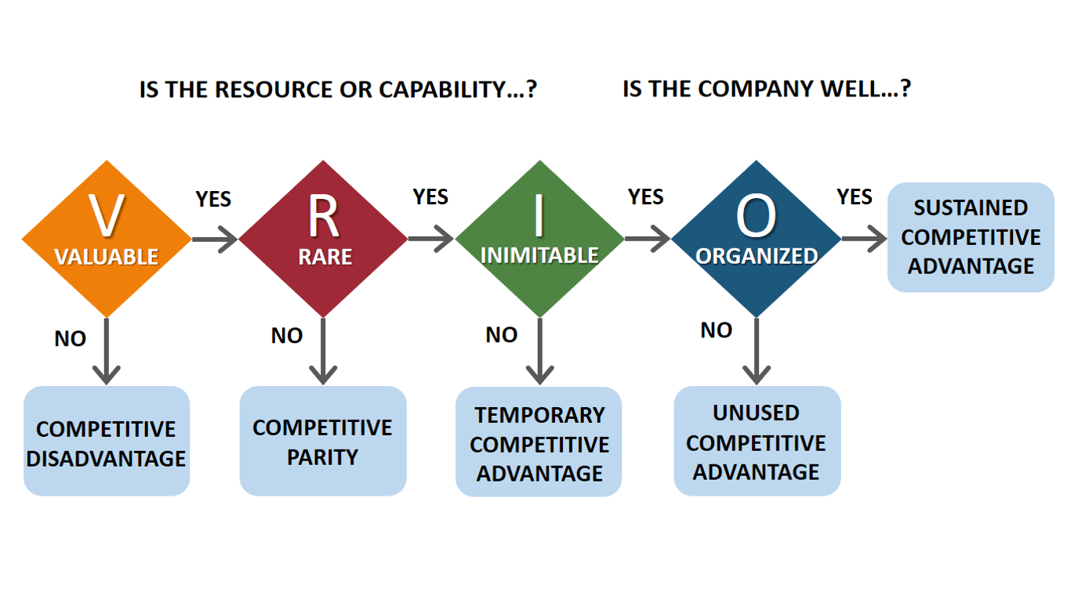
Appendix B
https://www.touchbistro.com/blog/commercial-kitchen-technology-the-equipment-you-need-for-your-restaurant/
Appendix C
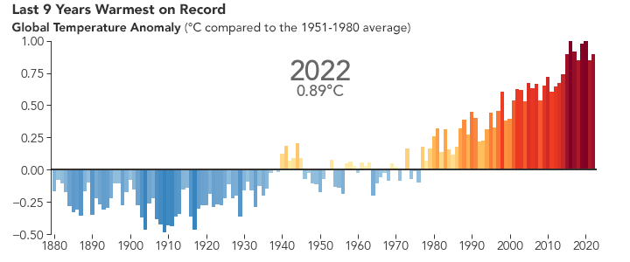
Source: United Nations
Appendix D
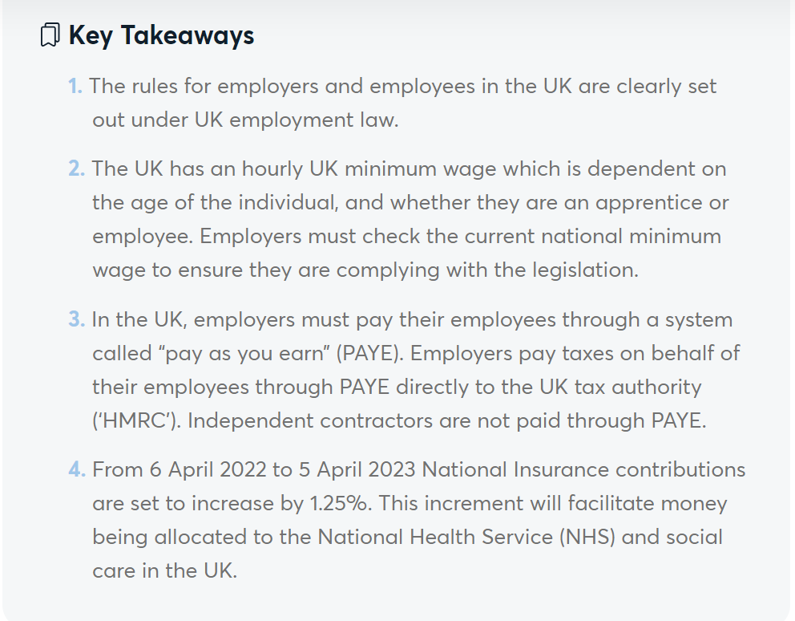
Source: https://nhglobalpartners.com/uk-employment-law-uk-labor-law/
Appendix E
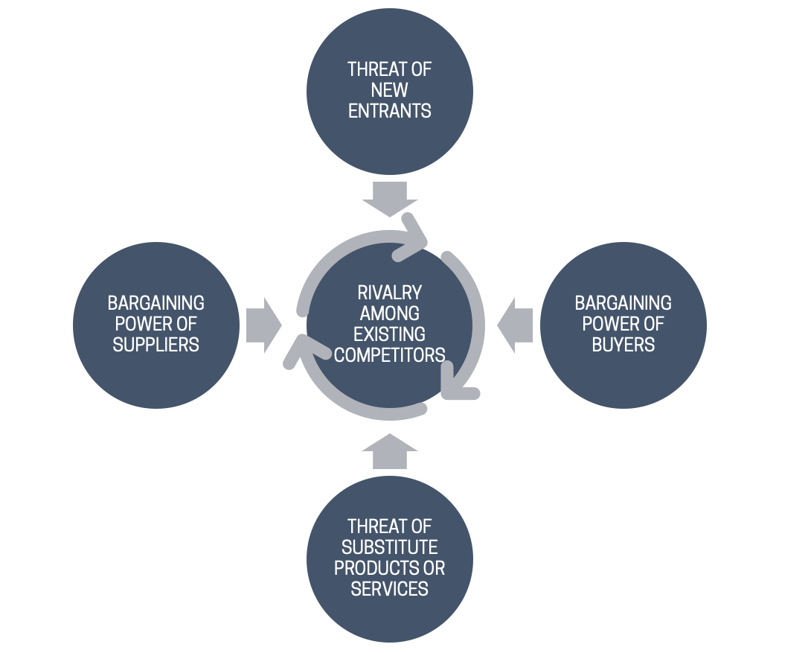
Source: MBA Management Models
Appendix F
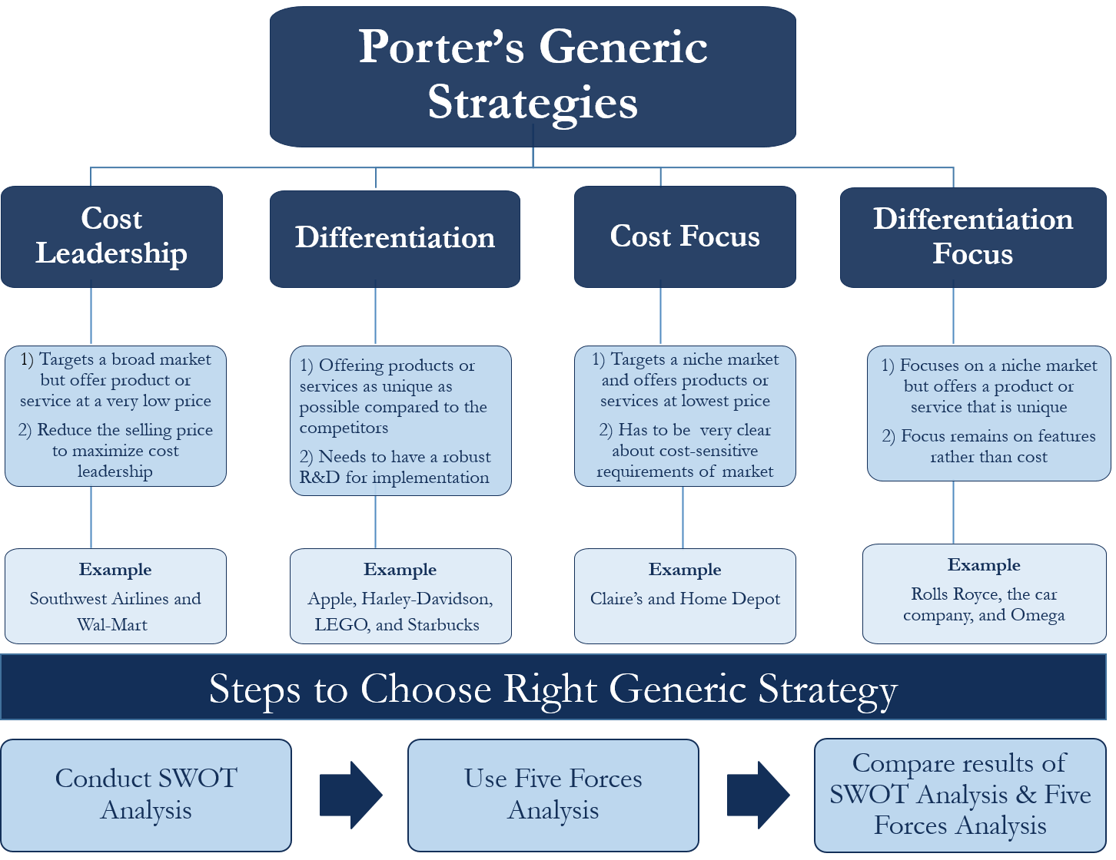

Source: eFinance Management

