Construction technology 2
Building Evaluation

Mark Preston – ID 2223676
HND / BSc Construction Management

Contents Page

- Introduction – Page 2

- Site Context and Local Planning Considerations – Page 2, 3

- Ground Conditions and Foundation Recommendations – Page 3, 4, 5

- Structural Frame Systems: Options and Justification – Page 6, 7, 8

- Building Envelope: Materials, Methods, and Coastal Performance – Page 8, 9, 10, 11

- Prefabrication vs. On-site Construction: Comparative Analysis – Page 12, 13, 14, 15

- Fire Safety and Regulatory Compliance – Page 15

- Energy Efficiency, Sustainability, and Lifecycle Assessment – Page 16

- Maintenance, Durability, and Long-Term Performance – Page 17

- Case Studies – Page 18

- Conclusion and Key Recommendations – Page 19

- Appendices – Page 20

- References – Page 21, 22, 23, 24

Introduction

This report provides a guide for the construction of a medium to high-rise hotel in Sketty, Swansea. It is tailored for a non-technical client and covers the selection and justification of structural frame and foundation systems, building envelope materials and methods, and the balance between prefabrication and on-site construction. The recommendations are built on UK standards, local site conditions, and best practices for coastal environments. Visual aids, tables, and diagrams are included to clarify key concepts and support decision-making.

Site Context and Local Planning Considerations

Location Overview

The plot is highlighted in red below and is located south west of Singleton Hospital which is situated in the Sketty area of Swansea, West Glamorgan, Wales. The site is within proximity to Swansea Bay, exposing it to coastal weather patterns, including high winds, salt-laden air, and frequent rainfall. The area is urban, with established infrastructure, but also subject to planning controls and environmental constraints.

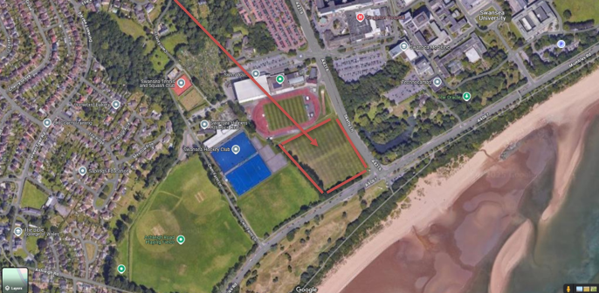

Local Planning and Regulatory Framework

Swansea City Council oversees planning and building control, ensuring that new developments are safe, sustainable, and accessible (Swansea Council, 2025). Key considerations for this hotel construction include:

- Compliance with Building Regulations (Wales), including fire safety, accessibility, and energy efficiency.
- Adherence to local planning policies, including sustainable drainage (SuDS), biodiversity, and nature conservation.
- Coordination with hospital operations to minimize disruption during construction.
- Consideration of local land charges, tree preservation orders, and street naming/numbering.

Site Constraints

The site is less than a kilometre from the coast, which means it is exposed to salt spray, strong winds, and heavy rain, and there is also a small risk of coastal erosion. (LABC Warranty, 2021). The location is close to the hospital and main roads, which makes access easier for construction vehicles, but the work would need to be carefully managed to avoid causing disruption to hospital services.

Ground Conditions and Foundation Recommendations

Local Ground Conditions

Ground conditions in Swansea can be quite mixed, as many urban areas contain made ground, clay, and sandy soils. These can vary in strength and may sometimes be contaminated, so careful investigation is needed before building. (Piling Construction, no date). In the appendices, there is a borehole sample in close proximity to the proposed site. (British Geological Survey, 2026).

Foundation Options for Medium to High-Rise Buildings

Table 1: Foundation Types and Suitability for Swansea

Foundation Type | Suitability for Swansea | Pros | Cons | Notes
Piled Foundations | High | Handles variable soils, deep bearing, minimal settlement | Higher cost, requires specialist equipment | Ideal for medium/high-rise, coastal sites
Raft (Mat) Foundations | Moderate | Spreads load, good for variable soils | Large excavation, not ideal for poor soils | May suit low-rise or stable ground
Pad Foundations | Low | Simple, cost-effective | Not suitable for high loads or poor soils | Used for small structures only
Ground Screws | Moderate | Fast installation, minimal excavation | Limited load capacity, not common for high-rise | Suits lightweight, modular builds
Sheet Piling | High (for erosion control) | Protects against coastal erosion, supports excavation | Not a primary foundation, but essential for site stability | Used in conjunction with other systems

Piled foundations involve driving steel or concrete piles deep into stable strata, bypassing weak or variable surface soils. This method is widely used for medium to high-rise buildings in urban/coastal settings, offering superior load-bearing and resistance to settlement. (Piling Construction, n.d.; Interdrive Piling, n.d.).

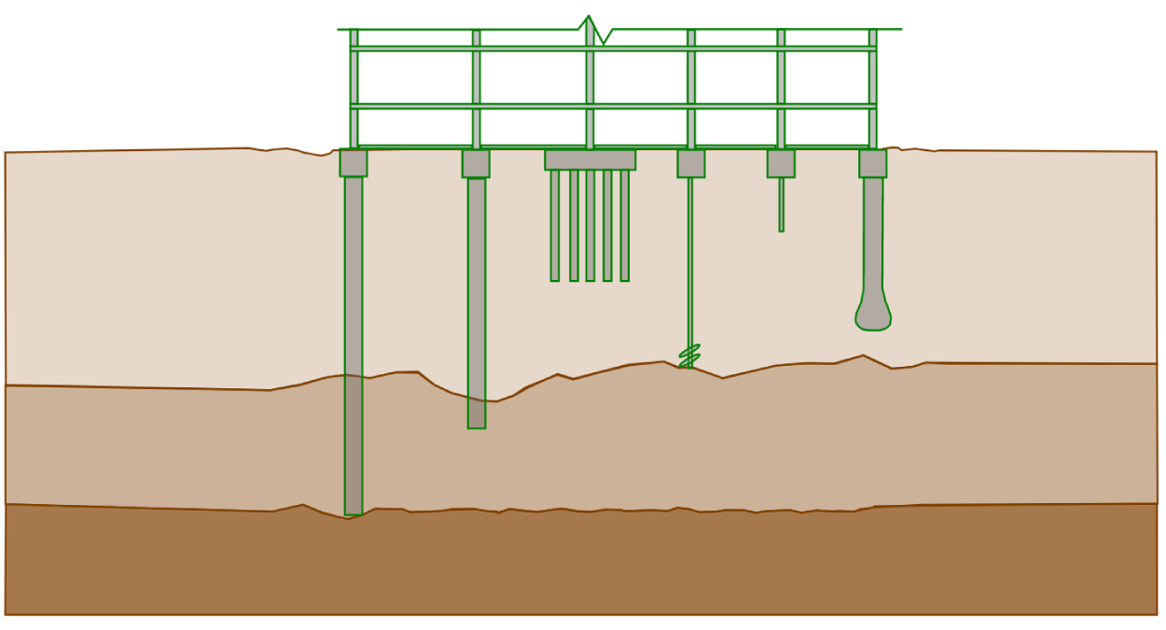
(Suckling Q, 2021)

Basement Construction

Basements offer extra space such as plant rooms etc for hotels but are challenging to design and build. BS 8102:2022 sets the standards for protecting below-ground structures, requiring combined waterproofing measures, structural resistance to water pressure and uplift, and carefully planned construction with appropriate temporary support and groundwater control.

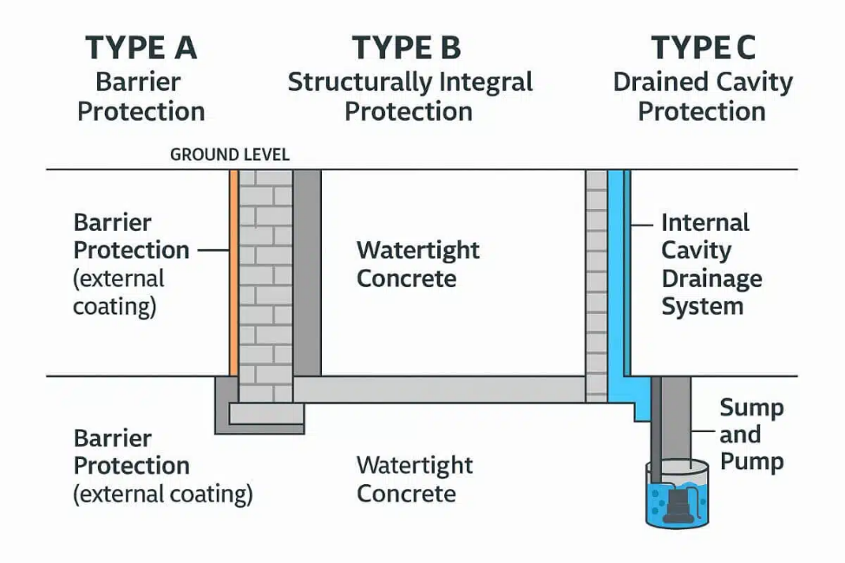
(Max Damp Proofing, n.d.)

Recommended Foundation System
For a medium to high-rise hotel for the proposed plot, a continuous flight auger piled foundation system is strongly recommended combined with a contiguous or secant (more watertight barrier) pile wall for the basement. This approach:

- Is fast installation because drilling and concreting happen in one continuous operation
- Low noise, virtually no vibration, so ideal next to existing buildings or hospitals
- Accommodates variable and potentially poor ground conditions
- Minimizes risk of differential settlement.
- Provides robust support for heavy structural loads.
- Can be integrated with sheet piling for coastal erosion protection. (Piling Construction, n.d.; Interdrive Piling, n.d.). UK Standards include:

- BS EN 1997-1: Eurocode 7 – Geotechnical Design
- BS 8004: Foundations for Buildings

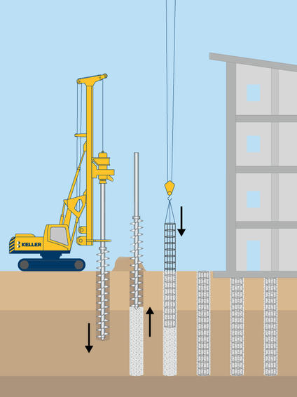
(Keller Australia, n.d.)

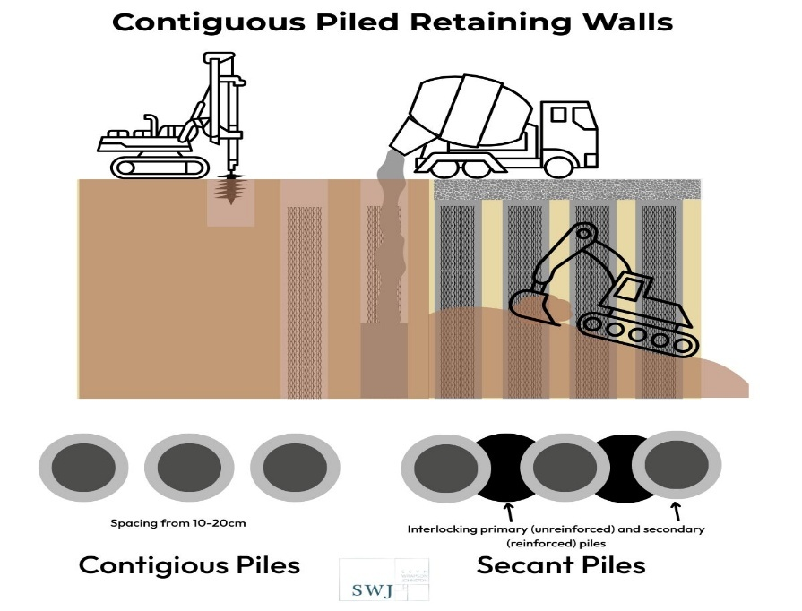
(SWJ Consulting, n.d.)
Structural Frame Systems: Options and Justification

Structural Frame Options

Table 2: Structural Frame Systems Comparison

Frame Type | Strength & Stability | Fire Safety | Coastal Durability | Sustainability | Speed of Construction | Cost
Steel Frame (Hot-Rolled) | Excellent | Good (with protection) | Needs corrosion protection | Recyclable, low embodied carbon | Fast (prefab possible) | Moderate
Concrete Frame | Excellent | Excellent | Good (with correct mix) | High embodied carbon | Moderate | High
Timber Frame (Mass Timber/CLT) | Good (low-rise) | Moderate (needs protection) | Vulnerable to moisture/salt | Renewable, low embodied carbon | Fast (prefab possible) | Moderate
Hybrid (Steel/Concrete) | Excellent | Excellent | Good (with protection) | Balanced | Moderate | High
Light Gauge Steel (Modular) | Good (mid-rise) | Good | Needs galvanizing | Recyclable | Very fast (modular) | Moderate

Steel Frame Systems

Steel frames are the preferred choice for medium to high-rise hotels in the UK, especially in coastal cities like Swansea (Ayrshire, n.d.; Volumetric Building Companies, n.d.). Key advantages include:

- High Strength-to-Weight Ratio: Allows for taller structures with slimmer profiles.
- Speed of Construction: Prefabricated steel components can be rapidly assembled on-site.
- Design Flexibility: Accommodates large open spaces, varied layouts, and modular construction.
- Sustainability: Steel is recyclable and can be sourced with low embodied carbon.

For coastal durability, steel frames must be protected against corrosion from salt-laden air. Recommended measures include:

- Hot-Dip Galvanizing to BS EN ISO 1461, providing a robust zinc coating.
- Marine-Grade Stainless Steel (A4/316) for critical connections and exposed elements. (LABC Warranty, 2021)

Concrete Frame Systems

Concrete frames offer excellent fire resistance and durability but are less favoured for coastal hotels due to:

- High Embodied Carbon as concrete production is energy-intensive.
- Longer Construction Times as on-site pouring and curing are weather-dependent.
- Potential for Chloride Attack as coastal environments require special concrete mixes (BS 8500 XS1/XS2/XS3 exposure classes). (ConcreteMath, n.d.; Concrete Society, n.d.)

Timber and Hybrid Systems

Mass timber (CLT) and hybrid frames are gaining popularity for sustainable construction but face limitations in high-rise applications and require rigorous fire and moisture protection. Insurance and regulatory barriers persist for timber in hotels above six storeys. (UK Government, 2025)

Recommended Structural Frame
A hot-rolled steel frame system, with all primary members hot-dip galvanized to BS EN ISO 1461 and critical connections in marine-grade stainless steel, is recommended for the hotel. The structure would also be designed to EN 1991-1-4, taking into account wind speed, terrain and builing height (EurocodeApplied.com, n.d). This system:

- Meets structural strength and stability requirements for medium/high-rise buildings.
- Is compatible with modular/prefabricated construction.
- Offers proven durability in coastal environments.
- Supports rapid construction and future adaptability.

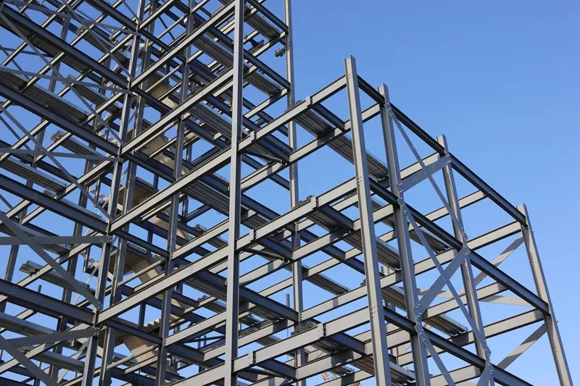
(iBeehive Steel Structures, n.d.)

UK Standards include:

- BS EN 1993: Eurocode 3 – Design of Steel Structures,
- BS EN ISO 1461: Hot Dip Galvanized Coatings
- BS EN ISO 12944-2: Corrosion Protection of Steel Structures.
Structural Floor System

For this I recommend composite steel–concrete floors (Steel beams with metal decking and a concrete topping) because it is fast to build, lightweight, and works well with steel frames. (Concrete Society, n.d.; SWJ Consulting, 2023)

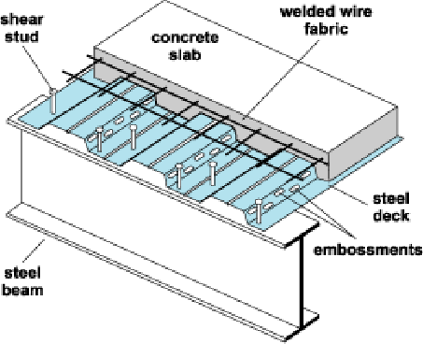

(ResearchGate, n.d.)

Building Envelope: Materials, Methods, and Coastal Performance

Coastal Weather Challenges

Swansea’s coastal climate presents several challenges for building envelopes. Salt Spray accelerates corrosion of metals and degradation of porous materials. Wind-Driven Rain penetrates cracks and junctions, causing damp and structural damage. High Humidity promotes condensation, mold, and decay. UV Exposure fades finishes and degrades polymers.

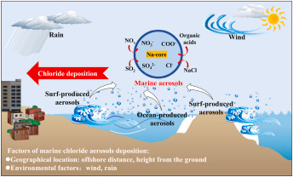
ScienceDirect (n.d.)

Envelope Material Options

Table 3: Envelope Materials Comparison

Material Type | Salt Resistance | Water Resistance | Fire Safety | Energy Efficiency | Maintenance | Aesthetics | Sustainability
Fibre Cement Cladding | Excellent | Excellent | Good | Good | Low | Flexible | Moderate
Composite Cladding | Excellent | Excellent | Good | Good | Very Low | Flexible | High (recycled)
Marine-Grade Aluminium | Excellent | Excellent | Excellent | Good | Very Low | Modern | High (recycled)
Treated Timber | Good | Moderate | Moderate | Good | Medium | Warm/Natural | High (renewable)
uPVC | Excellent | Good | Moderate | Good | Low | Variable | Moderate
Brick (Engineering) | Excellent | Excellent | Excellent | Good | Low | Traditional | Moderate
Silicone Render | Excellent | Excellent | Good | Good | Low | Flexible | Moderate
Aluminium Composite Panels (ACP) | Excellent | Excellent | Excellent | Good | Very Low | Modern | Moderate

Recommended Envelope Systems

Walls and Cladding:

Option 1 - Fibre Cement or Composite Cladding is highly resistant to salt, moisture, and UV. It is low maintenance and has a long lifespan (25–40+ years). It is available in a range of colours and finishes, including timber effect. It’s also suitable for rainscreen systems with ventilated cavities for moisture management. (Cladco, n.d.

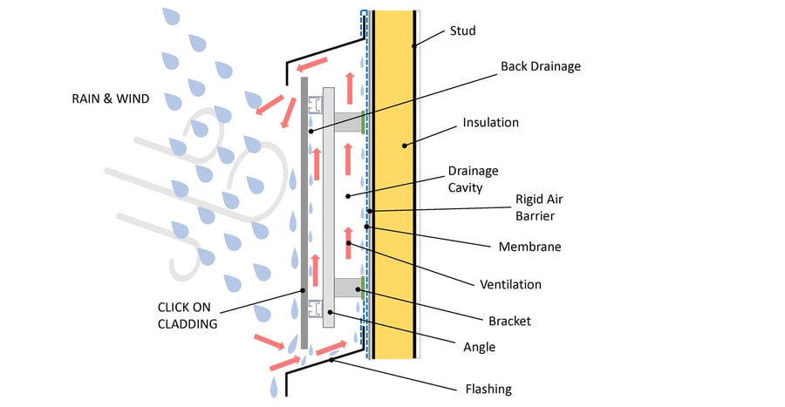
Typical Design of Rainscreen Cladding
(Sculptform, 2026)
Option 2 - Engineering Brick for the outer leaf is an option as dense, low-porosity bricks minimize water and salt absorption. It is traditionally aesthetic and has a robust performance.

Option 3 - Silicone-Based Render is also an option as it’s hydrophobic, self-cleaning, and vapor-permeable. It’s applied over dense blockwork or brick, with PVC/stainless steel beads.

Windows and Doors:

Option 1 - Powder-Coated Aluminium Frames has superior corrosion resistance with marine-grade coatings. It has slim profiles, high strength, and a long lifespan (45+ years). It also meets BS 6375-1 for weather tightness and wind resistance. (LABC Warranty, 2021)

Option 2 - uPVC Frames are cost-effective and has good resistance to moisture and salt. These have thicker profiles, shorter a lifespan (20–30 years).

Roofing:

Option 1 - Natural Slate is dense, impermeable, and highly durable. It needs to be mechanically fixed to BS 5534 for wind uplift resistance.

Option 2 - Metal Roofing (Aluminium/Coated Steel) is lightweight, corrosion-resistant, and suitable for high-wind zones. Standing seam systems are recommended
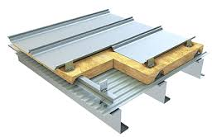
(Wiskind Steel Structure, n.d.)

Fixings and Fasteners:

Marine-Grade Stainless Steel (A4/316) are mandatory for all external fixings to prevent corrosion and ensure envelope integrity. (LABC Warranty, 2021)

Moisture Management and Ventilation

Cavity Wall Construction is essential for managing wind-driven rain and preventing internal damp. It incorporates cavity trays, weep holes, and vapor barriers. Ventilation strategies include Mechanical Ventilation with Heat Recovery (MVHR) for airtight, energy-efficient buildings, local extraction in wet rooms and background ventilation via trickle vents. Condensation control can be managed by high-performance insulation (mineral wool, PIR, or vacuum panels) and Smart vapor control layers and airtight construction. All the above is relevant to passive haus principles. (Partel, n.d.)

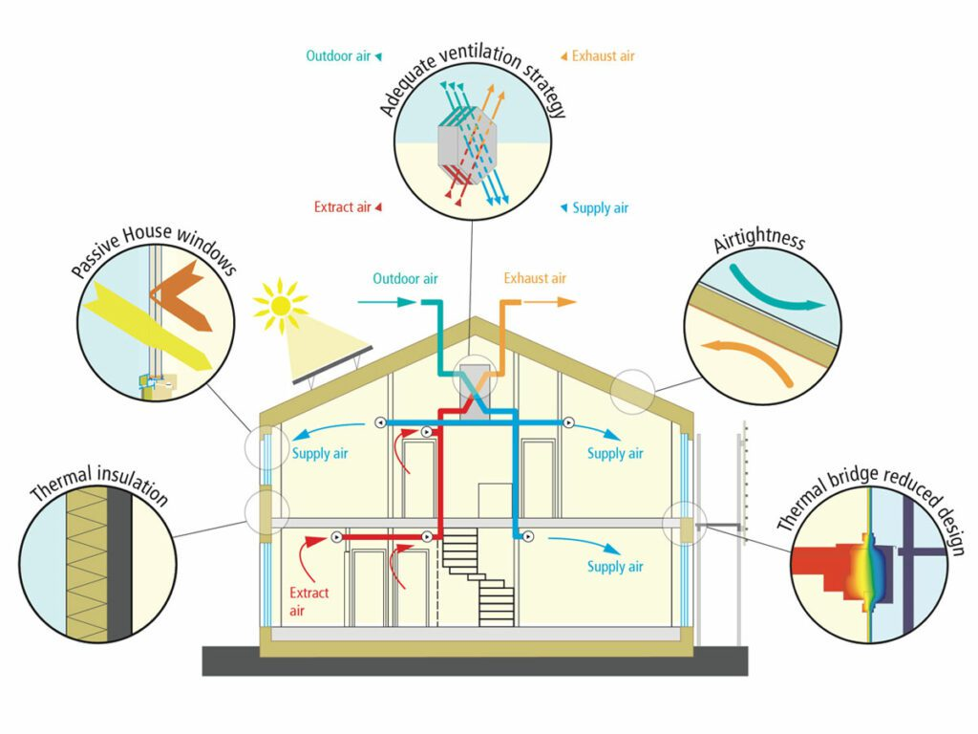
(Partel, n.d.)

Fire Safety in Envelope Design

There is a combustible materials ban for hotels over 18m. External walls and attachments must achieve A2-s1, d0 or better (non-combustible) as per Building Regulations. This applies to new builds and major refurbishments.

Compartmentation (fire-resistant barriers) are required between floors and rooms as well as fire doors and protected escape routes.

UK Standards include:

- BS 8500: Concrete Specification for Marine Exposure
- BS EN ISO 1461: Galvanized Coatings
- BS 5534: Slating and Tiling for Roofs
- BS 6375-1: Weather Performance of Windows and Doors
- BS 8104: Exposure to Wind-Driven Rain
- BS 5839-6: Fire Detection and Alarm Systems.

Prefabrication vs. On-site Construction: Comparative Analysis

Prefabrication (Offsite Construction)
Prefabrication involves manufacturing building components (modules, panels, pods) in a factory, then transporting them to site for rapid assembly. (KC Modular Buildings, 2025)

Elements Suitable for Prefabrication include:

- Hotel Room Modules: These are fully finished, including bathrooms, MEP, and furniture and stacked on-site to form the building’s core.

- Bathroom Pods: Pre-plumbed, tiled, and fitted for rapid installation.

- Wall and Floor Panels: Light gauge steel or timber panels, insulated and finished.

- MEP Subassemblies: Pre-wired and plumbed service risers.

- Furniture and Fit-Out: Custom-manufactured offsite for consistent quality.

Benefits include:

- Speed: It reduces on-site construction time by 30–50% and enables parallel site preparation and module fabrication.

- Quality Control: Factory conditions ensure precision, repeatability, and fewer defects.

- Environmental Impact: It minimizes waste, energy use, site disruption and has lower embodied carbon due to efficient material use.

- Cost Certainty: Involves fixed pricing, fewer change orders, and reduced overruns.

- Reduced Site Disruption: Ideal for constrained urban sites, especially near hospitals.

Limitations include:

- Design Flexibility: It has an early design freeze. Changes post-fabrication are costly and is best suited for standardized layouts.

- Transport and Logistics: Large modules require careful planning for delivery and craning.

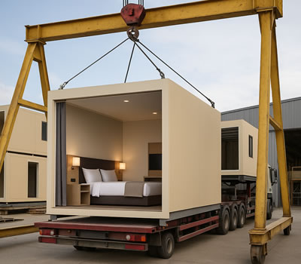
(Total Fabrications Wales, n.d.)

On-site Construction
Traditional construction involves building all elements sequentially on-site, using raw materials and labour. Elements Best Constructed On-site include:

- Foundations and Piling: These require adaptation to site-specific ground conditions.

- Podium Structures and Cores: It may need bespoke solutions for access, fire safety, and integration.

- External Envelope (Cladding, Roofing): This is generally applied after module installation to ensure weather tightness and aesthetic integration.

- Complex Public Spaces: Lobbies, restaurants, and event spaces may require bespoke finishes.

Benefits include:

- Flexibility: It’s easier to accommodate late design changes and site-specific requirements.

- Customization: It suits unique architectural features and irregular plots.

Limitations include:

- Longer Programme: Sequential work, weather delays, and site coordination extend timelines.

- Variable Quality: It’s dependent on-site conditions and workforce skill.

- Higher Environmental Impact: On-site construction has more waste, energy use, and disruption.

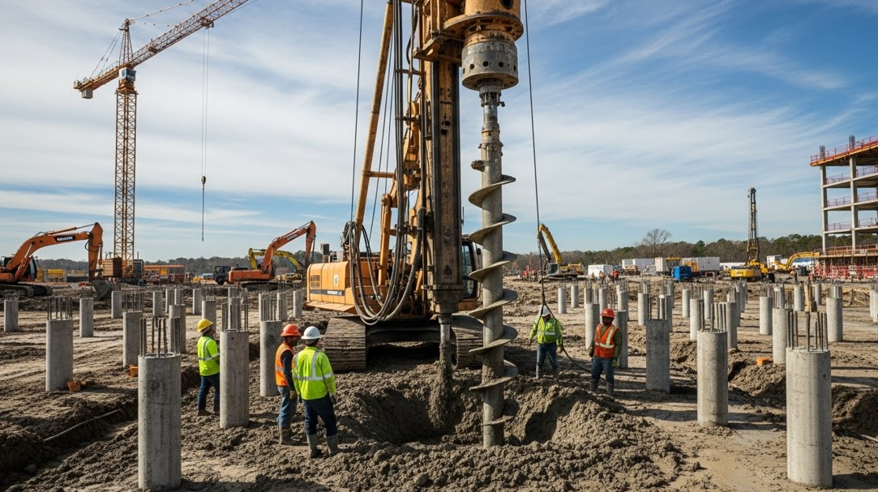
(Prime Piling, n.d.)

Table 4: Prefabrication vs. On-site Construction

Aspect | Prefabrication (Modular) | On-site Construction
Speed | 30–50% faster | Slower, weather-dependent
Cost Certainty | High (fixed price) | Variable, risk of overruns
Quality Control | Excellent (factory QA) | Variable (site conditions)
Environmental Impact | Low (less waste) | Higher (more waste)
Flexibility | Moderate (design freeze) | High (late changes possible)
Site Disruption | Minimal | Significant
Logistics | Requires planning | Standard deliveries
Suitability | Standardized rooms, repetitive layouts | Bespoke spaces, complex sites

Recommended Approach
Adopt a hybrid construction strategy:

Prefabricate hotel room modules, bathroom pods, MEP risers, and furniture and leverage proven modular suppliers (e.g., VBC, Stelling Properties, Premier Modular). (Volumetric Building Companies, n.d.; Stelling Properties, n.d.; Premier Modular, n.d.)

On-site Construction of foundations, piling, podiums, external envelope, public spaces and bespoke architectural features.
This approach maximizes speed, quality, and environmental benefits while retaining flexibility for site-specific and aesthetic requirements. (Premier Modular, n.d.; Chapman Taylor, 2017)

Fire Safety and Regulatory Compliance

Regulatory Framework

Building Regulations (Wales) Part B, Fire Safety states a combustible materials ban for hotels over 18m (A2-s1, d0 or better). Regulatory Reform (Fire Safety) Order 2005 requires a fire risk assessment, evacuation plans, and maintenance of fire protection measures. (UK Government, 2025) Building Safety Act 2022 (Wales) requires enhanced accountability and duty holder roles for multi-occupancy buildings. (Welsh Government, 2025; Fire Protection Association, 2025)

Fire Safety Measures for Hotels

Compartmentation is essential so needs to be fire-resistant walls and floors between rooms and storeys. There needs to be a Means of Escape which has protected stairwells, clear signage, and emergency lighting. Fire Detection and Alarm Systems need to have interlinked smoke and heat alarms (Grade D1), per BS 5839-6. Firefighting Equipment of extinguishers and fire blankets in kitchens and service areas are required. Evacuation plans including accessible routes and consideration for disabled guests. Also, maintenance and testing including regular checks, log books, and annual servicing.

Fire Safety in Modular Construction

Factory-Finished modules require fire-rated partitions, doors, and finishes installed offsite. Compliance of modules must meet UK fire safety standards and be certified before delivery.

Recent Developments

Post-Grenfell Reforms include stricter controls on cladding, fire doors, and evacuation procedures. The Welsh Building Safety Bill (2025) states further reforms are expected, with local authorities as regulators. (Fire Protection Association, 2025).

Energy Efficiency, Sustainability, and Lifecycle Assessment

UK Energy Efficiency Standards

Part L Building Regulations (2025) shows a 75–80% reduction in carbon emissions compared to 2013 standards. There is a fabric-first approach with improved insulation, airtightness, and low-carbon heating. There are no more gas boilers in new builds; heat pumps and MVHR systems are required. (CCA Environmental, 2025; UK Property Market News, 2025)

Envelope Performance

For insulation, U-values for walls: ≤0.18 W/m²K; roofs: ≤0.11 W/m²K; windows: ≤1.2 W/m²K. High-performance insulation include mineral wool, PIR and vacuum panels. For airtightness, air permeability targets are ≤3 m³/(h·m²) at 50 Pa. Thermal Bridging is minimized through careful detailing and modular construction.

Overheating and Ventilation

The CIBSE TM59 Assessment is a dynamic thermal modelling to prevent overheating in bedrooms and living spaces. (DesignBuilder, n.d.; TM59 Expert, n.d.) Ventilation through MVHR systems for whole-building air quality and energy recovery.

Sustainability and Embodied Carbon

To assist with a Whole Life Carbon Assessment (WLCA), the RICS WLCA standard (2024) is there for measuring embodied and operational carbon. (UK Government, 2025; RICS, 2023) With material selection, preference of recycled steel, low-carbon concrete (GGBS), and bio-based insulation would help. Also, for circular economy, having modular components designed for reuse and recycling.

Sustainable Hospitality Trends

Global hotel brands such as Accor, Marriott, and Hilton are now focusing on carbon‑neutral construction, energy‑efficient building systems, and achieving recognised green certifications to reduce their environmental impact (Volumetric Building Companies, n.d.). At the same time, guest expectations are changing, with research showing that 83% of travellers now prefer to stay in hotels that are environmentally friendly and make sustainability a clear priority.

Maintenance, Durability, and Long-Term Performance

Coastal Maintenance Challenges

Corrosion needs to be managed through regular inspections and ongoing maintenance of the steelwork, cladding, and fixings to ensure they remain in good condition over the building’s lifespan. Weathering also requires attention, meaning protective coatings must be applied and renewed, when necessary, surfaces should be cleaned on a scheduled basis, and any damaged finishes should be repaired quickly to prevent further deterioration. Effective moisture management is equally important, which involves consistently monitoring drainage systems, ensuring adequate ventilation, and maintaining all damp‑proofing measures so that moisture does not accumulate within the structure.

Maintenance Strategies

Scheduled inspections should take place once a year to check the building envelope, roof, windows, and all fire‑safety systems so that any issues can be found early and dealt with quickly. Most cladding, window systems, and roofing materials come with manufacturer warranties that usually last between 15 and 25 years, offering long‑term protection and reassurance. A maintenance plan should also be created during the design stage and then passed on to the building’s management team, giving them clear guidance on how the building should be looked after throughout its life.

Durability Enhancements

Durability can be improved in several practical ways. Choosing the right materials is important, such as using marine‑grade metals, dense masonry, and high‑performance protective coatings that can cope with coastal conditions. Good design detailing also helps the building last longer; features like deep roof overhangs, projecting window sills, and well‑protected junctions all work to direct water away from the structure. Regular cleaning is equally important, especially in coastal areas, as removing salt deposits and debris from exposed surfaces prevents long‑term damage and keeps the building in good condition.

Case Studies

Holiday Inn Express, Manchester (Modular Hotel) is A 220-bed hotel constructed from steel modules. Modules were fully fitted offsite and stacked in less than three weeks. The external envelope was applied on-site using rainscreen cladding. This achieved a fast programme, high quality, and cost certainty.

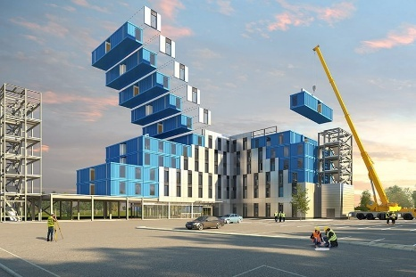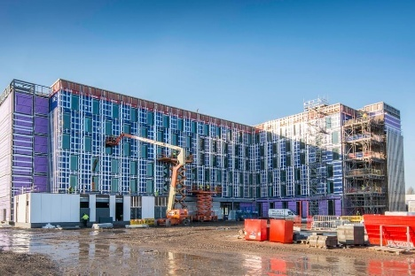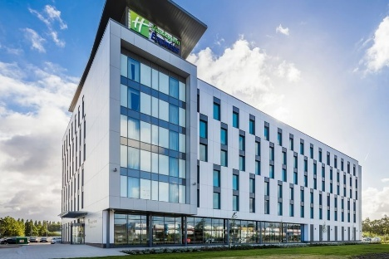
(Chapman Taylor, 2017)

Days Inn, Wakefield (Permanent Modular Hotel) is a 100-bed, four-storey hotel built in 16 weeks. It has beam and post steel frames and modules were fully fitted and decorated in a factory. Factory-fitted cladding minimized site duration and scaffold requirements. (Premier Modular, n.d.)

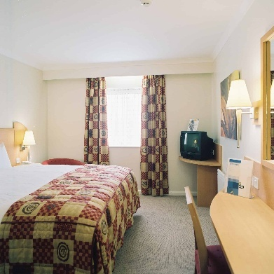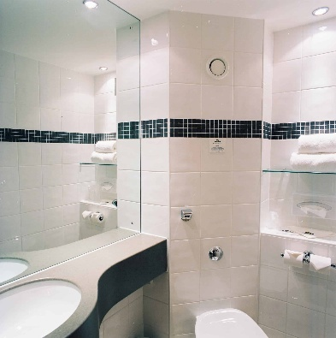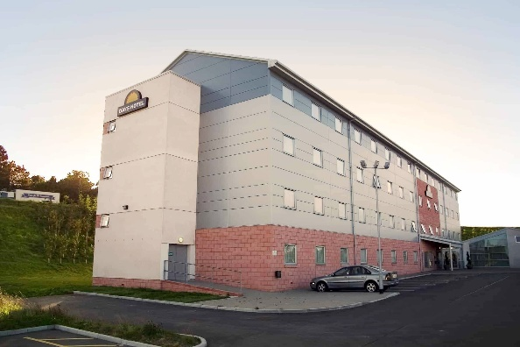
(Premier Modular, n.d.)

Singleton Hospital Facade Replacement was a £13 million, six-floor facade replacement with new cladding and windows. A phased approach minimized disruption to hospital services. Marine-grade materials and robust project management ensured durability and compliance. (Swansea Bay University Health Board, 2025; Construction Management, 2025)

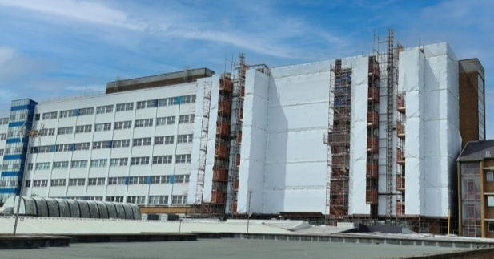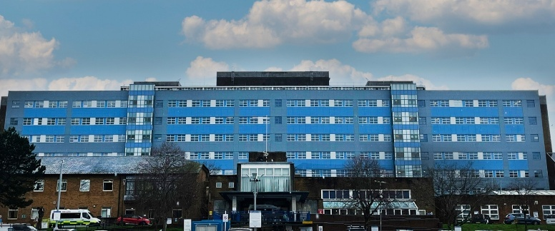
(Swansea Bay University Health Board, 2025)

Conclusion and Key Recommendations

Structural Frame and Foundations

Use hot-rolled, galvanized steel frame with marine-grade stainless steel connections.
Install piled foundations, with sheet piling for coastal erosion protection.

Building Envelope

Specify fibre cement or composite rainscreen cladding, powder-coated aluminium windows, and natural slate or metal roofing. Ensure all external fixings are marine-grade stainless steel.
Incorporate cavity wall construction, high-performance insulation, and MVHR ventilation.

Prefabrication vs. On-site Construction

Prefabricate hotel room modules, bathroom pods, and MEP risers. Construct foundations, podiums, and external envelope on-site. Use modular fit-out for furniture and finishes.

Fire Safety and Compliance

Design for compartmentation, protected escape routes, and non-combustible external walls.
Install interlinked fire detection systems and maintain regular testing.

Energy Efficiency and Sustainability
Meet or exceed Part L 2025 standards for insulation, airtightness, and low-carbon heating. Conduct whole life carbon assessment and select materials for low embodied carbon.

Maintenance and Durability
Develop a maintenance plan for envelope, fixings, and fire safety systems. Schedule regular inspections and cleaning, especially for coastal-exposed elements.

Next Steps

Commission a detailed site investigation and engage with modular suppliers early. Coordinate with Swansea City Council for planning and building control approvals. Consult with fire safety and sustainability experts to ensure full compliance.

Appendices

Borehole sample in close proximity to proposed site

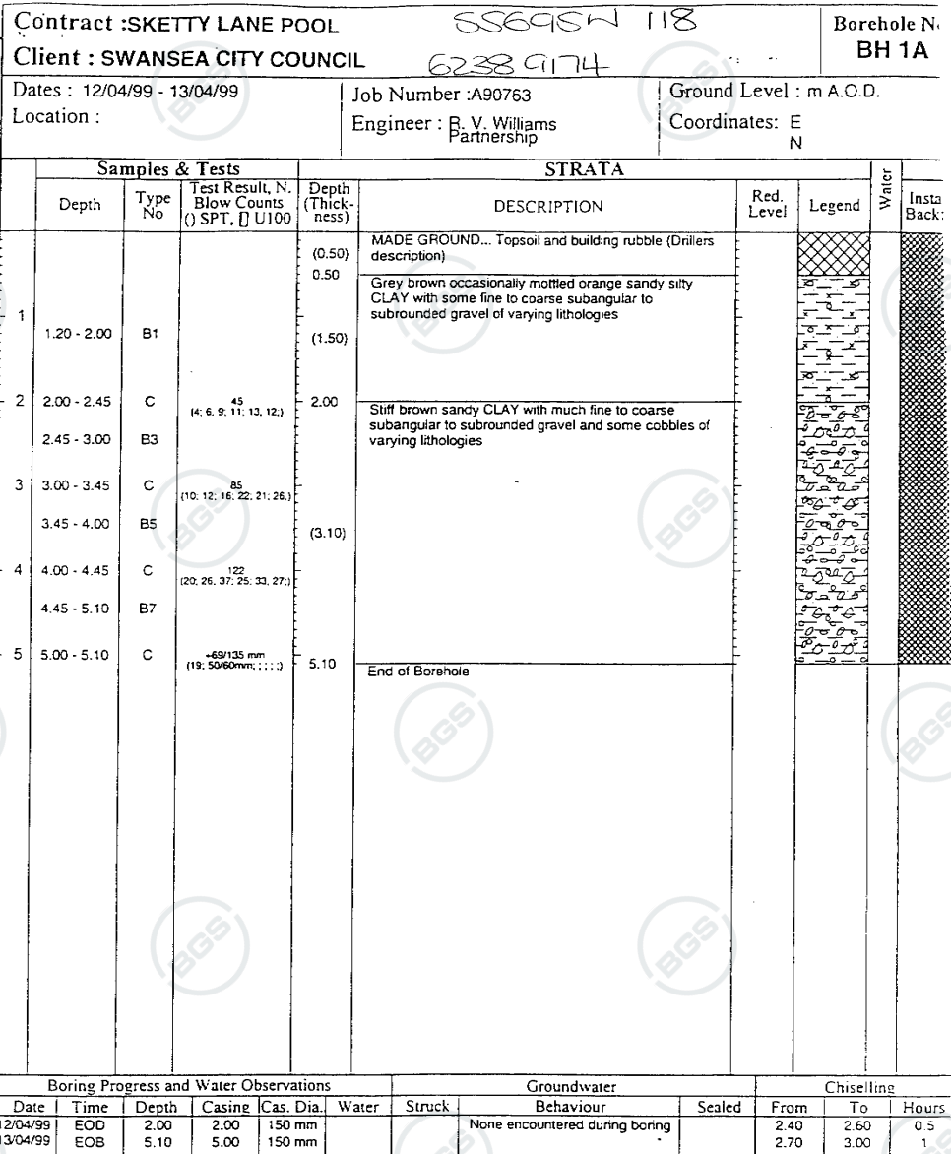
(British Geological Survey, 2026)

References

Ayrshire (n.d.) AyrFrame™ steel modular building frame system. Available at: https://www.ayrshire.co.uk/ayrframe (Accessed: 11 January 2026).

British Geological Survey (2026) BGS GeoIndex – geological mapping and borehole records for Wales and England. Available at: https://mapapps2.bgs.ac.uk/geoindex/home.html?_ga=2.142945205.108690770.1731939977-1995514978.1731939977 (Accessed: 12 January 2026).

British Standards Institution (2023) Project 9023-08202: NA to BS EN 1990 – UK National Annex for Eurocode. Basis of Structural Design. Available at: https://standardsdevelopment.bsigroup.com/projects/9023-08202 (Accessed 12 January 2026).

British Standards Institution (2005) UK National Annex to Eurocode: Basis of Structural Design (NA to BS EN 1990:2002+A1:2005). Available at: https://ia802903.us.archive.org/35/items/bs.na.en.1990.2005/bs.na.en.1990.2005.pdf (Accessed 12 January 2026).

CCA Environmental (2025) How the 2025 Part L regulations are transforming energy efficiency in UK buildings. Available at: https://cca-ltd.uk.com/how-the-2025-part-l-regulations-are-transforming-energy-efficiency-in-uk-buildings/ (Accessed: 11 January 2026).

Chapman Taylor (2017) Chapman Taylor behind the first volumetric modular hotel to be completed in Manchester. Available at: https://www.chapmantaylor.com/news/chapman-taylor-behind-the-first-volumetric-modular-hotel-to-be-completed-in-manchester (Accessed: 11 January 2026).

Chapman Taylor (2017) Holiday Inn Express, Trafford City – Modular hotel project. Available at: https://www.chapmantaylor.com/projects/holiday-inn-trafford (Accessed: 11 January 2026).

Cladco (n.d.) Cladding. Available at: https://www.cladco.co.uk/cladding (Accessed: 11 January 2026).

ConcreteMath (n.d.) Concrete exposure class table (BS EN 206 & BS 8500). Available at: https://concretemath.co.uk/concrete-charts/exposure-class-table/ (Accessed: 11 January 2026).

Concrete Society (n.d.) Exposure class to BS 8500. Available at: https://www.concrete.org.uk/fingertips/exposure-class-to-bs-8500/ (Accessed: 11 January 2026).

Construction Management (2025) CIOB Awards 2025: Healthcare – Gold Award Winner: Singleton Hospital facade replacement. Available at: https://constructionmanagement.co.uk/ciob-awards-2025-healthcare/ (Accessed: 11 January 2026).

DesignBuilder (n.d.) CIBSE TM59 – Modelling and analysis guide. Available at: https://designbuilder.co.uk/helpv7.0/Content/CIBSETM59.htm (Accessed: 11 January 2026).

EurocodeApplied.com (n.d.) Eurocode 1: Actions on structures (EN 1991) – Online calculations and guidance. Available at: https://eurocodeapplied.com/design/en1991 (Accessed: 11 January 2026).
Fire Protection Association (FPA) (2025) New Welsh Building Safety Bill announced. Available at: https://www.thefpa.co.uk/news/new-welsh-building-safety-bill-announced (Accessed: 11 January 2026).

iBeehive Steel Structures (n.d.) High-rise building steel frame structure. Available at: https://www.ibeehivesteelstructures.com/blog/high-rise-building-steel-frame-structure/ (Accessed: 11 January 2026).

Interdrive Piling (n.d.) Coastal erosion sheet piling in Swansea (Wales). Available at: https://interdrivepiling.co.uk/piling9/coastal-erosion-sheet-piling-in-swansea-wales/ (Accessed: 11 January 2026).

KC Modular Buildings (2025) Modular vs traditional construction: 2025 cost analysis. Available at: https://kcmodularbuildings.co.uk/faq/modular-vs-traditional-construction-cost-comparison/ (Accessed: 11 January 2026).

Keller Australia. (n.d.) CFA piles. Available at: https://www.keller.com.au/expertise/techniques/cfa-piles (Accessed: 12 January 2026).

LABC Warranty (2021) Developments within coastal locations: Technical update. Available at: https://info.labcwarranty.co.uk/hubfs/LABC%20Developments%20within%20coastal%20locations.pdf (Accessed: 5 January 2026).

Max Damp Proofing (no date) Understanding BS 8102:2022 – The UK Standard for Basement Waterproofing. Available at: https://maxdampproofing.co.uk/understanding-bs-81022022-the-uk-standard-for-basement-waterproofing/ (Accessed: 12 January 2026).

Partel. (n.d.) Passive House Component Testing – How Does It Work? Available at: https://www.partel.co.uk/blog/passive-house-component-testing/ (Accessed: 12 January 2026).

Piling Construction (no date) Piling Construction in Swansea. Available at: https://piling-construction.co.uk/near-me/swansea/ (Accessed: 5 January 2026).

Premier Modular (n.d.) Days Inn – Wakefield: Permanent modular hotel case study. Available at: https://www.premiermodular.co.uk/case-study/days-inn-wakefield/ (Accessed: 11 January 2026).

Prime Piling. (n.d.) CFA Piling. Available at: https://www.primepiling.co.uk/cfa-piling/ (Accessed: 12 January 2026).

ResearchGate (no date) Composite floor system. Available at: https://www.researchgate.net/figure/Composite-floor-system_fig2_259601882 (Accessed: 12 January 2026).

Royal Institution of Chartered Surveyors (RICS) (2023) Whole life carbon assessment (WLCA) for the built environment. Available at: https://www.rics.org/profession-standards/rics-standards-and-guidance/sector-standards/construction-standards/whole-life-carbon-assessment (Accessed: 11 January 2026).

ScienceDirect (no date) Marine aerosol. Available at: https://www.sciencedirect.com/topics/engineering/marine-aerosol (Accessed: 12 January 2026).

Sculptform (2026) What is a rainscreen façade system and what are its benefits? Available at: https://sculptform.com/en-gb/blogs/what-is-a-rainscreen-facade-system-and-what-are-its-benefits/ (Accessed: 11 January 2026).

Stelling Properties (n.d.) Hotel / Aparthotel modular accommodation. Available at: https://www.stellingproperties.com/hotel-aparthotel/ (Accessed: 11 January 2026).

Suckling, Q. (2021) Pile foundation types and their benefits. Sheer Force Engineering, 2 November. Available at: https://sheerforceeng.com/2021/11/02/pile-foundation-types-and-their-benefits/ (Accessed: 5 January 2026).

Swansea Bay University Health Board (2025) Singleton gets a facelift following renovation works. Available at: https://sbuhb.nhs.wales/news/swansea-bay-health-news/singleton-gets-a-facelift-following-renovation-works/ (Accessed: 11 January 2026).

Swansea Council (2025) Planning and building control. Available at: https://www.swansea.gov.uk/planning?lang=en (Accessed: 5 January 2026).

SWJ Consulting (no date) Retaining Wall Options for Basements. Available at: https://swjconsulting.co.uk/news/retaining-wall-options-for-basements/#post/0 (Accessed: 12 January 2026).

TM59 Expert (n.d.) TM59 knowledge base: Overheating risk and UK regulatory guidance. Available at: https://www.tm59expert.co.uk/knowledge-base/ (Accessed: 11 January 2026).

Total Fabrications Wales. (n.d.) Modular Hotel Room Construction Wales. Available at: https://totalfabricationswales.co.uk/modular-hotel-room-construction-wales (Accessed: 12 January 2026).

UK Government (2025) Making your small paying guest accommodation safe from fire (accessible). Available at: https://www.gov.uk/government/publications/making-your-small-paying-guest-accommodation-safe-from-fire/making-your-small-paying-guest-accommodation-safe-from-fire-accessible (Accessed: 11 January 2026).

UK Government (2025) The practical, technical and economic impacts of measuring and reducing embodied carbon in new buildings: Executive summary. Available at: https://www.gov.uk/government/publications/consideration-of-embodied-carbon-in-new-buildings/the-practical-technical-and-economic-impacts-of-measuring-and-reducing-embodied-carbon-in-new-buildings-executive-summary (Accessed: 11 January 2026).

UK Property Market News (2025) Part L Building Regulations 2025: Key changes you need to know. Available at: https://www.ukpropertymarketnews.co.uk/part-l-building-regulations/ (Accessed: 11 January 2026).

Volumetric Building Companies (n.d.) Modular hospitality solutions. Available at: https://www.vbc.co/en-gb/modular/hospitality (Accessed: 11 January 2026).

Welsh Government (2025) Written Statement: Building Safety (Wales). Available at: https://www.gov.wales/written-statement-building-safety-wales-1 (Accessed: 11 January 2026).

Wiskind Steel Structure (n.d.) Wind-resistant water-proof SR6 standing seam metal roofing sheets. Available at: https://www.wiskindsteelstructure.com/wind-resistant-water-proof-sr6-standing-seam-metal-roofing-sheets_p92.html (Accessed: 12 January 2026).

