curtis gwyther
FSG tool and die

Six sigma green belt project
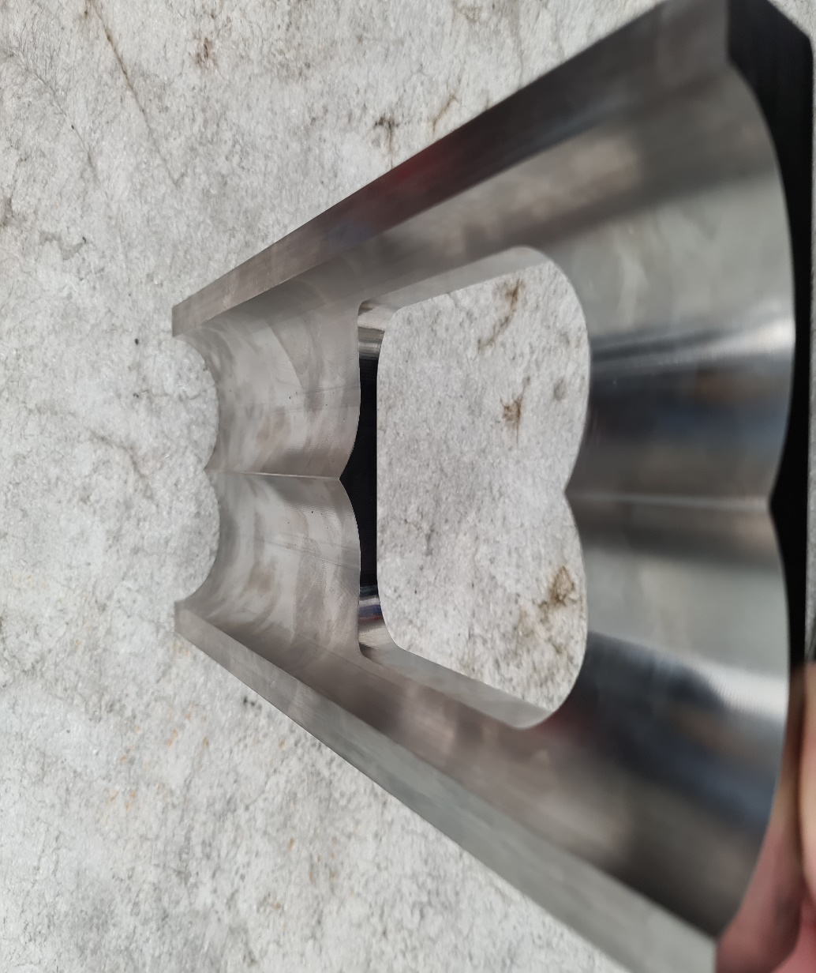
Contents
Introduction 1
Define 2
Problem statement 2
Voice of the customer 2
Process map 2
Project charter 2
Measure 3
Data collection plan 3
Quantitative data 3
Qualitative data 6
Sources of variation in measurement 7
Analyse 7
Sources of variation. 10
Improve 11
Identify and propose solutions. 11
Pilot plan 11
Pilot data 12
Cost benefit analysis 13
Control 14
References 14

Introduction
FSG tool and die is a tooling manufacturer that produces various components using a team of cnc millers and turners, grinders, edm operators and tool makers to very high standards for a variety of customers including muller, the royal mint, tesla, coppice alupack, I2R packaging solutions and many more. This six sigma project was undertaken by FSG tool and die for their customer Xtrutech in an effort to reduce costs associated with the liners that are produced frequently at the company. The Xtrutech liners were targeted for this project because there are various Liner sizes that are produced but all the different sizes have the same inside profile/form which will mean that a project on one type of liner can be related to all the different sizes that the company produces. FSG tool and die worked closely with a representative from mitsubishi tooling to see if trialling different tooling would have a cost saving benefit with regard to machining time or tool life improvements to increase the chance of the projects success.

Define

Problem statement
Ideally the manufacturing of the xtrutech liners would be as quick and as cost effective as possible, Currently the process for machining the liners is not as efficient or as quick as is desired due to too much variation in the process leading to varying machining times on the Liners and also no standard operating procedure in place for machinists to follow. The consequence of the process not being efficient enough is that the company’s costs to manufacture the liners are too high and leading to occasional losses for the company. FSG is seeking to resolve this issue by creating a team to standardise the process for machining the liners then make improvements in machining time and also investigate if there will be benefit in using new tooling to produce the liners more efficiently.

Voice of the customer
While the customer is currently happy with the surface finish and overall quality of the product that FSG is manufacturing there have been requests from the customer for a reduction in the cost of the liners should FSG continue to produce them for Xtrutech in the future, with the success of the project some of the reduction in the cost to manufacture the Liners could be passed on to the customer which would improve the chance of FSG at securing more work from Xtrutech in the future.

Process map
Issue material
Program
Machine for Hardening
Harden
Pre grind For HM
Hard machine
QA
This is the process map for the Xtrutech liners from when the material is issued onto the shop floor until the parts get checked by the QA department before being shipped to the customer.

Project charter
The main objective of the project is to reduce the machining time of the xtrutech Liners this will be important for the company moving forward as it will allow higher profit margins on these products and a cost reduction could also be passed on to the customer making FSG more attractive for future manufacturing of these products. The scope of this project will look at primarily the Program, Machine for hardening and hard machining processes as the project will be undertaken by the milling section that oversees these operations the hardening and pre grind for hard machining processes are beyond the scope of this project. The project will be led by the FSG milling team leader with the assistance of operator 1 and will also consult with the Mitsubishi tooling representative for FSG.

Measure

Data collection plan
The purpose of a data collection plan is to ensure that the data collected is useful and relevant to the project. (illinois, 2005)To begin the measure phase of the project the team firstly set a baseline for the current performance of the process through collecting the relevant data on how long the process was currently being completed in, this was done through Looking at the machining time that is given on the setup sheets that are provided, looking at the hours booked on the previous liners and getting operators to show they’re setup times on tickets so that the team could get an estimate for total and setup time for operations. Secondly as the Mitsubishi representative was part of the team tool life and feed rates were of interest so it was decided that the operators would record the tool life of the roughing cutters which are ajx indexable tip tools and the ball nose cutters used on op3 to determine how many parts could be machined before tips/ball noses needed to be changed and how fast were these cutters being run with a mind to trial new tooling to see if a time/cost saving could be made. This collection was done over the course of ten sets of Liners that were produced by the company and the data collected was Quantitative data.

Quantitative data
The data in this section is quantitative because it can be counted/measured in in numerical values. (story, 2023) The procedure for machining the Liners is done in three operations, firstly there is Operation 1 and 2 which are done pre hardening and consist of roughing the majority of material leaving 1mm of material to be finish machined after hardening as well as drilling and tapping the required holes in the component.
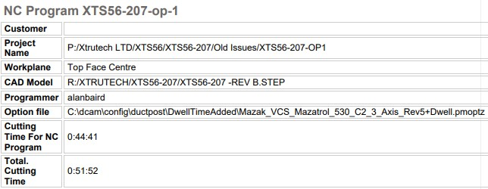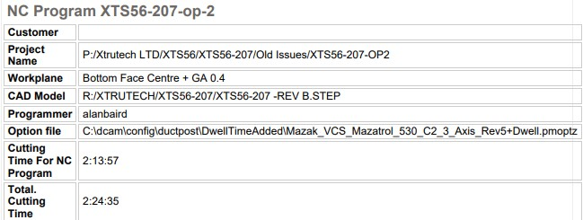
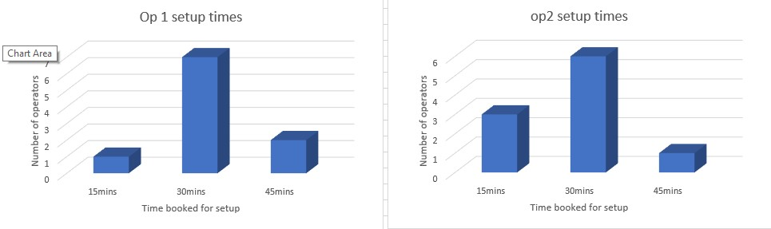
After collecting the time tickets for the amount of time booked on setup times we can see that the average setup time for the op 1 and op 2 operations was thirty minutes.
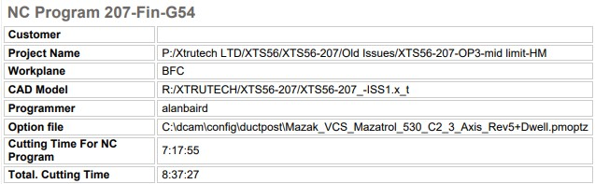
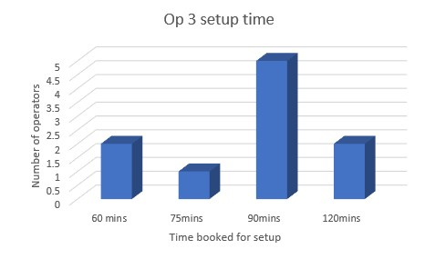
From the data collected from op 3 setup times it can be observed that the majority of operators took 90minutes to set up the liners for op 3.
The first two ops combined with half hour set up time for each operation brings the total time for the pre hardening stage of the process to four hours and twenty minutes. With the hour and a half setup time for op3 added to the eight hours and forty-minute run time that takes the time for op 3 up to ten hours and ten minutes. Therefore in total the machining processes of the xtrutech liners are currently taking fourteen and a half hours to complete, this will be used as the baseline and the aim will be to significantly improve this moving forward.
The data on tool life was recorded by the operators as the machine was running and written down when tips needed to be changed in op 1 and 2 once the edge degradation on the tips became visible to the operator and then once the surface finish was not meeting the requirement from the 10mm ball nose and it needed to be changed on op3 after the parts were hardened.
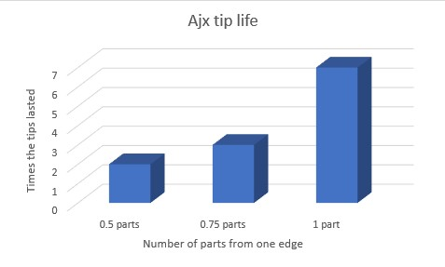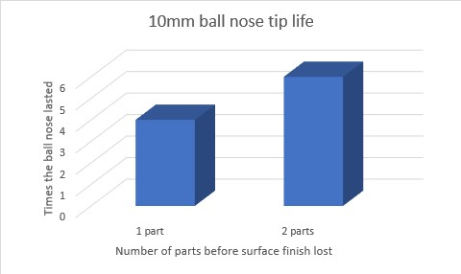

Qualitative data
Along side the quantitative data there was also qualitative this data is non numeric information this data was important to collect as it was giving insights into the experience of the operators (centre, 2023) data that was gathered by speaking to the operators and asking them what problems they encountered during the machining processes. These problems were as follows.
- During setup unable to find correct tooling in a timely manner leading to delay in setup.
- During machining feed rate needed to be turned down due to non-optimal tool holding.
- Tool degradation was increased due to non-optimal tool holding.
- Operators felt too much material was left in the forms for hardening leading to increased tool degradation.
- Material purchased for the job had excess material (too much material on stock) before beginning machining op 1 and 2.
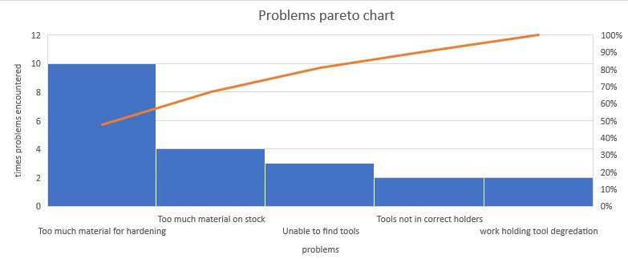

Sources of variation in measurement
The main source of variation in measurement was the recorded setup times for the operators and this was for two reasons firstly the ticket system that FSG uses only allows for the operator to book in 15minute intervals therefore if the setup took 20minutes there would either be a 5minute error if booking to 15minutes or a 10minute error if deciding to book up to 30minute setup time, Secondly due to the setup time being booked by the operator a true value would be difficult to ascertain as this time was booked by how long the operator thought he took on setup and written on a ticket rather than a digital clock in system which would give a much more accurate time. Another source of measurement variation is measuring tool life because of two main factors, when an operator checks for tool wear each operator will have a different view on when to change tips as this is mostly subjective until a tip breaks and the operator is forced to change the tip but operators will change before this as there are multiple usable edges on each tip. The same can be said for tool wear when it comes to ball nose cutters as some operators may leave the cutter wear more than others to not have to change the cutter as frequently.

Analyse
The first step of the analyse phase for the team was to conduct a 5 whys, the 5 whys is widely used for root cause analysis and is a brainstorming method where we repeatedly ask why until the source of the problem is identified (Kanbanize, 2023).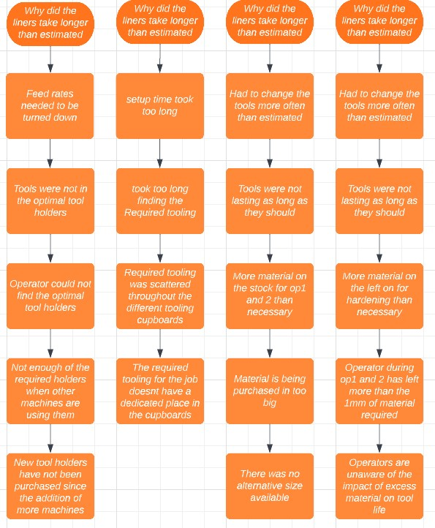
This is the 5 whys chart that the team created for the xtrutech liners for why the machining time and setup times were going over the estimated time that was created form the baseline in the measure phase. The 5 whys chart gets to the root cause of the problems that the operators were experiencing while machining the liners and shows where there are areas for improvement in the process.

Detaled process map for op1 then op2.
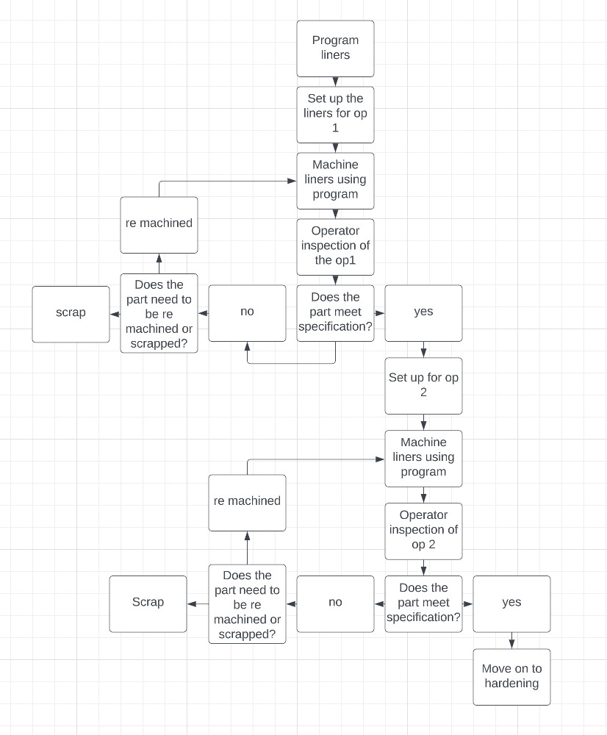

Detailed process map for op3.
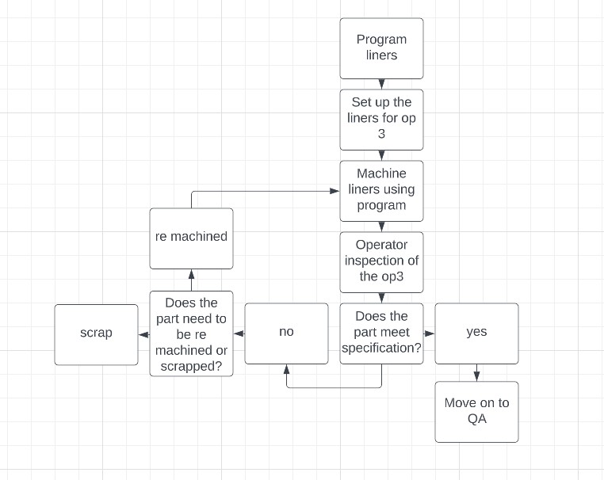
From the detailed process map the areas that are critical to quality or in this case critical areas to review for improvement will be the setup stage in op1, op2 and op 3, the machining liners phase for all ops and the operator inspection stage in op2 as these are the stages that can have the biggest impact on variation in the case of setup times this is causing different booked times from operator to operator, in the machining phase if this is not carried out correctly it could lead to the liners needing to be re machined or scrapped therefore improving this area should eliminate the need for those stages and then the operator inspection stage in op2 will need to be addressed as this is leading to more material than is required being left on the parts.

Sources of variation.
One of the problems from this process is in the first process map when inspection of the components is being undertaken there is a work culture at fsg that if you leave more material on than is necessary for hardening you are being “safe” and there is no need to re machine the component as more material is okay but as we can gather from the 5 whys that was done and from the pareto chart showing the problems that operators were encountering we can see that this is a major issue and will have to be addressed moving forward. Excess stock on the material being purchased in was also highlighted as an issue but as seen in the 5 whys exercise there is sometimes no alternative material size when purchasing this limits the options of how to address this problem as there is no way for fsg to control the maximum material size that is purchased. Setup was highlighted as a source of variation in the process looking at the graphs from the measure phase on setup times and this can be attributed to operators not being able to find the required tooling to machine the liners this is also having an adverse effect on tool life when sub optimal tool holders are being used causing even more cutter wear/degradation.

Improve

Identify and propose solutions.
The biggest obstacle to meeting or beating the estimated time for the machining of the xtrutech liners is the excess material that is on the stock before initial machining in op1 and op2 and then the excess material that is left on over the required 1mm of material that is left on to allow for bending or warping during the hardening process. This problem is causing excessive tool wear and the tools need to be changed more frequently than necessary leading to the time going over on the job, to combat this problem two solutions were put forward for trial, Firstly training the operators so that the operators will be made aware of the impact of leaving more material than necessary before the material goes for hardening on tool life on the next operation and secondly to trial new tooling one tool a moldino indexable tip tool to replace the currently used ajx for op 1 and 2, and a 10mm moldino ball nose to replace the current ball nose that is being used on op3. These new tools have more tips in the case of the moldino indexable tip tool having 5 tips instead of the ajx’s 3 and the 6 flute moldino ball nose being used over the current 2 flute ball nose. A more minor problem shown in the data from the analysis phase was that operators could not find the optimal tool holders because there were not enough on the section currently this could be improved quickly through the purchase of more tool holders that would be used for the liners and could be set aside so that operators would no longer struggle to find the tool holders or have to use less optimal tool holders.
The process for machining the liners would benefit from a 5s system being put in place for all of the tooling required, going by the tenants of 5s sort, straighten, shine, standardise and sustain all the necessary tooling should be sorted and compiled into a list this set of tooling should then be organised and stored in one location in a tooling cupboard, removing the problem of not being able to find correct tooling. After this the work area should be cleaned when the machine is running ensuring that no degraded/worn tooling are on the bench in case of confusion when replacing tools. To standardise the process the same work holding should be used every time the job is undertaken therefore new tool holders could be purchased and set aside for the liners as they are a frequent order. To sustain this change the milling section will be taken into a meeting and instructed on how the process should be carried out, 5s training would also be useful for the operators to understand the importance of the first 4 steps.

Pilot plan
The benefits of a pilot will be that lower amounts of resources will be used trialling the improvements and the team can assess the true performance of the improvements to the process before committing to purchasing new tooling, it also gives the opportunity to reverse the changes if the pilot is unsuccessful. (Hessing, 2023) For the pilot FSG wanted to simulate what the how the improvements would effect machining time and also setup times for this to take place the team set aside all the required tool holders before the beginning of the simulation and created a dedicated area in the tooling cupboard where these tools would temporarily be stored while this simulation was ongoing. Alongside this a tooling trial would be done to investigate the actual benefit of changing the ajx and ball nose cutters to the moldinos that was suggested to us, finally the program would be changed to accommodate the new tools and will also introduce a semi finishing toolpath to make sure that 1mm maximum of material was left on for after op 2 in the form and this would then be double checked by the operator, controlling these factors will be critical to tool life and eliminating variation.

Pilot data
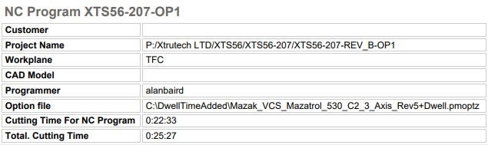

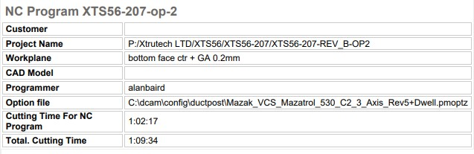
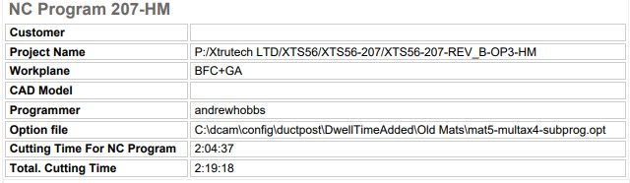
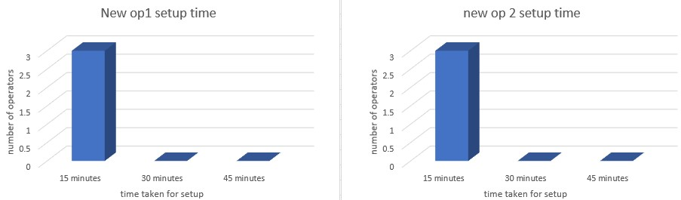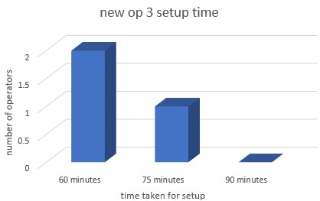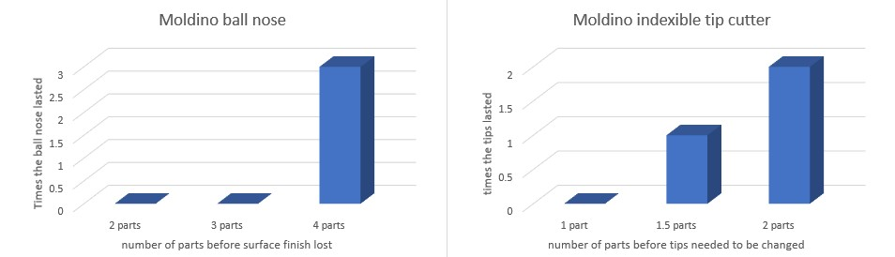
There was less data to collect for the trial because of time constrains therefore the data set is down from 10 operators to 3 but the team are confident that with the results of the trial if the improvements can be controlled they can continue to replicate these results. From the data collected during the pilot we can see that overall setup times were reduced and remain consistent at 15minutes on op 1 and 2, Setup time on op 3 was reduces down to a majority of 60minutes. Tool life was also drastically improved with the combination of new tooling and limiting the maximum material that was left on for hardening. Finally, the results of adjusting the feed rates to accommodate the new tooling can be seen in the massive reduction to overall machining time with the exception of op 2 where the semi finish toolpath was added to control the maximum material allowance for hardening. These new measures have brought the total estimated time for the process down to five and a half hours.

Cost benefit analysis
The cost for the required tool holders is £100 each and at present there would need to be an investment in four new tool holders dedicated to the xtrutech liners and the difference in price between the AJX that was previously used total tip cost £3 and the new moldino indexable tip cutter was £5 an increase in £2 per tip where the cost difference from the previous ball nose £60 to the moldino ball nose £80 is an increase in £20 per ball nose. FSG tool and die charges the customers in £60 per hour, with the time reduction in the process being 9 hours that is a cost saving to the company of £540 per part. If the initial investment was made to purchase the tool holders £400 and the switch to new tooling was also implemented even though the tools are initially more expensive the new cutters are lasting twice as long as the previous cutters meaning that the cost to manufacture 2 parts with the moldino will be a tip cost saving of £1 and the moldino ball nose will be a cost saving of £40 after 4 parts on top of the reduction in machining time this makes the investment in making the improvement worth while as FSG could also reduce the cost to the customer making the company more attractive for future work contracts while still making more profit on the liners than previously.

Control
To ensure that the operator is aware of the needs for the process going forward the method to control the improvements that have been suggested for this process the team has recommended the creation of a machining procedure booklet that would outline the new standard operating procedure that has been created from this project. This booklet would include tool overhangs, which tool holders to use, which tools to use, outline the maximum allowed material left on the components to be finished later in op3 hard machining from op 1 and 2 and where to find all the relevant tooling and holders to complete the components. It will be the duty of the milling section team leader to ensure that the tooling and tool holders required to complete the xtrutech liners are available and in the correct area of the tooling cupboard after the operators have completed their manufacturing of the components and any new tooling that needs to be ordered or tools sent out for regrinding can be done by the team leader if required after reviewing the state of the tooling area.

References
centre, u. d. (2023). Retrieved from https://ukdataservice.ac.uk/learning-hub/qualitative-data/#:~:text=Qualitative%20data%20is%20non-numeric,audio-visual%20recordings%20and%20images.
Hessing, T. (2023). six sigma study. Retrieved from https://sixsigmastudyguide.com/pilot-plan/
illinois, U. o. (2005). Retrieved from https://www.aits.uillinois.edu/UserFiles/Servers/Server_474/File/Professional_Services/BPI/BPI-DataCollectionPlan-HowToGuide.pdf
Kanbanize. (2023). Kanbanize. Retrieved from https://kanbanize.com/lean-management/improvement/5-whys-analysis-tool
story, f. (2023). full story. Retrieved from https://www.fullstory.com/quantitative-data/#:~:text=Quantitative%20data%20is%20data%20that,are%20examples%20of%20quantitative%20data.

