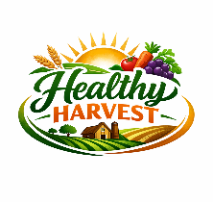

BUSINESS & WEB MANAGEMENT
Website Redesign for Online Business Presence




Module Name: BUSINESS & WEB MANAGEMENT
Module Code: ACCA 5019

Student Name: Beda Clement NDEPO
Student ID: 2411399

Lecturer’s Name: SUNETH FERNANDO

24/07/2026

Table of Contents
TASK1. UI/UX Web Design Phases 2
URL from Figma 2
TASK2. REPORT 2
I. INTRODUCTION 2
II. HEALTHYHARVEST WEBSITE REDESIGN 2
1 Navigation & Information Architecture Issues Problems 2
2 Outdated Visual Design 3
3 Limited Product Information 3
4 Weak Credibility Signals and Social Proof 3
5 Lack of Personalisation 4
III. RESPONSIVE DESIGN IMPLEMENTATION 4
1 Enhances navigation, readability, speed, and accessibility across devices 4
2 Reduces friction and improves overall usability for mobile shoppers 5
3 Strengthens user trust through consistent, reliable mobile interactions 5
4 Increases product discovery by making content easier to browse on small screens 5
5 Directly boosts mobile conversions and sales 5
6 Supports long-term competitiveness as mobile commerce continues to dominate 6
IV. IMPLEMENTATION SECTION 6
A. Mood Board of Healthy Harvest 6
B. Wireframe of Healthy Harvest 7
C. Influences of Mood Board and Wireframe on a design. 7
V. CONCLUSION 7
References 8

TASK1. UI/UX Web Design Phases

URL from Figma
https://www.figma.com/design/uiO7VWttdyVr086mnTy3iu/Untitled?node-id=0-1&t=Ym6OP7gp9s7FKTzZ-1

TASK2. REPORT

INTRODUCTION
Healthy Harvest is an organic grocery business that needs a clearer, more modern, and easier-to-use website. The current site has confusing navigation, outdated design, weak mobile performance, limited product details, poor trust signals, and a slow checkout, all of which reduce satisfaction and make purchasing or subscribing harder.
This project focuses on redesigning the UI/UX using professional tools rather than building the site. It involves creating mood boards, structuring the information architecture, designing wireframes, producing high-fidelity screens, and developing an interactive prototype. An academic report will justify these design decisions clearly and concisely.

HEALTHYHARVEST WEBSITE REDESIGN

Navigation & Information Architecture Issues Problems
Healthy Harvest’s website shows several core usability issues that limit its ability to meet customer expectations and support growth. Navigation is unclear, the design is outdated, mobile responsiveness is inconsistent, product information is minimal, trust signals are weak, and checkout is inefficient. These problems reduce satisfaction, hinder product discovery, and lower conversions and subscription sign-ups. Poor labelling and unclear pathways further reduce users’ ability to find information, weakening overall experience quality [1].

Healthy Harvest Website Problems
- The navigation bar lacks visual hierarchy, with every link styled identically, making it difficult for users to identify primary actions or know where to begin.

- Key actions like Shop or Subscribe are not visually emphasised, making them easy to overlook.
- Repeated testimonial sections create an unnecessarily long and confusing scroll path.
- Product categories like olive oils, skincare, pantry, and wellness aren’t clearly grouped, making browsing feel fragmented.

Solutions
Introduce a clear hierarchy by emphasising primary actions like Shop and Subscribe, add dropdown menus to group categories (Olive Oils, Pantry, Skincare, Wellness), use sticky navigation across devices, and remove repeated content while restructuring pages into shorter, scannable sections.

Outdated Visual Design
Outdated design signals a mismatch between current user expectations and modern technological capabilities. Research shows search must fit within broader user workflows, meaning visual design should evolve toward unified, consistent digital environments rather than isolated search interfaces [2].
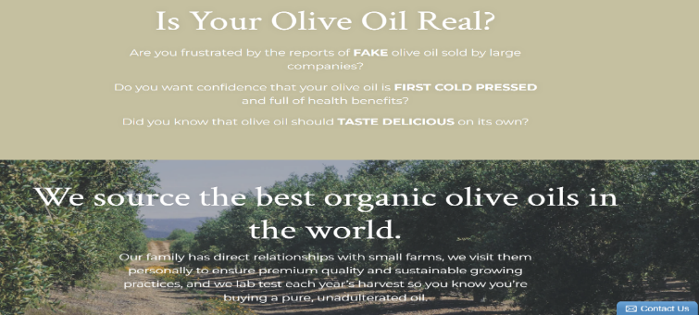

Healthy Harvest Website Problems
- Heavy text blocks lack visual breaks
- Images vary in size and alignment
- Testimonials appear as a long repetitive list that weakens credibility
- The overall visual style doesn’t fully convey the brand’s organic, sustainable identity.
Solutions
Adopt a modern organic aesthetic with earthy colours, clean typography, and spacious layouts; apply consistent image ratios and a unified photography style; replace long testimonial lists with a small, curated carousel; and add brand-story visuals such as farm photography, sourcing icons, and sustainability badges.

Limited Product Information
Limited product information mainly stems from gaps in completeness, accuracy, and clarity within product labels and leaflets, which directly affects medication safety and informed healthcare decision-making [3].
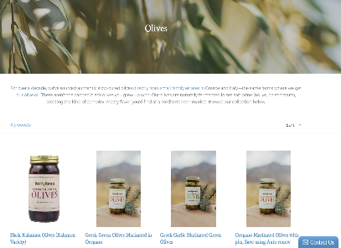
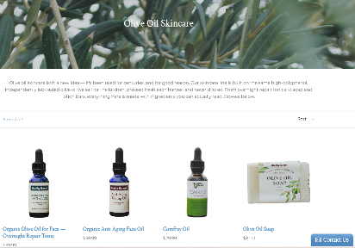
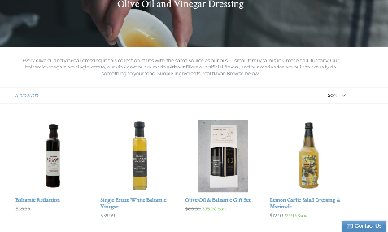

Healthy Harvest Website Problems
- Product pages provide minimal detail, lacking thorough descriptions, ingredient sourcing information, and practical usage guidance.
- There’s no clear explanation of what makes Healthy Harvest oils superior beyond broad claims.
- The site offers no nutritional or lab-test transparency.

Solutions
- Add richer product pages featuring
- ingredient sourcing maps
- harvest year and farm details, lab-test results
- usage suggestions and recipes
- clear polyphenol and health benefit information and include comparison charts such as Tuscan vs. Greek oils.

Weak Credibility Signals and Social Proof
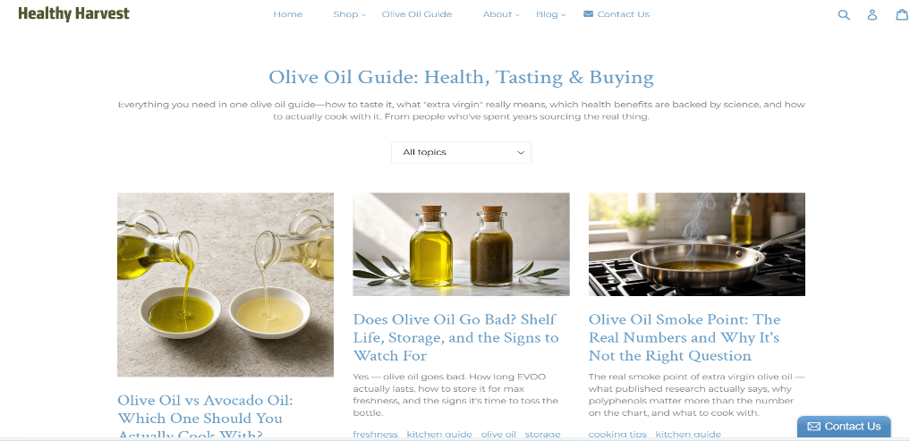

Weak credibility signals arise when trust indicators are vague, easily copied, or lack verification. Because unreliable retailers can imitate them without providing real quality or service, users question their authenticity. This lowers confidence during pre-purchase evaluation and increases the likelihood of complaints [4].

Healthy Harvest Website Problems

- Testimonials are long, repetitive, and unverified, reducing credibility.
- No customer ratings, product reviews, certification badges, or sustainability indicators.
- Limited transparency about ingredient sourcing, farming practices, and quality assurance.

Proposed Improvements

- Introduce verified customer reviews with star-rating metrics on each product page.
- Present testimonials in a short, curated carousel format.
- Display trust badges (organic certification, lab-testing, sustainability icons).
- Provide clear sourcing information, such as farm profiles or ingredient origin maps.
- Strengthen transparency to support higher conversions and subscription engagement.

- Lack of Personalisation
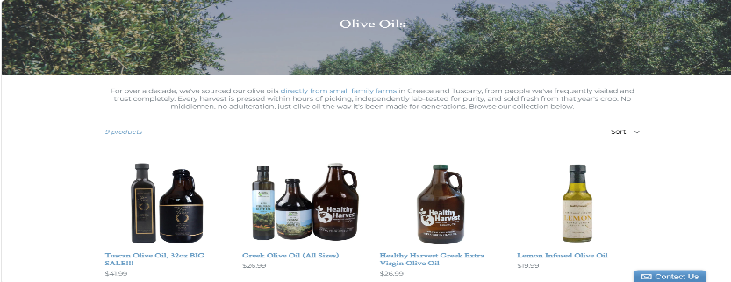

Personalisation issues reduce clarity and engagement by forcing users to sift through generic, non-relevant content. Without tailored recommendations or context-aware information, users face higher cognitive load, lower satisfaction, and weaker interaction with the site [5].

Healthy Harvest Website Problems

Healthy Harvest shows identical products and homepage content to all users, with no tailored suggestions, recently viewed items, or personalised bundles. This forces visitors to browse broad categories manually, increasing cognitive load and reducing engagement.

Solutions
- Add recommendation modules based on browsing or purchase history.
- Include bundles (e.g., “Starter Olive Oil Pack”, “Wellness Essentials”).
- Use dynamic homepage content for returning users.

Improving Healthy Harvest’s experience requires clearer navigation, a modern visual design, richer product information, stronger trust signals, and personalised content. Key actions include restructuring menus, updating the visual layout, expanding product details, adding credibility elements like reviews and certifications, and introducing personalised recommendations to create a smoother, more trustworthy mobile and desktop journey.

RESPONSIVE DESIGN IMPLEMENTATION
Responsive design boosts e-commerce performance by improving navigation, readability, speed, and accessibility across devices. By adapting smoothly to different screen sizes, it ensures consistent, easy-to-use interfaces that maintain engagement and reduce friction throughout the mobile shopping journey [6].

1 Enhances navigation, readability, speed, and accessibility across devices
Accessibility challenges for blind users affect navigation and usability in content-creation environments. Research on WordPress shows that block-based and drag-and-drop interfaces create major barriers for screen-reader users, disrupting consistent navigation and content management. AI-generated image descriptions can reduce reliance on sighted assistance, but automated tools often miss real-world obstacles, highlighting the need for more inclusive design and stronger navigation support [7].
Enhancing navigation, readability, speed, and accessibility across devices will significantly improve the Healthy Harvest website by making content easier to locate, reducing cognitive load, improving performance, and ensuring a consistent user experience for all users, including those on mobile or with accessibility needs.

2 Reduces friction and improves overall usability for mobile shoppers
Reducing friction for mobile shoppers requires identifying usability problems, optimising interface design, and validating changes through high-fidelity prototype testing. These steps create a smoother, more efficient mobile shopping experience, especially where mobile interaction is central [8].

Reduces mobile friction and enhances overall usability on Healthy Harvest Website by streamlining navigation, product discovery, and checkout on small screens.

3 Strengthens user trust through consistent, reliable mobile interactions
Managing perceived privacy, security, financial, and transaction-processing risks is crucial for maintaining user trust. These risks reduce users’ willingness to continue using mobile services. Strengthening data protection, ensuring transparent policies, securing transactions, and providing reliable, error-free payments lowers perceived risk and supports trustworthy mobile use [9].
Strengthening user trust on the Healthy Harvest website requires delivering consistent, reliable mobile interactions that make browsing, selecting products, and completing purchases feel seamless across all devices.

4 Increases product discovery by making content easier to browse on small screens
Improving product discovery on small screens requires a more efficient interface that makes browsing easier. Research shows layout style and display mode shape how users locate and interpret product information: women tend to prefer list layouts, men favour matrix layouts, and matrix designs perform better in dark mode while lists suit light mode. Adapting layout and display mode to user preferences reduces cognitive load and strengthens product discovery on mobile [10].
Improving content browsing on small screens increases product discovery on the Healthy Harvest website by making items easier to view, navigate, and compare on mobile devices.

5 Directly boosts mobile conversions and sales
Mobile advertising that uses geolocation data increases customer engagement and coupon redemption, leading to higher mobile sales. Geolocated coupons boost behavioural intention by targeting users based on their location, improving redemption rates and overall conversion performance [11].
Directly boosting mobile conversions and sales on the Healthy Harvest website requires a smoother mobile journey, where users can quickly find products, navigate the interface, and complete purchases without friction.

6 Supports long-term competitiveness as mobile commerce continues to dominate
Sustaining long-term competitiveness in mobile commerce requires more than adapting existing online services. Successful companies treat mobile-commerce as a distinct market with its own technologies, behaviours, and strategic demands [12].
Supports long-term competitiveness for Healthy Harvest by ensuring its mobile experience remains fast, intuitive, and aligned with evolving m-commerce expectations.

IMPLEMENTATION SECTION

Mood Board of Healthy Harvest
A mood board is a compact visual collection of images, colours, and materials that inspires designers and communicates a project’s intended style. It acts as a visual guide, helping clarify ideas and align stakeholders on the creative direction [13].
A mood board is a visual guide that defines Healthy Harvest’s look and feel. It combines colours, textures, imagery, and typography to set a natural, fresh, premium, wellness-focused tone and keep the design consistent.
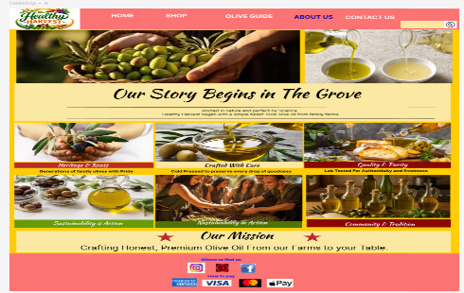
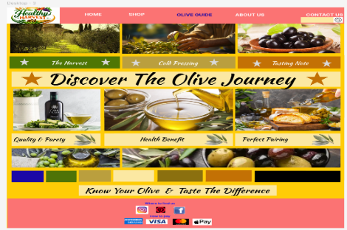
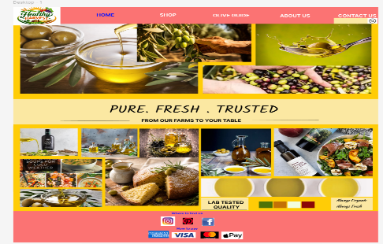

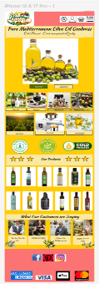
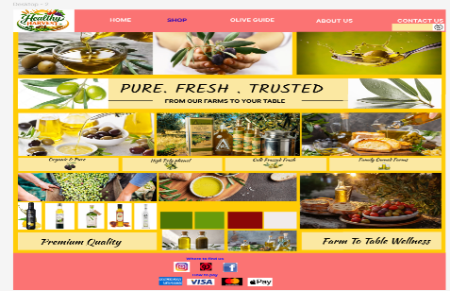
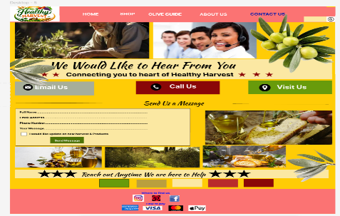

Wireframe of Healthy Harvest
Wireframes can be physical or digital. Physical models help teams visualise and discuss designs more easily. Their effectiveness depends on team experience, clear project goals, and selecting the right tools for each stage [14].
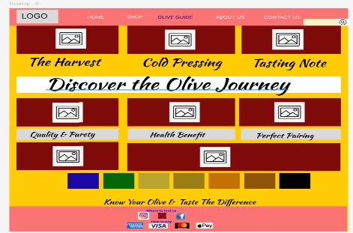
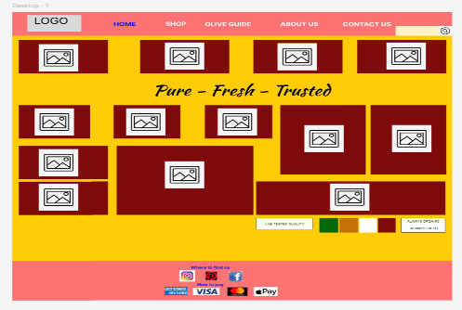
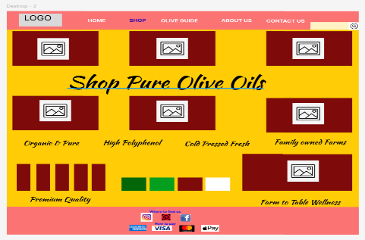
A wireframe is a simple visual blueprint of the Healthy Harvest site, outlining page structure, navigation, and key interactions before any final styling. It shows how users browse products, find information, and complete purchases.

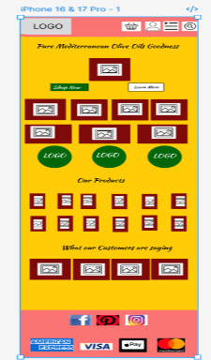
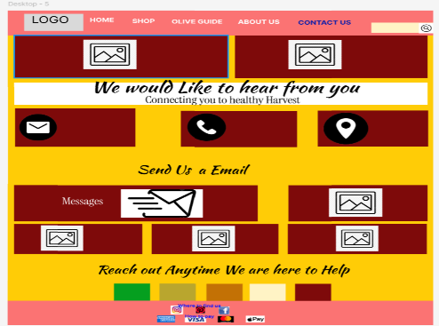
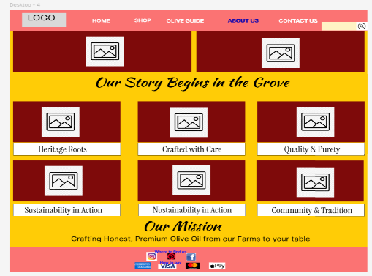

Influences of Mood Board and Wireframe on a design.
Mood boards set Healthy Harvest’s visual identity by defining colours, imagery, textures, and typography, establishing a natural, fresh, premium wellness tone that ensures aesthetic consistency. Wireframes define the site’s structural logic by mapping layout, navigation, and user flow, revealing how users browse and complete purchases. Together, they align visual direction with functional clarity, supporting early usability evaluation and coherent design development.

CONCLUSION
Healthy Harvest needs a targeted redesign to fix key usability, visual, and functional issues that reduce customer satisfaction and performance. A structured UI/UX process; from mood boards to wireframes and a final prototype creates a clear path to improving navigation, modernising the visual identity, strengthening mobile use, enriching product information, boosting trust signals, and adding personalisation. This ensures the final design reflects the brand’s sustainable values while supporting higher conversions, more subscription sign-ups, and stronger long-term engagement.

References

[1] | P. V. Schaik, R. H. Muzahir and M. Lockyer, “Automated Computational Cognitive-Modeling: Goal-Specific Analysis for Large Websites,” ACM transactions on computer-human interaction, vol. 22 , no. 3, pp. 1-29, 2015.
[2] | J. Gerken, M. Heilig, H.-C. Jetter, S. Rexhausen, M. Demarmels, W. A. König and H. Reiterer, “Lessons learned from the design and evaluation of visual information-seeking systems,” International journal on digital libraries, vol. 10, no. (2-3), pp. 49-66, 2009.
[3] | B. Knight and D. Mitrofanov, “Disclosing Low Product Availability: An Online Platform’s Strategy for Mitigating Stockout Risk,” Management science, vol. 72 , no. (2), pp. 1560-1578, 2026.
[4] | M. Hu, E. Rabinovich and H. Hou, “CUSTOMERS COMPLAINTS IN ONLINE SHOPPING: THE ROLE OF SIGNAL CREDIBILITY,” Journal of electronic commerce research, vol. 16 , no. (2), pp. 95-108, 2015.
[5] | D. Desai, “Website Personalization: Strategy for User Experience Design & Development,” Turkish journal of computer and mathematics education, vol. 12, no. (12), pp. 3516-3523, 2021.
[6] | F. Hussain, Responsive web design by example: embrace responsive design with HTML5, CSS3, JavaScript, jQuery, and Bootstrap 4, Birmingham: PACKT Publishing, 2017.
[7] | G. Vera-Amaro and J. R. Rojano-Caceres, “Accessibility Challenges for Blind Users Authoring in Content Management Systems: An Empirical Study,” IEEE-RITA, vol. 21, pp. 268-278, 2026.
[8] | W. Zhang, C. Zhou, M. Yu, T. Huang and J. Kaner, “Interface design for the mobile terminal for furniture shopping in the post-epidemic era: An empirical evidence of user demand collection,” Bioresources, vol. 18 , no. (3), pp. 5750-5764, 2023.
[9] | N. Zahira and R. G. Utomo, “Influencing Factor for Mobile Shopping Continued Usage Intention: A Trust-Risk-Relationship,” in 2025 International Conference on Data Science and Its Applications (ICoDSA), 2025 .
[10] | C.-H. Chen and W. Zhai, “The Effects of Information Layout, Display Mode, and Gender Difference on the User Interface Design of Mobile Shopping Applications,” IEEE access, vol. 11, pp. 47024-47039, 2023.
[11] | I. Khelladi, S. Castellano, V. Dutot, J.-M. Lehu and R. C. Haeb, “The Influence of Geolocated Mobile Coupons on Customer Behavior,” International journal of technology and human interaction, vol. 17, no. (2), pp. 23-39, 2021.
[12] | N. Nohria and M. Leestma, “A Moving Target: The Mobile-Commerce Customer,” MIT Sloan management review, vol. 42 , no. (3), p. 104, 2001.
[13] | D. Mcdonagh and I. Storer, “Mood Boards as a Design Catalyst and Resource: Researching an Under-Researched Area,” The Design journal, vol. 11, no. (3), pp. 16-31, 2004.
[14] | S. Sutipitakwong and P. Jamsri, “Pros and Cons of Tangible and Digital Wireframes,” in Proceedings - Frontiers in Education Conference, 2020.

