DS 1 Template

My Screenshots/Photos
- Please add 4–6 screenshots or photos of your digital life.
- You can use your phone or laptop.
- For each screenshot, write one or two sentences explaining what it shows.

Screenshot/Photo 1
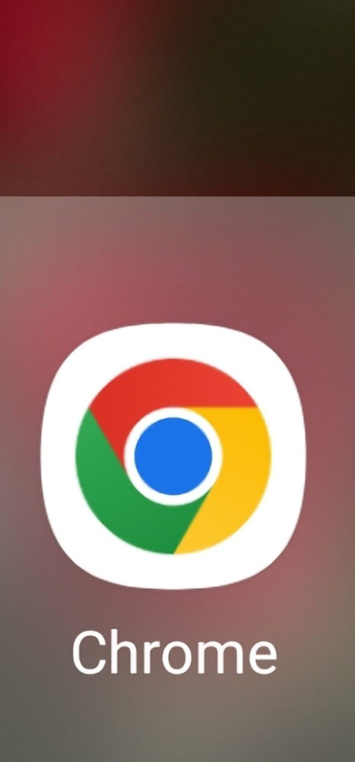
I use google Chrome to search for information

Screenshot/Photo 2
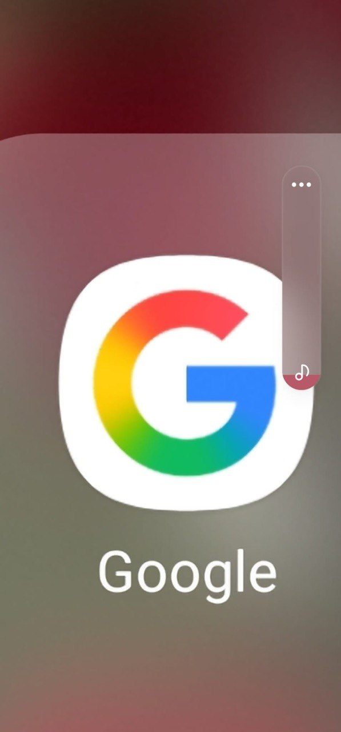
Google helps me to check news.

Screenshot/Photo 3
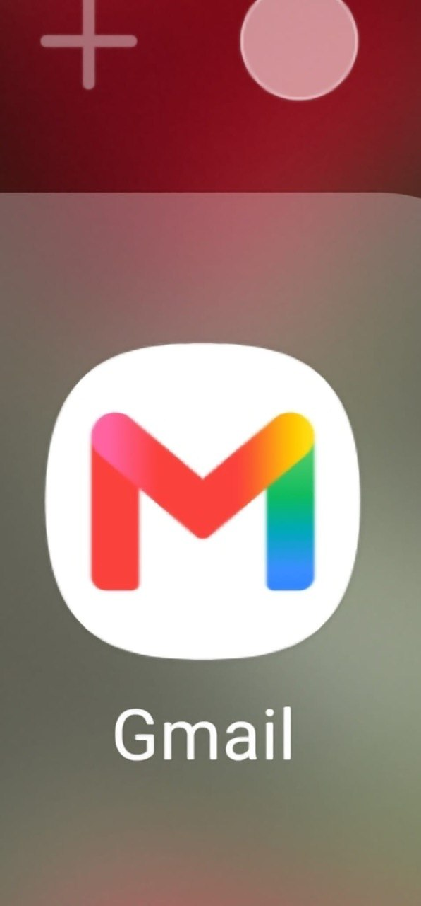
I use it do read and send emil.

Screenshot/Photo 4
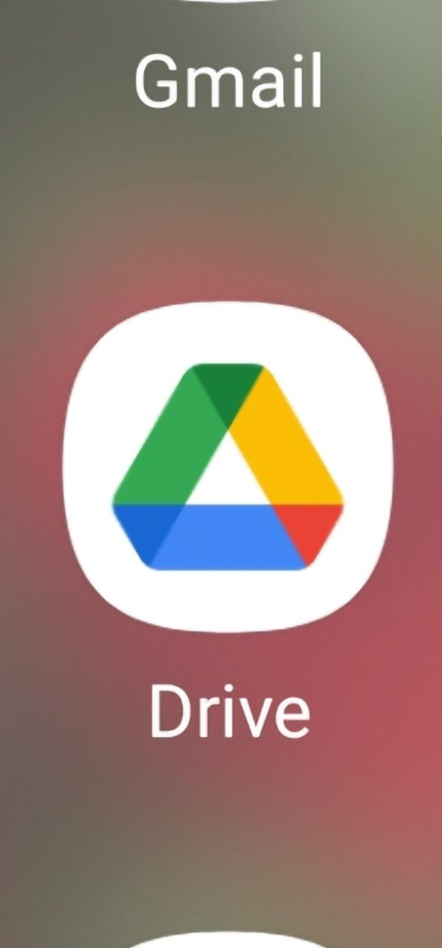
I use to save my documents.

Screenshot/Photo 5
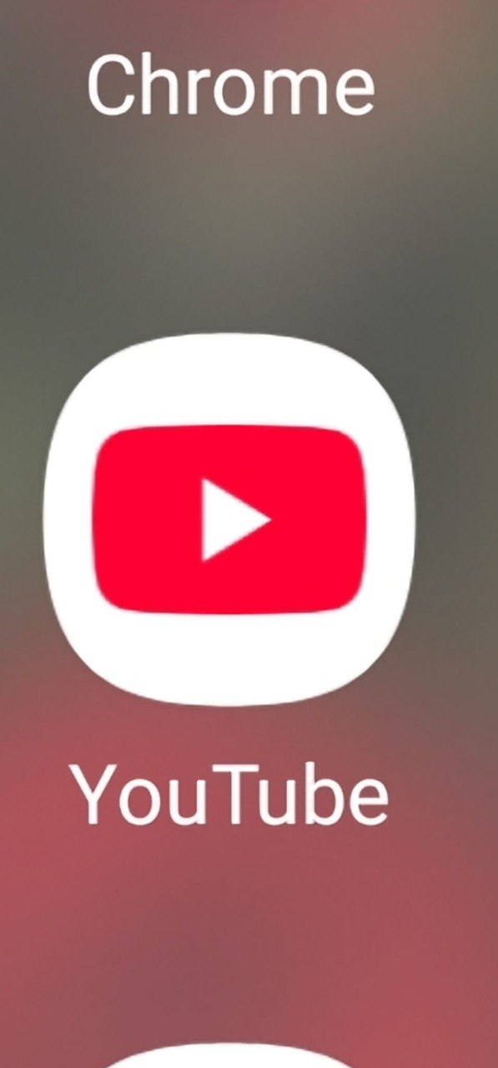
I use it to listen music.

Screenshot/Photo 6
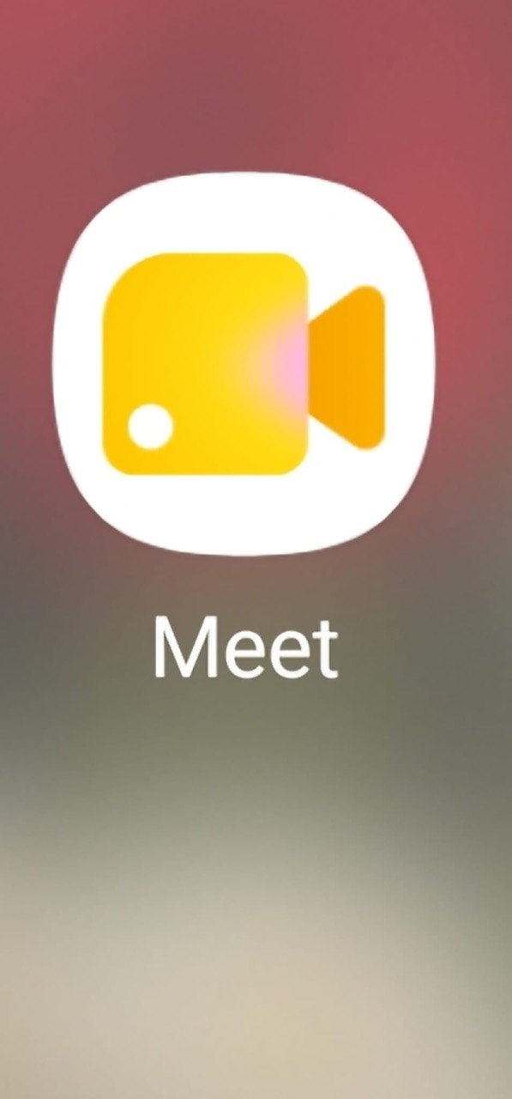
I use that tool to do meetings.

My Short Reflection
- Write 5–8 simple sentences about your digital life.
- You can use the sentence starters below if helpful.
I use digital tools to manage my life.
I feel confident when I use it.
I want to improve my skills with digitals.
I often use these tools make my day easy.
I sometimes feel nervous about my digital skills.
I hope this module will help me to improve my skills.
Digital skills are important for me because I can do better.

Submission Checklist
Before you submit, please check:
​​​ ☐ I added 4–6 screenshots
☐ I wrote short sentences for each screenshot
☐ I wrote my short reflection
☐ My work is my own
☐ My file opens correctly
​​☐ My file opens correctly

