DS 1 Template

My Screenshots/Photos
- Please add 4–6 screenshots or photos of your digital life.
- You can use your phone or laptop.
- For each screenshot, write one or two sentences explaining what it shows.

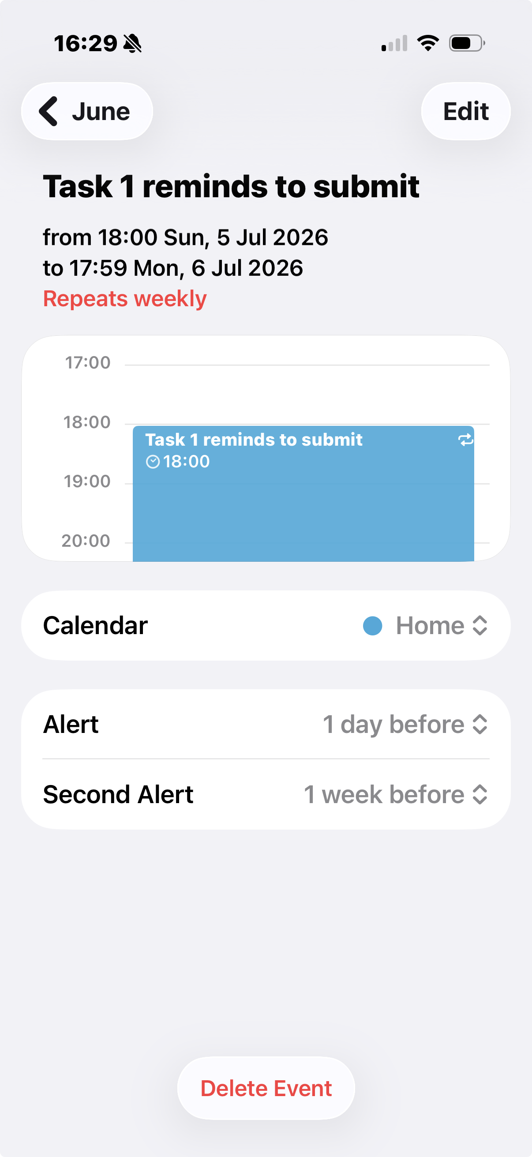
This screenshot shows how my digital life is organised around reminders and deadlines.

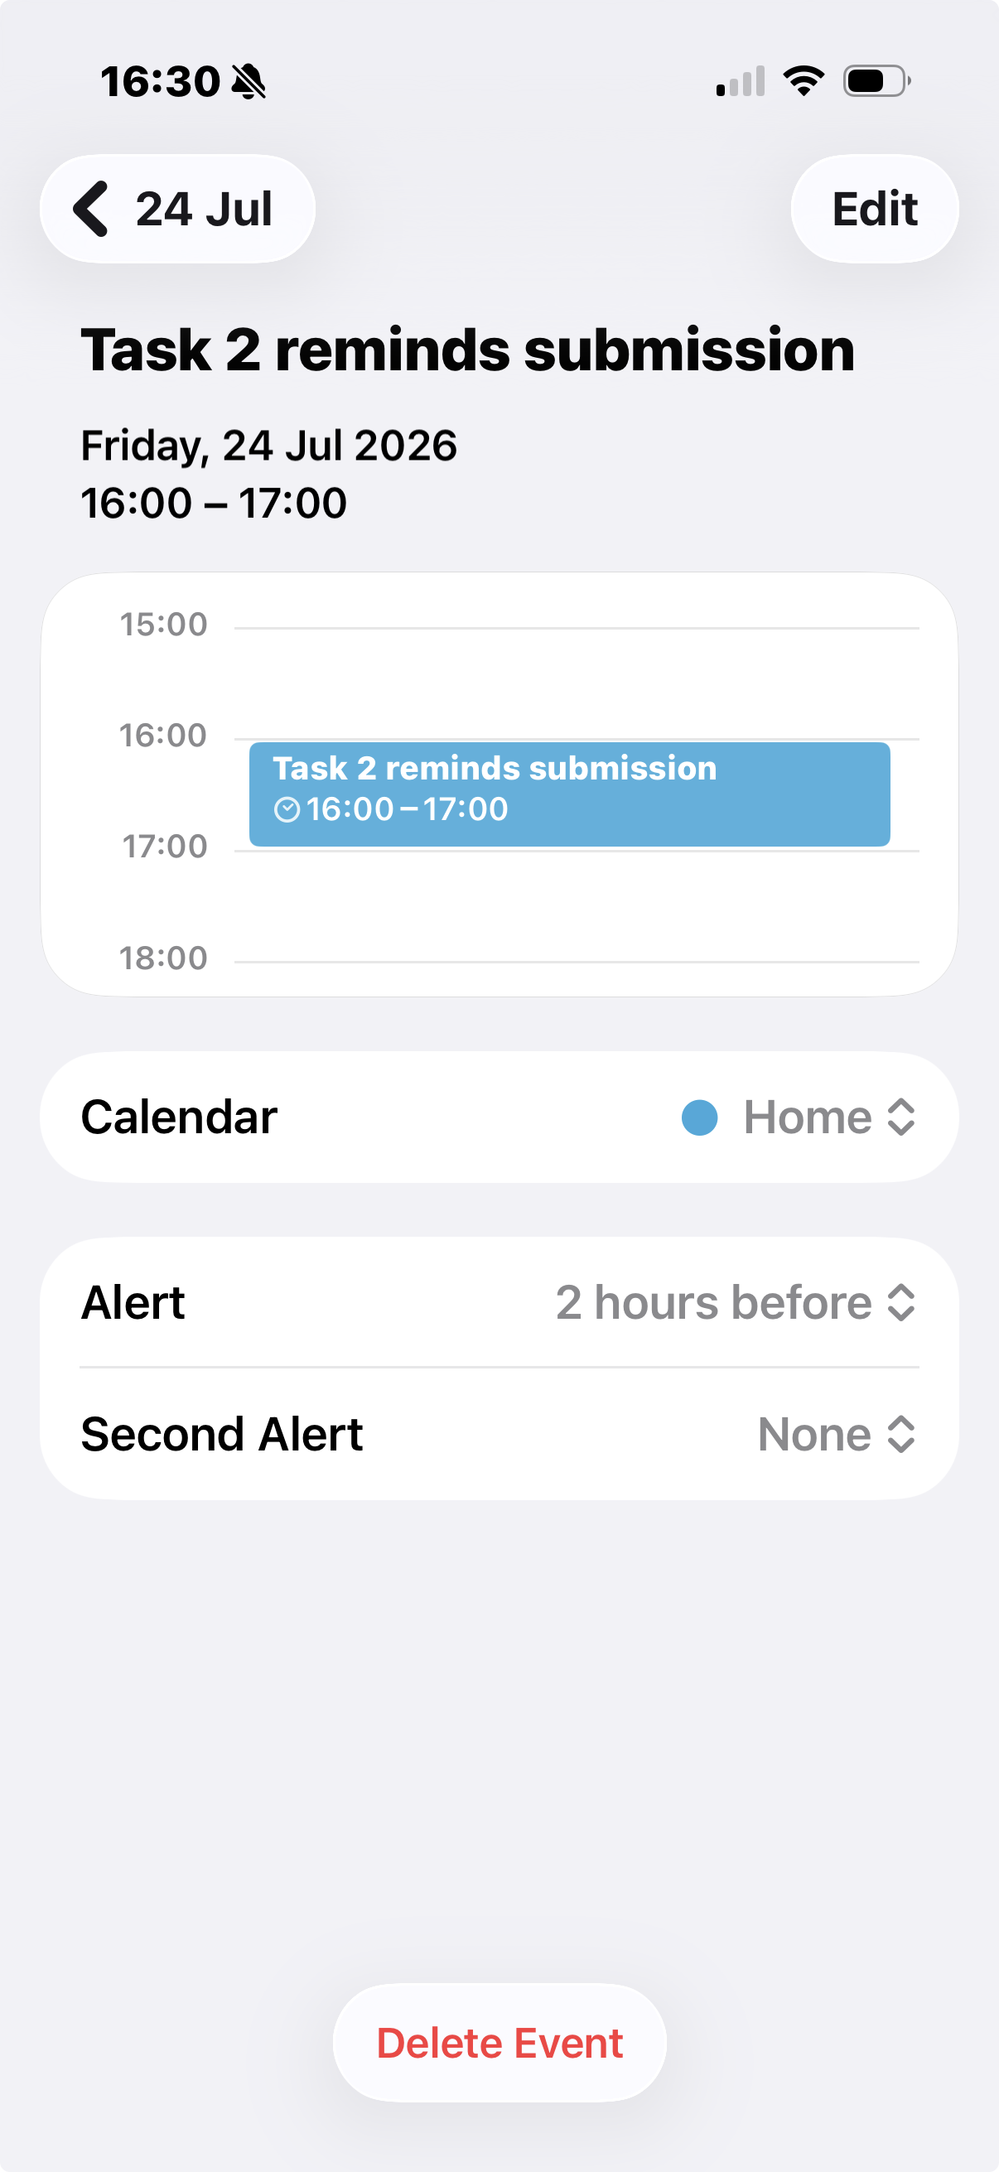
I use my phone’s calendar to schedule tasks and make sure I do not forget important work.

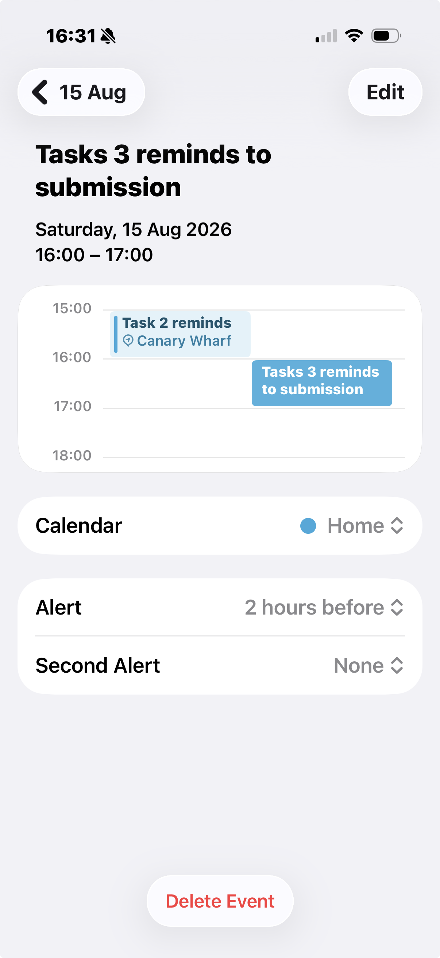
The event is set with a reminder two hour before showing that I rely on digital notifications to help me manage my time and prepare in advance

Screenshot/Photo 4
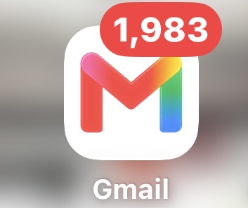
This shows that Gmail is an important part of my digital life for receiving university updates account notification and messages.
It also shows that I have a lot of unread emails because I don’t check them often.

My Short Reflection
- Write 5–8 simple sentences about your digital life.
- You can use the sentence starters below if helpful.
This shows how i use digital tools to complete my university work communicate with others and find information online.
I feel confident when I use apps like Gmail ,Microsoft teams ,and Google docs.
I want to improve my digital skills especially organising my files and using new software.
I often use these tools Gmail , YouTube , Google , and Microsoft word.
I sometimes feel nervous about online scams and keeping my personal information safe.
I hope this module will help me learn more about using technology safely and effectively .
Digital skills are important for me because they help me study ,ommunicate ,and prepare for future jobs.

Submission Checklist
Before you submit, please check:
​​​ ☒ I added 4–6 screenshots
☒ I wrote short sentences for each screenshot
☒ I wrote my short reflection
☒ My work is my own
☒ My file opens correctly
​​☒ My file opens correctly

