

BA (Hons) Business Management
Student Name: Stoican Elena Georgiana
Student Number: 2235647
Course Name: LCBB5014 - Data Handling & Business Intelligence
Session: October 2025 Term

Contents
Introduction 3
Data Cleaning and Preparation 3
Descriptive Statistics and Summary 4
Trend Analysis and Visualization 6
Statistical Analysis using SPSS 8
Independent-Samples T-Test 8
Correlation Analysis 9
Regression Analysis 10
Insights and Recommendations 12
References 14

Introduction
The growing availability of digital cinema data has changed the way media companies look at how well content performs and how people act. This paper looks at a big set of movie data to find trends in how people rate and connect with movies and to find the things that make a movie seem successful. The dataset has information on 10,000 films, such as their average rating, runtime, genre, original language, number of views, likes, and fans. These factors give us numbers that show both how people interact with each other and how they rate things, which makes them very useful for business intelligence in the film and entertainment industry.
We used both Microsoft Excel and IBM SPSS Statistics to do a dual-method analysis that met the goals of the research. Excel was used to clean up the data, look at it for the first time, and make visual trend analyses. SPSS was used to do inferential statistical tests, such as hypothesis testing, correlation analysis, and regression modelling. Integrating exploratory and inferential methodologies facilitates both pattern recognition and statistical validation, hence enhancing the dependability of conclusions derived from the data (Bryman and Cramer, 2011).
The report has three main goals: first, to prepare and standardise the dataset to make sure the analysis is correct; second, to describe important trends and characteristics in ratings and engagement; and third, to see if things like language, runtime, and engagement metrics have a big effect on film ratings. Accomplishing these goals facilitates evidence-based decision-making about content strategy, audience targeting, and performance assessment within the digital film industry (Foster et al., 2011).

Data Cleaning and Preparation
Microsoft Excel was used to clean and prepare the data to make sure it was consistent, reliable, and ready for statistical analysis. An first check of the dataset found that various numerical variables, such as average rating, runtime, watches, likes, and fans, were missing values. When there weren't many missing data and they were related to engagement measures, median imputation was used to lessen the effect of extreme observations. We took out entries with inadequate categorical data that couldn't be rationally deduced so that we wouldn't introduce classification bias (Osborne, 2013).
It was necessary to standardise categorical variables like Genres and Original Language because there were differences in spelling, formatting, and capitalisation. To make sure that the groups were correct throughout analysis, duplicate category labels (such "ENGLISH" and "English") were combined. We reviewed the layout of numerical fields for problems including text-based numbers and decimal precision that wasn't consistent. Then we changed them into standard numeric formats so that SPSS could read them.
Renaming variables for clarity and looking for extreme outliers were other phases in the preparation process. Instead of instantly getting rid of all outliers, extreme values were looked at to see if they were real high-engagement films. In business intelligence, these procedures are very important because bad or badly organised data can lead to wrong conclusions and bad strategic decisions (Foster et al., 2011). The cleaned dataset served as a solid basis for future descriptive, trend, and inferential analysis.

Descriptive Statistics and Summary
SPSS Statistics was used for descriptive statistical analysis in order to summarise the dataset's main features. This analytical phase offers a summary of central tendencies, variability, and distribution patterns, which is crucial for comprehending audience behaviour before hypothesis testing (Bryman and Cramer, 2011). The investigation concentrated on numerical data—mean rating, duration, views, likes, and followers—alongside categorical characteristics including original language.
According to the findings, average movie ratings show significant variety but are generally positive. A majority of films tend to receive average ratings, while a lesser number attain either very high or poor scores, indicating variations in perceived quality and audience expectations. The runtime exhibits considerable variation, including both short films and lengthy feature projects, while the average runtime generally adheres to industry standards.
The distributions of engagement variables, such as fans, likes, and watches, are extremely skewed. A limited handful of films garner exceptionally high engagement, whilst the bulk draw comparatively moderate attention. This phenomenon is typical of digital cultural industries, where audience attention is disproportionately allocated and success is confined to a select few titles (Webster, 2014).
In addition to the numerical results, visual summaries are provided. Boxplots of average ratings illustrate the distribution of ratings and the existence of outliers, whilst frequency tables verify that English-language films predominate the dataset quantitatively. Nonetheless, non-English films, despite their limited quantity, have robust performance in ratings. The descriptive study indicates significant discrepancies between popularity and perceived quality, highlighting the necessity of evaluating both engagement volume and assessment metrics in analysing film performance.
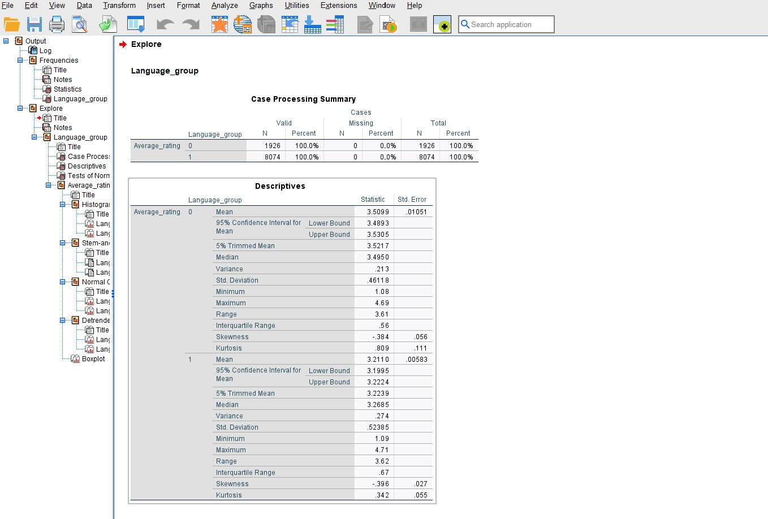
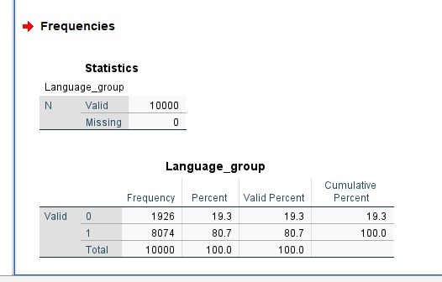
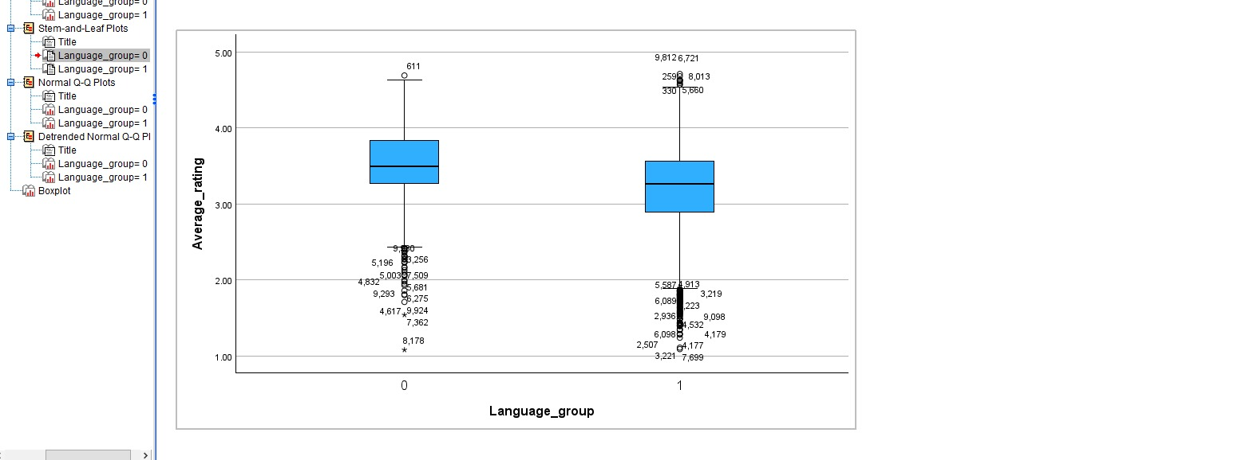

Trend Analysis and Visualization
Microsoft Excel was used to conduct trend analysis to investigate how ratings and engagement change across key variables. Visualisation is an important aspect of business intelligence because it allows patterns and linkages to be identified more naturally than numerical tables alone (Knaflic, 2020).
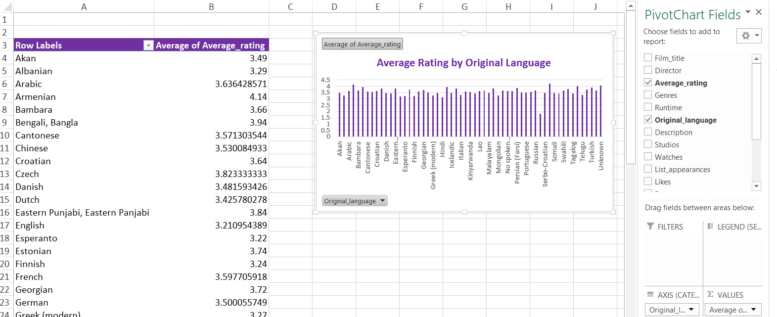
A comparison of average ratings by originating language demonstrates significant diversity among language groupings. Several non-English films receive average ratings comparable to or greater than English-language films. This implies that audience appraisal is not simply based on linguistic accessibility, and that foreign-language films may benefit from more niche appeal or cultural significance. This underlines the potential for international films to increase catalogue diversity and perceived quality on content platforms.
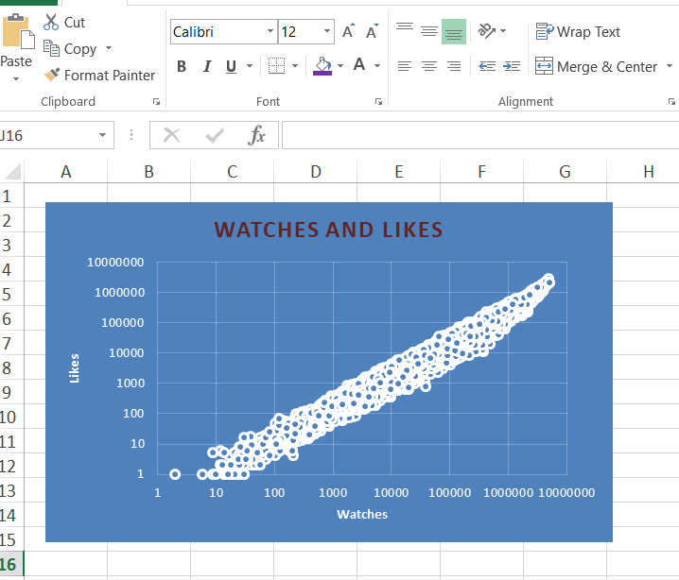
A scatter plot of watches and likes reveals a substantial positive correlation between the two variables. Films with greater viewing counts also garner more likes, demonstrating that exposure is a key factor in driving audience engagement. However, the distribution shows a concentration of films with poor interaction and a small number of extremely successful movies, indicating fierce rivalry for attention in digital contexts (Napoli, 2011).
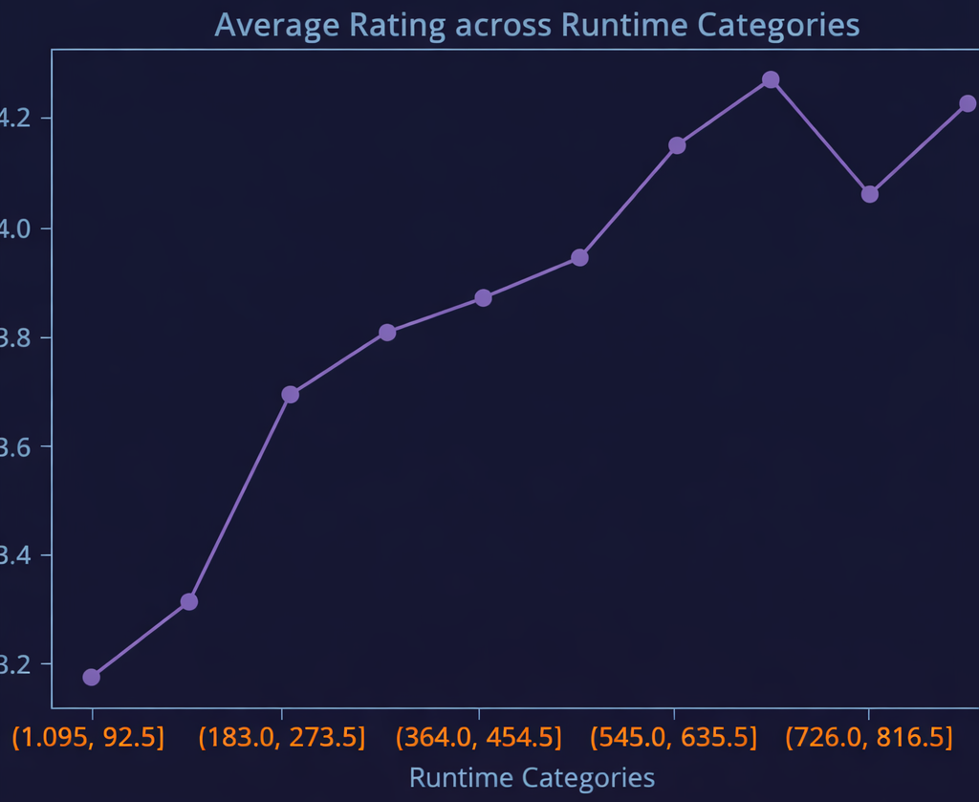
Trend analysis across runtime categories reveals that ratings improve as films progress from extremely short to moderate runtimes, but the pattern becomes erratic at longer lengths. This implies that, while lengthier films may allow for more narrative development, they do not necessarily result in higher scores. Runtime appears to interact with material quality and genre rather than acting as a standalone driver of audience approval.
Overall, these trends suggest that language and engagement indicators have a greater impact on ratings than runtime alone. Visual analysis thus gives useful context for evaluating statistics results and making strategic decisions about content promotion and positioning.

Statistical Analysis using SPSS
SPSS Statistics was used for inferential statistical analysis to see if the patterns in the dataset were statistically significant and to find the main factors that affect film ratings and audience engagement. There were three main methods used in the analysis: an independent-samples t-test, correlation analysis, and multiple regression analysis. These methods let you compare groups, look at how variables are related, and see how well the dataset predicts things (Field, 2018).

Independent-Samples T-Test
The study employed the independent-samples t-test to ascertain whether the average evaluations of English-language and non-English-language films differ significantly. The results show that there is a statistically significant difference (p < .001) between the two groups. Non-English films got a higher mean rating than English-language films. In the context of the dataset, this indicates that language correlates with audience film evaluations. Most of the content provided is in English, however non-English films seem to draw in viewers who are more critically engaged or who are interested in cultural and artistic value. This research undermines the idea that English-language dominance in the mainstream leads to higher perceived quality. It also shows how important it is for digital cinema libraries to have foreign content (Peterson and Anand, 2004).
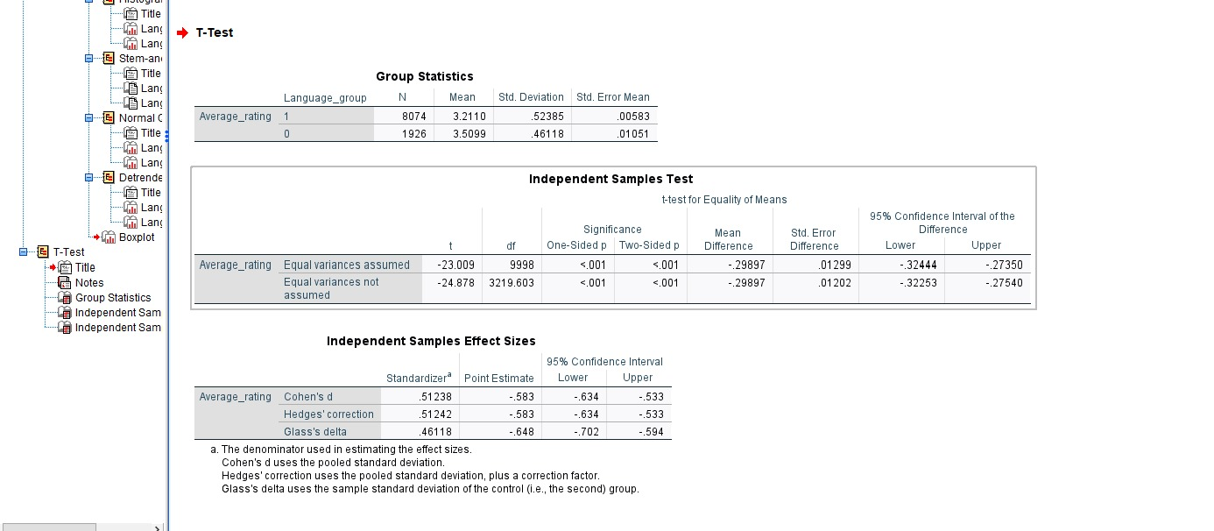

Correlation Analysis
A correlation study was performed to investigate the links among significant engagement and structural variables, such as views, likes, fans, and runtime. There was a very strong positive link between watches and likes. This means that films that are watched more often are far more likely to get likes. This association shows that exposure is a key factor in getting people to interact with and approve of something. On the other hand, the association between length and fans was positive but small. This means that longer films may draw in viewers who are more dedicated, but runtime alone does not have a strong effect on involvement. These results show that behavioural engagement measurements are much more important than structural factors like length (Hennig-Thurau, Marchand and Marx, 2012).
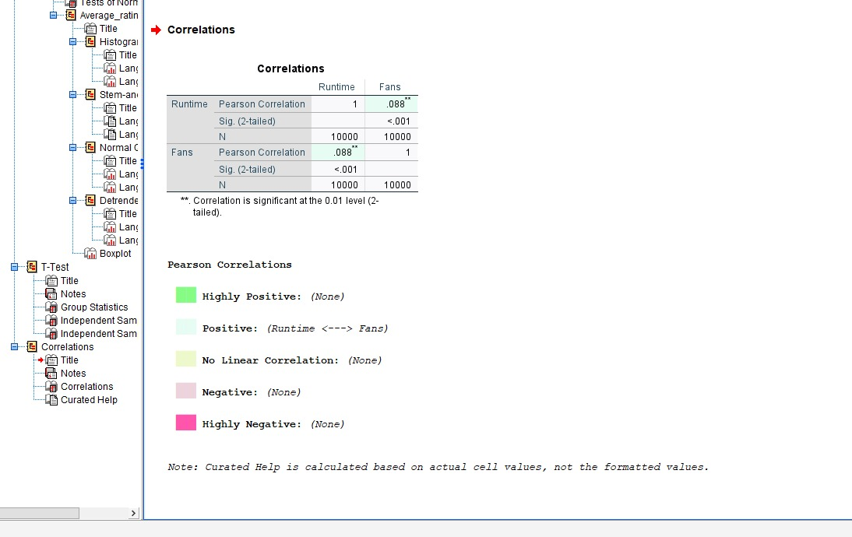
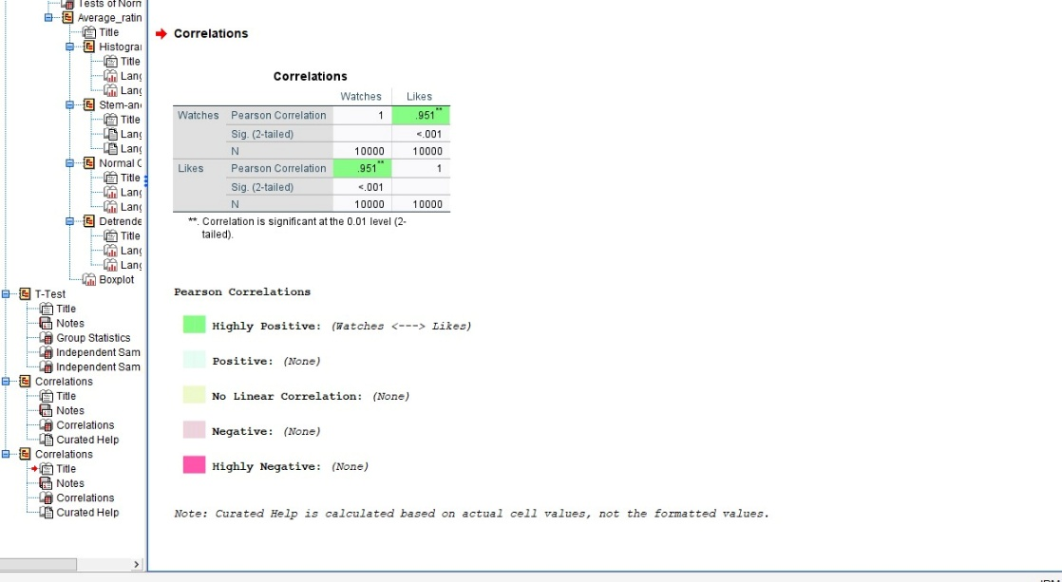
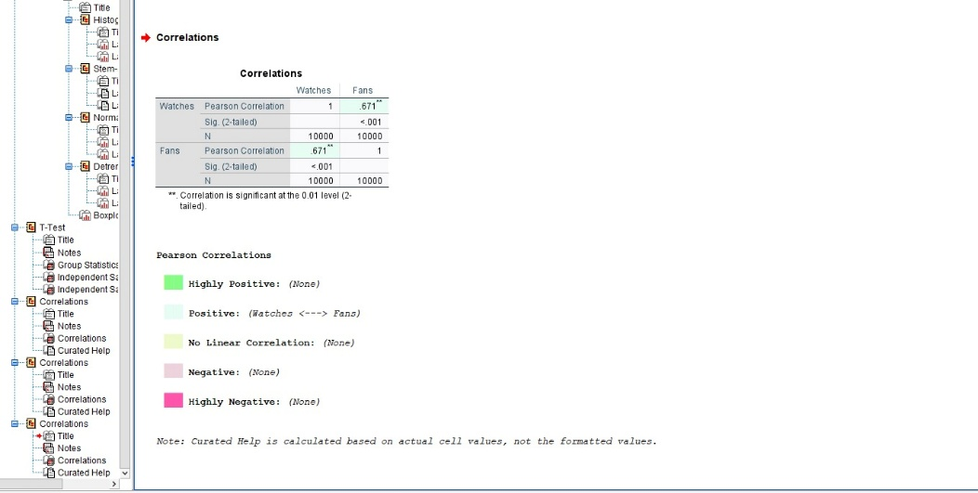
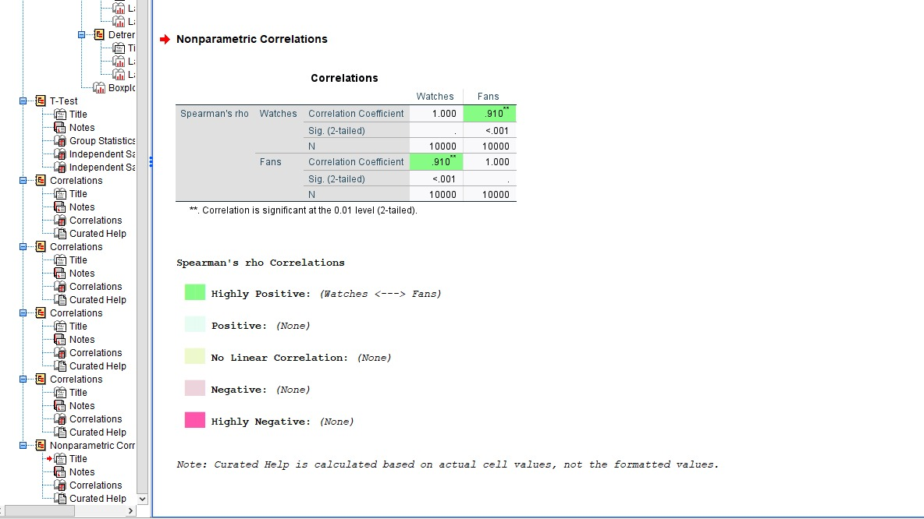

Regression Analysis
To go deeper into predictive associations, a multiple regression analysis was performed, utilising average rating as the dependent variable and likes, fans, and runtime as independent factors. The total regression model was statistically significant (p < .001) and accounted for around 10–11% of the variance in average ratings. This level of explained variance is not very high, but it is what we would expect for cultural and artistic datasets, where personal tastes and the situation have a big impact. The coefficients show that likes are the best predictor of average rating, followed by runtime. Fans have a lower but still important effect. This means that short-term audience acceptance is more strongly related to perceived quality than long-term loyalty or just structural qualities (James et al., 2020).
The SPSS analysis shows that the degree of audience involvement and the language context are the main factors that affect film ratings. The runtime, on the other hand, has a more subtle and secondary effect. These results show how useful inferential statistical analysis can be for making decisions based on data on content strategy, localisation, and audience targeting in the film and entertainment sector.
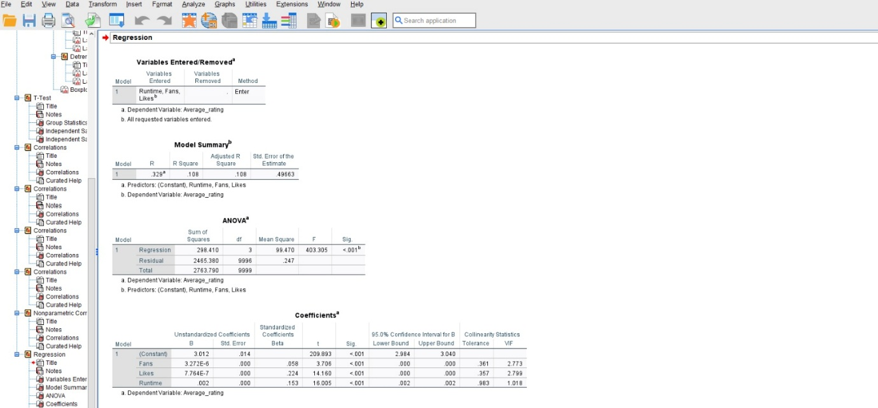
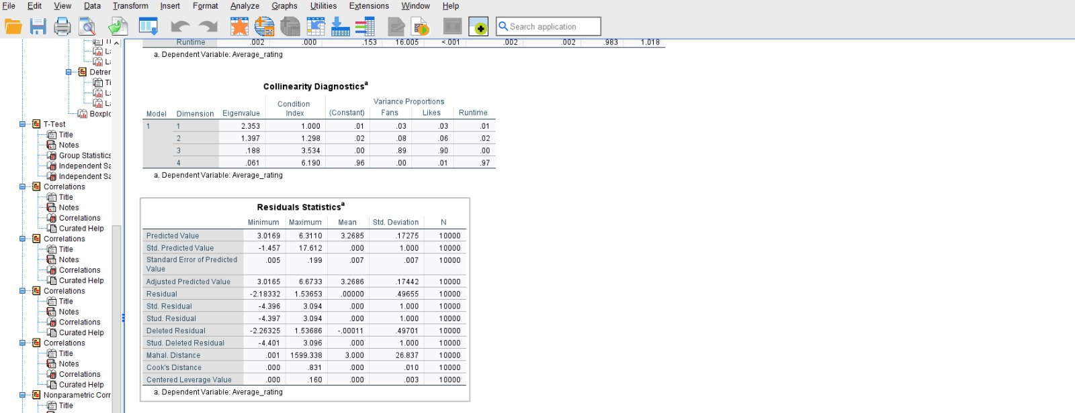
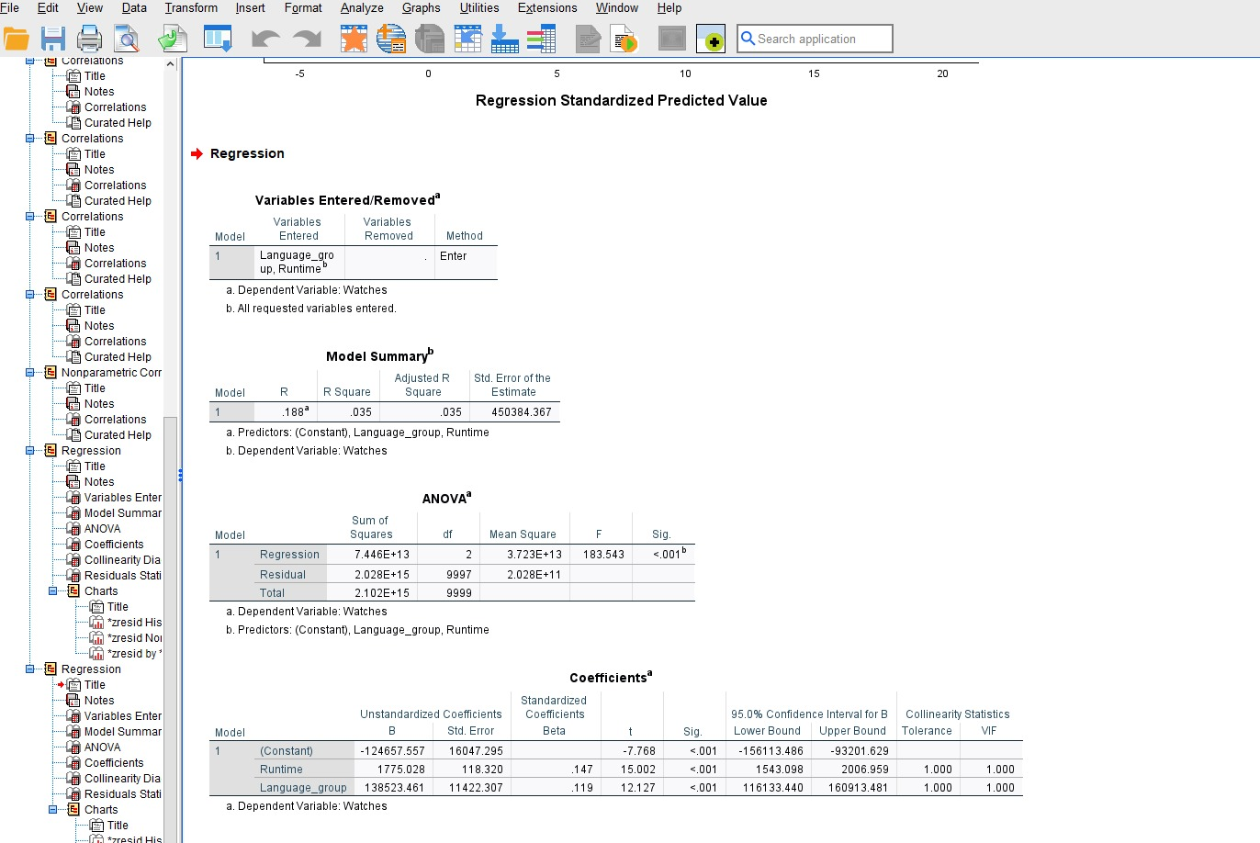

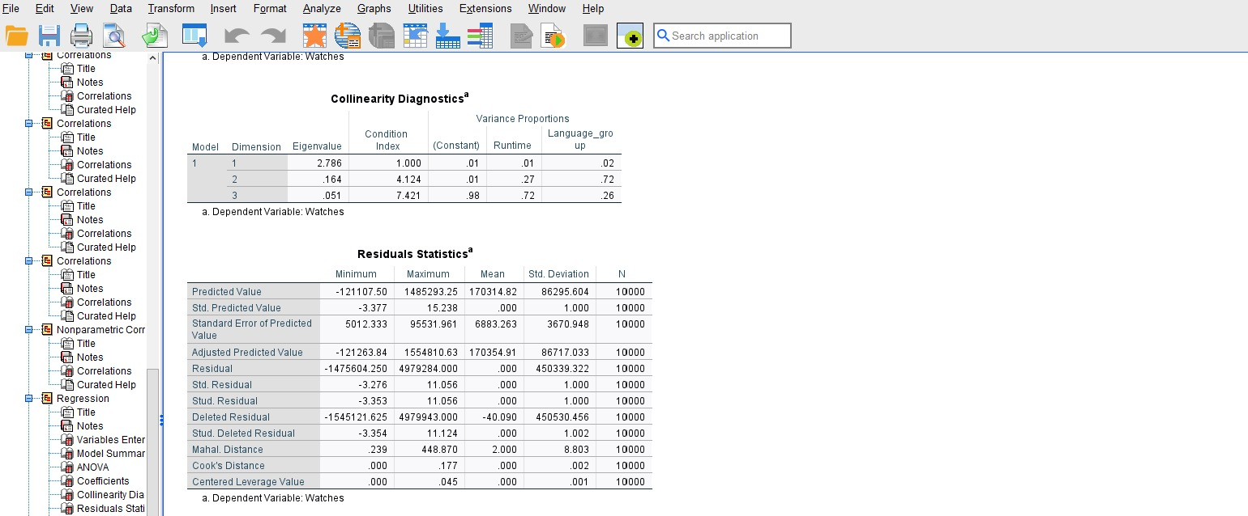

Insights and Recommendations
The analysis of the cinema dataset gives us a lot of useful information about how people act and what makes a movie do well. A significant discovery is that audience engagement indicators, especially views and likes, are highly correlated and are crucial in determining perceived film quality. Movies that get more attention tend to get more engagement and acceptance, which shows that exposure is an important part of how people respond to them. The data also demonstrates that non-English-language films generally get higher average ratings than English-language films, even though they are less common overall. This implies that viewers consuming international content may possess a more critical disposition or be driven by cultural and artistic significance rather than mainstream appeal. Also, runtime has a complex relationship with ratings: longer films may have higher ratings up to a point, but too much length doesn't always improve audience judgement. This suggests that narrative quality and genre expectations play a role in this effect.
Based on these findings, we can provide a number of data-driven suggestions for how to make business intelligence decisions better. First, media platforms could use genre and audience segmentation tactics. For example, they should promote critically acclaimed genres like drama or documentary to viewers who care about quality, while leveraging popular genres to get more people to watch. Second, putting money into subtitling and localisation should be a top priority in order to get the most out of high-rated non-English content and make it easier for more people to find. Third, platforms should focus on engagement-led promotion, employing recommendation algorithms and featured placements to get people to see the content early on, since this is closely tied to getting more likes and ratings. Finally, decision-makers should work on runtime optimisation by genre, which would let films be different lengths instead of making everyone follow the same rules.
The analysis has its limits, even with these findings. The dataset does not take into consideration things like marketing costs, when the product was released, or how platform recommendation algorithms work. Future study may include longitudinal engagement data, sentiment analysis of user reviews, or supplementary platform-level variables to enhance the knowledge of film performance and audience preferences.

References


