DS2 Assessment Business Digital Task - Completed Paper

DS2 Business Scenario 1; GreenLeaf Grocers.

Brief Summary of the Task
Given the choice from 3 options to use for my second assessment, I decided to go with Scenario 1 for my DS2 Paper titled; Business Scenario 1 - GreenLeaf Grocers.

To complete the stock management task for GreenLeaf Grocers, I used Microsoft Excel because it is the most effective tool for organising numerical information and presenting it clearly for business decision making. I entered the item names and quantities provided in the supervisor’s email, as these are the key details needed to carry out the task successfully.

Finally, I produced a clear, professional email summarising which items are low, which are high, and what needs to be ordered soon, ensuring the supervisor receives a useful and actionable update.
Stock List Current Quantities
- Apples 12
- Bananas 4
- Carrots 18
- Potatoes 30
- Milk (2L bottles) 6
- Bread Loaves 3
- Eggs (boxes of 6) 10
- Pasta (500g) 22

Digital Tools I Used and Why I Chose Them
For this task, I chose Microsoft Excel because it is the most suitable tool for organising stock information and presenting it clearly. Excel allowed me to create a structured table, apply conditional formatting to highlight low and high stock levels, and generate a chart to visually show which items need restocking. I also chose Excel because I feel confident using it and wanted to improve my skills in creating visual summaries for business tasks. The tool matches the needs of the shop owner, who requires a simple digital artefact that clearly shows stock levels at a glance.

Information I Used
I used the stock list provided in the supervisor’s email. The important information included:
- the item names (e.g., Apples, Bananas, Bread)
- the current quantities
- the business need: identifying low, high, and soon-to-order items

I focused on quantities because they directly determine whether an item is low or high. I also used the instruction that the summary must be simple and easy for the owner to understand.

How I Created My Artefact and the status of stock items.
First, I entered all items and quantities into an Excel table as taught in class. Then I applied conditional formatting for additional colour coding as well as for ease of use:

ITEMS | QUANTITY
Bread Loaves | 3
Bananas | 4 | - items with low stock (e.g., below 10) were highlighted in red
Milk (2L bottles) | 6 | - items with medium stock were highlighted in amber
Eggs (boxes of 6) | 10 | - items with high stock were highlighted in green
Apples | 12
Carrots | 18
Pasta (500g) | 22
Potatoes | 30
Average | 13.125

Next, I created a bar chart to visually compare quantities. This helped the supervisor quickly see which items were running low. I also added a small “Order Soon” column to mark items that needed restocking based on low quantities.
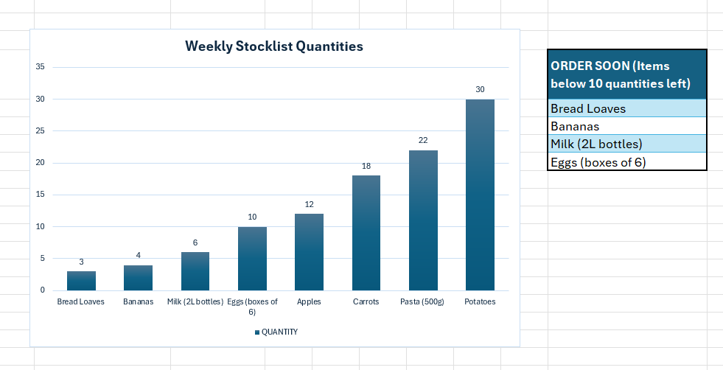

Changes I Made After My Draft
After reviewing my first draft, I made several improvements:
- I reorganised the table so that items were listed from lowest to highest quantity, making the summary easier to read.
- I adjusted the conditional formatting colours in the table to make them more visible.
- I added a title and labels to the chart to improve clarity.
- I removed unnecessary gridlines to make the artefact look more professional.
- I added a short note explaining the colour coding so the owner could understand the summary quickly.
These changes made the artefact clearer and more aligned with the business need.

Feedback I Used from Classroom Exercises
During classroom practice, I received feedback that my summaries should be:
- easy to understand at a glance
- visually clear, using colour and layout effectively
- professionally formatted, avoiding clutter
- linked directly to the business task

I applied this feedback by improving the layout, using conditional formatting more effectively, and ensuring the chart was simple and readable. I also made sure the artefact directly answered the supervisor’s three questions: low items, high items, and what needs ordering. Finally, I received feedback from my tutor that an overall summary of the entire assessment would be a great addition, which I found to be quite good, so I wrote a Brief Summary at the beginning to give an overall summation of my completed work.

My Final Response to the Supervisor’s Email.

To: John Li, Shop Supervisor
From: Junior Assistant
Subject: Stock Summary and Items to Order

Hi John,

I have created a digital stock summary using the quantities you provided. The table includes colour-coded indicators showing which items are low, high, and which ones need ordering soon.
Items that are low:
- Bananas (4)
- Bread Loaves (3)
- Milk – 2L bottles (6, close to low)
Items that need ordering soon:
- Bananas
- Bread Loaves
- Milk (recommended to restock before it drops further)
Items with high stock:
- Potatoes (30)
- Pasta (22)
- Carrots (18)

A chart has also been included to help you visually compare stock levels. Please let me know if you would like the summary updated weekly or if you want additional items added.

Kind regards,
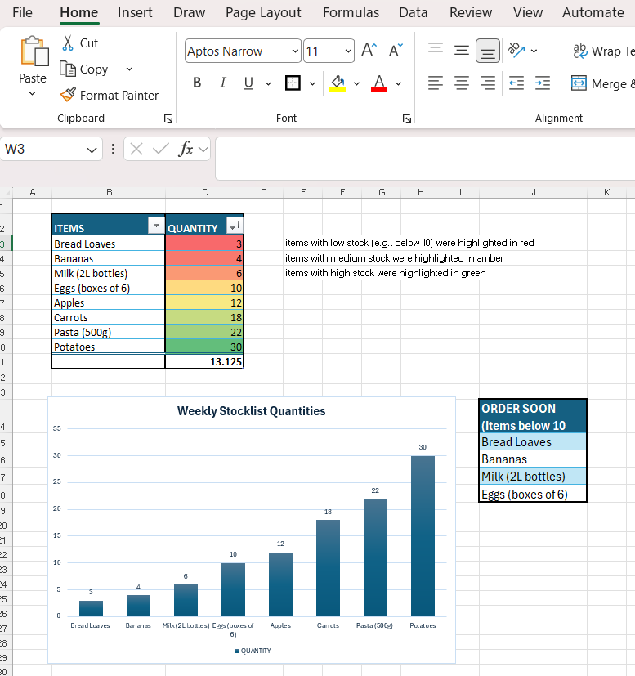
Junior Assistant

