14.12.2022
BMSW 4010 LEARNING IN A DIGITAL ERA. C2
CHRISTIAN FELICES | UWTSD
2012606
Sarah Johns
This reflection report will discuss the details such as background, the situation, and the reflective process using a cycle linked to academic use, the Gibs cycle. I will share the details of why I participated in this topic and why I chose this topic for my reflective report.
DESCRIPTION;
For a new P.D.Q system, also known as chip and pin to be installed on our systems at work, I and my team members had gathered around to discuss the finer details and how they should be operated. We expected it to take an hour at most to run through and then ask questions later if required. After possibly a few minutes it was clear that my other team members did not quite understand how it was meant to work with each of us using different sections of the club. Therefore, we decided to approach it together and try a process that demonstrated how it was to be connected and how we process it at the till. Taking charge of the situation, I understood how it was to function currently and promptly. It was explained that as I had learned this skill faster than the other team members, I was the lead to turn to if something went wrong or a simple misunderstanding during the work period.
During the task, I felt quite happy with how fast I was able to take instruction and apply it but also to demonstrate it to others so they in turn may learn. Before I attended the meeting, I was quite nervous thinking I.T. was not my strongest point, however after recognizing that I am the type to pick things up at a quicker pace than others I felt rather relieved. Not only because I understood but because it made me stand out amongst others and show my managers that I can work under pressure but learn something new. I knew a few of my colleagues were unsure about the new technology introduced as like me they felt uneasy about something new to learn but they did show they are able to learn this just but breaking it down and having things explained and shown visually. After the experience, I can now say that I am confident in demonstrating this skill to others who may need help when asked.
EVALUATING.
The good thing about this situation is that not only is it an experience of learning something new, but it also allowed me to see for myself how others learn. I know why the style of learning I have but it was refreshing to see if others matched my style or if they learn in a unique way. It was good to display a new skill and for management to see how people come together to support one another because without it the club wouldn’t be the best it can be. When expressing the bad things about the situation I did find it to not very helpful on management’s part for simply give a sheet of paper without a demonstration and expecting members to learn and adapt it themselves. Guidance for them would have benefited all around especially when it’s us team members that keep the club functioning on a daily basis. Without the training or even demonstration, it could have affected the club’s finances. The bar is a bit selling point and without having the ability to use the chip and pin machines then it would have impacted negatively not only for us but the customers.
Contributing my ability to work well under pressure and how well I support people it was made clear that I was to be the support needed all over the club in different departments and that made me feel proud of how much I am appreciated and needed within the workplace.

ANALYSIS;
I think things went well at the meeting because each of us had the opportunity to admit that technology either is or isn’t our strongest area. It went well because of my fast thinking and learning. Other team members had expressed that it’s best I master it first and then have me show them in a manner I knew would help them in understanding its process better and effectively. I found it rather interesting how myself only being there for 6 months, how fast I had become in getting not only total respect but recognition for how good I was at doing my job and how well I handle new tasks, and the ability I have in fast-tracking and learning a new skill. I do believe, however, the management style of wanting things done could leave a lot of room for improvement. They don’t recognize people with different learning styles and therefore expect everyone to learn a new skill at the same pace but this experience it showed me that will not always be possible.
It helped me understand more about my colleagues than I already knew, and it has also shown me that whilst we all want the same outcome for the situation it’s simply a case of how to make it work for u and then applying it so it works for everyone and the business. Using the Kolb cycle has helped me in reflecting on the situation and how I would apply the cycle in future references and experiences. Kolb(1984)

Conclusion
What I learned from this experience is how well I can apply a new skill to my abilities. How well I am able to recognize others’ learning skills. I can take the situation and reflect on it using both cycles of Kolb and Gibbs. Using the cycles, I was able to not only write this report, but I was also able to learn just how important it is to reflect on things whether it’s academically or within the workplace, or in life in general. Thinking about an experience or situation gives me the chance to understand what happened, why did it happen, and what went well or didn’t go well. How I think about what could have been different and how will the situation help me in the future when I need to reflect on something else.

ACTION PLAN;
If the situation was to ever come back around then I’m sure I would approach it differently. I would give the management the chance to express if they understand it and are able to visually demonstrate how they would like it done then continue to ask if my colleagues understand and then support those who would struggle by breaking it down into bite-size tasks so they can apply it in a way they understand and hopefully by the end of the task everyone is able to apply the new skill in a which way they find effective. It doesn’t matter how it is learned; it matters how you apply it to work with what best suits your ability.
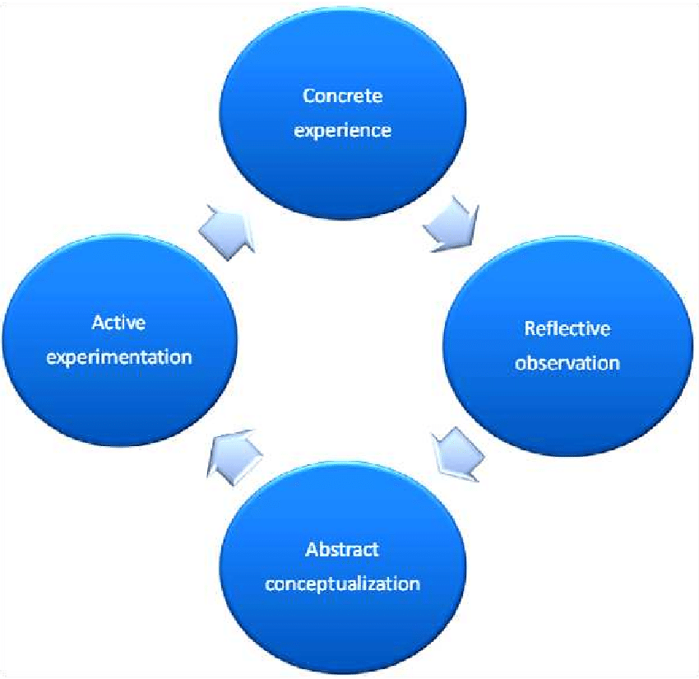

Kolb's learning theory (1984) sets out four distinct learning styles, which are based on a four-stage learning cycle (see above). Kolb explains that different people naturally prefer a certain single different learning style.
Gibbs' Reflective Cycle was developed by Graham Gibbs in 1988 to give structure to learning from experiences. It offers a framework for examining experiences, and given its cyclic nature lends itself particularly well to repeated experiences, allowing you to learn and plan from things that either went well or didn’t go well. It covers 6 stages:

Description of the experience
Feelings and thoughts about the experience
Evaluation of the experience, both good and bad
Analysis to make sense of the situation
Conclusion about what you learned and what you could have done differently
Action plan for how you would deal with similar situations in the future, or general changes you might find appropriate.

This is how I have written my report using the Gibbs cycle. The picture is available for further review in my reference list.

References.
Gibbs (1988) {online} Available at https://www.ed.ac.uk/reflection/reflectors-toolkit/reflecting-on-experience/gibbs-reflective-cycle Accessed 16.12.2022
Kolb (1984) picture {online} available at https://www.researchgate.net/figure/Kolbs-cycle-of-experiential-learning-model-Source-Smith-MK-2001-David-A-Kolb-on_fig2_301678373 {Accessed 16.12.2022
Gibbs G (1988). Learning by Doing: A guide to teaching and learning methods. Further Education Unit. Oxford Polytechnic: Oxford.

