

Terramar Hotel Consultancy Report

Lavinia Lenuta Siminiuc
2208461
Inspire Hospitality Group
12.11.2024

I acknowledge the use of Grammarly App and Microsoft Editor on 12th November 2024.
I confirm that I have not presented any Al generated text as my own work. I confirm I have copies of my drafts, notes, and other resources I used before, and after the use of Al tools which I may be asked to provide in evidence.

Contents
Executive Summary 2
Introduction 5
Consultancy Firm Background 6
Overview of Issues 6
Analytical Approach 7
Analysis - Detailed Issue Analysis 7
Facility Maintenance: Broken Amenities and Inadequate Cleanliness 8
Food and Beverage Quality: Limited Options and Low Quality 9
Safety Concerns: Hygiene, Safety Signage, and Broken Facilities 10
Frameworks 11
PESTEL Analysis 11
SWOT Analysis 13
Porter’s Five Forces Analysis 14
TOWS Analysis 16
Proposed Recommendations 18
Staff Training Programs: Improve Customer Service and Response 18
Facility Upgrades: Address Maintenance Issues and Cleanliness 19
Food Quality Improvement: Improve Food Variety and Quality 20
Safety Protocols: Implement Proper Signage and Safety Measures 20
Change Management Strategy 21
Details of the Action Plan 27
Conclusion 28

Executive Summary
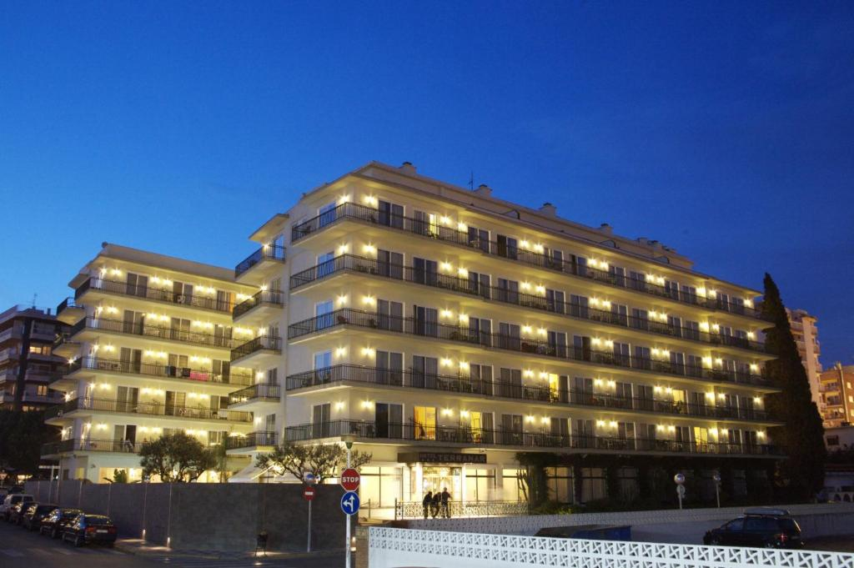
Hotel Terramar, a beachfront hotel in Calella, Spain, faces numerous operational difficulties that negatively impact guest experiences and its overall reputation. Recent ratings on TripAdvisor and Google consistently highlight concerns regarding service quality, safety, facility maintenance, cleanliness, and food quality. Repeated guest complaints highlight unresponsive and indifferent staff, insufficient cleanliness standards, limited and insipid food selections, and insufficient safety protocols. These problems have resulted in decreased guest satisfaction, reduced repeat customers, and harm to the hotel's reputation in a highly competitive hospitality sector. This analysis highlights the need for a systematic and proactive strategy to rectify these significant deficiencies effectively.
The consultancy assessment identifies four primary weaknesses at Hotel Terramar:
- Service Quality: Service quality is a significant issue, as guests often voice dissatisfaction with their interactions with hotel staff. Complaints focus on employees who are disinterested and poorly address guest requests or concerns. This poor service experience adversely affects guest satisfaction and decreases overall loyalty, as travellers anticipate a superior standard of hospitality.
- Facility Maintenance: The hotel’s maintenance standards are inadequate, with recurrent reports of broken amenities, malfunctioning lifts, damaged electrical outlets and insufficient bathroom cleanliness. Guests anticipate a fundamental standard of maintenance, and neglecting facility upkeep has resulted in unfavourable reviews. A reactive maintenance strategy, where issues are resolved solely in response to complaints, intensifies these problems.
- Food Quality: Guests frequently express discontent with the culinary selections, characterising them as insipid and lacking in diversity. In an all-inclusive environment, the dining quality is crucial to the guest experience, and current culinary standards must meet present expectations. The absence of varied, new, and attractive choices divides guests and reduces the perceived worth of the all-inclusive experience.
- Safety: Safety concerns are widespread, as reported by absent safety signage, insufficient hygiene protocols, and generally inadequate safety measures, especially in high-traffic zones. These deficiencies raise concerns regarding guest well-being and expose the hotel to legal consequences, consequently underlining the necessity for prompt repairs.
The issues originate from poor management practices, inadequate investment in facility maintenance, and insufficient employee training. Inexperienced and disengaged staff result in inconsistent service delivery, as they frequently need more skills to manage guest interactions with compassion and professionalism. The lack of regular facility inspections and proactive maintenance has resulted in considerable deterioration, adversely affecting the guest experience. The disparity between guest expectations and the hotel's culinary offerings indicates outdated practices, as customers increasingly anticipate variety, freshness, and options accommodating diverse dietary preferences. Safety concerns highlight a failure to keep up with industry standards, jeopardising reputation and legal accountability.

Recommendations
To address these issues, Inspire Hospitality Group recommend the following actionable steps:
- Service Improvement: Implement staff training initiatives centred on customer service, conflict resolution, and cultural competence. Training must prioritise empathy, proactive guest interaction, and prompt responses to guest requirements for better service quality.
- Facility Maintenance: Prioritise the repair of malfunctioning amenities and improve cleanliness protocols. Create a proactive maintenance system involving routine inspections and timely interventions to prevent deterioration and conform with industry standards.
- Food Quality Improvement: Strengthen and diversify menu selections, stressing fresh, locally sourced ingredients. A varied and appealing menu that conforms to contemporary health and dietary trends will elevate the guest experience and conform to industry standards.
- Safety Protocols: Implement multilingual safety signage, improve safety inspections, and perform regular audits to mitigate hazards, reassure guests, and ensure compliance with legal obligations.

Conclusion
The challenges faced by Hotel Terramar significantly reduce guest satisfaction and impede success in a competitive market. Inspire Hospitality Group's focused recommendations highlight service improvements, facility maintenance, food quality, and safety improvements. Implementing these modifications is crucial for restoring the hotel's reputation and conforming to contemporary hospitality standards. By implementing these measures, Hotel Terramar may reinforce its status as a preferred destination, providing guests with a superior, secure, and hospitable experience. Inspire Hospitality Group is dedicated to assisting the hotel in attaining continuous growth and success.

Introduction
Background
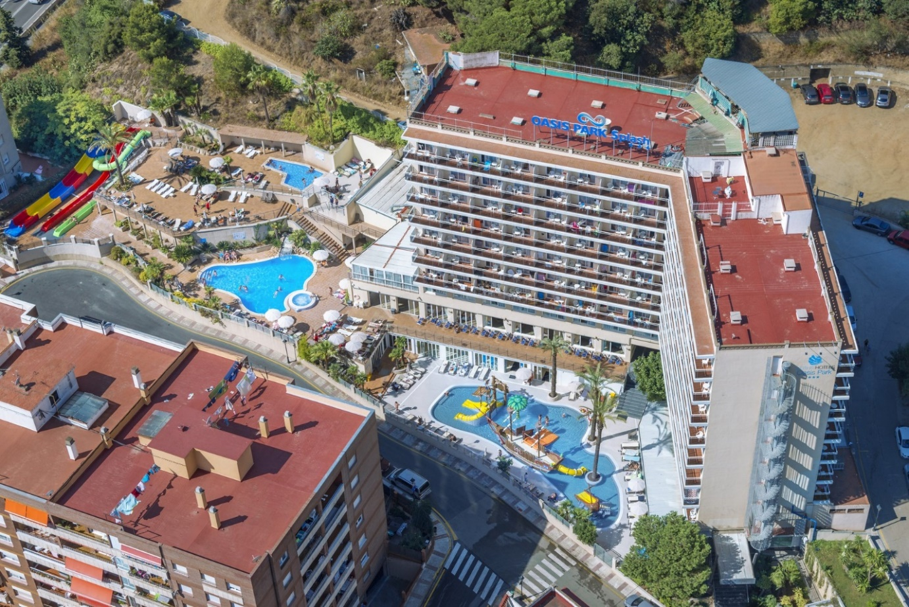Hotel Terramar is a beach hotel in Calella, Spain, recognised for its excellent access to the Mediterranean Sea. This mid-sized hotel is favoured by leisure travellers desiring coastal experiences, providing a range of rooms with sea views and convenient access to nearby attractions. The hotel offers amenities like a restaurant, bar, swimming pool, and event spaces, serving individual guests and larger groups. However, despite its advantageous location and attractive vistas, recent evaluations indicate multiple operational deficiencies impairing the overall guest experience. Amenities, including elevators, electrical outlets, and restrooms, have been identified as requiring maintenance, and guests often express worries regarding cleanliness and no longer relevant facilities. This destination, which should ideally draw a substantial number of repeat visitors, reveals a disparity between the hotel’s potential and the quality of service rendered, highlighting the necessity for focused improvements.

Consultancy Firm Background
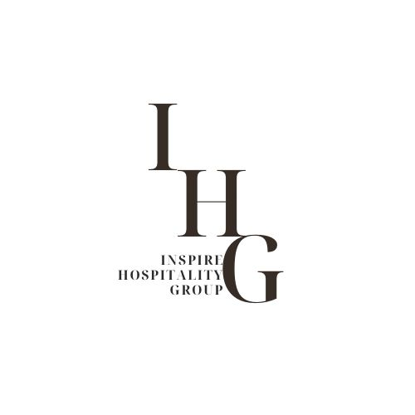
Inspire Hospitality Group is a consultancy firm specialising in delivering strategic solutions for the hospitality industry. The firm has expertise in operational efficiency, customer satisfaction, and service quality improvement, demonstrating a successful history of helping hotels optimise guest experiences and increase profitability. Our team integrates industry expertise with an in-depth understanding of emerging hospitality trends, allowing us to provide customised recommendations that meet specific client requirements. Hotel Terramar has commissioned us to evaluate its operational difficulties and formulate practical strategies to improve service standards, preserve its reputation, and strengthen its competitiveness in the Calella region.

Overview of Issues
Hotel Terramar has received multiple customer complaints, as recorded in reviews on platforms like TripAdvisor and Google Reviews. Principal issues include substandard service quality, demonstrated by unresponsive and indifferent staff failing to resolve guest complaints correctly. Consumers often indicate prolonged wait times and insufficient pleasant participation, negatively affecting their overall experience. Facility maintenance has become a persistent issue, with numerous reviews citing broken amenities, malfunctioning lifts and inadequate bathroom facilities, negatively impacting guest comfort and satisfaction.
Food quality is a significant concern, as customers often describe the hotel’s culinary offerings as insipid, restricted, and devoid of freshness. This is especially concerning in an all-inclusive environment where the dining quality significantly impacts guest satisfaction. Concerns regarding safety and hygiene have been documented, including the absence of safety signs and unsanitary conditions in communal areas. These deficiencies threaten guest well-being and the hotel's reputation in an industry that increasingly prioritises cleanliness. These issues underscore critical areas necessitating prompt intervention to reinstate guest satisfaction while improving the hotel's reputation.
Analytical Approach
This report employs various analytical frameworks, including PESTEL, SWOT, TOWS, and Porter’s Five Forces, to systematically tackle the challenges faced by Hotel Terramar. The PESTEL analysis will evaluate the external environment by examining political, economic, social, technological, environmental, and legal factors affecting the hotel's operations. This macro-level analysis contextualises the potential impact of external pressures on the identified issues. The SWOT analysis defines internal strengths and weaknesses with external opportunities and threats, thoroughly assessing the hotel's present status.
After the SWOT analysis, a TOWS analysis will recommend strategic actions by connecting internal competencies with external variables, facilitating a focused strategy to reduce weaknesses and leverage opportunities. Ultimately, Porter’s Five Forces will assess the competitive environment, including threats posed by new entrants, the bargaining power of suppliers and customers, the presence of substitute services, and the degree of industry rivalry. These frameworks will direct the formulation of practical recommendations to address the hotel's operational weaknesses and improve its market standing.
Analysis - Detailed Issue Analysis
Service Quality: Poor Customer Service and Unresponsive Staff
Hotel Terramar received complaints concerning poor service quality, especially regarding staff unresponsiveness and restricted capacity to effectively meet guest needs (TripAdvisor, 2024; Google Reviews, 2024). Research indicates that poor service quality can profoundly affect guest satisfaction and the reputation of hotels. Ali et al. (2017) argue that unresponsive and inattentive staff can reduce guest loyalty and an adverse brand perception. Customer service in hospitality is pivotal in determining the guest experience, as it directly affects customer satisfaction and retention rates (Arslan, 2020). Service failures, including extended wait times, insufficient problem resolution, and unfriendliness, have been demonstrated to diminish guest satisfaction and result in adverse online reviews, further harming the hotel's reputation (Rose and Blodgett, 2016).
Reviews of Hotel Terramar indicate that the staff showed a lack of interest or indifference towards guest complaints, which violates industry best practices (TripAdvisor, 2024). Effective customer service necessitates proactive engagement, compassion, and prompt responses to client concerns (Zhu et al., 2019). Rectifying these service quality concerns is essential for reinstating guest trust while improving the hotel's reputation.
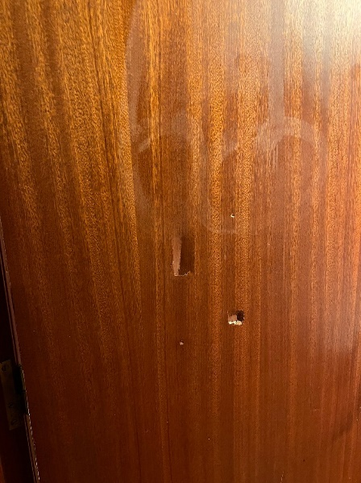
Facility Maintenance: Broken Amenities and Inadequate Cleanliness

The physical state of a hotel’s services, encompassing functionality and cleanliness, is crucial for guaranteeing guest satisfaction and safety. Hotel Terramar has been reported to experience significant maintenance problems, including defective electrical sockets, inoperative lifts and insufficient bathroom facilities, resulting in a frustrating and uncomfortable guest experience (Google Reviews, 2024). Research demonstrates that inadequately maintained facilities can result in dissatisfaction and decrease guests' propensity to recommend the hotel (Padma and Ahn, 2020). The absence of these fundamental issues indicates operational failure, potentially damaging the hotel's reputation and preventing prospective guests (Pizam and Tasci, 2019).
The maintenance shortcomings at Hotel Terramar underscore the departure from industry standards for fundamental hospitality infrastructure. Cleaning and maintaining facilities are essential, as guests generally anticipate a high standard of hygiene and functionality in their lodgings (Kim and Han, 2022). Maintaining facilities effectively improves guest satisfaction and reduces risks related to equipment malfunctions and sanitation problems (Öztürk, 2019).
Food and Beverage Quality: Limited Options and Low Quality


Food quality is a fundamental aspect of the hotel experience, particularly in an all-inclusive context where meals frequently serve as a key attraction. Customers of Hotel Terramar often complained of discontent with the cuisine, defining it as insipid, with few vegetarian or vegan selections, and at times stale or cold (TripAdvisor, 2024). Studies indicate that food quality is critical to guest satisfaction and loyalty in the hospitality sector (Ryu and Han, 2010). Superior food offerings connect positively with guest perceptions and may improve the hotel experience (Paulose and Shakeel, 2021).
Hotels serving diverse dietary requirements must provide various food options to avoid alienating specific guest demographics. Moreover, poor food quality can result in unfavourable reviews and discourage prospective guests from making reservations, as dining experiences are frequently perceived as a reflection of overall hotel quality (Fernandes, 2019). Improving meal variety, freshness, and taste to address food and beverage concerns could substantially improve guest satisfaction at Hotel Terramar.

Safety Concerns: Hygiene, Safety Signage, and Broken Facilities

Safety is a fundamental expectation in any hotel; however, reviews reveal that Hotel Terramar exhibits numerous safety-related deficiencies, including unsanitary conditions, absent safety signage, and dangerous infrastructure (Google Reviews, 2024). The perceptions of guests regarding hygiene are frequently correlated with their likelihood to return and recommend the hotel (Alnawas and Hemsley-Brown, 2019).
The absence of safety signage presents potential dangers, particularly in high-traffic locations such as staircases and restrooms, as indicated in the reviews of Hotel Terramar (Hu et al., 2020; TripAdvisor, 2024). Anichiti et al. (2021) discovered that visible safety protocols and appropriate signage improve guests' perceptions of a hotel's dedication to well-being. Moreover, unsanitary conditions, including unclean restrooms and contaminated linens, create health hazards, undermine guest confidence, and result in adverse word-of-mouth (Souki et al., 2023). Implementing stringent safety protocols and boosting cleanliness would likely improve the hotel's reputation and reassure guests regarding their safety.
Frameworks
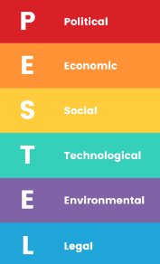
PESTEL Analysis
Political: Regulatory Implications Due to Inadequate Safety Standards
The hospitality sector is extensively regulated, especially concerning health and safety regulations. Hotel Terramar's insufficient safety protocols, including absent safety signage and unsanitary conditions, may lead to regulatory repercussions and legal liabilities (Todorov, 2017; TripAdvisor, 2024). Studies indicate that hotels must comply with rigorous safety standards to prevent accidents and safeguard their reputation (Robina-Ramirez et al., 2021). The inability to conform to these standards results in penalties and undermines customer trust, negatively impacting long-term sustainability (Bagga and Khanna, 2014).
Economic: Potential Financial Loss from Declining Customer Retention
Economic factors are essential, as poor service quality and maintenance of facilities can directly result in decreased customer retention. Numerous studies indicate that lousy guest experiences decrease repeat bookings, adversely affecting revenue (Ali et al., 2021; Ali et al., 2017). The reputation of Hotel Terramar has declined due to ongoing complaints regarding service and amenities, likely leading to decreased occupancy rates and potential financial losses. Preserving a high customer retention rate is economically advantageous, as it incurs substantially lower costs than acquiring new customers (Arslan, 2020).
Social: Rising Expectations of Cleanliness and Service in Hospitality
Today's travellers prioritise hygiene and service excellence, which are essential to a favourable guest experience. Post-COVID-19, societal expectations for hygiene standards have grown more severe, and hotels that do not comply with these standards encounter considerable guest dissatisfaction (Jiang and Wen, 2020). The inability of Hotel Terramar to pay attention to these rising standards leads to unfavourable reviews and restricts its attractiveness to discerning customers (Google Reviews, 2024).
Technological: Outdated Amenities like Poor Wi-Fi
Technology in the hospitality sector is increasingly regarded as indispensable. The outdated Wi-Fi and technological amenities at Hotel Terramar do not align with current guest expectations, resulting in decreased satisfaction and a diminished competitive advantage (Cobanoglu et al., 2011). Research demonstrates that technological advancements, including high-speed internet, are essential factors that directly influence guest satisfaction (Bilgihan et al., 2016).
Environmental: Importance of Sustainable and Clean Facilities
Responsibility for the environment is progressively valued in the hospitality sector. Customers are more predisposed to support environmentally sustainable hotels that uphold hygienic standards and sustainable practices (Bohdanowicz, 2006). Poor hygiene and absence of sustainable practices at Hotel Terramar could discourage environmentally-conscious customers, negatively impacting its reputation and attractiveness.

SWOT Analysis
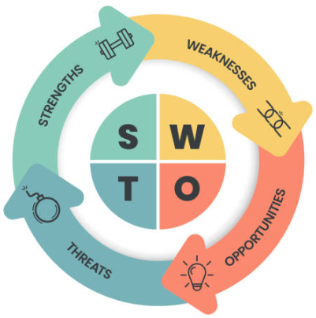
Strengths: Prime Beach Location
Hotel Terramar’s key strength lies in its prime beachfront location in Calella, just a short distance from the Mediterranean Sea. Research highlights that proximity to desirable attractions significantly improves hotel appeal, particularly among leisure travelers (Shoval and Cohen-Hattab, 2001). This location advantage gives Hotel Terramar a competitive edge, as beachfront properties often attract a steady stream of guests seeking coastal experiences, which can help sustain occupancy rates despite service and maintenance shortcomings (Urtasun and Gutiérrez, 2006).
Weaknesses: Maintenance and Service Issues
The hotel's shortcomings are primarily associated with persistent maintenance and service problems, such as malfunctioning amenities, unsanitary conditions, and inadequate customer service, as noted in various reviews (TripAdvisor, 2024; Google Reviews, 2024). Research demonstrates that unresolved maintenance and service problems significantly affect guest satisfaction and retention, resulting in a negative brand image and reduced customer loyalty (Padma and Ahn, 2020). The operational deficiencies indicate insufficient investment in facility maintenance and staff training, both essential for upholding quality standards in hospitality (Pizam and Tasci, 2019).
Opportunities: Potential for Brand Improvement
Although its present difficulties, Hotel Terramar possesses the capacity to further develop its brand by rectifying service quality and facility concerns. Improving brand reputation through superior guest experiences can lead to increased customer loyalty and higher ratings, as evidenced by research on the beneficial effects of quality improvements in the hospitality sector (Gontur et al., 2022). Executing a thorough renovation strategy and training initiative might improve Hotel Terramar's standing as a more respected option in the region, exploiting its locational benefits.
Threats: Rising Competition and Potential Legal Issues
The increasing competition in the Calella region, characterised by an influx of new and contemporary accommodations, compromises Hotel Terramar's market standing. Moreover, legal risks related to possible regulatory infractions concerning safety and hygiene may result in penalties or closures, particularly in light of increased regulatory oversight in the hospitality industry (Rawal et al., 2020). Noncompliance with safety standards or inability to respond to competitive pressures may lead to substantial financial and reputational harm.

Porter’s Five Forces Analysis
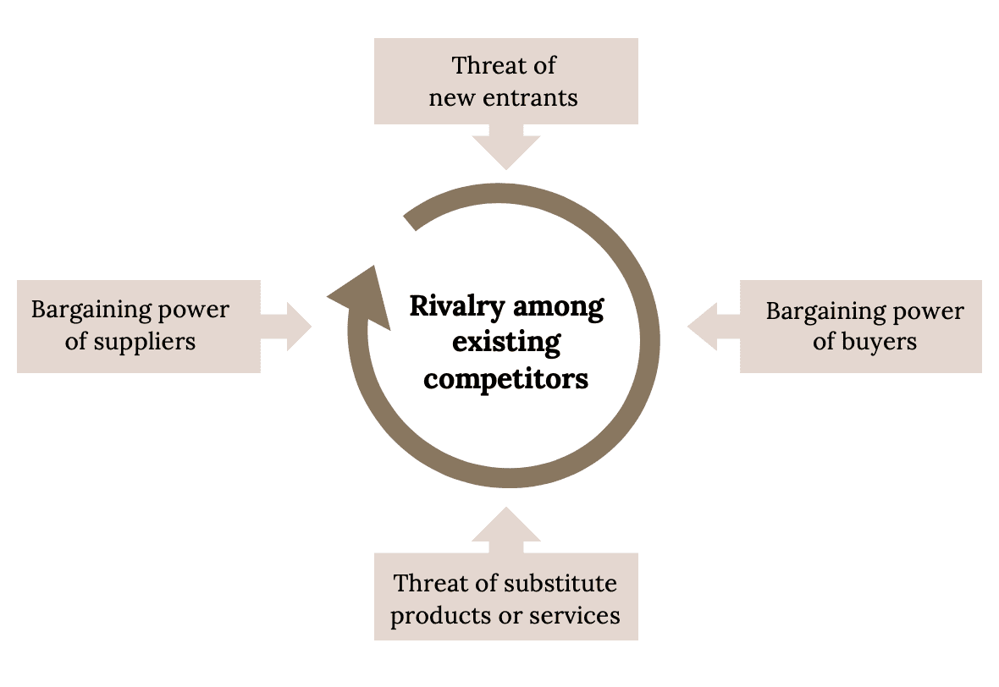Threat of New Entrants
The hotel sector, particularly in tourist-dense regions such as Calella, faces persistent competition from new entrants. Calella's popularity as a coastal destination is prompting an increase of newer hotels featuring modern amenities and modern design, providing guests with superior comfort and service compared to older establishments such as Hotel Terramar. Dev et al. (2010) demonstrate that new entrants in tourist regions frequently introduce competitive pricing and advanced technology, this in turn appeals to younger, tech-savvy clientele. The ongoing expansion of the hospitality sector in Spain contributes to this threat, as travellers are progressively favouring hotels that conform to modern standards of comfort and cleanliness.
Bargaining Power of Suppliers
The bargaining power of suppliers in the hospitality industry can substantially influence operational costs and quality norms. Hotel Terramar's restricted supplier options in Calella could compromise food quality and amenity standards, as indicated by guest reviews (TripAdvisor, 2024). Alzoubi (2021) claims that hotels with a limited range of suppliers face higher expenses and poor quality of supplies, which negatively impacts customer satisfaction. The constrained negotiating power with local suppliers hampers the hotel’s capacity to procure quality products at affordable prices, especially for basic amenities such as food and sanitation.
Bargaining Power of Customers
The bargaining power of customers in the Calella region increases due to the existence of numerous alternatives and unfavourable reviews for Hotel Terramar, enabling customers to select options with superior reputations (Google Reviews, 2024). Research indicates that higher customer bargaining power compels hotels to improve service quality and provide competitive pricing to maintain customers (Chen et al., 2016). Access to online review platforms allows potential guests to effortlessly compare hotels, leaving Hotel Terramar vulnerable to loss of clients in favour of better-reviewed competitors.
Threat of Substitute Services
Hotel Terramar also faces the threat of substitute services, particularly from alternative accommodations such as Airbnb and other rental platforms. According to Zervas et al. (2017), the rise of Airbnb has significantly affected traditional hotel bookings, especially among younger travelers seeking affordability and authenticity. These alternatives often offer more flexibility, further challenging Hotel Terramar’s ability to attract price-sensitive travelers.
Industry Rivalry
Hotel Terramar confronts the challenge of substitute services, especially from alternative accommodation choices like Airbnb and other rental platforms. Zervas et al. (2017) indicate that the rise of Airbnb has profoundly impacted conventional hotel reservations, especially for younger tourists pursuing cost-effectiveness and real-life experiences. These alternatives frequently provide greater flexibility, ultimately complicating Hotel Terramar's capacity to draw in price-sensitive travellers.

TOWS Analysis
A TOWS analysis for Hotel Terramar develops strategic directions by connecting the hotel's strengths with opportunities, while simultaneously lowers weaknesses and addressing external threats.
Strengths–Opportunities (SO) Strategies
Utilising its prime oceanfront location, Hotel Terramar may increase its appeal by implementing exclusive events and experiences that draw both local and international tourists, including beachside activities and partnerships with local tour operators. This corresponds with the findings of Pine and Gilmore (2013), indicating that distinctive, location-specific experiences may increase brand value and boost guest loyalty. The locational advantage strengthens the potential for raising the brand image by highlighting the hotel’s scenic attributes through focused marketing strategies, which might increase occupancy rates and customer satisfaction.
Weaknesses–Opportunities (WO) Strategies
Resolving the hotel's maintenance and service challenges offers a chance for improvement and market distinction (Chan et al., 2001). Investing in facility renovations and staff training programs helps the hotel to conform to industry standards, as indicated by Kim and Han (2022), who believe that quality improvements increase the experience of guests. Furthermore, modernising amenities and implementing upgraded room services might turn perceived weaknesses into opportunities for brand improvement.

Strengths–Threats (ST) Strategies
Hotel Terramar may reduce the risk of increasing competition by exploiting its prime beachfront location and providing distinctive services that set it apart from nearby options. Implementing loyalty programs for returning guests may improve customer retention and mitigate competitive threats (Shoemaker and Lewis, 1999). Furthermore, strengthening safety and hygiene protocols might reduce regulatory risks while simultaneously improving its reputation as a secure and appealing destination.
Weaknesses–Threats (WT) Strategies
To reduce the risk of guest dissatisfaction caused by operational mistakes, Hotel Terramar should prioritise prompt maintenance upgrades that conform to fundamental hospitality standards. Immediate improvements, such as replacing defective equipment and resolving hygiene issues, might prevent additional reputational harm and legal complications, as indicated by Pizam and Tasci (2019). This strategy minimises existing vulnerabilities while reducing susceptibility to external risks.

Proposed Recommendations
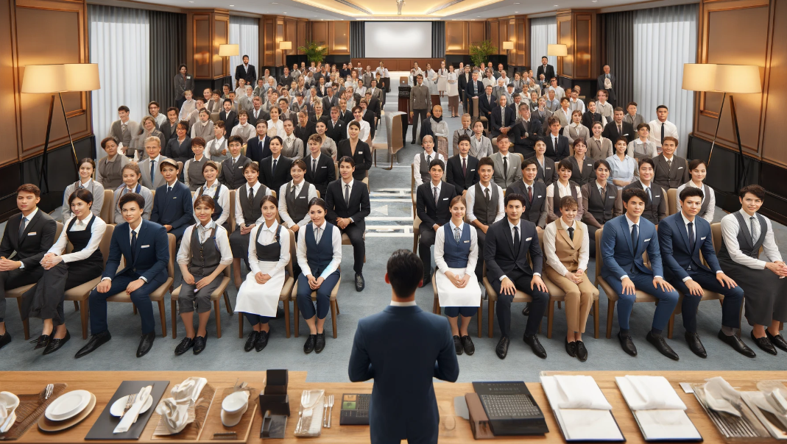
Staff Training Programs: Improve Customer Service and Response
To improve customer service quality, a crucial factor in guest satisfaction, Hotel Terramar should establish extensive staff training programs. Research highlights that employee proficiency and customer-oriented conduct greatly influence guests' perceptions of value and service excellence (Peter, 2018). Guests have indicated occurrences of staff indifference and insufficient responses to concerns, indicating a necessity for training in communication abilities, empathy, and problem-solving (TripAdvisor, 2024; Google Reviews, 2024).
Catro-Casal, Vila-Vazquez, and Pardo-Hayoso (2019) state that customer service training strengthens employees' capacity to address guest needs promptly and professionally, which boosts reliability of service and responsiveness. Furthermore, Baum (2007) contends that hospitality training focused on cultural sensitivity and diverse guest expectations is essential in international tourism, allowing staff to effectively manage diverse guest preferences and complaints. Regular training updates may maintain elevated service standards by reinforcing the significance of service excellence and promoting a guest-centered approach, which helps improve guest loyalty and the hotel's reputation.
Facility Upgrades: Address Maintenance Issues and Cleanliness
The quality of facilities is essential for a favourable hotel experience, especially regarding cleanliness and maintenance. Guest feedback indicates persistent maintenance problems at Hotel Terramar, such as malfunctioning amenities, substandard sanitation, and insufficient facility maintenance (Google Reviews, 2024). Research conducted by Parasuraman et al. (1988) demonstrates that dependable and well-maintained facilities are crucial for fulfilling guests' basic service expectations, as they reflect a dedication to quality and guest satisfaction.
Protocols for cleaning and maintenance must be improved to meet increased cleanliness standards, as highlighted by Souki et al. (2023), who discovered that cleanliness in facilities, particularly in bathrooms and communal areas, significantly influences guest satisfaction. Establishing a proactive maintenance system, including regular inspections and prompt repairs for defective amenities, could reduce additional guest complaints and decrease expensive replacements (Cobanoglu et al., 2021). By executing comprehensive daily cleaning protocols and incorporating quality assurance evaluations, Hotel Terramar can resolve cleanliness and maintenance issues, and thus deliver an environment that satisfies the higher post-pandemic standards for hygiene and maintenance (Jiang and Wen, 2020).
Food Quality Improvement: Improve Food Variety and Quality
Food quality is a vital factor influencing guest satisfaction, especially in all-inclusive or resort-style facilities where dining is a primary focus. Customers repeatedly expressed discontent regarding the restricted and frequently subpar culinary selections at Hotel Terramar (TripAdvisor, 2024). Ramanathan's research (2011) indicates that food quality affects guests' value perception and significantly influences their likelihood of returning. Guests anticipate diversity, freshness, and dietary alternatives that suit diverse preferences, necessitating hotels to provide a broader range of high-quality food options.
By procuring local, fresh ingredients and diversifying its menu, Hotel Terramar can improve the guest dining experience, aligning with modern trends in health-conscious and sustainable gastronomy (Roday et al., 2014). Furthermore, implementing feedback mechanisms, such as guest surveys or comment cards, helps the hotel to continually evaluate satisfaction with food offerings and make necessary adjustments (Ryu and Han, 2010). This proactive approach to upgrading the dining experience elevates guest satisfaction and acts as a unique attribute, differentiating Hotel Terramar from competitors with comparable services (Paulose and Shakeel, 2021).
Safety Protocols: Implement Proper Signage and Safety Measures

A secure environment is essential in the hospitality sector, as customers depend on hotels to uphold safety protocols that prevent accidents and manage emergencies. Hotel Terramar received complaints regarding insufficient safety signage and lacking preparedness for emergencies, potentially exposing guests to unnecessary dangers. (Google Reviews, 2024). Rawal et al. (2011) claim that unwavering compliance with safety standards and conspicuous safety measures are crucial for fostering guest confidence and fulfilling legal obligations.
Pizam and Tasci (2019) indicate that extensive safety protocols, such as multilingual signage, clear exit markings, and frequent safety drills, are essential for creating a secure environment. Hotel Terramar must put visible signage for emergency exits, hazards, and sanitation stations throughout all guest areas, ensuring multilingual accessibility for international customers. Furthermore, the routine inspection and maintenance of fire safety equipment, including alarms, fire extinguishers and emergency lighting, is imperative. Implementing these protocols, in conjunction with regular safety audits, can mitigate potential risks, improve the hotel's reputation, and assure guests of their safety during their stay (Wilks et al., 2004).

Change Management Strategy

Staff Engagement: Encourage Staff Participation in Changes
Engaging staff in implementing changes at Hotel Terramar is essential for securing their cooperation and commitment. Research indicates that engaging employees in organisational changes cultivates a sense of ownership, which helps improve their adaptability to new practices and raises overall morale (Armenakis and Harris, 2009). Utilising a participative approach helps the hotel ask for employee feedback on implementing changes, thus improving acceptance and reducing resistance (Lewin and Russ, 2012).
A competent strategy involves conducting regular meetings and workshops for staff to reflect on proposed changes, express concerns, and provide suggestions. This method corresponds with the findings of Whelan-Berry et al. (2003), who believe that interactive communication channels are essential for encouraging staff participation. Moreover, incentivising involvement through recognition programs and rewards for proactive participation may reinforce a favourable perspective on the changes (Bailey and Lumpkin, 2023). The hotel could implement an “Employee of the Month” program that acknowledges contributions to improvement initiatives, which would encourage active engagement. By maintaining consistent communication while motivating participation through incentives, Hotel Terramar can foster a supportive atmosphere for change, resulting in a smoother transition and improved staff retention rates.

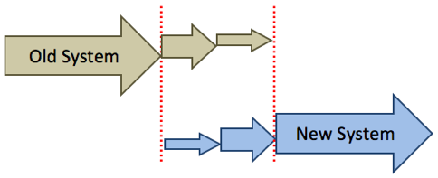
Timeline and Implementation: Phased Implementation for Changes

Adopting a gradual change implementation strategy permits Hotel Terramar to tackle its fundamental issues systematically without overloading staff or disrupting operations. Sachdev and Chakravarty (2020) assert that phased implementation improves the success rates of change by facilitating incremental adjustments and allowing for evaluation of each stage before progression. For Hotel Terramar, an incremental timeline may commence with immediate, high-impact modifications, such as correcting fundamental maintenance and sanitation concerns, which can produce swift benefits while improving guest satisfaction quickly.
After this initial stage, the hotel can start staff training and improvements to safety protocols, necessitating additional time and resources for effective implementation. Research indicates that deconstructing intricate change initiatives into smaller components improves the concentration and quality of each stage (Roodbari and Olya, 2024). Afterwards, extended projects, including menu diversification and facility improvements, may be planned for the next steps, facilitating budget allocation and modifications based on feedback from prior stages. By implementing this phased strategy, Hotel Terramar may reduce potential operational disruptions, assess progress at each phase, and guarantee that changes are seamlessly incorporated into daily operations. Measurement of Success
Customer Feedback Surveys: Regular Monitoring of Guest Satisfaction

Hotel Terramar should consistently collect and analyse guest feedback through structured surveys to evaluate the efficacy of implemented modifications. Research demonstrates that customer feedback surveys are essential for pinpointing areas for improvement, as they reflect customers' immediate experiences and perceptions (Barsky and Nash, 2002). Surveys may be conducted at checkout or via follow-up emails, allowing guests to provide feedback on critical elements such as service quality, cleanliness, dining experience, and overall satisfaction. Research indicates that participants are more inclined to engage with concise, focused surveys incorporating quantitative assessments and open-ended enquiries for complete feedback (Gilbert and Horsnell, 1998).
A monthly examination of survey outcomes will allow the hotel to monitor satisfaction trends and identify any persistent issues necessitating intervention. Comparing pre- and post-implementation feedback, Hotel Terramar may identify areas of improvement and those requiring additional modifications. Moreover, utilising guest feedback for iterative modifications corresponds with the observations of Pizam et al. (2016), who claim that continuous improvement in hospitality depends on proactive guest involvement. This method exemplifies a dedication to quality and cultivates favourable relationships with guests by indicating that their feedback is valued and utilised to improve their experiences.


Service Quality Audits: Conduct Maintenance and Service Quality Audits
Alongside guest feedback, internal service quality audits are crucial for guaranteeing the consistent implementation and ongoing upkeep of changes. Regular audits help Hotel Terramar to objectively evaluate its compliance with cleanliness, maintenance, and safety standards, providing a benchmark for continual improvement (Enz and Siguaw, 2000). Audits must be carried out by qualified quality control workers who carefully examine rooms, common areas, restaurants, and safety procedures. A systematic checklist can facilitate the full coverage of all relevant areas, allowing the hotel to detect and fix deficiencies promptly.
Service quality audits are especially beneficial in the hospitality sector, where operational standards must be consistently raised to guarantee customer satisfaction (Parasuraman et al., 1988). Studies indicate that regular internal audits increase staff accountability and assist management in identifying operational inefficiencies that may not be evident just from guest feedback (Roland, 2006). Moreover, unknown "mystery client" reviews may provide impartial insights into the guest experience, allowing Hotel Terramar to determine the effectiveness of their service improvements in practical situations. Integrating these audits into everyday operations enables the hotel to continuously comply with its quality standards, resulting in a more reliable and satisfying guest experience.


Cost Considerations
Implementing the recommended improvements at Hotel Terramar requires a detailed budget in pounds to finance staff training, facility repairs, upgrades, and upgrades in food safety protocols. Each section below defines the anticipated costs in pounds.
Staff Training Programs
The anticipated cost for staff training focused on improving customer service skills, conflict resolution, and cultural sensitivity is approximately £8,600. This budget covers initial training and periodic refresher sessions, which are essential to maintain high service standards and minimise staff turnover by encouraging a guest-centered approach (Baum, 2007; Worsfold et al., 2016).
Facility Repairs and Upgrades
The projected price for immediate repairs and upgrades to resolve maintenance and cleanliness issues is £25,800. This budget includes the necessary fixes (e.g., replacing damaged fixtures and renovating common spaces) and adopting contemporary cleaning protocols to comply with post-COVID hygiene standards (Padma and Ahn, 2020; Jiang and Wen, 2020).
Food and Beverage Improvements
Improving the quality and variety of food options requires approximately £12,900. This involves procuring fresh, local ingredients and expanding the menu selections to meet various dietary requirements, improving the guest experience (Fernandes, 2018; Goswami, 2011).
Safety Protocol Implementation
Implementing improved safety protocols, including emergency signage and routine safety inspections, is projected to incur a cost of approximately £4,300. This budget includes multilingual signage, maintenance of safety equipment, and regular audits to guarantee guest safety, responding to primary issues highlighted in guest feedback (Wilks et al., 2004).
Problem | Solution | Desired Outcome | Time Scale | Completion Date | Planned Budget
Service Quality | Staff Training | Improved customer satisfaction | 3 months | 12/02/2025 | £8,600
Facility Issues | Facility Maintenance | Improved guest experience | 6 months | 12/05/2025 | £25,800
Safety | Install Safety Protocols | Improved safety standards | 2 months | 12/01/2025 | £4,300

Details of the Action Plan
Service Quality
The main concern regarding service quality at Hotel Terramar is caused by insufficient staff responsiveness and deficient guest relations skills, as shown by guest reviews.
Create an effective staff training initiative centred on customer service, conflict resolution, and empathy in guest engagements.
This solution improves customer satisfaction by allowing staff to handle guest requests and complaints successfully, resulting in a more favourable guest experience and increased loyalty.
Time Scale: The training program is scheduled for implementation over 3 months, ending on 12th February 2025.
Planned Budget: £8,600.

Facility Issues
Guest dissatisfaction has been associated with maintenance deficiencies, including malfunctioning amenities and poor cleaning.
Implement facility upgrades, comprising repairs to essential amenities, renovation of common areas, and improvement of sanitation procedures.
These changes seek to deliver a better guest experience, as facilities are held to the necessary standards of comfort and cleanliness.
Time Scale: The overall effort will last for six months, concluding on 12th May 2025.
Planned Budget: £25,800.

Safety
Reported safety concerns caused by limited signage and the absence of safety protocols have raised potential risks.
Implement and install detailed safety protocols, including multilingual safety signage, regular maintenance of safety equipment, and systematic safety audits.
This initiative seeks to increase guest confidence in the hotel’s dedication to safety, which will boost its reputation as a secure and dependable accommodation option.
Time Scale: The safety protocols will be fully implemented within two months, with a Completion Date of 12th January 2025.
Planned Budget: £4,300.

Conclusion

This report identified significant operational challenges at Hotel Terramar, including poor service quality, insufficient facility maintenance, inferior food and beverage offerings, and safety issues, which negatively impact guest satisfaction and the hotel's reputation. Factors including unresponsive staff members, insufficient instruction, malfunctioning amenities, cleanliness deficiencies, restricted food options, and missing safety protocols negatively impact customer retention and present potential safety hazards and legal liabilities.
In response to these issues, Inspire Hospitality Group has suggested specific measures: training staff to improve service quality, updating facilities to guarantee cleanliness and functionality, expanding food selections with locally sourced ingredients, and increasing safety protocols through clear signage and routine equipment maintenance. These recommendations, backed by industry research and a systematic change management plan, seek to improve guest satisfaction, boost occupancy, and fortify the hotel’s competitive position.
Transparent communication between management and staff will be essential in formulating a realistic and effective strategy. By prioritising service excellence and operational improvements, Hotel Terramar may strengthen its status as an increasingly popular choice for travellers.
Inspire Hospitality Group advocates for periodic evaluations to ensure these modifications align with industry trends and guest expectations. The team is dedicated to helping Hotel Terramar with ongoing improvements, guaranteeing the hotel's competitiveness and durability in the changing hospitality sector. Inspire Hospitality Group expect future opportunities to support these initiatives.

References
- Ali, B., Gardi, B., Othman, B., AHMED, S., Ismael, N., Hamza, P., Aziz, H., Sabir, B., Sorguli, S., and Anwar, G., 2021. Hotel Service Quality: The Impact of Service Quality on Customer Satisfaction in Hospitality. . https://doi.org/10.22161/IJEBM.5.3.2.
- Ali, F., Amin, M., and Cobanoglu, C., 2015. An integrated model of service experience, emotions, satisfaction, and price acceptance: An empirical analysis in the hotel industry. Journal of Hospitality and Tourism Management, 449-475. https://doi-org.ezproxy.uwtsd.ac.uk/10.1080/19368623.2015.1019172
- Alnawas, I. and Hemsley-Brown, J., 2019. Examining the key dimensions of customer experience quality in the hotel industry. Journal of Hospitality Marketing & Management, 28(7), pp.833-861. https://doi.org/10.1080/19368623.2019.1568339
- Alzoubi, A., 2021. The impact of process quality and quality control on organisational competitiveness at 5-star hotels in Dubai. International Journal of Technology, Innovation and Management (IJTIM), 1(1), pp.54-68. https://www.academia.edu/download/98124206/3.pdf
- Anichiti, A., Dragolea, L.L., Tacu Hârșan, G.D., Haller, A.P. and Butnaru, G.I., 2021. Aspects regarding safety and security in hotels: Romanian experience. Information, 12(1), p.44. https://doi.org/10.3390/info12010044
- Armenakis, A.A. and Harris, S.G., 2009. Reflections: Our journey in organisational change research and practice. Journal of change management, 9(2), pp.127-142. https://doi.org/10.1080/14697010902879079
- ARSLAN, I.K., 2020. THE IMPORTANCE OF CREATING CUSTOMER LOYALTY IN ACHIEVING SUSTAINABLE COMPETITIVE ADVANTAGE. Eurasian Journal of Business and Management, 8(1), pp. 11-20. https://www.proquest.com/scholarly-journals/importance-creating-customer-loyalty-achieving/docview/2404652580/se-2?accountid=130472
- BAGGA, T. and KHANNA, G., 2014. Dell’s technical-support staff have the power to do more. Human Resource Management International Digest, 22(6), pp. 7-9. https://www.proquest.com/scholarly-journals/dell-s-technical-support-staff-have-power-do-more/docview/2088812010/se-2?accountid=130472
- Bailey, R.C. and Lumpkin, G.T., 2023. Enacting positive social change: A civic wealth creation stakeholder engagement framework. Entrepreneurship Theory and Practice, 47(1), pp.66-90. https://doi.org/10.1177/10422587211049745
- Barsky, J. and Nash, L., 2002. Evoking emotion: Affective keys to hotel loyalty. Cornell Hotel and Restaurant Administration Quarterly, 43(1), pp.39-46. https://doi.org/10.1177/0010880402431004
- Baum, T., 2007. Human resources in tourism: Still waiting for change. Tourism management, 28(6) https://doi.org/10.1016/j.tourman.2007.04.005
- BILGIHAN, A., SMITH, S., RICCI, P. and BUJISIC, M., 2016. Hotel guest preferences of in-room technology amenities. Journal of Hospitality and Tourism Technology, 7(2), pp. 118-134. https://www.proquest.com/scholarly-journals/hotel-guest-preferences-room-technology-amenities/docview/1826444051/se-2?accountid=130472
- Bohdanowicz, P., 2006. Environmental awareness and initiatives in the Swedish and Polish hotel industries—survey results. International journal of hospitality management, 25(4), pp.662-682. https://doi.org/10.1016/j.ijhm.2005.06.006
- Castro-Casal, C., Vila-Vázquez, G., and Pardo-Gayoso, Á., 2019. Sustaining Affective Commitment and Extra-Role Service among Hospitality Employees: Interactive Effect of Empowerment and Service Training. Sustainability. https://doi.org/10.3390/SU11154092.
- CHAN, K.T., LEE, R.H.K. and BURNETT, J., 2001. Maintenance performance: A case study of hospitality engineering systems. Facilities, 19(13), pp. 494-503. https://www.proquest.com/scholarly-journals/maintenance-performance-case-study-hospitality/docview/219650780/se-2?accountid=130472
- Chen, C., Lin, Y., Chi, Y., and Wu, S., 2016. Do competitive strategy effects vary across hotel industry cycles. International Journal of Hospitality Management, 54, pp. 104-106. https://doi.org/10.1016/J.IJHM.2016.02.003.
- Cobanoglu, C., Berezina, K., Kasavana, M., and Erdem, M., 2011. The Impact of Technology Amenities on Hotel Guest Overall Satisfaction. Journal of Quality Assurance in Hospitality & Tourism, 12, pp. 272 - 288. https://doi.org/10.1080/1528008X.2011.541842.
- Cobanoglu, C., Dogan, S., Berezina, K., Collins, G., Nanu, L., Shahtakhtinskaya, K., Kaya, G. and Parvez, O., 2021. Hospitality and tourism information technology. University of South Florida M3 Center Publishing, 17(9781732127593), p.2. https://www.researchgate.net/profile/Betsy-Stringam-2/publication/344753638_Hotel_and_Guestroom_Technology/links/614a1314a3df59440ba1339b/Hotel-and-Guestroom-Technology.pdf
- Cobanoglu, C., Dogan, S., Berezina, K., Collins, G., Nanu, L., Shahtakhtinskaya, K., Kaya, G. and Parvez, O., 2021. Hospitality and tourism information technology. University of South Florida M3 Center Publishing, 17(9781732127593), p.2. https://www.researchgate.net/profile/Betsy-Stringam-2/publication/344753638_Hotel_and_Guestroom_Technology/links/614a1314a3df59440ba1339b/Hotel-and-Guestroom-Technology.pdf
- Dev, C.S., Brown, J.R. and Zhou, K.Z., 2007. Global brand expansion: How to select a market entry strategy. Cornell Hotel and Restaurant Administration Quarterly, 48(1), pp.13-27. https://doi.org/10.1177/0010880406294472
- Enz, C.A. and Siguaw, J.A., 2000. Best practices in service quality. Cornell Hotel and Restaurant Administration Quarterly, 41(5), pp.20-29. https://doi.org/10.1177/001088040004100531
- Fernandes, T. and Fernandes, F., 2018. Sharing dissatisfaction online: analyzing the nature and predictors of hotel guests negative reviews. Journal of Hospitality Marketing & Management, 27(2), pp.127-150. https://doi.org/10.1080/19368623.2017.1337540
- Gilbert, D. and Horsnell, S., 1998. Customer satisfaction measurement practice in United Kingdom hotels. Journal of Hospitality & Tourism Research, 22(4), pp.450-464. https://doi.org/10.1177/109634809802200408
- Gontur, S., Gadi, P., and Bagobiri, E., 2022. Service Quality and Customer Loyalty. International Journal of Marketing & Human Resource Research. https://doi.org/10.47747/ijmhrr.v3i1.474.
- Google Review, 2024. Hotel Terramar. https://www.google.ro/travel/search?gsas=1&ts=EggKAggDCgIIAxocEhoSFAoHCOkPEAoYBBIHCOkPEAoYBRgBMgIQAA&qs=MhRDZ3NJdmRTYnJLM0I1ZVcyQVJBQjgC&ap=ugEHcmV2aWV3cw&biw=1536&bih=793&hl=en-RO&ved=0CAAQ5JsGahcKEwiQ_YiY0NSJAxUAAAAAHQAAAAAQBQ
- Goswami, S., 2011. THE ROAD TO GUEST DELIGHT: AN EMPIRICAL EXPLORATION IN THE HOTEL INDUSTRY. Asean Journal on Hospitality and Tourism, 10, pp. 122-145. https://doi.org/10.5614/ajht.2011.10.2.05.
- Hu, X., Yan, H., Casey, T., and Wu, C., 2020. Creating a safe haven during the crisis: How organizations can achieve deep compliance with COVID-19 safety measures in the hospitality industry. International Journal of Hospitality Management, 92, pp. 102662 - 102662. https://doi.org/10.1016/j.ijhm.2020.102662.
- Jiang, Y. and Wen, J., 2020. Effects of COVID-19 on hotel marketing and management: a perspective article. International journal of contemporary hospitality management, 32(8), pp.2563-2573. https://www.proquest.com/scholarly-journals/effects-covid-19-on-hotel-marketing-management/docview/2430152840/se-2?accountid=130472
- Kim, J.J. and Han, H., 2022. Redefining in-room amenities for hotel staycationers in the new era of tourism: A deep dive into guest well-being and intentions. International Journal of Hospitality Management, 102, p.103168. https://doi.org/10.1016/j.ijhm.2022.103168
- Lewis, L., and Russ, T., 2012. Soliciting and Using Input During Organizational Change Initiatives. Management Communication Quarterly, 26, pp. 267 - 294. https://doi.org/10.1177/0893318911431804.
- OLUSOJI, S.E., 2024. Entrepreneurial Marketing Dimensions and Performance of 3-Star Hotels Businesses in Ilorin Metropolis, Kwara State, Nigeria, Kwara State University (Nigeria). https://www.proquest.com/dissertations-theses/entrepreneurial-marketing-dimensions-performance/docview/3119304032/se-2?accountid=130472
- On The Beach, 2024. Hotel Terramar Calella. https://www.onthebeach.co.uk/
- Öztürk, H.M. and Öztürk, H.K., 2019. Maintenance and maintenance management systems in accommodation. Journal of Achievements in Materials and Manufacturing Engineering, 96(2), pp.83-93. https://yadda.icm.edu.pl/baztech/element/bwmeta1.element.baztech-c57a9790-a871-4a44-8bf5-317cf289dc59/c/Ozturk_jamme_2019_96_2.pdf
- Padma, P. and Ahn, J., 2020. Guest satisfaction & dissatisfaction in luxury hotels: An application of big data. International journal of hospitality management, 84, p.102318. https://doi.org/10.1016/j.ijhm.2019.102318
- Parasuraman, A., Zeithaml, V.A. and Berry, L.L., 1988. Servqual: A multiple-item scale for measuring consumer perc. Journal of retailing, 64(1), https://www.proquest.com/scholarly-journals/servqual-multiple-item-scale-measuring-consumer/docview/228609374/se-2?accountid=130472
- Paulose, D., and Shakeel, A., 2021. Perceived Experience, Perceived Value and Customer Satisfaction as Antecedents to Loyalty among Hotel Guests. Journal of Quality Assurance in Hospitality & Tourism, 23, pp. 447 - 481. https://doi.org/10.1080/1528008X.2021.1884930.
- Pine, B.J. and Gilmore, J.H., 2013. The experience economy: past, present and future. In Handbook on the experience economy (pp. 21-44). Edward Elgar Publishing. https://www.researchgate.net/profile/B-Pine-Ii/publication/260917972_The_experience_economy_past_present_and_future/links/56198eed08ae044edbaf8ec0/The-experience-economy-past-present-and-future.pdf
- Pizam, A. and Tasci, A.D., 2019. Experienscape: expanding the concept of servicescape with a multi-stakeholder and multi-disciplinary approach (invited paper for ‘luminaries’ special issue of International Journal of Hospitality Management). International Journal of Hospitality Management, 76, pp.25-37. https://doi.org/10.1016/j.ijhm.2018.06.010
- PIZAM, A., SHAPOVAL, V. and ELLIS, T., 2016. Customer satisfaction and its measurement in hospitality enterprises: a revisit and update. International Journal of Contemporary Hospitality Management, 28(1), pp. 2-35. https://www.proquest.com/scholarly-journals/customer-satisfaction-measurement-hospitality/docview/1752974497/se-2?accountid=130472
- RAMANATHAN, U. and RAMANATHAN, R., 2011. Guests' perceptions on factors influencing customer loyalty. International Journal of Contemporary Hospitality Management, 23(1), pp. 7-25. https://www.proquest.com/scholarly-journals/guests-perceptions-on-factors-influencing/docview/848011221/se-2?accountid=130472
- Rawal, Y.S., Pal, S., Bagchi, P. and Dani, R., 2020. Hygiene and safety: A review of the hotel industry in the era of COVID-19 pandemic. Bioscience Biotechnology Research Communications, 13(10), pp.79-83. https://www.researchgate.net/profile/Madhu-Druvakumar/publication/352992733_Study_on_Price_Discovery_of_Selected_Indian_Agriculture_Commodity_with_Special_Orientation_to_Ncdex/links/60e2b60c299bf1ea9ee1223d/Study-on-Price-Discovery-of-Selected-Indian-Agriculture-Commodity-with-Special-Orientation-to-Ncdex.pdf#page=86
- REILLY, P., 2018. Building customer centricity in the hospitality sector: the role of talent management. Worldwide Hospitality and Tourism Themes, 10(1), pp. 42-56. https://www.proquest.com/scholarly-journals/building-customer-centricity-hospitality-sector/docview/2025799023/se-2?accountid=130472
- ROBINA-RAMÍREZ, R., SÁNCHEZ-HERNÁNDEZ M, I. and DÍAZ-CARO, C., 2021. Hotel manager perceptions about corporate compliance in the tourism industry: an empirical regional case study in Spain. Journal of Management & Governance, 25(2), pp. 627-654. https://www.proquest.com/scholarly-journals/hotel-manager-perceptions-about-corporate/docview/2532422241/se-2?accountid=130472
- Roday, S., Pillai, A. and Deshpande, A., 2014. Emerging Healthy Food Options offered by the Hotel Industry. Applied Hospitality and Tourism Research, 52, p.110. https://www.researchgate.net/profile/Joseph-Roberson/publication/320976534_Quality_Management_Systems_in_the_Hospitality_Industry/links/5f47e4ca458515a88b755c2f/Quality-Management-Systems-in-the-Hospitality-Industry.pdf#page=110
- ROLAND, V.D., 2006. Service Operations Management: Improving Service Delivery. International Journal of Service Industry Management, 17(1), pp. 99-100. https://www.proquest.com/scholarly-journals/service-operations-management-improving-delivery/docview/233654956/se-2?accountid=130472
- Roodbari, H. and Olya, H., 2024. An integrative framework to evaluate impacts of complex tourism change initiatives. Tourism Management, 100, p.104829. https://doi.org/10.1016/j.tourman.2023.104829
- Rose, M., and Blodgett, J., 2016. Should Hotels Respond to Negative Online Reviews?. Cornell Hospitality Quarterly, 57, pp. 396 - 410. https://doi.org/10.1177/1938965516632610.
- Ryu, K. and Han, H., 2010. Influence of the quality of food, service, and physical environment on customer satisfaction and behavioral intention in quick-casual restaurants: Moderating role of perceived price. Journal of Hospitality & Tourism Research, 34(3), pp.310-329. https://doi.org/10.1177/1096348009350624
- Sachdev, A. and Chakravarty, A., 2020. Real-Time Strategic Change: Flashback to Whole Systems Change and Relating to Organisation Development Sponsors in India, NHRD Network Journal, 13(3), pp. 370–382. https://doi.org/10.1177/2631454120953036.
- Shoemaker, S. and Lewis, R.C., 1999. Customer loyalty: the future of hospitality marketing. International journal of hospitality management, 18(4), pp.345-370. https://doi.org/10.1016/S0278-4319(99)00042-0
- Shoval, N. and Cohen-Hattab, K., 2001. Urban hotel development patterns in the face of political shifts. Annals of Tourism research, 28(4), pp.908-925. https://doi.org/10.1016/S0160-7383(00)00083-9
- Souki, G., Oliveira, A., Barcelos, M., Guerreiro, M., Mendes, J., and Moura, L., 2023. Emotional, cognitive and behavioural repercussions of hotel guests' experiences. Spanish Journal of Marketing - ESIC. https://doi.org/10.1108/sjme-01-2023-0002.
- Todorov, D., 2017. Legal liability and claims for the hotel industry. Economics and computer science, (5), pp.7-20. https://eknigibg.net/Volume3/Issue5/spisanie-br5-2017_pp.7-20.pdf
- Tripadvisor, 2024. Terramar Hotel. https://www.tripadvisor.com/Hotel_Review-g580327-d232773-Reviews-Terramar_Hotel-Calella_Catalonia.html
- Urtasun, A. and Gutiérrez, I., 2006. Hotel location in tourism cities: Madrid 1936–1998. Annals of tourism research, 33(2), pp.382-402. https://doi.org/10.1016/j.annals.2005.12.008
- Whelan-Berry, K.S., Gordon, J.R. and Hinings, C.R., 2003. Strengthening organizational change processes: Recommendations and implications from a multilevel analysis. The Journal of applied behavioral science, 39(2), pp.186-207. https://doi.org/10.1177/0021886303256270
- Wilks, J. and Moore, S., 2004. Tourism Risk Management for the Asia-Pacific Region. An Authoritative Guide for Managing Crises and Disasters. Gold Coast. http://wise.co.th/wise/References/Tourism_Industry/Tourism_Risk_Management_in_Asia_Pacific.pdf
- Worsfold, K., Fisher, R., McPhail, R., Francis, M. and Thomas, A., 2016. Satisfaction, value and intention to return in hotels. International Journal of Contemporary Hospitality Management, 28(11), pp.2570-2588. https://www.proquest.com/scholarly-journals/satisfaction-value-intention-return-hotels/docview/1844596567/se-2?accountid=130472
- Zervas, G., Proserpio, D. and Byers, J.W., 2017. The rise of the sharing economy: Estimating the impact of Airbnb on the hotel industry. Journal of marketing research, 54(5), pp.687-705. https://doi.org/10.1509/jmr.15.0204
- Zhu, J., Lam, L., and Lai, J., 2019. Returning good for evil: A study of customer incivility and extra-role customer service. International Journal of Hospitality Management. https://doi.org/10.1016/J.IJHM.2019.03.004.

