
Skills for the Workplace
Module Assignment Submission
Student Name: | Natasha Mitchell
Student Number: | 2116387
Module No: | BMSK4002
Module Title: | Effective Team Working and Communication  Part 2

Statement of Confirmation of Authenticity
By the act of making this submission, the student declares that this is the work of the student named above. The work has not, in whole or in part, been knowingly presented elsewhere for assessment, or where assessment has been built on a previous assessment, this has been identified. Where materials have been used from other sources it has been properly acknowledged. If this statement is untrue, the student acknowledges that an assessment offence has been committed.
Attention is drawn to the plagiarism and unfair practice policies of both the University and of ILM.

Table of Contents
Part 2 Communication 3
1.0 3
Communication Cycle 3
2.0 4
Assessing Own Communication Skills as a Manager 4
Gap Analysis 4
PDP 4
Personal Development Plan to Improve own Communication Skills 5
References 6
Appendix A Presentaion feedback 6
Appendix B Communication questionairre……………………………………………………. 7

Part 2 Communication

Workplace communication, there a few people I am going to be writing about in this assignment and their theory on the communication procedure. How important is communication, we use different forms of communication daily wherever we are work, at home with friends and family. The different ways of communicating are, speech, text message, letter, email, sign language and video call, all these are proven effective ways to communicate but how good are we at doing them especially within out workplace or how good is your workplace at relaying information to you. Also how important is communication within the workplace. (chun, 2015)
“The communication cycle” it was created by clade Elwood Shannon and warren weaver 1949. The communication cycle explains the procedure a piece of information goes through before it reaches where it needs to be.
We also have Berlo’s model of communication, in 1960 Berlo took Shannon and weavers communication model and created his version which he simplified the communication process.
So how important is communication within the workplace, no matter what work field you’re in communication plays a big part, we communicate to let collages know what do, how to do things, we also must communicate any dangers or problems may occur during our workday so we need to make sure we can communicate clearly and effectively according to the needs of the situation.
I have a few examples of bad communication within the workplace, I recently applied for a new job, this application was sent off in November 2021, I had forgotten I had applied. in January 2022 I was contacted for an interview via teams due to covid which is understandable. I attended the interview and I thought it went well. To my surprise a week later I was offered the position which was great just what I was looking for. I had to send off ID for security checks which I passed and was given a start date of March 14th, as the date got closer, I hadn’t heard anything form the company, and to this day I still haven’t. no communication was given to me apart from that phone call saying I was given the position.
My example of good work communication is alongside that previous job offer I was given I had applied for a job in and office Monday – Friday which again is great, I had the interview had the job start date and contract within days of accepting. Start dates and job offer emailed to me, and confirmation as to who I was meeting and when. This kind of communication just shows me how well the company is running, how well they look after their staff, I felt at ease not worried or anxious about starting a brand-new career due to the correspondence I had received prior to starting.

1.0

Communication Cycle


(Shannon and Weaver, 1949)
Here we have the Sharon and weaver communication cycle, this was formulated in 1949, according to their theory the communication process has five stages these are sender, encoder, channel, decoder, and receiver.
So, the sender, this is the person giving out the information.
Encoder this is how the information is sent could be by email, letter or orally.
The channel this transports the data or information from the sender to the receiver.
Decoder this the opposite of encoder, this is when the message /information is received and how its interpreted.
Receiver, this is when the recipient has had the message or what’s left of it after noise has played a part. The message my not have been understood by the recipient due to several factors. Some of which are how clear was the message sent, as in laid out, who was the message for senior management, managers, general assistants, what terminology was used would it be understood by everyone. How simple and clear was the message that was sent out. All these points play a factor when communicating with in the workplace.
Shannon, C. and Weaver, W.(1949)
(p, 2021)

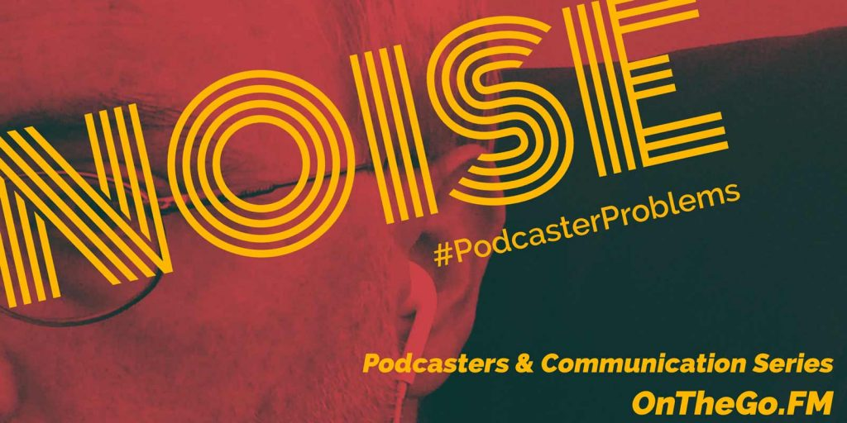
This brings me to “NOISE”. (e.norris, 2016)
What is noise, noise can be anything from interference during a telephone call which means the receiver aren’t getting the correct information that you’re trying to tell them. There are 5 types of noise when it comes to communication, physical noise, physiological noise, psychological noise, syntactical noise, cultural noise. Noise can occur at the begging middle or end of communication, the different types of noise then have an effect of how we give or receive information in all formats, information sent by letter, text or email we can go back to read over them, but it still plays a part. In my opinion noise plays the biggest part in live communication face to face or telephone call as it in the here and now, no pause to pay back this is when information or instructions can get misinterpreted. (kobiruzzaman, 2019)
One of the biggest factors for me is myself, my own noise, I am my own distraction. Granted I’m not the only one that does this by me, we have humans, people living very busy everyday lives we zone out sort of speak lose our trail of thought forget where we left off.

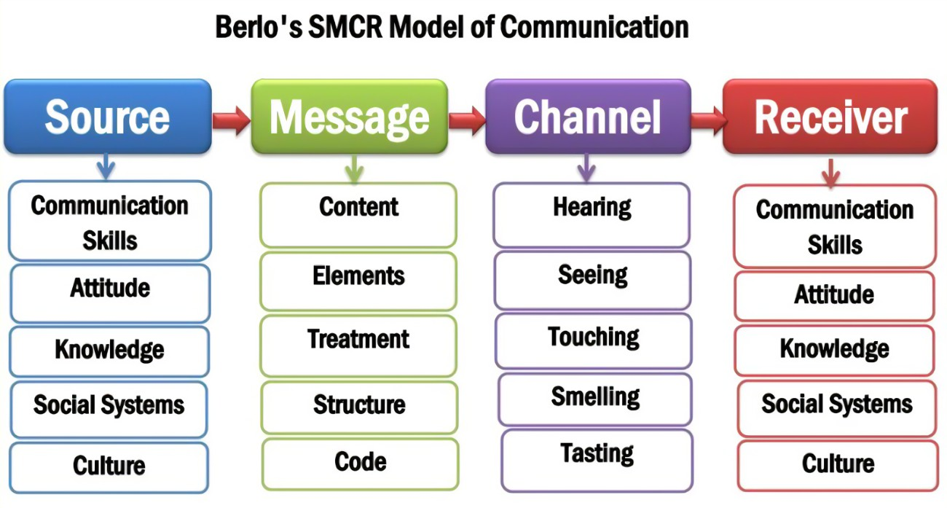
(archives, 2021)

Berlo’s SMRC model of communication, in 1960 David berlo took Sharon and weavers communication model and simplified it, he showed the different categories that would fall under source, message, channel and receiver. he believed that each model had factors that helped with having effective communication and relaying important information.
Looking at Berlo’s SMRC model, it gives you more of an understanding and to how to communicate to people using different skills. The source of the communication plays the biggest part this. The source is the one giving the information and how this is given will affect how the receiver, receivers it. Has the source of the information been given correctly has their attitude send off the correct tone of voice of how this information is meant to be received? Has the source got enough knowledge to structure the message so it can be reived correctly by the receiver?
All these little things play the part in communication, and how we get vital information across to colleges, students, family.
Berlo, D. (1960).
(SMCR model pf communication, 2021)

2.0

Assessing Own Communication Skills as a Manager

My own communication skills do need some work I will admit. I tend quickly write an email back I don’t proofread it, that’s my first mistake. I also tend to read my emails and forget to respond. Another communication error I have been working on is once I have spoken to a store or manger within one of my offices, with instructions on how I would like things to happen going forward or what needs to change to increase sales, I don’t send a follow up email explain what we have just spoken about. I have started to do it and I found that helpful as they have a written step by step to do list they can refer to when needed. When writing instructions of new procedures or information I need sent to me, memo notes on the company’s what’s app group I tend to take my time simplify the wording and what I want them to do as its going out to 200 people, and the last thing I need is 200 phone calls for something that’s easy to complete.
I have a few examples of poor communication within my workplace, this is where higher management don’t understand the process or aspects of my job and role and try to tell other employees what do in the office or say that’s not important, this resulted in figures for the stores sales being handed in late. Another is where no one in upper management communicates with one another about staffing, sickness, new procedures instore/ office. So, no one in store can devise what they are meant to be doing for example, in one of my offices they don’t have an option to pay out any money from till the except for lottery, a lot of staff within the company get their fuel paid, so they were told to put the fuel though as a lottery pay-out and keep the receipts so this can be cauterised during the banking procedure. They were then told to cash the fuel off for employees which resulted in the tills being down large amounts which them opened an investigation as it looked like theft. It was then told to them to revert to the old way of paying it out as a lottery prize. And of course, this information seems straight forwards, but the area manager didn’t tell the store a manger of the change he told a member of staff which has to relay the information, to which they had the response of I’ve been told by area manger to cash it off. No email was sent for clarification, no actual instruction from management was given to employees.

Presentation feedback
I recently had feed back from my peers for my presentation on communication and reading the comments on what went well and what needs improvement. Please see appendices I have colour charted the feedback from to reflect everyone view and added their comments.
I have had strong feedback that I wasn’t expecting as you can see from my PDP, I felt I needed to work on speaking clearly and being more organised, I will take on all the comments made I also agree with most of them, all this I can do. this will improve my communication and make sure I reach out to everyone. I few things I hadn’t taken into consideration was the font colour and size I also really need to work on my referencing as well. This feedback has shown me I have room for growth to improve my skills. My overall feed back gave me good/ excellent reviews which I am pleased with.

Gap Analysis

Objective | Current Position | Deficiency | Action
What do I want to do? | What can I already do? | What am I lacking? | How do I fix this?
I want to be able to communicate effectively | I communicate now using telephone, email, and text message. | Time, I tend to rush as I always feel pushed for time. | Slow down, think what I need and want to say.
Have all the correct answers to any questions relating to my field. | I can find out answers and relay information or | Actual knowledge | Learn as much as I can
Fulfil my new work roll effectively. | I can process orders, check on deliveries | Knowledge and training | Go on as many courses as possible and learn as many new tasks as I can.

PDP

Personal Development Plan to Improve own Communication Skills

Objectives | Tasks | Success Criteria | Time Frame | Resources
List your Goals | What do you need to do to achieve these goals? | How will you identify your success? | When do they need to be done by? | Who or what do you need to help you?
Start communicating effectively, telephone to email. | Act on the situation as it arises. Write email follow ups | By having feedback or less calls asking me to explain what I said. | This is ongoing no actual time frame. | No actual help in doing this but support from staff members to complete tasks.
Break down information for colleges remember who I’m writing or speaking to. | Simplify information to accommodate everyone. | More people will understand and not have to ask for help or explanations. | No time sale. | Again, staff support and product knowledge.
Talk slower | Speak clearly and slower so people have the chance to listen | Wouldn’t be repeating myself. | No time scale ongoing | stop rushing, think before speaking.

References
Berlo, D. (1960). The process of communication. Rinehart, & Winston.
Shannon, C. and Weaver, W. (1949) The Mathematical Theory of Communication. Urbana: University of Illinois Press.
(SMCR model pf communication, 2021)
(p, 2021)
(kobiruzzaman, 2019)
(e.norris, 2016)
(archives, 2021)
MindTools (2021)
(chun, 2015)

Appendix A

Presentation Evaluation Sheet
Module: BMSK4002
Topic: Effective Team working
Date 20.03.22 | Name of Presenter: Natasha Mitchell
 | Feedback
 | Weak | Fair | Good | Excellent
Prepared for Presentation |  |  | X | X X X
Presented in an interesting way |  |  | X X | X X
Objectives of the presentation are clear |  |  | X X X | X
Used visual aids effectively |  |  | X X X X
Organised the presentation logically |  |  | X X | X X
Spoke loudly enough |  |  | X | X X X
Spoke slowly and clearly |  |  |  | X X X X
Presented within appropriate time |  |  | X | X X X
Responded to questions accurately |  |  | X | X
What can I do better next time?  - Check for spelling/typos  - Possibly using actual workplace examples (anonymised)  - Use correctly formed references with APA system  - One of the slide designs (5 stages) have cut off some of the information.  - Personally, white text is harder for me to read as a dyslexic and the text size is small in places.  - Use of tables for comparison to compare good from bad.  - More colourful presentation slides  - More muted colours for academic presentation. | What went well?  - Interesting information  - Obvious understanding of topic  - All relevant areas covered  - Good explanations of theories  - Examples provided throughout  - Calm, relaxed, confident speaking voice  - Spoken clearly and confidently.  - Tone of voice and speed was easy to follow alongside slides.  - Slides are interesting and put together well.  - Good use of diagrams and images.  - Colourful and captivating.  - Spoke clearly and at an appropriate speed  - Obvious understanding of the Topic  - Was not scripted and explained theories using examples.

Communication Style Questionnaire
This questionnaire is designed to help you assess your preferred communication style.
Thinking about your behaviour at work, write a score against each statement to represent which best typifies your behaviour where
4 = agree strongly, 3 = agree somewhat, 2 = disagree somewhat, and 1 = disagree strongly.
As with all questionnaires, the level of your honesty and self-awareness will impact on the accuracy of the outcome…so, be truthful to yourself!

- I express my opinions in an honest and appropriate manner. 3
- I can get angry and let this show. 1
- I find it difficult to say ‘no’. 2
- If I do not agree with a task that my boss has given me, I find a way of dragging my feet on it. 4
- I feel comfortable in asking for help from someone if they know more than me. 4
- I feel guilty if I leave on time for a valid reason and other people are still working. 4
- I can be sarcastic. 4
- I think my way of doing things is better than other people’s. 2
- If someone takes advantage of me, I find a way of evening the score. 2
- I feel I have a right to say no to other people’s requests and to negotiate a compromise. 3
- If I am in a large meeting, I find I do not speak up. 2
- I like to be in control of a situation. 3
- I stare people down. 1
- I make good eye contact with other people. 2
- If I am unsure about a task that I have been given, I find it uncomfortable to ask for help. 1
- I talk about other people behind their backs. 1
- When I have to deal with someone in authority, I find it difficult to look them directly in the eye. 3
- I am a good listener and equally other people listen to what I have to say. 3
- Rather than confronting someone about an issue, I would rather give them the cold shoulder or drop hints to other people that I am not happy. 1
- I am not afraid to be direct with someone, even if they think I am being rude. 3

Self-Assessment: Results

To assess your preferred communication style, transfer the scores you have given to each statement to the boxes below.
Then total each column downwards.
Look at the column where your score is the highest.
This is the communication style you use most of the time.

Q1  3 | Q3  2 | Q4  4 | Q2  1
Q5  4 | Q6  4 | Q7  4 | Q8  2
Q10  3 | Q11  2 | Q9  2 | Q12  3
Q14  1 | Q15  1 | Q16  2 | Q13  1
Q18  3 | Q17  3 | Q19  1 | Q20  3
Total  14 | Total  12 | Total  13 | Total  10
Assertive | Passive | Passive Aggressive | Aggressive

