Name: Zena Samuels
Student No: 2408720
Module: LCLM 5003 Project Management
Lecturer: Kareem Sani

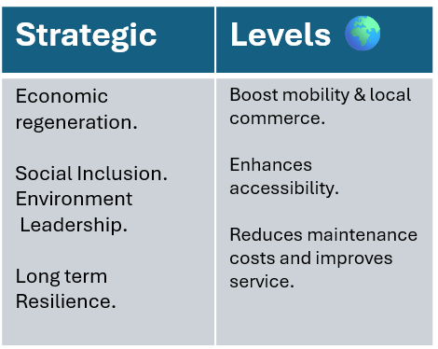
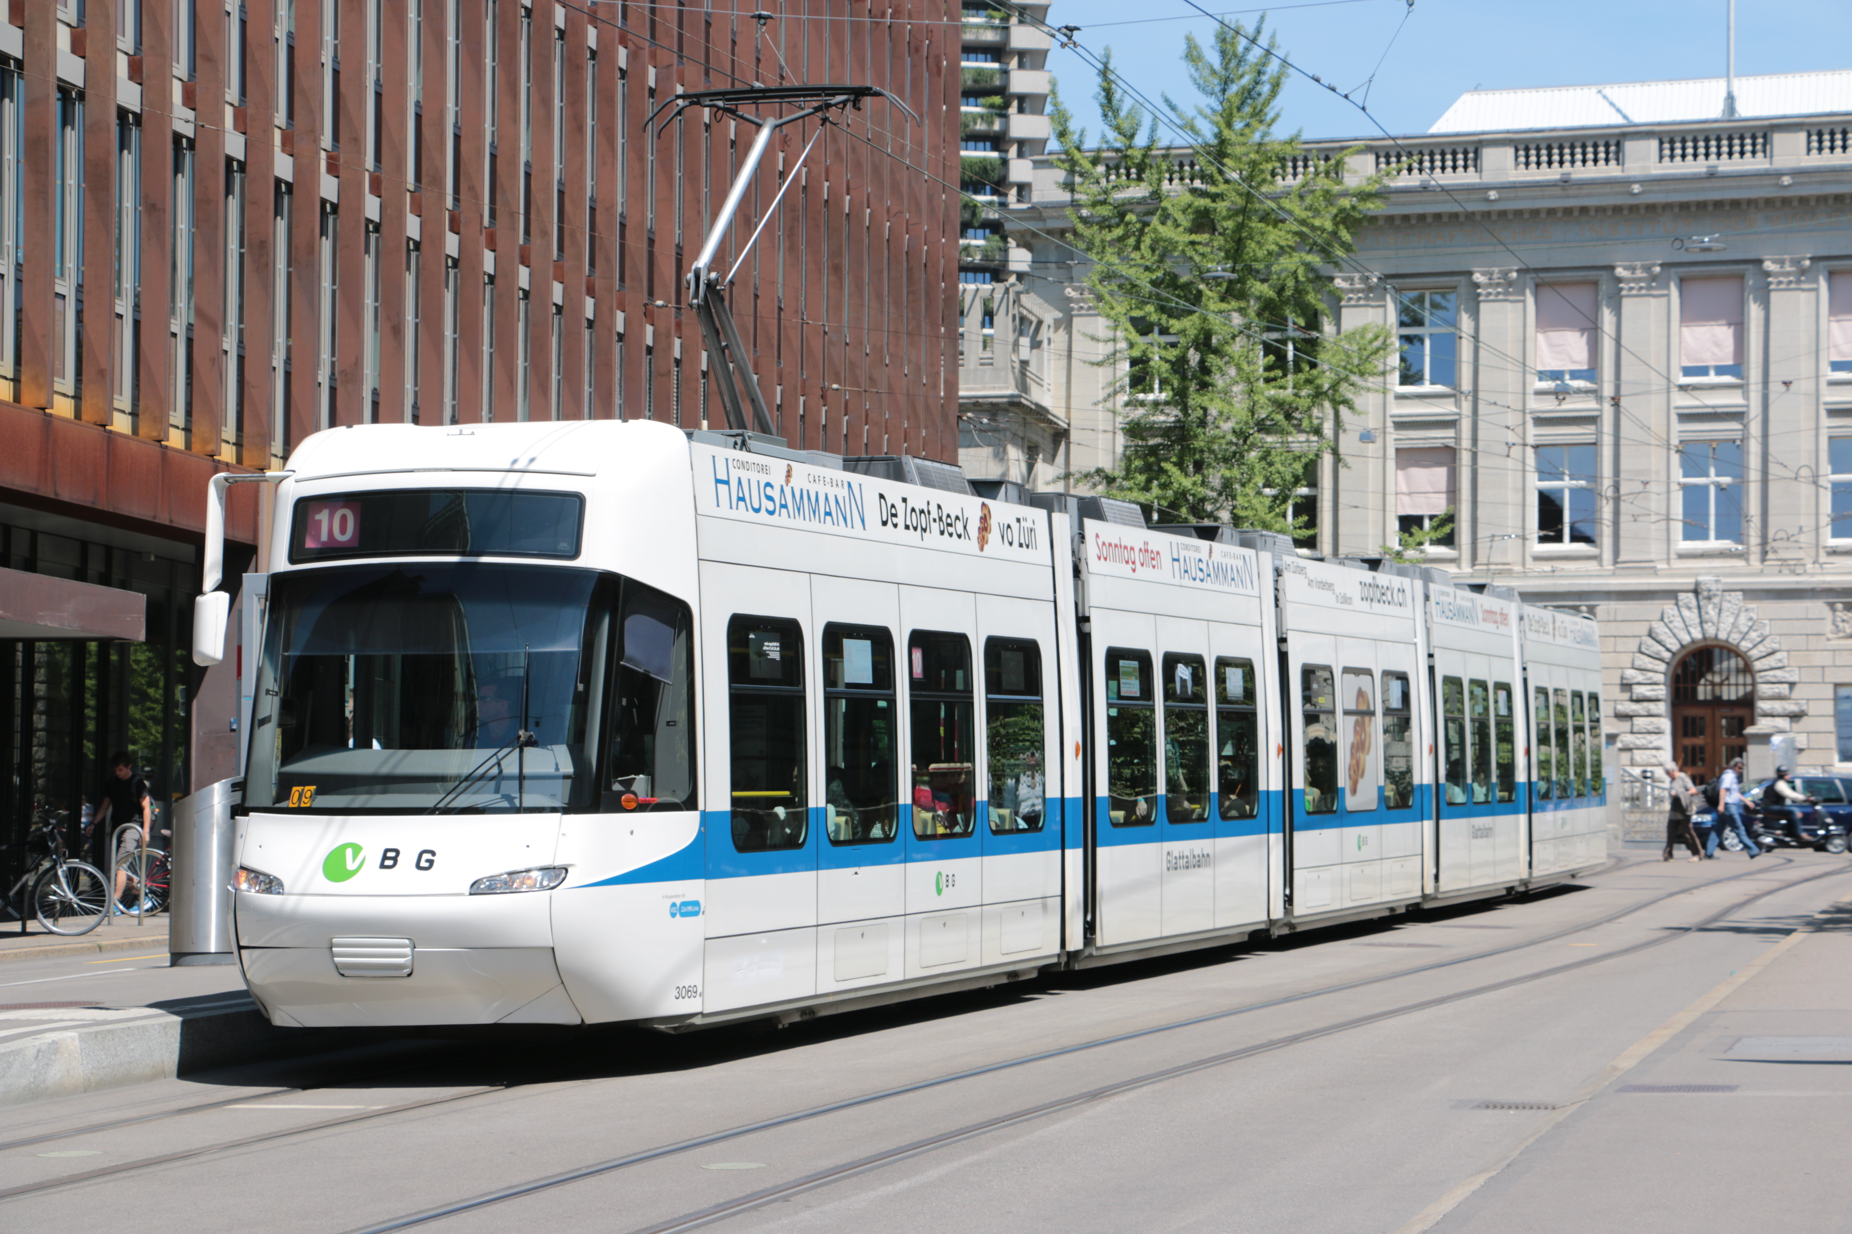
PART A:

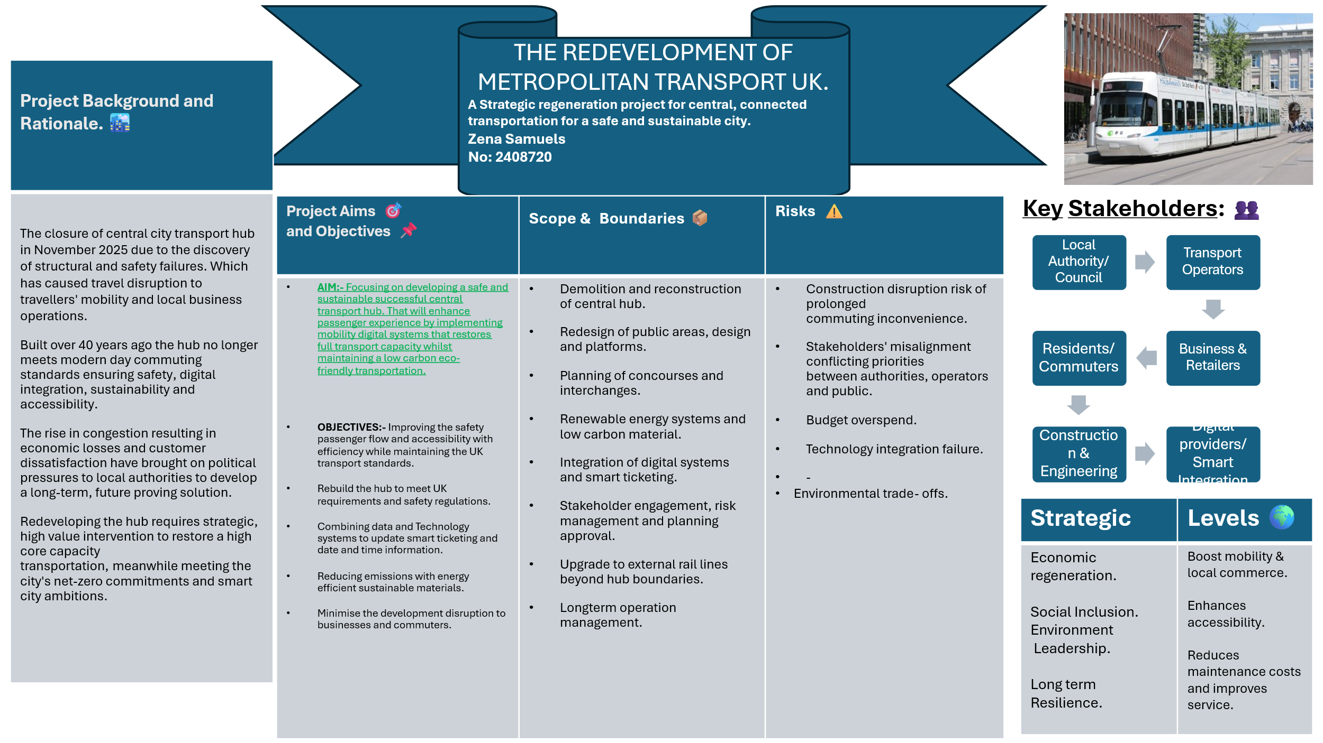

Part B:
THE REDEVELOPEMT OF METROPLITAN TRANSORT UK, CRITICAL EVALUATION.

The feedback given from my tutor and peers has highlighted valuable insight in what I need to focus on, the strengths and initially what is required taken from my poster working towards the final development of the central Metropolitan transportation project plan. Including the key strengths highlighting the needs and clarity of the development.
Stakeholders should fine the layout easy with clear structure to follow with each section defined clear for clarity of the development and professional expectations the decision of the redevelopment was noted that the justification is strong with a clear strategic focus on creating a safe sustainable digitally enabled transport hub ( Bahadorestani, A. et al 2020). Understanding the long-term value then short-term fixtures. With all possible objectives appropriately addressed whilst minimizing redevelopment disruption. The integration environmental sustainability of smart digital ticketing was also noted as a good understanding of future thinking that aligns with the priorities of modern time transportation and regeneration.
Along with the identification of key stakeholders the feedback given indicates the awareness of the wider economic, social and diverse groups that can be affected by the project. With the addition of risks and trade-offs into consideration with analysed greater depth and more mitigation strategies, shows the strategic and possible challenges in the realistic daily commuting that may occur.
Certain areas of the project were identified to strengthen the digital infrastructure work further. Suggesting that providing a clear SMART format including measurable targets and time scales (Kerzner, H., 2025). With scope and boundaries benefiting a clearer separation between project deliverables and exclusions with the greater enhancement of project management tools including stakeholder power- interest matrix, risk heat map and work break down structure (WBS). According to tutor feedback by applying these should strengthen the evidence of project management knowledge. Overall peers feedback felt that this area could be more detailed noting what has been excluded focusing on accurate planning and risk management that will support the project development plan.
I also improved the visual of the poster making the content strong with visual colours icons and elements easier to identify and suitable to present and for stakeholders to get a better point of view and understanding.
Overall, the feedback given states a good poster that addresses the key assessments. This has given me a clearer outlook to provide enhancement to the final redevelopment of the project focusing on stronger management methodologies, critical analysis, scope precision and measurable project objectives.
Part C:
Project Management Plan
Introduction

Now that one of the major city’s has closed the central transport hub in November 2025 a demanding need for the city’s transport network requires coordinated regeneration. It is the Metropolitan transportation interchange linked to trains buses and freight logistics. With the hub shutting down means that disruption has been caused to commuters using this route. And even weakened business local to the area and supply chains. With the structure being 40 years inspections show that the central system is no longer safe and meets accessibility and the operational standards which now requires a project management redevelopment.
By Implementing a project management plan will highlight the engineering, techniques in line with governance structure to deliver the successful completion of the project (Andersen ES, et al.,2025) by combining systems, techniques and people to complete the central hub within the established goal time frame and budget to complete the project with quality (Baker and Baker, 2014).
This will involve project management methodologies ensuring a controlled, structured and stakeholder aligned process, the project manager plan includes the work process break down structure the scope, a quad chart stake holders involved and importantly risk management and resource allocation.
By noting a PMP it will give stakeholders clarity and transparency with confidence of how the updated plan will be implemented successfully.

Project Description

The redevelopment is the reconstruction of modern time transportation hub based in central UK to restore full operational capacity with safety. Ensuring it is future proof for the city’s mobility. The project intends to deliver updated digital infrastructure loT cloud platforms, smart ticketing and environmentally sustained transport interchange that supports connectivity while considering alignment with net zero objectives (Chrysovalantis, et al., 2025)
The project should be done with resource planning, supported with stakeholder engagement and risk management enabling step by step construction minimise disruptions.
Features of the redevelopment required are:
A structural design plan compliant with UK transport and building safety regulations.
Integration of digital systems, cloud systems, smart ticketing, sensors real time passenger access and coordination platforms.
Updated features including inclusive signage, firm paving, with improved passenger circulation.
Connections to all rail networks, bus, cycling pedestrians and freight services.
Central hub Scope
The in scope of the project

Begin project with full demolition and reconstruction of the transportation hub.
All digital infrastructure to be installed for smart ticketing and loT sensors.
Environmental and sustainable design features.
Multimodal transport improvements for bus and rail connections, electric vehicle charging.
Engagement with all relevant stakeholders.
Operation plans with all required staff training.

The out scope of the project

Policy and city transportation changes
Redevelopment of the road beyond the perimeter of the hub
Network installation exceeding the boundaries of the hub operation.

Managers must assess any proposed changes particular with the time, all costs, safety and risk management with aligned projects in controlled environments management methodology prior to any approval. Stakeholder engagement in the project will maintain constructive relationships within the project, (Fageha, M.K. & Aibinu, A.A., 2013) maintaining transparent communication involving key players keeping expectations aligned that will lead to less unplanned scope adjustments.

Work Breakdown Structure (WBS)

Step 1:
Redevelopment of the hub in phases will entail:
Project Initiation
Project development
Stakeholder Identification
Establishment of governance
Procurement strategy development

Step 2:
Planning Phase
Design development to detail
Review environment and accessibility
Planning of digital infrastructure
Planning of risk management
Communication and engagement

Step 3:
Construction phase
Prepare site for demolition
Begin foundation and structural work
External and roofing
Internal construction and fit out
Accessibility installations
Install sustainable systems

Step 4:
Digital Integration
loT sensor control
smart ticketing system
passenger flow analytics Integration
coordination platform setup

Step 5:
Testing and Commissioning
Safety inspections
Testing of digital systems
Accessibility compliance testing
Operation trials to ensure the system is ready

Step 6:
Handover and Closure
Staff Training
Documentation and Handover
Final stakeholder review
Project closure report

For the redevelopment work breakdown structure, we will be focusing on the planning in the early phases in a step-by-step process to the final evaluation and review in the later phases of the project. The (WBS) will make the phase tasks definable making each phase easy to understand, independent with minimum interfaces, estimate able focusing on time and costs, measurable so that the progress is easily captured and adaptable making tasks easy to add or to be eliminated (Cretu, V.G.,2025)
This will breakdown large task in each phase making the tasks manageable avoiding missing out on what is important with good planning and scope control defining the project will map out the requirements when it comes to deliverables, clearly preventing any unexpected additions. Improving estimates making it easy to guess the timing of the project the labour and money needed, which allows management to add up costs from an accurate budget total.
By dividing the goal of the project into small areas will make the planning of the redevelopment easy to plan and track using the (WBS) method. (Suvvari,. M.S. K & Jarubula, S.R., 2024).

Central Hub Quad Chart

Project Overview  Redevelopment of the updated central transport hub restoring transport capacity.  Integrate digital s  Redevelopment systems and meet net zero objectives. | Key Deliverables  Implementing a new transport hub building with modern digital infrastructure, accessibility and sustainability systems, multichannel connectivity improvements.
Risks and Challenges  Construction delays, commuting delays, budget overruns, stakeholder disapproval,  Regulatory approval delays. | Benefits and Strategic values  Improved transportation, economic recovery, public satisfaction, future proof infrastructure.

The Quad chart will be used to introduce the project highlights what is important when it comes to making quick, reliable evaluating decisions and solutions. It notes down main goals and core concept ruling out or getting a problem solved.
It gives what is expected on the project, return on investment made, bringing the project to its advantages. It gives tram members and leaders a shared easy to note view of the current status of the project giving clear focus, organizing tasks and risks into separate boxes aligning everyone involved in the project on the goal we strive to achieve (Tague, N.R.,2023).
.

Gantt chart

Phase Action | Month 1-2 | Month 3-6 | Month 7-22 | Month 18-23 | Month 23-25 | Month 26
Initiation
planning
Construction
Digital Integration
Testing & commissioning
Handover & Closure

The Gantt chart is a useful tool that will be used for a visual project management update on the redevelopment of the transport hub and allocate resources. Allocating each phase process over a scheduled time span, to identify the progress at the start of the redevelopment to the final finish (Wadhwa, k.,2024). By adding shading or percentages within the task chart it highlights where we are at in the redevelopment. Showing the progress made and what still needs to be completed within the expected time frame.
This will ensure that the redevelopment is met during the expected date of completion avoiding delay overruns and to keep the stakeholders informed on the current phase of the project identifying any allocated resources needed while keeping on track of the project schedule.

Stakeholders' involvement
Stakeholders' engagement is crucial for the success of the project.

The Primary stakeholders include:

Local authorities, for project governance and funds approval.
Transportation operators, for the input of any requirements and operation readiness.
Contractors, delivers physical infrastructure.
Digital dashboard providers, with installation of all smart systems.
Residents / businesses, consultation for redevelopment disruption
Transport commuters, with feedback and accessible needs.
Environment group ensures sustainability requirements.

Performance engagement
Monthly stakeholder meetings
Realtime project updates
Report of any formal change control meetings with governance

The stakeholder's engagement strategy process of the stakeholders identifying and analysing the redevelopment, collaborating with groups that can have an effect on the project. All stakeholders involved are expected to attend monthly briefings and formal change- control meetings with governance board and keep public consultations at key milestones. With digital dashboard for real time update on the project, engaging with key involvement yield insight, having proactive communication and collaboration reduces any resistance.
Active stakeholder engagement delivers better decision making and proactive risk management on the redevelopment of the project building stronger trust and reputation (Shih-Weh, et al., 2023). It will help prevent costly scope changes to align the goals of the project with stakeholder needs.

Allocation of Resources

The redevelopment project resources are Human Resources, involving:
Project Management
Assistant project management
Construction management
Technology / Digital team
Sustainable consultant
Finance Officer
Communications
External contractors

Technology Resources Include:
Project Manager software
Smart ticketing devices
Digital stakeholder reports

And allocation of resource management approach gives optimal utilisation of monitoring through a weekly and monthly basis (Allu, et al., 2024). Human resources will guide the way through the redevelopment process with appropriate planning ensuring the required skills, job roles and reporting lines are in place preventing any issues or liability during the project process.
Human resources are a core part of the project developing the team by providing the relevant training required and team building for better performance. With keeping on track of each task giving feedback and fixing any conflicts that arise. Having strong project HR management skills can help manage project resources, budgets, timelines and people.
This will encourage the team with added training bringing in new skills and talent, HR communicate effectively with the team and stakeholders. With planning and implementing the right training improves team bonding, enhancing change and management decisions. HR in project management help in the proper resource planning for project management, which can help HR utilize human capital, finances and budgets effectively (Belas, J. et al., 2024). Common objectives help the employees complete their tasks with the redevelopment to achieve strategic goals of the final project. The benefits of Project management and human resource management improve the resource allocation.

Risk Analysis

RISK | IMPACT | LIKELIHOOD | MITIGATION
Budget overruns | High | Medium | Contingency funds and valued engineering
Construction delays | High | Medium | Monitoring contractures performance
Regulatory delays | High | Low | Early submission compliance and operation reviews
System failures | Medium | Medium | Ontime testing and collaboration
Supply chain resistance | High | Medium | Multiple suppliers
Stakeholders' resistance | Medium | Medium | Transparent communication and planning

Having a PM approach in risk management approach is highly important, to reduce the impact of delays and any possible lawsuits. The project must include weekly risk review meetings with escalation to the high project boards to minimize any high severe risks (Kerzner, H., 2023). Doing a key performance indicator will monitor the daily progress of the project. With the help of project management and HR any risks should be identified quickly to implement strategies that will prevent any risks to avoid further disruption during the redevelopment operation.

Metropolitan UK Redevelopment Conclusion

Restoring the central transportation hub is a major project with critical infrastructure that will achieve to restore the commuter's transportation capacity, support economic growth and enhance travel safety with following national sustainability and modern digital needs.
The project manager plan includes having a stakeholder engagement with transparency approval, with a structured project management and HR management plan.
With a defined clear scope and firm risk management and allocation of resources, the project will deliver to its expectations providing a strong stake holders engagement and to ensure all strategies are aligned to the project to achieve the group goal of the new safe and improved Metropolitan transportation hub.

References

Allu, S.R., Bhaumik, A., Ramakrishna, A., Lakavat, M., Allu, H. and Chandini, S., 2024. A Critical Review of Resource Allocation Optimization in Project Management. International Research Journal on Advanced Engineering Hub (IRJAEH), 2(06), pp.1855-1861.
Belas, J., Dvorsky, J., Hlawiczka, R., Smrcka, L. and Khan, K.A., 2024. SMEs sustainability: The role of human resource management, corporate social responsibility and financial management. Oeconomia Copernicana, 15(1), pp.307-342.
Andersen, E.S., Grude, K.V. and Haug, T., 2025. Goal directed project management: effective techniques and strategies. Taylor & Francis.
Bahadorestani, A., Naderpajouh, N. and Sadiq, R., 2020. Planning for sustainable stakeholder engagement based on the assessment of conflicting interests in projects. Journal of Cleaner Production, 242, p.118402.
Chrysovalantis, P.I., Stylianos, K., Evangelos, N., Fotios, Z. and Grigorios, K., 2025. A comprehensive evaluation of IoT cloud platforms: A feature-driven review with a decision-making tool. Sensors, 25(16), p.5124.
Cretu, V.G., 2025. Features Of Implementing a Work Breakdown Structure in Multidisciplinary Projects. Emerging Frontiers Library for The American Journal of Management and Economics Innovations, 7(8), pp.106-114.
Fageha, M.K. and Aibinu, A.A., 2013. Managing project scope definition to improve stakeholders’ participation and enhance project outcome. Procedia-Social and Behavioral Sciences, 74, pp.154-164.
Kerzner, H., 2023. Project management metrics, KPIs, and dashboards: a guide to measuring and monitoring project performance. John wiley & sons.
Kerzner, H., 2025. Project management: a systems approach to planning, scheduling, and controlling. John Wiley & Sons.
Tague, N.R., 2023. The quality toolbox. Quality Press.
Shih-Wei, W., Yan, Y., Pan, J. and Wu, K.S., 2023. Linking sustainable project management with construction project success: moderating influence of stakeholder engagement. Buildings, 13(10), p.2634.
Suvvari, M.S.K. and Jarubula, M.R., 2024. Project Management and Software Engineering. Academic Guru Publishing House.
Wadhwa, K., 2024. The Role of Gantt Chart in the Project Management.

