

Student name: Erkan Paca
Student ID: 2010132

Module name: Introduction to Research
Module code: BMHP-5005
Lecturer name: Dr Eleni Koutsogeorgou

Table of contents

Contents
Table of contents 2
1. Introduction 3
2. Background 3
3. Methods 5
4. Results 9
5. Discussion 11
6. Conclusion 14
References 14

Introduction

This study is about Prevention methods, strategies and the risk factors for prostate cancer for older/adults in the UK.

Aim
The study aims to establish and explore what risk factors are significant in prostate cancer for British males in the UK and what methods of prevention measures are used to achieve that prospectively.
Objectives
This will be achieved by examining and evaluating primary research articles on the impact of PSA testing as early intervention, prevention, how specific foods consumption can connect, how lifestyle factors can be a determinant in prostate cancer and suggest a relevant recommendation prospectively.

2. Background

The rationale of the research Prostate cancer is the second most deadly life-threatening disease after lung cancer that affects males around the world, adding 1.276.106 new episodes that are resulting in 358.989 death (3.8 % of all fatalities resulting from cancer in men) (Bray et al., 2018) (Ferlay at al, 2019) The prevalence and fatality of the disease in men worldwide correspond with growing age to the estimation of 66 years old when they were clinically diagnosed.
(Image by Microsoft Bing)

The UK version of prostate cancer is also alarming in British males, with 40.300 episodes identified in 2015 (ONS, 2017). Although the philosophical study of the causation of prostate cancer is not well acknowledged, the risk factors such as age, ethnicity, and the family history of the disease are not alterable either. (Cuzick et al., 2014). Nevertheless, based on the evidence, the flowing insulin-like advancement factor- I (IGF-I) is determined by environmental impacts connected with a high level of prostate cancer threat. (Travis et al., 2016). And the recent presumptive study by ‘World Cancer Research Fund’ stated that adiposity is likely connected with a high prevalence of assertive prostate cancer. There is not enough empirical proof for the other type of lifestyle-related threat components. (WCRF/AICR, 2014). Proportionately high interpretation in prevalence ratio around the world predicts that the variations in subjection to environmental aspects may have a part in prostate cancer progression. Nevertheless, some of these changes are because of the characteristics of countries’ prostate-specific antigens (PSA) examination (Ferlay et al., 2015).
Many episodes progress in men aged 50 or older. However, discrepancies in prostate cancer are still unknown but are more widely identifiable in black men and more minor cases in Asian men. Men whose father or brother had prostate cancer are considerably more at risk than others who have no family history. Current studies also suggest that adiposity maximises the threat of prostate cancer. (NHS, 2021).
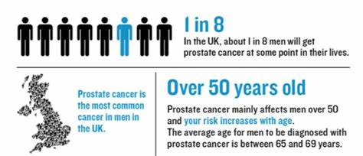

According to NICE (2021), 50% of prostatic malignancy cases identified within the UK each year were people aged 70 years and above (2012). Moreover, the prevalence ratio is high in communities that are 90 years and over (2012 to 2014). Figuratively 10/4 of prostate cancer episodes have been identified at the last phase in England (2014) and Northern Ireland (2010 to 2014). Prevalence figures were forecasted to increase 12% between 2014 and 2035 within the UK, to 233 episodes each 100,000 in 2035.
84% of individuals are 60 to 69 years identified in 2010/2011 forecasted to get through for ten or above years. When placed at the primary phase, effectively all people with prostate cancer pull through five years or more; this has corresponded with less than a third of people surviving five years or more when identified at the last stage.
There were roughly 11,000 individuals who lost their lives to prostatic malignancy in 2014. Fatality figures from prostate cancer are high in people aged 90 years and over (2012 to 2014). Over the past decade, fatality figures have reduced by 13% in the UK. Mortality rates are forecasted to reduce by 16% between 2014 and 2035 to 48 deaths per 100,000 people in 2035.
Individuals with an Afro family ethnicity are at high threat of prostatic malignancy (lifetime risk of 1 / 4). Prostatic malignancy is conversely to poverty, along with a high prevalence of episodes established in the more prosperous region of the UK.
Expenditure for the inpatient therapy of prostatic malignancy is predicted to go up to £320.6 million per year in 2020 (from £276.9 million per year in 2010).
Advancements in X-raying, particularly multiparametric MRI, have guided changes in the application, and new verifications related to prostate cancer therapy mean more guidance needs to be in place.

3. Methods

A systematic literature review was conducted with a thematic analysis of the topic explored. A literature review produces a critical understanding of specific educational subjects. It composes an announced exploration of a subject, observes contrasting studies of resources, and a detailed examination of these resources. A published article analysis may be contentious, integrable, recorded, organised, or conceptual. These points of view may be embraced and determined by the types of surveys in specific research. (Jahan, Naveen, Zeshan, 2016)

Inclusion Criteria;
- Using the databases of ProQuest and PubMed.
- Research articles published in the last ten years (2012-2022).
- The language is English.
- Type of documents researched; Peer review articles.
- Geography (Location); UK.
Exclusion Criteria;
- Dissertations, books, magazines and publications that are ten years old.
Conducted keywords for the researched articles were prostate cancer, screening, prevention, risk factors, older/adults, UK, United Kingdom.
The NHS Prostate Cancer Risk Management Programme (PCRMP) enables General practitioners and primary care workers guidance to advise people showing no sign of physical sign of medical issues, men who are 50 and above who seek to find out the Prostate Specific Antigen (PSA) examination for prostate cancer.
PSA examination screen to discover where prostate cancer is located so that appropriate therapy can be applied to heal cancer or increase the lifespan.
The threat multiplies for males 50 or above when a person gets older. Family history aspects, particularly close ones like a father or brother, are significant. Black ethnicity is more susceptible than Caucasian men.
PSA examination and prostate cancer progression;

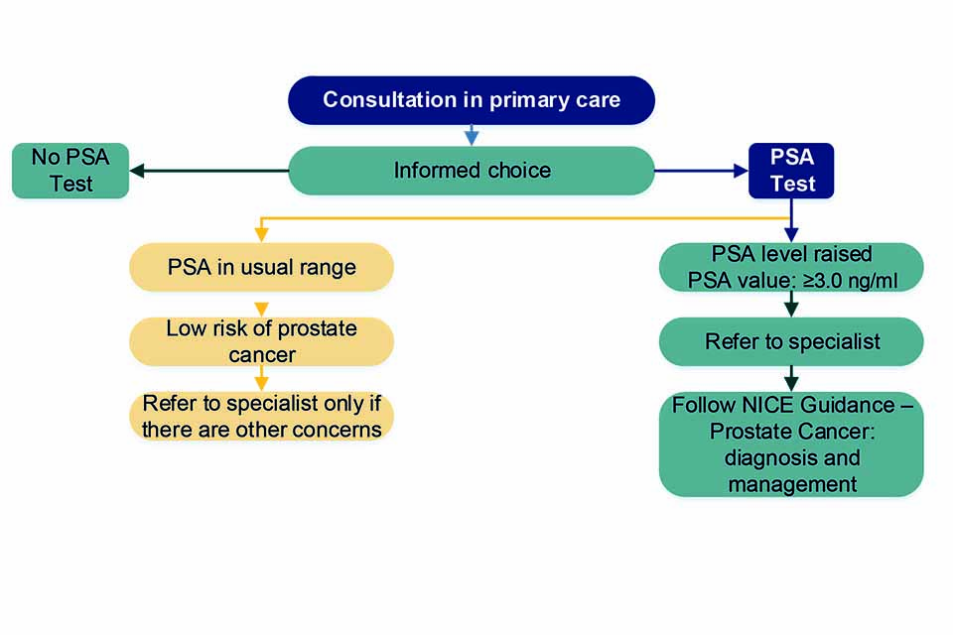
There are ratios above three ng/ml (PSA) where GP’s counsel is involved.
According to NICE guidelines, the ‘Digital Rectal Examination (DRE) advises including these procedures to manage prostate cancer as an intervention method for prevention and ‘multiparametric’ biopsy and therapy plan as effective monitoring prostatectomy and radiotherapy brachytherapy, hormone treatment. (MRI) (MP-MRI). (GOV. UK, 2020). According to outcomes from the largest ever examination carried out by Cancer Research UK-funded scientists at the University of Bristol, males with no symptoms of a one-off PSA* test for prostate cancer do not save lives.
Researchers at the Universities of Bristol and Oxford discovered that examining symptomless males who are not exhibiting any sign of PSA indicates ailments not likely to create any destruction and skips any destructive and fatal prostate cancers.
The ‘CAP Trial’, which covered nearly 600 GP practices in the UK and involved more than 400,000 men who are aged 50-69, is a sizeable examination at any time to look into prostate cancer filtration. The study collated 189,386 men who were called in to have a one-off PSA test with 219,439 men who were not called in for filtering.
After a median of ten years of checkout, there were 8,054 (4.3 per cent) prostate cancers in the filtered group and 7,853 (3.6 per cent) cases in the controlled group. Essentially, both groups obtained the same ratio of men dying from prostate cancer (0.29 per cent).
There is no national filtering system for prostate cancer in the UK. However, this can be requested from your GP if you are 50 and above.
Dr Richard Roope, ‘Cancer Research UK’s GP specialist, has informed that "The PSA test is an ineffective mechanism lacking the nuance of the ailment and create suffering for males.
"This examination clarifies the necessity to discover more precise systemic devices if we want to rescue males' existence.

Cancer Research UK's guidance for males is:
- If males don't have any indications or are concerned about prostate cancer, we recommend they should discuss the pros and cons of a PSA test with their GP.
- If males are showing indications, it's advisable to consult. Your GP is still a crucial place to take advice for. Therefore, visiting the GP is recommendable for preventing cancer. (University of Bristol, 2018)

According to (Martin et al., 2018), In this particular randomly experimentation, males who are 50-69 years undertaking one PSA filtering against the neutral ones with no PSA filtration. The percentage of males identified with prostatic cancer was more excessive in the involvement cohort than in the other controlled group (3,6%). Nevertheless, there was no significant differentiation in prostatic cancer fatalities. (0,30 per 1000 individuals against 0,31 control cohort) after an average check-out of ten years.

Despite all the various studies conducted, a large portion of it still endures unspecified. The well-known peril components in connection with prostate cancer include age, ethnicity, genomic elements and family history, and other risk aspects influencing prostate cancer, including dietary consuming saturated fats, red meat, and low -consumption vitamins, as well as leafy greens and coffee, adiposity, sedentary, infection, high blood sugar and being exposed to chemicals or electromagnetic rays. ‘The Derby National Research Ethics Service Committee East Midlands’ (formerly the Trent Multi-Centre Research Ethics Committee) approved discovering fatality and cancer prevalence and evaluating service users' health information for prostate cancer. Permission for learning males in the control and engaged group without a person's consent was gained by the UK Patient Information Advisory Group (now the Confidentiality Advisory Group) under 251 of the National Health Service Act 2006.
Permission granted from the UK Patient Information Advisory Group permitted evaluation of the health pieces of information for males who ceased of a reason potentially related to prostate cancer before consent could be acquired. Men who underwent PSA testing in the intervention group gave personal data permission. All clinical headquarters had regional evaluation governance approval. Bristol University performed as the research supporter (the institution has taken total management).

4. Results

According to Littlejohns, Travis, Key et al. (2016), in the first article on how lifestyle factors contributed to prostate-specific antigen (PSA) examination in UK Biobank. Research and the suggestions for the purposed epidemiological study examine the risk components. Social and demographical, lifestyle, dietary and health attributes affecting prostatic cancer are connected with PSA examination as an early intervention in a predominantly middle-aged population, which robustly suggests the age connection in a cohort study among 65-70 years versus 40-44 years ratio in the UK. Wide range of community-centred accomplice research on age, region, family history, ethnicity, employment, lifestyle factors such as smoking, alcohol consumption, BMI Index height and private medical care. These discoveries are significant because PSA detection plays a vital role in identifying prostatic malignancy with an age group aspect. The article's key point suggests that the effect of PSA testing was connected with factors of socio-demographics, lifestyle, dietary, and health attributes as preventive measures. Ethical approval was taken into consideration by the North-West Centre Ethics Committee by questionnaire and endorsed electronic interview where a specimen of urine, saliva, blood and BMI level were obtained.
According to Vanessa, Lane, Martin, et al. (2014), certain foods are connected to reducing the threat of prostatic cancer by consuming a substantial amount of plant food, and tomato commodities specifically may support to defend you from prostatic malignancy. After conducting embedded case-control research that includes 227.300 males between the age of 50 to 69 years old who were certified with GP in nine different regions were called to participate in a prostate examination clinic in 2001-2009. 110.000 males had the PSA examination with their permission taken. % 11 of that percentage with an increased level of > three ng/ml were called back to do the PSA examination, digital rectal examination, and ten rectal led biopsies. Along with Gleason’s outcomes which were taken into consideration. The Trent Multicentre Research ethics with ethical approval. Suggests that if tomato or tomato related foods were consumed in 10 portions each week relatively can reduce the threat of prostate cancer.
Themes of the purposed article;
Age, Socio-Economic Factors, Lifestyle, Food Consumption, Sedentary and Ethnicity: The age group of the study was 40 to 69 years old individuals and the age, population-based, lifestyle, and health-connected factors robustly present themselves as a prevention method for monitoring contribute and are associated with PSA examination and the period was the critical component which has a connection with PSA examination. Also, men over fifty years old were less interested in undergoing a PSA examination than men above fifty years old.
Cornago, Key, and Allen et al. (2017) article exploring the family history and individuals who had experienced PSA test with intensified prostate in Black ethnicity are strongly associated with prostatic cancer compared to Asian nationality. Bias in terms of obesity and BMI index some studies agree, but some firmly oppose.
However, According to Lane, Oliver, Appleby et al. (2016) review, the risk of Prostate cancer is related to foods and food groups with food diaries as the impact of dietary influence is still uncertain and disputable for screen-detected prostatic cancer and undetermined for medically identified ailments. It was intended to examine these connections by utilising gathered food journals to collect detailed food diaries of 37 elements of nutrition. Protensively accomplice study including 1.717 patients middle-aged and older UK men was, included four future accomplices with the medically diagnosed ailment. Embedded in a randomised trial of prostate cancer treatment. (Lane et al. 2016). As a result of the study, there was no vital evidence suggesting that dietary consumption can be a risk factor before identifying prostatic cancer.

The latest meta-analysis of nutritional influences for prostatic cancer suggests that meat consumption, fat, and milk consumption of red and well-cooked meat should be restricted. On the contrary, lycopene, green tea and soya-based commodities can be a remedy for prostate cancer. (Brunner et al., 2001, p 405-414). 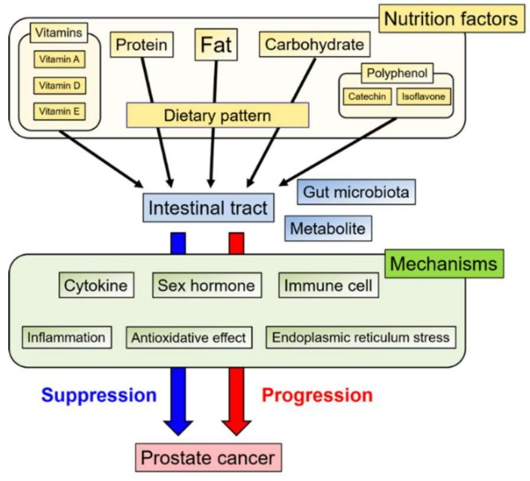

The overall analysis predicts that particular lifestyle elements have a minor connection. Still, it is worth mentioning for prospective studies, particularly PSA examination as a preventative method, along with specific age groups like black ethnicities are more vulnerable than Caucasian white males.

5. Discussion

In England, where PSA levels for prostate cancer filtering are noticeably less ordinary, African males are three times more likely to have the prevalence than Caucasian peers.
Contrastingly, there are verifications that South Asian males in England are not so much as conceivable to be diagnosed with prostate cancer as their Caucasian peers (Lynch, 2010). Nevertheless, in an earlier study on the former research, 159 South Asian males identified with prostatic malignancy (Schatzkin, 2001). The others were minor analysed based on between three and 38 episodes (Lacey, 2001). Four out of five former analyses have depended upon cancer registration for discovering males identified with prostate cancer (Thunel, 1994). Three have relied on categorising names to find race. Therefore, any partiality announced by these two aspects of the study plan will essentially affect the minor evidence confirmation for the South Asian ethnic group preserving over prostate cancer.
In contrast to Caucasian males, black ethnicity from southern England is more expected to be verified with prostatic malignancy. (Ben-Shlomo et al., 2008) While Asian males have a minimal risk of prostatic malignancy. (Metcalfe et al., 2008). According to Hospital Episodes of Statistics for England, the African ethnicity was identified as possessing a greater risk of prostatic malignancy. (Maruthappu et al.,2015)

‘Plant-based’ foods consist of many nutritional benefits such as phytochemicals and cruciferous vegetables that reduce the threat of prostate cancer prevalence and development. (Kirsh, Petrs, Mayne, et al. 2007), (Richman, Carroll, Chan, 2012).
Other studies, such as the sitting time aspect, analysed that non-obese males were not affected by their attitudes. However, males who have adiposity and have a higher BMI index may have a connection with a maximised threat of Prostatic malignancy, particularly over obese males, and with a decreased exposure to prostate cancer than males who have healthy BMI levels. (Lynch, Freidenreich, Kopciuk, et al, 2014). After analysing the lifestyle components mentioned in this study, they had a minor risk connection with prostate cancer.
Recommendations
“UK National Screening Committee” (UK NSC) pieces of Advice;
Prostate filtering is not recommendable in the UK. Due to the lack of accuracy and insufficiency in determining prostatic malignancy therapy. Discrepancies can occur whilst trying to find out the detection. It can mislead patients. This can signify that; many unnecessary procedures can damage males unessentially.
The doubt still exists in MRI filtering whether or not related to ‘PSA’. Researchers recently worked on the predictability of prostate cancer with multiple blood test methods. Nevertheless, more research is needed. The participation rate for PSA examination has risen in numbers within the UK, similarly causing an immense increase in prostate cancer. (Lilja et al., 2008).

The intervention;
Currently, there is not even one therapy that solely and solidly supports a better treatment for service users in the initial phase of prostate cancer, and the efficacy should depend on the side effect.
The Filtering strategy;
The PSA filtration initiatives can damage males even if they have been identified and have symptomless complaints with prostatic malignancy.
This could guide doing extra examinations and therapy, which can be damaging as side effects.
The review’s recommendations were conducted in 2015 and advised that; PSA rooted filtering for prostate cancer in males with no symptoms is not presently advisable within the UK. Research findings are significant for early diagnosis, creating life-changing therapies, preventing illnesses, promoting better prospective care, and equally enhancing the quality of life. (NHS, 2021).
Limitations include the frequency impact on people who can participate more often than others who are less able to do the examination, which created social class in this accomplice study. (Morgan et al., 2013, p 1207-1212).
Cornago et al. (2017)
The study strength that one of the most significant prospective examinations based on threat components, on the obesity-related aspect, service users were called to be identified in the location another means instead of filling the questionnaires themselves medical professionals have processed patients in the clinics in person. The research includes many individuals who were involved from different sides of the country, including underprivileged districts. The lacking component information was about the medical family background.
Littlejohns et al., (2016) The strength and limitations of the research were that the broader scale of population-based, lifestyle and medical aspects has a connection with PSA examination, which includes and is attributed formerly described as factors of risk in prostatic malignancy. Older adults are more likely to go through with PSA than younger adults. Therefore, population-based elements and lifestyle components are essential to evaluate the population accordingly. The previous analysis emphasises the importance of detecting bias in the population-based study when examining the threat components for prostatic malignancy. It is connected to a person’s well-being and how they lead their lifestyle.

6. Conclusion

Lifestyle factors and dietary consumptions have no clear interrelation with prostatic cancer. However, specific ethnicity, particularly African males from southern England, carries greater exposure to prostatic malignancy. Although no connection was found between social and demographic factors, anthropometrics, lifestyle elements, and some figures of the studies were biased. Further studies are needed for prospective purposes, particularly PSA testing and family history factors. Explored studies suggest no routine screening program is available in the UK due to non-definitive tests to utilise. (Cancer Research UK, 2019).
In conclusion, many research studies conducted outside the UK can contribute to better analysis and evaluation regarding better management, early prevention, correct treatment, and the appropriate policy plans.
More research will enable medical professionals to look into prostate cancer from various angles in the UK.

References

Ben-Sholomo Y, et al. (2008) The risk of prostate cancer amongst black men in the United Kingdom: The progress cohort study. bjui- journals p 99- 105 [online] Available at: https://bjui-journals.onlinelibrary.wiley.com/doi/abs/10.1111/j.1464-410X.2008.07818. (Accessed: 13/04/2022).
Brunner, et al. (2001) Dietary assessment in Whitehall II: Comparison 7 diet diary and food frequency questionnaire and validity against biomarkers. Br J Nutr 2001 Sep;86(3):405-14. [online] Available at doi.10.1079/bjn2001414 (Accessed: 13/04/2022)
Cuzick J, Thorat MA, Andriole G. (2014) Prevention and early detection of prostate cancer. Lancet Oncology 15(11): e484-e492. [online] Available at: https://pubmed.ncbi.nlm.nih.gov/25281467/ (Accessed: 14/04/2022)
Ferlay J, Soerjomataram I, Dikshit R, et al. (2015) Cancer Incidence and mortality worldwide: sources, methods and major patterns in GLOBOCAN 2012. Int J Cancer 136(5): [online]. Available at: https://pubmed.ncbi.nlm.nih.gov/25220842/ (Accessed: 14/04/2022)
GOV.The UK, (2020) Adult screening programme: Prostate Cancer. Gov. UK [online] Available at: https://view-health-screening-recommendations.service.gov.uk/prostate-cancer/ (Accessed: 29/04/2022).
Kirsh VA, Peters U, Mayne ST, et al. (2007) Prospective study of fruit and vegetable intake and risk of prostate cancer. J Natl Cancer Inst 2007;99: p1200-9 [online]Available at: https://pubmed.ncbi.nlm.nih.gov/17652276/ (Accessed: 16/04/2022)
Lilja H, et al. (2008) Prostate-specific antigen and prostate cancer: Prediction, detection and monitoring, Nat Rev Cancer p 268-278 [online] Available at: https:// doi: 10.1038/nrc2351 (Accessed: 13/04/2022)
Lynch, B.M. (2010). Sedentary behaviour and cancer: a systematic review of the literature and proposed biological mechanisms. Cancer Epidemiology Biomarkers Previous 2010; [online] Available at: https://pubmed.ncbi.nlm.nih.gov/20833969/ (Accessed: 17/04/2022)
Lacey J, Deng J, Dosemeci M, et al. (2001) Prostate cancer, benign prostatic hyperplasia and physical activity in Shanghai, China. Int J Epidemiology 2001; 30:341 [online] Available at: https://pubmed.ncbi.nlm.nih.gov/11369740/ (Accessed: 18/04/2022)
Lynch, B, M, Friedenreich, C, M, Kopciuk, K, A, et al. (2014) Sedentary Behaviour and Prostate Cancer Riskin the NIH-AARP Diet and Health Study. Academia Edu [online] Available at: (Accessed: 01/05/2022).
Littlejohns, T.J., Travis R.C., Key T.J., et al. (2016) Lifestyle factors and prostate-specific antigen (PSA) testing in the UK Biobank: Implications for epidemiological research. Cancer Epidemiology [online] Available at: https://doi.org/10.1016/j.canep.2016.09.10 Available at: https://pubmed.ncbi.nlm.nih.gov/27693812/ (Accessed: 18/04/2022)
Martin, R. M., Donovan, J. L., Turner, E. L, et al. (2018) CAP Trial Group. Effect of a Low-Intensity PSA-Based Screening Intervention on Prostate Cancer Mortality: The CAP Randomized Clinical Trial. JAMA, 319(9), 883–895. [online] Available at: https://www.ncbi.nlm.nih.gov/pmc/articles/PMC5885905/ (Accessed: 19/04/2022)
Maruthappu, A. (2015) Incidence of prostate and urological cancers in England by Ethnic group,2001-2007: A descriptive study Cancer 15:753 [online] Available at https:// DOI: 10.1186/s12885-015-1771-2. (Accessed: 13/04/2022)
Metcalfe, C, Patel, B, Simon Evans, S (2008) The risk of prostate cancer amongst South Asian men in southern England: the PROCESS cohort study 008 BJU International 102, 1407–1412 [online] Available at: doi:10.1111/j.1464-410X.2008.07818. (Accessed: 02/05/2022).
Morgan, R.M. (2013, p 1207-1212) Socioeconomic variation and prostate-specific antigen testing in the community: A United Kingdom-based population study. The Journal of Urology, 19 Apr 2013, 190(4):1207-1212. Available at https://europepmc.org/article/MED/23608675. (Accessed: 19/04/2022)
Msn (N.D) Prostate Cancer: [online] Available at: https://www.msn.com/en-gb/health/condition/prostate cancer (Accessed: 25/04/2022)
NHS (2021) Overview: Prostate Cancer NHS [online] Available at:// https://www.nhs.uk/conditions/prostate-cancer/ (Accessed: 25/04/2022)
NHS (2021) What does the new clinical research vision mean for NHS patients and health professionals. NHS [online] Available at: www.England.nhs.uk/bolg/what-does-the-new-clinical-research-vision-mean-for-nhs-patients-and-health-professionals/ (Accessed: 13/04/2022)
NICE (2021) Prostate cancer: diagnosis and management. National Institute for Health and Care Excellence [online] Available at: https://www.nice.org.uk/guidance/ng131/chapter/Context (Accessed: 27/04/2022)
ONS (2017) Office for National Statistics: Cancer registration statistics, England; first release, 2015. ONS [online]Available at: https://www.ons.gov.uk/people/populationand community/healthandsocialcare/conditionsanddisease/bulletins/cancerregistrationstatisticsengland/firstrelease2015 (Accessed: 24/04/2022) .
Owen N, Bauman A, Brown W. et al. (2009) Too much sitting: a novel and significant predictor of chronic disease risk? Br J Sports Med 2009; 43:8 [online] Available at: https://bjsm.bmj.com/content/43/2/81 (Accessed: 22/04/2022)
Lynch, B.M. (2010) Sedentary behaviour and cancer: a systematic review of the literature and proposed biological mechanisms. Cancer Epidemiology Biomarkers Previous 2010; 19:2691 [online] Available at: https://link.springer.com/chapter/10.1007/978-3-319-61552-3_10 (Accessed: 25/04/2022)
Richman EL, Carroll PR, Chan JM. (2012) Vegetable and fruit intake after diagnosis and risk of prostate cancer progression. Int J Cancer 2012; p131:201-10 [online] Available at: https://pubmed.ncbi.nlm.nih.gov/21823116/ (Accessed: 29/04/2022)
Schatzkin A, Subar AF, Thompson FE, et al. (2001) Design and serendipity in establishing a large cohort with broad dietary intake distributions: The National Institutes of Health American Association of Retired Persons Diet and Health Study. Am J Epidemiology 2001; 154:1119 [online] Available at: https://pubmed.ncbi.nlm.nih.gov/11744517/e] (Accessed: 29/04/2022)
Jahan N, Naveen N, Zeshan M. et al., (2016) What is a literature review? The University of Missouri Libraries.[online] Available at: http://libraryguides.missouri.edu/literaturereview. Reviews. 2016. (Accessed:30/04/2022).
WCRF/AICR, (2014) World Cancer Research Fund International/American Institute for Cancer Research Continuous Update Project Report: Diet, Nutrition, Physical Activity and Prostate Cancer. [online] Available at: http://www.wcrf.org/sites/default/files/ProstateCancer-SLR-2014.pdf (Accessed: 24/04/2022).
Travis RC, Appleby PN, Martin RM, et al. (2016) A meta-analysis of individual participant data reveals an association between circulating levels of IGF-I and prostate cancer risk. Cancer res 76(8): 2288-2300. Available at: https://research.monash.edu/en/publications/a-meta-analysis-of-individual-participant-data-reveals-an-association (Accessed: 02/05/2022)
ThuneI, Lund E (1994) Physical activity and prostate and testicular cancer risk: a cohort study of 53,000 Norwegian men. Cancer Causes Control 1994; 5:549 [online] Available at: https://pubmed.ncbi.nlm.nih.gov/7827242/ (Accessed: 03/05/2022)
The University of Bristol, (2018) Bristol scientists behind the most prominent trial ever to investigate prostate cancer screening: Journal of the American Medical Association (JAMA) [online] Available at: https://www.bristol.ac.uk/integrative-epidemiology/programmes/icep/news/2018/psa-test-cap-results (Accessed: 29/04/2022).

