BA (Hons) International Hotel Management
Module: Sustainable Hospitality &Tourism Management
Code: BMIH5006

Student Name: Selina Akhter Seema
Student Number: 2225106
Lecturer Name: Lisa-Marie Bassler

AI Acknowledgement
I confirm that I have not used any AI tools in the research and creation of this assignment. I confirm that I have not presented any AI generated materials as my own work. I confirm I have copies of my drafts, notes, and other resources I used, which I may be asked to provide in evidence.

Executive Summary
Sustainable waste reduction practises at The Greenway Hotel & Spa Cheltenham have resulted in environmentally and operationally beneficial impacts. The hotel, through recycling 88 tonnes of waste per year, produces renewable energy via incineration and anaerobic digestion, as well as minimising its landfill impact, has cut down its carbon footprint, supporting the UK’s net-zero emissions goal. They have also served to attract common union eco-friendly guests; cut operating costs; and promote greater employee engagement. The hotel’s operations are however faced with high upfront costs, staff training and sustainability with suppliers. The cost and benefits related to The Greenway Hotel & Spa Cheltenham recommends the gradual implementation of eco-friendly practises, engaging guests with sustainability efforts, and exploring forming partnerships with local waste management organisations. Taken as a whole, the hotel's struggle to be more sustainable within the boutique hospitality space raises a bar for its own sustainability and supports a broader environmental social goal.
Table of Contents
1. Introduction 4
2. Green Practice Initiative 5
3. Impact of Integrating Sustainability on The Greenway Hotel and Spa 6
3.1 Benefits for the Hotel 6
3.2 Environmental Impact 7
4. Challenges and Feasibility 8
4.1 Operational Challenges 8
4.2 Cost-Effectiveness and Realism 9
5. Conclusion 10
6. Recommendations 11

1. Introduction
Sustainable initiatives in the hospitality industry related to increased environmental impact are known as greener practises (Inkson and Minnaert, 2018). Waste reduction, energy efficiency, water conservation and sourcing of eco certified products are often included in these practises. Certifications such as the Green Key or Green Tourism- learn more accreditation show that many hotels pursue a commitment to sustainability and offer a structure to keep working on the subject.
Sustainable practices in the hotel business are crucial to resource conservation, pollution reduction, and efficiency. Sustainable hotels may attract eco-conscious customers, decrease operating costs, and community service. These practises allow hotels to meet their environmental obligations and build a brand that meets current visitor expectations. The UK hotel business was worth 24.7 billion British pounds in 2023, up from 16.42 billion in 2022. This business was expected to shrink by 400 million British pounds in 2024 (Statista, 2024).
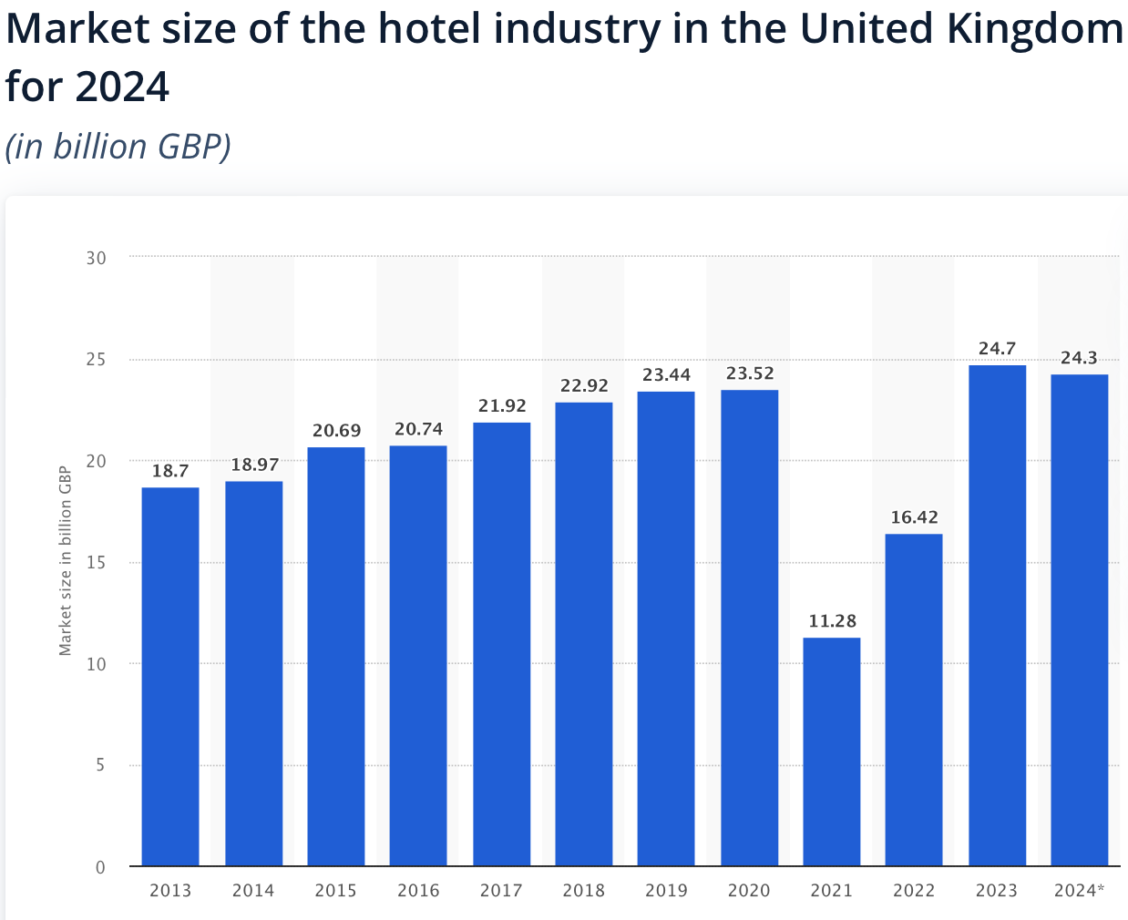
Figure 1: Market size of the hotel industry in UK (Statista, 2024)
The Greenway Hotel & Spa Cheltenham is one of a number of hotels that manage to demonstrate a commitment to sustainability through things like comprehensive waste recycling, local sourcing, and energy efficient lighting (Greenway Hotel, 2024). It’s located in Cheltenham and is part of the Eden Hotel Collection, it has made strides to reach Green Tourism accreditation and is looking to reduce its carbon footprint. This hotel gives an example of how luxury hospitality can reconcile greener practises.

2. Green Practice Initiative
The term green tourism refers to vacations that are environmentally conscious and make an effort to minimize negative impacts on local ecosystems (Pizzichini, 2024). It focused on waste reduction as a leading 'Green Practice' at The Greenway Hotel & Spa Cheltenham. Waste reduction includes approaches that minimise landfill impacts through reducing, as much as possible, the creation and reuse of waste through prevention and responsible management. With 88 tonnes of waste recycled each year, generating renewable energy via incineration and anaerobically digesting food waste, methane emissions are reduced (Cho et al, 2024). Also, paper, cardboard, and glass are recycled from it, which helps keep the hotel’s carbon footprint at a minimum and favours environmental sustainability (Greenway Hotel, 2024).
Other hotels too have adopted similar initiatives very successfully. Hilton Hotels, for instance, has instituted a strict waste management programme that recycles much of the food waste, eliminates as much single use plastic as possible, and searches for biodegradable materials to package products. Hilton is one of those that has set goals of cutting its waste by 50% by 2030, as part of its corporate social responsibility (Hilton, 2024). Marriott International has taken a series of comprehensive waste reduction strategies, for instance, set food donation programmes to reduce food waste, and more effectively joined with local waste management company to increase the throwing away levels of recycled material at its properties (Marriott, 2024).
These practises will bring substantial environmental and operational benefits to hotels. These initiatives don’t only reduce waste costs, they also are interesting to environmentally friendly travellers. Waste reduction practises also support broader sustainability objectives – like the UK‘s ambition to achieve net zero emissions by 2050 and wider UN Sustainable Development Goals (Shahzad et al, 2024). In particular waste reduction supports SDG 12, responsible consumption and production (UN, 2023).
By leading the way for other boutique hotels by adopting waste reduction, The Greenway Hotel & Spa Cheltenham shows that by having an efficient waste management, an already large tourist draw can have a positive impact on the environment and earn guest loyalty.

3. Impact of Integrating Sustainability on The Greenway Hotel and Spa

3.1 Benefits for the Hotel
There are a number of benefits that adopting waste reduction practises provides for The Greenway Hotel & Spa Cheltenham in both appearance and operational efficiency. In the first place, mergence of ecological initiatives is highly praised in raising its reputation as an ecologically conscious hotel (Yildiz et al, 2023). As consumer demand for sustainable travel options continues to grow, hotels where guests are actively driven by green practises tend to attract eco-friendly travellers who prefer to stay in places that prioritise environmentally friendly policies (Murtaza et al, 2024). In securing The Greenway’s partnership with The Green Tourism accreditation, The Greenway is taking a leading role within the boutique hotel sector in terms of hospitality that is as environmentally aware as possible and can further increase the appeal to environmentally aware clientele to establish it as a fore runner in sustainable hospitality.
Cost savings also make up a large financial benefit of waste reduction (Cooper, 2021). The hotel’s waste management practises, such as recycling and anaerobic digestion, help it lower landfill disposal fees, which can be high, as landfill taxes increase (Galavote et al, 2024). The hotel uses recycling programmes to re-purpose materials away from having to buy new resources and instead simply recycle; this minimises their overall supply expenses (Hilton, 2024). That same adage is applied in operation, where The Greenway, for example, recycles coffee grounds as compost or egg boxes for planting as part of their gardening supply costs, reducing waste production and saving operational costs.
Implementation of green practises promotes employee satisfaction and engagement as well. The Greenway encourages staff to join initiatives that are sustainable, such as being a ‘Green Champion’ and acting as a role model and buoying the culture of responsibility. Korstanje et al, (2020) stated that studies show employees are more motivated and job satisfaction when they work in a company with sustainability. This is how The Greenway Hotel & Spa Cheltenham actually fosters an eco-friendly room as well as boosting staff morale which helps to ensure the workforce are a committed, productive team.

3.2 Environmental Impact
The Greenway Hotel & Spa Cheltenham’s waste reduction initiative is exactly that, positive for the environment. One of the biggest things it will do is help to reduce greenhouse gas emissions. The hotel recycles and converts waste into renewable energy, which significantly reduces methane emission caused by the organic waste decomposition in landfills as the first result. Another benefit to the hotel, and one that further reduces its carbon footprint, is anaerobic digestion, a process that breaks down organic material without oxygen production of biogas as a renewable source of energy (Greenway Hotel, 2024). These programmes directly contribute to The Greenway’s contribution to meeting the UK’s net zero emissions goal by 2050 and through national, national and international climate (Gov.UK, 2024).
The reduction of waste reduces the need for raw materials as well as natural resources conservation. By recycling materials like glass, paper and cardboard, demand for those virgin materials is reduced and deforestation, water consumption and energy use related to raw material extraction and processing are reduced. This goal is supported also by the fact that the Greenway commits to sourcing local produce – limiting the environmental footprint of transportation which is often associated with higher emissions (Greenway Hotel, 2024). Sustainable supply chain principles are practised through this practise, as resources are utilised responsibly and the environmental footprint of sourcing activity is minimised.
Additionally, the hotel’s efforts at waste management help support local biodiversity, ecological health. In addition to composting used coffee grounds and putting repurposed food waste to good use in the Garden, The Greenway adds to soil quality and aids in plant growth on the land. Since this approach generates habitats for local wildlife, a healthy ecosystem is achieved within the grounds of the hotel (Helden et al, 2024). Similarly, the decrease of plastic waste and use of bio-selective materials shield against risk of pollution, within the proximity of natural area, to the detriment of wildlife that are acquainted to the circumstances of non-bio select plastic waste (Legrand et al, 2021).
It also has a social impact, as it involves and educates guests in sustainable practises in the waste reduction initiative. Guests of the Greenway are actively encouraged to practise green initiatives whilst they stay there, such as using reused linens and using reduced use of energy. Not only does this support the hotel’s efforts to commit to sustainability, but for guests it can bring awareness of the importance of sustainability and be a call to action to engage guests in post visit sustainable habits (Wickham et al, 2020). The Greenway Hotel & Spa Cheltenham ensures the breadth of an environment responsibility culture through integrating sustainability into the guest experience.

4. Challenges and Feasibility

4.1 Operational Challenges
There are many operational challenges associated with implementing of waste reduction and sustainability in the operational implementation of The Greenway Hotel & Spa Cheltenham. Long-term reducing waste can save cost but that initial investment can be very costly. However, anaerobic digestion or dedicated advanced recycling system measures require the addition of expensive equipment and infrastructure. Furthermore, the sourcing of eco-friendly products often carries a premium since premium sustainable materials and suppliers are used (Chilombe and Chiziwa, 2024).
The barrier is that the practise must be continuously trained by staff to make it work. But it is always necessary to train staff in waste segregation, eco aware habits, recycling, etc., and all of that requires time and resources. The Greenway Hotel’s "Green Champions’ initiative, for example, works because it places dedicated personnel responsible for sustainability matters at the hotel depends on their ongoing involvement and support (The Greenway Hotel, 2024). With a high turnover industry such as this, staff members need to know waste management principles in great detail to comply.
In addition, sustainable practises can disrupt daily operations by changing existing processes. Planning for changes, for instance, energy efficient systems or local, biodegradable goods, is necessary to minimise service quality interruptions (Korstanje et al., 2020). Many of these changes can also be challenging to coordinate with suppliers and service providers, especially when viable sustainable alternatives are limited or are not consistently available in the region.

4.2 Cost-Effectiveness and Realism
Paying for The Greenway’s waste reduction initiatives goes beyond a desire to lessen our impact on the environment: it also ensures that we remain financially sustainable and that we continue to align with our operational structure at The Greenway. Waste reduction can ultimately reduce the costs, but the return on cost reduction has to be into scale where the savings do outweigh the initial investment (Farina et al, 2023). Seems that the hotel could avoid paying costly disposal fees and recycling the material that it repurposes. There are long years to wait until the financial benefits become visible and this cost reduction is gradual.
The boutique hotel structure of the Greenway offers the opportunity to tailor sustainability to a suite of practises that can be implemented in a way that is effective. Despite this smaller scale, on the other hand, the hotel might be constrained in producing the economies of scale that large hotel chains enjoy in sustainability initiatives (Pizzichini, 2024). This might however limit the speed as well as the extent to which the hotel can incorporate more advanced waste reduction technologies onto its use of ecological components without altering its budget.
Guests and the local community support is also reliant on waste reduction efforts being feasible. The Greenway can teach customers how to care for the world around them and encourage them to help with various eco-friendly initiatives thus building up a supporting clientele of people with a respectful attitude to The Greenway’s sustainability projects (Greenway Hotel, 2024). Indirectly, it can also help the programme’s success by reducing the waste created by guests and can even encourage responsible consumption.

5. Conclusion
The Greenway Hotel & Spa Cheltenham’s efforts on waste reduction is in line with targets to gain Green Tourism accreditation as such it is setting a flag bearer to sustainable hospitality. This initiative is beneficial to both operationally and ecologically because the benefits of waste reduction, like strengthening the reputation, complement cost savings and the reduction of environmental impact. Yet challenges including high up-front costs and the requirement for operational shifts also need to be treated carefully to enable the programme's success.

6. Recommendations
The Greenway Hotel & Spa Cheltenham is encouraged to pursue the gradual implementation of eco-friendly practises to strike a balance between the cost and the benefits for its waste reduction efforts. However, as a hotel, it should also pay for a thorough staff training and keeping its guest highly engaged to fan its green initiatives. Additional support, including cost reduction opportunities, could come from a partnership with local waste management organisations (Kurniawan et al, 2024). These recommendations are to help the hotel keep on doing its bit to reduce its waste at the same time as making the guest feel right at home and increasing the use, there by the environmental goals of broad.

Reference

Chilombe, J. and Chiziwa, S. (2024). CSR and Environmental Responsibility Eco-friendly Practices. IntechOpen eBooks, 75(45). doi:https://doi.org/10.5772/intechopen.1005333.

Cho, H.H., Strezov, V. and Evans, T.J. (2024). Life cycle assessment of power-to-methane and renewable methane production technologies. Renewable and Sustainable Energy Reviews, 206(89), pp.114856–114856. doi:https://doi.org/10.1016/j.rser.2024.114856.

Cooper, C. (2021). Essentials of Tourism. 3rd ed. London: SAGE.

Farina, E.D., Hernández, J.J.D. and Fumero, N.P. (2023). Analysis of hospitality waste generation: Impacts of services and mitigation strategies. Annals of Tourism

Research Empirical Insights, [online] 4(1), p.100083.

doi:https://doi.org/10.1016/j.annale.2022.100083.

Galavote, T., Chaves, G. de L.D., Yamane, L.H. and Siman, R.R. (2024). The effects of municipal waste reduction and recycling policies on the economic feasibility of landfill gas generation. Energy for Sustainable Development, 81(56), pp.101–493. doi:https://doi.org/10.1016/j.esd.2024.101493.

Gov.UK (2024). Net Zero Strategy: Build Back Greener. [online] GOV.UK. Available at: https://www.gov.uk/government/publications/net-zero-strategy.

Greenway Hotel (2024). The Greenway Hotel & Spa. [online] The Greenway Hotel & Spa. Available at: https://www.thegreenwayhotelandspa.com [Accessed 6 Nov. 2024].

Helden, V., Skates, L.M. and Close, P.G. (2024). Use of wildlife-friendly structures in residential gardens by animal wildlife: evidence from citizen scientists in a global biodiversity hotspot. Urban ecosystems, 56(45). doi:https://doi.org/10.1007/s11252-024-01530-4.

Hilton (2024). Our Progress. [online] Travel With Purpose | Hilton ESG. Available at: https://esg.hilton.com/our-progress/.

Inkson, C. and Minnaert, L. (2018). Tourism Management: an introduction. 2nd ed. London: SAGE.

Korstanje, M.E., George, B.P. and Nedelea, A. (2020). Strategies for promoting sustainable hospitality and tourism services. Hershey, Pa: Igi Global.

Kurniawan, T.A., Meidiana, C., Goh, H.H., Zhang, D., Othman, M.H.D., Aziz, F.,

Anouzla, A., Sarangi, P.K., Pasaribu, B. and Ali, I. (2024). Unlocking synergies

between waste management and climate change mitigation to accelerate decarbonization through circular-economy digitalization in Indonesia. Sustainable Production and Consumption, [online] 46(75), pp.522–542. doi:https://doi.org/10.1016/j.spc.2024.03.011.

Legrand, W., Sloan, P. and Chen, J.S. (2021). Sustainability in the hospitality industry : principles of sustainable operations. Abingdon, Oxon ; New York, Ny: Routledge.

Marriott (2024). Sustain responsible operations. [online] csr-marriott. Available at: https://serve360.marriott.com/sustain/.

Murtaza, S.H., Khan, A. and Mustafa, S.M. (2024). Eco‐centric success: Stakeholder approaches to sustainable performance via green improvisation behavior and environmental orientation in the hotel industry. Business strategy and the environment, 43(42). doi:https://doi.org/10.1002/bse.3860.

Pizzichini, L. (2024). Green tourism. Edward Elgar Publishing eBooks, 86(65), pp.220–242. doi:https://doi.org/10.4337/9781789904833.00023.

Shahzad, S., Faheem, M., Muqeet, H.A. and Waseem, M. (2024). Charting the UK’s path to net zero emissions by 2050: Challenges, strategies, and future directions. IET Smart Grid, 67(43). doi:https://doi.org/10.1049/stg2.12185.

Statista (2024). Hotel industry market size UK 2024. [online] Statista. Available at: https://www.statista.com/statistics/1364712/hotel-industry-market-size-uk/.

Wickham, M., Donnelly, T. and French, L. (2020). STRATEGIC SUSTAINABILITY MANAGEMENT IN THE EVENT SECTOR. Event Management, 25(3). doi:https://doi.org/10.3727/152599519x15506259856318.

Yildiz, H., Tahali, S. and Trichina, E. (2023). The adoption of the green label by SMEs in the hotel sector: a leverage for reassuring their customers. Journal of Enterprise Information Management, 45(54). doi:https://doi.org/10.1108/jeim-03-2023-0160.

