Student name: Muhammed Hashim
Student Id: 2526540
Module name: Problem-Solving and Decision-Making
Module code: LCLM4004
Lecturer: Annamarie Dufficy
Assessment Component 2: Individual Report Basil’s Bakery

Table of Contents
Introduction 3
Task 1: Overview of Case Study 3
Task 2: Two Proposed Solutions 3
Solution A – Online Ordering System 3
Solution B – Delivery Service Expansion 4
Task 3b: Evaluation Results and Justifications 4
Task 4b: Justifications for the Implementation Plan 4
Task 6: Key Findings 5
Reference List 6
Appendices 8
Appendix 1: Task 3a 9
PMI Evaluation Table 9
Appendix 2: Task 4a 11
Implementation Plan 11
Appendix 3: Task 5a 13
Key Performance Indicator 13
SMART Objective Table 13

Introduction
This report examines the difficulties Basil's Bakery faced during the Covid-19 pandemic. It examines the sales reduction and how it impacted the business. It will begin with an overview of the case study and identify the primary issue. Two potential solutions will be suggested and assessed using the Plus, Minus and Interesting (PMI) method before choosing the best one. Key Performance Indicators (KPIs) and SMART objectives are used to track the performance of the chosen solution once an implementation plan is provided to show how it may be implemented. The main conclusions and suggestions for enhancing Basil's Bakery's long-term sustainability are included in the appendices.

Task 1: Overview of Case Study

The independent artisan baker Basil owns Basil's Bakery, which is situated in a retail establishment in Coventry. After 2015, Basil's Bakery saw significant growth in sales and developed dedicated customers. However, lockdown limitations during the COVID-19 outbreak caused a sharp fall in sales. Sales never reached their pre-pandemic levels and have remained roughly 25% below 2019 levels, raising questions about the business's future sustainability even when the restrictions were lifted. Reduced sales brought on by fewer customers behaviours was the main issue. Office workers visited less due to the rise of remote work, while customer convenience is limited by the absence of online ordering. The profit margin has also decreased due to growing expenses for utilities, rent and organic ingredients. These problems indicate that the bakery's difficulties are a result of both internal and external causes, such as low digital capabilities and economic situations.

Task 2: Two Proposed Solutions

Solution A – Online Ordering System

Solution A suggests putting in place an arrangement for online ordering and pre-purchasing. Customers might use a website or mobile platform to explore products, place orders and choose collection options. This solution responds to shifting costumers demands by increasing accessibility and ease. Technology can improve customer happiness and business effectiveness (Li and Chen, 2024). Basil's Bakery can connect with customers through technology who work remotely and cannot visit the bakery. Pre-ordering will enhance operational effectiveness, shorten wait times and improve sales, all of which can help to reverse the current revenue drop (Poovizhi et al., 2025).

Solution B – Delivery Service Expansion

In Solution B, introducing a local delivery service where bakery goods could be delivered to customers' homes and places of employment. Customers who cannot visit the retail park can be reached by the bakery, which expands its market reach. Delivery services have grown significantly in shifting customer preferences and the need for convenience (Pai and Maya, 2022). However, logistical, staff training and transportation expenditures would be necessary for execution. Although the plan has the potential to improve sales, it has higher operating costs than Solution A (Seghezzi and Mangiaracina, 2021).

Task 3b: Evaluation Results and Justifications

The two solutions for Basil's Bakery have potential to increase sales and improve growth. However, when compared using the Plus, Minus and Implications (PMI) method for: implementing an online ordering system (Solution A) and growing through a delivery service (Solution B), scores from 1-5 of the PMI evaluation revealed solution A was more beneficial and had less drawbacks, while solution B comes with more operational expenses, staff needs and puts the company at risk (see Appendix 1). Therefore, the online ordering system is the most sensible, economical and sustainable option for a small, independent bakery with little funding (Anugrah and Istiono, 2024).

Task 4b: Justifications for the Implementation Plan

The implementation strategy has been organised logically to ensure that the online ordering is implemented effectively with less disturbance to business activities (Rajagopal, et al., 2022). Prior to the launch, staff should be given up to date training to enhance their basic knowledge so they can confidently handle online purchases and help customers (Esthi, 2022). Once the system is operational, marketing initiatives start to increase customer awareness and promote immediate service use. Basil will oversee the majority of the implementation, with IT support helping with technical details because he is familiar with the objectives and operations of the bakery. Finally, continuous observation allows Basil to assess performance and make improvement where necessary. This procedure lowers risk by guaranteeing that technological problems are fixed earlier. Additionally, the timeline minimises disturbance and increases the possibility of successful implementation by providing enough time for employee preparation (see Appendix 2).

Task 5b: Justifications for KPI and SMART Objectives

Basil's Bakery employ one KPI backed by SMART objectives to evaluate the effectiveness of the online ordering system (see Appendix 3). The KPI measures the amount of online orders received each month, it provides a clear indication of customers using the new service and effectiveness of the online ordering system (Mhaskey, 2024). The SMART objectives support the bakery’s aim of enhancing sales and strengthening customer satisfaction. Achieving 100 online orders per month in four months provides a realistic goal for measuring customer engagement with the new technology. Basil can evaluate whether online ordering is improving economic performance using the increased monthly sales of 15% within six months. Using pre-orders to reduce wait times for customers by 20% within six months will show benefits in operating effectiveness. Together, the performance of the KPI and SMART objectives measures enable Basil to monitor progress, evaluate improvement of the solution and make informed choices to support ongoing development for the bakery (Manoharan et al., 2023).

Task 6: Key Findings

The key findings outlined from the analysis of this study provide a clear direction for Basil Bakery

• Basil’s Bakery continues to experience sales that are 25% below pre-pandemic levels.
• Reduced footfall and changing customer behaviour are contributors to reduced sales.
• Lack of digital ordering limited customer convenience and accessibility (Saha et al., 2023).
• Online ordering provides a cost-effective solution (Li et al., 2020).
• KPIs and SMART objectives monitor progress, support future growth and guarantee quantitative improvements (Sreedharan et al., 2024).

These findings demonstrate that solution A is a sustainable pathway for revenue recovery and long-term solution.

Reference List

Aithal, P.S. and Aithal, S. (2023) ‘Key performance indicators (KPI) for researchers at different levels & strategies to achieve it’, International Journal of Management, Technology, and Social Sciences (IJMTS), 8(3), pp.294-325.

Anugrah, C. And Istiono, W. (2024) ‘Implementing Online Ordering Systems For Small Culinary Businesses: A Case Study Of Nasi Cia’, Jurnal Tekno Kompak Учредители: Universitas Teknokrat Indonesia, 19(1), P.50.

Cahyani, I., Nurhadi, J. and Mentari, M. (2023) ‘Enhancing writing skills and language creativity through the plus-minus-interesting technique: A case study at the primary school level’, Indonesian Journal of Applied Linguistics, 13(1), pp.63-71.

Chmutova, I., Xiaoqing, G.U.O., Zhang, Q., Mazhuta, V. And Nimets, A. (2024) ‘Formulating key performance indicators for an integrated enterprise management system using a sustainable development balanced scorecard’, Development Service Industry Management, (2), pp.270-278.

Daniel, Z. and Oye, E. (2024) Key Performance Indicators (KPIs) for Financial Control Systems. Available at: https://www.researchgate.net/profile/Antony-Owen/publication/388498271_Key_Performance_Indicators_KPIs_for_Financial_Control_Systems/links/679b32d6645ef274a45207c8/Key-Performance-Indicators-KPIs-for-Financial-Control-Systems.pdf (Accessed: 5 July 2026).

Esthi, R.B. (2022) ‘The Effect of Competence and Job Training on the Performance of Crab Meat Agro-industry Employees in West Java’, Jurnal Ilmiah Agrineca, 22(2), pp.1-9.

Felemban, H., Sohail, M. and Ruikar, K. (2024) ‘Exploring the readiness of organisations to adopt artificial intelligence’, Buildings, 14(8), p.2460.

Hindarto, D. (2023) ‘The management of projects is improved through enterprise architecture on project management application systems’, International Journal Software Engineering and Computer Science, 3(2), pp.151-161.

Ishak, Z., Fong, S.L. and Shin, S.C. (2019) ‘SMART KPI management system framework’, In 2019 IEEE 9th International Conference on System Engineering and
Technology, pp. 172-177.

Li, C., Mirosa, M. and Bremer, P. (2020) ‘Review of online food delivery platforms and their impacts on sustainability’, Sustainability, 12(14), p.5528.

Li, J. and Chen, H. (2024) ‘Analysis of the impact of live E-commerce on consumer happiness based on big data technology from the perspective of perception control’, Electronic Commerce Research, pp.1-21.

Manoharan, G., Durai, S., Rajesh, G.A., Razak, A., Rao, C.B. and Ashtikar, S.P. (2023) ‘An investigation into the effectiveness of smart city projects by identifying the framework for measuring performance’, In Artificial intelligence and machine learning in smart city planning, pp. 71-84.

Mhaskey, S.V. (2024) ‘Evaluating Key Performance Indicators for Effective Supply Chain Digitization’, Journal of Supply Chain Management Systems, 13(3), pp 1-10.

Nasri, H., Nurman, N., Azwirman, A., Zainal, Z. and Riauan, I. (2022) ‘Implementation of collaboration planning and budget performance information for special allocation fund in budget planning in the regional development planning agency of Rokan Hilir regency’, International Journal of Health Sciences (IJHS) Ecuador, 6(S4), pp.639-651.

Pai, S. and Mayya, S. (2022) ‘A study on consumer preferences with reference to online food delivery amenities’, International Journal of Management, Technology and Social Sciences (IJMTS), 7(2), pp.144-166.

Poovizhi, P., Brindhasri, S., Harthika, S., Subramanian, K., Kavipriya, N. and Dharani, K. (2025) ‘Optimizing Canteen Operations: A Digital Approach to Queue Management’, In 2025 6th International Conference on IoT Based Control Networks and Intelligent Systems, pp. 993-1000

Rajagopal, N.K., Qureshi, N.I., Durga, S., Ramirez Asis, E.H., Huerta Soto, R.M., Gupta, S.K. and Deepak, S. (2022) ‘Future of business culture: An artificial intelligence‐driven digital framework for organization decision‐making process’, Complexity, 2022(1), p.7796507.

Saha, S.K., Duarte, P., Silva, S.C. and Zhuang, G. (2023) ‘The role of online experience in the relationship between service convenience and future purchase intentions’, Journal of Internet Commerce, 22(2), pp.244-271.

Seghezzi, A. and Mangiaracina, R. (2021) ‘On-demand food delivery: investigating the economic performances’, International journal of retail & distribution management, 49(4), pp.531-549.

Sreedharan, J., Subbarayalu, A.V., Kamalasanan, A., Albalawi, I., Krishna, G.G., Alahmari, A.D., Alsalamah, J.A., Alkhathami, M.G., Alenezi, M., Alqahtani, A.S. and Alahmari, M. (2024) ‘Key performance indicators: a framework for allied healthcare educational institutions’, Clinico Economics and Outcomes Research, pp.173-185.

Sultan, E.W.A.M. (2022) ‘Key performance indicators (KPIs), key result indicator (KRIs) and objectives and key results (OKRs): A new key incorporated results (KIRs) approach’, Arabian Journal of Business and Management Review (AJBMR), 11(4), pp.147-157.

Appendices

Appendix 1: Task 3a

PMI Evaluation Table

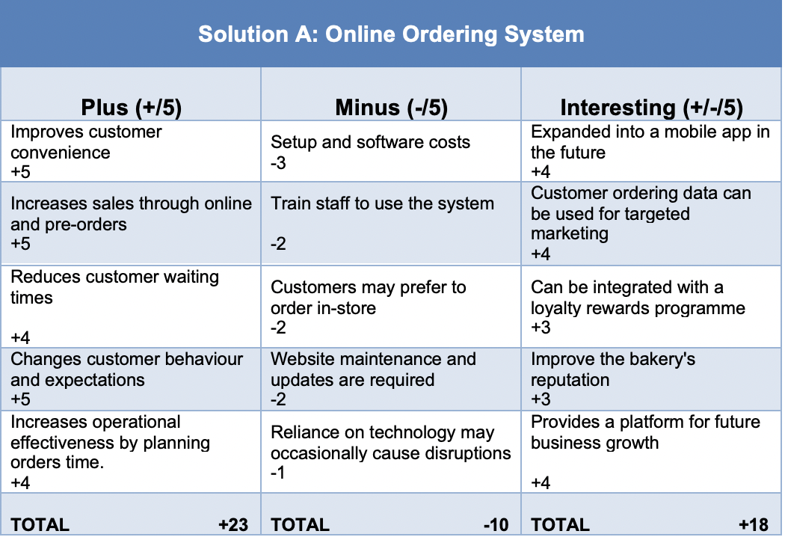

Therefore: Overall Total for Online Ordering System = +31

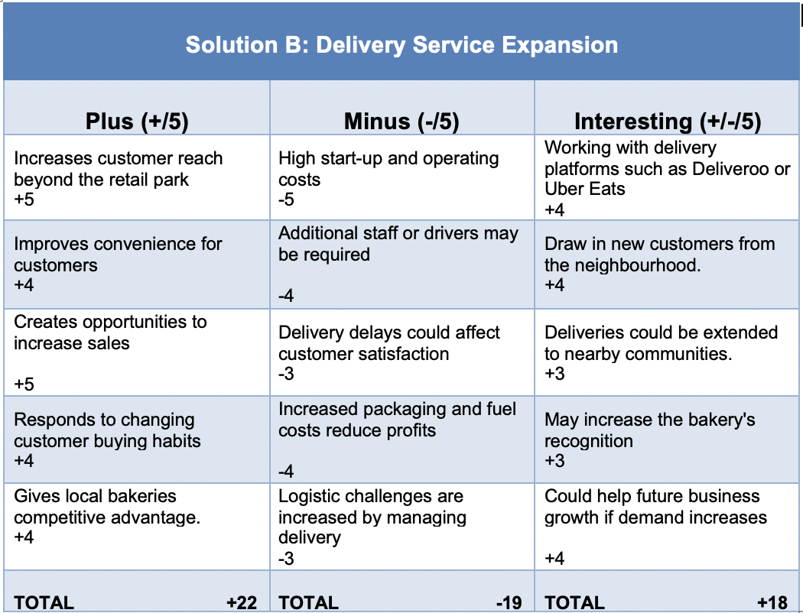

Overall Total for Delivery Service Expansion = +21

Task 3a – PMI Evaluation (Appendix 1)
De Bono (1994) created the Plus, Minus and Implications (PMI) strategy as a decision-making tool to assist in evaluating several possibilities before choosing the best solution (Cahyani et al., 2023). the method encourages decision-makers to consider each choice's positive, negative and interesting features rather than just its benefits (Felemban et al., 2024). This provides a fair assessment and reduce the possibility of bias decision-making. For Basil's Bakery, the PMI technique was applied to compare two possible solutions: introducing an online ordering system and expanding the bakery's delivery service. Each plus, minus and interesting factor was scored on a scale of one to five according to its importance to the business. This allowed both solutions to be compared objectively and highlighted the potential benefits and risks associated with each option. The PMI technique facilitates more informed choices because it promotes critical thinking and considers both immediate and long-term effects before putting a solution into practice. As a result, it offers an organised and transparent way to choose the best plan of action for enhancing Basil's Bakery's sales performance.

Appendix 2: Task 4a

Implementation Plan

Name the problem you are solving: Declining sales as a result of fewer customers and changed customer behaviour.

Name the solution you are implementing: Online Ordering System

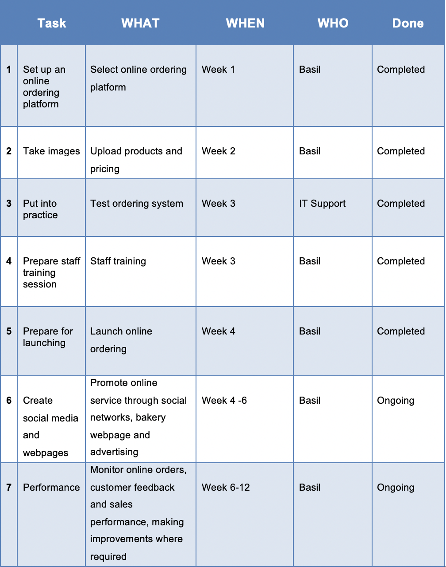

Task 4a: Implementation Plan (Appendix 2)
An implementation plan offers an organised structure that sets out the duties, deadlines and tasks necessary to effectively implement a suggested solution (Hindarto, 2023). It supports organisations in successfully allocating resources, tracking progress and lowering the possibility of implementation mistakes or delays (Nasri et al., 2022). The implementation strategy was created for Basil's Bakery in order to facilitate the launch of the online ordering system. The strategy outlines the essential tasks, such as choosing an appropriate online ordering platform, inputting product details, testing the system, educating employees and advertising the service. To make sure the implementation process is well-organised and achievable, every task has been assigned a particular schedule and responsibility. Assigning tasks increases accountability because it enables Basil to keep an eye on developments and make sure each phase is finished before going on to the next. The implementation strategy helps to avoid disruption to the bakery's regular operations while offering a clear roadmap for implementing the online ordering system. Overall, it assists Basil supervise the project effectively and promotes the correct implementation of the suggested solution.

Appendix 3: Task 5a

Key Performance Indicator: Increase monthly sales revenue by 15%

SMART Objective Table

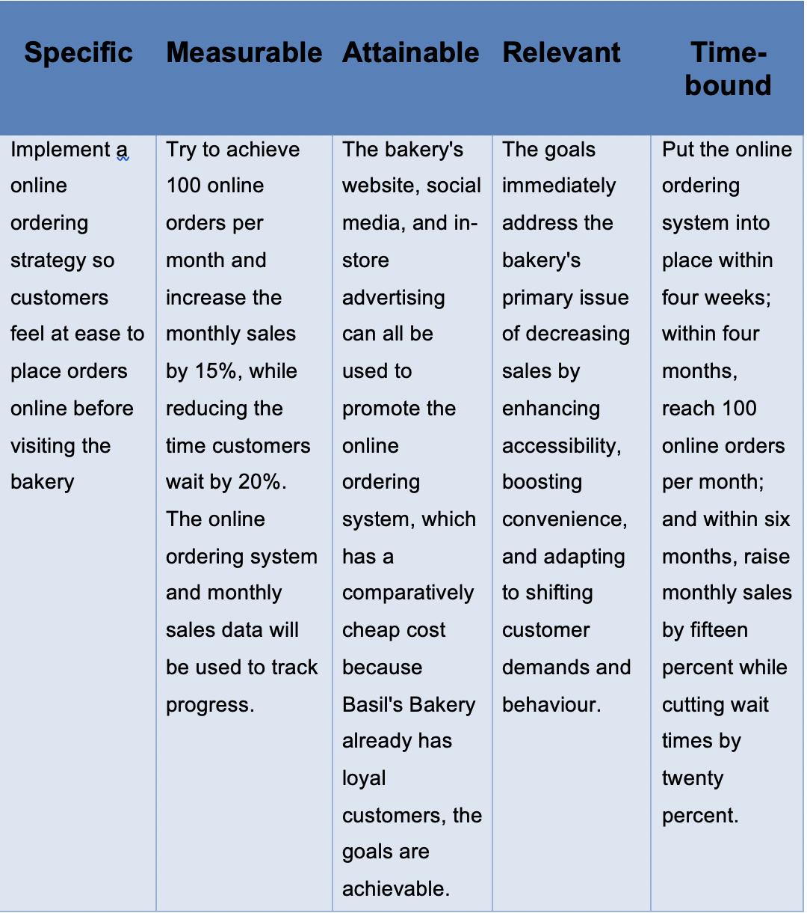

Appendix 3 – Task 5a: KPI and SMART Objectives
Key Performance Indicators (KPIs) are crucial measurable values used by businesses for evaluating the efficacy and effectiveness of financial management systems (Daniel and Oye, 2024). Organisations can assess whether they are achieving their strategic and operational objectives (Chmutova, 2024). The aims and objectives of the company being assessed are closely matched with effective KPIs. KPIs indicate what success looks like in terms of reaching objectives, whether it's an individual's performance, a team's project, or a company's strategic plan (Aithal and Aithal, 2023). To complement KPIs, organisations frequently utilise SMART objectives, which ensure that company goals are Specific, Measurable, Achievable, Relevant and Time-bound (Ishak et al., 2019). Together, these technologies offer an organised approach to performance management by establishing specific objectives and monitoring progression (Sultan, 2022). For Basil's Bakery, the selected KPI is the number of online orders received each month, as this directly measures customer use of the new online ordering system. The SMART objectives focus on increasing online orders, improving monthly revenue and cutting customer wait times within time limits. Basil is able to track business success, identify areas in need of development and assess whether the online ordering system is accomplishing its goals. The long-term success of the company will be enhanced by routinely evaluating these measurements.

