Robert Lewis 1810455
Craig-y-nos Country Park management plan
Introduction
Craig-y-nos Country Park was acquired by the Brecon Beacons National Park Authority in 1976 and was formerly part of the Craig-y-nos estate once owned by Dame Adelina Patti the famous opera singer. The park comprises of woodland, meadows and three ponds along with two rivers flowing through the Tawe and the Llynfell. The park offers tranquil walks along pathways which wind around the park which are popular with day visitors and dog-walkers very close to the highly popular Dan-yr-ogof Showcaves located on adjoining land attracting visitors from a very wide area. Historically the park was developed by private owners who indulgently who created an environment for their own enjoyment which nowadays may not be as suitable a place of interest to the general public. The park has been blighted by evermore frequent flooding and high winds creating increased pressures on available resources and reducing visitor numbers with the meagre staff and volunteers being re-deployed for the completion of remedial works for both the preservation of existing features and the safety of the visiting public. Funding for Craig-y-nos Country Park like many other National Park properties has to be of paramount importance as reduced government funding the limited resources available have to be utilised efficiently and visits by the paying public has to be an essential contributor to the everyday management of the park with staffing costs a major expenditure. The purpose of this management plan will focus on the development of the far lake to create a more attractive and bio-diverse location for the enjoyment of visitors and beneficial to wildlife.
Methodology
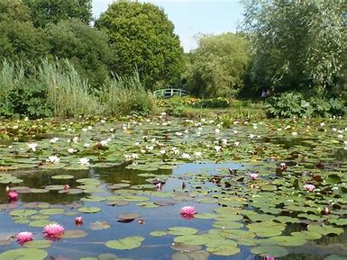
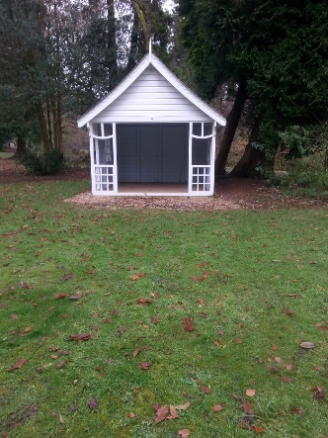
The far lake at Craig-y-nos Country Park through a lack of maintenance has been unable to maintain a constant water level has water has been draining from a leak on the east side of the park. This failure in the embankment has now been remedied and so the development of this lake can be exploited to enhance its contribution as an attraction to the park complex. The lake currently contains a small island with vegetation which was previously lacking maintenance now being reduced allowing habitation by a wider range of wildlife. There remains a lack of biological life (Fig.1) such as plants, invertebrates, fish and amphibians and by the introduction of water plants such as Water Lilies (Nymphaea odorata) and Cattail (Typha). These would produce necessary shade and shelter, previously this lake has been stocked with Rainbow Trout (Oncorhynchus mykiss) primarily as a sporting fish and requiring very little by the way of a natural source of requirements for their survival but now be stocked with Roach (Rutilus rutilus) and Perch (Perca). By creating a more natural freshwater environment this would create a much more diverse range of wildlife and an increasingly more interesting, picturesque location. Once completed this lake could be a major attraction to the park and so additional provisions should be made available to the visiting public by providing additional benches and shelters. The park currently lacks shelter around the park thus limiting the attraction by visitors to the park during periods of poor weather and so by providing shelters with seating the park would hopefully benefit from additional visitors enabling them to have a greater insight into the natural occurrences faced by wildlife in adverse conditions. With the numbers of mature trees such as Beech (Fagus sylvatica), Black Pine (Pinus nigra) and Ash( Fraximus excelsior) reducing constantly through falling during storms, disease and others that have reached or are reaching the end of their natural life this timber could be utilised by the park for the construction of shelters(Fig2.) and benches to reduce costs. The current procedure for areas which have experienced fallen trees seems to replace them with the re-planting of similar species but these tree types are very slow growing requiring decades and sometimes centuries to reach maturity and with current climactic conditions may not be suitable for growing. Many of these trees were planted during the Regency and Victorian era to create a parkland within the estate for their splendour and ornamental interest whereas these trees nowadays would be classed unsuitable in such wet conditions and even more so with the current conditions where the land is flooding more regularly. The park area has now regularly become a flood plain of sorts and will always be a problem within the park for future projects. It may be possible to witness this occurrence with the erection of boardwalks upon areas that are susceptible to flooding as to allow the continuation of visitors to experience weather extremes which sometimes seem devastating but also fascinating. These boardwalks would protect sensitive species on the ground from walkers and dogs and provide an area free from disturbance to grow more rapidly. As trees are removed from within the park it will allow more light and will accentuate the drying of the ground which is now damp and wet which is not ideal for many plant species and create an increased biodiversity within. In these areas smaller tree and bushes such as Hawthorn (Craetus monogyna), Crab Apple (Malus sylvestris), Hazel (Corylus avellana) and Holly (Ilex) which would provide a feeding environment for passerines where there is a noticeable lack of. As it currently operates Craig-y-nos Country Park does not appeal to much of the general public and is more often become a location for local dog-walkers failing to attract day-trippers and dog owners from further afield. Naturalists would fail to be impressed by the current wildlife examples so would be less inclined to visit.
Fig.1 Established pond. Source. Google-images
Fig2. Existing shelter. Source-author
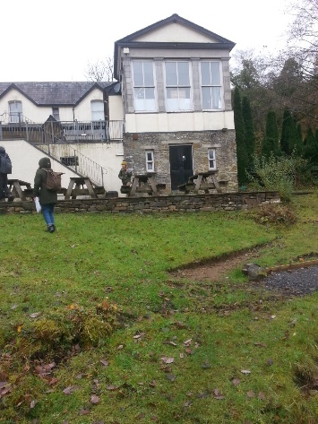
Funding
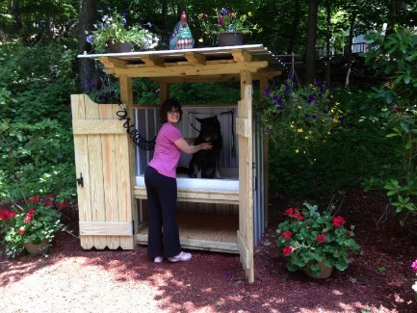
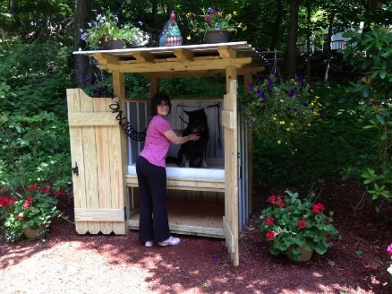
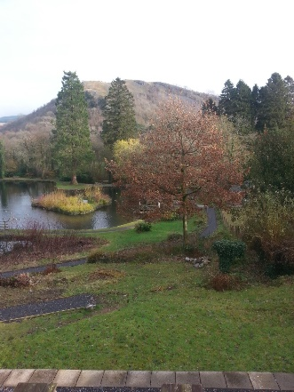
To increase funds available to the park to increase the biodiversity and create additional visitors I would suggest that services provided be improved. The location of Craig-y-nos Country Park is ideally located on the A4067 a popular highway and enroute to the Brecon Beacons National Park. With the larger towns and cities of Swansea and Neath easily accessible so by making the park a more attractive location could attract many more visitors. Currently the park has very little to offer by the way of services and facilities. The existing Changing Seasons café/restaurant is very limited in size and provisions and if visitor numbers were increased is probably inadequate. Alongside the Victorian constructed café building is the more recently constructed boiler room with classroom and gift shop. This building is currently poorly utilised as a classroom and the gift shop with erratic opening yet occupying the premium location within the park. (Fig3) This location commands tremendous views over the duck pond area to the Brecon Beacons in the distance and is at the moment not being exploited. If this building was replaced by a larger two-tier construction including a larger restaurant on the upper floor with a decked sheltered area below providing an interesting, picturesque dining area. The restaurant would incorporate bi-fold doors which during the summer months could be opened up and creating an almost al fresco dining area allowing visitors to enjoy the beauty of the parks’ location. The lower sheltered. decked area would provide a seated area for visitors requiring a snack or hot drink in all weather and could be accompanied by their pets. For dog owners may be dissuaded to visiting the park as they may not wish to put muddy, wet dogs in their vehicles especially if they have travelled some distance to visit the park. With the provision of a dog washing station (Fig.5.) visitors would pay a nominal fee for a warm water shower installation where their pets could be cleaned before leaving in their vehicles. Most of the roadside public houses along the A4067 offer dining facilities and facilities. The National Parks Authority may not find it acceptable to finance such a major project as they have to operate within a restricted budget so a possibility may be to finance the project through private investors. Many projects by Private Financial Initiatives (P.F.I.) where investors or developers will participate towards the scheme and its construction obtaining the land possibly on a long term lease enabling them to construct the required facility and when completed could be offered to private businesses or in this case leased back to the National Parks Authority. Many outdoor attractions have the attraction of providing dining facilities and for many families planning a day out is nowadays essential. Increasingly dog-owners planning a day out will actively select a destination where their pets can accompany them and during Winter months many coastal locations prohibit dog-walkers on beaches this reduces their choice of destinations. By making the park more appealing to a much wider public this would also result in larger visitor numbers and where currently private tenants in retail facilities the Park Authority could command higher rental and leasehold incomes as due to increased footfall making these businesses more lucrative. With the café/restaurant relocated the existing businesses would be able to relocate to the now vacant café building allowing them to open throughout the year and capitalise with a more prominent retail location. The National Parks Authority locations have since their conception been well supported and appreciated by the public but are restricted to how they can maximise their income with much of it being generated by parking charges. Presently Craig-y-nos Park as it exists currently with meagre visitor numbers could become a drain on Brecon Beacons National Parks resources if it does not attract additional visitors and so becomes essential to become more appealing with its facilities and the variety of wildlife and so provide a more valuable environment for the visiting public to enjoy. With the Brecon Beacons becoming increasingly popular as a tourist destination Craig-y-nos is ideally located to capitalise on this position. Many people are now looking more to explore natural locations during holidays and weekends and many people are more aware of environmental conditions putting additional pressure on the countryside and by attracting visitors not only in fine weather enabling them to visit in adverse conditions this will help them to become aware of the various conditions experienced in the countryside.
Fig.5.. Dog-washing station. Source. Google-images
Fig.3.. Gift shop/classroom extension. Source-author
Fig.4. Duck Pond view. Source-author
Conclusion
As it currently operates Craig-y-nos Country Park offers very little in the way of facilities or biodiversity and so the attraction to visitors is very limited. The park is operating on a limited budget with a large proportion of available funds being allocated to wages and remedial works. With a large number of mature trees now suffering from old age and disease plus falling in high winds this puts tremendous pressure the parks staff and resources and by replanting with existing species will take a very long time for any visible reconstruction. By replanting with smaller, faster growing trees and bushes more valuable to a wider cross-section of wildlife this will increase the biodiversity within the park and visually more attractive. The far lake if planted with freshwater plants will too improve its biodiversity and appearance and by stocking with coarse fish which would survive with no support attracting birds and mammals. All this would be funded by an ambitious provision of a new restaurant and facilities around the park.

References

Boothby, J.(1999). ‘Framing a strategy for pond landscape conservation: Aims, objectives and issues’. Landscape Research; Abingdon Vol.24. Issue 1,(Mar. 1999): 67.
Brecon Beacons Our national park (no date) Craig-y-nos Country Park. Available at:
Cloke, P. J. and Park, C. C. (1981) ‘Country Parks in National Parks-a case study of Craig -y-nos in the Brecon Beacons, Wales’, Journal of Environmental Management, 12, pp.173-185
Craig y nos Management Planhttps://aderyn.lercwales.org.uk/public/search/results?l
Eagles, P.F.J. and McCool S.F. (2002) Tourism in national parks in protected areas-planning and management, CABI Publishing, Wallingford, p.212-287

Edington, J.M. and Edington A. (1977) ‘A National Park’, Ecology and Environmental Planning, pp.163-184

http://www.breconbeacons.org/craig-y-nos-country-park (Accessed: 7th November 2019)

Restaurants near the National Showcaves Centre for Wales.
https://www.tripadvisor.co.uk/RestaurantsNear-g3845704-d243020(Accessed:8th. December 3019)
Short, F.T., Kosten, S., Morgan, P.A., Malone, S., Moore, G.E.; Impacts of climate change on submerged and wetland plants. (2016) ‘Aquatic Botany’. Vol.135, pp.3-17
Small woodland management, Forestry Commission, dataset http://data.gov.uk (Accessed: 4th December 2019)

.

