Changemakers: Creativity and Value Creation
Eben Gidney (2203532)
Setting up a Christian Union (CU)

There are two main reasons for me wanting to set up a Christian Union. One of them is to provide a safe space where current Christians can come together and have fellowship, supporting and encouraging each other in our faith and lives.
The second reason is to reach out to people at UWTSD Carmarthen to tell them about Jesus. One way I’m thinking of doing this, is by setting up a group where people interested can meet in a safe, non-judgmental environment to ask any questions they might have. I would also go through a series with them looking at the cornerstone of Christianity, Jesus.

Why is this important? (Secondary research)
As a Christian I believe that Jesus Christ (God) came down to earth from heaven to show us His character and to die the death we deserved. Taking the punishment for our sins upon Himself and covering those who believe in Him with His righteousness, so that we can live in loving relationship with the almighty God who created us and loves us above all His creation. That is what makes me a Christian. Having faith in Jesus Christ. Not going to church, not trying to do good, but through faith in Jesus and His sacrifice on the cross.
Many people have a misled view of what it means to be a Christian. From conversations I’ve had with people, they often think it’s about following a strict set of rules (Gods standards), of which the bible actually says no man (besides Jesus) has been able to live up to. Romans 3:22-24 in the bible (NIV translation) says, “This righteousness is given through faith in Jesus Christ to all who believe. There is no difference between Jew and Gentile, for all have sinned and fall short of the glory of God, and all are justified freely by his grace through the redemption that came by Christ Jesus.”
It is also our duty as Christians to spread the gospel of Jesus and to be His representatives on earth to draw others to Him. God calls those who believe in Him to go out and spread the gospel of Jesus. This is said in many bible passages, one of them being from Mark 16:15-16 “He (Jesus) said to them (His disciples), ‘Go into all the world and preach the gospel to all creation. Whoever believes and is baptised will be saved, but whoever does not believe will be condemned.’”
The bible says to do this in a kind, gentle, loving manner as Jesus did, because it’s part of His character, He says in Matthew 11:29 “for I am gentle and lowly in heart”. Unfortunately, many Christians in the past haven’t got this right, and some are still getting it wrong today. In many disappointing cases, people have actually used their ‘religion’/status in church to get what their sinful heart’s desire. One example being priests in the Roman Catholic church in Boston using their position to sexually abuse children. This is ungodly and sinful and will not go unpunished. Jesus warns us in the bible of ‘false prophets’, who appear to be followers of Jesus, but their intention is to destroy and lead people away from God. (Matthew 7:15-16a & 18-20) “Watch out for false prophets. They come to you in sheep’s clothing, but inwardly they are ferocious wolves. By their fruit you will recognise them…”, “A good tree cannot bear bad fruit, and a bad tree cannot bear good fruit. Every tree that does not bear good fruit is cut down and thrown into the fire (hell). Thus, by their fruit you will recognise them.”
The disciple Peter says in his letter to one of the early churches “Always be prepared to give an answer to everyone who asks you to give the reason for the hope that you have. But do this with gentleness and respect.” And so, when I form a Christian Union, I want it to spread the gospel in a gentle and respectful way.
God wants to be in loving relationship with all of us (that’s why He sent Jesus to die on the cross), “He yearns for relationship with us. ‘Now this is eternal life: that they may know you, the only true God.’” Wild At Heart (2021). God has given us free will, because He loves us, and because there cannot be love without free will. If you programme a robot to do your bidding, then it’s not doing it out of love but out of its programming. And so God has given us free will so we can choose to be in loving relationship with Him. The thing is, a lot of people don’t want to know God, or be in relationship with Him, possibly because they haven’t been told about Him, or have a misunderstanding of Him. (John 1:10) “He (Jesus) was in the world, and though the world was made through Him, the world did not recognise Him.” God won’t force people who don’t want to be with Him into His full presence (heaven). This is why not everyone goes to heaven. Because they don’t want God in their lives and they reject Jesus’ sacrifice. And so, because God is just and doesn’t let evil go unpunished (Deuteronomy 32:4) “He is the Rock, His works are perfect, and all His ways are just. A faithful God who does no wrong, upright and just is He”, and because they’ve rejected Jesus’ sacrifice (an atonement for our sins), they go to hell to pay for their sins. The late Reverend Billy Graham says (Tribune Content Agency, 2019) “We are free agents. God didn’t create us as machines to be compelled to love Him. We choose to obey or to disobey Him. By His marvellous grace and mercy, He’s given us the power of free choice. Those who reject or neglect Christ will be in hell. No man will go to hell because he lived an immoral life, for Christ Himself will forgive those who repent of sin and received Him as Saviour. People go to hell because they do not repent; rejecting God’s perfect plan of salvation.” This is why there is an urgency to spread the good news of Jesus. So that people might hear what He’s done for them, leading them to repent of their sins, so they would be saved from damnation. But, we all have a choice to put our faith in Jesus or not. That is why it’s important to spread the news of Jesus, so they have an informed choice. We all need to make our choice.

These are the reasons why I want to reach out to people at UWTSD Carmarthen. To tell them the wonderful news of Jesus’ sacrifice, which has redeemed us from our sins, not only to save us from eternal hell but to allow us to be in relationship with God.

I feel an effective way to spread this gospel is through a Christian Union (CU). I want it to offer opportunities for people to ask questions and learn more about God in a safe, open, non-judgmental and gentle environment.

Primary Research
But, before I set up an official CU, I would like to know if there is any interest surrounding this topic at UWTSD Carmarthen. So, I compiled together a short survey with simple closed questions related to the topic, as I know it can be sensitive to some and I didn’t want to make people write a long paragraph explaining their views, because I think it would be better to do that in person with people who are interested.
While I felt it necessary to give a backdrop for the purpose of the survey, I didn’t want to preach through it, rather mainly gather information to know if anyone was interested. This survey doesn’t have a specific target audience, simply people at UWTSD Carmarthen, which made sending the survey out quite easy. I sent the survey to my class WhatsApp group chat and a couple of my friends class group chats. I got a total of 19 responses. While it would have been good to send the link to more people to get more responses, its main purpose wasn’t to advertise the CU but to gather information, and I feel I got enough information to show people are interested.

My survey consisted of the introduction and three questions:
Introduction: I'm writing this survey to see how many Carmarthen students are interested in learning about God through the bible and exploring Christianity. Using this information, I would like to form a society where all students are welcome to gather and ask any questions about Jesus, God, the bible and faith in a safe, open, non-judgmental environment and to provide a biblical answer to those questions.
- What do you have faith in (what do you believe in)?
- Are you put off by words like God, Jesus, Christianity, church?
- Would you like to be able to ask questions about God, Jesus and the bible in a safe, non-judgmental space?
These are the results:

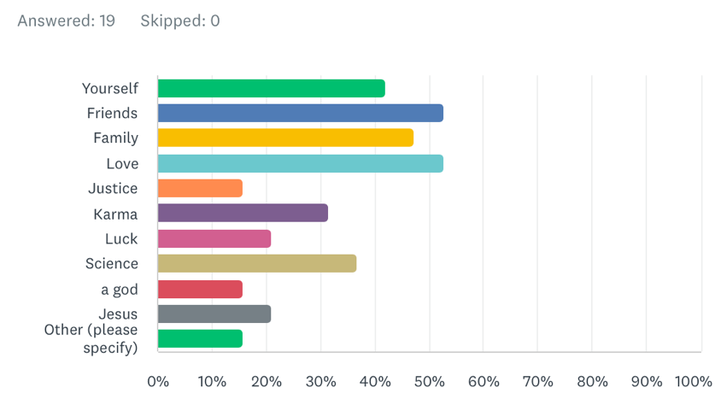
What do you have faith in (what do you believe in)?
I gave multiple examples of things people could have faith in, of which they could tick multiple, and I gave them an ‘other’ chat box for them to add anything specific I didn’t include (of which I had 1 genuine answer being ‘spiritualism and science’). This was to help me get a rough idea as to what sort of things people believe in.
I’m not surprised that friends, love and family are the highest on the chart, I’m glad they are. But to be honest I was expecting to see more than 50% of people tick those options. Which is a shame because it probably means 50% of the people who did the survey haven’t had a great experience of friends, family and love. It’s also a shame to see how not many people believe in justice. All the more reason to share what the bible says about God, because those four things are hugely important to Him. I’ve already shown that the bible says God is just and that He loves us (in saving us through Jesus’ sacrifice). The bible also says that when you have faith in Jesus, God the Father adopts us as children into His family. “He predestined us for adoption to sonship through Jesus Christ, in accordance with His pleasure and will” (Ephesians 1:5). “You were made for friendship with God. God does not just want us to know about him; he wants us to know him – and to experience his friendship.” Hunter. D (2018). Based off the fact that four people ticked ‘Jesus’ as one of their answers, that leads me to believe that at most, four people who took the quiz might be Christians, because they might believe Jesus existed but not have an active faith. Equally, they could be Christians in which case I now know there are Christians who might benefit from a CU where they can come together in fellowship.

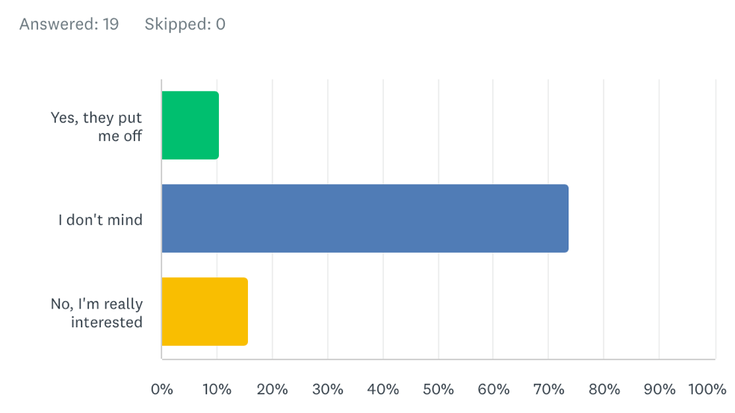
Are you put off by words like God, Jesus, Christianity, church?

I asked this question to see if there were people I needed to be careful with when bringing this topic up to go about spreading God’s word gently and respectfully. And it’s also nice to know that some people are interested.

Would you like to be able to ask questions about God, Jesus and the bible in a safe, non-judgmental space?
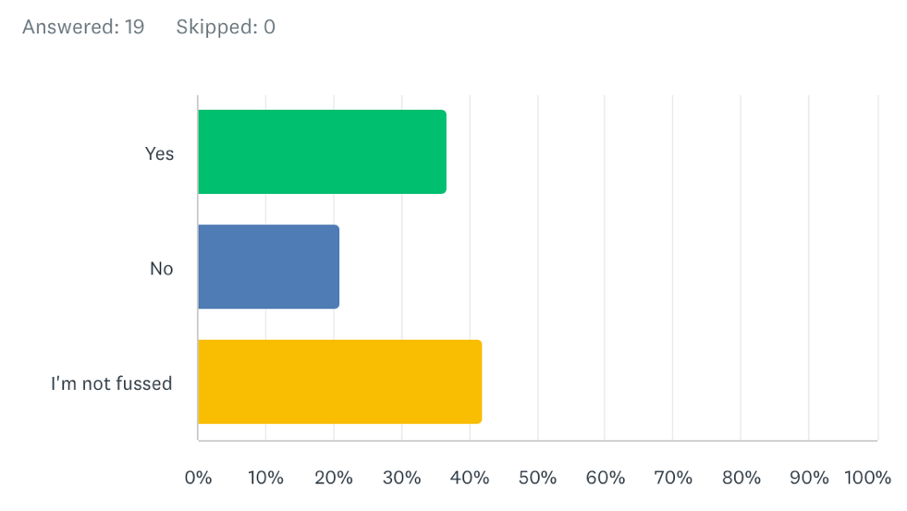
This is a very straightforward question to see if there is any interest, as I intend to set up this space as part of the CU. From the results there were seven people who said yes, four who said no, and eight who weren’t fussed. These results are very helpful because now I know there is an interest in that part of the CU. I also find it interesting that four said no in comparison to only two people saying they’re put off by this topic. My assumption from this is that those extra 2 people just don’t want to know about God. From this information I could do further research to see if platforms like social media or sending videos on the topic of Christianity would be helpful, particularly for the group of people who said they weren’t fussed.

Conclusion
Based off the results from my survey, I now know that there is an interest both in the fellowship side of a CU, and a ‘finding out more’ / ‘open questions’ group as the other side of a CU. While I’m not entirely sure how to go about setting up these groups and the structure for them, and would need further research, I know there will be people who could turn up to either of them.
One thing I’d also like to do, out of the urgency to spread the gospel, is to set up something that will help me spread the good news of Jesus to those who aren’t particularly fussed. To help them see the urgency to repent of their sins and make the choice or not to turn to Christ, but again, to do so in a loving, gentle and respectful way.

Bibliography & Referencing list

Jesus being the cornerstone:
Ephesians 2:20
Psalm 118:22-23
1 Corinthians 3:11
Isaiah 28:16
Matthew 21:42
Acts 4:11
1 Peter 2:4 & 2:6-8

Jesus being rejected by the world:
Matthew 21:42
Acts 4:11
John 1:10-11

God being just:
Deuteronomy 32:4
Psalm 89:14
Psalm 82:3
Isaiah 1:17
- Shared Hope (2018) Biblical Justice & Social Justice. Available at: https://sharedhope.org/2018/06/04/biblical-justice-and-social-justice/#:~:text=A%20God%20of%20faithfulness%20and,means%20He%20is%20always%20just. (Accessed: 17th Jan 2024).

Receiving or rejecting Jesus:
John 3:36

Evangelising:
Mark 16:15-16
Romans 1:16
Matthew 28:19-20
1 Peter 3:15

Being gentle:
Philippians 4:5
Matthew: 11:29-30
Colossians 3:12
1 Peter 3:15

False Teachers:
Jeremiah 14:14
Matthew 24:24
2 Timothy 4:3-4
Acts 20: 28-30
1 John 4:1
Matthew 7:15-20

- Billy Graham quote: Tribune Content Agency (2019) Those who reject Christ choose to follow Satan. Available at: https://www.chicagotribune.com/sns-201910080749--tms--bgrahamctnym-a20191022-20191022-story.html#:~:text=Those%20who%20reject%20or%20neglect,God%27s%20perfect%20plan%20of%20salvation. (Accessed: 14th Jan 2024).

- Bible Study Tools (2021) Bible Verses About Evangelism. Available at: https://www.biblestudytools.com/topical-verses/bible-verses-about-evangelism/ (Accessed: 13th Jan 2024).

- Bible Study Tools (2019) Bible Verses about Gentleness. Available at: https://www.biblestudytools.com/topical-verses/bible-verses-about-gentleness/ (Accessed: 13th Jan 2024).

- Wild At Heart (2021) Gods Heart for Relationship. Available at: https://wildatheart.org/daily-reading/gods-heart-relationship#:~:text=In%20fact%2C%20this%20may%20be,He%20yearns%20for%20us (Accessed: 17th Jan 2024).

- Hunter, D. (2018) What a Friend We Have in Jesus. Available at: https://www.desiringgod.org/articles/what-a-friend-we-have-in-jesus#:~:text=He%20said%2C%20“You%20are%20my,%2Dfilled%20sacrifice%20for%20friends (Accessed: 19th Jan 2024).

- Bauer, P. (2015) Spotlight. Available at: https://www.britannica.com/topic/Spotlight-film#:~:text=Spotlight%2C%20American%20fact%2Dbased%20dramatic,Roman%20Catholic%20priests%20in%20Boston. (Accessed: 13th Jan 2024).

- Bible Study Tools (2021) Bible Verses About False Teachers. Available at: https://www.biblestudytools.com/topical-verses/bible-verses-about-false-teachers/ (Accessed: 13th Jan 2024).

