Artificial intelligence tool Perplexity was used for the development of this report to support research and idea generation for part 2 of the assignment.

Digital Loyalty and Community Value:
An Incremental Innovation Proposal for Seren Coffi
Iustina Mirela Rusei (1905309)
19th of June 2026
Creativity and Innovation BMSW5013_SWAN
Module Lead: Chris Wilkin
Table of Contents
Executive summary 3
Part 1 4
Introduction 4
Creativity, Innovation and the limits of capitalist growth 5
Proposed innovation: Coffi Cylch 6
Applying the 4p’s to Coffi Cylch 7
Business Model Canvas application 8
Creativity Process and Developing the idea 9
Implementation cost and staff training plan 11
Cost breakdown 11
Training plan 12
Viability using Lewin’s Force Field Analysis 14
Organisational climate and support for innovation 15
Conclusion 16
Part 2 – Using AI tool to develop and critically evaluate the Coffi Cylch innovation 17
Introduction 17
Original idea before AI support 18
AI Prompts used to develop the idea 18
How Perplexity improved the proposal 19
Critical Appraisal of AI Recommendations 20
Advantages and Disadvantages of using AI 21
Conclusion 22
References: 23
Appendix 26
Appendix 1-2 26
Appendix 3-4 27
Appendix 5-6 28
Appendix 7-8 29
Appendix 9-10 30
Appendix 11-12 31
Appendix 13-14 32

Figure 1. BMC 8

Table 1. Cost breakdown 11
Table 2. Training plan 13

Executive summary

This report examines the sustainability challenges facing Seren Coffi, an independent Welsh coffee business based near Cardiff’s old docks. Although the case study shows that customer demand remains strong, the organisation is weakened by rising costs, equipment problems, slow service, founder fatigue, reduced community activity and competition from a nearby chain café. The central issue is therefore not lack of demand, but the need to improve operational efficiency, repeat engagement and value capture while protecting Seren Coffi’s ethical, Welsh and community-focused identity.
The proposed solution is Coffi Cylch, an incremental innovation combining digital marketing, a simple membership programme, pre-ordering and a limited new drinks range, including iced lattes, matcha lattes and selected teas. Using Tidd’s 4Ps of innovation, the proposal is mainly product, process and position innovation, as it refreshes the menu, improves ordering and strengthens Seren Coffi’s position as a digitally connected community café. The Business Model Canvas shows that the main changes occur in customer relationships, channels, revenue streams and value proposition.
The report also applies creativity theory, including Goller and Bessant’s structured creativity approach and De Bono’s lateral thinking, to explain how the idea was developed. Lewin’s Force Field Analysis is used to evaluate viability, showing that the proposal is realistic if implemented as a controlled pilot within the available £2,000 budget. Overall, Coffi Cylch offers a practical way to strengthen Seren Coffi’s resilience without forcing it into a standardised chain-style model.

Part 1

Introduction

Seren Coffi is an independent Welsh coffee business near Cardiff’s old docks. More than a traditional caffé, it promotes ethical sourcing, sustainability, Welsh-language visibility and community engagement through features such as bilingual signage, reclaimed furniture and local events (Schein, 2010; Seren Coffi Case study).
Although demand remains strong, the business faces significant sustainability challenges. Rising costs, equipment issues, slow service, founder fatigue and competition from a nearby chain café have weakened operations (Seren Coffi: Case study). This suggests that Seren Coffi creates social and cultural value but struggles to capture sufficient financial value to remain resilient. According to Foss and Saebi (2015; 2017), business-model success depends on how value is created, delivered and captured.
This report proposes an incremental innovation called Coffi Cylch, meaning “coffee circle”. The initiative combines low-cost digital marketing, a membership scheme, digital pre-ordering and a small range of new drinks, including iced and matcha lattes. These changes aim to improve customer engagement, service efficiency and repeat purchasing while responding to changing consumer preferences (Foroudi et al., 2017; Kwiatek, Morgan and Thanasi-Boçe, 2020; Trott, 2016).
Rather than transforming Seren Coffi into a chain-style business, Coffi Cylch strengthens existing products, processes and customer relationships. As an example of incremental innovation, it seeks to improve commercial sustainability while preserving the caffé’s ethical, cultural and community-focused identity (Tidd, 2018; Bessant and Tidd, 2020).

Creativity, Innovation and the limits of capitalist growth

Creativity and innovation are connected but distinct. Creativity involves producing original and useful ideas, while innovation is the practical application of those ideas to create organisational value (Trott, 2016; Tidd, 2018). West and Farr (1990) define innovation as the deliberate introduction of new ideas, products, processes or procedures to benefit an organisation. This distinction is relevant to Seren Coffi because the caffé already shows creativity through Welsh-language visibility, ethical sourcing, community events and transparent communication. Its main weakness is not a lack of ideas, but difficulty turning them into consistent practices that support financial and operational sustainability.
Creativity should also be understood as a structured process rather than a sudden moment of inspiration. Goller and Bessant (2023) argue that creative thinking can be developed through questioning, reframing and testing ideas. In Seren Coffi’s case, this means shifting the focus from simply selling more coffee to improving sustainability without losing the café’s ethical and community identity.
Innovation is often linked to capitalist growth. Schumpeter’s (1934) theory of creative destruction presents innovation as a driver of economic development and market change. From this perspective, Seren Coffi must respond to rising costs, operational problems and competition from the nearby chain caffe. However, the hospitality group’s proposal reflects a traditional growth model based on standardisation, bulk purchasing and centralised control (Seren Coffi case study).
Although this could improve efficiency, it may weaken Seren Coffi’s distinctive value, including Welsh identity, ethical transparency, local trust and community relationships. Foss and Saebi (2017) argue that business model innovation should consider how value is created, delivered and captured, not only how profit is increased. For Seren Coffi, value is therefore financial, cultural and social.
Coffi Cylch adopts an incremental rather than radical approach. Incremental innovation introduces manageable improvements to existing products, processes and customer relationships while reducing risk (Dewar and Dutton, 1986; Tidd, 2018). The proposal does not reject commercial growth, but reframes it through resilience, repeat purchasing, service efficiency and customer participation instead of standardisation or loss of local identity.

Proposed innovation: Coffi Cylch

Coffi Cylch is an incremental innovation based on four connected elements:
- Digital marketing
- Membership programme
- Simple pre-ordering system
- A new small beverages range selection
Its purpose is to increase repeat custom, reduce queuing, refresh customer interest and create more predictable income without changing Seren Coffi’s leadership, governance or suppliers.
Digital marketing would use Instagram, Facebook, TikTok, Google Business and WhatsApp updates to improve customer communication. This is relevant because Seren Coffi already has a strong ethical and community story, but the case study shows that its visible communication has weakened through reduced chalkboard updates and fewer events. Digital tools can improve marketing capability and growth in SMEs by helping businesses reach and engage customers more effectively (Foroudi et al., 2017).
The membership programme would encourage regular visits through benefits such as loyalty rewards, buy 6 drinks and get one free, priority event booking, member tastings and updates on ethical sourcing. This suits Seren Coffi because its customers are attracted to belonging and values, not only price. Loyalty programmes are most effective when they strengthen relationship quality rather than relying only on discounts (Kwiatek, Morgan and Thanasi-Boçe, 2020).
Pre-ordering would remain simple, using WhatsApp Business, Google Forms, QR codes and scheduled collection times. This would reduce waiting times, help staff organise orders and improve lunchtime service. Practical digital tools can improve service flow, responsiveness and delivery efficiency (Manners-Bell and Lyon, 2022).
The new drinks range would refresh the menu through iced lattes, matcha lattes and selected teas. This responds to consumer interest in convenience, variety, cold drinks and speciality beverages. UK coffee market trends also show growth in sustainability, speciality coffee, technological integration, convenience and digital engagement (Market Research Future, 2026).

Applying the 4p’s to Coffi Cylch

Tidd (2018) explains innovation through four categories: product, process, position and paradigm. Coffi Cylch is best understood as an incremental innovation because it improves Seren Coffi’s current offer rather than replacing the business model completely.
Product innovation appears through the introduction of iced lattes and matcha lattes. These are not radical products, but they refresh the menu and meet changing customer preferences. Trott (2016) argues that new product development can include adaptations and improvements to existing offerings. This is exactly what Seren Coffi needs: manageable menu development rather than an expensive reinvention.
Process innovation is seen in pre-ordering. Customers can order ahead, staff can manage preparation more effectively and queues can be reduced. This directly addresses the case study problem that some customers liked the care but complained about slow service. A simple digital ordering process also avoids the cost and complexity of a full app.
Position innovation occurs because Seren Coffi becomes positioned not only as an ethical Welsh café, but as a digitally connected community caffé. This matters because the chain caffé nearby competes on discounts and convenience. Seren Coffi cannot win by copying a chain badly. It can win by combining convenience with stronger identity.
Paradigm innovation is limited with earlier versions of the idea could be described as paradigm changing, but the safer and more realistic approach is incremental. Seren Coffi remains a caffé. It still sells coffee and community experience. The difference is that membership, pre-ordering, digital storytelling and a refreshed drinks range make the existing model more resilient.

Business Model Canvas application

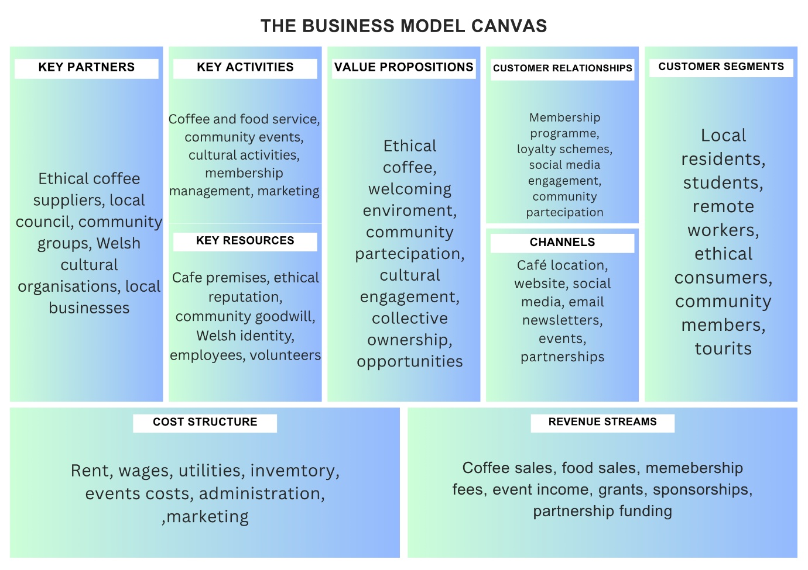

Figure 1. BMC

Coffi Cylch changes parts of Seren Coffi’s business model without changing its basic identity. Foss and Saebi (2015) argue that business model innovation concerns how organisations create, deliver and capture value. In this case, the strongest improvements are in customer relationships, channels, revenue streams and value proposition.
The value proposition becomes ethical Welsh coffee, community belonging, convenience and seasonal drink variety. The customer segments remain residents, students, workers, Welsh-language learners, ethical consumers and community groups. The channels expand from in-store service to Instagram, WhatsApp, Google Business and QR-based ordering. The customer relationship becomes more structured through membership and regular digital updates.
The revenue streams include normal drink sales, member purchases, event bookings and pre-ordered drinks. The membership does not need to generate huge income immediately. Its main value is increasing repeat visits and customer attachment. Wu, Tian and Wang (2019) show that loyalty programmes can be strengthened through social media and analytics tools. Even basic tracking, such as noting popular drinks and peak order times, could help Seren Coffi make better decisions.
The key resources include staff skills, recipes, digital content, the café space, customer goodwill and the Welsh brand identity. The key activities include drink preparation, social media updates, order management, membership communication and small community events. The key partners remain existing suppliers, local cultural groups, customers and possibly the council office mentioned in the case study (Seren Coffi Case Study).

Creativity Process and Developing the idea

The development of Coffi Cylch began with an analysis of the symptoms identified in the case study, including founder fatigue, slow service, reduced community activity, rising costs, equipment failure and competitive pressure. However, Goller and Bessant (2023) argue that effective creativity requires organisations to move beyond immediately visible symptoms and reframe the underlying problem. Seren Coffi’s central problem was therefore reframed from insufficient customer demand to insufficient operational resilience and value capture.
De Bono’s (1992) theory of lateral thinking was used to challenge the conventional assumption that growth must involve opening additional locations, increasing scale or accepting external ownership. Lateral thinking encourages individuals to move away from established patterns and examine a problem from alternative perspectives. In this case, customers were reconsidered not only as purchasers of coffee but also as potential members, contributors and participants in the caffé’s community.
The questioning, observing, networking and experimenting behaviours identified by Dyer, Gregersen and Christensen (2011) also informed the process. Observing the service problem led to the pre-ordering proposal, while examining the decline in events and communication led to the digital marketing and membership elements. Market trends and customer preferences informed the addition of iced lattes, matcha lattes and selected teas as limited product trials.
The proposal also applies Osgood and Schramm’s (1954) circular communication model. Rather than treating marketing as a one-way transmission of promotional messages, Coffi Cylch would use Instagram polls, WhatsApp communication, member tastings and customer feedback to create a continuous exchange. Customers would therefore help Seren Coffi test and refine the membership benefits, ordering process and beverage range.
The initial ideas were evaluated against four criteria: alignment with Seren Coffi’s values, affordability within the £2,000 budget, compatibility with existing leadership and suppliers, and the ability to reduce rather than increase pressure on staff. This convergent evaluation resulted in an incremental proposal combining digital marketing, membership, pre-ordering and limited product development.

Implementation cost and staff training plan

Cost breakdown

The £2,000 budget should support a controlled pilot, not a full transformation. The proposed cost breakdown is as follows
Area | Cost | Purpose
Digital marketing launch | £300 | Basic photography, Canva Pro or design tools, boosted Instagram/Facebook posts, Google Business updates
Pre-ordering setup | £200 | QR codes, printed collection labels, Google Forms/Jotform setup, WhatsApp Business materials
Membership programme materials | £250 | Loyalty cards, QR sign-up posters, member stickers, welcome cards, small tasting vouchers
New beverage stock and equipment | £500 | Matcha powder, extra milk/plant milk, syrups, ice trays/ice storage, shaker tins, clear cups, reusable recipe tools
Staff training and paid time | £400 | Short training sessions on recipes, allergens, digital ordering and customer communication
Launch tasting event | £200 | Small samples of iced latte and matcha latte, community launch evening, bilingual flyers
Maintenance/contingency | £150 | Minor equipment support, replacement utensils, unexpected setup costs
Total | £2,000

Table 1. Cost breakdown

The spending supports incremental innovation because it improves existing operations rather than replacing them. It also avoids changing leadership, governance or suppliers. Where possible, ingredients should be sourced through current suppliers or existing approved purchasing routes.

Training plan

Training should be short, practical and designed to reduce pressure on founders. Schein (2010) argues that organisational culture shapes how people respond to change. Seren Coffi’s culture values care and discussion, but the case shows that decision-making has become slow and tiring. Training therefore needs to create clarity, not more meetings.
This training follows Turner’s (2020) argument that innovation depends on engaged people rather than passive compliance. It also reflects Handy’s (1993) view that organisational change must fit the character of the organisation. Seren Coffi does not need corporate scripts. It needs simple routines that protect its personality while improving delivery.

Training area | Time | Content | Outcome
Coffi Cylch briefing | 1 hour | Purpose of membership, pre-ordering and new drinks | Staff understand the idea and how it protects Seren Coffi’s values
New beverage preparation | 3 hours | Iced latte and matcha latte recipes, measurements, presentation, allergen awareness | Drinks are consistent and quick to prepare
Pre-ordering workflow | 2 hours | How to receive orders, confirm collection times, label drinks and manage queues | Faster service and fewer customer frustrations
Digital marketing basics | 2 hours | Posting schedule, customer photos, Welsh/English messaging, responding to comments | More consistent online engagement
Membership communication | 1 hour | Explaining benefits, signing up customers, collecting feedback | Staff can promote membership
Weekly review meeting | 30 minutes weekly for first month | What sold, what caused delays, customer feedback | Continuous improvement

Table 2. Training plan

Viability using Lewin’s Force Field Analysis

Figure 2. Lewin’s viability tool

Lewin’s Force Field Analysis explains change as a balance between forces that support change and forces that resist it (Lewin, 1947). This model is useful for assessing Coffi Cylch because Seren Coffi has clear reasons to innovate but also faces practical barriers.
The main driving forces are strong customer demand, community goodwill, Welsh identity, ethical values, loyal customers and the available £2,000 pilot budget. Competition from the nearby chain caffé also increases the need to improve convenience and communication. Digital marketing, membership and pre-ordering could strengthen customer relationships, while new drinks such as iced lattes and matcha lattes could refresh interest.
The main restraining forces are founder fatigue, limited staff capacity, financial pressure, equipment problems, slow decision-making and possible resistance to digital ordering. The greatest risk is overcomplication, as too many platforms, membership benefits or new drinks could increase workload rather than reduce it.
Lewin’s model suggests that reducing barriers is as important as increasing pressure for change (Lewin, 1947). Therefore, Coffi Cylch should begin as an eight-to-twelve-week pilot using one pre-ordering channel, a simple membership offer and a limited drinks range. Staff training, clear procedures and short weekly reviews would help reduce uncertainty and support improvement.
Success could be measured through membership sign-ups, repeat visits, pre-orders, waiting times, new drink sales, social media engagement, customer feedback and staff workload. Overall, the analysis suggests that Coffi Cylch is viable if it remains controlled, incremental and responsive to feedback.

Organisational climate and support for innovation

Seren Coffi’s organisational climate is supportive of innovation but also fragile. West and Farr (1990) argue that innovation requires not only new ideas, but also the conditions needed to apply them successfully. Seren Coffi has shown openness to experimentation through Welsh-language initiatives, community events, transparent sourcing and alternative pricing, suggesting a culture that values creativity, participation and social purpose.
Schein (2010) explains organisational culture through artefacts, values and underlying assumptions. Seren Coffi’s bilingual signage, reclaimed furniture, supplier information and community events reflect its visible culture, while its values centre on ethical sourcing, sustainability, Welsh identity and community involvement. Coffi Cylch fits this culture because it improves customer participation and service access without replacing the café’s identity.
Hofstede, Hofstede and Minkov (2010) argue that shared values influence communication, cooperation and responses to change. Seren Coffi’s community-focused culture may therefore support collaborative innovation. However, this should be applied cautiously, as Hofstede’s work mainly relates to national culture rather than one small organisation.
The main barriers are founder fatigue, delayed decisions, limited resources and reduced community activity. Hess (2023) argues that psychological safety helps teams share concerns, suggest ideas and learn from mistakes. Staff should therefore be involved in testing the new drinks, membership scheme and pre-ordering process. Short weekly review meetings could support learning, but they must be focused to avoid further delays. Overall, Seren Coffi’s climate supports Coffi Cylch culturally, but implementation must remain simple, structured and manageable.

Conclusion

Seren Coffi’s central issue is not lack of demand but lack of sustainable operating capacity. The business is loved, but it is becoming brittle. A conventional capitalist solution, such as accepting the hospitality group’s standardised growth proposal, may improve efficiency but risks damaging Seren Coffi’s Welsh, ethical and community-based identity.
Coffi Cylch offers a more suitable incremental innovation. By introducing digital marketing, membership, pre-ordering and a small new beverage range, Seren Coffi can improve customer engagement, reduce queue pressure, increase repeat visits and refresh its offer. The £2,000 should be used carefully on low-cost digital tools, training, membership materials, drink stock and a launch event. The idea is viable because it works within the organisation’s current constraints while creating both commercial and community value.

Part 2 – Using AI tool to develop and critically evaluate the Coffi Cylch innovation

Introduction

This supplement explains how I used Perplexity, an AI large language model, to develop and critically evaluate my original innovation idea for Seren Coffi. My initial concept included digital marketing, a membership programme, pre-ordering and a small healthy drinks range. These ideas were chosen because Seren Coffi still has demand and a strong ethical identity, but faces rising costs, equipment problems, staff pressure, founder fatigue and competition from a nearby chain café. The aim was therefore to create a realistic recovery strategy that could improve loyalty, efficiency and value creation while protecting Seren Coffi’s independent Welsh and community-focused identity.
Perplexity was used as a creative support tool, not as a replacement for my own judgement. AI can support problem-solving by helping users explore alternatives, structure ideas and evaluate options (Hajj, Schmitt and Nehme, 2025). However, Crain et al. (2024) warn that AI can also create risks such as over-reliance and uncritical acceptance. For this reason, I used Perplexity to improve my idea, but I critically reviewed its suggestions before including them.

Original idea before AI support

My original idea was for Seren Coffi to use WhatsApp Business, Facebook and Instagram for digital marketing, introduce a membership scheme with pre-ordering, and add healthier drinks such as iced lattes and matcha lattes. This was suitable because it did not require changes to leadership, governance or suppliers. It was also more realistic than expensive options such as opening a second site, buying a custom app or accepting the hospitality group’s investment offer.
However, the idea was still broad. I had not fully explained the role of each digital platform, how membership would create loyalty beyond discounts, or how pre-ordering would help with queues, staffing and cash flow. I therefore used Perplexity to turn the idea into a clearer and more practical innovation strategy.

AI Prompts used to develop the idea

The first prompt gave Perplexity the Seren Coffi case background and described my original proposal. I explained that the café had strong values and customer demand, but was struggling with rising costs, equipment problems, staff shortages and competition. I then asked how my ideas could be improved.
This prompt was useful because Perplexity responded with specific recommendations. It suggested that my ideas should be made more practical, low-cost and linked to Seren Coffi’s identity. This helped me reframe the proposal as Coffi Cylch, one connected recovery strategy focused on loyalty, convenience, customer engagement and differentiation from chain competitors.
A second prompt asked Perplexity to summarise its answer. This helped me identify the strongest recommendations: clear uses for WhatsApp, Facebook and Instagram, a simple loyalty or membership scheme, a low-cost pre-order system, a trial drinks menu, community partnerships and cost-control actions such as reducing waste.
I also asked: “What are the risks in implementing these ideas?” This moved the AI use from idea generation to critical evaluation. Perplexity identified risks such as lack of money, staff pressure, low customer uptake, wasted stock, operational confusion, weak digital engagement and founder fatigue. These risks helped me strengthen the viability section and apply Lewin’s Force Field Analysis, which considers the forces supporting and resisting change (Lewin, 1947).
Another prompt asked: “What would be the costs of your idea?” Perplexity recommended a lean pilot rather than a full transformation. It estimated a minimum version at around £530–£850 and a more realistic version at around £800–£1,450. It also suggested keeping £500–£800 in reserve for repairs, unexpected bills and supplier increases. This was useful because Seren Coffi only has £2,000 available.
Finally, I asked whether the idea would be viable in real life. Perplexity gave a balanced response, stating that the proposal could work if introduced carefully, cheaply and in stages, but that success was not guaranteed because the business already faced serious problems.

How Perplexity improved the proposal

Perplexity improved the digital marketing idea by giving each platform a clear purpose. WhatsApp Business became a tool for direct customer communication, loyalty reminders and pre-orders. Instagram became useful for visual storytelling, new drinks, ethical sourcing and community events. Facebook became more suitable for local groups and community announcements. This made the marketing strategy more focused and supported the view that digital tools can improve SME marketing capability and customer engagement (Foroudi et al., 2017).
Perplexity also improved the membership idea. My original version focused mainly on repeat purchases, but the AI suggested linking membership to Seren Coffi’s values. For example, members could receive early event access, reusable cup rewards, member-only drinks and ethical sourcing updates. This made the scheme more suitable because Seren Coffi’s customers are likely to value belonging and community, not only discounts. Kwiatek, Morgan and Thanasi-Boçe (2020) argue that loyalty programmes are stronger when they build relationship quality.
The pre-ordering idea was also improved. At first, I saw it mainly as a convenience tool. Perplexity helped me connect it to operational problems, including queues, staff pressure, lunchtime service and cash flow. This made it a stronger process innovation. Manners-Bell and Lyon (2022) argue that practical digital tools can improve responsiveness and service delivery, which supports using a simple WhatsApp or Google Forms system instead of an expensive app.
Finally, Perplexity helped narrow the drinks idea. Rather than launching a large range, it recommended a small trial menu. I used this to focus on iced lattes, matcha lattes and selected teas. This reduced the risk of wasted stock and made the product innovation incremental rather than radical.

Critical Appraisal of AI Recommendations

Although Perplexity was useful, its recommendations needed critical judgement. Some suggestions were too broad, including multiple partnerships, several drink options and too many digital activities. These ideas could have been useful but implementing them all at once would create pressure for a business already dealing with staff shortages and fatigue. I therefore selected only the most realistic ideas.
Another limitation was that AI sometimes made implementation sound easier than it would be. For example, using WhatsApp and Instagram appears simple, but staff still need time to reply to messages, create content and manage orders. This supports Crain et al.’s (2024) argument that AI can support learning, but users must remain aware of its limitations.
Reliability was another issue. AI can provide confident answers, but these still need checking against evidence and context. Suazo-Galdames and Chaple-Gil (2025) argue that AI systems can support critical thinking and creativity, but only when users evaluate and apply outputs carefully. In this assignment, I compared Perplexity’s recommendations with the case study, the £2,000 budget and academic models such as Tidd’s 4Ps and Lewin’s Force Field Analysis.
There were also ethical issues. The task required me to explain how AI was used, so I documented my prompts, screenshots and reflections. This showed that Coffi Cylch was not simply copied from Perplexity. AI supported the process, but I made the final decisions.

Advantages and Disadvantages of using AI

The main success of using Perplexity was that it helped turn a general idea into a practical innovation strategy. It improved the structure of the proposal, gave each element a clearer purpose and helped identify risks. The cost question was especially useful because it showed that Seren Coffi should not spend the full £2,000 immediately when it still has equipment and operational problems.
AI also helped me frame Coffi Cylch as an incremental innovation. Instead of presenting digital marketing, membership, pre-ordering and healthy drinks as separate ideas, Perplexity helped connect them into one strategy based on loyalty, convenience and community-based marketing. This links to Tidd’s (2018) view that innovation can involve improvements to products, processes and positioning rather than only radical change.
The main issue was that AI needed very specific prompts. When I included details about Seren Coffi’s problems, budget and identity, the responses were useful. When prompts were general, the answers became less focused. This showed that AI depends heavily on the quality of the questions asked.

Conclusion

Overall, Perplexity helped develop Coffi Cylch by improving the clarity, practicality and critical evaluation of my original idea. It supported problem-solving by suggesting improvements to digital marketing, membership, pre-ordering, drinks development, cost planning and risk management. However, I did not accept all recommendations automatically. Some were adapted, narrowed or rejected because they did not fit Seren Coffi’s limited budget, staff pressure or community identity.
The final proposal is therefore a refined version of my original idea, not an AI-generated solution. Perplexity acted as a creativity and problem-solving support tool, but the final decisions were based on the case study, academic theory and critical reflection. This shows that AI can support innovation development, but only when its outputs are questioned, tested and applied carefully to the specific organisational context.

References:

Amabile, T.M., Conti, R., Coon, H., Lazenby, J. and Herron, M. (1996) ‘Assessing the work environment for creativity’, Academy of Management Journal, 39(5), pp. 1154–1184
Anderson, N., Potočnik, K. and Zhou, J. (2014) ‘Innovation and creativity in organizations: A state-of-the-science review, prospective commentary, and guiding framework’, Journal of Management, 40(5), pp. 1297–1333. Available at: https://doi-org.uwtsd.idm.oclc.org/10.1177/0149206314527128 (Accessed:17 of June)
Bessant, J. and Tidd, J. (2020) Managing Innovation: Integrating Technological, Market and Organizational Change. 7th edn. Hoboken: Wiley.
Case Study: Seren Coffi case study
Chesbrough, H. (2014) New Frontiers in Open Innovation. Oxford: Oxford University Press.
Crain, C., Ewing, A., Billy, I. and Anush, H. (2024) The advantages and disadvantages of AI in higher education. London: Centre for Business & Economic Research. Available at: https://www.proquest.com/conference-papers-proceedings/advantages-disadvantages-ai-higher-education/docview/3204366518/se-2?accountid=130472 (Accessed: 17 of June)
De Bono, E. (1992) Serious Creativity: Using the Power of Lateral Thinking to Create New Ideas. New York: HarperBusiness.
Dyer, J., Gregersen, H. and Christensen, C.M. (2011) The Innovator’s DNA: Mastering the Five Skills of Disruptive Innovators. Boston, MA: Harvard Business Review Press.
Foroudi, P., Gupta, S., Nazarian, A. and Duda, M. (2017) ‘Digital technology and marketing management capability: Achieving growth in SMEs’, Qualitative Market Research, 20(2), pp. 230–246. Available at: https://www.proquest.com/scholarly-journals/digital-technology-marketing-management/docview/1895058720/se-2?accountid=130472 (Accessed: 17 of June)
Foss, N.J. (2015) Business Model Innovation: The Organisation Dimension. Oxford: Oxford University Press.
Foss, N.J. and Saebi, T. (2015) ‘Business model innovation: The organizational dimension’, in Foss, N.J. and Saebi, T. (eds.) Business Model Innovation: The Organizational Dimension. Oxford: Oxford University Press.
Foss, N.J. and Saebi, T. (2017) ‘Fifteen years of research on business model innovation: How far have we come, and where should we go?’, Journal of Management, 43(1), pp. 200–227.
Goller, I. and Bessant, J. (2023) Creativity for Innovation Management: Tools and Techniques for Creative Thinking in Practice. Abingdon: Routledge.
Hajj, C., Schmitt, C. and Nehme, A. (2025) ‘Enhancing problem-solving skills with AI: A case study on innovation and creativity in a business setting’, Administrative Sciences, 15(10), p. 388. Available at: https://www.proquest.com/scholarly-journals/enhancing-problem-solving-skills-with-ai-case/docview/3265804966/se-2?accountid=130472 (Accessed: 17 of June)
Handy, C. (1993) Understanding Organizations. 4th edn. London: Penguin.
Hess, D.W. 2023, "Improving Team Effectiveness Through Psychological Safety", Chemical Engineering Progress, vol. 119, no. 10, pp. 35-39. Available at: https://www.proquest.com/trade-journals/improving-team-effectiveness-through/docview/2881466835/se-2?accountid=130472 (Accessed: 17 of June)
Hofstede, G., Hofstede, G.J. and Minkov, M. (2010) Cultures and Organizations: Software of the Mind. 3rd edn. New York: McGraw-Hill.
Kwiatek, P., Morgan, Z. and Thanasi-Boçe, M. (2020) ‘The role of relationship quality and loyalty programs in building customer loyalty’, Journal of Business & Industrial Marketing, 35(11), pp. 1645–1657. Available at: https://doi.org/10.1108/JBIM-02-2019-0093 (Accessed: 17 of June)
Lewin, K. (1947) ‘Frontiers in group dynamics’, Human Relations, 1(1), pp. 5–41.
Manners-Bell, J. and Lyon, K. (2022) Logistics and Supply Chain Innovation: A Practical Guide to Disruptive Technologies and New Business Models. 2nd edn. London: Kogan Page.
Market Research Future (2026) UK Coffee Market Size, Share, Industry Trend and Analysis Research Report. Available online at: UK Coffee Market Trend, Size, Share, Industry Report, 2035
Osgood, C.E. and Schramm, W. (1954) ‘A circular model of communication’, in Schramm, W. (ed.) The Process and Effects of Mass Communication. Urbana: University of Illinois Press, pp. 3–26.
Schein, E.H. (2010) Organizational Culture and Leadership. 4th edn. San Francisco: Jossey-Bass.
Schumpeter, J.A. (1934) The Theory of Economic Development. Cambridge, MA: Harvard University Press.
Suazo-Galdames, I. and Chaple-Gil, A. (2025) ‘AI-driven assessment systems in higher education: Effectiveness for enhancing critical thinking and creativity’, Ingenierie des Systemes d’Information, 30(6), pp. 1665–1671. Available at: https://www.proquest.com/scholarly-journals/ai-driven-assessment-systems-higher-education/docview/3240453268/se-2?accountid=130472
Tidd, J. (2018) Managing Innovation: Integrating Technological, Market and Organizational Change. 6th edn. Hoboken: Wiley.
Trott, P. (2016) Innovation Management and New Product Development. 6th edn. Harlow: Pearson.
Turner, E. (2020) Be Less Zombie: How Great Companies Create Dynamic Innovation, Fearless Leadership and Passionate People. Chichester: Wiley.
West, M.A. and Farr, J.L. (1990) Innovation and Creativity at Work: Psychological and Organizational Strategies. Chichester: Wiley.
Wu, H., Tian, X. and Wang, F. (2019) ‘Innovating the customer loyalty program with social media: A case study of best practices using analytics tools’, Journal of Enterprise Information Management, 32(5), pp. 807–823. Available at: https://www.proquest.com/scholarly-journals/innovating-customer-loyalty-program-with-social/docview/2277119027/se-2?accountid=130472 (Accessed: 17 of June)

Appendix

Appendix 1-2

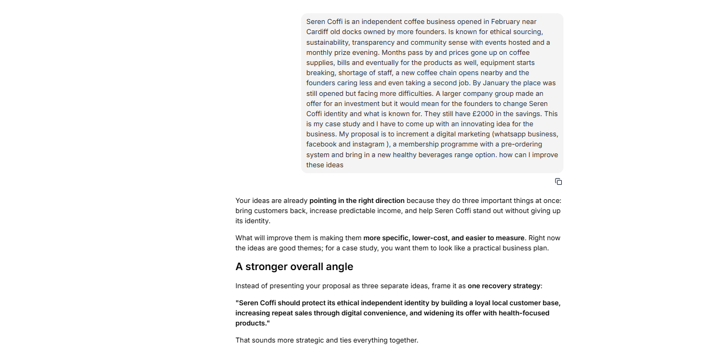

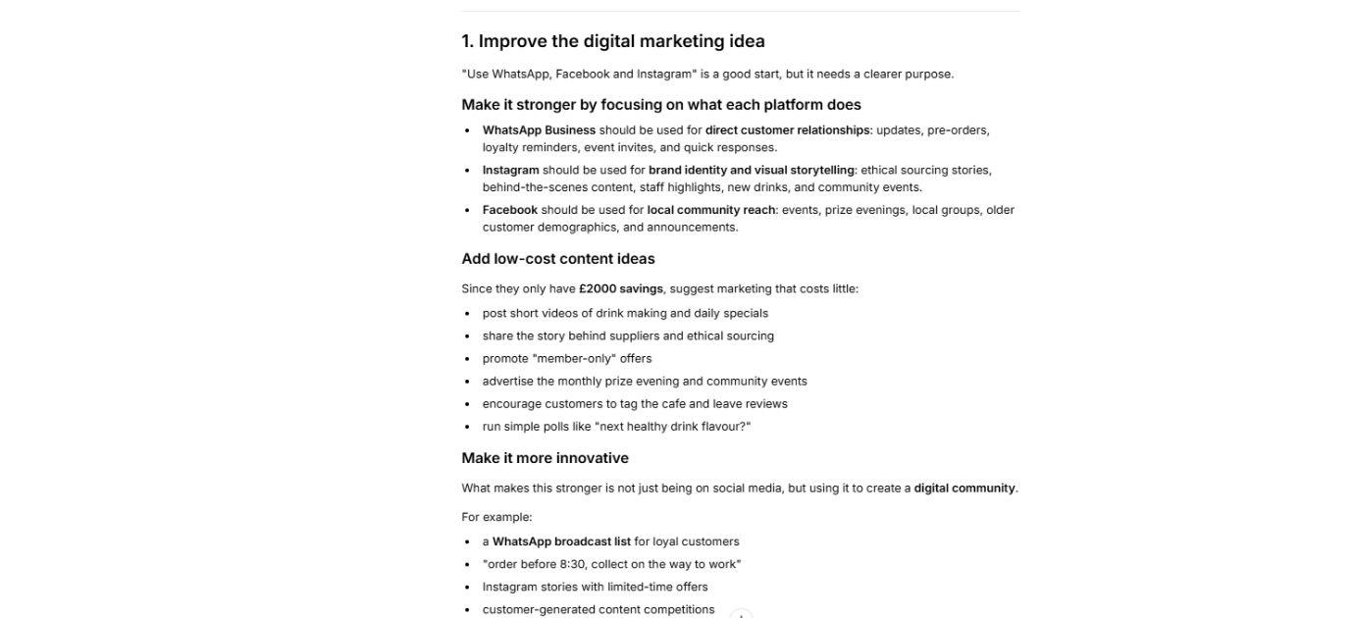

Appendix 3-4

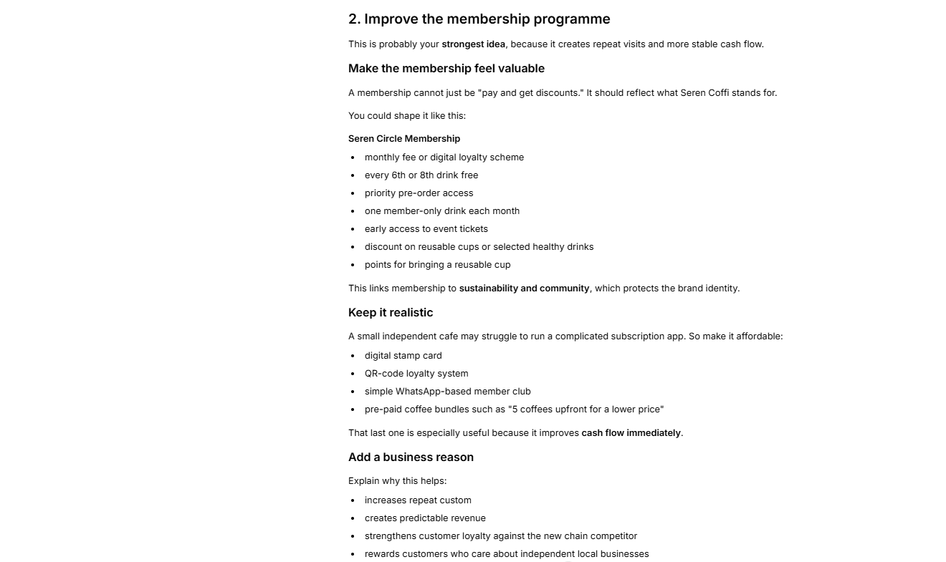

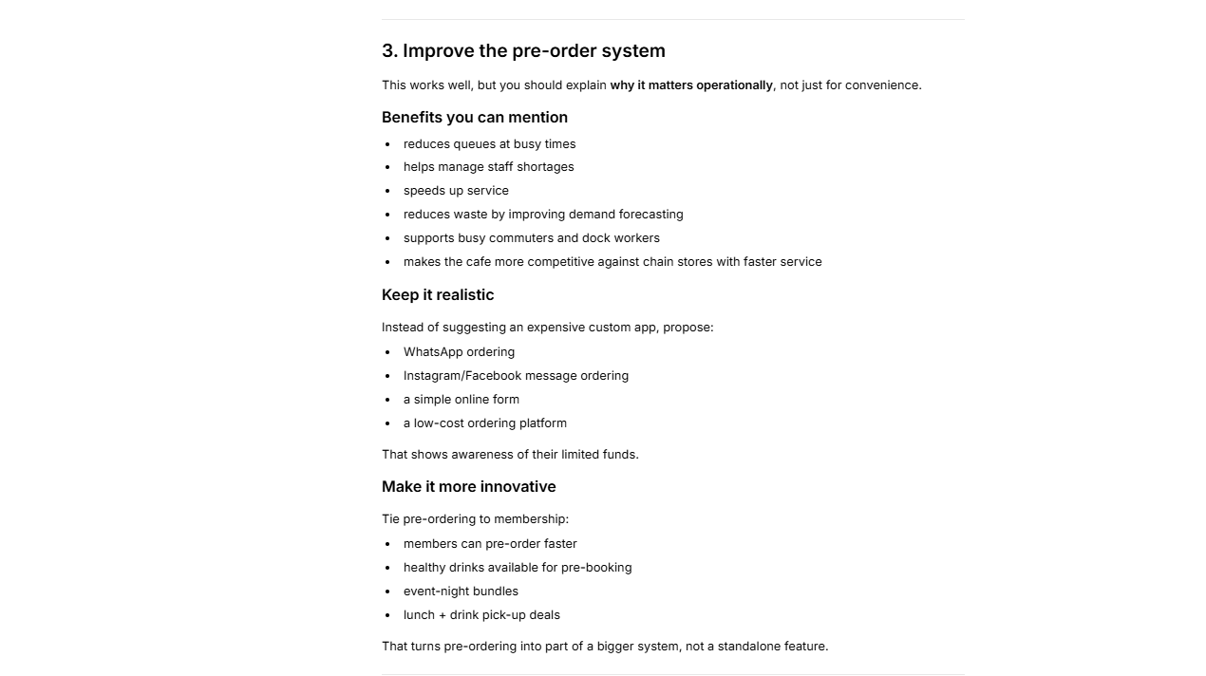

Appendix 5-6

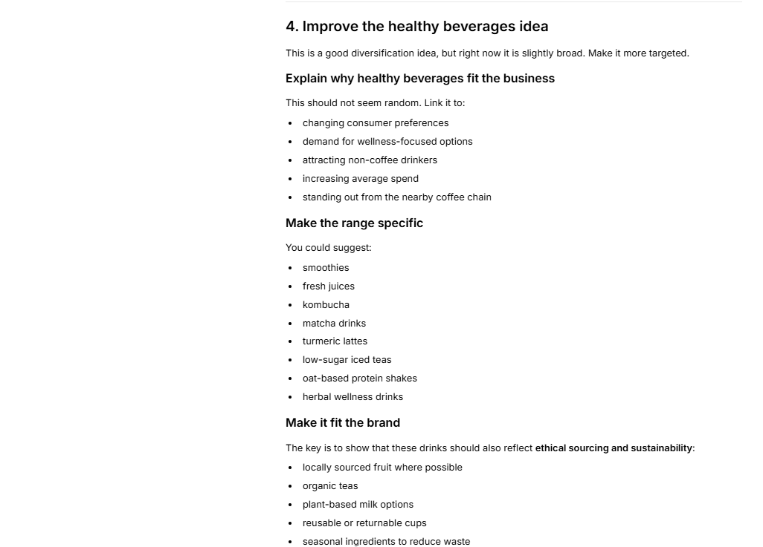

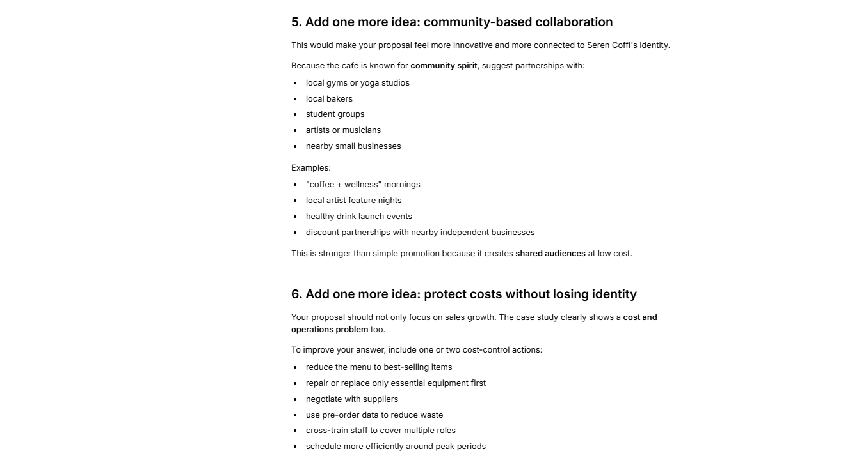

Appendix 7-8

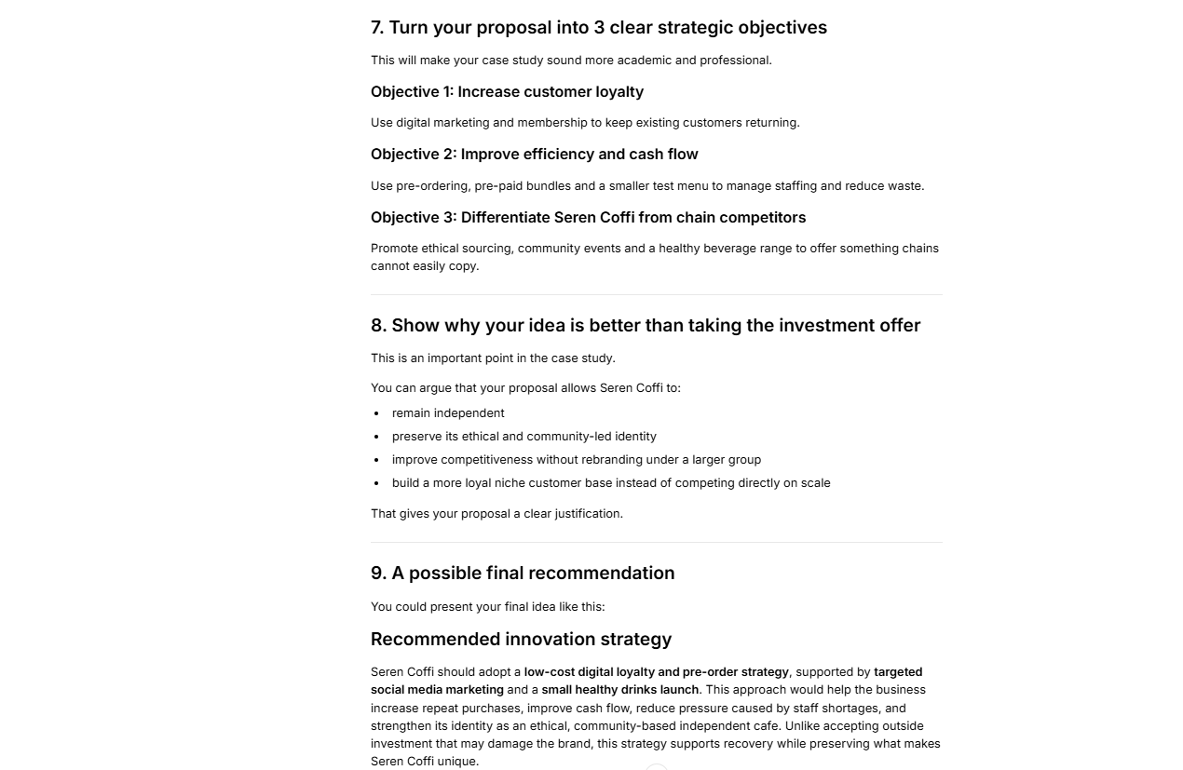

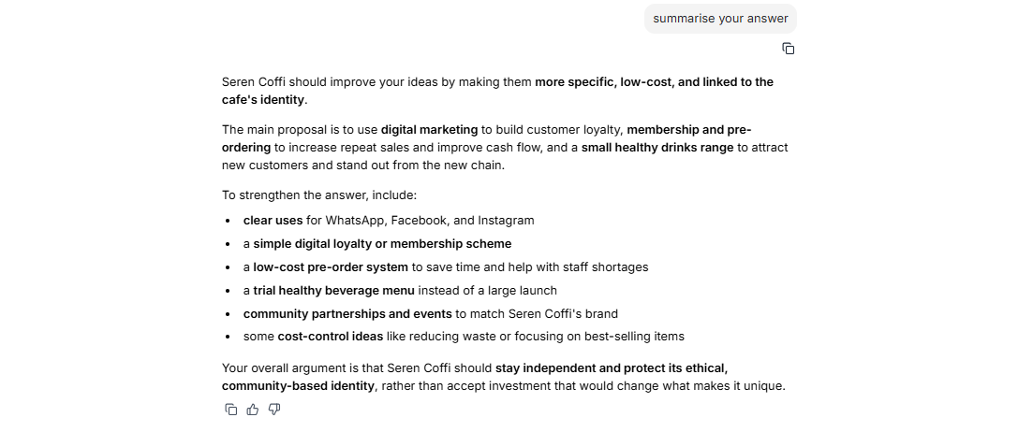

Appendix 9-10
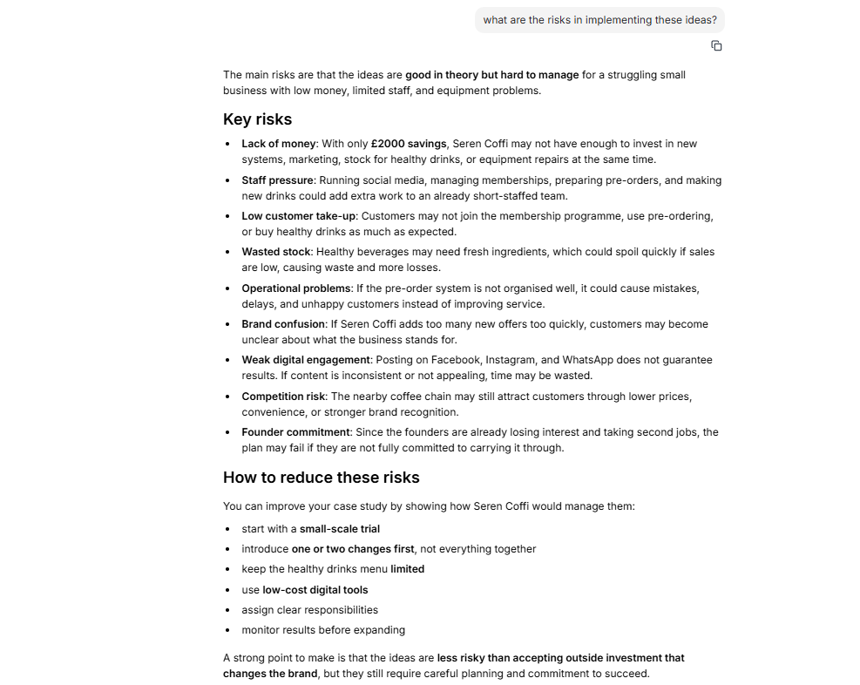

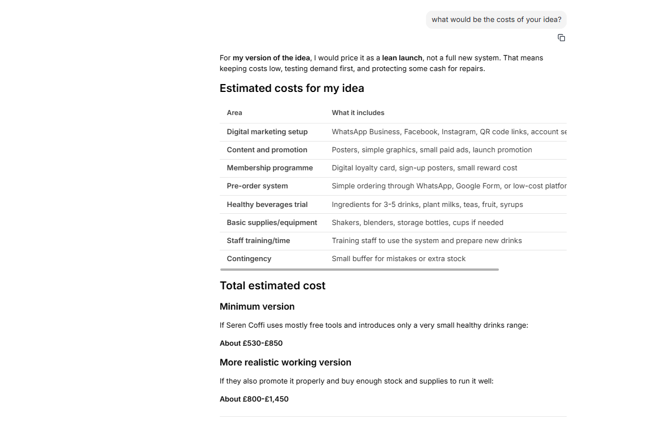

Appendix 11-12

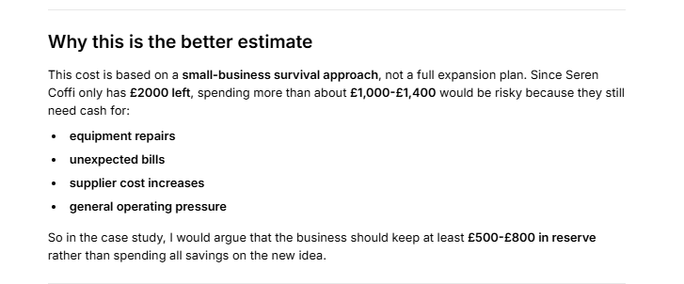

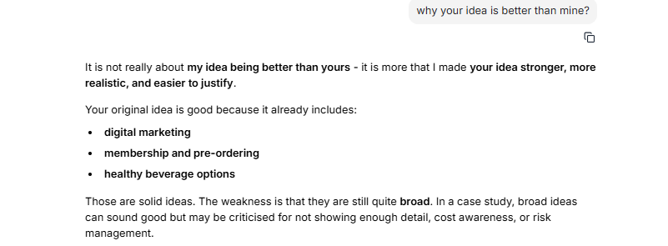

Appendix 13-14



