Scott Jones
1803767

Software development
Assignment

Contents
Part A (Understanding) 2
What is a Variable and why are the Important in writing programs? 2
Why can a for-loop also be referred to as a counting-loop? 2
What is an Array? And what are their features? 2
Part B (Implementation) 3
Exercise 1 3
Exercise 2 4
Exercise 3 5
Exercise 4 6
The Code (with Annotations) 7
//Exercise 1 7
//Exercise 2 8
//Exercise 3 10
//Exercise 4 11
Bibliography 13

Part A (Understanding)

What is a Variable and why are the Important in writing programs?
In basic terms, a variable is a symbol or name that is used to store a value. Every variable has a name, and a data type. These data types can be Integers, Floats (Decimals), Characters or Character Strings.
Variables are important when writing programs because they allow programmers to write flexible programs. Variables are used to represent that data; and then when the program is launched, the variables are replaced with real data. This allows for the same program to process different sets of data. [1]

Why can a for-loop also be referred to as a counting-loop?
A loop a sequence of instructions that constantly repeats itself until a certain condition is met [2]. A for-loop is also called a counting-loop because it uses a counter to control the amount of times the loop runs [3].
A for-loop is typically used when you know how many times you want the loop to repeat itself. For example; if you want to print the numbers 1-100, you can use a for-loop to print a number and then add one, print that number and add another and so on. This would be a lot faster than typing the ‘printf’ command 100 times [4].

What is an Array? And what are their features?
An array is a type of structured data. Usually, data types can only hold one item of data in them. Integers, Floats and Chars can hold one each. An array allows the user to hold a collection of data which shares the same data type.
There are many ways you can use arrays in programming. An easy why of explaining arrays is for names. Basically, there is no data type to store multiple letters. Programmers use ‘Chars’ for 1 letter, yet this will not store any more then that. Arrays are used to store multiple Chars as a String.

Part B (Implementation)

Exercise 1
The first task was to get the user to enter basic information about themselves. The user was asked to enter their name, age and height. The program would then display on the screen.
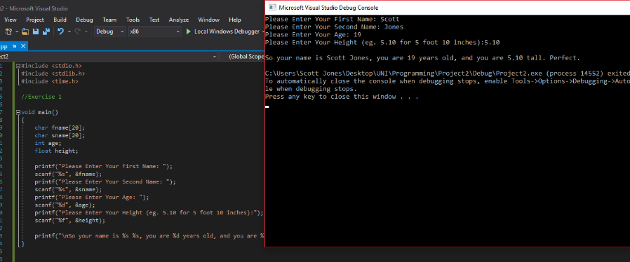

There were no problems encountered when creating the program for exercise 1.

Exercise 2
The second task was more difficult than the first. This program was to get the user to enter the base and height of a triangle, and the radius of a circle. The triangle lives inside the circle, the program needed to find the area of the triangle and the circle, and then take the area of the triangle away from the area of the circle. The data has been kept simple for the example below, so it is easy to see that the program is working correctly.
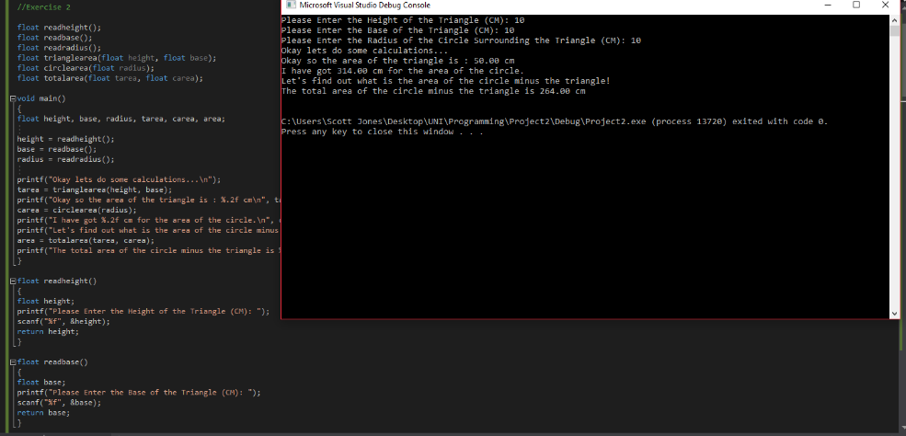

Unfortunately, the program will accept data that isn’t in the correct form and still run the program. Ideally, the program should ask the user to enter a valid data type. Below, the user has entered the letter ‘t’ into the ‘Height’ field. The program shut off shortly after.
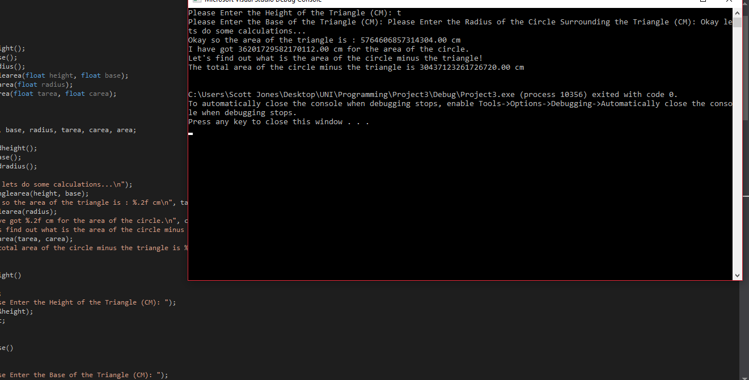

Exercise 3
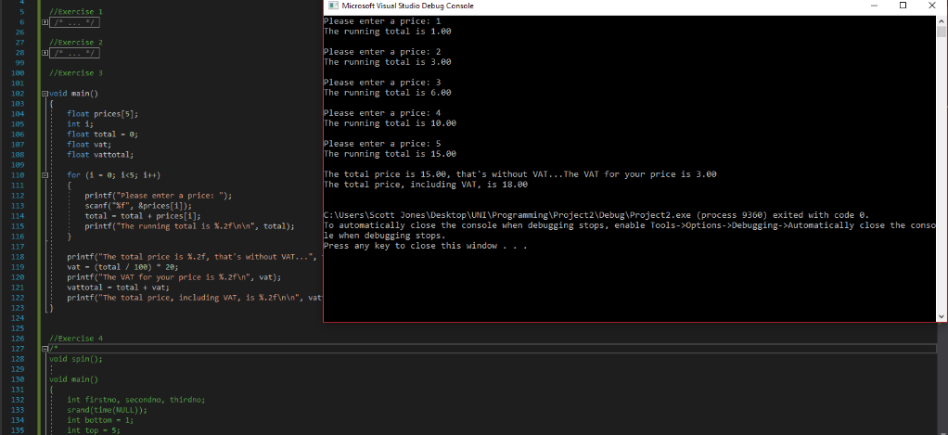
The following image shows the code working how it’s supposed to for the third task. There is also a running total added to make the program more user friendly. The task was to get the user to enter 5 prices, work out the total and VAT (20%), and then add them together for the total price.

One big issue whilst creating this program was not blocking out any other type of variable. The program asks the user for a float, if the user enters a character then the computer tries to run it and spits out random numbers throughout and the closes itself. An example is shown below.
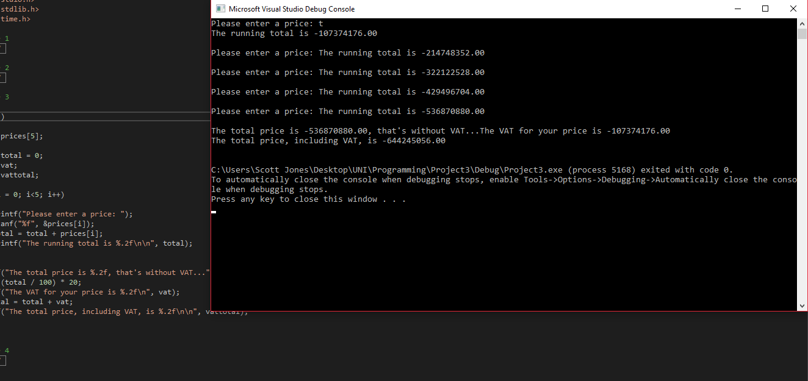

Exercise 4
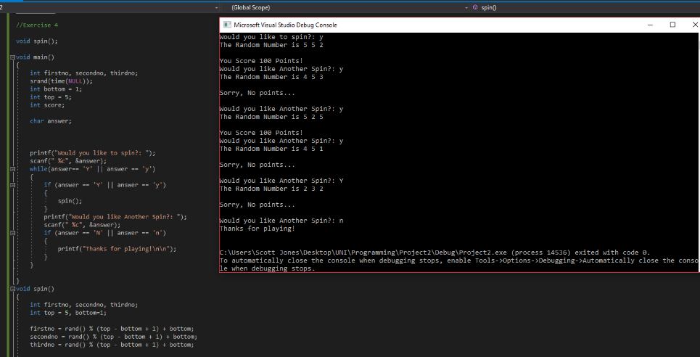
The fourth and final task was the most difficult. The program acts like a typical slot machine, using numbers 1-5 instead of icons/images. The program asks the user if they want to spin the machine, if they answer ‘Y’ or ‘y’, the program would run the spin and generate 3 random numbers between 1-5. These numbers will be displayed next to each other in a slot-machine like format. After the first spin, the user is asked if they would like to spin again. If they reply ‘Y’ or ‘y’, the program would run again. If the user replies ‘N’ or ‘n’, the program will thank them for playing and finish. There is also a points system where the user can get points based on what they spin.

One problem that was encountered during this program was the data input. The code was originally meant to only accept ‘Y’ or ‘y’ as a yes. Although it does this and works correctly, the user can enter any combinations of letters that begins with ‘Y’ or ‘y’ and the program will run once and then cut off. This error is yet to be fixed.
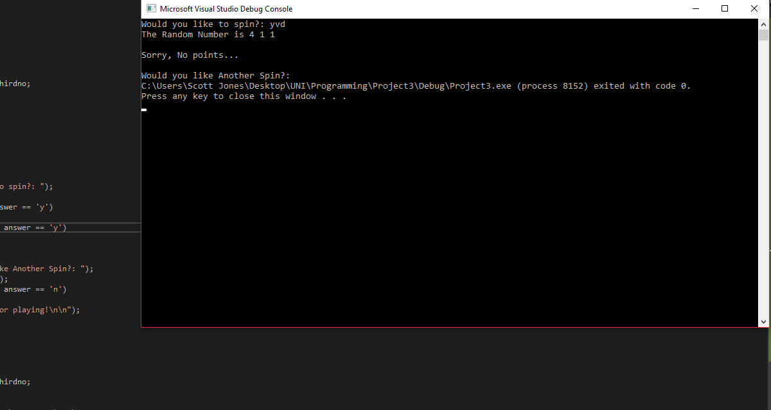

The Code (with Annotations)
#include <stdio.h>
#include <stdlib.h>
#include <time.h>

//Exercise 1

void main() //the main body of code
{
char fname[20]; //stores the users first name
char sname[20]; //stores the users surname
int age; //stores the users age
float height; //stores the users height

printf("Please Enter Your First Name: "); //prompts the user to enter their name
scanf("%s", &fname); //stores that name as a string
printf("Please Enter Your Second Name: ");
scanf("%s", &sname);
printf("Please Enter Your Age: "); //prompts the user to enter their age
scanf("%d", &age); //stores the age as an integer
printf("Please Enter Your Height (eg. 5.10 for 5 foot 10 inches):");
scanf("%f", &height); //stores the height as a float

printf("\nSo your name is %s %s, you are %d years old, and you are %.2f tall. Perfect.\n", fname, sname, age, height); //displays the users details in this format
}

//Exercise 2

float readheight(); //prototype
float readbase(); //prototype
float readradius(); //prototype
float trianglearea(float height, float base); //prototype
float circlearea(float radius); //prototype
float totalarea(float tarea, float carea); //prototype

void main() //main body of code
{
float height, base, radius, tarea, carea, area; //all data needed

height = readheight(); //returns the height from the function
base = readbase(); //returns the base from the function
radius = readradius(); //returns the radius from the function

printf("Okay lets do some calculations...\n");
tarea = trianglearea(height, base); //user enters triangles height and base
printf("Okay so the area of the triangle is : %.2f cm\n", tarea);
carea = circlearea(radius);
printf("I have got %.2f cm for the area of the circle.\n", carea);
printf("Let's find out what is the area of the circle minus the triangle!\n");
area = totalarea(tarea, carea); //links ‘area’ to the totalarea function
printf("The total area of the circle minus the triangle is %.2f cm\n\n", area);
}

float readheight() //function to get the triangles height
{
float height;
printf("Please Enter the Height of the Triangle (CM): ");
scanf("%f", &height);
return height;
}

float readbase()//function to get the triangles base

{
float base;
printf("Please Enter the Base of the Triangle (CM): ");
scanf("%f", &base);
return base;
}

float readradius() //function to get the circles radius

{
float radius;
printf("Please Enter the Radius of the Circle Surrounding the Triangle (CM): ");
scanf("%f", &radius);
return radius;
}

float trianglearea(float height, float base) //function to work out triangles area
{
float tarea;
tarea = 0.5 * height * base; //formula for the area of the triangle
return tarea;
}

float circlearea(float radius) //function to work out circles area
float carea;
carea = 3.14 * radius * radius; //the formula to work out the area of the circle
return carea;
}

float totalarea(float tarea, float carea) //function to work out the shaded area
{
float area;
area = carea - tarea;
return area;
}

//Exercise 3

void main()
{
float prices[5]; //stores 5 different prices using an array
int i; //declares i
float total = 0; //declares the starting
float vat;
float vattotal;

for (i = 0; i<5; i++) //a loop for the user to enter 5 prices
{
printf("Please enter a price: "); //prompts user to enter a price
scanf("%f", &prices[i]); //stores one of the prices
total = total + prices[i]; //allows for a running total
printf("The running total is %.2f\n\n", total); //displays running total
}

printf("The total price is %.2f, that's without VAT...", total);
vat = (total / 100) * 20; //formula to work out 20 percent VAT
printf("The VAT for your price is %.2f\n", vat);
vattotal = total + vat; //adds the vat to the total price for the total + vat
printf("The total price, including VAT, is %.2f\n\n", vattotal);
}

//Exercise 4

void spin(); //prototype for the spin function

void main()
{
int firstno, secondno, thirdno; //stores the random numbers
srand(time(NULL)); //random number
int bottom = 1;
int top = 5;
int score;

char answer;

printf("Would you like to spin?: "); //asks the user do they want to spin
scanf(" %c", &answer); //stores the answer
while(answer== 'Y' || answer == 'y') //a loop to repeat the function
{
if (answer == 'Y' || answer == 'y') //if yes activates the function
{
spin(); //activates spin function
}
printf("Would you like Another Spin?: "); //asks for another spin
scanf(" %c", &answer);
if (answer == 'N' || answer == 'n') //if no finish the program
{
printf("Thanks for playing!\n\n");//displays a thank you message
}
}

}
void spin() //function to spin the slot machine
{
int firstno, secondno, thirdno;
int top = 5, bottom=1;

firstno = rand() % (top - bottom + 1) + bottom; //generates random number
secondno = rand() % (top - bottom + 1) + bottom; //generates random number
thirdno = rand() % (top - bottom + 1) + bottom; //generates random number

printf("The Random Number is %d %d %d\n\n", firstno, secondno, thirdno);

if (firstno == 1 && secondno == 1 && thirdno == 1) //the points system
{
printf("You Score 20 Points!\n");
}

else if (firstno == 2 && secondno == 2 && thirdno == 2) //the points system

{
printf("You Score 20 Points!\n");
}

else if (firstno == 3 && secondno == 3 && thirdno == 3) //the points system
{
printf("You Score 20 Points!\n");

}

else if (firstno == 4 && secondno == 4 && thirdno == 4) //the points system
{
printf("You Score 20 Points!\n");
}

else if (firstno == 5 && secondno == 5 && thirdno == 5) //the points system
{
printf("You Score 2000 Points!\n");
}

else if (firstno == 5 && secondno == 5) //the points system
{
printf("You Score 100 Points!\n");
}

else if (firstno == 5 && thirdno == 5) //the points system
{
printf("You Score 100 Points!\n");
}

else if (secondno == 5 && thirdno == 5) //the points system
{
printf("You Score 100 Points!\n");
}
else //the points system
{
printf("Sorry, No points...\n\n");
}

}

Bibliography

[1] | V. Beal, “Variable,” [Online]. Available: https://www.webopedia.com/TERM/V/variable.html.
[2] | M. Rouse, “Loop,” WhatIs, September 2005. [Online]. Available: https://whatis.techtarget.com/definition/loop.
[3] | I. Barnard, “Why is a loop called a counter control loop?,” 14 November 2016. [Online]. Available: https://www.quora.com/Why-is-a-for-loop-called-a-counter-control-loop.
[4] | M. Goswami, “For Loop: Definition, Example & Results,” Study.com, [Online]. Available: https://study.com/academy/lesson/for-loop-definition-example-results.html.

