University of Wales Trinity Saint David
Wales Institute of Science & Art



Engine Performance Characteristics
Motorsport and Vehicle Technology 2
ACHA4003 / 4004 / 4012

Isaac Jones
2403961
28/03/2025

Table of contents
Table of contents 2
Chapter 1 - Introduction 3
Chapter 2 - Method 4
Chapter 3 - Data 6
Table 6
Graphs 11
Chapter 4 - Conclusion 14
Chapter 5 - Evaluation 15
References 16

Chapter 1 - Introduction
This report will provide an in-depth analysis of dynamometers, exploring their functions, how to properly use them, and the type of data they generate. Additionally, it will examine the significance of this data and how it can be utilized to calculate crucial performance metrics of an engine.

Chapter 2 - Method
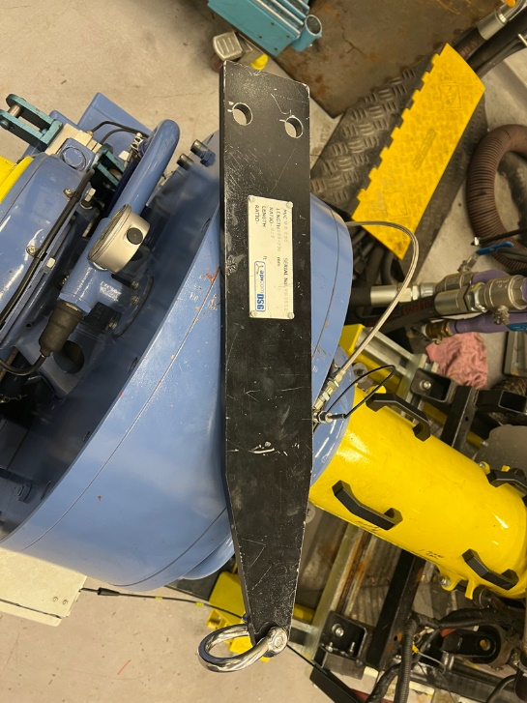
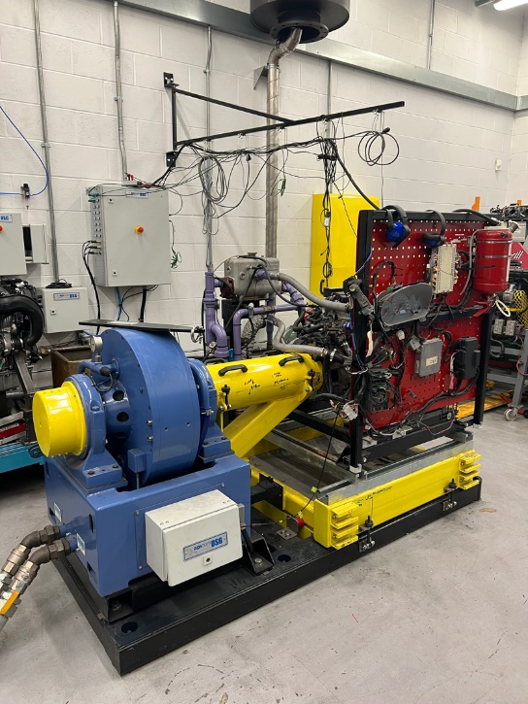
To perform the dyno test, a 1.6L Honda engine is mounted to the Schenck WS230 dynamometer via a driveshaft that is securely bolted to the engine's crankshaft, see figure 1. The engine operates as usual, however, both the engine and the dynamometer are covered in sensors which send information to the computer for analysis. The dynamometer itself consists of two main casings: an inner core and an outer casing. The inner core is free-spinning and is rotated by the engine’s power. The outer casing, which is energized by an electrical current, generates an electromagnetic field. This field applies a load to the engine, creating resistance that attempts to slow down the engine’s rotation. As the outer casing tries to rotate, it is restrained by a strain gauge, which sends a voltage signal ranging from 0 to 10 volts to the computer, providing real-time data on the engine's performance. Additionally, calibrated arms can be attached to the dynamometer, see figure 2, with a mass placed on one end. The greater the mass, the more resistance the engine must overcome, further influencing the measurements (UWTSD WISA Workshops, 2020a).
Figure 2: Calibrated arms
Figure 1: Dynamometer
For safety purposes, the computer controlling the test is located in a separate room. There are several methods for conducting dynamometer tests, but the specific test performed here is known as a "sweep test." During a sweep test, the engine quickly cycles through a range of RPMs while the system records measurements at various points. This method is preferred for gathering large datasets as it minimizes engine strain and reduces the likelihood of overheating, compared to other testing methods. To set up the sweep test, the ramp and hold times were configured to 1 second, with the RPM range set between 1000 and 5500 RPM. The system was set to log data at 50 RPM intervals, with the total ramp time set to 15 seconds. After the test was completed, the throttle was programmed to automatically return to idle within 5 seconds. Finally, the dyno was configured to allow the computer to control the engine speed throughout the test. To begin the test, the throttle was fully opened to 100% using the throttle actuator, and the "start test" command was initiated. The engine then completed the cycle, and the computer recorded the full set of data, which provided an insight into the engine's performance across the specified RPM range (UWTSD WISA Workshops, 2020b).

Chapter 3 - Data

Table

 |  |  |  | Baro |  | Humidity | Ambient temp | Distance | Calorific value of fuel
 |  |  |  | Bar | mBar | % | Deg C | (m) | (J/kg)
 |  |  |  | 1.0189 | 1018.9 | 46 | 27 | 0.815776 | 43391000
Load | Dyno Speed | Fuel Flow Rate |  | Lambda | Torque | BMEP | SFC | Overall thermal efficiency | Power |  |  | Corrected power
Newtons (N) | (rpm) | (l/min) | (kg/hr) | (Λ) | (Nm) | (Kpa) | (kg/kWh) | (%) | BHP | KW | W | KW
102.275 | 1000 | 0.0704 | 3.048 | 1.2658 | 83.433 | 655.285 | 0.349 | 23.785 | 11.717 | 8.737 | 8737.135 | 8.792
102.756 | 1050 | 0.0724 | 3.134 | 1.26783 | 83.826 | 658.367 | 0.340 | 24.399 | 12.360 | 9.217 | 9217.137 | 9.275
103.689 | 1100 | 0.0737 | 3.190 | 1.27344 | 84.587 | 664.345 | 0.327 | 25.338 | 13.067 | 9.744 | 9743.723 | 9.805
104.209 | 1150 | 0.0728 | 3.152 | 1.28476 | 85.011 | 667.676 | 0.308 | 26.952 | 13.729 | 10.238 | 10237.705 | 10.302
105.811 | 1200 | 0.0744 | 3.221 | 1.29181 | 86.318 | 677.941 | 0.297 | 27.942 | 14.546 | 10.847 | 10847.049 | 10.915
107.51 | 1250 | 0.07895 | 3.418 | 1.29729 | 87.704 | 688.826 | 0.298 | 27.869 | 15.395 | 11.480 | 11480.437 | 11.552
109.488 | 1300 | 0.079 | 3.420 | 1.29895 | 89.318 | 701.499 | 0.281 | 29.498 | 16.306 | 12.159 | 12159.324 | 12.235
111.797 | 1350 | 0.0796 | 3.446 | 1.29469 | 91.201 | 716.293 | 0.267 | 31.043 | 17.290 | 12.893 | 12893.281 | 12.974
114.268 | 1400 | 0.0835 | 3.615 | 1.2855 | 93.217 | 732.125 | 0.264 | 31.368 | 18.327 | 13.666 | 13666.339 | 13.752
115.783 | 1450 | 0.0847 | 3.667 | 1.27818 | 94.453 | 741.832 | 0.256 | 32.452 | 19.233 | 14.342 | 14342.087 | 14.432
116.985 | 1500 | 0.08865 | 3.838 | 1.2795 | 95.434 | 749.533 | 0.256 | 32.408 | 20.103 | 14.991 | 14990.668 | 15.085
117.788 | 1550 | 0.0932 | 4.035 | 1.27766 | 96.089 | 754.678 | 0.259 | 32.072 | 20.915 | 15.597 | 15596.685 | 15.694
118.471 | 1600 | 0.0959 | 4.152 | 1.28235 | 96.646 | 759.054 | 0.256 | 32.361 | 21.715 | 16.193 | 16193.159 | 16.295
118.772 | 1650 | 0.09875 | 4.275 | 1.29028 | 96.891 | 760.983 | 0.255 | 32.492 | 22.451 | 16.742 | 16741.623 | 16.846
118.656 | 1700 | 0.10005 | 4.331 | 1.29942 | 96.797 | 760.240 | 0.251 | 33.009 | 23.109 | 17.232 | 17232.098 | 17.340
118.861 | 1750 | 0.10305 | 4.461 | 1.31053 | 96.964 | 761.553 | 0.251 | 33.048 | 23.829 | 17.770 | 17769.572 | 17.881
119.584 | 1800 | 0.1093 | 4.732 | 1.3149 | 97.554 | 766.185 | 0.257 | 32.243 | 24.659 | 18.388 | 18388.450 | 18.504
119.934 | 1850 | 0.11415 | 4.942 | 1.31849 | 97.839 | 768.428 | 0.261 | 31.824 | 25.418 | 18.955 | 18954.555 | 19.073
120.176 | 1900 | 0.11745 | 5.084 | 1.31892 | 98.037 | 769.978 | 0.261 | 31.830 | 26.158 | 19.506 | 19506.120 | 19.628
120.948 | 1950 | 0.12055 | 5.219 | 1.31484 | 98.666 | 774.925 | 0.259 | 32.032 | 27.019 | 20.148 | 20148.042 | 20.274
122.157 | 2000 | 0.12555 | 5.435 | 1.31653 | 99.653 | 782.671 | 0.260 | 31.860 | 27.989 | 20.871 | 20871.223 | 21.002
122.845 | 2050 | 0.12785 | 5.535 | 1.32098 | 100.214 | 787.079 | 0.257 | 32.250 | 28.850 | 21.513 | 21513.491 | 21.648
123.796 | 2100 | 0.1309 | 5.667 | 1.32287 | 100.990 | 793.172 | 0.255 | 32.516 | 29.782 | 22.209 | 22208.818 | 22.348
124.794 | 2150 | 0.13435 | 5.816 | 1.32164 | 101.804 | 799.566 | 0.254 | 32.697 | 30.737 | 22.921 | 22920.902 | 23.064
125.137 | 2200 | 0.1377 | 5.961 | 1.31652 | 102.084 | 801.764 | 0.253 | 32.733 | 31.539 | 23.518 | 23518.410 | 23.666
126.028 | 2250 | 0.14105 | 6.106 | 1.30465 | 102.811 | 807.473 | 0.252 | 32.915 | 32.485 | 24.224 | 24224.181 | 24.376
126.66 | 2300 | 0.14495 | 6.275 | 1.29646 | 103.326 | 811.522 | 0.252 | 32.905 | 33.374 | 24.887 | 24886.674 | 25.043
126.822 | 2350 | 0.14985 | 6.487 | 1.28229 | 103.458 | 812.560 | 0.255 | 32.563 | 34.143 | 25.460 | 25460.211 | 25.620
126.69 | 2400 | 0.1537 | 6.654 | 1.27304 | 103.351 | 811.714 | 0.256 | 32.389 | 34.833 | 25.975 | 25974.854 | 26.138
126.552 | 2450 | 0.15565 | 6.738 | 1.26984 | 103.238 | 810.830 | 0.254 | 32.614 | 35.520 | 26.487 | 26487.114 | 26.653
126.438 | 2500 | 0.1596 | 6.909 | 1.27446 | 103.145 | 810.100 | 0.256 | 32.426 | 36.212 | 27.003 | 27003.320 | 27.172
126.239 | 2550 | 0.1626 | 7.039 | 1.27876 | 102.983 | 808.825 | 0.256 | 32.414 | 36.878 | 27.500 | 27500.036 | 27.672
126.161 | 2600 | 0.16805 | 7.275 | 1.27634 | 102.919 | 808.325 | 0.260 | 31.958 | 37.578 | 28.022 | 28021.928 | 28.197
125.847 | 2650 | 0.17145 | 7.422 | 1.28027 | 102.663 | 806.313 | 0.261 | 31.847 | 38.205 | 28.490 | 28489.727 | 28.668
124.911 | 2700 | 0.17465 | 7.561 | 1.28371 | 101.899 | 800.316 | 0.262 | 31.616 | 38.637 | 28.811 | 28811.375 | 28.992
123.927 | 2750 | 0.1784 | 7.723 | 1.2812 | 101.097 | 794.011 | 0.265 | 31.277 | 39.042 | 29.114 | 29113.752 | 29.296
123.689 | 2800 | 0.18005 | 7.794 | 1.27448 | 100.903 | 792.487 | 0.263 | 31.493 | 39.676 | 29.586 | 29586.163 | 29.771
123.389 | 2850 | 0.1831 | 7.926 | 1.26036 | 100.658 | 790.564 | 0.264 | 31.445 | 40.286 | 30.041 | 30041.447 | 30.230
122.519 | 2900 | 0.1879 | 8.134 | 1.2531 | 99.948 | 784.990 | 0.268 | 30.959 | 40.704 | 30.353 | 30352.955 | 30.543
121.837 | 2950 | 0.19255 | 8.335 | 1.23943 | 99.392 | 780.621 | 0.271 | 30.561 | 41.175 | 30.704 | 30704.410 | 30.897
121.709 | 3000 | 0.199 | 8.615 | 1.22735 | 99.287 | 779.800 | 0.276 | 30.040 | 41.829 | 31.192 | 31192.019 | 31.387
121.123 | 3050 | 0.20605 | 8.920 | 1.2193 | 98.809 | 776.046 | 0.283 | 29.354 | 42.322 | 31.559 | 31559.201 | 31.757
121.124 | 3100 | 0.21005 | 9.093 | 1.20692 | 98.810 | 776.052 | 0.283 | 29.267 | 43.016 | 32.077 | 32076.830 | 32.278
120.851 | 3150 | 0.21605 | 9.353 | 1.19274 | 98.587 | 774.303 | 0.288 | 28.848 | 43.611 | 32.521 | 32520.734 | 32.724
120.596 | 3200 | 0.21795 | 9.435 | 1.18481 | 98.379 | 772.669 | 0.286 | 28.990 | 44.210 | 32.967 | 32967.227 | 33.174
120.84 | 3250 | 0.22305 | 9.656 | 1.17378 | 98.578 | 774.233 | 0.288 | 28.827 | 44.991 | 33.550 | 33550.085 | 33.760
121.633 | 3300 | 0.2255 | 9.762 | 1.16118 | 99.225 | 779.314 | 0.285 | 29.143 | 45.983 | 34.290 | 34289.796 | 34.505
122.181 | 3350 | 0.2285 | 9.892 | 1.15104 | 99.672 | 782.825 | 0.283 | 29.328 | 46.890 | 34.966 | 34966.167 | 35.185
122.933 | 3400 | 0.2342 | 10.139 | 1.14117 | 100.286 | 787.643 | 0.284 | 29.220 | 47.883 | 35.706 | 35706.472 | 35.930
123.475 | 3450 | 0.23605 | 10.219 | 1.12669 | 100.728 | 791.115 | 0.281 | 29.547 | 48.801 | 36.391 | 36391.309 | 36.619
123.428 | 3500 | 0.24195 | 10.474 | 1.11975 | 100.690 | 790.814 | 0.284 | 29.233 | 49.490 | 36.905 | 36904.666 | 37.136
124.205 | 3550 | 0.24545 | 10.626 | 1.10622 | 101.323 | 795.793 | 0.282 | 29.412 | 50.513 | 37.668 | 37667.515 | 37.903
124.066 | 3600 | 0.25505 | 11.041 | 1.09697 | 101.210 | 794.902 | 0.289 | 28.671 | 51.167 | 38.155 | 38155.296 | 38.394
123.967 | 3650 | 0.25755 | 11.149 | 1.09401 | 101.129 | 794.268 | 0.288 | 28.764 | 51.836 | 38.654 | 38654.361 | 38.896
123.815 | 3700 | 0.26445 | 11.448 | 1.09659 | 101.005 | 793.294 | 0.293 | 28.363 | 52.482 | 39.136 | 39135.828 | 39.381
123.767 | 3750 | 0.2651 | 11.476 | 1.09808 | 100.966 | 792.986 | 0.289 | 28.664 | 53.171 | 39.649 | 39649.314 | 39.898
123.509 | 3800 | 0.2693 | 11.658 | 1.09907 | 100.756 | 791.333 | 0.291 | 28.534 | 53.767 | 40.094 | 40094.218 | 40.345
122.672 | 3850 | 0.27375 | 11.851 | 1.10533 | 100.073 | 785.971 | 0.294 | 28.247 | 54.105 | 40.346 | 40346.486 | 40.599
122.157 | 3900 | 0.2759 | 11.944 | 1.11704 | 99.653 | 782.671 | 0.293 | 28.271 | 54.578 | 40.699 | 40698.885 | 40.954
121.184 | 3950 | 0.28285 | 12.245 | 1.12259 | 98.859 | 776.437 | 0.299 | 27.708 | 54.837 | 40.892 | 40892.336 | 41.148
120.004 | 4000 | 0.28455 | 12.318 | 1.12461 | 97.896 | 768.876 | 0.300 | 27.619 | 54.991 | 41.007 | 41006.741 | 41.264
118.734 | 4050 | 0.2871 | 12.429 | 1.1222 | 96.860 | 760.739 | 0.303 | 27.423 | 55.089 | 41.080 | 41079.927 | 41.337
117.442 | 4100 | 0.28895 | 12.509 | 1.12394 | 95.806 | 752.461 | 0.304 | 27.283 | 55.162 | 41.135 | 41134.558 | 41.392
116.5 | 4150 | 0.29305 | 12.686 | 1.12233 | 95.038 | 746.426 | 0.307 | 27.011 | 55.387 | 41.302 | 41302.236 | 41.561
115.931 | 4200 | 0.2949 | 12.766 | 1.12179 | 94.574 | 742.780 | 0.307 | 27.033 | 55.781 | 41.596 | 41595.698 | 41.856
115.034 | 4250 | 0.29715 | 12.864 | 1.12456 | 93.842 | 737.033 | 0.308 | 26.937 | 56.008 | 41.765 | 41765.212 | 42.027
114.391 | 4300 | 0.3022 | 13.082 | 1.12278 | 93.317 | 732.913 | 0.311 | 26.649 | 56.350 | 42.020 | 42020.368 | 42.284
114.016 | 4350 | 0.30605 | 13.249 | 1.11943 | 93.012 | 730.511 | 0.313 | 26.532 | 56.819 | 42.370 | 42369.623 | 42.635
113.871 | 4400 | 0.3092 | 13.385 | 1.11986 | 92.893 | 729.582 | 0.313 | 26.530 | 57.399 | 42.802 | 42802.127 | 43.070
113.985 | 4450 | 0.3099 | 13.416 | 1.11873 | 92.986 | 730.312 | 0.310 | 26.798 | 58.109 | 43.332 | 43331.853 | 43.603
113.306 | 4500 | 0.31445 | 13.613 | 1.11563 | 92.432 | 725.962 | 0.313 | 26.548 | 58.412 | 43.558 | 43557.702 | 43.831
113.074 | 4550 | 0.3171 | 13.727 | 1.10953 | 92.243 | 724.475 | 0.312 | 26.564 | 58.940 | 43.951 | 43951.499 | 44.227
112.195 | 4600 | 0.3194 | 13.827 | 1.10569 | 91.526 | 718.843 | 0.314 | 26.455 | 59.124 | 44.089 | 44089.064 | 44.365
111.061 | 4650 | 0.32055 | 13.877 | 1.09782 | 90.601 | 711.578 | 0.315 | 26.377 | 59.163 | 44.118 | 44117.823 | 44.394
109.973 | 4700 | 0.3207 | 13.883 | 1.09558 | 89.713 | 704.607 | 0.314 | 26.388 | 59.213 | 44.155 | 44155.364 | 44.432
108.654 | 4750 | 0.32485 | 14.063 | 1.08827 | 88.637 | 696.156 | 0.319 | 26.012 | 59.125 | 44.090 | 44089.875 | 44.366
107.076 | 4800 | 0.32455 | 14.050 | 1.08396 | 87.350 | 686.046 | 0.320 | 25.928 | 58.880 | 43.907 | 43906.914 | 44.182
105.24 | 4850 | 0.3257 | 14.100 | 1.08221 | 85.852 | 674.282 | 0.323 | 25.658 | 58.473 | 43.604 | 43603.577 | 43.877
103.632 | 4900 | 0.3277 | 14.186 | 1.0846 | 84.540 | 663.980 | 0.327 | 25.370 | 58.173 | 43.380 | 43379.995 | 43.652
102.335 | 4950 | 0.32845 | 14.219 | 1.08823 | 83.482 | 655.670 | 0.329 | 25.251 | 58.032 | 43.274 | 43274.189 | 43.545
101.106 | 5000 | 0.3287 | 14.229 | 1.08687 | 82.480 | 647.795 | 0.329 | 25.180 | 57.914 | 43.186 | 43186.348 | 43.457
99.3149 | 5050 | 0.32985 | 14.279 | 1.0891 | 81.019 | 636.319 | 0.333 | 24.895 | 57.457 | 42.846 | 42845.511 | 43.114
97.5815 | 5100 | 0.3297 | 14.273 | 1.09185 | 79.605 | 625.213 | 0.336 | 24.713 | 57.013 | 42.515 | 42514.513 | 42.781
95.8486 | 5150 | 0.33095 | 14.327 | 1.09407 | 78.191 | 614.111 | 0.340 | 24.420 | 56.549 | 42.169 | 42168.926 | 42.433
94.8033 | 5200 | 0.3338 | 14.450 | 1.09346 | 77.338 | 607.413 | 0.343 | 24.180 | 56.476 | 42.114 | 42113.985 | 42.378
93.0976 | 5250 | 0.3313 | 14.342 | 1.08804 | 75.947 | 596.485 | 0.343 | 24.154 | 55.993 | 41.754 | 41753.927 | 42.015
91.7886 | 5300 | 0.3324 | 14.390 | 1.08339 | 74.879 | 588.098 | 0.346 | 23.962 | 55.731 | 41.559 | 41558.911 | 41.819
90.5938 | 5350 | 0.3308 | 14.320 | 1.08007 | 73.904 | 580.443 | 0.346 | 23.988 | 55.525 | 41.405 | 41404.906 | 41.664
89.6374 | 5400 | 0.3388 | 14.667 | 1.07895 | 73.124 | 574.315 | 0.355 | 23.391 | 55.452 | 41.351 | 41350.670 | 41.610
88.9256 | 5450 | 0.3438 | 14.883 | 1.07923 | 72.543 | 569.754 | 0.359 | 23.080 | 55.521 | 41.402 | 41402.146 | 41.661
88.6474 | 5500 | 0.3488 | 15.100 | 1.08366 | 72.316 | 567.972 | 0.363 | 22.886 | 55.855 | 41.651 | 41651.269 | 41.912
Figure 3: Table of Figures (Andrew Harrison, 2025)

Graphs
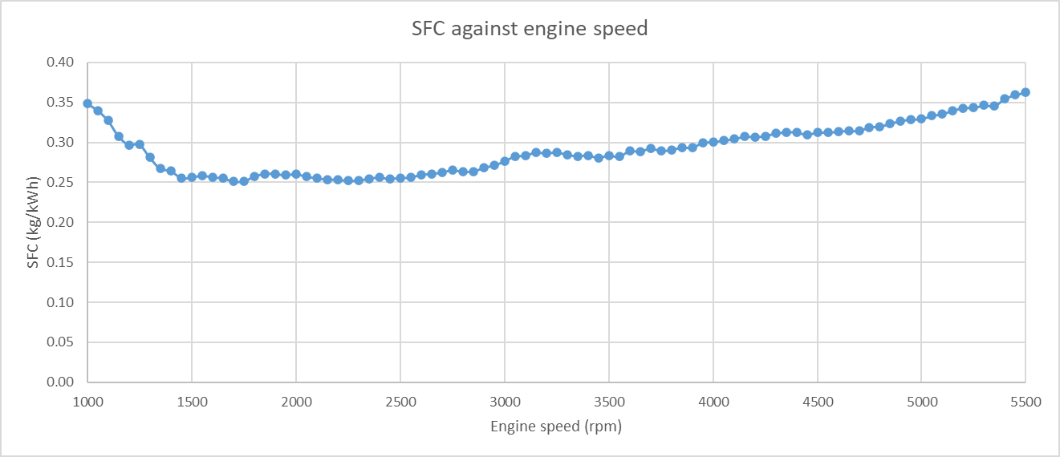
Figure 4: SFC / Engine Speed Graph
Looking at figure 4, the graph compares Specific Fuel Consumption (SFC) with engine speed, clearly illustrating that the engine operates most efficiently in terms of fuel usage between 1500 and 2500 RPM. This finding is consistent with studies such as those by (RPM in Car & Bike: Full Form, Meaning & Formula, 2025), which identify this range as the most fuel-efficient for coasting. This is likely because, in this mid-range RPM, the engine achieves a balanced efficiency between fuel delivery, air intake, and combustion processes.
In contrast, the graph also shows that the engine exhibits a higher SFC at an idle of around 1000 RPM. At this low RPM, the engine operates inefficiently, with the combustion process not generating enough power to overcome internal losses. Another significant factor contributing to the high SFC at idle is that there is more time for heat energy to escape through the combustion chamber walls instead of being converted into useful work. As noted by sources such as (Julian Edgar, 2012), this inefficiency at idle results in the engine consuming more fuel relative to the work it performs.
Additionally, as the engine speed increases beyond the 2500 RPM mark, the SFC gradually rises. At higher RPMs, more friction is generated within the engine’s moving components, and while the combustion rate increases, much of the energy is converted into heat rather than useful mechanical energy. This leads to a higher SFC, as the engine is expending more fuel to overcome these internal losses and maintain higher speeds.
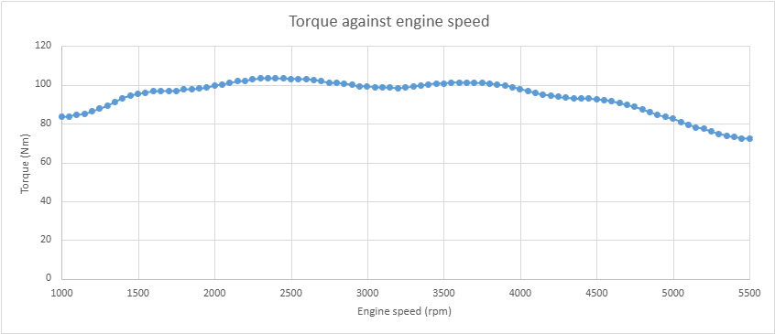
Figure 5: Torque / Engine Speed Graph

Looking at figure 5, the graph illustrates the relationship between torque and engine speed. While the torque remains relatively consistent across a wide range of engine speeds, with a deviation of approximately 35 Nm, it is noticeably lower at both the lower and higher ends of the RPM spectrum. At lower engine speeds, the reduced torque output is primarily due to the limited airflow entering the engine. At lower RPMs, the intake valves are not opening and closing as quickly, meaning less air is drawn into the engine, which in turn reduces the amount of fuel that can be combusted in each cycle. This results in lower force being generated, and consequently, less torque.
On the other hand, at higher RPMs, the torque also begins to decrease. This is largely due to the limitations of the engine's ability to efficiently intake the air-fuel mixture at higher speeds. As RPM increases, the engine's intake and exhaust valves struggle to keep up with the demand for air and fuel, leading to incomplete combustion. Incomplete combustion reduces the power generated in each cycle, which results in a drop in torque. For this particular engine, the decline in torque becomes noticeable around 4000 RPM, signalling the point where the engine begins to approach its peak operating limits. Beyond this point, the engine can no longer maintain optimal combustion conditions, leading to the torque drop-off seen in the graph.

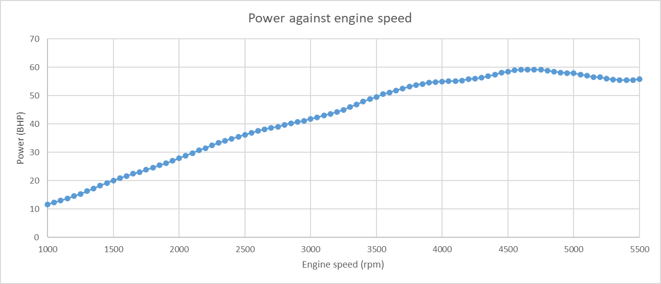
Figure 6: Brake Power / Engine Speed Graph
Looking at figure 6, the graph depicts the relationship between engine power and engine speed. The power of an engine can be calculated using the formula; Power = Torque × RPM × Constant. This means that power is directly dependent on both torque and RPM. As RPM increases, power typically increases as long as torque remains relatively constant. In the initial portion of the graph, the power increases linearly because RPM is rising consistently, with torque remaining relatively stable.
However, once the engine approaches around 4500 RPM, the engine starts to experience a decrease in power, despite the increase in RPM. This is because the drop in torque is large enough to cause a reduction in power. This drop-off is indicative of the engine’s limitations at higher speeds, such as reduced air-fuel mixture intake or less efficient combustion, which hampers the ability to maintain high torque levels (Torque and Power, 2024).

Chapter 4 - Conclusion
Looking at the lambda values in figure 3, the initial readings at idle are around 1.266, but this quickly rises to 1.3 before reaching 2000 RPM. This indicates that the engine is injecting more fuel during idle to help maintain smooth operation, as it struggles to intake and exhaust enough air (Julian Edgar, 2002). As the RPM increases, the engine shifts to a leaner fuel ratio, reaching a lambda value of 1.32 between 2050 and 2150 RPM. This is the range where the engine operates most efficiently in terms of fuel consumption. Beyond this point, the fuel ratio becomes richer again, reaching a value of 1.08 at 5500 RPM, likely due to limitations in air intake and exhaust.
Looking at thermal efficiency values of the engine across different RPM ranges, it is clear that the engine operates most efficiently between 1500 and 2500 RPM, reaching up to 30% efficiency. This range provides the best balance of power output for the fuel consumed. At idle, however, efficiency drops to around 24%, which is expected, as the vehicle remains stationary and doesn't require high efficiency, but rather enough to maintain smooth operation. At higher RPMs, efficiency falls below 23%, primarily due to the richer fuel mixture and lower air intake and exhaust. This trend aligns with the behaviour of the lambda values, as a richer mixture correlates with a decrease in efficiency.
Looking at the calculated BMEP values, it is clear that the engine achieves its highest BMEP between 2200 and 2700 RPM, reaching over 800 kPa. This indicates that the engine performs optimally within this range. At idle, the BMEP is much lower, peaking at just 655 kPa, and at 5500 RPM, it drops even further to 568 kPa.
The corrected power, when compared to the power in kW, is slightly higher, indicating that the test conditions were less optimal than the baseline used for assessing an average engine's performance according to DIN Standard 70020.
Overall, looking at a variety of performance parameters, the engine performs best between 1500 and 2500 RPM, where it shows higher fuel efficiency. It's also evident that performance significantly drops at higher RPMs, likely due to the engine's inability to efficiently intake and exhaust air, limiting its ability to generate more power.

Chapter 5 - Evaluation
This assignment introduced me to new techniques and calculations for measuring engine performance, helping me to analyse the data sets provided by the dynamometer. Unfortunately, the dynamometer was experiencing technical issues, preventing us from conducting our own experiment. As a result, we used previously collected data from the engine. In the future, I could improve my performance by organizing my Excel sheet more efficiently from the start, as I had to make several adjustments throughout the assignment. If I were to conduct this experiment in the future, I would make some modifications to the engine and observe how these changes impact its performance, comparing the results with the data used in this assignment.

References
Andrew Harrison (2025) Powertrain_25. Available at: https://uowtsd-my.sharepoint.com/personal/andrew_harrison_uwtsd_ac_uk/_layouts/15/Doc.aspx?sourcedoc={c9dd2410-c111-4550-b00f-0a3dc3baa55d}&action=view&wd=target%28Lecture%20Notes.one%7Cab796523-684d-4952-84b9-95a1ebd8661c%2FWeek%201%7C118585a6-9587-4c08-85d1-d1e2160e1729%2F%29&wdorigin=NavigationUrl (Accessed: 26 March 2025).
Julian Edgar (2002) AutoSpeed - Tuning Air/Fuel Ratios, Autospeed. Available at: https://www.autospeed.com/cms/a_1595/article.html@populararticle (Accessed: 25 March 2025).
Julian Edgar (2012) AutoSpeed - Brake Specific Fuel Consumption, Autospeed. Available at: https://www.autospeed.com/cms/a_112611/article.html (Accessed: 24 March 2025).
RPM in Car & Bike: Full Form, Meaning & Formula (2025) Bajaj Allianz. Available at: https://www.bajajallianz.com/blog/motor-insurance-articles/understanding-rpm-in-cars-and-bikes.html (Accessed: 24 March 2025).
Torque and Power (2024) largiader.com. Available at: https://largiader.com/articles/torque.html (Accessed: 24 March 2025).
UWTSD WISA Workshops (2020a) (4670) Engine Dynamometer Overview - YouTube, Youtube. Available at: https://www.youtube.com/watch?v=-WajOAp2LUE (Accessed: 26 March 2025).
UWTSD WISA Workshops (2020b) (4670) Engine Dynamometer testing - YouTube, Youtube. Available at: https://www.youtube.com/watch?v=VD9OPoaAcJU (Accessed: 26 March 2025).

