Student name: Lukasz Perski Student ID number: 2219674

Date: 16-12-2022

Programme: MBA Part-time Distance

Module: Global Business Challenges

Module code: BMMB7006D

Lecturer: Anthony Burns

Assignment title: Global Challenges

Contents
Executive Summary 3
Introduction 4
About Apple 5
Company history 5
Company products and services 6
Values and company culture 6
Current position in the market 8
SWOT Definition 8
SWOT Analysis 8
PESTEL definition 9
PESTEL analysis of Apple 10
Main competitors 12
Assessment of performance indicators relevant to Apple 13
Apple revenue analysis by year 13
Apple revenue analysis by region 14
Apple revenue breakdown analysis by category of product 15
Apple revenue breakdown analysis by main products 16
Apple's market share (smartphones) 20
Apple market share (tablets) 21
Apple market share (personal computers) 22
Conclusion 23
Recommendations 25
References 26

Executive Summary

The below report was written to critically assess the current environmental conditions and their impact on an organisation – Apple Inc. which operates in the mobile phone, tablet, and personal computer market. The methods used to assess the above conditions and their impact on the company are SWOT and PESTEL analysis and national and international macro-economic performance indicators which are relevant to this organisation. The conclusions drawn from this assessment will be used to form recommendations to Apple’s senior management to help improve the company’s position within the market.

Introduction

The purpose of the below report is to assess the current position and condition of Apple Inc., the impact of its competition and the impact of these factors on the organisation. The findings included in this report will also help to provide a recommendation to the senior management of Apple Inc. which will hopefully allow improving the future of the company.

The report will provide an overview of the current affair of the company including its history, and then it will look at the industry-specific figures gathered from the company’s website and statistical information. This will allow us to ‘paint the picture’ in terms of the current position of Apple Inc. in the market in comparison to its competitors.

The report will also utilise SWOT and PESTEL to further analyse Apple’s position and will also provide an outlook on the competitive environment.

Finally, information gathered from the above analysis will be used to form a conclusion and help to formulate recommendations for the future development of the organisation.

About Apple

Company history

Apple Inc. (‘Apple’) history starts in 1976 when it was founded under Apple Computer Company by Steve Jobs and Steve Wozniak, two high-school friends who shared a passion for computers. The third founder, Ronald Wayne left the company only a few months after its foundation.

Wozniak was passionate about designing and building his personal computer and when in 1976, Hewlett-Packard where Wozniak was employed, rejected his idea of a personal microcomputer which could be built out of a kit, he decided to leave the company and formed a partnership with his high-school friend Steve Jobs. Initially, they worked in Jobs’ family garage and in 1976 they created ‘Apple I’, which was just a single circuit board. In 1977, they released an improved model ‘Apple II’ which was the first micro-computer, sold in a plastic case with a colour display screen and was one of the first on the market accessible to an average person. The success of Apple II was further stimulated by a disk controller which was invented by Wozniak and allowed to use of a floppy disk drive for the transfer of data to and from the computer.

Following the development of the Graphical User Interface (GUI) in the early 1980s, Apple took full advantage of the possibility to use of on-screen windows interface which consisted of icons in contrast to the previous text-based protocol interface. This allowed Apple to compete with then market-leader IBM in the field of personal computers which started becoming very profitable due to the growing popularity and use of computers. Following the release of the model Lisa computer in 1983 and the Macintosh in 1984, Apple started becoming a serious player in the personal computer market. The mid-1980s brought some changes to the company’s management, with high-production costs and internal conflicts leading to Steve Wozniak leaving the company and selling all his shares and Steve Jobs being replaced as CEO by John Sculley. Under Sculley, Apple continued its path in the personal computer market, however, issues with software compatibility between their products led to further loss of the personal computer market in favour of companies like Microsoft and IBM in the early to mid-1990s.

In the 1990s, Apple was present in the personal computer market however it saw a decline in sales which led to the company moving to other consumer products such as cameras, portable CD players, video game consoles and (very early version) tablets which rather poor sales negatively contributed to financial results. This was mainly caused by quite a confusing product line at the time and the growing popularity of cheaper personal computers mainly based on the Microsoft Windows system. In 1996, being only a few weeks away from announcing bankruptcy, in the last attempt of saving the company Apple’s board decided to acquire NeXT company. NeXT was founded by Steve Jobs and offered its operating system called NeXTSTEP which was seen as the only solution to improve declining sales. In 1997, Steve Jobs become an interim CEO of Apple and in the following years, he reviewed the company products and also reduced the company’s headcount by 3,000 people.
Under Jobs, Apple had become one of the most innovative and profitable companies in history thanks to a completely new approach to its products. Thanks to innovative products like the iMac, iPod and iPad and the very successful iPhone company dramatically increased its profitability. In 2011, Steve Jobs had to resign to due health problems and was replaced by Tim Cook. Steve Jobs passed away on 5 October 2011. In 2018, Apple had become the first company to report its value at over 1 trillion dollars and by 2022, that figure was tripled.

Company products and services

Apple is a manufacturer and seller of the following products:
- Mobile smartphones - iPhone,
- Tablets – iPad,
- Smartwatches – Apple Watch
- Computers (desktop and laptop) – Mac and Macbook
- Headphones – AirPods
- Smart devices such as Apple TV boxes.

Apple is also selling the following services through either Apple Store or its App Store:
- Access to various applications, books, and music that operates on various Apple devices
- Apple TV – movie and tv series streaming service
- Apple Music – music streaming service.

Values and company culture

According to the quote from Apple’s website: “Apple conducts business ethically, honestly, and in full compliance with the law. We believe that how we conduct ourselves is as critical to Apple’s success as making the best products in the world. Our Business Conduct and Compliance policies are foundational to how we do business and how we put our values into practice every day.”

Right from the start, Apple’s approach to its own culture was based on promoting the ‘start-up’ culture based on individuality and individual excellence. Program ‘Fellows’ which was created by Apple to reward employees for their excellent leadership and technical skills was a great success. Apple’s approach to individual employees is that they are not and should not be exposed to functions which are outside their expertise. This is to ensure that every individual is ‘best-in-class’ so they can focus on their task without being absorbed with other tasks outside their remit. Also, from the accountability point of view, Apple is very serious about enforcing it by nominating ‘Directly Responsible Individuals’ for every single project which helps to promote honesty and credibility for actions.

Apple values are based on the following principles:
- Accessibility – Apple designs its products in such a way that they are easy to access for everyone. Technological innovations used in Apple products are aimed to help also people with physical limitations to use Apple products in the same way as people without limitations to create one experience for everyone.
- Education – Apple partnered with many universities and schools worldwide to minimise the educational gap in poorer areas of the world.
- Environment – Apple aims to build its products in a way that will result in the smallest impact on the environment. They use recycled materials in their products and also introduced an ‘Apple Trade-In’ service where users can replace their old devices with new ones and old devices can be reconditioned and donated to poorer areas.
- Inclusion and diversity – Apple aim to provide its products for everyone regardless of their race, gender, culture or religion. Also from an employment perspective, Apple aims to be a very diverse employer supporting individuals at every step of their careers regardless of who they are.
- Privacy - Apple is also putting a bit of emphasis on privacy to ensure that Apple’s intellectual property is protected in the best possible way. This is being implemented by various company policies, rules and special clauses in employees’ contracts and also motivating employees to keep any confidential information within the boundaries of the company. This gives Apple a competitive edge over other companies thanks to its robust processes which help to secure the future results of the research and development unit and to reduce the risk of employees being ‘poached’ by the competition.
- Supplier Responsibility – Apple ensures that every company in its supply chain is providing a safe environment for its employees, and it operates most sustainably with a minimal impact on the environment.

Current position in the market

SWOT Definition

SWOT (Strengths, Weaknesses, Opportunities and Threats) helps to assess the internal and external factors that have an impact on the company. It was introduced in the 1960s by Albert Humphrey from the Stanford Research Institute for companies that needed a better planning tool. His idea was to analyse specific criteria such as Strengths, Weaknesses, Opportunities and Threats to identify factors which would companies understand their situation and improve their long-term planning and approach to their business.

SWOT Analysis

Strengths – characteristics that give the businesses a competitive advantage over others. Strengths are internal factors.
- Brand – Apple brand is widely recognised by consumers around the world and their high-quality, high-end products have been appreciated by the clients.
- Worldwide presence – Apple products are available globally via their website and numerous Apple Stores and third-party sellers.
- Financial condition – Thanks to its popularity Apple had become a first 1-trillion dollars value company in the world in 2018, and since then it had tripled its value (3 trillion dollars in 2022).
- Consumers – Apple has a very strong consumer base with every new product being a big event attracting a great number of Apple fans around the world. Also, due to its compatibility across many different Apple products, consumers are usually using more than one product.
- Innovation – since its foundation, Apple was focusing on innovative technologies and ways to differentiate its products from competitors.

Weaknesses – characteristics that help the business to understand what improvements are required to grow the company. Weaknesses are internal factors.
- Expensive products – although highly popular, Apple products are more expensive than competitors and quite often clients chose other brands when seeking a similar user experience.
- Product portfolio – product portfolio had become slightly confusing in the last few years with many different versions of iPhones and other products which are difficult to be distinguished between themselves and other products. Also, the product line is limited to only a few types: mobile phones, tablets, laptops and headphones.
- Poor compatibility with other brands and products – Apple products are known for their great compatibility with other Apple products, this allows so start to work on one device and finish it on the other. However, when it comes to compatibility with other brands, they are very limited which is forcing the users to use only one brand.

Opportunities – characteristics derived from the above Strengths and Weaknesses which help the business to have a better outlook on potential future activities. Opportunities are external factors.
- Product introduction – with a small portfolio of product types, Apple can easily introduce new and innovative products.
- Company acquisitions – In the past, Apple had increased its market share and improved its technology by buying out other companies such as NeXT, Siri or Shazam.
- Sustainability – Apple can improve its production and supply chain by becoming ‘greener’ so focusing on more environmentally friendly transport methods and production/packaging and increasing the usage of recycled materials in its production process.

Threats – characteristics that help the business to understand the factors which can affect the plans and what changes are needed/contingency plans to mitigate. Threats are external factors.
- Competitors – Apple has strong competition mainly from Asian-based companies which in the past, have been producing for Apple and now they have gained sufficient knowledge to release their products, sometimes cheaper and more innovative than Apple’s own.
- Economic situation – Apple sales can be affected by the current economic situation with people having less disposable income and either not buying new Apple products or turning to second-hand or cheaper alternatives.
- Supply Chain – Apple’s supply chain can be affected by events such as tensions in Asia between China and Taiwan, issues caused by the COVID pandemic in China and other unpredictable events.
- Legislation – Changing legislation can have an effect in Apple operations worldwide, for example – obligatory USB-C sockets in Europe or requirements to include chargers in Brazil.

PESTEL definition

PESTEL acronym stands for Political, Economic, Social, Technology, Environmental and Legal and it is a tool that helps businesses to identify the factors that could have an impact on the organisation. Analysis of these factors helps organisations to make their decisions and also to plan for the future. Although there is no single individual who could be solely credited for developing this process, there are a few individuals who can be credited considering their input. In 1967 Francis J. Aguilar who was a professor at Harvard Business School in his work “Scanning the Business Environment” discussed how certain environmental factors can impact the business. Based on his thesis, he formed an acronym ‘ETPS’ to describe these factors which stand for ‘Economic, Technical, Political and Social’. In the 1970s, Arnold Brown who worked at the American Institute of Life Insurance has come up with a new acronym – ‘STEP’ which stands for ‘Strategic Trend Evaluation Process’. Over the next decades, the acronym was changed to ‘STEPE’ which was used to describe ‘Social, Technical, Economic, Political, and Ecological’ factors. It has gone through other name changes such as STEEPLE, PESTLE or PESTEL and PEST and it is often referred to, depending on the geographic location. PESTEL analysis added two more factors ‘Legal and Environmental’ and it has gained popularity mainly in the UK.

PESTEL analysis of Apple

Political

Political factors play an important role in Apple’s operations all over the globe. With its headquarters in Cupertino California, US and production facilities in multiple counties such as mainly China but also Thailand, India, the Czech Republic and South Korea, Apple is being dependent on many political systems and legislations. Political stability in each of the countries which host Apple operations plays a vital role in supply chain and distribution. Growing civil unrest in China caused by very strict COVID laws poses a danger to new Apple products as recently observed in Apple’s Foxconn factory which was completely closed by Chinese authorities due to a COVID outbreak.
Also, growing concerns over labour conditions in China’s largest iPhone factory Foxconn hurt Apple’s image. Being a highly profitable company, it also is required to pay large amounts of tax in the United States. Also, the ongoing Russia-Ukraine war had an impact on Apple’s operations as due to sanctions it had to pull out of the Russian market.

Economic

Economic factors have a significant impact on Apple’s condition and forecast for the future. With global recessions happening once a couple of years, Apple sales are regularly affected by such events. People are often losing jobs, and sometimes even their homes as they are unable to pay their mortgages, so they are not focused on the latest mobile phone trends as they simply don’t have sufficient income. Other people are either holding off with upgrading or are going for cheaper equivalents to save money. During times of global economic prosperity, Apple sales are going up thanks to people having more disposable income which means higher profits. On the other side, Apple products although very good quality – are considered one of the most expensive on the market and not everyone can afford an iPhone or Apple Watch. Apple has made a progress in this field by introducing cheaper versions (and not as ‘high-end’ as the most expensive flagship products) of its products (called ‘SE’) which helped to increase sales amongst clients with less disposable income who are not bothered by the latest technological advancements who just want to own and use an Apple device.

Social

With growing pressure on businesses to be more diverse, Apple needs to follow to be still attractive to younger generations. Young people are more likely to choose a brand that is the most appealing and not only because it sells devices that are more advanced than competitors but also because they can relate themselves to the company’s value and approach to its workforce. Also, the way how the company handles modern social problems such as the treatment of LGBTQIA+ communities (definition: lesbian, gay, bisexual, transgender, questioning, queer, intersex, asexual, pansexual, and allies), racial issues, women’s equality is important to potential clients as it shows that at least from the client perspective, company is not focusing on just taking their money. Considering global markets and emerging economies, with the US and European markets being more saturated, Apple needs to focus on the new markets in Africa, India and the Middle East which are also attractive to Apple’s competitors mainly from China. Also, consumer behaviours are constantly shifting, technology advancement is moving forward, and new features are being added once a couple of months, so Apple needs to respond to these behaviours.

Technological
Technological factors are also very important to Apple as with growing competition from mainly Chinese manufacturers, but also from its biggest rival south-Korean Samsung, Apple needs to ensure that its products are on the same if not more advanced technological level than the competition. Considering its rich heritage and a long-time label of being an innovative company, Apple needs to ensure that the technology it offers provides the best consumer experience which will allow it to retain the ’innovative’ status. Technological factors are also strongly linked with Social as changing consumer behaviours are mainly depending on the amount of new technology included in the products and how they compare to the others.

Environmental

With growing concern over the impact of manufacturing on natural resources and the future of humanity, companies producing electronic goods need to focus on being more sustainable and continuously look for a way of reducing their carbon footprint. For the past two decades, Apple has worked to reduce the amount of packaging and the weight of its packaging to reduce CO2 emissions generated during transport. They started using recycled materials in the manufacturing process of their mobile phones and to further help to reduce the amount of electrical waste, they removed chargers from mobile phones. The logic behind it was that many Apple consumers are long-term clients so they have already a compatible charger that they can use so there is no need to add another one. Apple also invested in their global headquarters in Cupertino the United States to ensure that it operates on a zero-emissions basis.

Legal

Legal factors are very important to Apple's operations worldwide, considering that it has complied with many legal systems and regulatory bodies. Lack of compliance could result in quite hefty fines and could also have a catastrophic impact on the brand’s image. Apple is also very serious about the privacy of its users and its operating systems such as iOS and macOS are one of the best in the world when it comes to the safety of data and external attacks. From the secrecy point of view, Apple has very strict policies preventing industrial espionage and intellectual property from being stolen by competitors.

Main competitors

According to the whatcompetitors.com website, the companies below are the main Apple competitors in the market:

Samsung Group
South Korean global manufacturing company founded in 1938 by Byung-Chull Lee. Headquartered in Seoul, South Korea they comprise many subsidiary companies and produce consumer white goods and electronics, and mobile devices and also provide financial, hospitality, medical and healthcare services. Samsung Electronics, considered the world's biggest manufacturer of electronic goods and chipsets, is Apple’s biggest competitor with over 320,000 employees worldwide and almost 30% share in the market of smartphones and other mobile devices.

Microsoft

Company founded by Bill Gates in the United States in 1975, originally as a software developer now is the biggest producer of software and hardware in the world. The main products are cloud-based software solutions, laptops, tablets, wearables and gaming devices. Microsoft employs over 140,000 people and with a revenue of 25 billion dollars is considered the third-largest company after Apple and Samsung.

DELL

Founded in 1984 by Michael Dell in the United States, the company is a global manufacturer of software and personal computers with over 165,000 employees and a revenue of 92 billion dollars.

Lenovo

Chinese technology company founded in 1984 by the Chinese Academy of Sciences in China, is a manufacturer of software, laptops, tablets, smart TVs, and IT equipment such as servers and storage solutions. Based in Hong Kong, China it employs 66,000 people and has a revenue of 46 billion dollars it has 7% of the global smartphone market share and is Apple's fourth biggest competitor.

Assessment of performance indicators relevant to Apple

Apple revenue analysis by year

According to data gathered by David Curry in his article titled ‘Apple Statistics (2022)’ published on the businessofapps.com website, Apple's revenue since 2006 has gone up from 19.1 billion dollars to 394.3 billion dollars in 2022.

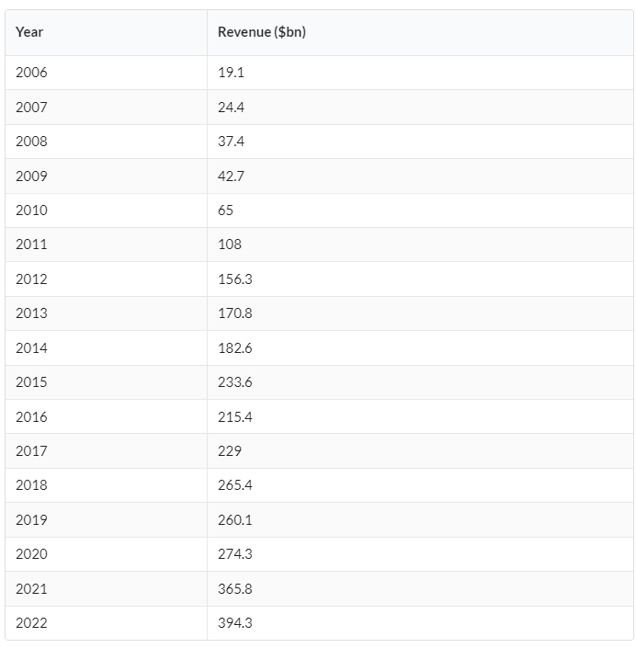
Source: https://www.businessofapps.com/data/apple-statistics/

Apple revenue analysis by region

Looking at market share by region, in 2021 the largest portion of revenue was made in the Americas then in Europe, China, Japan and the rest in the region of Asia Pacific region.

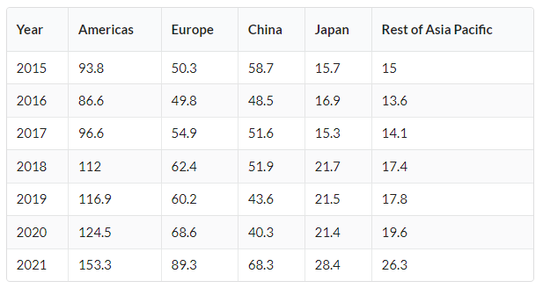
Source: https://www.businessofapps.com/data/apple-statistics/

Apple revenue breakdown analysis by category of product

Apple’s smartphone iPhone is the current flagship product which generates the highest revenue out of all Apple’s products. Revenue in 2022 from iPhone was 205,489 billion dollars, Mac computers generated 40,177 billion dollars, iPad 29,292 billion dollars, Wearables (Apple Watch) and home accessories 41,241 billion dollars and services (Apple TV, Music etc.) 78,129 billion dollars.

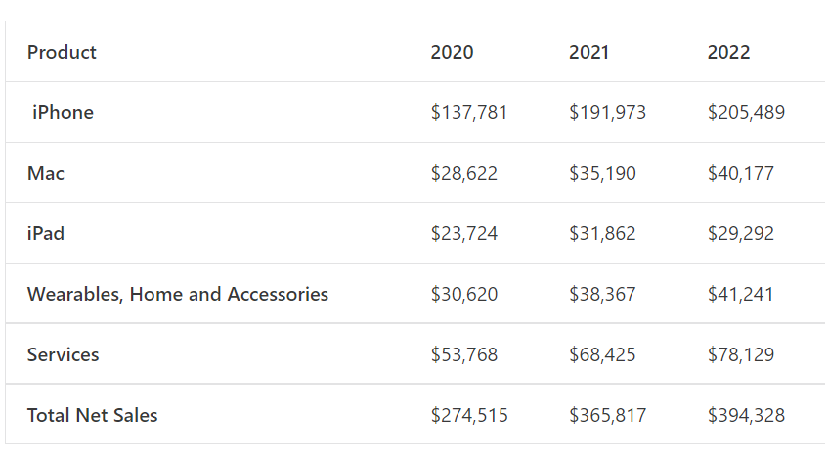
Source: https://statstic.com/apple-revenue-by-product-category/

Apple revenue breakdown analysis by main products

iPhone
Revenue generated by sales of iPhones has gone up from 1.8 billion dollars in 2008 to 205.4 billion dollars in 2022.
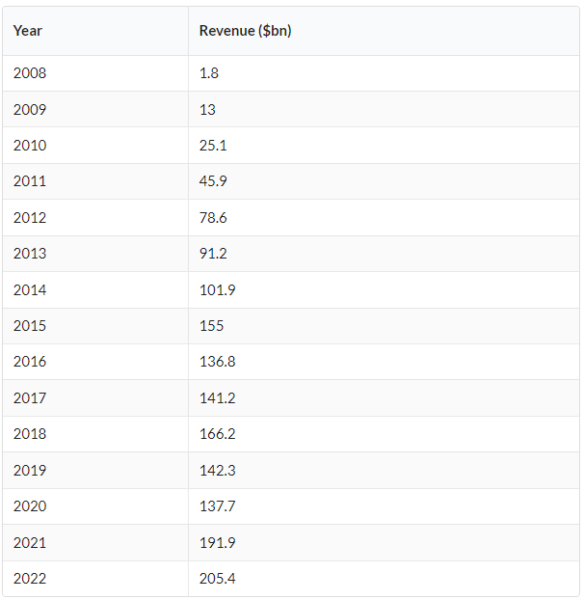
Source: https://www.businessofapps.com/data/apple-statistics/

iPad
iPad, Apple’s tablet revenue has gone up from 19.1 billion dollars in 2011 to 29.2 billion dollars in 2022.
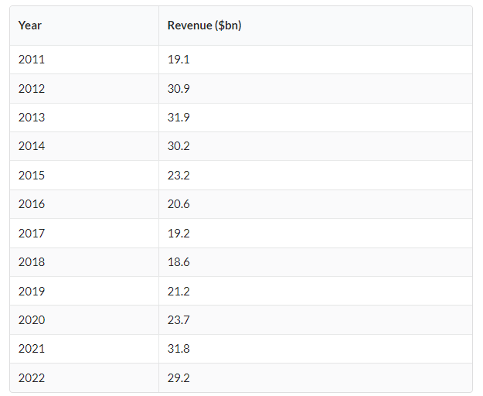
Source: https://www.businessofapps.com/data/apple-statistics/

Wearables (Apple Watch) and home accessories
Revenue from the Wearables category (including Apple Watch) and home accessories has gone up from 9.8 billion dollars in 2015 to 41.1 billion dollars in 2022.
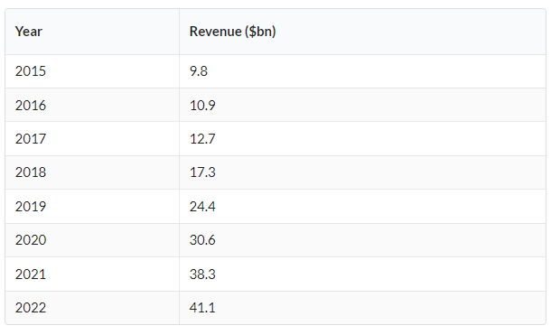
Source: https://www.businessofapps.com/data/apple-statistics/

Mac computers
Apple Mac computers revenue has gone up from 13.6 billion dollars in 2009 to 40 billion dollars in 2022.
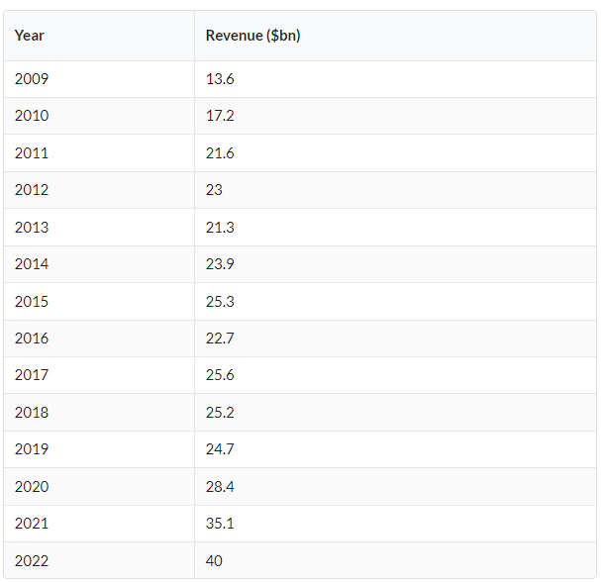
Source: https://www.businessofapps.com/data/apple-statistics/

Apple's market share (smartphones)

Looking at Apple’s highest revenue contributor in the smartphone category - iPhone, the below chart sourced from the ‘Statcounter Globalstats’ website, shows Apple’s market share in comparison to competitors between November 2021 and November 2022.

According to the data, Apple's market share was 28.08%, Samsung's 27.96%, Xiaomi's 12.35%, Huawei's 12.35%, Oppo's 5.44% and Vivo's 4.23%.

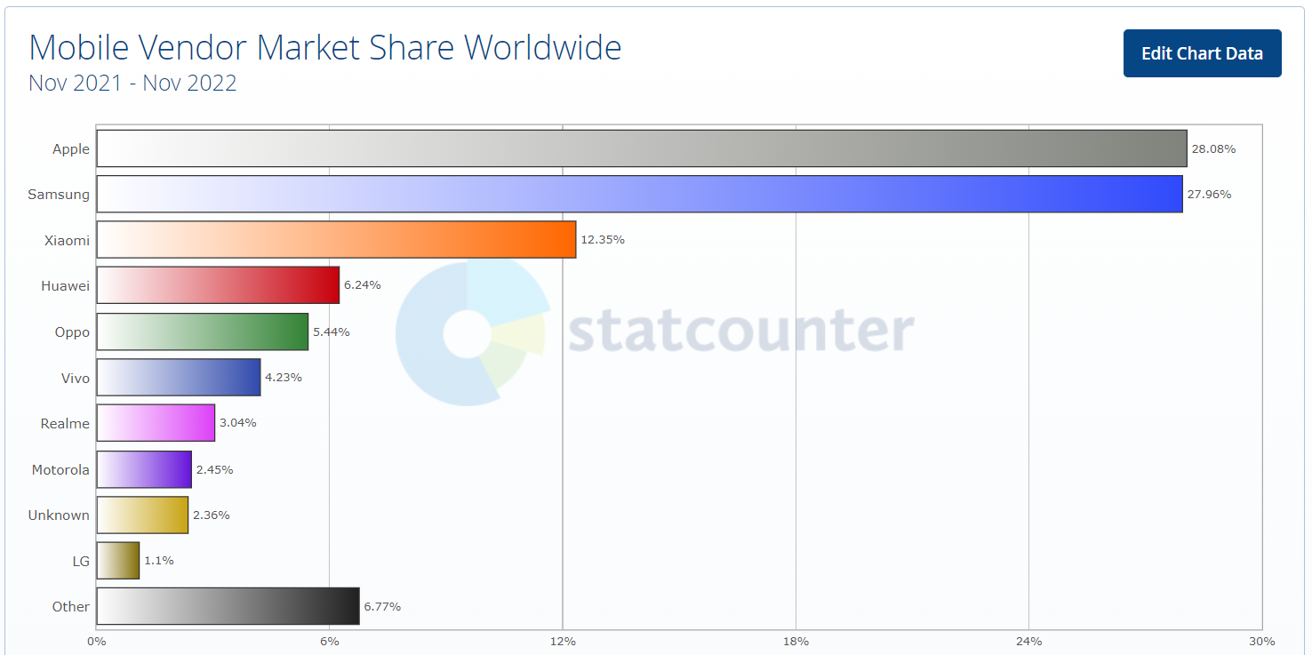
Source: https://gs.statcounter.com/vendor-market-share/mobile/worldwide

Apple market share (tablets)

In the tablet market, looking at the data from ‘Statcounter Globalstats’ website, Apple’s market share between November 2021 and November 2022 was 53.27%, Samsung's 28.36%, ‘Unknown’ brands 6.38%, Amazon's 4.95%, Huawei's 3.1%, and Xiaomi 0.55%.

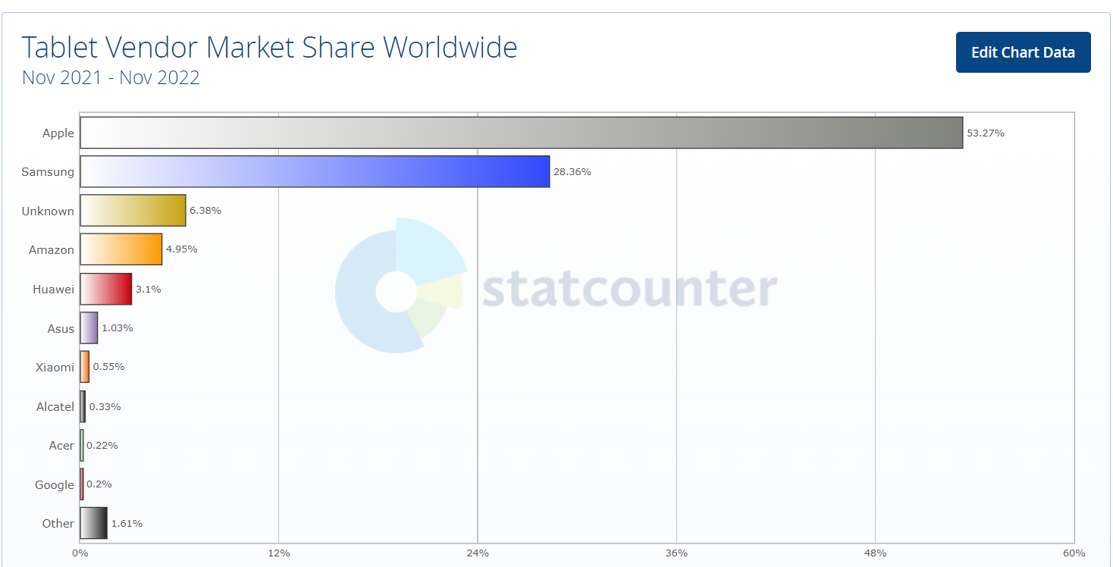
Source: https://gs.statcounter.com/vendor-market-share/tablet/worldwide

Apple market share (personal computers)

In the global market share for personal computers in 2021, Apple came at fourth place with 7.6% behind Dell with 17.6%, HP with 21.8% and Lenovo with 24.7% according to Statista report ‘Personal computer (PC) vendor market share worldwide from 2006 to 2021’.
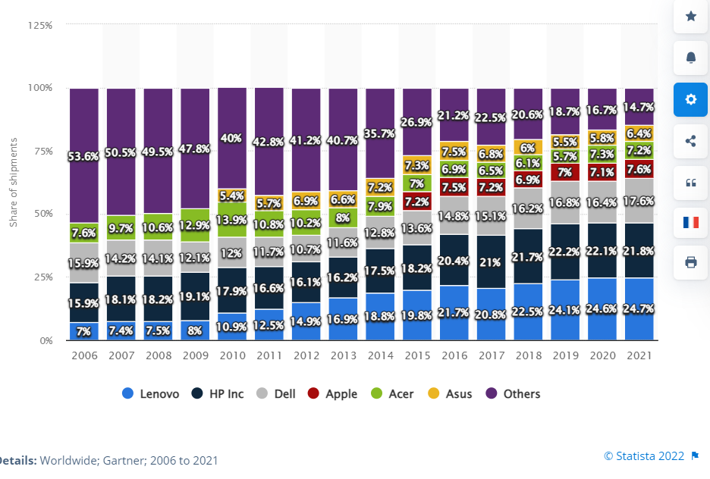
Source: https://www.statista.com/statistics/267018/global-market-share-held-by-pc-vendors/

Conclusion

To conclude from the analysis, Apple is an American technology company based in Cupertino, California with over 46 years of experience in the market of personal computers, mobile phones, tablets, and wearables. The company has very strong values and company culture which is encouraging individualism and excellence in leadership but also promotes accountability and honesty amongst its staff. Apple is promoting diversity, care for the environment and supplier responsibility ensuring that all its suppliers share the same values. Apple is also quite heavily involved in promoting accessibility ensuring that all users regardless of their physical abilities can get the possible best experience when using its products. Following the SWOT analysis, we found that Apple has a very strong brand image thanks to its widely recognised drive for innovation and high-quality products. Apple is also one of the first companies with a 1 trillion-dollar value which tripled again in 2022. One of the main weaknesses of Apple is the price of its products which is pushing potential new clients to look for a cheaper alternative which offers a similar experience. The product portfolio is somewhat confusing with different versions of mobile phones and tablets which apart from small differences offer the same functionality which resembles the company’s path in the 1990s which almost ended with bankruptcy. Also, poor compatibility with other brands is another factor which is off-putting the new clients from switching from the other brands to Apple. On the other side, Apple’s portfolio is still relatively small so there is an opportunity to introduce some new products. The company can also seek some new acquisitions to expand its market share either in the mobile phone market, personal computers, or software. From a sustainability perspective, Apple is already a leader in ensuring that its manufacturing processes and operations are becoming ‘green’ and it can do so much more further working on using recycled materials and improving its supply chain. The biggest threat to the company’s future would be competitors mainly from Asia. Many companies which are now successfully competing with Apple have been Apple’s producers in the past which allow them to learn new technologies and implement them in their products. Apple’s position can be also affected by a worsening global economic situation which can lead to dropping in sales in favour of cheaper equivalents. Also, the ongoing COVID situation which is still affecting its supply chain in Asia has an impact on the overall availability of its product in the global market with the latest products having long lead times. Changing legislation can also impact Apple considering the latest developments in Brazil and Europe which resulted in Apple being forced to either revert to adding chargers to its products or ensuring that USB-C sockets will be present in all its products sold in European markets.
From PESTEL analysis we can find out that Apple can be affected by changing political factors, being a global manufacturing company with its factories located almost across the globe. Social factors such as growing pressure on diversity in the workplace and consumer behaviours can lead to Apple losing its market share if they will not follow up. In terms of technology, Apple’s competition is not far behind offering products with very similar specifications at a lower price which in the longer term can erode Apple’s position on the market. In terms of environmental factors, Apple invested in the state-of-art headquarters in Cupertino, California making its operations emissions-free. It is also continuously working on becoming ‘greener’ in terms of cutting CO2 emissions in its manufacturing and transport process. Being a global company, Apple can be affected by legal factors such as changing legislation and pressure from different regulatory bodies.
Apple’s main competitors are mainly Samsung, Microsoft, Dell, and Lenovo with Xiaomi and Oppo competing mainly in the mobile phones market.
In terms of revenues, Apple has been consistently increasing its revenue across all product groups with its smartphone iPhone being a flagship product with the biggest share in the total revenue. Also, in terms of revenues by region, Apple is consistently growing its revenues in all regions.
Looking at the global market share of smartphones, Apple is still a leader however, it is closely followed by Samsung and a group of Chinese manufacturers such as Xiaomi, Huawei and Oppo. In the tablet market, Apple is a leader with a 53.27% market share leaving its competitors far behind. Unfortunately, in the personal computers market, Apple being historically a pioneer in the field has lost the lead to its competitors. Which only a 7.6% share of the market it is a worrying trend which in the long run can lead to Apple eventually pulling out from this segment in favour of others.

Recommendations

Based on the above, I have formulated the following recommendations for Apple’s senior management for the company to improve its position:
- Look closer at the price of the products and introduce cheaper versions considering that in the current market people have less disposable income and in the post-COVID era, the further economic outlook is not looking promising. Providing that the price-to-value ratio and technology comparison will be in favour of Apple, this should attract new clients.
- Revisit product portfolio, having many versions of the iPhone in 2022 such as iPhone 14, iPhone 14 Plus, iPhone 14 PRO and iPhone 14 PRO MAX is not sustainable in the long run as it is difficult to differentiate between them to find the best one.
- Look for alternatives in terms of manufacturing in Asia, mainly due to the still highly uncertain COVID situation and civil unrest in China which is having an impact on Apple’s factories and supply chain.
- Apple needs to conduct extensive market research to find out why it is performing so poorly in the personal computers market, considering in the past Apple was a pioneer in the field and the leader in computer technology innovation.

References

Apple (2022). Business Conduct The way we do business. [online] Available at: https://www.apple.com/compliance/pdfs/Business-Conduct-Policy.pdf.

Apple: Chinese workers flee Covid lockdown at iPhone factory. (2022). BBC News. [online] 30 Oct. Available at: https://www.bbc.com/news/world-asia-china-63447755.

Apple. (n.d.). Work at Apple - Careers at Apple. [online] Available at: https://www.apple.com/careers/uk/work-at-apple.html.

Curry, D. (2022). Apple statistics (2021). [online] Business of Apps. Available at: https://www.businessofapps.com/data/apple-statistics/.

Fesmina Faizal (2021). The History of Apple. [online] Feedough. Available at: https://www.feedough.com/the-history-of-apple/.

Harding, S. (2022). Brazil court orders Apple to reimburse customers for charger-less iPhones. [online] Ars Technica. Available at: https://arstechnica.com/gadgets/2022/10/apple-fined-19-million-in-brazils-third-ruling-against-charger-less-iphones/.

Johnson, K., Li, Y., Phan, H., Singer, J. and Trinh, H. (2012). The Innovative Success that is Apple, Inc. Available at: https://mds.marshall.edu/cgi/viewcontent.cgi?article=1420&context=etd.

Lashinsky, Adam (August 25, 2011). "How Apple works: inside the world's largest startup". Fortune. CNN. Archived from the original on November 13, 2011. Retrieved November 14, 2011.

Levy, S. (2022). Apple Inc. | American company. In: Encyclopedia Britannica. [online] Available at: https://www.britannica.com/topic/Apple-Inc.

Oxford College of Marketing (2016). What is a PESTEL analysis? [online] Oxford College of Marketing Blog. Available at: https://blog.oxfordcollegeofmarketing.com/2016/06/30/pestel-analysis/.

POLITICO. (2022). Apple joins other global giants in Russia exit. [online] Available at: https://www.politico.eu/article/apple-pulls-products-from-russia/.

Pratap, A. (2022). APPLE Revenue by Product Category. [online] Statstic. Available at: https://statstic.com/apple-revenue-by-product-category/.

StatCounter Global Stats. (2019). Mobile Vendor Market Share Worldwide | StatCounter Global Stats. [online] Available at: https://gs.statcounter.com/vendor-market-share/mobile/worldwide.

StatCounter Global Stats. (2019). Tablet Vendor Market Share Worldwide | StatCounter Global Stats. [online] Available at: https://gs.statcounter.com/vendor-market-share/tablet/worldwide.
Statista (2018). PC market share 2018 | Statista. [online] Statista. Available at: https://www.statista.com/statistics/267018/global-market-share-held-by-pc-vendors/.

Turton, W. (n.d.). Inside Apple’s global war on leakers. [online] The Outline. Available at: https://theoutline.com/post/1766/leaked-recording-inside-apple-s-global-war-on-leakers [Accessed 4 Dec. 2022].
the Guardian. (2022). Apple to put USB-C connectors in iPhones to comply with EU rules. [online] Available at: https://www.theguardian.com/technology/2022/oct/26/iphone-usb-c-lightning-connectors-apple-eu-rules#:~:text=Apple%20will%20ditch%20the%20Lightning.
Washington, D. (n.d.). UNITED STATES SECURITIES AND EXCHANGE COMMISSION. [online] Available at: https://s2.q4cdn.com/470004039/files/doc_financials/2022/q4/_10-K-2022-(As-Filed).pdf.
WCS (2021). TOP 10 APPLE COMPETITORS in 2020 - What Competitors. [online] whatcompetitors.com. Available at: https://whatcompetitors.com/apple/.

‌

