

DOCTOR OF BUSINESS ADMINISTRATION

QUANTITATIVE RESEARCH METHODS
(LCDB7011_LON)

LECTURER
Dr. RAVSHONBEK OTOJANOV

TOPIC
QUANTITATIVE ANALYSIS ON THE SUSTAINABILITY OF THE FRANC ZONE

NAME AND STUDENT ID
Francine TAGOUDI SILATSA MAFOUGANG (2306963)

7325 Words

ABSTRACT

Established during colonisation, the CFA Franc remains today the only colonial currency in the world which still in use in fourteen countries in the Sub-Saharan Africa called the Franc zone. Pegged to the French Franc since 1945, then to the Euro since 1999, this currency survives thanks to the so-called mechanisation of the "account of operation" (Nubukpo, K. 2015) which makes France, the former colonising power, the guardian of the stability of this currency.
The purpose of this topic is to highlight the role of currency in the economic development of countries in transition. The intention is to assess the economic costs and/or benefits of using the CFA Franc on the Franc zone. Additionally, it offers economic, political and historical justifications to evaluate the neo-colonial perception of the CFA Franc. Ultimately, the aim is to determine the CFA Franc's impact on the economies of the Franc zone.
Certain questions emerge. What are the economic impacts of the CFA Franc on the Franc zone? What are the monetary and fiscal policy frameworks of the CFA Franc, and their implications? What role does the CFA Franc play in the economic trade of countries in the Franc zone? Does it favour trade with as many partners as possible to benefit the Franc zone, in accordance with the thesis supported by Adam Smith and David Ricardo, stipulating that “the prosperity of peoples depends on their cooperation, mutual fund, their specialization and the free movement of goods, services, capital and even people”? Or on the contrary does it serve as an instrument to perpetrate a plundering system, favouring the interests of a metropolis that the course of history has only kept at the head of Africa?
The previously mentioned findings prompt us to examine the role of the CFA Franc in the Franc zone as the research problem. The thesis adopts positivism and interpretivism as its research philosophies, employing quantitative and qualitative methods for its methodological approach, respectively.
According to our previous quantitative analysis, the CFA Franc evidently has a detrimental effect on the Franc zone. It hampers macroeconomic stability by contributing to sluggish and negligible real GDP growth; provoke high inflation and increasing deficits and high debts. Moreover, it hinders trade performance and intra-regional commerce, leading to trade deficits, reduced competitiveness, and minimal trade surpluses.

INTRODUCTION

On the international sphere, the current situation is mainly characterized by accelerated globalisation and digital economy that accentuate the risks of financial instability and exchange rate volatility. These situations have strengthened theories defending the ability of regional monetary unions to respond adequately to global economic problems. Therefore, taking part in a monetary union has considerable advantages such as reducing transaction costs, as well as reducing uncertainties about exchange rate changes, removing the exchange rate between the entities that make up the union or building confidence in policy direction (Zhao and Kim, 2009). These theories served as the basis for the establishment of regional monetary systems so the two largest in the world are the Euro and the CFA Franc (CFAF).
The CFAF was established on the 26th December 1945 by decree N° 45-0136, and firstly stood for the "Franc of the French Colonies of Africa". In 1958, it became the “Franc of the French African Community”. Later in 1960, after independences, it became the "Franc of the African Financial Community, XOF" in West Africa and the "Franc of the Financial Cooperation in Central Africa, XAF" in Central Africa. It is the currency in use in 14 countries of Sub-Saharan Africa (SSA), all members of the Franc zone (FZ). The distinguishes of this currency is much less the history of its introduction than the longevity of its fixed exchange rate regime which remains one of the most stable in the world (Gulde and Tsangarides, 2008). Indeed, despite the major shocks and changes that the world has experienced, its rate has changed only once with the devaluation in 1994.
The FZ is divided into two African monetary zones. The West African Economic and Monetary Union (UEMOA) uses the CFAF (XOF) in Benin, Burkina Faso, Côte d'Ivoire, Mali, Niger, Senegal, Togo, and Guinea Bissau. Meanwhile, the Central African Economic and Monetary Union (CEMAC) uses the CFAF (XAF) in Cameroon, Congo, Gabon, Equatorial Guinea, Central African Republic, and Chad.
The stability, the entire of the FZ owes it to monetary cooperation with France, through the mechanism known as the "operating account", which helps to guarantee a fixed parity between the CFAF and the Euro (Nubukpo, 2007). Essentially, this mechanism is presented as a kind of insurance of "monetary stability" subscribed to with the French treasury, against 50% deposit of foreign exchange reserves that each of the central banks, which make up the zone, will have centralised. This situation has edged with several controversies surrounding the FZ.
Some authors and economists who are interested in the issue find that the fixed parity regime of the CFAF backed by the mechanism of the operating account is suboptimal (Owoundi, 2001) while for others, the argument of "monetary stability" represents only a false flash for to bring respectability to a monetary policy that is too restrictive and mainly serves the well-understood interests of European groups (Tinel, 2016). These authors focus their criticisms on the CFAF as a tool for economic development. Their arguments meanly demonstrate that the CFAF is not compatible with the possible development of Africa.
Other authors are interested in the more political dimension of the currency. Their criticisms refer to the historical foundations of the Franco-African relationships. By supporting the modus operandi of the colonising power in Africa, this current maintains that the tutelary power of the French treasury is only a reinvention of the paternalism of the Elysée authorities. They use the term "monetary servitude" to define this neon-colonial survival. In front of them, economists and authors of liberal obedience for whom, what the precedents wrongly present as the perpetration of an asymmetric relationship, is nothing more than the expression of multilateral solidarity (Hugon, 1999).
The use of the CFAF currency as a tool for domination or economic development is based on various observations. Notably, this comes from analysing the economic growth of the FZ. As the African continent advances with new powers like China, which is nearly rivalling France's influence (La Tribune, 2013), the perceived reduction in French influence following the disbandment of the old Foccart networks is contrasted by the growing power of French firms. These firms maintain a significant market share in the FZ (Adjagbe, 2009). For example, France has outpaced China in Côte d'Ivoire with a 14% market share versus 6%, in Senegal with 17% compared to 10%, and in Gabon with 33% against 8% (La Tribune, 2013). Consequently, Alexandre Vilgrain, president of the French Council of Investors in Africa, stated that French companies are unrivalled in Africa (French Council for Investment in Africa, 2013). These insights are key to understanding the longstanding economic interactions between France and its African partners, including the historical "privilege of the flag" (Gounin, 2009, p.27), which restricted colonies from trading with other countries.
Presently, France significantly influences the daily management of the CFAF. The French public treasury backs its convertibility, giving France preferential access to the board of directors of the central banks issuing the CFAF. This role is controversial, especially since, just after independence, the currency and public development aid were deemed essential for French subsidiaries in Africa to carry out major infrastructure projects (Glaser and Smith 2005). The purpose of this study is to evaluate the economic costs and benefits of utilising the CFAF in the FZ. It also aims to provide economic, political, and historical justifications to assess the neo-colonial view of the CFAF.

Hypothesis
Since its establishment and especially in recent times, the CFAF has not promoted economic growth of the FZ.

Aim
The goal is to ascertain the economic impact of the CFAF on the FZ.

Research objectives
This subject is part of the literature that underscores the significance of currency in the economic advancement of transitioning countries. It establishes a conducive framework for analysing the effects of monetary, fiscal, and exchange rate policies on the economic development in the FZ. It illuminates both the internal and external factors that contribute to the FZ's underdevelopment.

Problem Statement
The topic investigates the role of the CFAF in the FZ.

Research Questions
For this assignment, only one question will be asked: what are the economic impacts of the CFAF on the FZ?

LITERATURE REVIEW
THEORETICAL MODELS, SYSTEMS AND LAWS ESTABLISHING THE ECONOMIC IMPACT OF THE USE OF CFAF ON THE FZ

The theory of currency
According to Aristode, currency is the property that is at the same time means of payments, unit of account and reserve of values. Moreover, perceived by Hicks (1967), currency is what currency does. Furthermore, currency represents a timeless invention, the traces of which date back to the very birth of humanity and which, surprisingly, is not attributable to any society (Théret, 2008). It is, de facto, a privileged instrument guaranteeing trade. At least it is the universal aspect that it presents since everywhere it acts as operator of social belonging, mediation in the most diverse social exchanges within which it operates as a representative of the social totality (Ibid). However, to limit its definition to this aspect would be to underestimate one of the most complex terms in the economy. Given the multiplicity of these characters, it seems difficult to conceptualise it without failing to remove some of these fundamental constituents. This is what Charles Rist (1938) claimed by refusing to comment on a possible definition to be given to the term. For him, to try to give a definition to currency would be to discard so many characteristics of real currencies, that it will no longer represent much interest.
In the absence of a consensual definition and in logic of coherence, this topic retains the definition of Diallo (2002) which presents the currency as being legal tender refers to a medium of payment recognised by a legal system to be valid for meeting a financial obligation. It typically includes both notes and coins, which are issued by the sovereign authority of a country and must be accepted if offered in payment of a debt within the territory where such authority applies. From this definition, it can be remembered that a substantial part of state sovereignty finds its essence in the currency. The national management of the currency appears in this context to be a natural end of the sovereignty of a state. Moreover, it is customary for a State to reserve an exclusive right over monetary prerogatives. Around the world, it is the states that set up their own currency by reserving the exclusive right to assign them a value and even by deciding to open them up to the foreign exchange market.
In the context of the CFAF, the situation is different. All the fourteen states that use the currency have decided to give up the management of their currency to entrust it to the public treasury of their former coloniser. However, a State cannot fully relinquish the management of its currency without simultaneously surrendering a significant portion of the power it holds from its status as a sovereign entity (Ibid). Thus, many authors claiming to be pan-African or neo-Pan-African have developed a current presenting the CFAF as an imperial currency intended to perpetuate the system of 1960. The literature dealing with the question of the CFAF is quite heterogeneous. This multi-disciplinary of the criticisms reveals the extent of the complexity of the subject.
From an economic point of view, the CFAF is presented as an element of inertia of the African economies of the zone (Nubukpo, 2015). Economists who support this hypothesis, have developed criticisms based mainly on the theory of the Optimal Monetary Zone (OMZ), fuelling a debate on the need for an Africa-exit.

The theory of the OMZ
This theory was introduced into the literature in the 1960s, by Robert Mundell (Ott and Vignolles, 2012). It aims to judge the optimality of an area, based on criteria that would benefit a geographical area, both national and multinational areas to adopt a monetary union of the common currency type or the fixity of the exchange rate.
According to Mundell (1961), one of the conditions that must be met for an area to acquire the optimality lies in the level of the gains that each of the states should derive from the union. According to him, if the fixing of the exchange rate or the adoption of a common currency brings more advantages to states than offers them their main instruments of macroeconomic adjustment, the exchange rate, then it is called an OMZ. Therefore, he points out that for the opportunity cost of the exchange rate to be properly compensated, there would have to be labour mobility (Ott and Vignolles, 2012).
The theory of the OMZ will also be developed by other authors who will form with Mundell, a traditional school of theory. Mackinnon (1963) is part of this traditional current of the theory of the OMZ. It will broaden the criteria of optimality by introducing the degree of openness (ratio of exchangeable goods to non-exchangeable goods) as a new criterion to be considered before the decision to guide a monetary union. To this he will add that the intensity of trade between states should also guide a monetary union. In other words, the more "open" the states are that is, the higher the ratio, the more they have an interest in adopting a fixed exchange rate regime (Bourginat, 1992). And all other things being equal, the more "closed" states are that is, the lower the ratio, the more states have an interest in adopting a flexible regime. The rationale for his reasoning is because if the exchange rate of an open economy changes, this will have an impact on the general price level (Laurent Joye, 2014). This means that the change will impact both the relative prices of trade-able and non-exchangeable goods, which could disrupt the allocation of resources. Also, in this type of economy, a change in the exchange rate that would cause a fall in demand for external goods would require large increases in the demand for non-exchangeable goods to maintain an unchanged level of real income. In the end, this could give rise to large compensations in terms of prices and wages that would not benefit the competitiveness of the economy in question (Ibid). He concludes that the more open economies are and the more they trade with each other, the more they should form a monetary union. This union will be more closed and will enable them to better cope with the perverse effects of exchange rate fluctuations.
For Kenen (1969), a union can arise to the extent that countries have a high degree of diversification of their productive structures. It criticizes Mundell's model (1961) and complements that of McKinnon (1963). In his view, factor mobility alone should not be used to justify the optimality of an area, as other factors could come into play to meet exchange rate opportunity costs (Bamba, 2004). His hypothesis of strong diversification of production is mainly based on the principle of "Law of large number" (Kenen, 1998) to describe the law of the large number that will play a role to better withstand the macroeconomic shock.
Cooper (1977) and Kindelberger (1986) will in turn develop the theory by introducing a contemporary criterion, the homogeneity of national preferences. According to this new criterion, optimality is judged by the degree of similarity of the economic preferences of states both consumer preferences and the collective economic policy preferences of the states themselves that wish to form a monetary union. In this context, countries with intense trade relations and similar preferences, for both private and public goods (Bamba, 2004) can constitute an optimal area.

Limitations of the theory of the OMZ
Based on the empirical results of the FZ, some economists show that there is no real mobility of factors of production in the area (Ondo Ossa, 2000). They argue that the disparity of adequate legislation and regulations has a restrictive effect on labour mobility (Nubukpo, 2013). Their results are opposed, to a lesser extent, to those of Musugaie (2010), which has a more global view of labour mobility. He concluded that the mobility criterion would be met in the FZ, in a "partial and unsatisfactory" way, by observing the results of the whole of Africa and particularly on the consequent mobility in West Africa. However, he points out that several factors hinder this mobility, including military conflicts, social and political tensions or economic changes (Ibid). Among other factors, he does not hesitate to mention the bureaucratic obstacle that is presented by his peers as the factor restricting labour mobility.
Some have applied the McKinnon model to the FZ. And it concluded that it is not compatible with them. Ondo Ossa (2000) showed that the ratio of external trade to GDP and the ratio of intra zonal trade to external trade between 1995 and 1996, before the Euro was anchored, are both quite low, justifying a flexible exchange rate between them. Diop (2017) revealed that the FZ have undiversified productive structures which, at the same time, lead to the non-diversification of exports. He identifies this as one of the main reasons hindering the development of intra-regional trade. Kenkouo (2014) wanted to measure the impact of external shocks on CEMAC economies particularly in terms of inflation whose production and exports are largely dominated by petrol. He concluded that, in the short term, an increase in world petrol prices did not significantly affect the countries of the area.
However, in the long term, it notes inflationary effects that are expected to spread throughout the region. Guillaumont and Jeanneney (2017), analyse the effect of a reverse shock, and complete this hypothesis through an empirical study of the situation of the countries of the CEMAC. These authors argue that the sharp drop in the price of oil has had considerable direct consequences on their balances of payments and public finances (Ibid). They also explain that this situation has led the countries of the zone to put in place severe adjustment policies and that if they do not manage to control their public finances or if their common external reserve is exhausted, the zone will be obliged to apply the extreme measure of the devaluation of its currency. A situation may have repercussions at the level of the UEMOA currency and therefore in the FZ.

The theory of neo-colonialism
France-Africa is inevitably the ultimate term symbolising the hardening, if not the evolution, of relations between France and its former colonies whose imminent independence seemed inevitable. It is moving from direct domination of the metropolis over its colonies to collaborative domination an independence accompanied by the motherland. The term France-Africa describes this invisible umbilical cord that exists between France and its former colonies. It is the result of colonial separation, because further back than its genesis, it was placed at the very beginning of independence, in 1960. It has long been under the supervision of the mythical Africa cell of the Élysée, which at the time had no legal existence (Gounin, 2009). However, it is under the direction of Jacques Foccart, the very famous Mr. Africa that this cell will serve as a lever determining the policy of France in Africa.
The logic behind this term was to perpetuate the old colonial order, which largely benefited France, while ensuring that the elites of these decolonised countries share the national cake. "Access to the State as a condition for direct access to economic resources" (Medard 1990: 93); Thus, through Foccart, France inducted and dethroned the leaders of these countries stricto sensu, depending on whether they were in favour of their interests. In this vein, electoral fraud directed disputes in such a way that the president-elect was France's initial choice. Robert Bourgi describes a more occult dimension of this mafia network, showing that there was recourse various stratagems specific to secret organisations and societies: the formation of intelligence networks, surveys of the political opinions of colonial administrators and officials, and an attempt to infiltrate the business community in Africa (Médard, 2002).
These stratagems made it possible not only to control the African political universe, but also and above all to keep an eye on all the markets that could take place there. To do this, all those who opposed this system were systematically ousted in the worst possible way. Thomas Sankara, in Burkina Faso, paid the price, when he came to power, preferring a rapprochement with Gaddafi (Verschave 1999) who was very reclusive of France. Indeed, the barons of France-Africa favoured its elimination, and admitted with open arms the put schist leader in their brotherhood (Ibid). This is how it worked in the Focartian dwellings.
Since the mentioned above of French interests, this is the place to mention them in the sense that they will be of particular importance in explaining France’s role in Africa. As a colonial power, the French economy was partly built by the exploitation of raw materials and wealth that it could obtain cheaply in the territories under its domination (Capron, 2009) so the birth of a French pre-square presented itself as a continuum allowing it to operate its economy by sourcing raw materials at a lower cost, priority given to energy sources. Several economic agreements will then emerge ensuring that metropolitan companies have a grip on the market for exploiting this type of resource (Noirot, 2012). These companies included the Elf, AREVA and CFAO companies specializing in the mining and oil, distribution and trade sectors.
A striking feature of this period is the economic nationalism that developed and that inextricably equated the commercial successes of French companies with the successes of the entire nation (Capron, 2009). At that time the international scene was breathing the air of the Cold War, and that the Gaullist Republic was in search of supremacy. It then considered its influence on Africa, in the same way as the atomic bomb (Gounin, 2009) therefore as a weapon, which by guaranteeing a precarious balance, would allow it to redistribute power on the international scene. The CFAF was then a fundamental element of French policy. Firmly anchored to the French Franc then to the Euro, this currency was mainly to serve to slow down the advance of foreign powers in the SSA (Migani, 2012).
In addition, it represented an advantage for French companies since for a country in the FZ that wants to place an order abroad; priority will be given to them. As Noirot (2012) tells, the currency has the appearance of a "straitjacket" guaranteeing French companies a monopoly in African markets. It is important to point out that, in addition to the fact that French economic nationalism did not differentiate between the success of its enterprises and national success; it also did not tolerate foreign companies having managed to get a head start on its own. To the extent that such situations are arrived at, they are perceived as attacks on national sovereignty and call for government retorts (Ibid) of the order of Thomas Sankara. These French companies developed more and more in African countries during the 1990s, taking advantage of structural adjustment plans, initiated by the Breton Woods institutions to establish themselves permanently in the African landscape. Indeed, the associated wave of privatisation coincided with a strong presence of French companies and French capital in the FZ. In Ivory Coast, they have enabled the Bouygues group to afford key sectors of the economy such as the Ivorian Electricity Company and the Ivory Coast Water Distribution Company of which it remains a major shareholder (Ibid). French banks have also taken advantage of this framework to establish their subsidiaries on a lasting basis, which are today the main institutions and references in this field throughout the FZ. The Total group and France Telecom are other large groups that generate significant turnover and around which all the economic activity of the area is crystallised.

The system of the monetary servitude
At first glance, these principles were set up to bring invaluable benefits to the economies of countries that use the CFAF. However, some analyses have demonstrated their counter-productive effects. The real contrast is observed in the choice of policies adopted by the FZ to preserve this currency. To guarantee fixed parity for the Euro and unlimited convertibility, the FZ have put in place a whole series of public policies which continue to benefit the countries of the North. The most important of these is the liquidity management policy. The example of UEMOA illustrates this device which is a great part to European companies. Nubukpo (2011) tells that since 1989 the UEMOA has implemented a policy called "competitive disinflation" whose objective is to ensure the internal and external stability of the currency. This policy relies heavily on key interest rates. The challenge is to play on interest rates so that current inflation is equal to the target inflation rate. For example, an increase in the interest rate should lead to a fall in the rate of inflation. This targeting is set at 2% (Tadenyo, 2015).
The logic behind this policy is based on a monetary explanation of inflation that establishes a causal relationship between the change in the money supply and inflation (Sall, 2016). More concretely, excess liquidity should sustain inflation and, conversely, less liquidity should help to keep inflation relatively low. Following this logic, the central bank has put in place a restrictive monetary policy (Dembo Toe and Hounkpatin, 2007) which was mainly used to contract liquidity in the union. To limit the volume of money, it was necessary to address the main sources of its growth. These are net external assets and mainly domestic credit (Ibid). Thus, the banks of the space have tightened the criteria for granting credit. The result is a restrictive monetary policy that limits the bank contribution to the financing of economic development in the area. As proof, the ratio of credit to the economy to GDP, intended to show the share of bank credit in the GDP of the zone, rose from 14% in 2000 to 18% in 2009 (Trinnou and Igue, 2015).
Some empirical analyses (Tadenyo, 2015) have shown that economic growth in the UEMOA area in the short and long term depends mainly on investment, which comes mainly from credit to the economy (Nubukpo, 2012). As a result, the tightening of the conditions for granting credit only has the consequence of reducing local investment and to some extent limiting the development of the UEMOA. In pursuing this policy, the Central Bank of the West is choosing to "atrophy" the UEMOA economies in favour of monetary stability since it favours stability at the expense of economic growth motivated by indigenous or local investment. Of course, foreign investors find themselves at an advantage of this policy in that they, having colossal financial resources in their country, will be able to invest them directly in UEMOA countries. This is where the whole question of addiction arises. Indeed, the development of the area will depend entirely on the outside. On the one hand, it is the foreign direct investment particularly from the Euro area because of the parity of the exchange rate and free transferability and on the other hand of public development aid.
The same applies to Official Development Assistance (ODA). The case of ODA is somewhat different from Foreign Direct Investment. It illustrates the whole neo-colonial dimension of the currency, or more precisely the situation of dependency in which the policies that accompany the operation of this currency position the countries that use it. Taking up the arguments of the theorists of dependency, ODA integrates into the exchanges between France and its former colonies the mechanism of linked aid, which guarantees it a right of legitimate domination over the African countries’ beneficiaries of the aid. According to Thomas Noirot (2012), the aid is a real conquest machine owned by France, which uses it to ensure that its companies execute contracts in the countries receiving aid. This argument has been confirmed by analysing the financing of projects in the FZ for example the financing of the Ivorian metro. Already during the Cold War, France multiplied aid to the regimes that are friends of French-speaking Africa (Hugon, 2007) to prevent them from exchanging with the Soviets or the Americans, who already shared the world leadership. Most of this aid was loans and was conditional, or to use Noirot logic of linked aid, is related to the purchase of French products and services (Ibid).

RESEARCH PHYPLOSOPHY

The Ontology Approach pertains to varying beliefs about the legitimacy of the FZ and the CFAF. In terms of the FZ, discussions focus on its purpose, with some authors treating it as an OMZ and others disputing this classification. As for the CFAF, it is viewed by some as a colonial currency, while others regard it as a symbol of multilateral solidarity. This segment of the study will utilise qualitative methods and adopt interpretivism as its philosophical framework.
The Epistemology Approach concerns the differing perspectives of authors based on data regarding the CFAF's ability to foster development in the FZ, characterised by the dual views of the CFAF as a source of macroeconomic instability and stability. The study addresses research questions using quantitative methods and embraces positivism as its philosophical stance.
The Axiology Approach addresses the study's potential to advise African governments, traders, and economists that the FZ must evolve to endure global financial changes that threaten its viability. Such evolution should recognize and rectify the system's deficiencies in response to on-going contextual shifts.

Methodology
Indeed, this thesis integrates both positivism and interpretivism as its research philosophies, applying quantitative and qualitative methods accordingly. Nonetheless, for this assignment, the study focuses on quantitative methods using SPSS and maintains positivism as its ideological approach to tackle the research issue.

Data collection
The research utilises secondary quantitative data spanning twenty years, from 2003 to 2023, from fourteen countries that are members of the FZ, as sourced from the World Bank. These 14 countries are: Benin, Burkina Faso, Côte d'Ivoire, Mali, Niger, Senegal, Togo, Guinea Bissau, Cameroon, Congo, Gabon, Equatorial Guinea, Central African Republic, and Chad.
It is crucial to acknowledge that this data comprises twenty macroeconomic indicators from each of the fourteen FZ member countries such as: Agriculture, forestry, and fishing, value added (% of GDP); Central government debt, total (% of GDP); Exports of goods and services (% of GDP); Final consumption expenditure (% of GDP); External balance on goods and services (% of GDP); Expense (% of GDP); Gross national expenditure (% of GDP); Industry (including construction), value added (% of GDP); Imports of goods and services (% of GDP); Merchandise trade (% of GDP); Net acquisition of financial assets (% of GDP); Revenue, excluding grants (% of GDP); Stocks traded, total value (% of GDP); Tax revenue (% of GDP); Trade (% of GDP); Trade in services (% of GDP); Current account balance (% of GDP); Net lending (+) / net borrowing (-) (% of GDP); Foreign direct investment, net inflows (% of GDP); and Foreign direct investment, net outflows (% of GDP).
Following data collection, it became clear that some indicators were absent in the Excel file. Consequently, codification was necessary. For the missing indicators, I assigned a placeholder number (99) and created a scale that was measurable upon transferring the excel sheet to SPSS.

DATA INTERPRETATION – TESTS OF CORRELATION

Simple diagram
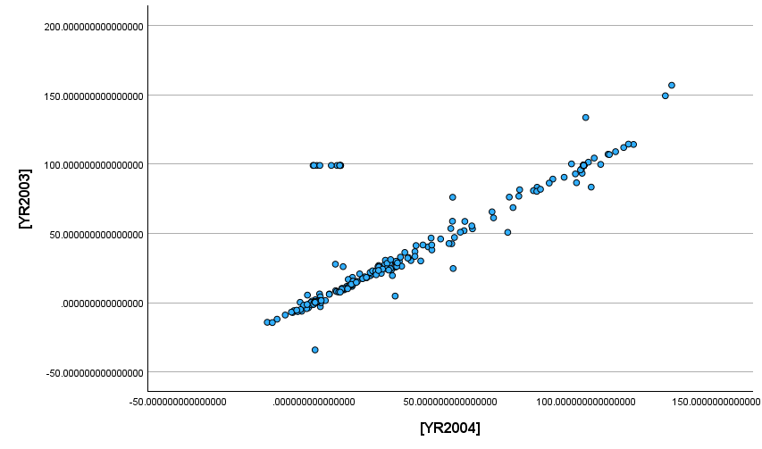
The initial simple diagram between 2003 and 2004 displays a high positive correlation, although there are a few outliers which are considered negligible between [YR2003] and [YR2004].

Scatter diagrams
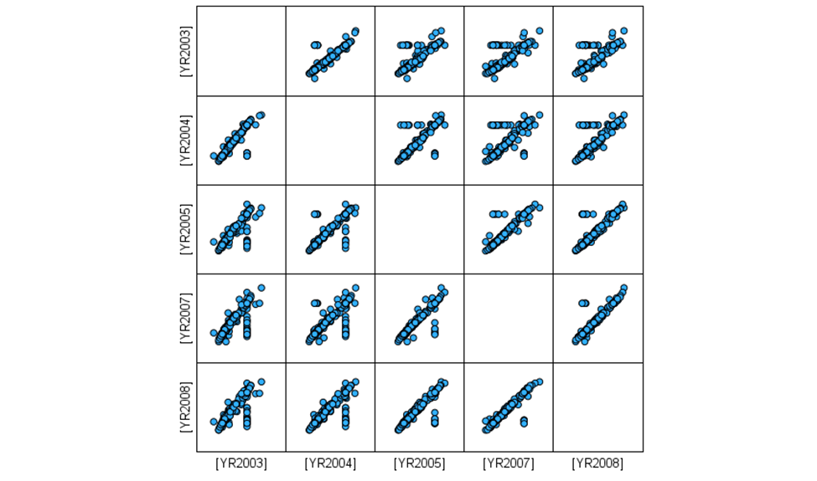
A clear, linear arrangement of points ascending with few outliers, signifies a high positive correlation between the years compared (2003-2008).

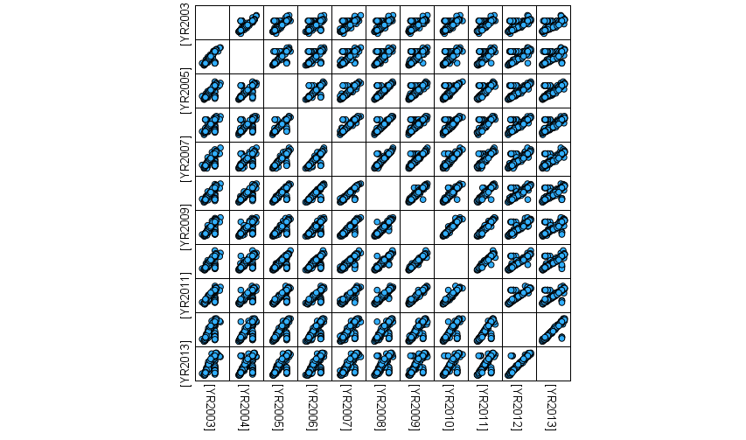
The second scatter diagram, covering the period from 2003 to 2013, also indicates a high positive correlation with a small number of outliers.

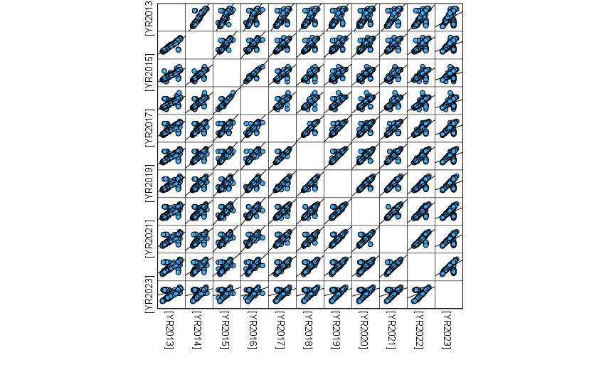
Idem the third scatter diagram, covering the period from 2013 to 2023, also indicates a high positive correlation.
In summary, the simple diagram and the three distinct scatter diagrams representing the years from 2003 to 2023 all demonstrate a high positive correlation.

Correlations
The analysis below involves non-parametric tests on the 20 macroeconomic indicators of 14 Sub-Saharan Africa countries from 2003 to 2023. It is evident that the correlation between these years fluctuates annually and has a slight downward trend over time. For example, the correlation began at 0.912 in 2004, indicating a very strong relationship. It then gradually decreased, ranging from 0.897 to 0.722 between 2004 and 2014, signifying a substantial relationship. Ultimately, it steadily fell from 0.693 to 0.421 between 2015 and 2023, denoting a moderate relationship. In summary, despite the fluctuations, a positive correlation exists over the years, making regression analysis feasible.

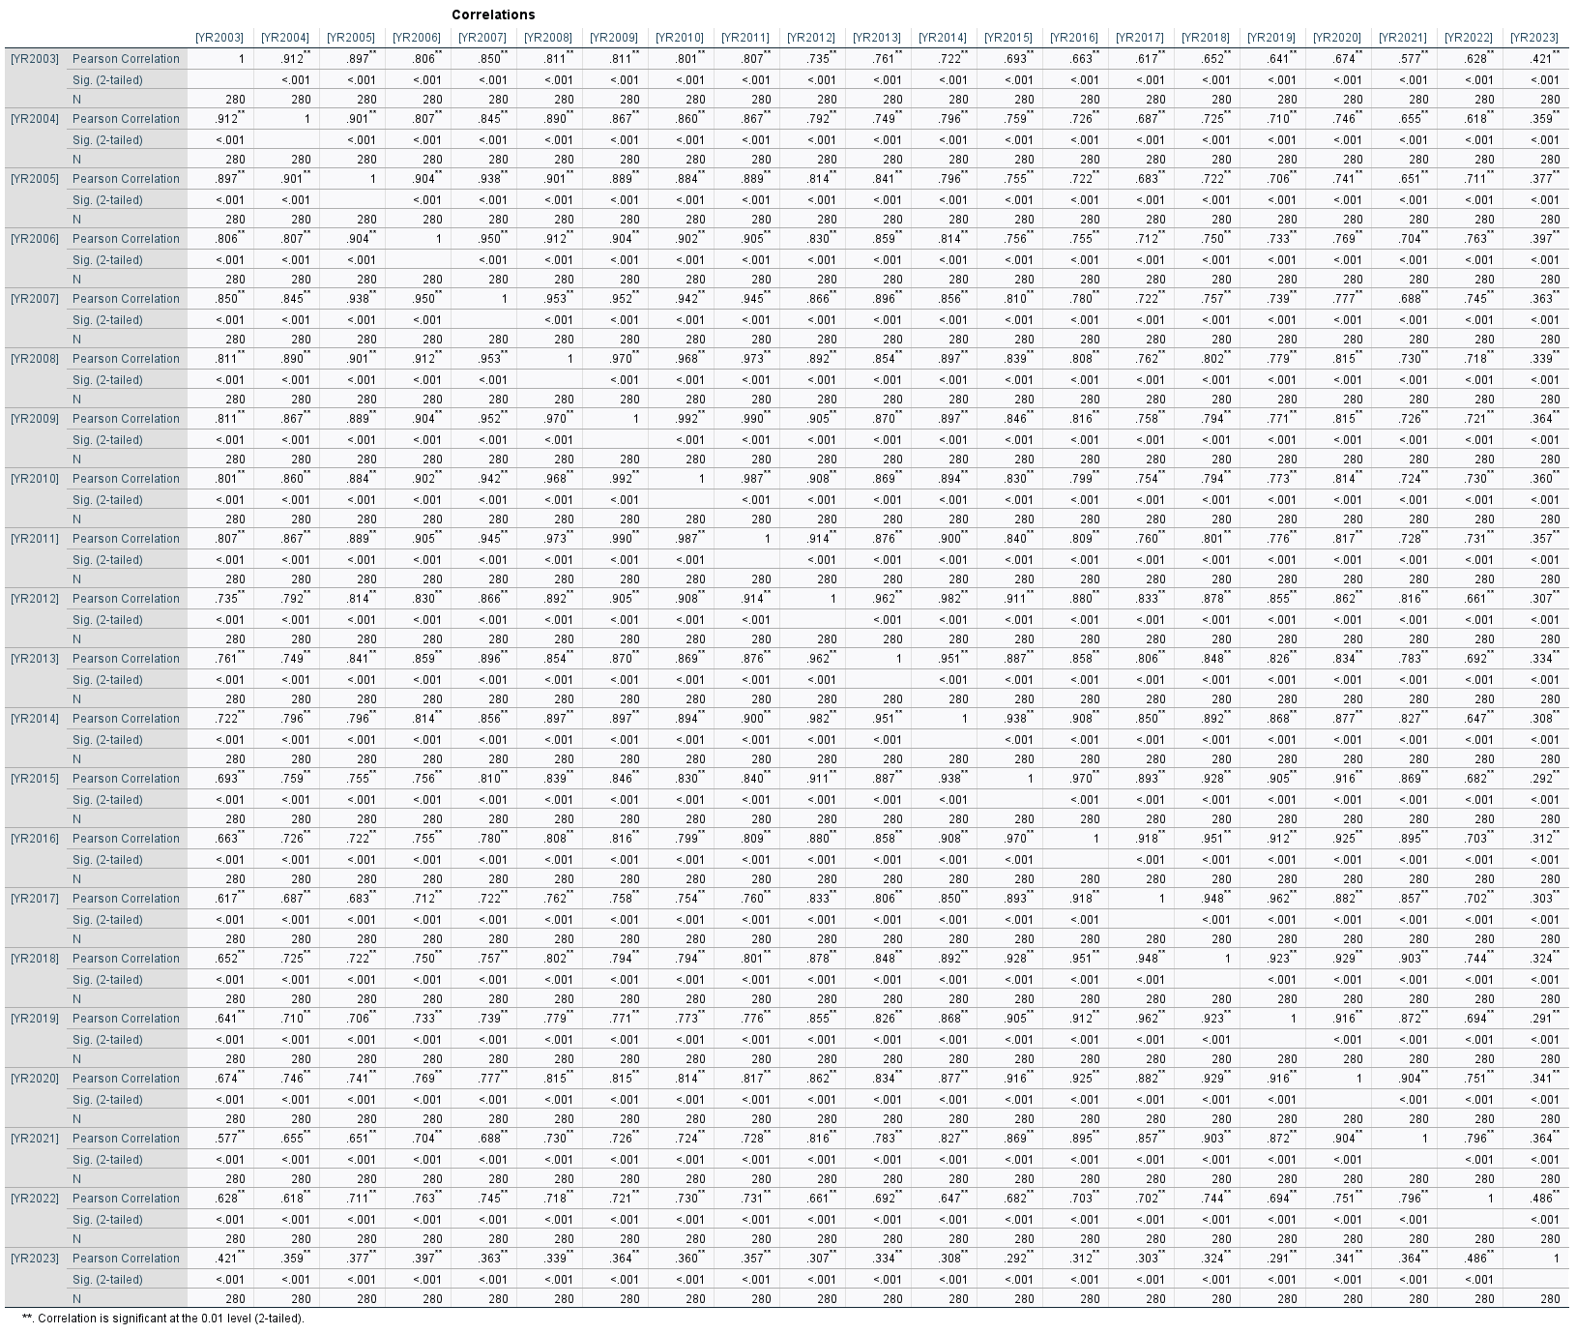

Casewise diagnostics
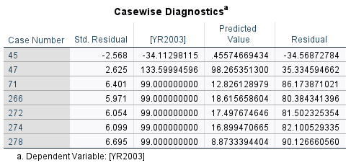
The table presents data associated with a dependent variable marked as [YR2003]. It enumerates cases (such as 45, 47) and their respective standardised residuals set at 2 SDs, predicted values, and residuals. Such data is commonly utilised to evaluate the accuracy of a statistical model and to pinpoint any outliers or instances where the model's predictions deviate markedly.

Formula for the Spearman’s rank correlation
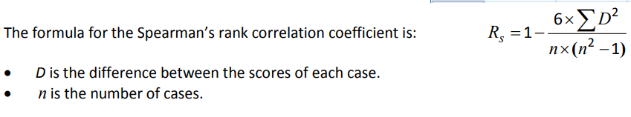
Rs = 1 – / 6 .(0.057)2 : 6.401 .((6.401)2 – 1)
= 1 – / 6 .(0.003249) : 6.401 .(40.972801 -1)
= 1 – / 0.019494 : 6.401 .(39.972801)
= 1 - / 0.019494 : 255.84797
= 1 - 0.0000762 = 0.999238
Based on our calculations and using 2 standard deviations, the Spearman's rank correlation coefficient is approximately 0.999238. Fortunately, considering all variables or standard deviations from 2003 to 2023 and using SPSS, the interpretation aligns with the explanation provided for Pearson's correlation coefficient on page 18.

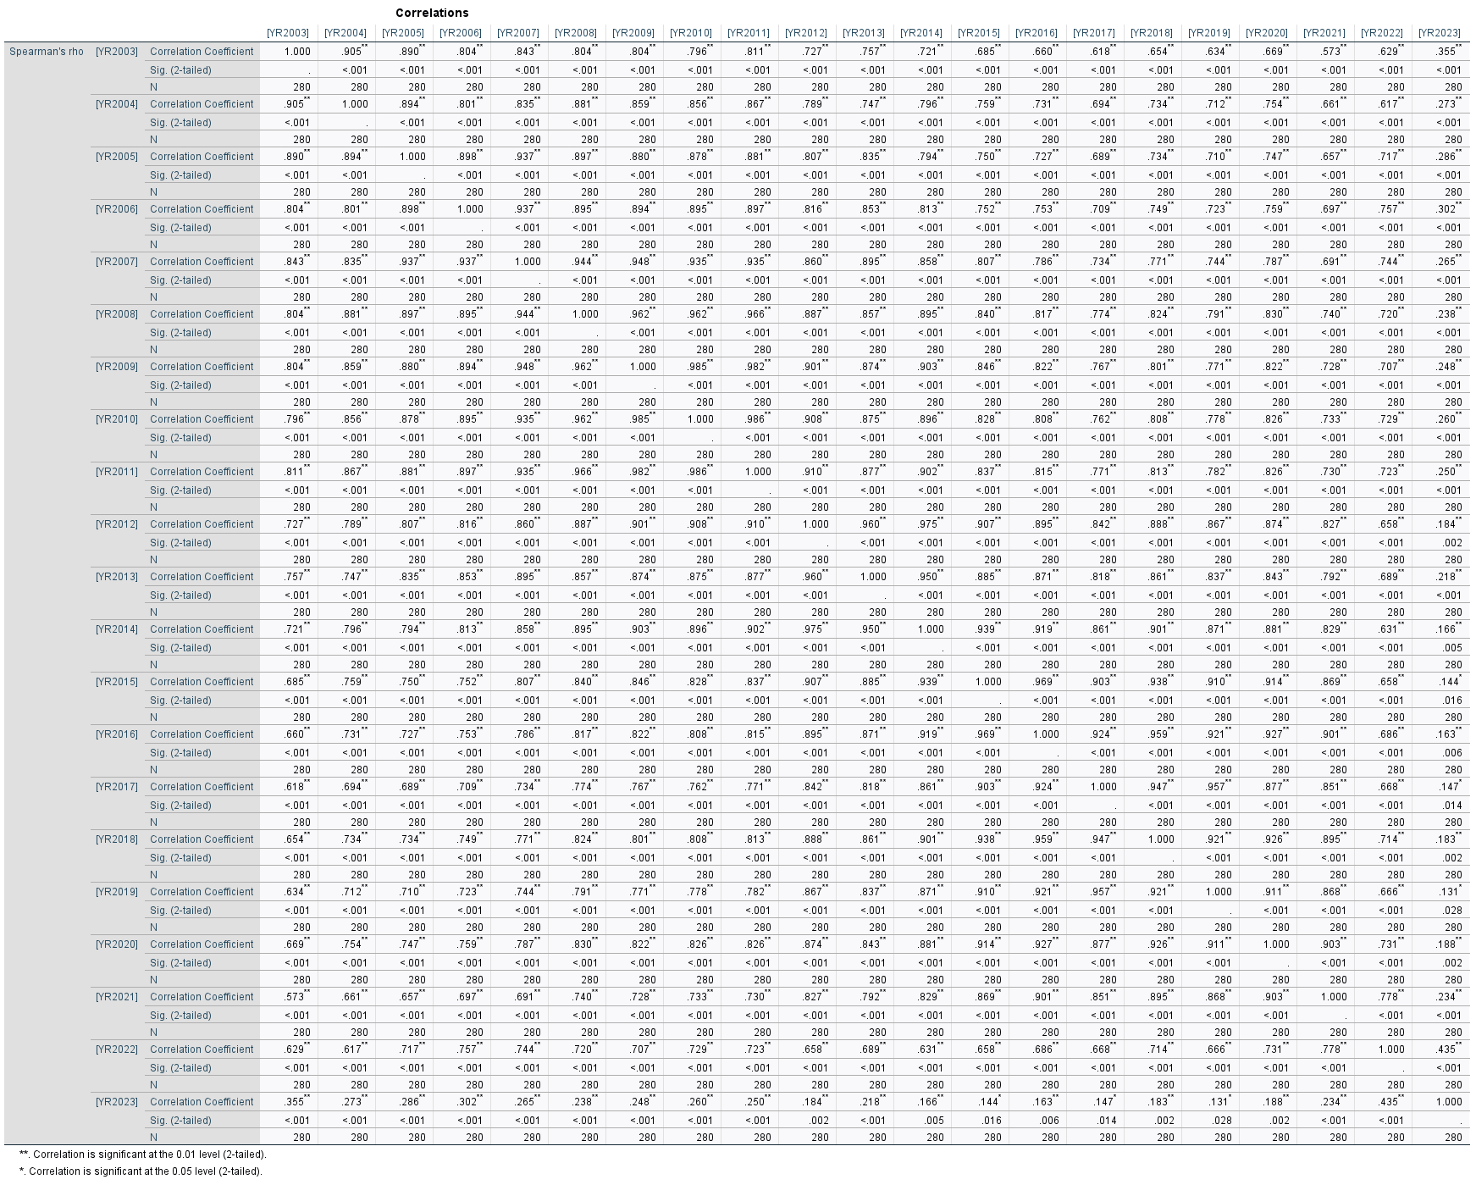
DATA INTERPRETATION – REGRESSION ANALYSIS

R Square
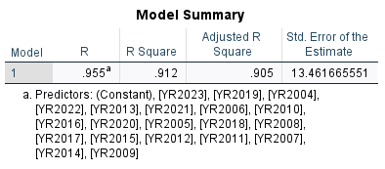
The provided table summarises a regression analysis, a statistical method to explore the relationship between a dependent variable and one or more independent variables. The R value of 0.955 is the correlation coefficient, reflecting the strength and direction of the linear relationship between the observed and predicted values. A value near 1 indicates a strong positive correlation. The value R Square of 0.912 signifies the percentage of variance in the dependent variable that can be predicted from the independent variables. Here, 91.2% of the variance is accounted for by the model. In other words, approximately 91.2% of the variation in the CFAF is explained by the variation in the 20 macroeconomic variables sub-mentioned. The remaining 8.8% can be increased by other variables that are not mentioned in this study.

Anova
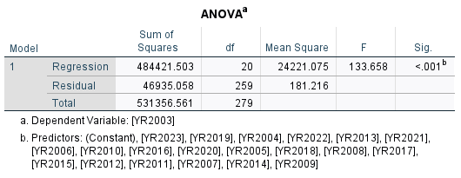
The table displays the outcome of an ANOVA test, which assesses if the means of three or more independent groups differ significantly. The model significantly elucidates the variance in the dependent variable (YR2003), evidenced by the high F-statistic and the extremely low p-value (< .001). The substantial Regression Sum of Squares relative to the Residual indicates a well-fitting model to the data. For a significant correlation, the Sig value must be 0.05 or lower. The ANOVA results show a Sig value of 0.01, which indicates a significant correlation.

Coefficients
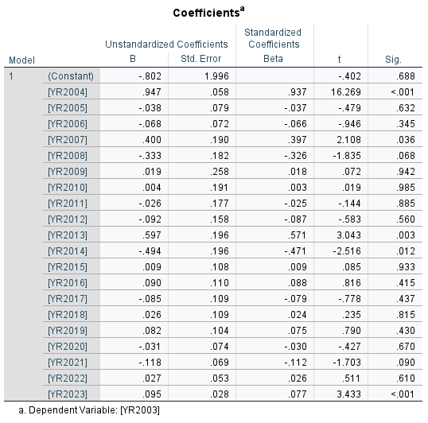
This table displays the results of a regression analysis, focusing on the coefficients for each year from 2004 to 2023. Sig., a value below 0.05 usually means the coefficient is statistically significant. In essence, the data for YR2023 presents a B value of 0.095, a t-statistic of 3.433, and a significance level below 0.001, suggesting that YR2023 significantly predicts YR2003.
According to the formula representing by y = a + bx
YR2003 = - 0.802 + 0.947.YR2004 + (-0.038). YR2005 + (-0.68). YR2006 + 0.4.YR2007 + (-0.333).YR2008 + 0.19.YR2009 + 0.04.YR2010 + (-0.026).YR2011 + (-0.092).YR2012 + 0.597.YR2013 + (-0.494).YR2014 + 0.09.YR2015 + 0.090.YR2016 + (-0.085).YR2017 + 0.026.YR2018 + 0.082.YR2019 + (-0.031).YR2020 + (-0.118).YR2021 + 0.027.YR2022 + 0.095.YR2023

CONCLUSION

Regarding the neo-colonial dimension of the currency, the study showed that beyond the borders that were inherited from colonisation, the CFAF represents a real transfer of economic formatting (Derbie, 2007) built on the idea of ​​exploiting the colonies according to the needs of the metropolis. The division of the zone with two separate central banks constantly refers to the structures that served the colonial empire. In addition, the acronym "CFA" which meant "French colony of Africa" ​​has been maintained. Even if it has lost its former definition, it remains that in everyone's imagination, this acronym helps to remind the countries that use the currency of their former position as a satellite of France. And as if that were not enough, foreign exchange reserves are kept in the French treasury, currencies are printed in Auvergne (in France) and France has a right of veto within the administration of the central banks of the FZ. All this contributes to reinforcing this neo-colonial perception maintained in the collective conscience.
Furthermore, the current study is primarily undertaken to prove our unique hypothesis: since its establishment and especially in recent times, the CFAF has not promoted economic growth of the FZ. The analysis of large quantitative data, highlighting 20 macroeconomic variations of every 14 members of the FZ, through SPSS showed that there is a high positive correlation between the CFAF and the economy of the FZ, making regression possible. A deep and structural regression analysis reveals that the CFAF as a currency has a negative impact on the economic development of the FZ. Therefore, it gives a clear affirmation answer to the hypothesis.

RECOMMANDATIONS

The problem of the CFAF is part of a global type of problem, insofar as it symbolises a certain interconnection between the local context of a problem and its repercussions at the global level. It invites us to take an interest in the management of public policies in the most remote areas of the globe because these can cause seismic shocks leading to global movements. This is evidenced by the consequences of maintaining the CFAF, despite obvious failures, which have had repercussions well beyond the borders of the countries that use the currency. Let think of the migration crisis that Europe is going through, and the problems related to poverty.
The management of these crises necessarily involves resolving issues such as that of the CFAF, which to exist requires public policies that limit credit to the economy, thus preventing job creation and ultimately negatively affecting economic development in the FZ.
Without wanting to propose the ultimate solution of leaving the CFAF, because I believe in the positive effects that a common currency could bring to economies in transition, I believe that the states that use this currency should begin deep restructuring. First and foremost, they must work to complete the efforts to Africanise the currency that began at independence. To achieve this goal, they should prioritise redefining France's status in Africa. They can achieve this goal by focusing on three axes (Le Monde Afrique, 2017): abolish France's right of veto, place control of foreign exchange reserves under the supervision of the two central banks of the zone and negotiate limited issuing power for central banks and launch a competitive call for tenders for money printing services.
Secondly, the latter should rethink the structure of monetary zones by prioritizing economic integration that would promote the optimality of the zones. This could be achieved by pooling together countries that share the same trade preferences and economic objectives. Finally, central banks should pursue objectives that best meet an African development perspective.

REFERENCES

Adjagbe, M. (2009), The underside of Operation Licorne in Côte d’Ivoire: for a new geopolitical reading of French interventions in Africa. Africa Development, 34(2)
Bamba, L. (2004), Analysis of the convergence process in the UEMOA zone (No. 2004/18), Research Paper, UNU-WIDER, United Nations University (UNU)
Bour, H. (1992). Maastricht and the theory of optimal currency zones, Revue française d'économie, 7(3), 3-27
Capron, M. (2009), From France-Africa to corporate social responsibility, The dynamics between firms, the State and social movements in France, United Nations Research Institute for Social Development, 3-4
Debrie, J. (2007). Geohistory of a technical layout: borders and networks in continental “French-speaking” West Africa. Flux, (4), 49-58.
Diallo, O. (2002). The anchoring of the CFA franc to the euro, Consequence for West African sub-regional integration (Doctoral dissertation, University of Geneva)
Emmanuel Moussone, "Market and investment potential of the countries of the Economic and Monetary Community of Central Africa (CEMAC)", Market and organizations 2011/2 (No.14), pp.33-56
France 24. (2017). Eliminating or renaming the CFA franc: Emmanuel Macron does not say "no". At https://www.france24.com/fr/20171129-afrique-franc-cfa-emmanuel-macron-changement-perimetre-nom
French Investment Council in Africa (2013), French companies unbeatable in Africa
Gnansounou, S. U., and Verdier-Chouchane, A. (2012), Real effective exchange rate misalignment: When will the CFA franc needs to be devalued again? African Development Bank.
Gulde, M. A. M., and Tsangarides, M. C. G. (2008), The CFA franc zone: common currency, uncommon challenges. International Monetary Fund
Guillaumont, P. and Jeanneney, S. G. (2013), Monetary cooperation agreements of the franc zone: assets and constraints. Clermont-Ferrand: Ferdi, Working Paper, (65)
Gounin, Y. (2009). France in Africa: The fight of the Ancients and the Moderns. Louvain-la-Neuve, Belgium: De Boeck Supérieur. doi:10.3917/dbu.gouni.2009.01.
Hugon, P. (1999), The franc zone in the time of the euro, KARTHALA Editions
Hugon, P. (2007), France’s economic policy in Africa, African policy, (1), 54-69
La Tribune Afrique. (2013). French companies reconquering Africa, At http://www.latribune.fr/actualites/economie/france/20131204trib000799270/les-entreprisesfrancaises-a-la-reconquete-de-l-afrique.html
Laurent Joye, T. (2014), Theory of monetary zones: critique of orthodoxy and prospects for redesign.
Mbemba, A. (2011). Fiscal Policy in Selected African Countries: The CFA Franc Zone. International Journal of Economics and Finance, 3(2), 101
Médard, J. F. (2002). “Politics is at the end of the network”. Questions on the Foccart method, The Notebooks of the Centre for Historical Research, Archives, (30)
Migani, G. (2012). Sékou Touré and the contestation of the colonial order in sub-Saharan Africa, 1958-1963. World(s), 2,(2), 257-273. doi:10.3917/mond.122.0257.
Musungaie, A. (2010). Monetary integration in Africa: particularities and economic rationality. Reflections and perspectives of economic life, volume xlix,(4), 83-92. doi:10.3917/rpve.494.0083.
Noirot, T. (2012), French companies in Africa, Plunder against transparency. Outre-Terre, (3), 537-546.
Nubukpo, K. K. (2007). The Effectiveness of Monetary Policy in Situations of Uncertainty and Extraversion: The Case of the West African Economic and Monetary Union (WAEMU). The European Journal of Development Research, 19(3), 480-495.
Nubukpo, K. (2013). Fifty Years of West African Monetary Union: What Have We Learned? Revue d'économie financière, 110,(2), 145-164. doi:10.3917/ecofi.110.0145.
Nubukpo, K. (2015). The CFA franc, a brake on the emergence of African economies? Political Economy, (4), 71-79.
Ondo Ossa, A. (2000), Monetary zone and exchange rate crisis: the case of the African franc zone. Cahiers du SISERA/Secretariat d'appui institutionnel pour la recherche économique en Afrique; 2000/1
Ott, A. C., and Vignolles, B. (2012), What is an optimal currency area? Crossed views on economics, (1), 31-32
Ramdé, M. (2004), The limits of international regional integration: the case of the Economic Community of West African States (ECOWAS).
Rist, C. (1938), History of the doctrines relating to credit and currency from John Law to the present day
Sall, A. K. (2016), The prospects for inflation targeting in the countries of the West African Economic and Monetary Union (WAEMU) (Doctoral dissertation, University of Orléans)
Smith, S., and Glaser, A. (2005), How France lost Africa. Calmann-Lévy
Tadenyo, Y. D. (2015), “Impact of BCEAO Interest Rate Shocks on Inflation Evolution in the WAEMU Zone: Implications for the Pursuit of a Price Stability Objective”, BCEAO. Economic and Monetary Review, (18)
Trinnou G. M, (2015). Charlemagne B. Igue. “Bank credit risk and monetary policy in the West African Economic and Monetary Union (WAEMU)”, BCEAO Economic and Monetary Review, (18)
Yao, S. P. (2011). The CFA Franc: A Colonial Currency that is Delaying Africa’s Development. European Review of Social Law, 145
ZHAO, Xiaodan and KIM, Yoonbai. Is the CFA Franc Zone an Optimum Currency Area? World Development, 2009, vol. 37, no. 12, pp. 1877-1886.

