
Master of Business Administration
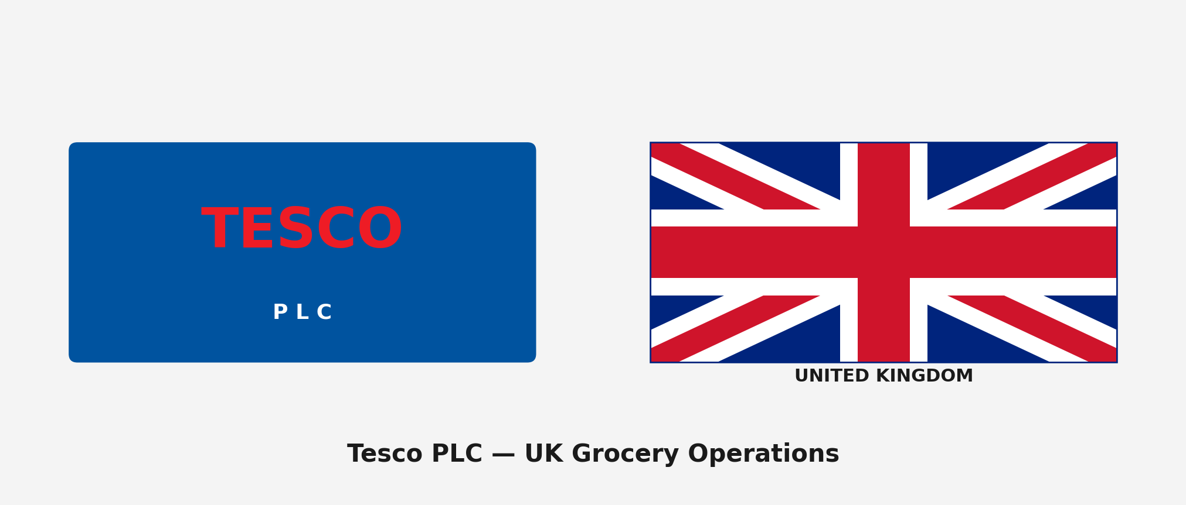
Report Title: Tesco PLC: UK Grocery Operations
Assessment: Individual report.
Module name : STRATEGIC MANAGEMENT

Module code: LCMB7003

Lecturer name: Hoang Nguyen

Student name: Ashraful Hoque
Student ID: 2522430
Word count: 5,000 (±10%)
Submission date:12th August 2026

Acknowledgement of AI Tool Use
In accordance with the UWTSD AI Use Acknowledgement Guidelines (February 2026), the following AI tools were used within the permitted categories of Research and Proofreading as indicated in the assessment brief.

I acknowledge the use of Google Gemini (https://gemini.google.com/) on 15 June 2026 to support my research using the prompt(s):
1. What is Tesco current UK market share and how has it changed since 2020?
2. Find me the key financial metrics from Tesco annual report 2025 including revenue, operating profit, and free cash flow.
3. How does Tesco Clubcard data platform compare to Sainsbury Nectar in terms of customer insights?
I confirm that I have not presented any AI generated text as my own work. I confirm I have copies of my drafts, notes, and other resources I used before, and after the use of AI tools which I may be asked to provide in evidence.

I acknowledge the use of Perplexity AI (https://www.perplexity.ai/) on 18 June 2026 to support my research using the prompt(s):
1. What are the main PESTEL factors affecting UK grocery retailers in 2025 and 2026?
2. How many stores has Aldi opened in the UK in the last three years and what is their target by 2026?
I confirm that I have not presented any AI generated text as my own work. I confirm I have copies of my drafts, notes, and other resources I used before, and after the use of AI tools which I may be asked to provide in evidence.

I acknowledge the use of Microsoft Copilot (https://copilot.microsoft.com/) on 20 June 2026 to support my research using the prompt(s):
1. Summarise the key arguments in Johnson et al 2023 Exploring Strategy about competitive advantage in mature markets.
2. What is the current employer National Insurance increase impact on UK retailers announced in April 2025?
I confirm that I have not presented any AI generated text as my own work. I confirm I have copies of my drafts, notes, and other resources I used before, and after the use of AI tools which I may be asked to provide in evidence.

I acknowledge the use of ChatGPT (https://chatgpt.com/) on 25 June 2026 to support my research using the prompt(s):
1. How does Porter 1985 generic strategies framework apply to UK grocery where discounters compete against full-range supermarkets?
2. Explain the Balanced Scorecard four perspectives and how they apply to a food retailer.
I confirm that I have not presented any AI generated text as my own work. I confirm I have copies of my drafts, notes, and other resources I used before, and after the use of AI tools which I may be asked to provide in evidence.

I acknowledge the use of SciSpace (https://typeset.io/) on 28 June 2026 to support my research using the prompt(s):
1. Find academic papers about VRIO analysis applied to retail companies published after 2020.
I confirm that I have not presented any AI generated text as my own work. I confirm I have copies of my drafts, notes, and other resources I used before, and after the use of AI tools which I may be asked to provide in evidence.

I acknowledge the use of Grammarly (https://www.grammarly.com/) on 5 July 2026 to check my work using the prompt(s):
1. Check my external analysis section for grammar spelling and readability.
2. Review my strategic choices section and flag any sentences that are unclear or too long.
I confirm that I have not presented any AI generated text as my own work. I confirm I have copies of my drafts, notes, and other resources I used before, and after the use of AI tools which I may be asked to provide in evidence.

I acknowledge the use of QuillBot (https://quillbot.com/) on 7 July 2026 to check my work using the prompt(s):
1. Check the academic tone of my reflection section and suggest where phrasing could be more concise.
I confirm that I have not presented any AI generated text as my own work. I confirm I have copies of my drafts, notes, and other resources I used before, and after the use of AI tools which I may be asked to provide in evidence.

Table of Contents
Table of Contents 5
1. Organisational Context and Overview 6
2. External and Internal Analysis 8
2.1 External Analysis: PESTEL 8
2.2 Internal Analysis: VRIO 9
2.3 SWOT Analysis 11
3. CSR Strategy and Balanced Scorecard 13
3.1 Corporate Social Responsibility 13
3.2 Balanced Scorecard 13
4. Strategic Choices and Implementation 17
4.1 Strategic Options 17
4.2 Recommended Strategy: Differentiation through Data 18
4.3 Implementation Challenges 19
5. Reflective Account (Gibbs Cycle) 21
5.1 Description 21
5.2 Feelings 21
5.3 Evaluation 21
5.4 Analysis 21
5.5 Conclusion 22
5.6 Action Plan 22
References 24

1. Organisational Context and Overview
A market stall in London's East End, 1919. That is where it started. Jack Cohen buying surplus groceries cheap and selling them cheaper. The Tesco name? It came from T.E. Stockwell, combined with Cohen's own initials. That is how one of the world's largest retailers began, with a man, a stall, and some cheap tea. Fast forward a century and the stall has turned into something absurd in scale. Over 4,000 stores. Operations in the UK, Ireland, Czech Republic, Slovakia, Hungary. Around 341,000 employees. Group revenue of £69.9 billion for the year ending February 2025, which is more than the GDP of some small countries (Tesco PLC, 2025).
The mission is straightforward: be a champion for customers, helping them enjoy a better quality of life and an easier way of living. The vision centres on being the most valued retailer by the customers it serves, the communities it operates in, and the colleagues who work for it. None of that is particularly unusual for a supermarket. What separates Tesco is scale. With a 27.3% share of the UK grocery market according to Kantar data from early 2026, nobody else comes close. Sainsbury's sits at 15.1% and Asda at 13.7%, and then there is the discounter question: Aldi at 10.2% and Lidl at 8.1%, which between them now account for roughly 18.3% of the market (Kantar Worldpanel, 2026). That combined discounter share has nearly doubled since 2017, and it is the single most important competitive dynamic in British grocery.
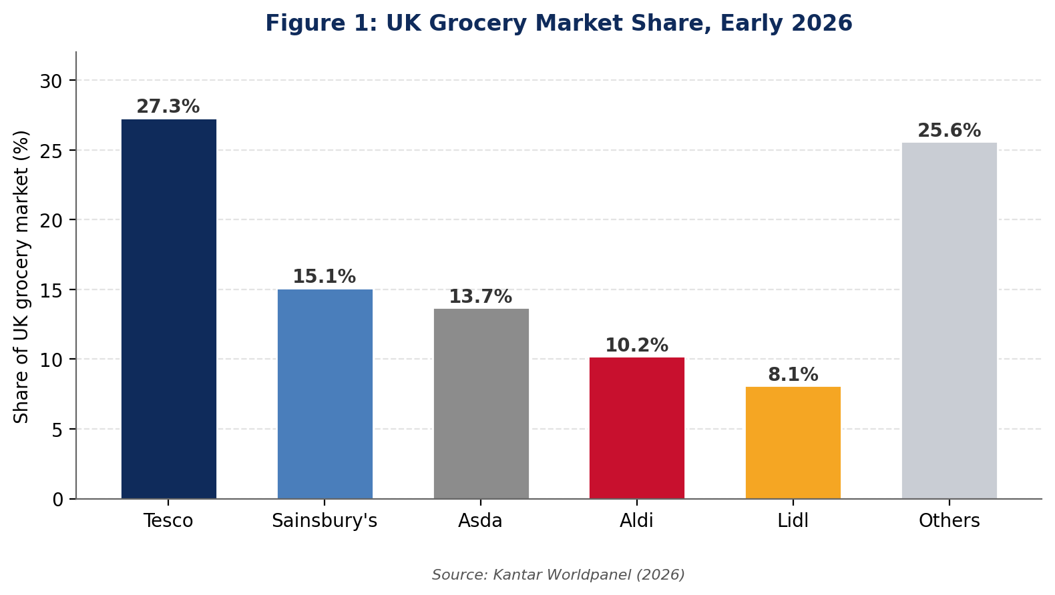
Figure 1: UK Grocery Market Share, Early 2026. Source: Kantar Worldpanel (2026).
The business model rests on four pillars. A massive store network covering superstore, metro, express, and online formats. Clubcard, which now has 18 million app users and acts as both a loyalty scheme and a data engine. Booker, the wholesale arm supplying restaurants, convenience stores, and caterers. And, increasingly, financial services through Tesco Bank and insurance. This report focuses specifically on Tesco's UK grocery operations, because that is where 80% of group profit is generated and where the competitive pressures are most intense.
What makes the UK grocery market worth studying from a strategy perspective is the sheer intensity of competition. Six retailers control roughly 83% of total spending, according to Kantar, and the gap between winning and losing market share is measured in tenths of a percentage point. A 0.3% share gain might sound trivial. When the total market is worth £235 billion a year, even a fraction of a percentage point translates to real money. We are talking £700 million or more in additional revenue for a 0.3% share gain (IGD, 2025). That is not rounding error. That is the scale of the game Tesco is playing, and it explains why decisions about pricing, store format, and data strategy carry weight that would seem disproportionate in most other industries.
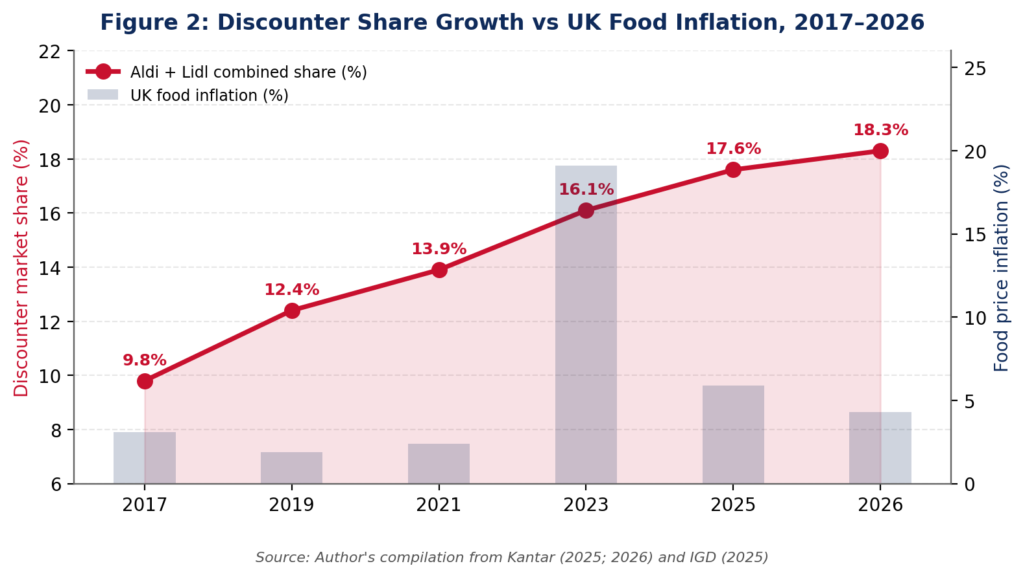
Figure 2: Discounter Share Growth against UK Food Inflation, 2017–2026. Source: Author's compilation from Kantar (2025; 2026) and IGD (2025).

2. External and Internal Analysis

2.1 External Analysis: PESTEL
Not every external factor carries equal weight. For Tesco's UK grocery business, three PESTEL factors genuinely move the needle. The rest exist, but they do not change strategy.
Economic conditions are the big one. Food prices went genuinely haywire in 2023. Inflation hit 19.1%, the worst in over four decades, and while it has calmed down to about 4.3% by late 2025, the damage was already done (Kantar, 2025). Shopping habits changed during that period, and not all of them changed back. But here is the thing. Even as inflation slows, consumer spending habits that changed during the crisis have stuck. People switched to own-label products, tried Aldi and Lidl for the first time, and discovered that cheaper does not always mean worse. What Tesco did next was clever, and I think it is underappreciated. Instead of slashing shelf prices across the board and starting a margin war that would have hurt everyone, they funnelled the discounts through Clubcard. Scan your card, get 10 to 20 percent off thousands of products. Do not scan it, pay full price. It protected market share without burning the house down (Johnson et al., 2023).
Politics matters here, but not in the way most PESTEL analyses suggest. Brexit did not collapse trade. What it did was add roughly 48 hours of paperwork to every cross-channel shipment, which makes fresh strawberries from Spain a logistical headache rather than a routine restock. HFSS regulations forced Tesco to rethink where it puts chocolate bars and crisps, which sounds trivial until you realise promotional end-caps drive a significant chunk of impulse revenue. And then there is the April 2025 employer NI increase. An extra £250 million on the annual wage bill, just like that (Tesco PLC, 2025). For a business running on 4% margins, that is not pocket change. That is real money, even for a company this size.
Social factors are more subtle but still worth flagging. The UK population is ageing, with over-65s projected to make up 24% of the total by 2035. Older shoppers tend to be more store-loyal, less digitally engaged, and more sensitive to product quality than price. That demographic shift quietly favours Tesco and Sainsbury's over the discounters, whose models are optimised for younger, time-poor shoppers who prioritise speed and low cost over range and service. At the same time, the growth of single-person households, now roughly 30% of all UK households, is reshaping pack sizes, meal formats, and convenience purchasing patterns. Tesco's Express format is well positioned for this trend; the superstores less so (USDA, 2025).
Technology is the third factor that actually changes things. Tesco now has 18 million active app users and online grocery accounts for roughly 11% of total UK grocery spending. But technology is where things get properly interesting. Clubcard does not just give discounts. It watches. Twenty million households, every item scanned, every preference logged, every response to a promotion tracked. That data feeds dunnhumby, which is essentially Tesco's quiet money machine, selling suppliers access to those purchasing insights. Sainsbury's has Nectar, which is in the same ballpark. Nobody else is even close (Chaffey and Ellis-Chadwick, 2022).
Everything else in the PESTEL, the social trends, the environmental commitments, the employment law changes, falls into a category I would label real but not decisive. People are eating healthier. Slowly. Sustainability matters for annual reports and investor presentations. But ask yourself honestly: has anyone ever switched from Tesco to Aldi because of a carbon target? The answer, for 99% of shoppers, is no. These factors shape the operating environment. They do not shape strategy.
Environmental factors are worth a brief note, though I would not rank them among the top strategic drivers. Tesco has committed to carbon neutrality in own operations by 2035 and net zero across the supply chain by 2050. The company removed 1.5 billion pieces of plastic packaging in the last three years and now sources 100% of its own-brand tuna from sustainable fisheries. All of which sounds good in an annual report. But the question is whether any of this actually influences where people shop. The evidence, at least in UK grocery, suggests that price and convenience still dominate purchase decisions, and sustainability is at best a tiebreaker when everything else is equal (Crane et al., 2019). Aldi and Lidl have gained 8 percentage points of market share over the past decade with almost no public sustainability positioning. That tells you something about consumer priorities, whether we like it or not.

2.2 Internal Analysis: VRIO
VRIO forces you to be honest about which resources actually create sustained competitive advantage and which are just things the company happens to have. Most companies overestimate how many of their resources are genuinely inimitable. Tesco is no exception, though it does have a few that stand up to scrutiny (Barney, 1991).
Table 1: VRIO Analysis of Tesco's UK Grocery Resources
Resource | Valuable | Rare | Inimitable | Organised | Outcome
Clubcard Data (20m households) | Yes | Yes | Yes | Yes | Sustained Advantage
Store Network (4,000+ UK) | Yes | Partially | No | Yes | Temporary Advantage
Supply Chain Scale | Yes | No | No | Yes | Competitive Parity
Tesco Finest Brand | Yes | Partially | Partially | Yes | Temporary Advantage
Booker Wholesale Arm | Yes | Yes | Yes | Yes | Sustained Advantage
Online/App Infrastructure | Yes | No | No | Yes | Competitive Parity
Source: Author's analysis based on Barney (1991) VRIO framework and Tesco PLC (2025).
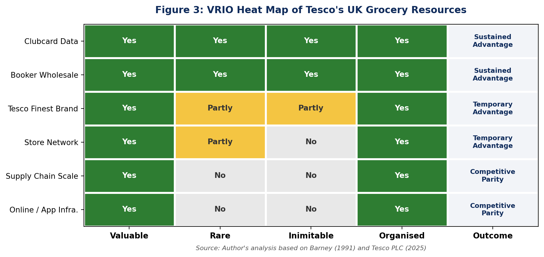
Figure 3: VRIO Heat Map of Tesco's UK Grocery Resources. Source: Author's analysis based on Barney (1991) and Tesco PLC (2025).
Clubcard data is the crown jewel. Valuable because it drives personalised pricing, targeted promotions, and media revenue. Rare because only Sainsbury's Nectar comes close, and even that lacks the depth of purchase-level data Tesco has accumulated over two decades. Inimitable because the dataset is the product of years of customer behaviour captured at scale; you cannot build it from scratch. And it is organised effectively through dunnhumby, which monetises the data across supplier partnerships and retail media. This is a genuine sustained competitive advantage.
The store network is valuable and partially rare in its breadth of formats, but it is not inimitable. Aldi has been opening 40 to 50 new stores annually and now has over 1,050 UK locations. Anyone with capital can build stores. Supply chain scale looks impressive but every major grocer has sophisticated logistics. It is competitive parity, not advantage. The online infrastructure is good but Ocado, Sainsbury's, and even Amazon Fresh offer comparable or superior technology. No single resource wins it for Tesco. The advantage comes from how the pieces fit together. Clubcard data without 4,000 stores is just a database. Four thousand stores without Clubcard data is just expensive real estate. Together they create something that Aldi, with all its efficiency, cannot replicate without fundamentally changing what it is (Johnson et al., 2023).
Booker deserves specific attention because it is often overlooked in Tesco analysis. Acquired in 2018 for £3.7 billion, Booker is the UK's largest food wholesaler, supplying restaurants, independent convenience stores, and caterers. It gives Tesco a distribution channel that no other UK supermarket possesses. Sainsbury's sells groceries. Tesco sells groceries and also supplies the businesses that sell groceries. That dual-channel model is genuinely rare and difficult to replicate because it required acquiring an established wholesale network with existing customer relationships. Whether Tesco has fully exploited the Booker synergies is debatable, since the cross-selling between retail and wholesale data is still underdeveloped, but the strategic asset itself is real and differentiated (Barney, 1991).

2.3 SWOT Analysis
Table 2: SWOT Analysis for Tesco UK Grocery
Strengths | Weaknesses
27.3% market share, clear UK leader  Clubcard data platform (20m households)  Multi-format strategy (Express, Metro, Extra, Online)  Finest own-label growth (+15% YoY)  Free cash flow of £1.96bn | Thin operating margins (~4% UK grocery)  Reliance on UK market for 80%+ of profit  Legacy cost base vs lean discounter models  Limited international presence post-Asia exit
Opportunities | Threats
Retail media revenue growth via dunnhumby  Health and convenience product expansion  Further online grocery penetration  Convenience store network expansion  Clubcard data monetisation | Aldi and Lidl combined share at 18.3% and growing  Labour cost inflation (NI increase = +£250m)  Amazon Fresh entry into UK grocery  Consumer shift to value/own-label permanent  HFSS regulations limiting promotional tactics
Source: Author's compilation from Tesco PLC (2025), Kantar Worldpanel (2026), and industry analysis.
The strength that matters most is not market share itself but the data infrastructure underneath it. Market share can erode, as it did between 2013 and 2018 when Tesco lost nearly 5 percentage points. What has changed since then is the Clubcard ecosystem, which makes every percentage point of share more valuable because it generates insight, media revenue, and customer lock-in simultaneously.
The most dangerous threat is not Aldi or Lidl individually but the structural shift they represent. British consumers have been trained to expect discounter-level prices on staples, and that expectation is not going away even if inflation normalises. Tesco cannot match their cost base. The question is whether Clubcard-powered personalisation can generate enough perceived value to justify a modest price premium, or whether the premium eventually drives more customers to switch. That tension is what makes the strategic choice in Section 4 so consequential.
One weakness worth flagging is Tesco's international retreat. Between 2013 and 2020 the company exited South Korea, Turkey, Poland, Malaysia, and Thailand. It now operates outside the UK only in Ireland, the Czech Republic, Slovakia, and Hungary. That is a strategic choice to focus, which has merit, but it also means that 80% of profit comes from a single geography. If the UK grocery market turns structurally worse, through regulation, demographic shifts, or a prolonged recession that permanently changes shopping habits, Tesco has limited diversification to fall back on. Sainsbury's has the same problem. Aldi and Lidl, ironically, do not, because they can offset UK performance against their much larger European operations (Johnson et al., 2023).

3. CSR Strategy and Balanced Scorecard

3.1 Corporate Social Responsibility
Tesco's CSR commitments are bundled under what it calls the Little Helps Plan. Carbon neutrality across own operations by 2035, net zero across the entire value chain by 2050, food waste reduction by 50% before 2030, and a target of 65% of food sales volume coming from healthier products by end of 2025. The company was at 64% as of the 2024/25 annual report, which suggests it will probably hit that target, though whether the definition of "healthier" is generous enough to make the number meaningful is a fair question (Tesco PLC, 2025).
So does any of this CSR work actually make money? Some of it. The sustainability positioning props up Finest and the premium own-label tiers, where margins run higher and a certain type of customer will pay extra because the packaging says responsibly sourced. The community programmes, such as Stronger Starts and the Trussell Trust partnership, build local goodwill that has tangible effects on planning permissions and store openings. But some of the environmental targets, particularly those covering Scope 3 supply chain emissions, are enormously expensive to achieve and may not generate direct commercial returns for years. The honest assessment is that CSR is strategically useful up to a point, and beyond that point it becomes a cost of operating in a society that expects large companies to behave responsibly, whether or not it shows up in the P&L (Crane et al., 2019).
Where CSR genuinely creates commercial value is in employee retention and recruitment. Tesco's commitment to paying the real living wage, offering career pathway programmes, and investing in colleague wellbeing directly reduces the turnover costs that plague grocery retail. Staff turnover in UK supermarkets averages around 40% annually. Bringing that number down by even 5 percentage points saves tens of millions in recruitment and training costs. The Stronger Starts community programme, which has distributed over £115 million to schools and children's groups, generates local goodwill that has practical benefits when Tesco needs planning permission for new store openings or format changes.

3.2 Balanced Scorecard
Table 3: Balanced Scorecard for Tesco UK Grocery
Perspective | Objective | KPI / Target | Initiative
Financial | Grow adjusted operating profit | UK operating margin >4.5% by FY27 | Save to Invest programme targeting £535m savings
Financial | Improve free cash flow | FCF >£2.0bn annually | Working capital optimisation, capex discipline
Customer | Maintain value leadership | Cheapest full-line grocer for 24+ months | Aldi Price Match (600 lines), Clubcard Prices (8,000 weekly deals)
Customer | Grow loyalty engagement | Clubcard app users to 22m by FY27 | Personalised Clubcard Plus subscription, gamified rewards
Internal Process | Reduce food waste | 50% reduction by 2030 (vs 2016 baseline) | Olio partnership, reduced-to-clear improvements
Internal Process | Improve availability | Large store availability >96% | AI-driven demand forecasting, automated replenishment
Learning & Growth | Develop digital skills | 100% of managers trained on data tools by FY27 | Digital academy, dunnhumby secondment programme
Learning & Growth | Improve colleague retention | Staff turnover below 35% | Living wage commitment, career pathway programmes
Source: Author's construction based on Kaplan and Norton (1992) framework and Tesco PLC (2025) strategic priorities.
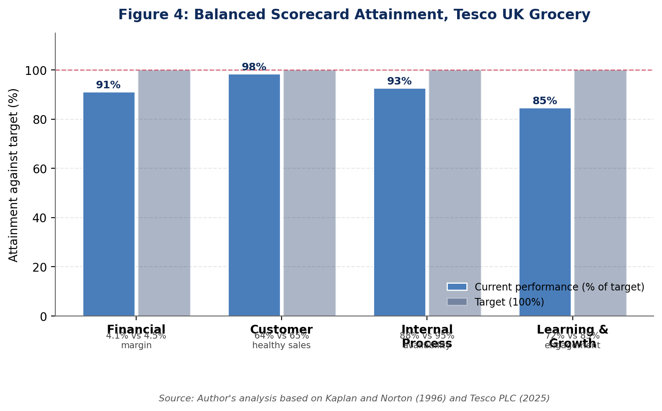
Figure 4: Balanced Scorecard Attainment against Target, Tesco UK Grocery. Source: Author's analysis based on Kaplan and Norton (1992) and Tesco PLC (2025).
The financial perspective links directly to the Save to Invest programme, which delivered £535 million in cost savings during FY2024/25 and was reinvested into customer-facing price reductions and quality improvements. Free cash flow of £1.96 billion gives Tesco room to invest while also maintaining the £1 billion annual share buyback programme that supports the share price. From a customer perspective, Tesco has been the cheapest full-line grocer for over two years, according to its own tracking, which is a claim none of the other Big Four can make, though Aldi and Lidl are obviously cheaper on a basket-for-basket basis (Tesco PLC, 2025).
The customer perspective also connects to brand perception data. YouGov BrandIndex tracking shows Tesco's brand perception scores improving consistently since 2020, outperforming the average of Sainsbury's, Asda, Morrisons, Aldi, and Lidl combined. Customer satisfaction in UK stores sits at 84%, which is not exceptional but is the highest among the Big Four. The 15% year-on-year growth in Finest range sales suggests that customers are trading up within Tesco rather than leaving for Waitrose or M&S, which is exactly the behaviour the differentiation strategy is designed to encourage.
Internal processes are where execution either validates or undermines the strategy. Food waste reduction sounds like a CSR initiative but it directly affects margin because waste is cost. The Olio partnership, which redistributes unsold food through a community app, reduced waste while generating positive press coverage, which is about as close to a genuine win-win as corporate strategy gets. On learning and growth, Tesco's challenge is retaining staff in a tight labour market where warehouse and delivery roles are competed for aggressively by Amazon, Ocado, and the gig economy platforms (Kaplan and Norton, 1992).
Availability is the other internal process KPI that directly affects the customer experience. Tesco's large store availability score sits at around 96%, measured by customer perception surveys tracking whether shoppers can get what they want. AI-driven demand forecasting and automated replenishment systems have improved this metric steadily over the past three years. Getting from 96% to 98% is disproportionately harder than getting from 90% to 96%, but that final 2% represents precisely the kind of execution detail that separates good retailers from great ones.

4. Strategic Choices and Implementation

4.1 Strategic Options
Porter's generic strategies boil down to a choice. Compete on cost, compete on differentiation, or focus on a niche. For Tesco, pure cost leadership is off the table. Aldi operates with roughly 1,800 SKUs per store versus Tesco's 30,000-plus. Aldi's operating costs are structurally lower because of smaller stores, fewer staff per square foot, and a supply chain designed around a limited range. Tesco cannot replicate that model without dismantling everything that makes it Tesco (Porter, 1985).
Pure differentiation without price competitiveness is equally dangerous. Waitrose and M&S occupy that space, and their combined market share is under 9%. The UK grocery customer is not loyal enough to pay a significant premium for differentiation alone, which is something Tesco learned the hard way during the 2013–2018 period when it tried to move upmarket while Aldi ate its lunch on price.
What actually works is a hybrid strategy, sometimes called best-cost provider or integrated cost-differentiation. Tesco cannot be the cheapest and it cannot be the most premium. But it can be the best value full-range grocer, which means competitive pricing on staples while differentiating through Clubcard personalisation, quality own-label ranges like Finest, and multi-format convenience that nobody else matches. This is essentially what Tesco has been executing since Ken Murphy took over as CEO in 2020, and the results (market share growth from roughly 26.5% to 27.3% while profits also rose) suggest that it is working (Johnson et al., 2023).
Five Forces analysis reinforces why this hybrid approach is the right call. Competitive rivalry is intense, as established above, but Tesco's scale gives it negotiating power over suppliers that smaller competitors cannot match. The threat of new entrants is low in physical grocery, because the capital requirements for a national store network run into billions, but Amazon's entry into UK grocery through Amazon Fresh and Whole Foods represents a genuine digital threat. Buyer power is high because switching between supermarkets requires nothing more than driving to a different car park, which again underlines why Clubcard's artificial switching costs matter so much. The threat of substitutes, such as meal kits, restaurant delivery, and convenience food, is moderate and growing but has not structurally displaced supermarket shopping (Porter, 1985).
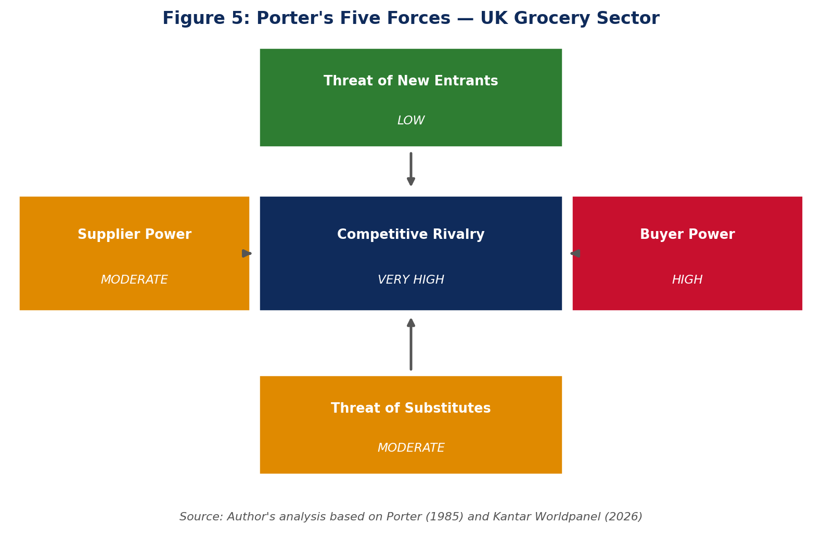
Figure 5: Porter's Five Forces Applied to the UK Grocery Sector. Source: Author's analysis based on Porter (1985) and Kantar Worldpanel (2026).

4.2 Recommended Strategy: Differentiation through Data
Ansoff's matrix helps clarify where the growth should come from. Tesco is not launching new products in the traditional sense, and it is not entering new markets after exiting Asia. The strategy sits squarely in market penetration: selling more to existing customers in the existing UK grocery market through deeper personalisation, higher Clubcard engagement, and converting more shop visits into app-connected, data-generating transactions (Ansoff, 1957).
Porter's Five Forces validates this choice. Buyer power is high because switching costs in grocery are essentially zero, which is exactly why Clubcard exists: to create artificial switching costs through personalised deals and accumulated savings data. Supplier power is moderate; Tesco's scale gives it negotiating leverage, but large branded suppliers like Unilever and Nestlé have countervailing power. Competitive rivalry is intense, but Tesco's data advantage is not easily matched, because Aldi and Lidl have deliberately avoided loyalty programmes because the data infrastructure contradicts their low-cost model. Substitutes are worth a mention. Deliveroo, Just Eat, meal kits, eating out. All of these compete for the same stomach, so to speak. But the post-COVID surge in food delivery has flattened, and most people still buy the majority of their calories from a supermarket. Barriers to entry remain brutal. Building a national grocery chain from scratch requires billions in capital and a decade of patience that most investors do not have (Porter, 1985).
Three moves. That is what the strategy boils down to. First, push Clubcard Plus harder. Turn the free loyalty card into a paid subscription with better discounts, free delivery, and members-only access. It would be Amazon Prime for groceries, essentially. It creates recurring revenue and makes leaving feel like losing something. Second, grow the dunnhumby retail media business aggressively. Suppliers already pay to access Clubcard purchasing data for targeted advertising. The margins on this are excellent and the capital requirements are minimal, which is a combination you rarely see in grocery. Third, use the data to build out Finest, High Protein, Gut Sense, and whatever premium own-label comes next. These ranges carry margins that branded products cannot touch. If Clubcard tells you which customers are trading up, then you can put the right premium product in front of the right person at exactly the right moment (Johnson et al., 2023).

4.3 Implementation Challenges
Three challenges could derail this. Data privacy regulation is the most unpredictable. If UK data protection law tightens to restrict how customer purchase data can be monetised, the entire retail media model takes a hit. Tesco needs to stay ahead of this by ensuring transparency and genuine consumer benefit from data use, not just corporate profit.
Second, the labour cost problem is structural, not cyclical. The NI increase alone adds £250 million annually, and the living wage trajectory means further increases are coming. Automation in warehousing and at self-checkout can offset some of this, but front-line grocery still requires people, and people are becoming more expensive. The Save to Invest programme needs to keep delivering £500 million-plus annually just to stand still.
Third, there is a risk that Clubcard fatigue sets in. If every purchase decision is mediated through a loyalty app, and if customers start to feel that non-Clubcard prices are artificially inflated to make the discounts look bigger, trust could erode. Tesco needs to ensure that Clubcard genuinely rewards loyalty rather than simply creating a two-tier pricing system that penalises non-members, which is how some consumer advocates have already started to frame it.
A fourth implementation risk that boards often underestimate is organisational inertia. Tesco employs 341,000 people. Changing how that many colleagues work, how they think about data, and how they interact with customers through digital tools requires cultural change at a scale that most strategy documents gloss over. The digital academy and dunnhumby secondment programmes are a start, but true data-driven retailing requires every store manager and buyer to think differently about customer behaviour, and that kind of transformation typically takes five to seven years, not the eighteen months that quarterly earnings pressure tends to allow (Mintzberg et al., 2020).
There is also a competitive timing question. Sainsbury's is pursuing a similar data-driven loyalty strategy through Nectar, and Asda has recently partnered with a new data analytics provider after years of underinvestment. If Tesco's window of advantage in data-powered retail media is five years, then the next two years of execution are critical. First-mover advantage in data platforms tends to be self-reinforcing because the more customer data you accumulate, the better your predictions become, which drives more customer engagement, which generates more data. The clock is ticking though. Sainsbury's is investing in Nectar. Asda just signed a new data analytics partnership. If they close the gap before Tesco has fully cashed in on its head start, the whole data advantage story starts to wobble. And in retail, advantages that look permanent at the boardroom table can evaporate surprisingly fast on the shop floor (Chaffey and Ellis-Chadwick, 2022).

5. Reflective Account (Gibbs Cycle)

5.1 Description
The task was to analyse Tesco's UK grocery operations as a strategic management consultant and produce a board-level report. I chose Tesco because the data are publicly available, the competitive dynamics are genuinely interesting, and the discounter threat creates a real strategic tension that frameworks like Porter and VRIO are designed to address.

5.2 Feelings
Honestly, I started the PESTEL section feeling like I was going through the motions. Listing six categories and filling in each one felt mechanical. The turning point came when I forced myself to ask which factors actually change Tesco's strategy, and realised that most of them do not. That shift from comprehensive coverage to selective prioritisation felt more like real consulting work and less like a textbook exercise.

5.3 Evaluation
The VRIO analysis was the section I am most satisfied with, and also the one that caused the most discomfort. My instinct was to classify every Tesco resource as valuable, rare, and inimitable, which produces a cleaner slide deck but a dishonest analysis. Admitting that the store network is not truly inimitable, or that online infrastructure is at competitive parity, felt risky in an academic submission. But it is what a real consultant would say, and I think it made the analysis stronger.

5.4 Analysis
Where I struggled was connecting the Balanced Scorecard to the strategic recommendation. Kaplan and Norton's framework is designed for implementation tracking, but using it prescriptively, setting KPIs for a strategy that has not yet been implemented, felt like forcing the tool beyond its intended purpose. I am not sure I resolved that tension entirely, and if I did this again I might use the Scorecard retrospectively rather than prospectively.

5.5 Conclusion
The biggest lesson was about selectivity. Early drafts tried to cover everything comprehensively, which is what the assessment brief seems to ask for, but which produced analysis that was wide and shallow. The better approach, which I only arrived at through multiple revisions, was to identify the two or three things that actually matter and go deep on those. Mintzberg et al. (2020) argue that strategy is fundamentally about making choices, and I think they are right. Checklists make you feel thorough. Choices make you feel exposed. But exposed is where the actual learning happens.

5.6 Action Plan
In future strategic analysis work, I will start by identifying the three most important factors before writing anything. I will also practise being more direct in my recommendations, rather than hedging behind academic language. A board does not want to hear that something "may potentially represent an opportunity." They want to hear whether to do it or not, and what it will cost if they are wrong. That directness is something I need to work on.
One thing I would change about my approach, and this connects to Kolb's (1984) idea of abstract conceptualisation following reflective observation, is how I handled the PESTEL analysis. My first draft treated all six factors with roughly equal depth, which is how most textbooks present the tool. But a real consultant would walk into a board meeting and say: three things matter, here is why, and here is what we do about them. The rest is context. Learning to prioritise was uncomfortable because it felt like I was leaving out important information, but the result was a tighter, more actionable analysis.
I also struggled with the tension between academic convention and practical utility. The brief asks for frameworks like PESTEL, VRIO, and the Balanced Scorecard, and there is an expectation that you apply all of them systematically. But in practice, some frameworks fitted the analysis better than others did. VRIO worked well for Tesco because the question of which resources create sustained advantage is genuinely interesting. The Balanced Scorecard felt more forced, partly because I was applying it prescriptively rather than using it retrospectively, which is arguably not how Kaplan and Norton intended it. Recognising that tension, rather than pretending that every framework fitted perfectly, feels like the more honest and ultimately more useful conclusion to draw from this exercise (Gibbs, 1988).
The Five Forces analysis was the section I found most natural to write, probably because the competitive dynamics in UK grocery are so visible. You can literally walk into any town centre and count the Tesco Express, Sainsbury's Local, Aldi, and Co-op stores within a few hundred metres of each other. The theory becomes tangible when you can observe it on every high street. That connection between academic frameworks and observable reality is something I want to carry into future strategic work.

References
Ansoff, H.I. (1957) 'Strategies for diversification', Harvard Business Review, 35(5), pp. 113–124. Available at: https://hbr.org/1957/09/strategies-for-diversification (Accessed: 5 July 2026).
Barney, J. (1991) 'Firm resources and sustained competitive advantage', Journal of Management, 17(1), pp. 99–120. doi:https://doi.org/10.1177/014920639101700108.
Chaffey, D. and Ellis-Chadwick, F. (2022) Digital Marketing: Strategy, Implementation and Practice. 8th edn. Harlow: Pearson Education. Available at: https://www.pearson.com/en-gb/subject-catalog/p/digital-marketing/P200000003697 (Accessed: 5 July 2026).
Crane, A., Matten, D., Glozer, S. and Spence, L.J. (2019) Business Ethics: Managing Corporate Citizenship and Sustainability in the Age of Globalization. 5th edn. Oxford: Oxford University Press. Available at: https://global.oup.com/ukhe/product/business-ethics-9780198810070 (Accessed: 5 July 2026).
Gibbs, G. (1988) Learning by Doing: A Guide to Teaching and Learning Methods. Oxford: Oxford Polytechnic. Available at: https://thoughtsmostly.wordpress.com/wp-content/uploads/2015/06/gibbs-g-1988-learning-by-doing.pdf (Accessed: 5 July 2026).
Grocery Gazette (2025) UK Grocery Market Share 2025. [online] Grocery Gazette. Available at: https://www.grocerygazette.co.uk/market-share (Accessed: 5 July 2026).
IGD (2025) UK Grocery Market Valuation. [online] IGD. Available at: https://www.igd.com/articles/article-viewer/t/uk-grocery-market-valuation (Accessed: 5 July 2026).
Johnson, G., Whittington, R., Regner, P., Angwin, D. and Scholes, K. (2023) Exploring Strategy: Text and Cases. 13th edn. Harlow: Pearson Education. Available at: https://www.pearson.com/en-gb/subject-catalog/p/exploring-strategy-text-and-cases/P200000005820 (Accessed: 5 July 2026).
Kantar (2025) Grocery price rises slow as retailers roll out festive deals. [online] Kantar. Available at: https://www.kantar.com/uki/inspiration/fmcg/2025-wp-grocery-price-rises-slow-as-retailers-roll-out-festive-deals (Accessed: 5 July 2026).
Kantar Worldpanel (2026) Grocery Market Share: Great Britain. [online] Kantar. Available at: https://www.kantar.com/uki/campaigns/grocery-market-share (Accessed: 5 July 2026).
Kaplan, R.S. and Norton, D.P. (1992) 'The balanced scorecard: measures that drive performance', Harvard Business Review, 70(1), pp. 71–79. Available at: https://hbr.org/1992/01/the-balanced-scorecard-measures-that-drive-performance-2 (Accessed: 5 July 2026).
Kolb, D.A. (1984) Experiential Learning: Experience as the Source of Learning and Development. Englewood Cliffs, NJ: Prentice Hall. Available at: https://www.pearson.com/en-us/subject-catalog/p/experiential-learning-experience-as-the-source-of-learning-and-development/P200000009536 (Accessed: 5 July 2026).
Mintzberg, H., Ahlstrand, B. and Lampel, J.B. (2020) Strategy Safari: The Complete Guide Through the Wilds of Strategic Management. 3rd edn. Harlow: Pearson Education. Available at: https://www.pearson.com/en-gb/subject-catalog/p/strategy-safari/P200000003660 (Accessed: 5 July 2026).
Porter, M.E. (1985) Competitive Advantage: Creating and Sustaining Superior Performance. New York: Free Press. Available at: https://www.hbs.edu/faculty/Pages/item.aspx?num=193 (Accessed: 5 July 2026).
Statista (2025) Tesco Group Revenue in the United Kingdom 2013–2025. [online] Statista. Available at: https://www.statista.com/statistics/490931/tesco-group-finance-revenue-united-kingdom-uk/ (Accessed: 5 July 2026).
Stirling Retail (2025) Grocery Market Shares in Great Britain, 1997 to 2025. [online] University of Stirling. Available at: https://stirlingretail.com/2025/08/05/grocery-market-shares-in-great-britain-1997-to-2025/ (Accessed: 5 July 2026).
Tesco PLC (2025) Annual Report and Financial Statements 2025. Welwyn Garden City: Tesco PLC. Available at: https://www.tescoplc.com/media/ky0bfwpo/tesco_ar25_interactive.pdf (Accessed: 5 July 2026).
Tesco PLC (2026) Preliminary Results 2025/26. Welwyn Garden City: Tesco PLC. Available at: https://www.tescoplc.com/media/ch1fbgss/tesco-plc-preliminary-results-statement-fy26.pdf (Accessed: 5 July 2026).
USDA (2025) Retail Foods Annual: United Kingdom. [online] USDA Foreign Agricultural Service. Available at: https://apps.fas.usda.gov/newgainapi/api/Report/DownloadReportByFileName?fileName=Retail+Foods+Annual_London_United+Kingdom_UK2025-0035.pdf (Accessed: 5 July 2026).

