L4 - Learning in the Digital Era (ACCA4025)

Contents
e-Portfolio 2
Link 2
Task 1 -Written Summary 2
3
Task 2 -Mind Map 3
Task 3 -Video Presentation 3
Task 4 -Academic Poster 4

e-Portfolio

Link
https://sites.google.com/view/thomasellisbennett/home
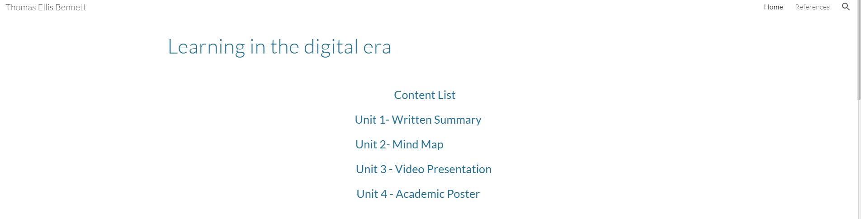

Task 1 -Written Summary
https://sites.google.com/view/thomasellisbennett/home
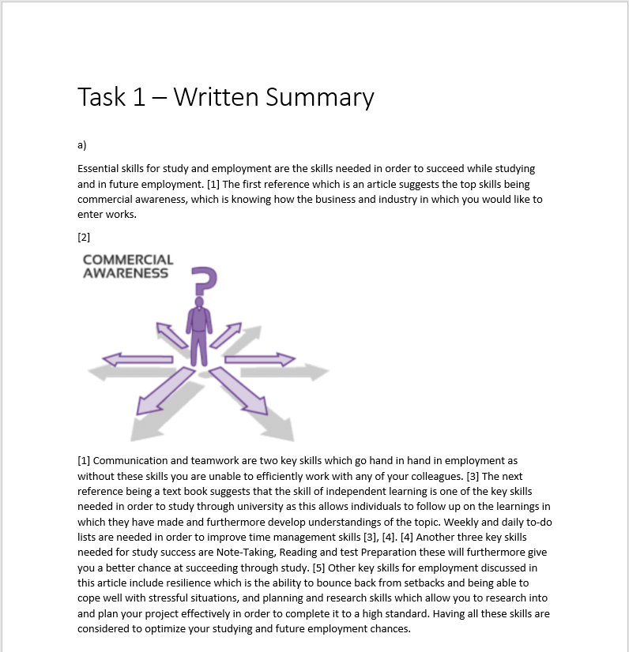

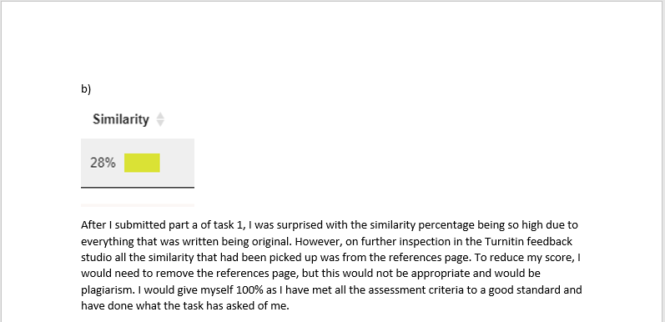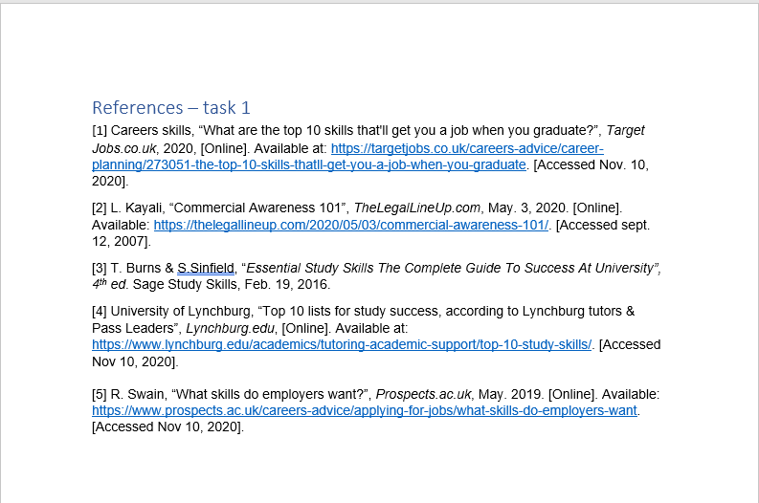

Task 2 -Mind Map
https://sites.google.com/view/thomasellisbennett/home
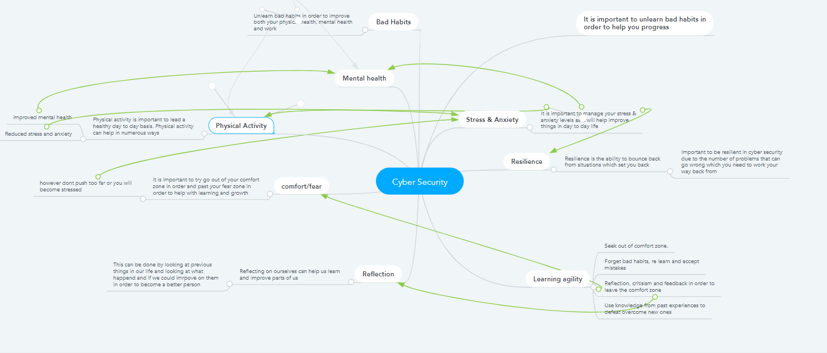

Task 3 -Video Presentation
https://sites.google.com/view/thomasellisbennett/home
YouTube Link:
https://youtu.be/BLD09eitn2M
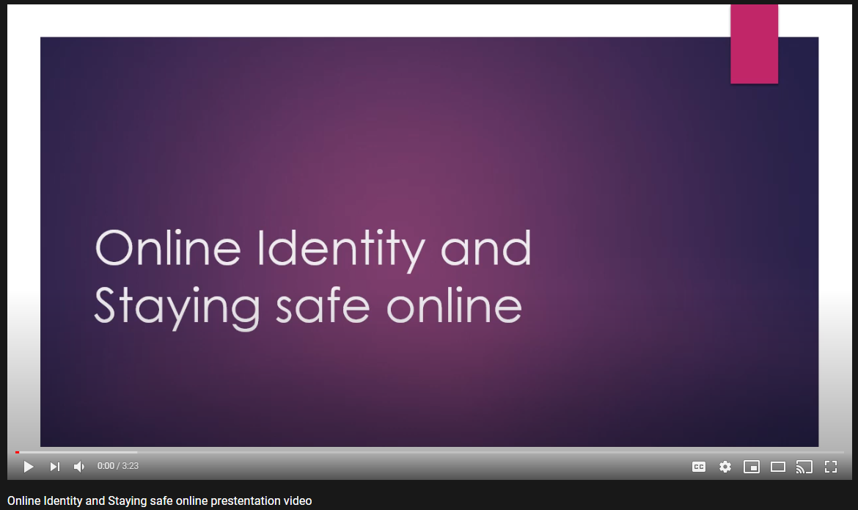

Task 4 -Academic Poster
https://sites.google.com/view/thomasellisbennett/home


