Managing Enterprise in the 21st Century
Course Code: BMSK4006
Lecturer: Molly Jack
Student Name: Forhad Ali
Student ID: 1707076

Reflection Report

Introduction
The reflective learning is the process for identifying the strength in individuals for performing certain work and also finds out the limitations so that individuals could undertake strategies for overcoming the limitations (Siklos and Sturm, 2013). In this section a business plan has developed for ‘Global Food’ to provides international food and packaging services to the countries nationwide in a price competitive way. I along with my there other group members have developed a business plan for Global food. I have realized the significance of business plan as it makes the business strategy process implementation very easy. I have decided to use the Gibbs model for performing self-reflection. Gibbs model is a systematic process to perform all activities systematically to achieve the ultimate aim and objectives.
Figure 01: Gibbs Model
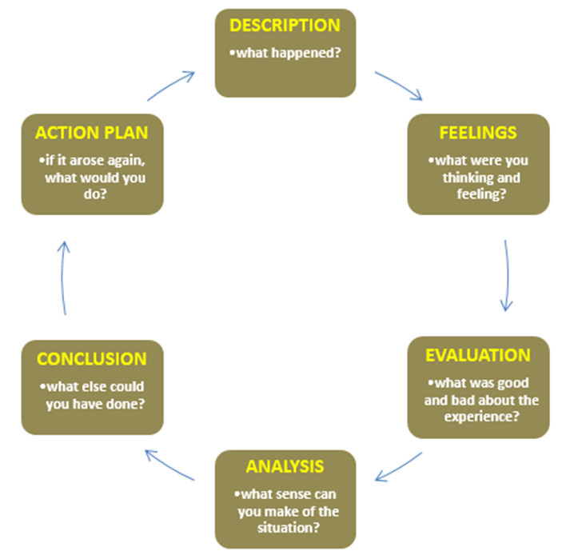
Source: (Gibbs, 1988)
Description
The event was performed week before and I participated in a presentation session which was a part of my module Managing Enterprise in the 21st Century at University of Saint Davis. In this presentation I was supposed to develop a group presentation with three other members to develop a business plan. Previously I thought that a business planning process I very time taking and individuals have spent years for developing a business plan. I along with my other three group members has develop a business plan for ‘Global Food’ to provides international food and packaging services to the countries nationwide in a price competitive way. The business plan has developed with the aim to ensure high quality product developed and serviced nationally and also ensure the service quality is high. I have participated to develop business plan which would make me able to gain proper knowledge for developing a business project. I had developed that management process for the business. I found that the management process ensures the smooth operation of the business and make the companies able to perform all strategies successfully implemented and the business get able to gain success. I have analyzed all the management processes that have been investigated for the sales management. Technical support of the organization is also very crucial to make the company able to properly smoothly perform business activities. This module was different than the rest of the module of my course and it also has very high level of significance. I thought that for developing a business plan a individuals required years of experience and then get able to develop a business plan appropriately. But I was wrong as business plan is not developed after gaining experience it mainly developed initially when people start thinking to open new business. The effectiveness of business plan is very high as individuals get chance to develop strategies successfully what supposed to implement in near future. I am very much willing to start my own business in coming days and this module found very effective with the practical life. This module is very much important and different module compared to others as effectiveness of this module is very high as the success of my future life depends on the proper business plan. I participated in this group presentation session which makes me able to gain my ability and a get a clear vision that a company required before starting business. I would be able to find out all necessary strategies that my planned company needs to consider before implementation within the market.

Feelings
I had enjoyed the module a lot as I got an opportunity to gain a deeper knowledge about the processes of starting the business. I have very high interest to start my own business and this presentation has made me able to gain a deeper understanding about the development of the business activities and associated issues. I found that the business plan has strong impact on the success and failure of the company, so it is very important to ensure that the business plan has developed appropriately. I also realized that the business plan would benefit the company to get able to use the proper resources to improve the work efficiency and also minimize the cost. I was always interested to perform the managerial job and it will be a great opportunity for me if I get able to work in managerial post in my own company. I am really feeling opportunistic as I get a great opportunity to develop a business plan before start the business under a great supervision of our course coordinator.
Evaluation
I am very hard working and work every activity with care. I had developed my part of the presentation very carefully and I had developed business plan which make me able to gain proper knowledge for developing a business project. I had developed that management process for the business. The managerial decisions are very crucial for the organization so right task was allocated for me as it goes with my ability and skill. I take care of the management activities appropriately and effectively developed a plan to ensure that ‘Global Food’ would able to perform all managerial activities appropriately. I have some limitation that some time makes me unable to perform all tasks appropriately as I am not good in communication with other to ensure that collaborative work being performed in workplace. At the beginning I was not properly communicating and sharing information’s with other members but soon I was advice by my other team members to share my part of information and receive their as the management planning needs to consider all information and take decision after making proper synchronizing those information’s. Other team members were very concern on sharing information and they developed a good relationship with me and other which make me able to complete the group presentation appropriately but i need to overcome my this limitation. I also have problem of time management as some time I do not get able to complete all of my activities on time. As this was a group work and I communicated with all members and I had to attend the group meeting so I got able to perform all my activities within the determined time period and get able to enhance performance of the team.
Analysis
I take proper initiatives to enhance my knowledge and ability and gain skill. I started to read books and magazines and visited the university digital library. I first gain knowledge on the issue that I have performed in my group presentation session. I found that the management process ensures the smooth operation of the business and make companies able to perform all strategies successfully implemented and business get able to gain success. According to Goldstein (2011), to perform the business operational activities it is important to ensure that all organizational operations has been performed appropriately. Basically the success of the organization depends on the proper managerial activities. I have analyzed all management processes that have been investigated for sales management. Technical support of the organization is also very crucial to make company able to properly smoothly perform business activities. I had gain skill on managing the people as the work force management is very important for the businesses. Ephraim (2013) stated that the work force is the foundation of the organizational success and it needs to properly manage. Had gain skilled to minimize the dissatisfaction of the employees and enhance their motivational level and also minimize the employees’ turnover rate within the organization. I have studied several motivational theories like, Adams Equity Theory, Maslow Theory, Hertzberg Two Factors Theory, etc. as these theories found very crucial to enhance the employee’s motivational level. I performed the external business analysis and conducted the PESTLE analysis for the “Global Food” business environment and in this process I gained knowledge of the UK’s business environment for the business operation. The company will first operate nationally and after few years of time it would start to operate internationally. My depth knowledge on business external environment has evaluated that the company needs to ensure that currently the pricing strategies needs to keep minimum as the economic situation in UK is in its downturn as found the inflation rate is higher in past few years. My contribution for the group presentation was significant to make the company able to evaluate its business situation and set associated strategies to perform appropriately and get able to achieve business goal appropriately.
I then focused to enhance my self-ability to perform all group activities appropriately. I had focused to minimize my identified likings. I found that I am not good in communication with other to ensure that collaborative work being performed in workplace. I have studied several books and attended one seminar to enhance my communication ability. According to Conrad, and Poole (2012), the communication could be made verbally or non-verbally. Both types of communication ability are important for the companies. The verbal communication is the processes that make individual communicate with other person face to face or over telephone. Voice tone is important for the verbal communication either face to face communication or telephonic communication. Body language communication is significant for face to face communication. At the beginning I was not properly communicating but I had recovered to make proper communication with others. Still I believe I need to work for gaining my communication ability with other.
I also find that my interpersonal communication ability needs to improve. According to Gamage (2006), the interpersonal communication is very effective to make individuals work well within the team and also share information to develop relationship among all members. Moreover the interpersonal communication is very effective to develop relationship among the team mates and work together in way that the problem gets resolved. I shared my part of information and receive other individuals information’s as the management planning needs to consider all information and take decision after making proper synchronizing those information’s. All team members were very concern on sharing information and they developed a good relationship with me and other which make me able to complete the group presentation appropriately. I gain confident through the presentation to develop relationship with all members as it consider as one of the important issue to develop overall work efficiency of the organization.
I also found problem on time management as some time I do not get able to complete all of my activities on time. According to Frankel (2008), the time management is very crucial for the organizational success as it important to maintain proper synchronize of the organizational work activities. I realized that the proper time management found very effective to organization the work activities of the companies and make all work being performed appropriately. I found that the productivity of the organization get improved when all the members able to perform all activities appropriately. As this was a group work and I communicated with all members and I had to attend the group meeting so I got able to perform all my activities within the determined time period and get able to enhance performance of the team.
Conclusion
In conclusion I evaluate the total presentation session was very knowledge able as first of all I gain confident in me for developing business plan and work accordingly. I had gain deep understanding on the organizational management processes and the external business environment tool. I find out self-strength and weakness. I found that I am very hard working and work every activity with care. I had developed my part of the presentation very carefully and I had developed business plan which make me able to gain proper knowledge for developing a business project. I have some limitation that some time makes me unable to perform few issues appropriately as I am not good in communication with other to ensure that collaborative work being performed in workplace. I had attended one seminar to improve my performance and in future I also needs to several conferences and seminars to enhance my communication ability. I also need to study theories of body movement as it has strong impact on listeners. I got time management problem in me. I realized the significance of time management and I have started using a digital tab where I keep note of my weekly and monthly activities which reminds me to perform work activities appropriately.
Action Plan
I have undertaken strategies to develop my communication ability and it would take some time to improve my confident level and enhance my communication ability. If I further find the communication problem then I need to receive training on gaining my communication ability. I also have undertaken effective process of time management and started to use digital note book and it would gradually improve my skill and ability.

References
Siklos, P, L., Sturm, J-E, (2013) Central Bank Communication, Decision Making, and Governance: Issues, Challenges, and Case Studies: MIT Press
Goldstein, M. L., (2011) FCC Management: Improvements Needed in Communication, Decision-Making Processes, and Workforce Planning: DIANE Publishing
Ephraim, N., (2013) Collaborative Communication Processes and Decision Making in Organizations: IGI Global
Conrad, C. Poole, M. S., (2012) Strategic Organizational Communication: In a Global Economy: John Wiley & Sons
Gamage, D., (2006) Professional Development for Leaders and Managers of Self-Governing: Springer Science & Business Media
Frankel, E.G., (2008) Quality Decision Management -The Heart of Effective Futures-Oriented Management: Springer Science & Business Media,

