Table of Contents
Appendix 1- Pupil interview questions. 2
Appendix 2- Pupil interview transcripts 3
Appendix 3- Staff questionnaire 5
Appendix 4- Responses to question one of the questionnaires 8
Appendix 5- Responses to question two of the questionnaires 8
Appendix 6- Responses to question three of the questionnaires 8
Appendix 7- Responses to question four of the questionnaires 9
Appendix 8- Responses to question five of the questionnaires 9
Appendix 9- Responses to question six of the questionnaires 9
Appendix 10- Responses to question seven of the questionnaires 10
Appendix 11- Responses to question eight of the questionnaires 10
Appendix 12- Responses to question nine of the questionnaires 10
Appendix 13- Responses to question ten of the questionnaires 11
Appendix 14- Responses to question eleven of the questionnaires 11
Appendix 15- Responses to question twelve of the questionnaires 11
Appendix 16- Responses to question thirteen of the questionnaires 12
Appendix 17- Responses to question fourteen of the questionnaires 12
Appendix 18- Responses to question sixteen of the questionnaires 12
Appendix 19- Responses to question seventeen of the questionnaires 13
Appendix 20- Responses to question eighteen of the questionnaires 13
Appendix 21- Responses to question nineteen of the questionnaires 13
Appendix 22- Responses to question twenty of the questionnaires 14
Appendix 23- Responses to question twenty-one of the questionnaires 14
Appendix 24- Responses to question twenty-two of the questionnaires 14
Appendix 25- Ethics form 15
Appendix 26- A blanket copy of the consent form and information letter for the school. 27

Appendix 1- Pupil interview questions.

Key questions for pupils.

Q1. What do you know about peer assessment? What does peer assessment mean to you?

Q2. Do you think peer marking helps you understand your work better? Why or why not?

Q3. Do you think the feedback you receive from your peers is relevant and effective to your work?

Q4. Does the chosen peer affect the feedback?

Q5. Does the feedback from your peers help you improve your work? How?

Q6. Is there anything you would change about how peer marking is done in your class?

Appendix 2- Pupil interview detailed notes

Data has been colour coded into relevant key points for analysis:

Definition and examples of Peer assessment
Pupils’ opinion on their friend assessing their work.
Emotional effect between pupils
Areas for improvement

Interview:

The interview was conducted with a group of 10 pupils. The pupils are referred to as pupil 1-10. The interview took 10 minutes estimated.

Interviewer: Today I have asked you to take part in some research for my assignment in university. I will be asking you a number of questions related around the use of peer assessment. I would like to hear your honest thoughts on how your learning outcome increases by using peer assessment. Your opinions and views will not be shared with members in your school and the research will be 100% confidential. Your name will not be used when writing my assignment. You can tell me at any point during the research session that you do not want to take part anymore. There will be no consequences if you do not want to participate. Before we start, do you all want to take part?

All pupils: yes/yeah/nods of heads.

What do you know about peer assessment? What does peer assessment mean to you?

Pupil 1: We swap books with someone.
Pupil 2: Yes, we mark our friends work (agreeing with pupil 1).
Pupil 3: We get to choose who we swap our books with. I like swapping mine with my friend because they give me nice comments.
Pupil 4: My friend puts a good comment about how good my work is.
Pupil 5: When my friend marks my work, they do too. (agreeing with pupil 4 and 5).
Pupil 6: The good comments help me feel better.
Pupil 7: Our partners also have to write an even better if comment.
Pupil 4: Oh yes, it helps us make your work better.
Pupil 1: It helps us know how to purple pencil our work.
Pupil 9: We use purple pencil to correct the bad things.
Pupil 4: When I purple pencil, I keep my normal pencil in my pocket to change my work if it’s wrong, so no one knows.
Pupil 10: You’re not supposed to do that.

Do you think peer marking helps you understand your work better? Why or why not?

Pupil 3: When my friend makes a nice comment, it makes me feel better about my work and make me want to work more.
Pupil 1: I like marking my friends work because they help me know how good my work is.
Pupil 3: I don’t like my friend marking my work. I like marking my own work because you can like make better comments on how to change my work and to make me feel good about my hard work.
Pupil 9: I like it too. I can give myself easy even better ifs do I don’t have to do more work.
Interviewer: Do you think that helps you though?
Pupil 9: Yes, because I don’t have to do more work. It takes all my time up.
Pupil 5: Purple pen takes forever. There’s always some in my book.
Pupil 10: It takes a long time, but I like writing my spellings out because I can remember how to spell it again.
Pupil 2: Using purple pencil helps me know how I did my work wrong.
Pupil 6: Sometimes I only answer the comments with an Okay through.
Pupil 8: Me too because it takes so long to find what they are talking about.
Pupil 4: I ask my friend to show me because they help me too.
Pupil 7: It helps me know if I used the success criteria.

Does anyone not want to participate any further?
Pupil 3: I like the questions.
All the pupils: No.

Do you think the feedback you receive from your peers is relevant and effective to your work?

Pupil 6: What does that mean?
Interviewer: When your friend writes a comment on your work, does it help you make your work better or does it not help?
Pupil 2: Yes, they give me good things about my work. It makes me feel proud of how well I did.
Pupil 6: My friend does that too (agreeing with pupil 2).
Pupil 3: It makes me want to do well in all my work, so they think I’m smart.
Pupil 2: But when they aren’t my friend, it isn’t good like when my friend writes it.
Pupil 5: I must mark people who aren’t my friend sometimes too.
Pupil 1: I hate when it’s not my friend. Their comment makes me feel dumb because the feedback is not about my work.
Pupil 5: I like even better if because it helps me know what to change in my work to make it better than my friends.
Pupil 9: It helps me if I forgot something from the success criteria.

Does the chosen peer affect the feedback? Does your comment from the person marking your book change if it’s your friend or not?

Pupil 10: My friend gives me helpful comments to make my work good.
Pupil 5: My friend is kind when they help me make my work better.
Pupil 7: I only like marking with my friend because it makes me feel good that they like how I do my work.
Pupil 6: Yes pupil 10 is my friend and they tell me really lovely things about my work.
Pupil 10: We always mark our work together good. (agreeing with pupil 6).
Pupil 3: If it’s not my friend they don’t help me. It does make sense and I don’t know what they mean because they don’t talk to me.
Pupil 7: Sometimes they are nasty and give me an even better if, but I already done it. Then we argue because they won’t change it, then I hate my work.
Pupil 2: Only my friend gives me good help to do my work.
Pupil 1: My friend even lets me change my work if I did something wrongs so they don’t make me purple pencil it.
Pupil 2: You’re not allowed to change your work if it’s wrong.
Pupil 4: I do it too.

Does the feedback from your peers help you improve your work? How does the comment like even better if, help you make your work better?

Pupil 1: My friend shows me how to make it good like hers.
Pupil 10: Yeah, I can make my work perfect before mrs marks it and gives me loads on green highlighter.
Pupil 1: The green highlighter makes me feel like my work is terrible.
Pupil 10: Me too (agreeing with pupil 1).
Pupil 5: My friend always remembers more things than me and I forget. She helps me remember what to add.
Pupil 8: People just say stuff that I already have in my work so I can’t make it better.
Pupil 2: I like marking my friends' work. I can make my work better and mrs will think my work is the best and show Mr.
Pupil 3: He thinks our class is the smartest class, he tells all the other people, and they come to watch how good we are.
Pupil 4: They come all the time.

Is there anything you would change about how peer marking is done in your class?

Pupil 10: I only want people to say good stuff about me.
Pupil 6: I want people to help me more. I want to make my work better, but their comments don’t help me because I don’t understand.
Pupil 7: People don’t give good comments.
Pupil 6: I want the person to help me and show me how to correct my work.
Pupil 2: I want my friend to always mark my book.
Pupil 1: We could have partners that always mark our books, so we know each other well.
Pupil 10: Yes, the same friend all the time (agreeing with pupil 1).
Pupil 3: But some people don’t help you, so I don’t want them all the time.
Pupil 4: I don’t too.

Thank you for being so honest with me and giving so good answers. Your answers will be kept confidential.

Appendix 3- Staff questionnaire

https://forms.office.com/Pages/ResponsePage.aspx?id=-REPTm4EBUWcuNshUjEeIVPeBZz7zvdPg7ZtUKNXRiJUQjA5WUxFMEtKUTNPUUVVV09TVDIwTEszWC4u
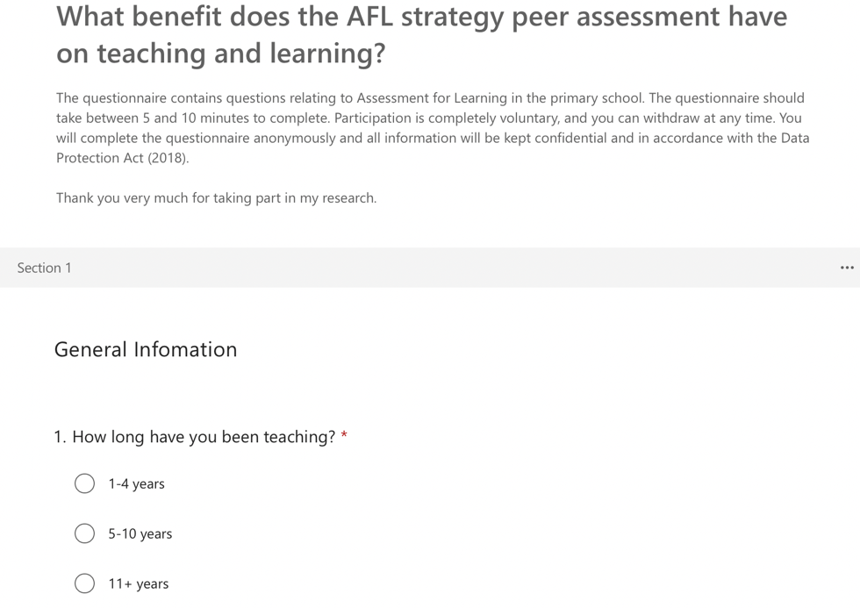
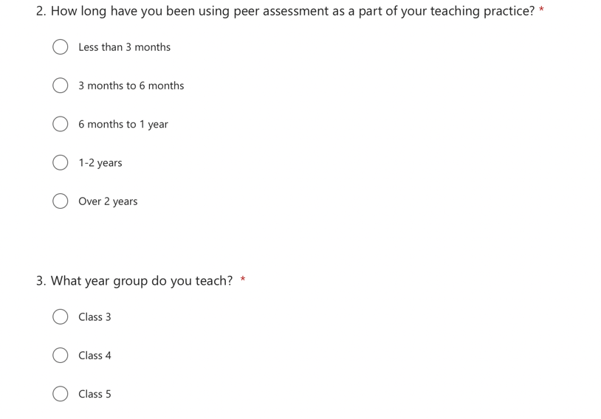
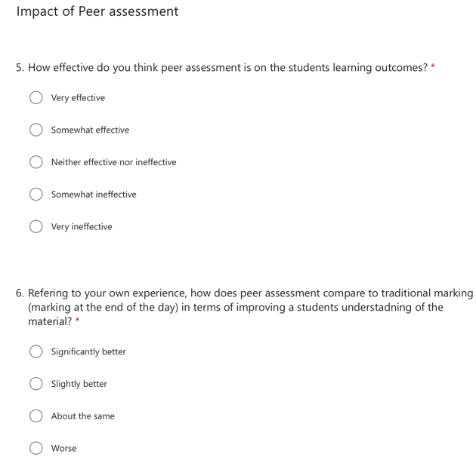
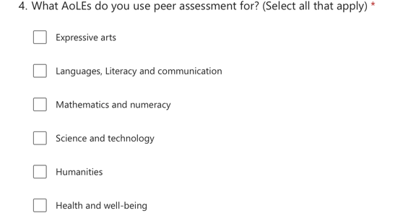
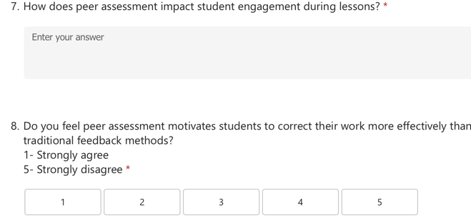
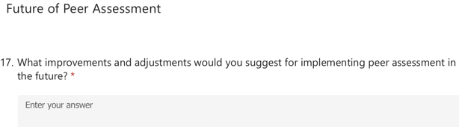
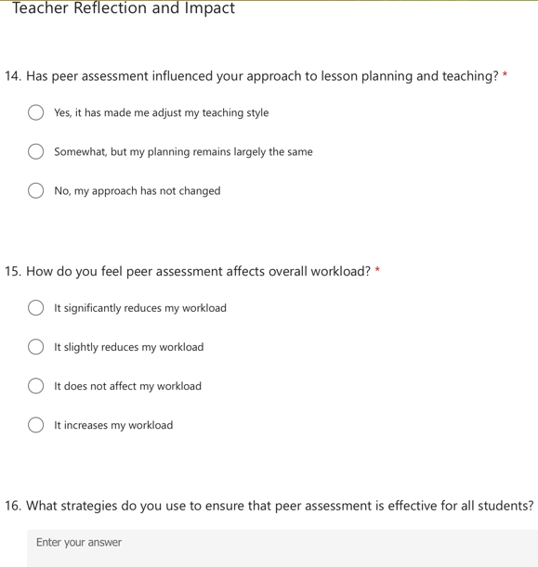
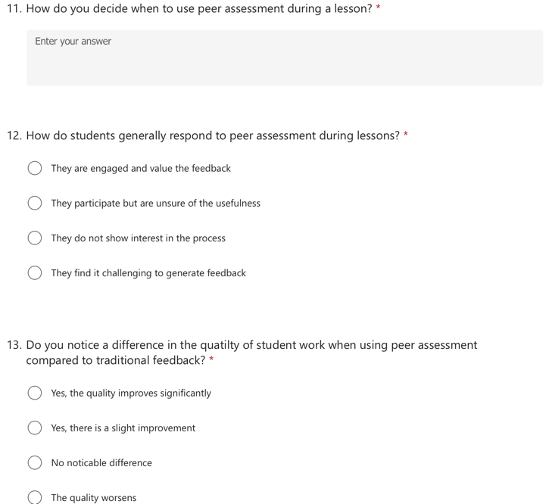
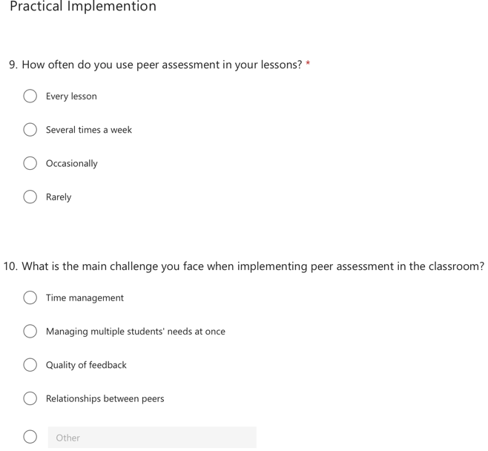
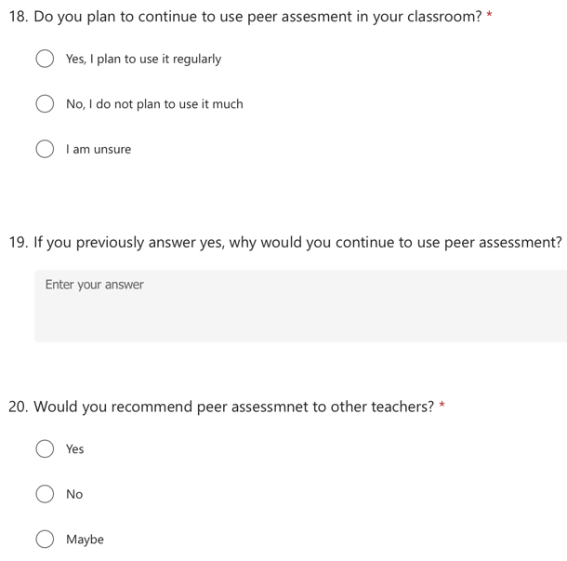
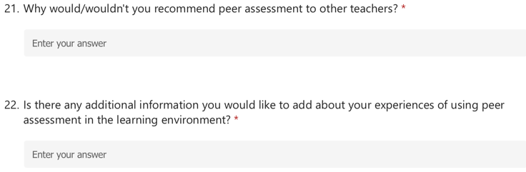

Appendix 4- Responses to question one of the questionnaires
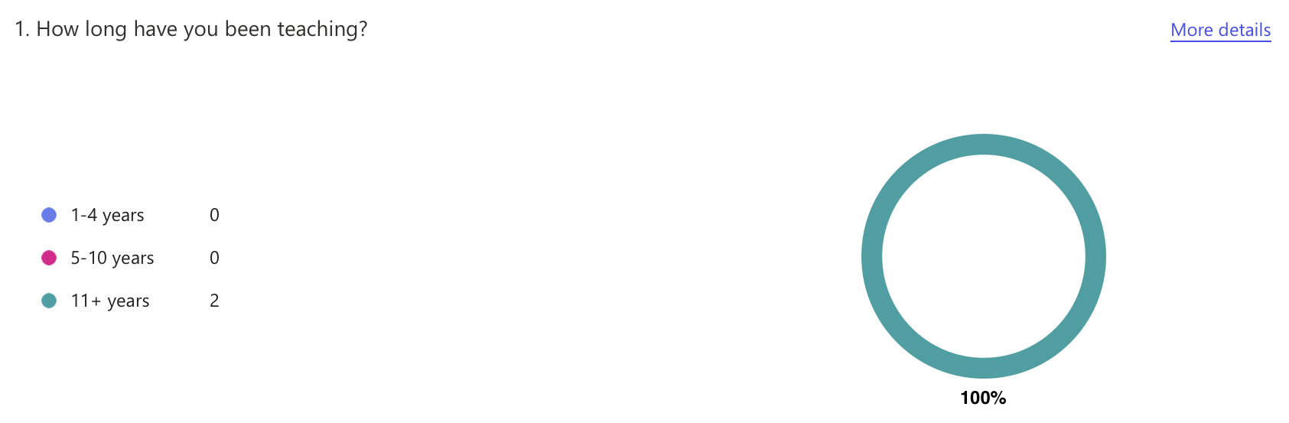

Appendix 5- Responses to question two of the questionnaires

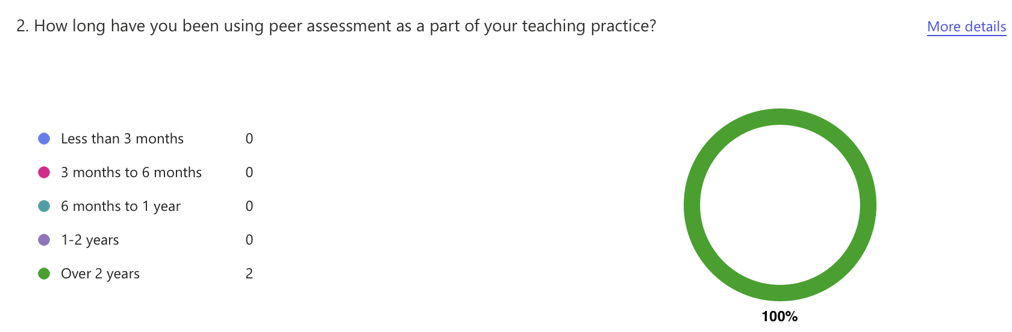

Appendix 6- Responses to question three of the questionnaires
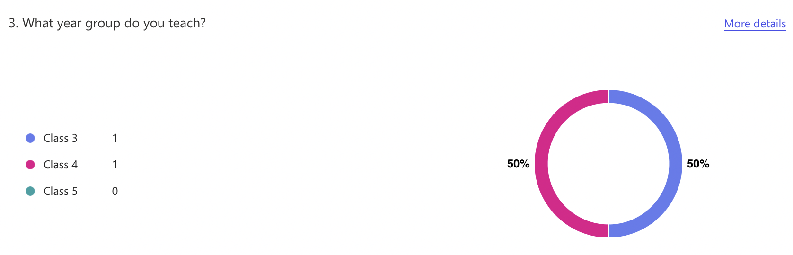

Appendix 7- Responses to question four of the questionnaires

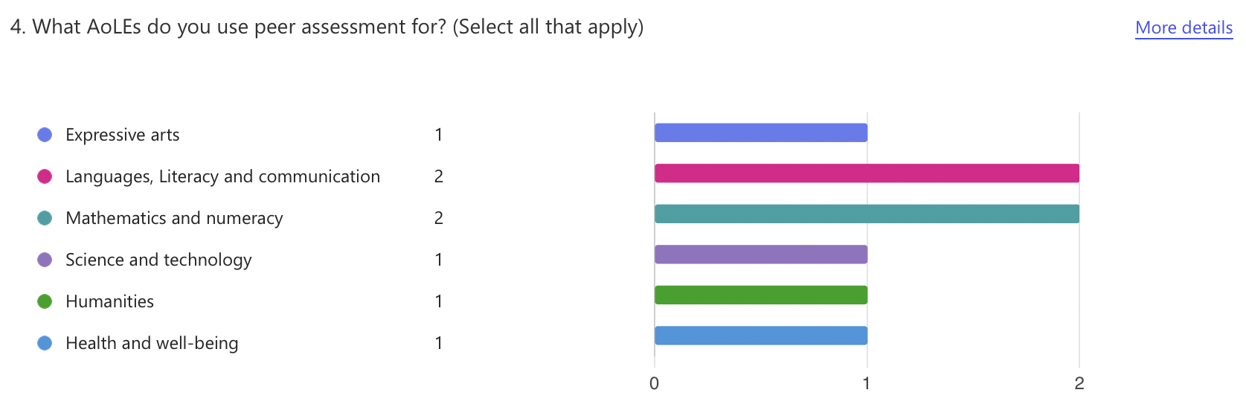

Appendix 8- Responses to question five of the questionnaires

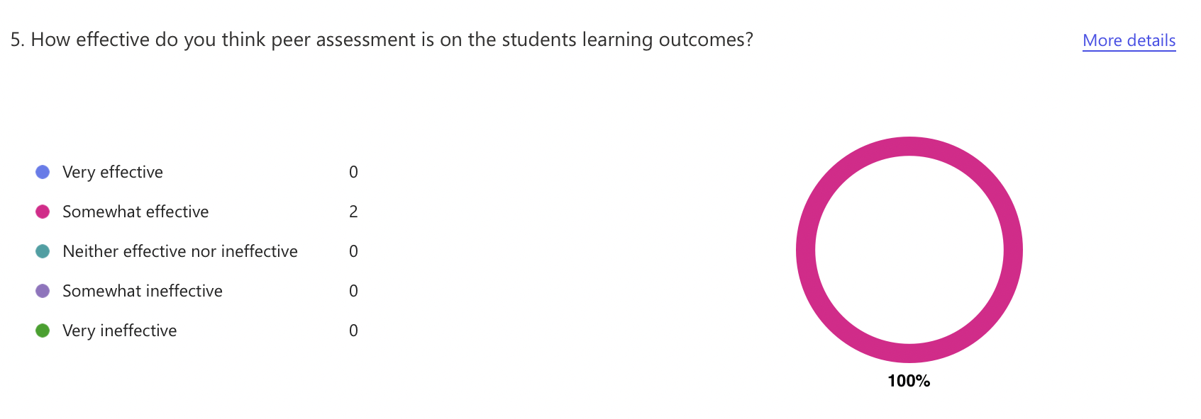

Appendix 9- Responses to question six of the questionnaires

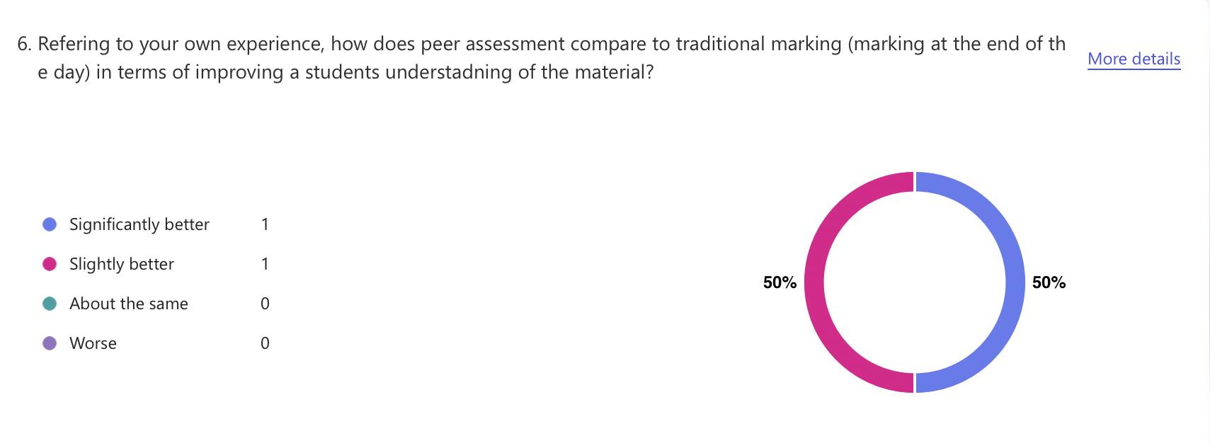

Appendix 10- Responses to question seven of the questionnaires

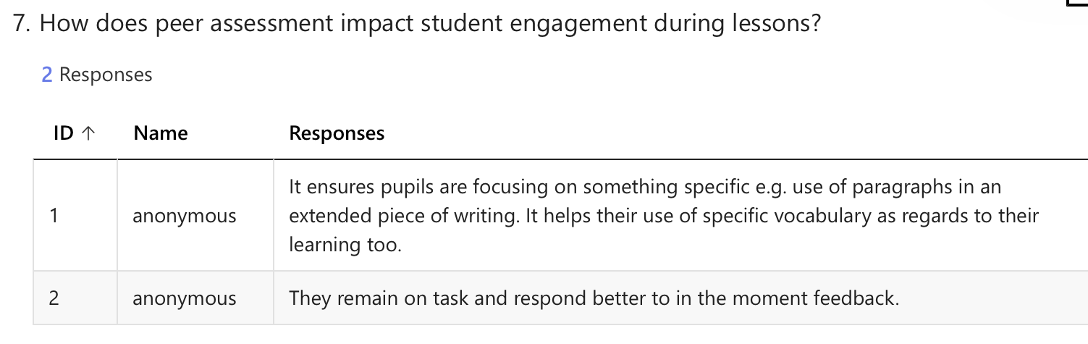

Appendix 11- Responses to question eight of the questionnaires
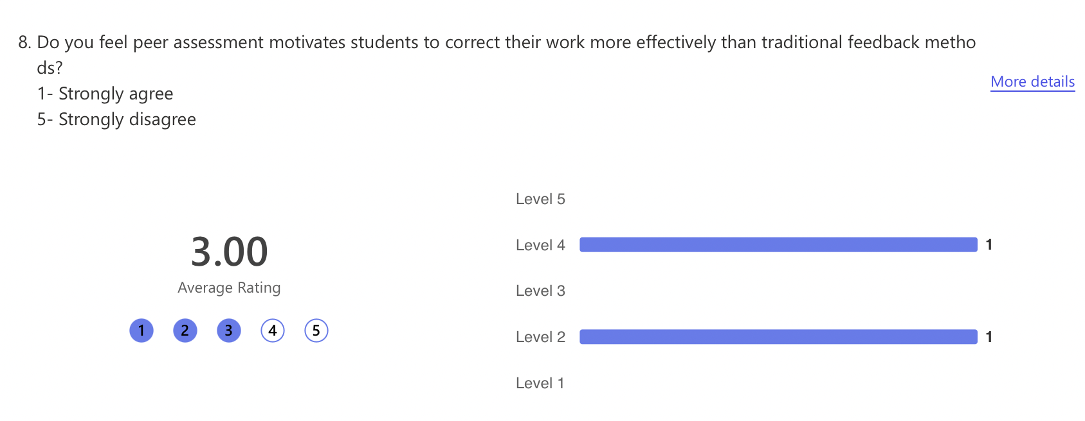

Appendix 12- Responses to question nine of the questionnaires

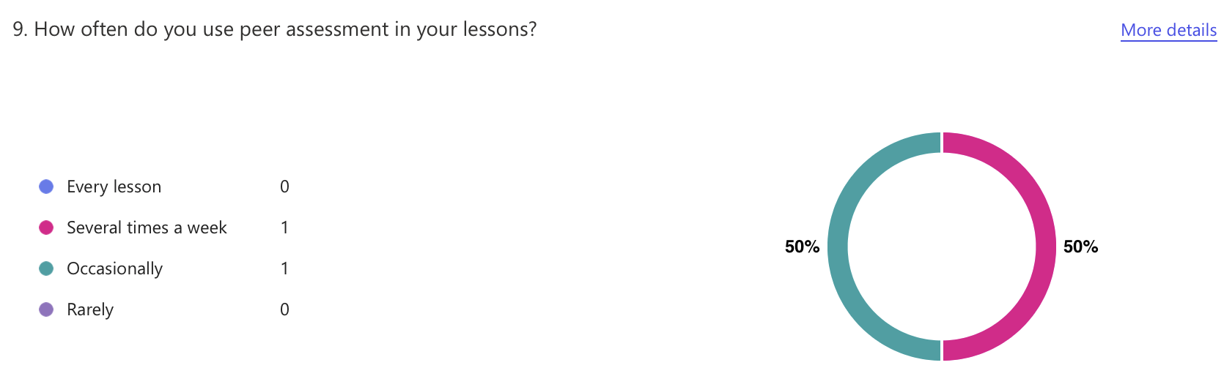

Appendix 13- Responses to question ten of the questionnaires

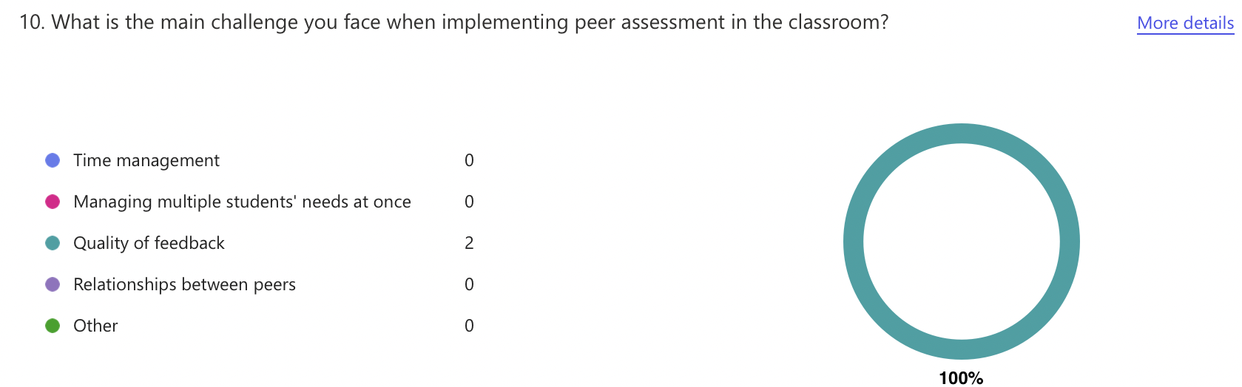

Appendix 14- Responses to question eleven of the questionnaires

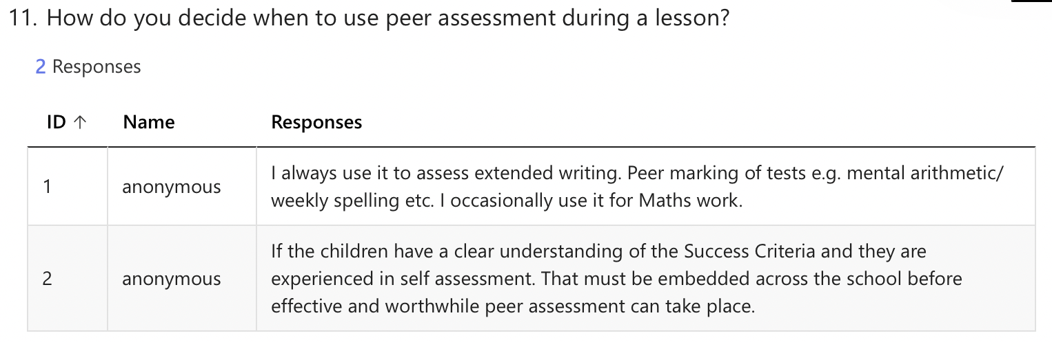

Appendix 15- Responses to question twelve of the questionnaires

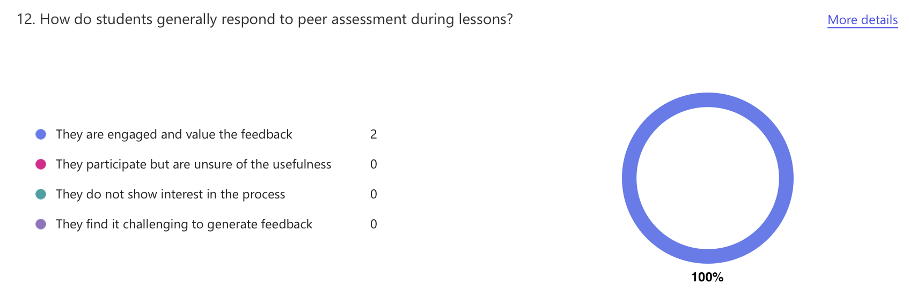

Appendix 16- Responses to question thirteen of the questionnaires

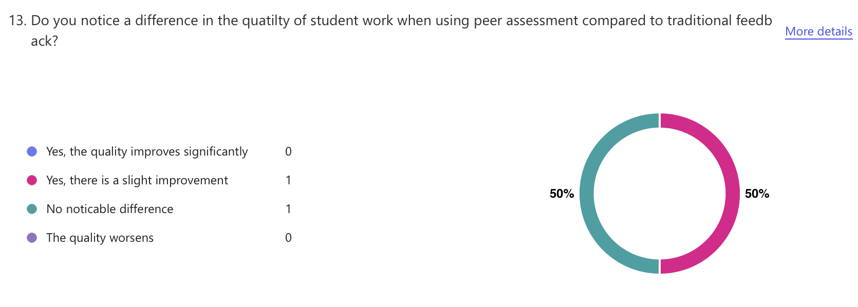

Appendix 17- Responses to question fourteen of the questionnaires

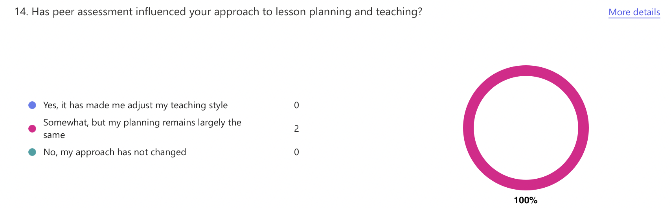

Appendix 18- Responses to question sixteen of the questionnaires

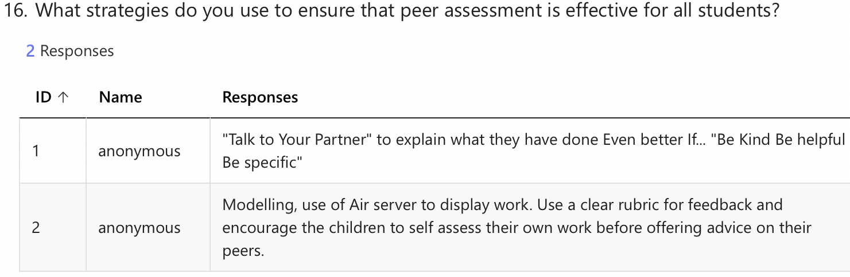

Appendix 19- Responses to question seventeen of the questionnaires

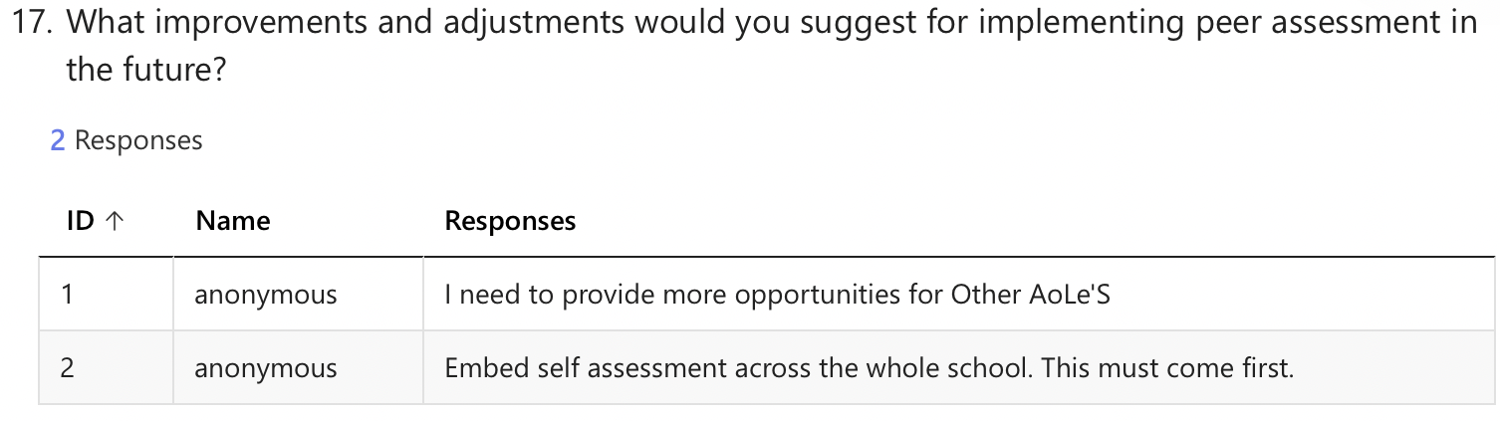

Appendix 20- Responses to question eighteen of the questionnaires

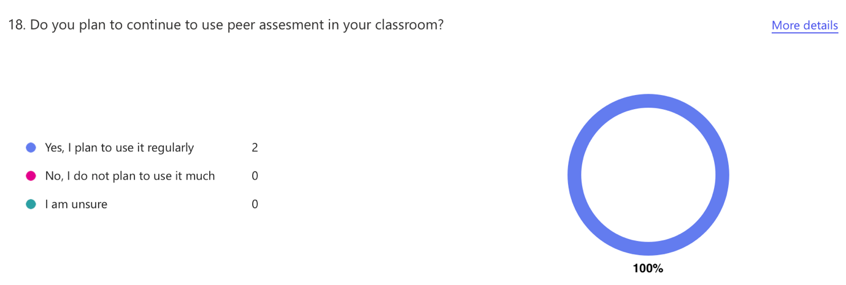

Appendix 21- Responses to question nineteen of the questionnaires

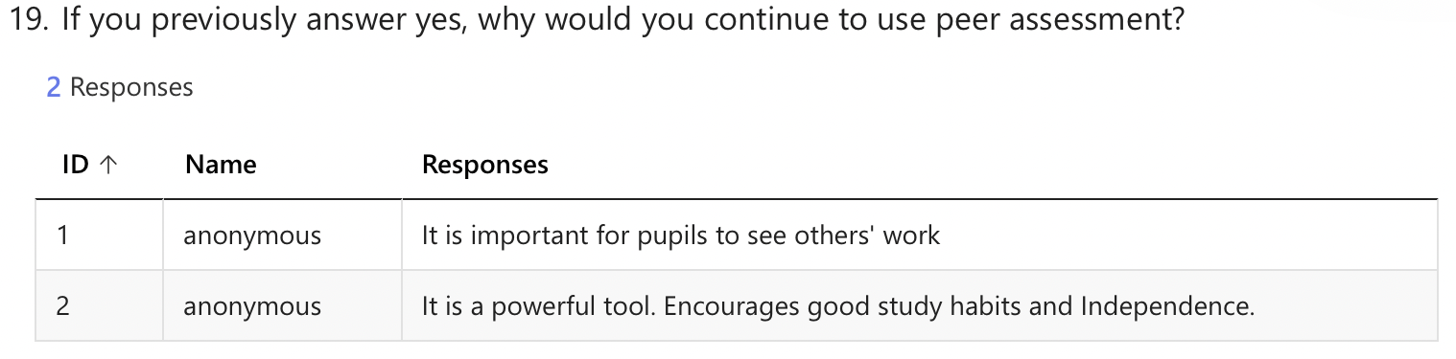

Appendix 22- Responses to question twenty of the questionnaires

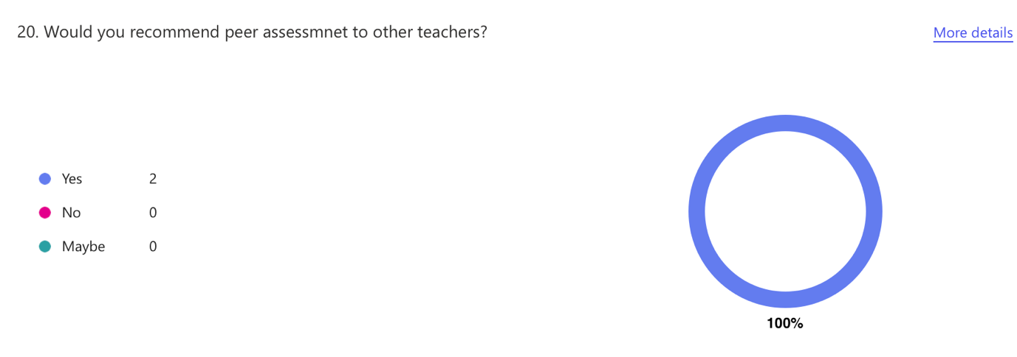

Appendix 23- Responses to question twenty-one of the questionnaires

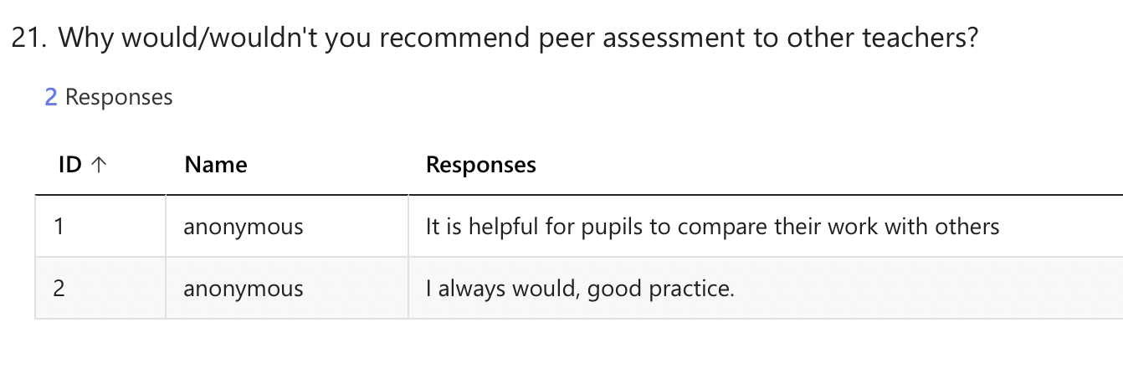

Appendix 24- Responses to question twenty-two of the questionnaires

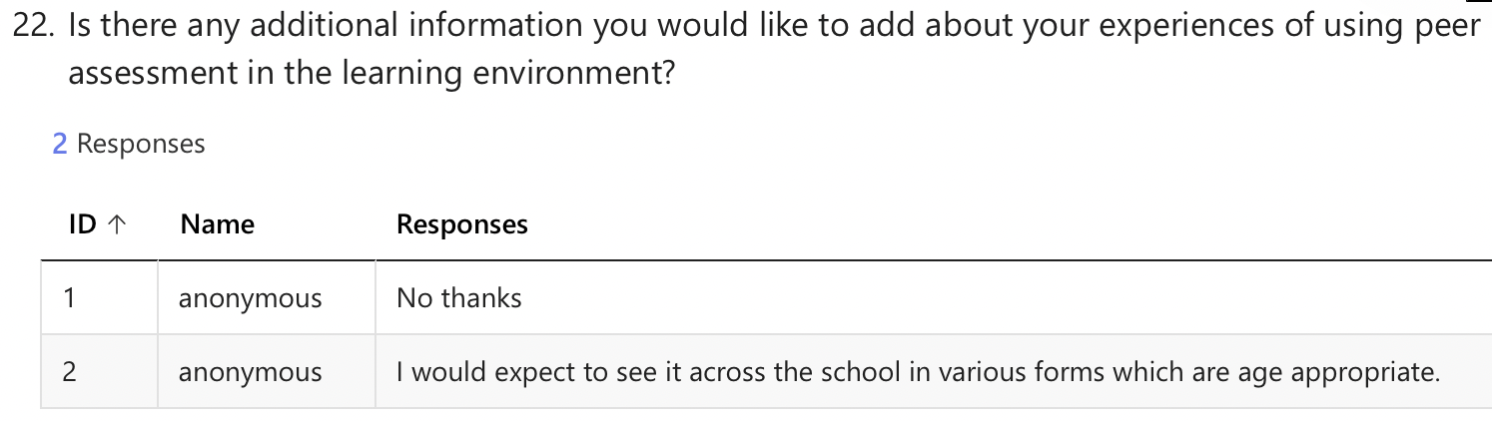

Appendix 25- Ethics form

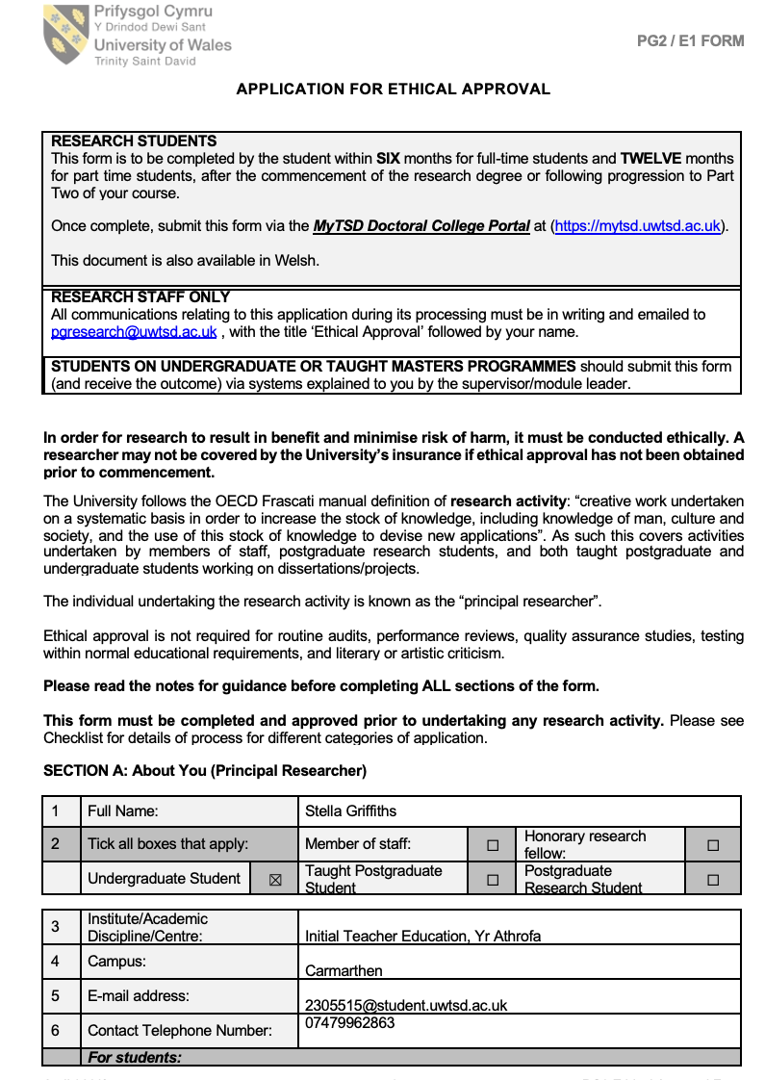

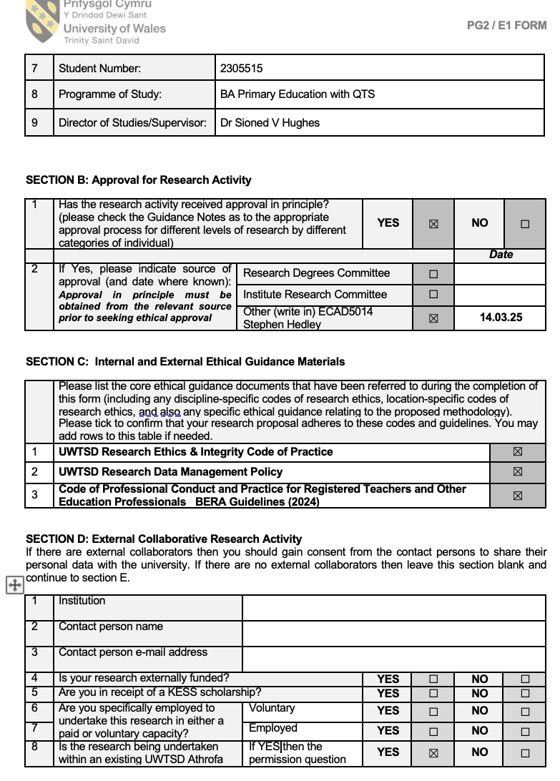

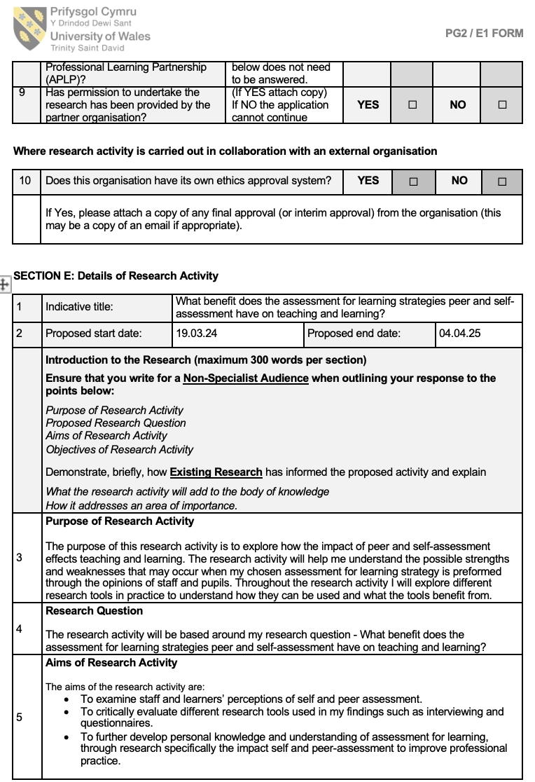

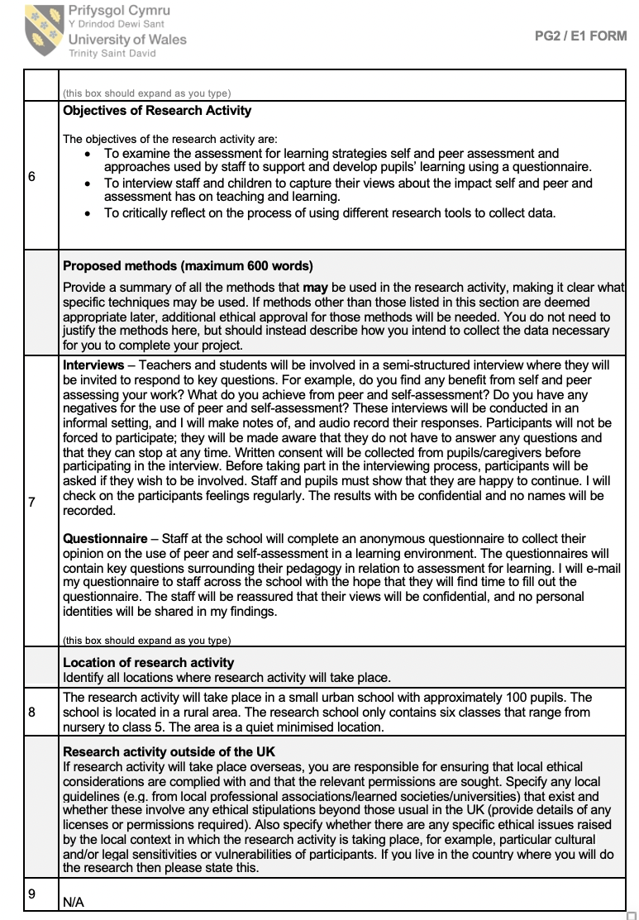

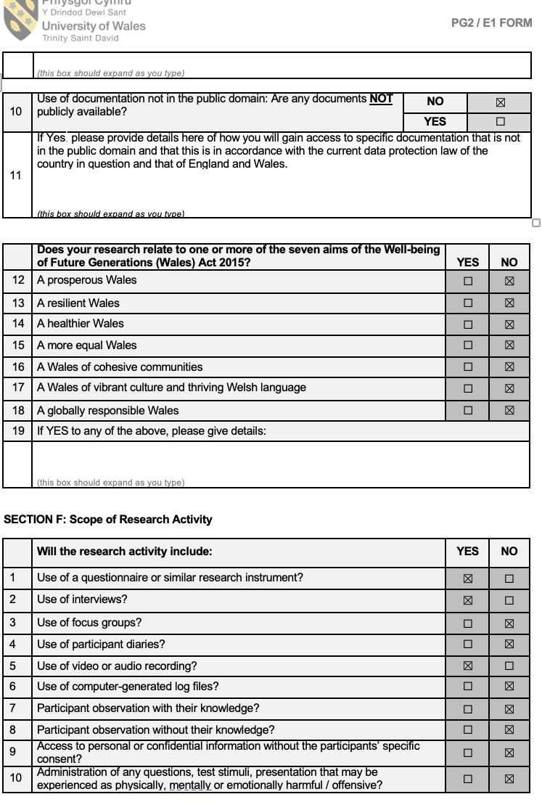

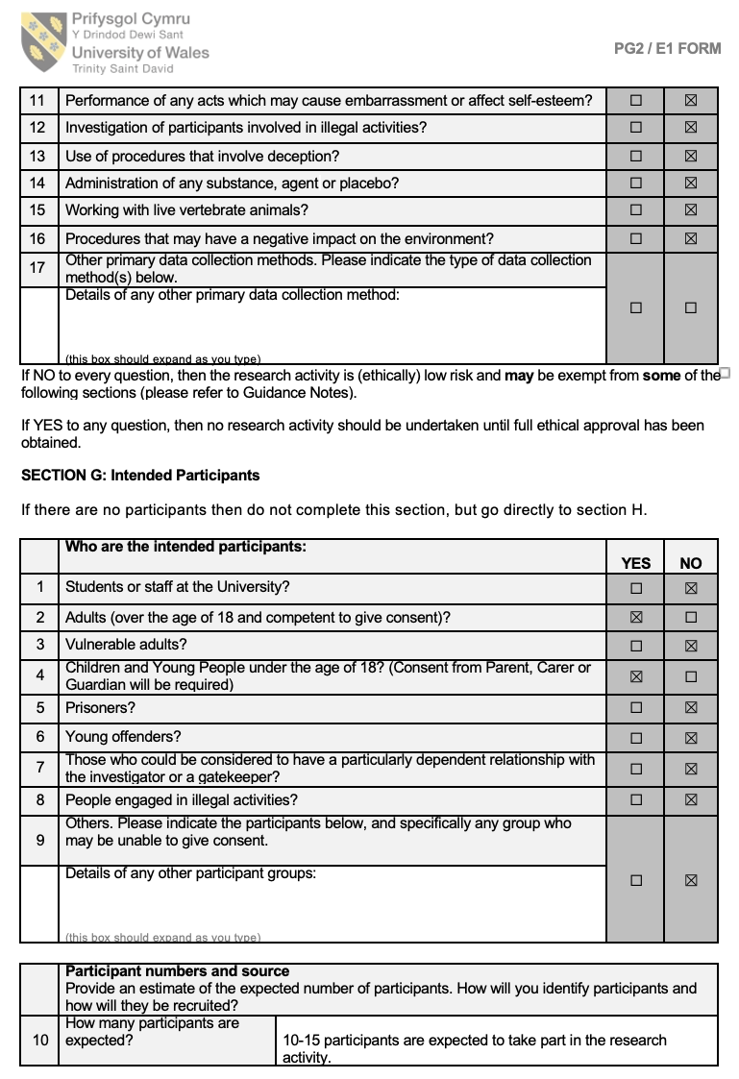

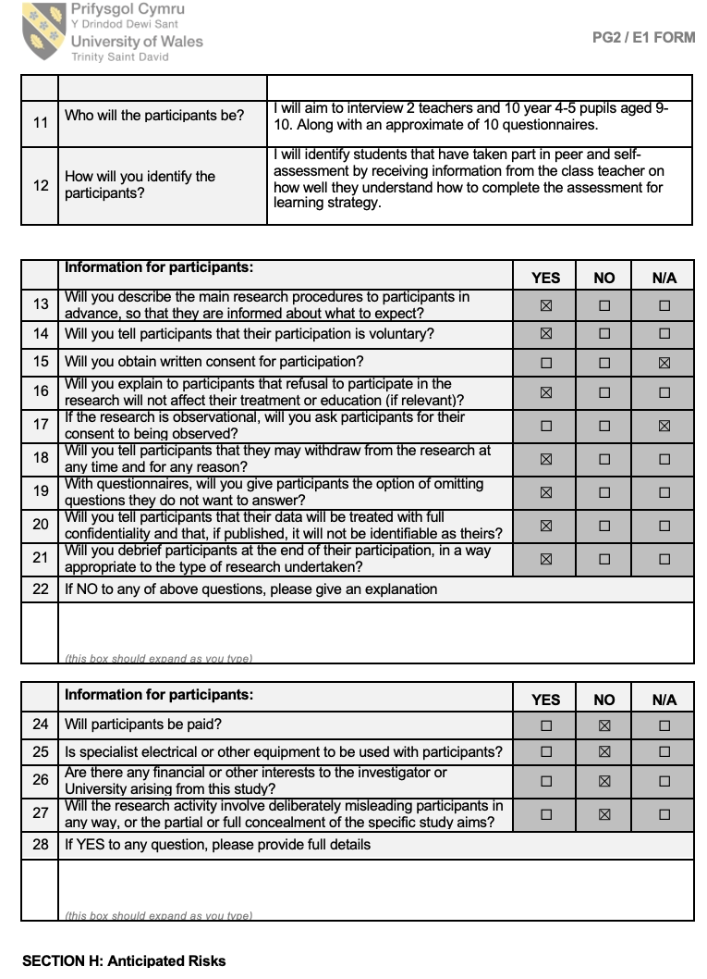

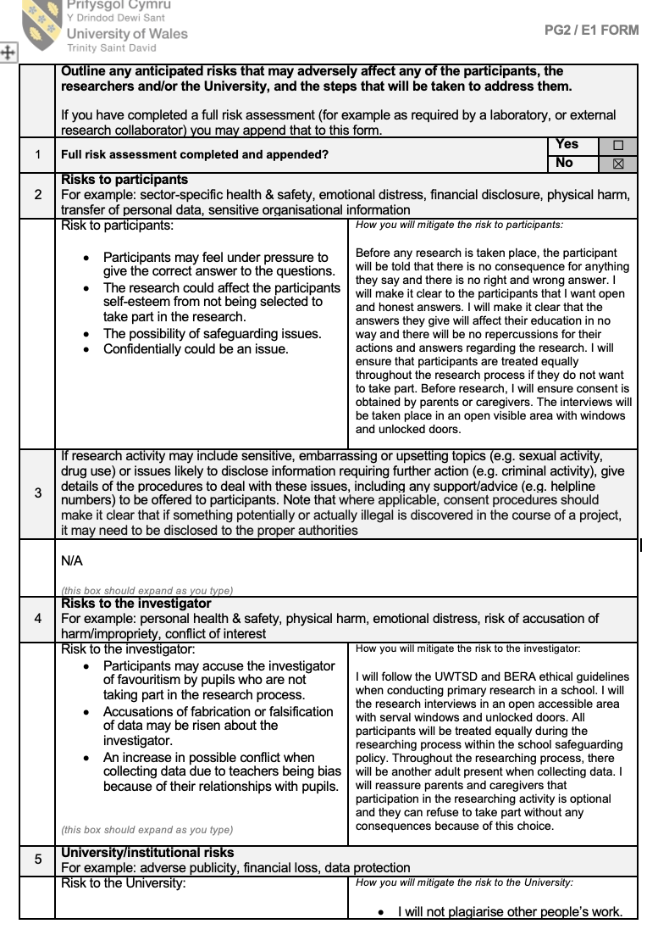

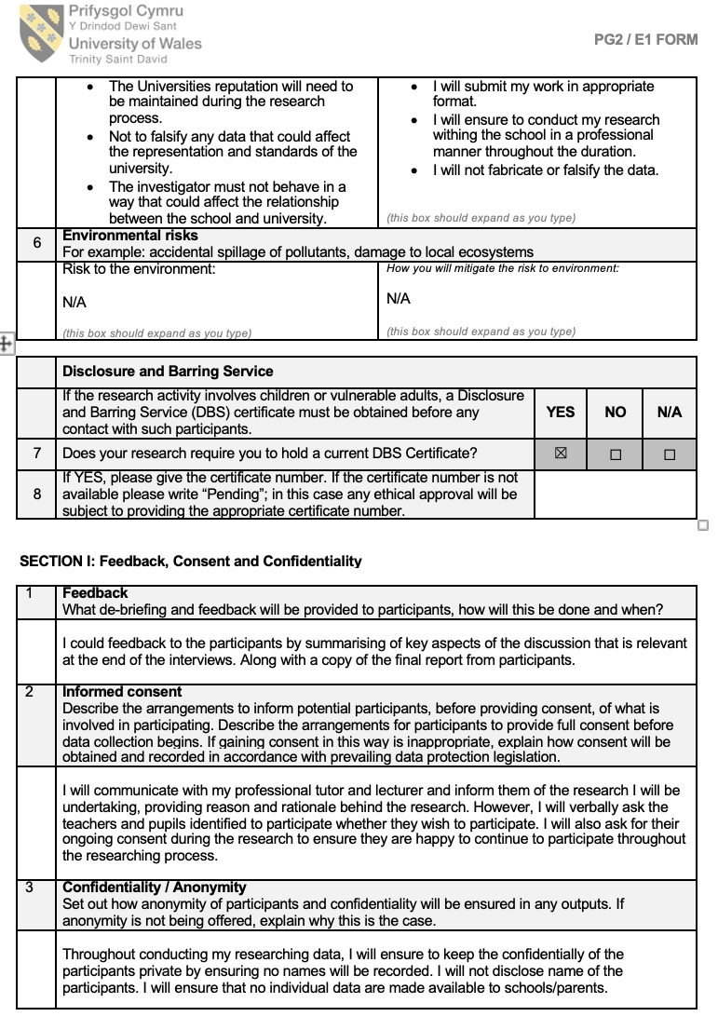

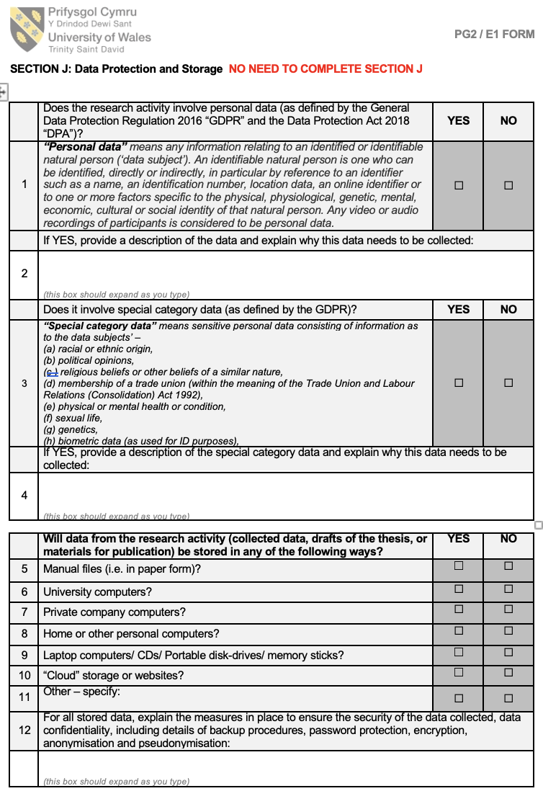

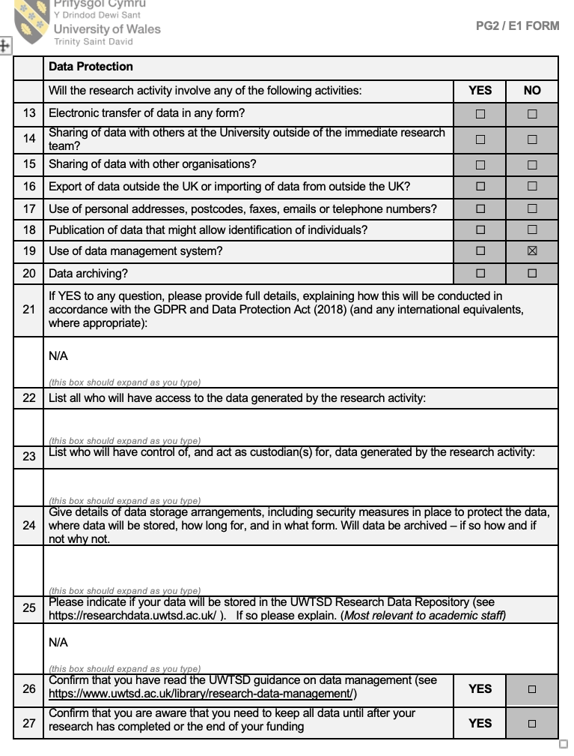

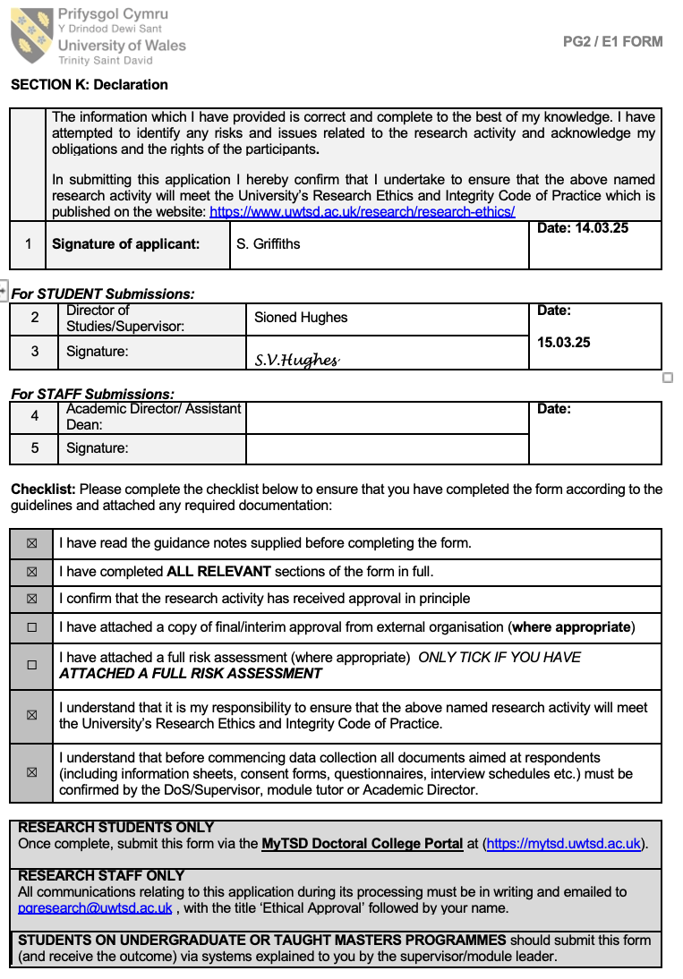

Appendix 26- A blanket copy of the consent form and information letter for the school.



