Module Code and Name:
BMIH6002 – Managing food and Beverage Operations

Student id:
2224087

Reflective Learning Log: Development Through Industry acements in Hospitality Operations

Introduction and Objectives
This reflective writing examines my learning and growth in the context of two industry placements: Delta Hotels by Marriott, where I practiced as a breakfast assistant, and Novotel Wembley, where I performed a shadowing experience in the supervision of housekeeping. Delta, which is affiliated with an international brand and serves business and leisure travellers, needed me to keep the breakfast buffet going and keep the area clean in a quick-paced surrounding. Novotel Wembley, provided a deeper understanding of the supervisory practice, as I had an opportunity to shadow the room supervisors and assess the room preparedness.
Three central learning objectives guided my placements. In the first place, I sought to establish operational competency with regard to the performance of time-sensitive food and beverage functions. Second, I wanted to learn and experience supervisory leadership practice, especially in service standards coordination and evaluation. Third, I planned to use theoretical conceptualisations of learning to critically think of professional development. It coincides with the model of work-integrated learning that cultivates the connection between academic learning and employability outcomes (Yang et al., 2021), as well as the relevance of supervisory skills training in contemporary hotel operations (Yahya, 2024).

Professional Role Experience and Reflection
Placements offered me contrasting, though complementary, skill development prospects, which could be analysed to best effect when utilising Gibbs Reflective Cycle. My key roles at Delta Hotels encompassed the preparation and replenishment of the breakfast buffet, responding to guest demands, and cleaning. In the first place, I was concerned about handling busy services. Nevertheless, I managed to adjust soon by setting priorities and taking the initiative to communicate with kitchen and service workers. This approach has worked on my confidence and time management. After this consideration, I discovered that emotional intelligence, such as self-regulation and empathy, played a critical role in preventing the escalation of guest expectations (Yahya, 2024; Anton et al., 2024).
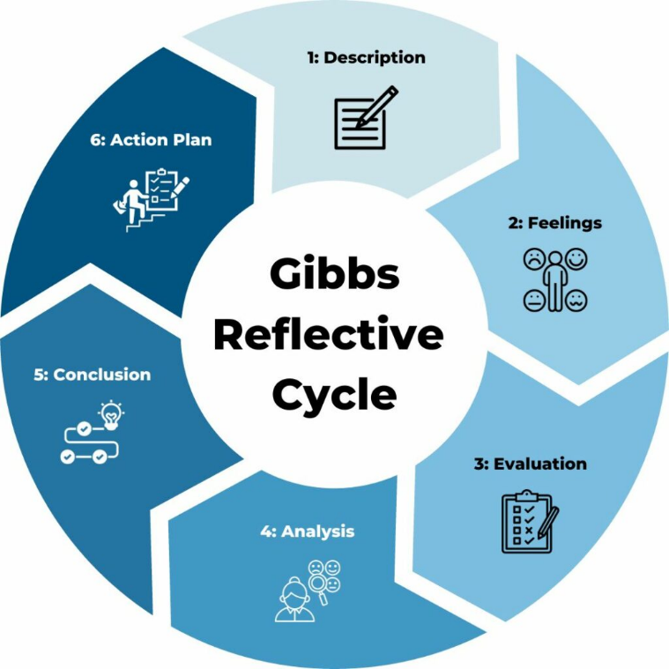
Figure 1: Gibbs Reflective Cycle
On the contrary, my placement in Novotel Wembley provided a management outlook. On the first days of observation, I understood how supervisors-plan their work with housekeeping teams, provide quality control, and deal with shift reports. As time went by, I was able to participate in room inspections and report discrepancies; such experiences gave me a slow and steady clarity on what the role of a leader is. This learning through observations helped me convert my passive to active learning, which is also consistent with action learning in hospitality training (Yang et al., 2021; Adams et al., 2022).
My perception of guest satisfaction was also influenced by leadership styles practised in Novotel. The experience of supervisors who offered constructive criticism and solved conflicts in a composed manner showed how positive leadership can raise the morale of the staff and consistency in operations. The results of this study are aligned with the literature that reveals the importance of communication and interpersonal skills in the hospitality area of supervision (Talawanich and Wattanacharoensil, 2020).
The two placements identified my strengths as being reliable and paying attention to detail and my development needs as being assertive. This conforms to the models of hospitality education, which place reflection as a facilitator of competency in supervision (Yahya, 2024). Furthermore, the importance of emotional and interpersonal skill sets continues to grow in dynamically changing service settings, especially under the condition of being backed by systematic mentorship (Anton et al., 2024). Applying theory to practice helped me become more professionally aware and convinced me that I was interested in working as a supervisor.

Placements and Development Prior Study
This is evidenced in the placement experiences between my Level 4 and Level 6, which indicate a vast difference in responsibility and depth. Unlike my previous experience, where I was involved in doing regular tasks, my recent placements involved me being strategic, using theoretical knowledge, and communicating with various departments. At Delta Hotels, I went beyond the service performance to check the efficiency, guest needs anticipation, and presentation standards evaluation, which can be linked to the menu design and food safety concepts learnt in previous modules.
The Novotel placement experience emphasised the role that leadership plays in an operational environment. The supervisors I accompanied were focused on team motivation, the application of SOPs, and daily evaluations; these practices aligned well with the HRM and sustainable operations materials covered in Level 5 modules. This contrast shows that my job position has shifted to a more analytical role, as well as assisting in the leadership process.
In the academic literature, it is confirmed that, with the help of structured exposure and reflection, hospitality trainees can build major competencies (Yang et al., 2021). Both placements share the consistent focus on cleanliness and efficiency, which aligns with the strategies for operational performance addressed in the quality-oriented research (Agus et al., 2022; Akanmu et al., 2023). In addition, the emphasis made on environmentally friendly housekeeping practices and the minimum waste of resources correspond with the wider trends in sustainability education (Fonseca and Carnicelli, 2021; Zimon et al., 2021).
Thanks to the previous learning, I could recognise the way theoretical knowledge, like TQM and digital adaptation of the supply chain, is applied to everyday hotel practice. This application has supported my analytical skills and increased my knowledge of the changing needs of the hospitality industry.
- Service Upgrade Plan
When I was doing my placement at Delta Hotels, the bottleneck at the coffee and beverage station during the busy period of breakfast was one of the operational problems that I observed. Although there was a buffet that was well prepared, the dissatisfaction of the guests was heightened by the delays in getting a drink, which, on most occasions, led to long queues, stress for the staff, and inconsistency in the delivery of the service. This problem was worsened by the low number of staff and a poor layout design, which affected both the movement of guests and the rate of table turnover.
I would improve this situation by suggesting three evidence-based enhancements. Firstly, redistribution of personnel during peak periods so that there is dedicated service to beverage service. Rotational staffing models introduced by Geminarqi and Purnomo (2023) are a way to decrease the pressure on the service and enhance labour efficiency without raising the aggregate staffing expenditures. Second, it would be efficient to upgrade to self-service coffee dispensers that have automated sensors to indicate refills. This recommendation is aligned with digital transformation strategies found in the research of hospitality operations (Saryatmo and Sukhotu, 2021), in which technology is applied to manage the peak service demand efficiently.
Third, I suggest that a brief pre-shift briefing should be implemented; it should be based on the principles of Total Quality Management (TQM) and flow management and task delegation. Akanmu et al. (2023) show that the consistency of the services provided by a certain team can be increased by following structured team planning, whereas Zimon et al. (2021) insist that TQM coupled with lean service principles decreases operational waste. Also, as Mistry et al. (2022) mention, the role of supervisory leadership cannot be underrated in realising such changes without any disruptions.
My first-hand observations and empirical data support these suggestions. Their goals are to increase guest satisfaction, ease staff stress, and be in line with sustainable hospitality operations (Adams et al., 2022). This plan demonstrates critical thinking and applied learning to Level 6 of hospitality education by connecting the operational change to theoretical frameworks and evidence in the industry.

Conclusion
Considering my attachments in Delta Hotels and Novotel Wembley, I have been able to achieve the three learning objectives that I had set at the beginning. I developed skills in dealing with time-pressured operational matters, increased my knowledge of supervisory practice and was able to practically use the theory of Gibbs Reflective Cycle to aid professional growth. These experiences have emphasised the increased significance of emotional intelligence, sustainability, and digital integration in hospitality operations (Fonseca and Carnicelli, 2021; Talawanich and Wattanacharoensil, 2020). By and large, the learning experience has reinforced my desire to become a supervisor and armed me with analytical tools I will need when becoming a future leader in the field.

References
Adams, R., Jeanrenaud, S. and Bessant, J., 2022. Sustainability in large food and beverage companies and their supply chains: An institutional theory analysis. Business Strategy and the Environment, 31(1), pp.430–448.
Adams, M., White, C. and Cavenagh, K., 2022. Transforming graduates into successful hotel management trainees: Exploring important management trainee competencies. Journal of Hospitality and Tourism Education, 34(4), pp.315–330.
Agus, A., Shukor, S.A. and Johari, I., 2022. Quality of housekeeping services and its impact on customer satisfaction in the hotel industry. Journal of Hospitality and Tourism Management, 50, pp.293–302.
Akanmu, M.A., Okorie, V. and Kamaruddeen, A.M., 2023. Assessing sustainability performance using total quality management practices in food and beverage SMEs. International Journal of Quality & Reliability Management, 40(2), pp.345–368.
Anton, R.D., 2024. Hotel Supervision Management: Key Functions and Decision-Making Responsibilities. Manajemen dan Bisnis Indonesia, 10(1), pp.45–53.
Fonseca, J. and Carnicelli, S., 2021. Sustainability in Bed & Breakfast tourism businesses: An exploratory study. Sustainability, 13(7), pp.1–15.
Geminarqi, R.R. and Purnomo, H., 2023. Analysis of strategies for increasing operational efficiency and cost control in the hospitality industry. Open Access Indonesia Journal of Social Sciences, 6(5), pp.369–377.
Mistry, D., Verma, R. and Agrawal, R., 2022. What makes a good supervisor in hospitality? Understanding perceptions of hotel employees. International Hospitality Review, 36(1), pp.76–91.
Saryatmo, S. and Sukhotu, V., 2021. Digital transformation in food and beverage supply chains: A review of smart service technologies. Sustainability, 13(9), pp.1–19.
Talawanich, Y. and Wattanacharoensil, W., 2020. Developing key competencies of hotel management students through cooperative education in Thailand. Journal of Hospitality & Tourism Education, 32(3), pp.122–135.
Yang, Y., Manoharan, A. and Connolly, D.J., 2021. Work-integrated learning in hospitality education: A systematic review. Journal of Hospitality and Tourism Education, 33(2), pp.113–126.
Yahya, M.F., 2024. The influence of emotional intelligence and digital literacy on the performance of hotel supervisors. Manajemen dan Bisnis Indonesia, 10(1), pp.1–10.
Zimon, D., Madzík, P. and Sroufe, R., 2021. Total quality management and corporate social responsibility: A systematic literature review. Sustainability, 13(7), pp.1–19.

