The Act of Looking, The Audience and Representations of Idealised Beauty
Cloe Thomas
P146586
Ainsley Hillard
Surface Pattern Design
5,317

List of Contents
Introduction: 3-4
List if Illustrations: 5
Chapter 1: 6-10
Chapter 2: 11-27
Conclusion: 28-29
Bibliography 30-32

Introduction
The essay will include two chapters. In the first chapter there will be a discussion about the traditional western ideals of beauty in paintings. That chapter will specifically be focusing on the representation of the female nude, artists and paintings that will be looked at are Theoadore Chasseriau ‘Sleeping Bather beside a Spring, 1850, Venus, Cupid Time and Love by Bronzino 1503-1572 and Helene Fourment in a fur coat by Rubens 1577-1640. These images will be looked at because they are representations of the female nude that will support my argument. Considering the nude and what it means to the women in these paintings by critically analysing the images and talking about what they mean and represent, also why they were chosen. Concentrating looking in to what these images mean to the audience and what the audience see and feel when looking at the images
The second chapter will lead on to look at a few contemporary artists and designers that empower women by giving back there identity and also looking at the spectacle. The chapter will carry on to talk about the female nude but in the way that contemporary artists and designers have used it in their work. Joel-Peter Witkins ‘sanatorium’ that is very much like the classic female nudes of the past but with a dark twist, then will be comparing that to Alexander McQueen’s ‘Voss’ and his centrepiece that was inspired by Witkins ‘sanatorium’ then taking a look at another McQueen piece Aimee Mullins and the wooden prosthetic boots she wore for a runway show also connecting that to Witkin and his use of disabled models. Moving on to one of McQueen’s earlier shows ‘Highland Rape’ were there will be a discussion about the meaning of savage beauty and how McQueen made it a spectacle.
Another designer that uses identity empowerment in this essay is Marco Marco, in his runways he has men, women, plus sized, androgynous men, transsexuals and drag queens all to wear his clothes and walk for him moving away from the norms of the fashion world run by western ideals.
Hussein Chalayan’s Manifest Destiny’ similar to McQueen in the way the garments look but Chalayan used his garments as a way to break away from western traditions and used them as a way to represent the body and the flesh.
Another example of using the body and flesh is Jenny Saville, the way she paints the body is seen as grotesque by western ideals of beauty, but Saville’s work empowers women by not shaming the natural body.
The next artist Jo Spence also empowers women in the same way by documenting her battle with cancer she goes against the male gaze by showing her scars and not presenting herself has western ideals would like her too.
And the last is the online fashion label Missguided, they they are challenging western ideals by also going against the male gaze and choosing not to edit out the models stretchmarks this also connects to Jo Spence in the way that they empower women. I will be explaining how these contemporary artists and designers subvert and challenge traditional western conventions of idealised beauty throughout this essay.

List of Illustrations
Image 1 – Theoadore Chasseriau (1850) Sleeping bather by the lake
Image 2 – Bronzino (1503-1575) Venus, Cupid, Time and Love
Image 3 – Rubens (1577-1640) Helene Fourment in a fur coat
Image 4 – Joel-Peter Witkin (1987) Sanatorium
Image 5 – Alexander McQueen (2001) Voss
Image 6 – Alexander McQueen (1999) No.13
Image 7 – Alexander McQueen (1995) Highland Rape
Image 8 – Hussein Chalayan (2003) Manifest Destiny
Image 9 – Marco Marco (2014) Collection 2
Image 10 – Jenny Saville (1992) Branded
Image 11 – Jo Spence (1982) The picture of health
Image 12 – Missguided Advertisment (2017)

Chapter one
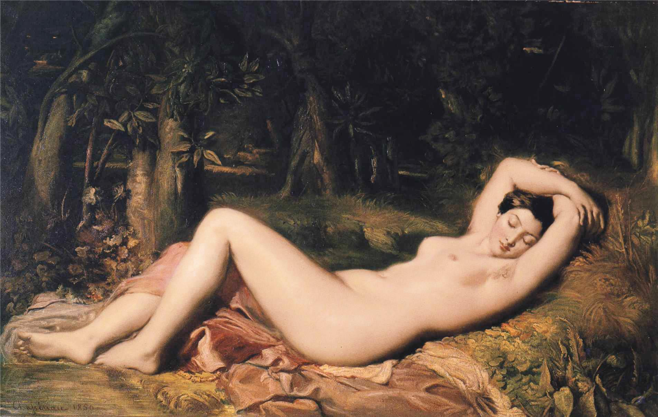Image 1
The female nude is a very common image. This painting by Theoadore Chasseriau ‘Sleeping Bather beside a Spring, 1850 is a good example of a classic female nude. Historically the female nude is painted with the woman always in a reclining or relaxed pose. There is no hair on her body and her skin is fair and soft. Her eyes are always averted or closed as to never look at the viewer. She is perceived as “…Passive, available, possesable, powerless” (Parker and Pollock, 1981, 116) she is seen simply as an object, she has no identity. Traditional western beauty ideals derive from the female nude. People believe that this is the most desirable female form, to have no hair or marks on the body that could be unsightly.
The female nude was historically only painted by men as women were not allowed to practice this art for some time even though they were used as the models for these paintings they were not allowed to paint them themselves. “Man is absent from the image but it is his speech, his view, his position of dominance which the images signify” (Parker and Pollock, 1981, 116) men’s dominance is made very obvious in paintings of the female nude with how passive and available the women are portrayed, the audience looks at the nude and are made to feel empowered because
“The female figures are frequently asleep, unconscious or unconcerned with mortal things, and such devices allow undisturbed and voyeuristic enjoyment of the female form” (Parker and Pollock,1981,116)
The audience is not embarrassed by this they study her naked body and feel no shame. They feel no shame because to the audience doesn’t see her identity they just see her as an object.

“To be naked is to be oneself. To be nude is to be seen naked by others and yet not recognized for oneself. A naked body has to be seen as an object in order to become a nude” (Berger, 1972, 54)
this quote helps to focus the theory that women were seen as objects in these paintings that they were not simply naked but they were nude. And being nude meant that you lost all identity and handed over all power to the audience that you are being viewed by.
John Berger stated in his book Ways of seeing “the ‘ideal’ spectator is always assumed to be male and the image of the woman is there to flatter him” (Berger, 1972, 64). This is because all artists at this time were male all painting for a specific clientele that were other men.
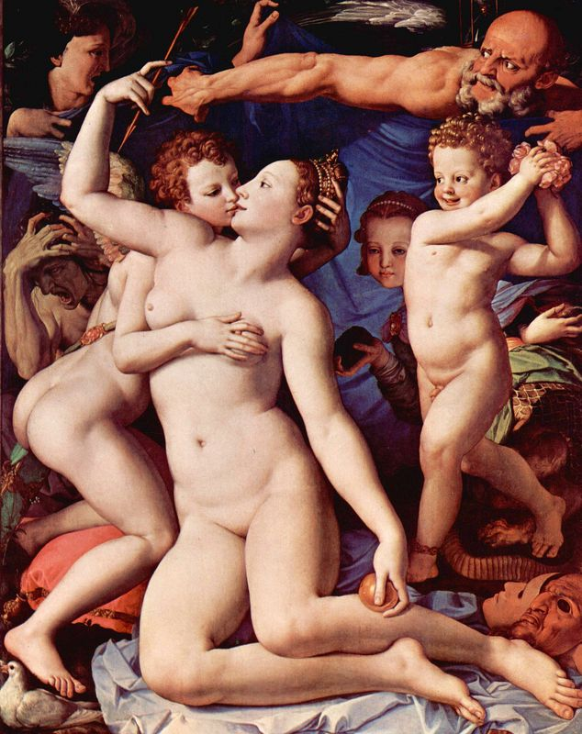
Image 2
This image Venus, Cupid Time and Love by Bronzino 1503-1572 is a good example of men gifting other men paintings of the female nude. Berger stated that this painting was given to the King of France as a present from the Grand Duke of Florence. The way her body is on display to the audience is done purposefully so that the man looking at the picture can see her body the painting is “…Made to appeal to his sexuality. It has nothing to do with her sexuality” (Berger, 1972, 55) again looking back on the audience seeing her as an object, the man only sees her as something sexual she has no identity and she belongs to him.

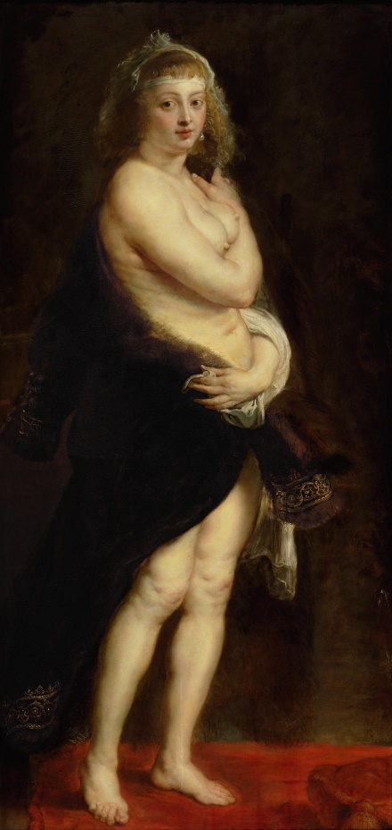

Image 3
This painting of Helene Fourment in a fur coat by Rubens 1577-1640 is an interesting nude. Although all female nudes are rather banal this one not being an acceptation it has slight differences to those in this essay. She is stood rather than reclining, she is covering the bottom half of her body with a fur robe were the others do not and she is looking directly at the audience leading her to de different to the others. If feels although she is naked that she is in control. She looks in the eyes of the viewer demanding recognition she is also covering the parts of her body that she wants to cover seeming in control but also at the same time noticing that the shawl is actually slipping away to expose more of her skin suggesting a balance of power. “…Rubens compulsive painting of the fat softness of Helene Fourments flesh which continually breaks every ideal convention of form…” (Berger, 1972, 61). This is intriguing as Berger uses the words ‘fat softness’ to describe Helene Fourments skin leading to believe that she is still a classic nude model with soft pale and hairless skin but now the word fat is being used to describe her and as stated in the quote above although not very drastically this does brake the ideals of the time of what makes a nude a nude.

Chapter two
Although in many instances the western beauty ideals of the past still have not changed, the beauty standards followed then are still followed today for the most part. We as an audience still look at images of women voyeuristically and without comprehension that we are looking at them and seeing them as objects. But contemporary artists and designers have been challenging and subverting the traditional western conventions of idealised beauty and over the years have produced work that has shown us the audience that beauty is something that comes from within and has also shown them the spectacle.
“The spectacle presents itself as a vast inaccessible reality that can never be questioned. Its sole message is: “What appears is good; what is good appears.” The passive acceptance it demands is already effectively imposed by its monopoly of appearances, its manner of appearing without allowing any reply.”(Debord, 2014, 9-10)
The artists and designers in this essay have all used the spectacle to demand the audience to really see their work and view how they have challenged have challenged ideals pushed boundaries and helped change beauty ideals.
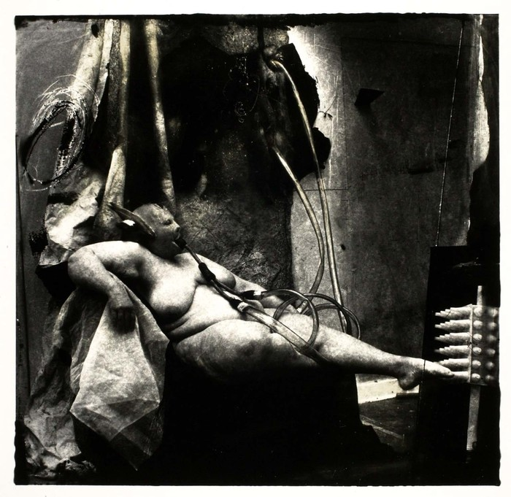Image 4
In keeping with the theme of the female nude using this image by Joel-Peter Witkin Sanatorium 1987 we see that Witkin has used the classic style of female nude but with a dark twist. He is a photographer that is known for inviting
“…Sufferers, contortionists, dwarfs, anorexics, pre – and post- op transsexuals, narcissists, exhibitionist, the obese, the physically and mentally disabled , the congenitally ill or conjoined, side-show curiosities and the dying – to his studio, to pose and be directed in timeless theatricals of obscure, symbolic gestures.” (Parry, 2001, 3)
Witkin uses models that are not conventional or idealistic in his photographs he wants to give these people a platform so to feel empowered and be part of the stories he tells by being a part of his work. Although similar this cannot be seen as a nude she is naked it’s the flesh that is important here, she is real.
The woman in the image has been described as “…deliciously fat and sensuous…” (Parry, 2001, 58) Words that are rarely ever used when being associated with someone who is seen as being fat. Delicious and sensual are normally words that are associated with people who meet the western ideals of beauty. In an interview with Witkin the author stated that he “…explores a process of re-examining what we regard as beautiful” (Berry, 1998, 34-39) We as the audience make the assumption that the models Witkin uses for his images are vulnerable people that we need to feel sorry for. The reason we may feel this way is because we have been brainwashed and conditioned by western ideals to feel that people who don’t meet those ideals are then vulnerable beings who should be felt sorry for rather than treating them as normal people. The impact Witkins work has had on contemporary culture is great. By forcing our ways of seeing an image as a story and not simply an image he has helped other artists and designers with their own narratives including the work of contemporary fashion designer Alexander Mqueen.

Alexander McQueen was a British contemporary fashion designer that used many narratives and stories to co-inside with his runways. Taking inspiration from Joel-Peter Witkins ‘sanatorium’ McQueen created the narrative much like Witkins of life in a sanatorium. All of the models wore bandages on their heads and were placed in to a cushioned box runway with a mirror around the outside so that the audience could see themselves for the first half an hour of the show. Mqueen made the audience aware of themselves so that they are no longer the voyeur they are now aware of their shame. He made the audience question their pre conceived ideals of beauty giving all power over to the models. McQueen also used the classical nude as part of his runway show, but instead of the banal nudes we are used to seeing he completely turned it on its head and created a spectacle out of his brand new and empowering version of the female nude.
In this image of Michelle Olley in his asylum themed SS01 show VOSS we see a reclining and overweight woman covered in moths wearing a mask with breathing tubes attatched. He referenced the image ‘sanatorium’ by Joel-Peter Witkin to create this centrepiece to his show.
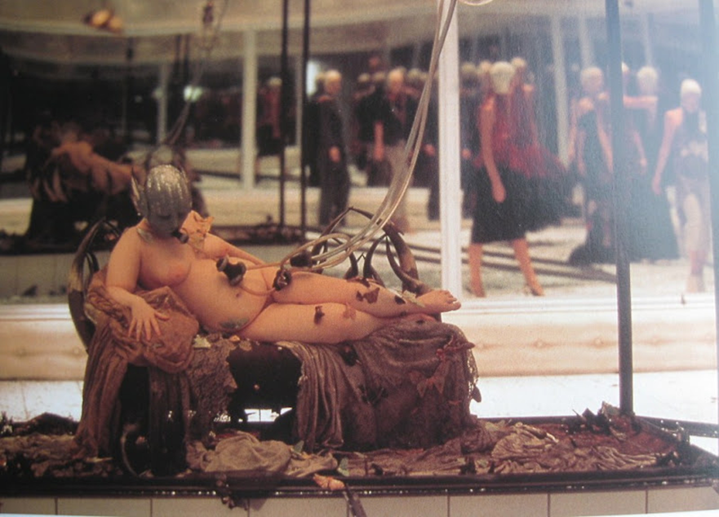

Image 5
As seen from the Theoadore Chasseriau image and this McQueen image there are a lot of similarities. Both are naked women with pale hairless skin, they are also both reclining you also cannot see their eyes leaving them to look passive.
Olley stated that McQueen had told her that “Basically it’s going to be about beauty – it’s going to be really beautiful, but it’s also going to be about death and rebirth and you’ll be completely naked” (Olley, DAZED, 2015)
Here Olley has told us that McQueen’s main focus for this runway show is beauty and there are clear connections with the standard painted nude and beauty ideals. But McQueen used Olley as this spectacle of beauty even though she is not what western standards of beauty represent.
“I did it for the spectacle. It was such a ballsy thing to do…what he did there was to present something ugly as something beautiful and I think he succeeded” (Olley, DAZED, 2015). As stated by Olley to present something ugly as something beautiful, so to use a model that doesn’t conform to the beauty standards we see all around us every day as the centrepiece of his runway and to make a spectacle of it was unheard of at this time. And for people to adore and applaud and to also accept this as beautiful is to give Olley and other women alike a great empowerment and self-worth using the glass box as a form of trapping something (much like trapping a moth in a glass case) that isn’t conventionally beautiful and showing that beauty comes from within.
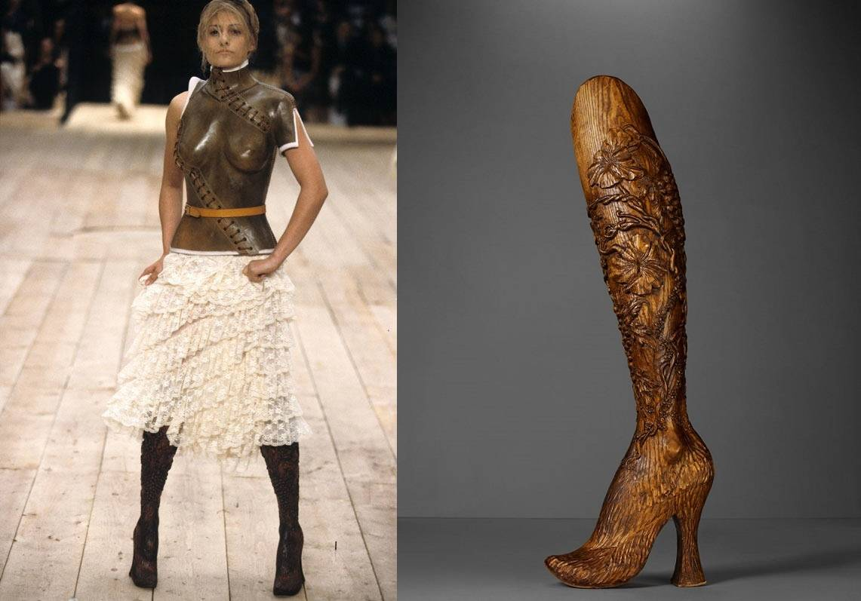
Image 6
Another piece of work from McQueen that could possibly have been inspired by Witkin again is the carved wooden prosthetic boots made for Aimee Mullins a Paralympian. Just like Witkin used unconventional models many of them disabled McQueen decided to take it one step further pushing the boundaries of conventional beauty and using a disabled model to walk down his runway. “As was the case with everything that he did, he wanted to push the boundaries further, questioning narrow preconceptions of beauty” ( Wilcox, 2015, ?)
McQueen’s wooden prosthetic boots worn by Paralympian Aimee Mullins are an excellent example of female empowerment and empowerment in general. Made from hand carved elm wood the boots appear sturdy and strong, but also elegant and beautiful. Perhaps this could be a reflection on McQueen’s perception of the model, a double amputee and Paralympian, as well as being a strong, beautiful, independent young woman she has also overcome all western ideals by being a spectacle for McQueens show. As quoted above McQueen definitely pushed the boundaries of modern beauty standards at that time as it was something no one had ever done, nor had ever dared to do before. He was a designer that would always go against the system. McQueen crushed the preconceptions of beauty by using a disabled model to walk in his show changing perceptions forever and opening the door to a whole new verity of models innovating fashion as we know it by making prosthetics fashionable and elegant rather than the clinical norm. People didn’t know that Mullins boots were actually prosthetics so she walked the runway free from judgment McQueen handed all the power to Mullins in that show empowering her and others alike leading them to be judged as “normal”.
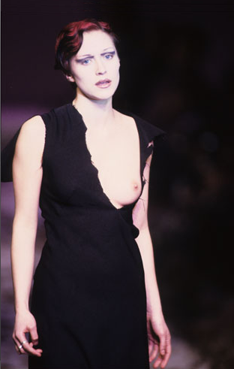

Image 7
What is ‘savage’ beauty? Fierce, violent, uncontrolled, vicious and ruthless are among the many words used to describe ‘Savage’ and beauty is described as a combination of qualities, such as shape, colour, or form, that pleases the aesthetic senses, especially the sight. In one way you could look at these words in the form of a woman. Maybe this was how McQueen saw women. As beings who were fierce and uncontrollable not to be messed with or underestimated. In another way you could use the words uncontrolled, violent and fierce to describe McQueen’s designing style as he isn’t afraid to push the letter using stories to create his collections, ‘Highland Rape’ to name one.
He used a “…Visual commentary on England’s violation of Scotland” (Hall, 2013, Highland Rape) to create a spectacular collection full of meaning that at first would be wasted on the media as they would accuse him of being a “…Misogynist – an insensitive idiot glorifying rape to gain media coverage” (Hall,2013,Highland Rape) when in reality he was making a spectacle of this runway to portray a part of history and to also highlight the challenges that many women go through every day. And although he is depicting something horrible he gives women a platform to feel empowered by his work. McQueen has stated “I design clothes because I don’t want women to look all innocent and naïve, because I know what can happen to them. I want women to look strong” (Watt, 2012, 76) I think that this may be what McQueen means by ‘savage’ beauty in that it is what he sees women as, strong and empowered he wants them to feel as if no one would dare touch them without their permission as it should be “When a woman came in to a room wearing his clothes they shouldn’t, ‘cor, I’d love to screw her,’ but ‘she looks amazing but I couldn’t go near her” (Watt, 2012, 84)
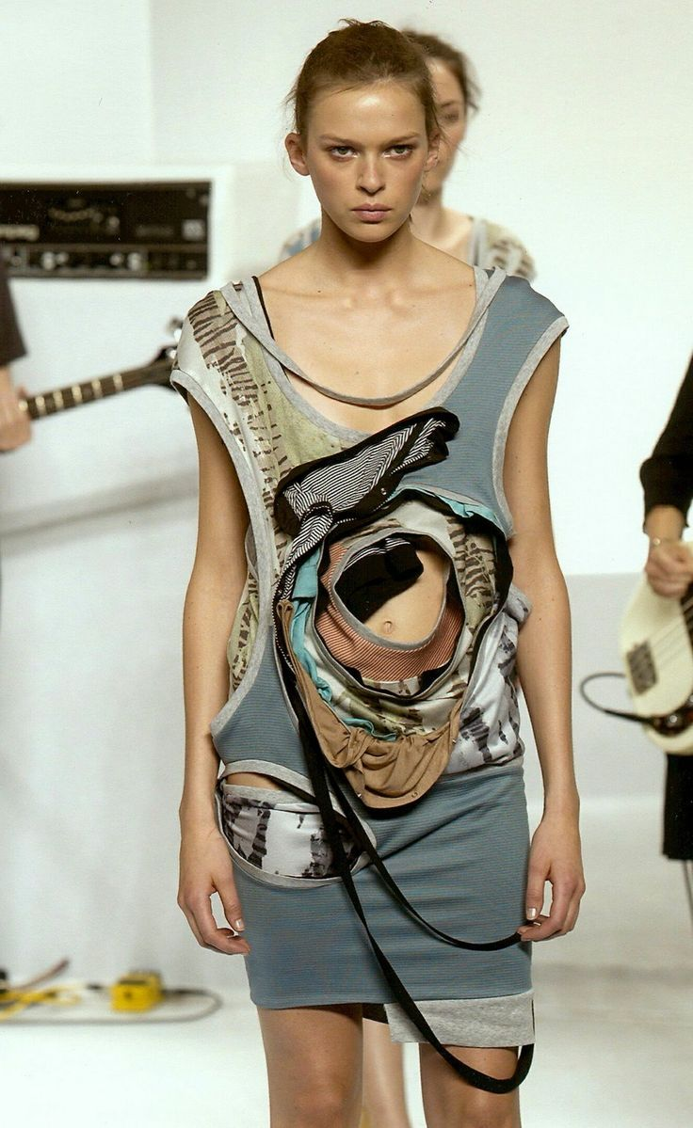

Image 8
The garments made by Chalayan are similar in design and look to McQueen’s Highland rape although the narratives behing are rather different.
“Strict Western clothing standards can be regarded as a means if imposing such ideologies. Clothes are used to place the naked body within the cultural setting of prevailing notions about beauty, chastity and decency.” (Evans, Menkes, Polhemus, Quinn, 2005 , 128)
As stated by Evans, Menkes, Polhemus and Quinn in the book ‘Hussain Chalayan’ Chalayan used his collection ‘Manifest Destiny’ to liberate the body from the Western traditions of covering and distorting the body as well as restricting its movement and function almost disabling the body. Chalayan created this collection attempting to restore identity, and also look at anatomy, the multiple layers of elasticated fabric and coloured strips are there to represent the multiple layers and folds of the skin and the holes in some of the garments are to represent different body parts or organs that could be removed. Due to the elasticity of the garments the models were able to move freely and comfortably as if they were naked, thus successfully braking away from Western traditions of having to cover up and uncomfortably pull everything in. Without knowing the narrative behind these garments you would never describe them as slightly grotesque. But if you do know then thinking about the garments as folds and folds of skin and holes resembling cut out body parts then you could connect this piece of work to that of Jenny Saville’s as she too uses the flesh to create her artwork and also is breaking western beauty ideals.

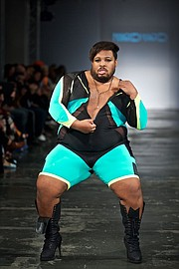

Image 9
A fashion designer also heading in the right direction is Marco Morante, the image above shows plus sized male model and professional dancer Dexter Mayfiled who strutted down Marcos runway "Being a professional dancer, I already know the pressure of not fitting into the typical look of what a dancer should be" (Guillory, 2015, Online article) Mayfield although being a man is still a victim of beauty ideals and is still judged for not meeting them.
“I don’t know very many models who can walk the runway and give the same essence of a pop sensation like many of these girls from Drag Race. I think that we are moving forward. Betsy Johnson just had Willam walk in her show. So we are making good strides. It’s kind of been happening under the radar with a lot of trans girls. We are embracing it all. I love that Marco Marco is blazing it and just doing it.” (Temblador, 2014, Celebrating high fashion and unique beauty)
Marco Morante is an innovative fashion designer using an array of models from men and women, androgynous men and women, transgender, drag queens and pus sized to wear his creations and walk down the runway. His decision to have this array of models goes against the western ideals of your average runway model and promotes the beauty to be found in different bodies. Monrante’s work is mostly aimed at gay men but he does design for women and drag queens as well. He empowers women through making his runway show a spectacle and a celebration of uniqueness and being comfortable in your own skin. He makes us as the audience feel empowered by turning our differences in to something beautiful. Morante does not discriminate against size, gender or age he is paving the way for the future making it important that everyone knows that everyone is beautiful no matter what their size or gender as beauty comes from within.

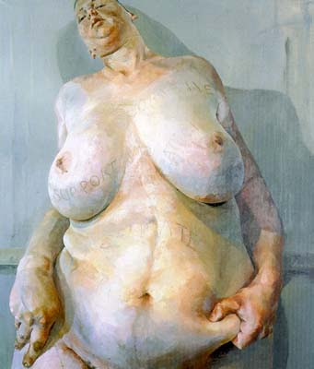

Image 10
"As a child I'd look through art books and there were no women artists. Of course, you start to ask why not." And: "Could I make a painting of a nude in my own voice? It's such a male-laden art, so historically weighted. The way women were depicted didn't feel like mine, too cute. I wasn't interested in admired or idealised beauty." (Saville, 2005, under the skin)
This quote reminds me of one of my first point in this essay where I talk about an image by Theoadore Chasseriau and the history of the female nude. Saville talks about idealised beauty being to ‘cute’ for her taste. She was more interested in the realness of the body that it wasn’t always hairless and pale and thin. That to western standards the body Saville is interested in is ugly.
Saville states that “Ugliness there is aplenty here… it is always the first step to beauty.”(Schwabsky, Barry, Tincelin, Aude,2004,22-28) This quote is very interesting to me as the use of the word ugliness, as to be the first step to beauty to describe the woman’s body. To be beautiful by Western ideals is to be thin and to be ugly is to be fat. But Saville’s ideal of beauty portrayed through her paintings is that there is no ugly, but only beauty and to be ‘ugly’ is simply to be individual in your own beauty.
As addressed in the article “Saville embraces heaviness in many ways” (Schwabsky, Barry, Tinceln, Aude, 2004, 22-28) One way I would like to focus on is that she uses models that we would perceive as heavy. Unlike some historical paintings were women are often depicted as slim with no hair on the body and usually lying down or reclining. Saville has chosen to put the gaze on to ‘heavy’ women with natural hair on their bodies usually painted at an up close angle and pulling or squeezing the skin, empowering the women in the paintings rather than like historical paintings normally empower the viewer.
“Reviews have spoken of repulsion, brutalized femininity and abject self- image. Psychological and existential states which are, to say the least, difficult to take lightly” (Schwabsky, Barry, Tincelin, Aude, 2004, 22-28)
I agree with this statement that these reviews are difficult to take lightly, as people are still stuck in Western ideals of beauty they become repulsed at the sight of a woman’s body is raises the question as to why. Why do they believe these paintings are showing brutalized femininity when it is simply a painting of an image Saville has taken of a real woman who really looked like that?
“Females, as she says, are used to being looked at: "I don't like to be the one just looking or just looked at. I want both roles." Taking herself as her own model, her exaggerated nudes point up, with an agonising frankness, the disparity between the way women are perceived and the way that they feel about their bodies” (Saville, 2005, under the skin)
Saville stating that females are used to being looked at also relates to the Theoadore Chasseriau painting in that, women have always been the vocal point, they are used to being looked at for so long that it is just a part of daily life, unfortunately women are usually looked at for the wrong reasons weather it’s a sexualizing way or an undermining way more often than not being judged for not looking or acting a certain way. But mostly for not meeting Western beauty ideals. Saville though does not care for beauty ideals she is interested in the flesh and interested in what is really real about the body. In her painting she makes a spectacle of the flesh and the body with the way she paints with thick strokes and marks to resemble the skins texture. The sheer size of the paintings leave you unable to look away and forces your perspective. Forcing you to give in the flesh. You realise that the flesh is everything. "It's all things. Ugly, beautiful, repulsive, compelling, anxious, neurotic, dead, alive." (Saville, 2005, under the skin) And it is nothing.
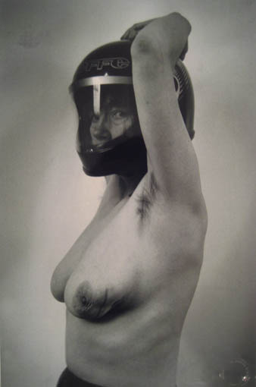

Image 11
Connecting again with the work of Joel-Peter Witkin is the work of photographer Jo Spence. As Witkin used models for his photographs that were ill or disabled Jo Spence used herself as her own model while documenting her fight with breast cancer. The image above shows Spence in a post op state showing her mutilated breast after the cancer has been removed. In her book Spence speaks about “…the way that disease and health are represented to us” (Spence, 1988, 155) We normally see a glamorized version of health and even disease we never really see the real and raw side if illness.
Spence also speaks of the fact that women are an object of the male gaze, this could suggest that she sees illness for a woman as being more difficult because of the male gaze. Because women are put under the pressure of western beauty ideals and conventions feeling that they have to look ‘beautiful’ to be loved or feel loved by anyone. Women are expected to look a certain way so when a woman has some kind of deformity or difference that isn’t pleasing to men or conforming to western ideals they are seen as no longer desirable.
She “merely wanted to be ‘seen’ as a person in the daily struggle” (Spence, 1988, 162) going back to John Berger’s ways of seeing she doesn’t want to be seen as an object or a patient or even a woman, she wants to be seen as a person who is real and who feels trying to work through something.
Spence also stated that after she found out that they would have to remove part of her breast that she realized that her body “…was not made of photographic paper, nor was it an image, or an idea or psychic structure…it was made of blood, bones and tissue” (Spence, 1988, 151) a possible connection could be made with Jenny Saville’s work here as she realises that her body is real flesh and bone her disease has made her really see her body for the first time instead of seeing under western beauty ideals she sees her flesh not her skin she sees naked and not nude. Her work is an excellent example art empowering women as she has documented her body with no regard for western ideals making her disease a spectacle of self-empowerment.

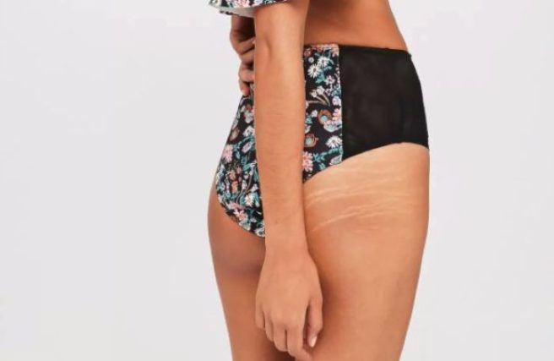Image 12
The online fashion label Missguided have also decided that they no longer are slaves to the male gaze much like Saville has. They have made a statement about celebrating individuality they do not want us to live under idealised beauty as they claim it doesn’t exist. They have made a spectacle out of normal.
“So we're on a mission to do just that by showing our audience it's okay to be yourself, embrace your 'flaws', celebrate individuality, and not strive for what the world perceives as perfection. Because basically, it doesn't exist.” (Brennan, 2017, So much respect for missguided)
The fashion brand has recently been in the media for showing images of models on their website with their stretch marks unedited or airbrushed. I would consider this a way of empowering women by showing women that flaws are natural and a part of what makes you individually beautiful. Reading the article I have seen that people have been very happy about this change in the fashion world as it is something that has never been done before. “Just saw a Missguided pic in which they didn't edit the model's stretch marks out and that's beautiful.” (Brennan, 2017, so much respect for missguided).
People calling the images of the stretchmarks beautiful id a step forward in eliminating beauty ideals and empowering women further as these things become more of the norm and less of the taboo things that we have to hide from other people or risk being judged.“Hey Missguided, if you're going to use models with stretch marks can you not also use a variety of sizes? We aren't all a size 8.” (Brennan, 2017, so much respect for missguided). Although Missguided are not fully away from the Western beauty standards as some people pointed out, they have gotten rid of the photoshoped images we are used to seeing they still do not have any models over a size 10 nor do they have a variety of ethnicities or heights leaving them still trapped under western ideals but gladly heading in the right direction.

Conclusion
For the conclusion of this essay I will be talking about the information that I have gathered and how this as affected the conclusion of this essay.
Beginning with the spectacle using Debord’s idea of “decontextualisation” (Debord, 2014, society of the spectacle) by taking something out of its context is makes us the audience look in a new way. For example McQueen’s ‘voss’ had mirrors around the outside of the runway so the audience were looking at themselves for the first half an hour of the show. This is a very clever way of playing with power as Mqueen is making the audience aware of themselves; they are no longer being voyeuristic as they are now conscious of their shame. McQueen challenges the audience to question their ideology then changing the audience pre conceived ideas of beauty. McQueen has changed the way that men perceive women by no longer seeing them as fragile and passive but strong and passionate and demanding of their respect.
I believe that this essay was mostly aimed at considering the audience more than the sitter. We as an audience have always been brainwashed in to believing in the western ideals of beauty and the male gaze were we have been conditioned to think that women should look and act a certain way or risk not being lovable. This essay has taught me that beauty ideals are changing with every new runway show or piece of art and we as the audience are ever changing with it.
“So we're on a mission to… show our audience it's okay to be yourself, embrace your 'flaws', celebrate individuality, and not strive for what the world perceives as perfection. Because basically, it doesn't exist.” (Brennan, 2017, So much respect for missguided)
As used before in this essay using it to make this point that this quote from Missguided could be a good example of how influential designers, like Alexander McQueen are changing the way people think. Empowering women to feel confident in their own skin. And although western ideals of beauty do still exist and are still quite prominent in our society artists like McQueen and brands like Missguided are taking us a step in the right direction in to the future.

Bibliography
Books
BERGER. J. (1972). Ways of Seeing. London: Penguin books LTD
DEBORD.G (2014) Society of the Spectacle. Whitechapel highstreet, London: Rebel press
EVANS, C. MENKES, S. POLHEMUS, T. QUINN, B. (2005). Hussein Chalayan. (1st edn). Rotterdam: NAi Publishers
KNOX, K. (2010). Alexander McQueen Genius of a Generation.(1st edn). Soho Square, London: A & C Black Publisher Limited
PARRY.E, (2001). Joel-Peter Witkin 55. All saints street, London: Phaidon Press Limited
PARKER. R, POLLOCK.G. (1981). Old Mistresses Women, Art and Ideology. 114 Hemingford Road, London: Pandora
SPENCE.J. (1986). Putting Myself in the Picture. 43 Camden Passage, London: Camden Press, LTD
WATT. J. (2012). Alexander McQueen The Life and the Legacy. New York: Harper Design
WILCOX, C. (2015). Alexander McQueen. (1st edn). South Kensington: V&A Publishing
Articles/Journals
BERRY, IVAN (1998) Art papers. The marriage of heaven and hell. November/December, Issue 6, p34-39. 6p
JULIUS, CORINNE (2015) Craft Arts International . SAVAGE BEAUTY: The performance fashion of Alexander McQueen. Issue 94, p72-75. 4p
SCHWABSKY, BARRY, TINCELIN, AUDE (2004) Art-press. Jenny Saville: “Unapologetic” February 2004, Issue 298, p22-28, 7p
Websites
ALLWOOD, EMMA HOPE, ‘Being McQueen’s Muse’ [online] Published 26/09/15. Available from: http://www.dazeddigital.com/fashion/article/26688/1/michelle-olley-mcqueen-muse-voss-ss01
BRENNAN, SOPHIA, 'So much respect for Missguided': Retailer praised for using unretouched photos of models baring their STRETCH MARKS to show women as 'real and authentic' [online] Published 10:15 7/11/17. Available from: http://www.dailymail.co.uk/femail/article-5057551/Missguided-praised-using-models-stretchmarks.html
GUILLORY, NICK, ‘A Model Completely Destroyed The Runway At A Fashion Show And It Was Everything’ [online] Published 1:55 am 10/22/15. Available from: https://www.buzzfeed.com/nickguillory/this-runway-model-completely-dominated-a-fashion-show-and-it?utm_term=.ra6kgZYdg#.hl4k8O5p8

HALL,JAKE, ‘Highland Rape’ [online] Published 22/11/13. Available from: http://stylejourno.blogspot.co.uk/2013/11/highland-rape.html
TEMBLADOR, ALEXANDRA, ‘Marco Marco: celebration of high fashion and unique beauty’ [online] Published 1:36 pm 16/10/14. Available from: https://www.huffingtonpost.com/2014/10/16/marco-marco-2014-show_n_5997916.html

Images
Theoadore Chasseriau (1850). Sleeping bather by the lake [online] Available at: https://www.pinterest.co.uk/pin/16395986116025118/?lp=true (Accessed: 05/12/17)
Bronzino (1503-1575). Venus, cupid, time and love [online] Available at: https://www.artble.com/artists/agnolo_bronzino/more_information/biography (Accessed: 05/12/15
Rubens (1577-1640) Helene Fourment in a fur coat [online] Available at: https://arthistoryproject.com/artists/peter-paul-rubens/helene-fourment-in-a-fur-robe/ (Accessed:05/12/15
Joel-Peter Witkin (1987) Sanatorium [online] Available at: https://www.icp.org/browse/archive/objects/sanitarium (Accessed: 05/12/17)
Alexander McQueen (2001) Voss [online] Available at: https://vossehf.wordpress.com/2012/01/24/hello-world/ (Accessed: 12/10/17
Alexander McQueen (1999) No.13 [online] Available at: https://www.designersatelier.co.uk/dagmars-articles/alexander-mcqueen/ (Accessed: 11/10/17)
Alexander McQueen (1995) Highland Rape [online] Available at: http://luxx-noire.blogspot.co.uk/2011/06/ive-confession.html (Accessed: 29/11/17)
Hussain Chalayan (2003) Manifest Destiny [online] Available at: https://www.pinterest.co.uk/explore/rebel-fashion/?lp=true (Accessed: 31/10/17)
Jenny Saville (1992) Branded [online] Available at: https://theartstack.com/artist/jenny-saville/branded-1992 (Accessed: 29/11/17)
Missguided (2017) [online] Available at: : http://www.dailymail.co.uk/femail/article-5057551/Missguided-praised-using-models-stretchmarks.html (Accessed: 01/11/17)
Marco Marco (2014) Collection 2 [online] Available at: https://apparelnews.media.clients.ellingtoncms.com/img/photos/2015/10/19/marco-101915-aa-004_t180.jpg?370a03faaa4bde2115f371a02430eb3e6a451be5 (Accessed: 01/11/17)
Jo Spence (1982) The Picture of Health [online] Available at: https://artlogic-res.cloudinary.com/w_960,h_500,c_limit,f_auto,fl_lossy/artlogicstorage/richardsaltoun/images/view/f1d47c42b82bff55b8da85ce7e15eb46bbf142f8.jpg (Accessed: 05/12/17)

