Student Name | Halima Hussain
Student ID | 2408734
Module Code | LCBB4012
Module Name | Academic Skills
Assignment title | Component 1: Coursework:  Individual Written Report
Submission Date | 01st March 2026

Table of Contents
1. Introduction 3
2. Definition of Time Management 3
3. Importance of Time Management for Academic Success 3
4. Time Management Strategies 4
4.1 Urgent/Important Matrix 4
4.2 Mayo Jar Principle 5
5. Conclusion 5
References 7

1. Introduction
Time management is an important skill that helps students handle their tasks and meet deadlines. Students might feel anxious and affect their performance in academics if not get ready ahead of time. This report explains time management and its importance for students. It also points out two key strategies to help improve balance and productivity.

2. Definition of Time Management
Time management is the skill of planning and using time wisely to get more work done. This idea highlights that managing time means planning carefully and deciding which tasks are most important, not just staying busy (Aeon et al., 2021). Academic literature agrees with this concept based on research articles. According to Claessens et al. (1990), Time management is a behaviour that includes making goals, deciding what is most important, scheduling activities, and monitoring progress. According to Fu et al. (2025), effective time management helps people perform better and feel less stressed because they feel more in control of what they do. In an academic environment, students should plan their study time, give themselves enough time to finish their work, and avoid studying everything at the last minute.

3. Importance of Time Management for Academic Success
Academic success in school is closely connected to time management. Effective time management helps students finish their homework and prepare for tests better. Britton and Tesser (1991) found that those students who manage their time better usually perform better in school. Being well-prepared helps reduce stress. Students who are unorganised might feel overwhelmed, miss due dates, or rush to study before tests. Scheduled study times help them feel less tired and improve their confidence.
The Mayo Jar Activity shows how important it is to set priorities. By focusing on the most important tasks first, to ensure complete essential academic work before tackling less important ones. For example, starting a project early leads to better results than waiting until the last minute to get it done. Also, since university students need to organise their own study time besides scheduled classes, managing their time helps them become more independent and responsible. Learning this skill helps students become more responsible and prepares them for future jobs where they need to manage tasks and meet due dates.

4. Time Management Strategies

4.1 Urgent/Important Matrix
The Urgent/Important Matrix, also known as the Eisenhower Matrix, is a helpful tool that splits tasks into four parts:
- Urgent and Important
- Important but Not Urgent
- Urgent but Not Important
- Neither Urgent nor Important

This method helps students focus on what really matters instead of just what seems urgent (Al-Shidhani, 2011). For example, studying for a test in two weeks is important, but it's not urgent; however, it becomes urgent if it is ignored. Students feel less stressed and do better work when they complete important tasks early.

4.2 Mayo Jar Principle
The Mayo Jar principle highlights the importance of setting priorities. Applying the Mayo Jar Principle to a student's life, the exercise puts the important things, like homework or studying for tests, into the jar first. Less important actions are shown by small rocks, gravel, and sand. Students might not have enough time for important schoolwork if they choose to do less important things instead.
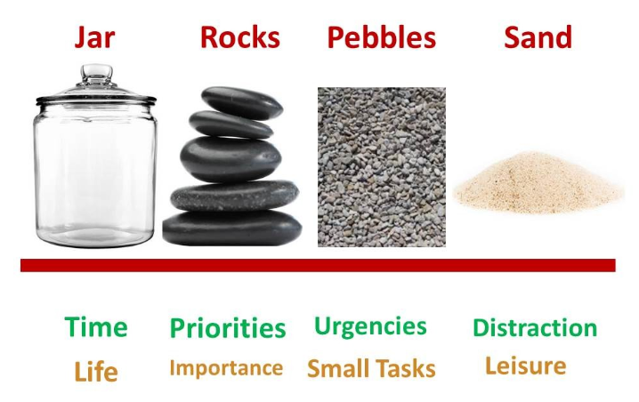
To put this idea into action, need to set goals, make a schedule, choose deadlines ahead of time, and check or change plans when necessary. In the lecture, these actions were highlighted as important for managing time effectively. Personal situations should also be considered when managing time. Students should know their duties, set clear learning goals, and find out which study methods work best for them. Personalised planning increases confidence and helps students work better.

5. Conclusion
In summary, effective time management is an important skill for students. It helps them utilise their time wisely, reduces stress, and helps them perform better in their studies. Choosing goals, picking what’s most important, and regularly checking plans are all important for managing time in a better way. The Mayo Jar idea and the Urgent/Important Matrix are two methods that help students focus on important tasks instead of less important ones. Students can complete their work on time, do better quality work, and have a productive academic life by managing their time well. In the end, it can be said that effective time management skills help with both career growth and academic success.

References
Aeon, B., Faber, A., and Panaccio, A. (2021). ‘Does time management work? A meta-analysis’, PloS one, 16(1), e0245066.
Al-Shidhani T. A. (2011). ‘The Seven Habits of Highly Effective People’, Sultan Qaboos University Medical Journal, 11(3), 426–427.
Britton, B. K., and Tesser, A. (1991). ‘Effects of Time-Management Practices on College Grades’, Journal of Educational Psychology, 83, 405-410.
Claessens, B.J., Van Eerde, W., Rutte C.G., and Roe, R.A. (2007). ‘A review of the time management literature’, Personnel Rev. 36(2), 255-76.
Fu, Y., Wang, Q., Wang, X., Zhong, H., Chen, J., Fei, H., Yao, Y., Xiao, Y., Li, W., & Li, N. (2025). ‘Unlocking academic success: the impact of time management on college students' study engagement’, BMC psychology, 13(1), 323.

