Content Analysis Report: Analysis of types of aggressive behaviour demonstrated by two opposing groups in a video of protesters against hunting with hounds confronting pro-hunt group members.
Abstract

Using quantitative data from ten participants, five from each side, this study analyses different types of aggressive behaviour within a three-minute video demonstrating a protest on foxhunting in the UK. Protests on hunting are frequent and often exhibit high levels of aggression. Explanations for aggression such as provocation, gestural, verbal, and physical and theories like aggressive cue theory and frustration-aggression hypothesis describe aggression and relate to behaviours demonstrated within this video. This study investigated the results of the types of aggression shown and found that the anti-hunting group delivered the highest level of aggression overall, although there were different patterns regarding the types of aggression. The aggressive-cue theory gives insight to the results suggesting that the opposing sides delivered environmental stimuli to ignite aggression. Further research into the topic, or researcher attendance for future protests could enhance the supporting evidence and create a greater in-depth report.

Introduction

Aggression, when used as a noun, is defined in the Oxford dictionary as, “hostile or violent behaviour or attitudes” (Buxton, 2013., pp. 10). There is proximate (immediate) and primary (pre-meditated) intention and can be defined through violence, hostile and instrumental aggression. However, it becomes difficult to define aggression universally when considering cultural differences. Culture and societal norms can influence the way aggression is defined and perceived, and what is ordinary for one culture, may not be for another. Bandura (1973) defines aggression as destruction of property or personal injury that has resulted from a person’s intentional behaviour. While Anderson and Huesmann (2003) state that aggression immediate aim to inflict harm by behaviour intended for another individual. There are vast definitions for aggression that are based on conceptual differences but the argument for a universal definition has yet to be definitive (Gross, 2020; Hogg & Vaughan, 2014; Kassin et al., 2011).

Aggression types like provocation, gestural, verbal and physical can all define aggression Provocation, although can be unintentional, is sometimes regarded as a type of aggression and expressed through taunting, goading, etc. that can trigger a reciprocation. Physical aggression relates to harm/damage being inflicted on a person/object while gestural aggression is intimidation via, pointing, angry facial expressions. Verbal aggression concerns language as the aggressive act via means of threats or insults, even one’s tone can heighten the intimidation (Baron & Branscombe, 2014; Gross, 2020; Kassin et al., 2011).

Dollard et al. (1939) Frustration-aggression hypothesis (FAH) lays its foundations to Freuds theories that aggression was an innate response. Instead of looking at it in this term, Dollard et al. argued that the innate response had to be triggered by an irritating situation. Frustrative stimuli awakens aggression into aggression itself. The consequence of frustration is aggression (Hewstone et al., 1995; Hogg & Vaughan, 2014)

According to Berkowitz (1966) aggression derives from frustration and acts of aggression are ignited by learnt triggers. Although psychological and physical pain are present and can produce anger, they do not cause the aggression, only when certain cues, such as environmental stimuli or unpleasant experiences, are triggered does the aggression occur. This is aggressive cue theory (ACT) where frustration is the catalyst for aggression. Berkowitz and LePage’s (1967) experiment found that provoked participants displayed more aggression when an object of aggressive stimulus was present, in this instance a shotgun. This was called the weapons effect (Gross, 2020).
Foxhunting was a controversial sport that is now illegal within the UK apart from certain exceptions. High levels of aggression are a constant occurrence in protests on foxhunting with anti-hunt activists regarding it cruel, while pro-hunters state it’s a part of their inherited culture or a means of pest control. The controversy remains constant and displayed aggression almost unavoidable (Carwardine, 2022).
Hypothesis
The main group aggressor will be the anti-hunt group, displaying more aggressive behaviours over the pro-hunt. Each group will demonstrate their own forms of aggression with different intentions. The pro-hunters may display more provocative behaviour to entice a negative reaction. Anti-hunters will be more verbal as they will want to express their protest without embroiling themselves with the law.
Method

The data of this analysis will be collected in a quantitative form from a pre-recorded video and gathered from the moment the video is played. The results will reflect the scores of two opposing groups already identified within this video, pro-hunt and anti-hunt. Although there are police present, their behaviours will not be accounted for as they remain non-bias.

The video was watched ten times to clearly identify opposing sides and an equal number of five participants were chosen. A scoring grid will be generated to measure the aggression of each participant and a numerical comparison will be determined for each group. The scoring grid will be sectioned to tally every type and incidence of aggression for each group. The only materials being used for this report are the pre-recorded video and the scoring grid.

The video was watched four times for each participant consistently to ensure all types of aggression were recognised and equally recorded accordingly. The data is secondary data and was collected individually and independently.

As this is a pre-recorded video, and is freely available on you tube, there is no requirement to recruit any participants to help conduct this content analysis report. It is also not necessary to include a debrief as the video is publicly available.

Here is the link for the pre-recorded video that will be used for this analysis with the scoring grid attached within the appendix.

https://www.youtube.com/watch?v=0aLAbwR3fog

Results

Below show two figures from the results. The specific types of aggression that were apparent were, physical, verbal, gestural and provocation. These results were based upon five participants chosen from each opposing group, pro-fox hunting and anti-fox hunting.

The results support the hypothesis where the anti-hunt exhibited higher levels of aggressive behaviour by 29.51% (calculations in appendix). As is shown in figure one, their main aggression was verbal whereas the pro-hunt groups main aggression was the acts of provocation.

Physical aggression mostly involved shoving/pushing behaviour towards the opposition but wasn’t present until the video was almost at an end. As demonstrated in figure two, both sides conducted this act of aggression almost equally.

Verbal aggression was demonstrated more predominantly by the anti-hunt group where a repetitive pattern of the use of the word ‘scum’ and other such name calling was apparent. Verbal aggression was conducted less in relation to the pro-hunt as represented in figure one.

Gestural aggression, was again, almost equally displayed from both groups and presented this act of aggression very similarly. Each group of participants would conduct the same behaviours, such as pointing, squaring up and angry facial expressions which generated intimidating behaviour.

Provocation was mainly displayed by the pro-hunt participants. The patterns included taunting, encouraging hand gestures, horn blowing and waving of hats. There was very little provocation undertaken by the anti-hunt group, other than the siren being played.
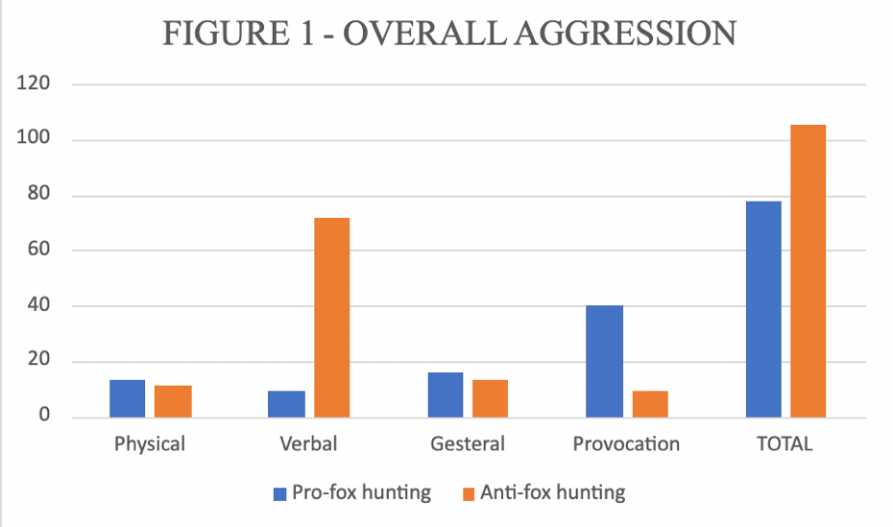

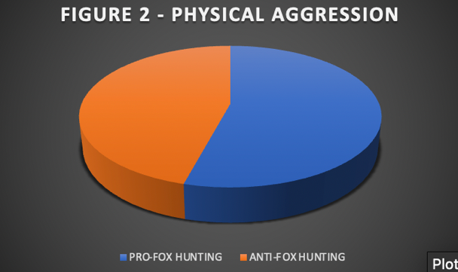
Discussion

As already discussed in the results, the findings to the pre-recorded video analysis concluded that the anti-fox hunting group displayed a higher level of aggression overall coinciding with the hypothesis.

Gestural aggressive acts like pointing, irate facial expressions etc. in the video could each provoke a physical aggressive reaction. This relates to the frustration-aggression hypothesis as the environment becomes irater in the video, levels of frustration rise readying aggression and converting it into aggressive behaviour and could have further encouraged the physical aggression that was exhibited equally by both groups (Hewstone et al., 1995).

The anti-hunt intentions were not to provoke a negative reaction but to promote their message. The siren being played to drown out their opposers could be seen as provocation and a means to be heard. Whereas the pro-hunting group encouraged their behaviour and actions to intimidate and gain an elicit reaction via provocation. The frustration-aggressive hypothesis could explain that both sides were equally frustrated over the presence of each other along with their difference of opinions and their aggressive response was motivated by frustration (Kassin et al., 2011).

The protest objective seemed to be projecting their views about foxhunting largely through verbal aggression. They were strong and pronounced in an aggressive tone/manner, using abusive name calling and argumentative behaviour. The aggressive-cue theory would explain this as frustration could be wanting to be heard or their opinion of foxhunting then enduring the provocative acts, such as horn blowing, of the pro-hunting group could trigger further verbal aggression displayed by the anti-hunting group. Even the presence of the opposing groups themselves, dressed in hunting clothes on horses could be trigger enough to cause the verbal aggression. The weapons effect had similar findings where the presence of an aggressive object created more aggression, in this case the hunters were the aggressive stimulant (Gross, 2020).

This video is in a natural and real-life setting promoting ecological validity where no variable manipulation/influence are involved, and the actions are not within the constraints of a closed environment. However, there is risk of it being subjective and bias could be formed from its creator and the observers’ perspective. The short video may have been edited, only to display what the creator intended, and vital information disregarded. Given the versatile nature within the video, it was hard to identity participants on each side or how representative they were. Further research and researcher attendance could help expand supporting evidence for future study and create greater variable results.

Conclusion

In conclusion, the results from this analysis conclude the similarity with the hypothesis. Results founded that the anti-hunt group displayed more aggression overall with both groups aggressive behaviour correlating to two aggressive theories. FAH stating that when frustration exists aggression is more than likely to follow, and aggression does not exist without frustration. The ACT requires stimulus cues for aggression to follow. The weapons effect correlated to the act of verbal aggression from the anti-hunt group. In instances like this, frustration will always occur due to a difference of opinions, values and norms where aggressive behaviour is almost unavoidable.

References

Baron, R. A., & Branscombe, N. R. (2014). Social psychology (13th ed.). Pearson Education Limited.

Buxton, C. (2013). Oxford english mini dictionary (8th ed.). Oxford University Press.

Cardwardine, M. (2022, Janurary 1). What is fox hunting and why was it banned? Retrieved from Discover wildlife: https://www.discoverwildlife.com/animal-facts/what-is-fox-hunting-and-why-was-it-banned/

Gross, R. (2020). Psychology the science of mind and behaviour (8th ed.). Hodder Education.

Hewstone, M., Stroebe, W., Codel, J.-P., & Stephenson, G. M. (1995). Introduction to social psychology. Blackwell Publishers Ltd.

Hogg, M. A., & Vaughan, G. M. (2014). Social psychology (7th ed.). Pearson Education Limited.

Kassin, S., Fein, S., & Markus, H. R. (2011). Social psychology (8th ed.). Cengage Learning.

Appendences

AGGRESSTION TYPE | PRO-FOX HUNTING | ANTI-FOX HUNTING
PHYSICAL | |||| |||| ||| | |||| |||| |
VERBAL | |||| |||| | |||| |||| |||| |||| |||| |||| |||| |||| |||| |||| |||| |||| |||| |||| ||
GESTERAL | |||| |||| |||| | | |||| |||| |||
PROVOCATION | |||| |||| |||| |||| |||| |||| |||| |||| | |||| ||||
TOTAL | 78 | 105

Percentage difference calculation for total results.

a = Anti-fox hunting
b = Pro-fox hunting

a = 105
b = 78

a–b = 105-78 = 27
(a+b)/2 = (105+78)/2 = 183/2 = 91.5
((a-b)/(a+b)/2) x 100 = 27/91.5 x 100 = 29.51(2dp)

Percentage difference between totals = 29.51%

